+ Change agent mode
agent has 2 mode:
- active: driver + monitor
- passive: only monitor

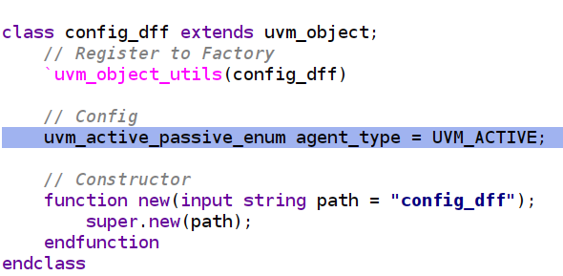

→ uvm_active_passive_enum method reference:
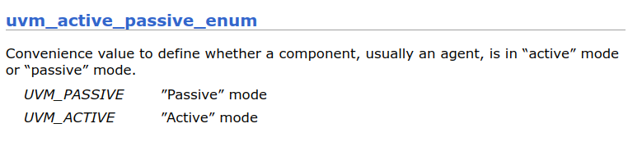
→In short, driver = active | no driver = passive

UART VERIFICATION

+ Definition:
1. what is uart baud rate?
→ The UART (Universal Asynchronous Receiver-Transmitter) baud rate refers to the rate at which data is transmitted over a UART communication channel. It is commonly measured in bits per second (bps) and represents the number of bits transmitted per second.
In UART communication, data is transmitted asynchronously, meaning there is no separate clock signal shared between the sender and receiver. Instead, both devices agree on a baud rate, which determines the timing of bit transmission.
The baud rate defines the duration of each bit, including the start bit, data bits, optional parity bit, and stop bit(s). For example, with a baud rate of 9600 bps, each bit lasts approximately 96001​ seconds.
When configuring UART communication, it is essential for both the sender and receiver to use the same baud rate to ensure proper data transmission. If the baud rates do not match, communication errors may occur, leading to data corruption or loss.
Common baud rates used in UART communication include 9600 bps, 115200 bps, and 57600 bps, among others. The choice of baud rate depends on factors such as the communication distance, noise immunity requirements, and the capabilities of the devices involved in the communication.
2. what is the count of the uart
→ The "count" of a UART typically refers to the number of bits per character that are transmitted or received in UART communication. This count includes the start bit, data bits, optional parity bit, and stop bit(s).
In UART communication, the number of data bits per character can vary, commonly being 7 or 8 bits, although other configurations are possible. Here's a breakdown of the count components:
- Start Bit: The start bit is always present at the beginning of each character transmitted or received. It signals the start of a new data frame and prepares the receiver for incoming data. The start bit is typically a logic low (0) level.
- Data Bits: These bits carry the actual data being transmitted or received. The number of data bits per character can vary, but common configurations are 7 or 8 bits. The data bits represent the payload of the UART communication and encode the actual information being sent or received.
- Optional Parity Bit: Parity is an optional error-checking mechanism in UART communication. If parity is enabled, an additional bit (the parity bit) is transmitted or received after the data bits. The parity bit is used to detect transmission errors, such as single-bit errors. Common parity configurations include none (no parity), even parity, and odd parity.
- Stop Bit(s): The stop bit (or bits) follow the data bits and parity bit (if present) and signal the end of the data frame. The stop bit(s) allow the receiver to distinguish between successive data frames. Common configurations include one or two stop bits.
Overall, the count of the UART refers to the total number of bits transmitted or received for each character, including the start bit, data bits, optional parity bit, and stop bit(s). The count configuration is crucial for ensuring proper communication between UART devices and must be consistent between the sender and receiver.

+ Clock gen:
→ Idea: input clock la 50Mhz, dua vao 1 baud rate → output se la mot tx_clk co tan so =

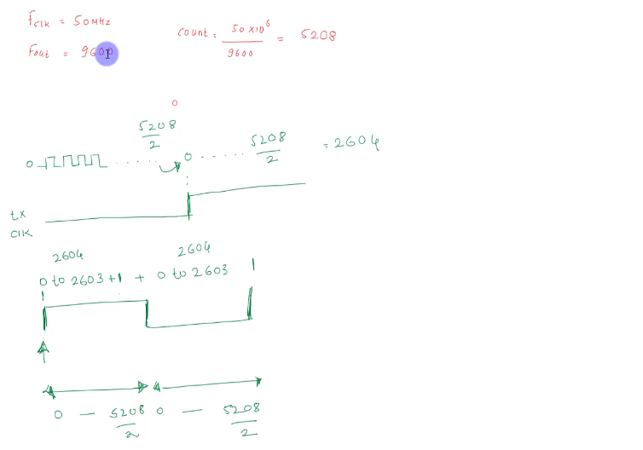
→ Count = input clock rate / output rate (baud rate) (count chinh la so chu ky tx_clk (fast clk) ben trong 1 input clk (slow clk))
→ uart co 2 thanh phan chua frequency, co the xem nhu 2 clock khac nhau bao gom input clock va output clock (baud rate). Count chinh la so input clock (clk) co trong 1 output clock (tx_clk) → De tinh count ta su dung cong thuc count = T_{tx_clk} / T_{output_clk} = F_{clk} / F_{out} (cong thuc mau do o hinh tren).
→ Vi du: baud rate = 9600 => count = 50Mhz / 9600 = 5208 => one cycle of tx_clk = 5208 cycles of input clk

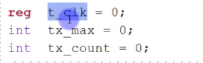

→ tx_max chinh la count value. (Max count)
→ tx_count is the number of clock tick so far. (Current count)

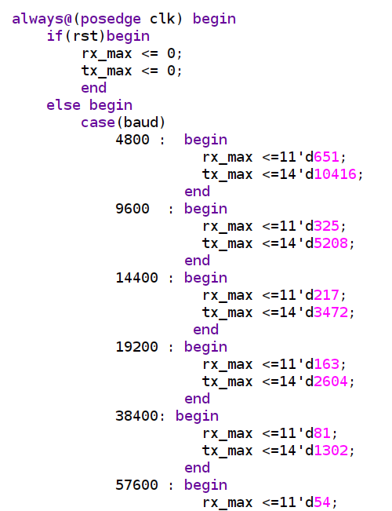

=> calculate tx_max for each baud rate: tx_max = 50Mhz / baudrate
=> 50Mhz / 4800 = 10416
=> 50Mhz / 9600 = 5208
=> 50Mhz / 14400 = 3472

+ UART SYSTEM AND HOW IT WORKS?

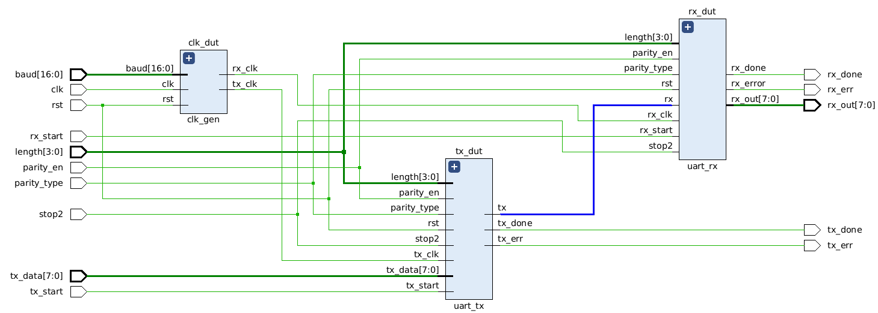
Signals:
- length[3:0] : how long the uart frame is (max_length = 16 bc of 4 bits)
- parity_en : turn on/off the parity bit
- parity_type: using even or odd parity
- stop2 : enable 2 stop bit – user want to transmit 2 stop bits instead of 1 (stop could be 2 stop bits or 1 stop bit)
- rx_start: rx start receiving data from tx
- tx_start: tx start transmitting

* even parity: neu tong cac bit 1 la so chan thi tich cuc (su dung xnor)
* odd parity: neu tong cac bit 1 la so le thi tich cuc (su dung xor)
The design works fine when:
- the data from the input tx_data[7:0] go to tx and then send to rx through tx-rx wire and go out at rx_out[7:0]

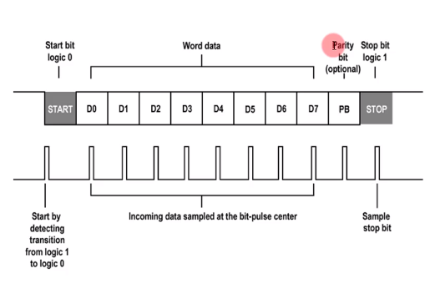
* TX send bit from lsb to msb as the picture above, D0 → D1 → … → D7
* RX receive each bits and push them to the right (like using a right shifter) → and we’ll get the packet perfectly
- transaction bat dau khi 1 → 0, ket thuc khi truyen xong length + parity bit (optional) va 0→ 1
- VD: neu length = 6 → data bits = 6 → stop after parity bits (if there is any) → the stop bit could be 1 or 2 depent on the stop2 input signal

+ UART CLOCK GENERATOR
- Clock gen tao ra 2 xung clock cho rx va tx tu input clock.
- Thong thuong, data duoc truyen toi RX duoc sample tai bit pulse center cua tx_clock (chinh giua tx_clock)
- Do do, rx_clock se nhanh hon tx_clock, ta xem rx_clock nhanh hon tx_clock 16 lan (ko nhat thiet chon 16, co the chon bat ki so nao) thi ra co duoc rx_max nhu sau:
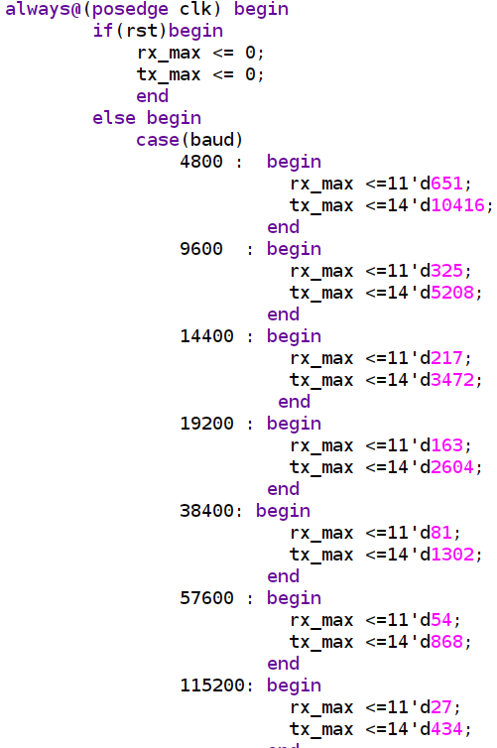

→ rx_max = tx_max / 16 → rx_clk nhanh gap 16 lan tx_clk (1 clock cycle of TX = 16 clock cycles of RX)
→ vi du: baud = 4800 nghia la:
+ 1 tx_clk cycle = 10416 input clock cycle
+ 1 rx _clk cycle = 10416 / 16 = 651 input clock cycles

+ How transaction work:
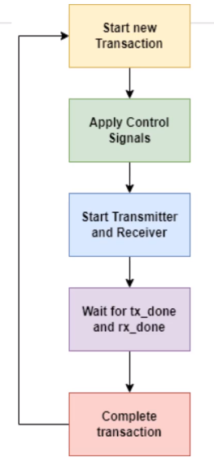

+ UVM testbench for uart:
sequence 1:
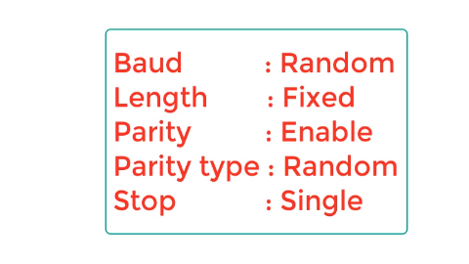
sequence2:
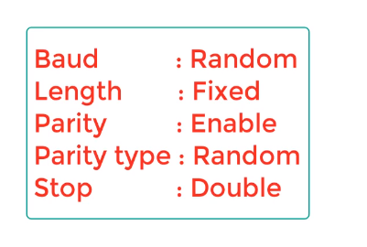
sequence3456: random baud - with fixed length of 5/6/7/8 – with parity => 4 cases
sequence7890: random baud - with fixed length of 5/6/7/8 – without parity => 4 cases

+ Verification of SPI memory (Basic of SPI protocol: https://www.circuitbasics.com/basics-of-the-spi-communication-protocol/):
*SPI – Serial Peripheral Interface
Dac diem cua SPI:
- SPI co the truyen bit lien tuc ma khong bi gioi han thanh cac packet nhu UART hay I2C.
- SPI giao tiep thong qua master – slave. Master la control device, slave nhan instruction tu master
- 1 master co the control 1 hoac nhieu slave
- Data sent from the master to the slave is usually sent with the most significant bit first.
- The data sent from the slave back to the master is usually sent with the least significant bit first.
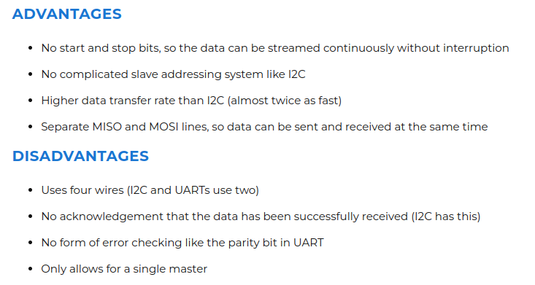

Cac tin hieu co ban cua SPI:
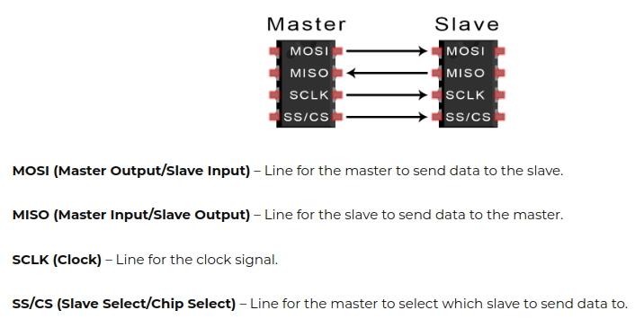

Cach hoat dong cua SPI:
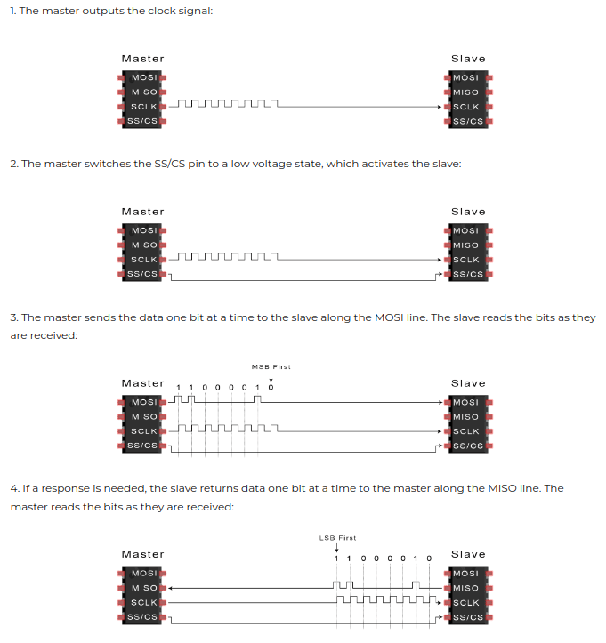

+ SPI Memory top module schematic:

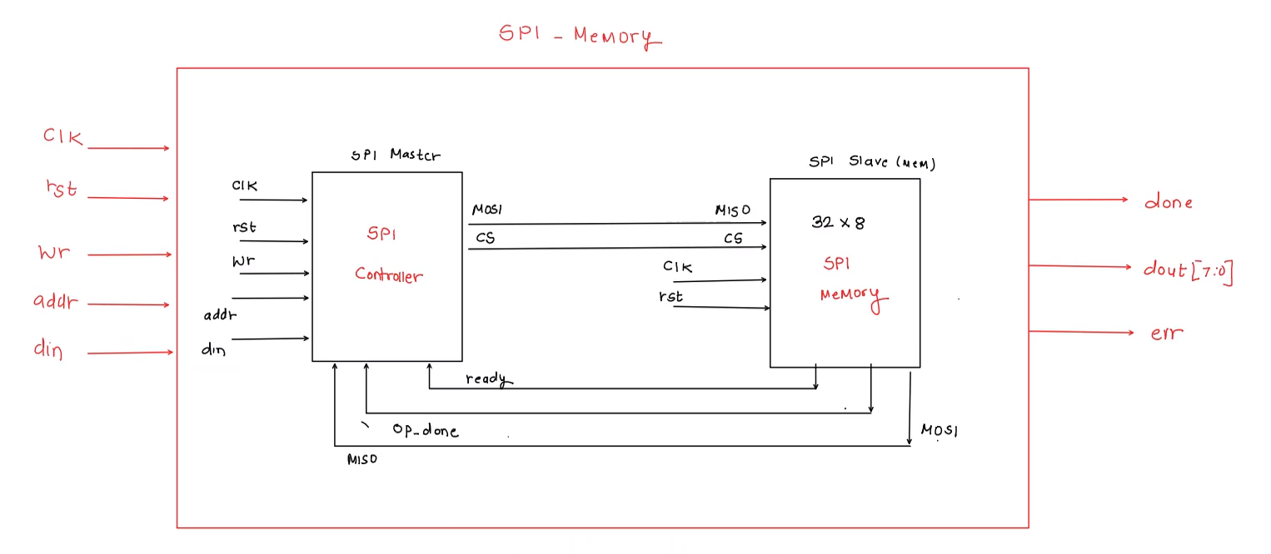
done: tich cuc khi viec write/read hoan thanh
err: tich cuc khi input addr vuot qua bo nho cua memory

+ SPI controller flow chart:
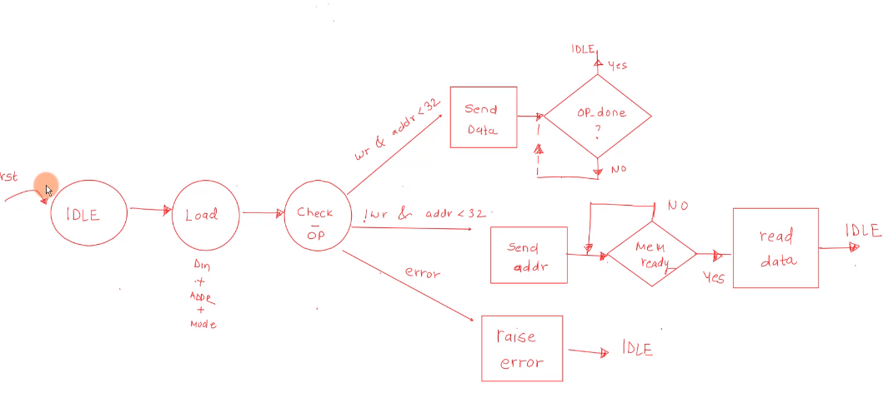
sau check OP, if (wr & addr < 32) → change state to send data
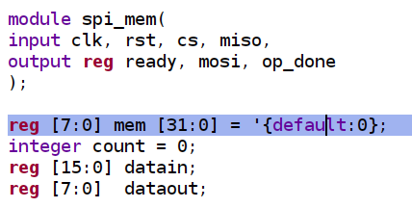

Kiem tra xem addr < 32 hay khong vi memory khai bao trong spi_mem co depth = 32 => neu addr > 32 ta phai tich cuc output err

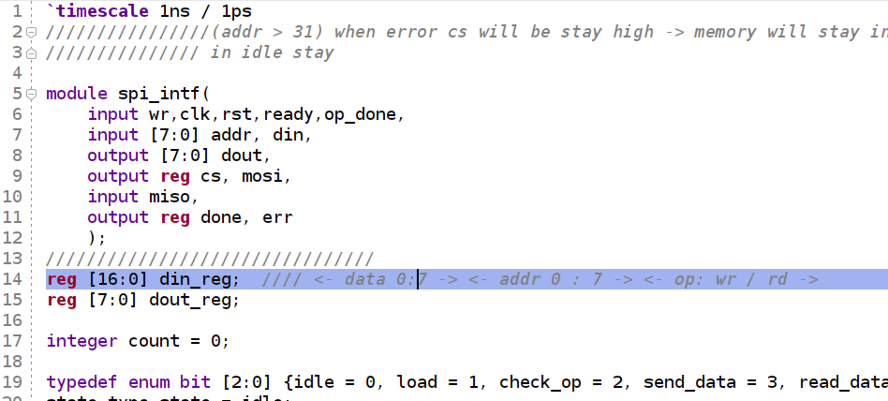
=> din_reg width = 17 (8 bits for data; 8 bits for address; 1 bit for read/write operation). The input of spi intf combine of wr, addr[7:0] and din[7:0], these 3 input get stored into the din_reg[16:0] to send to the spi mem → send one bit each clock edge
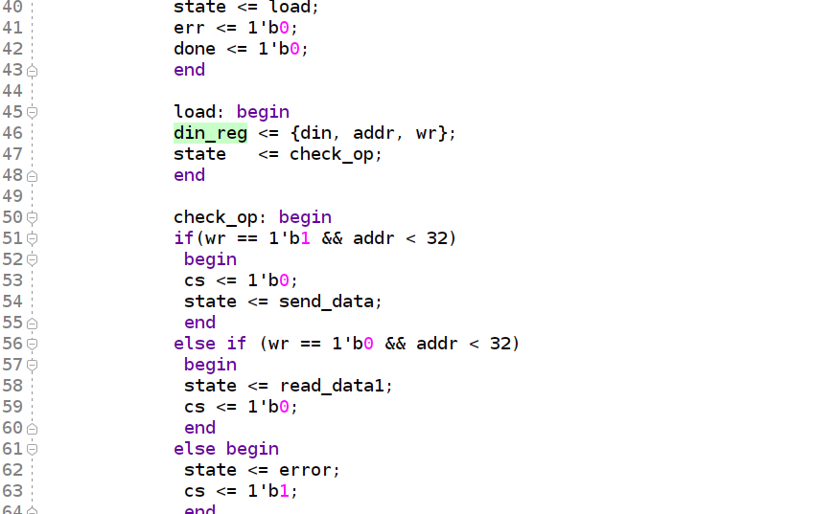

+ SPI memory flow chart:
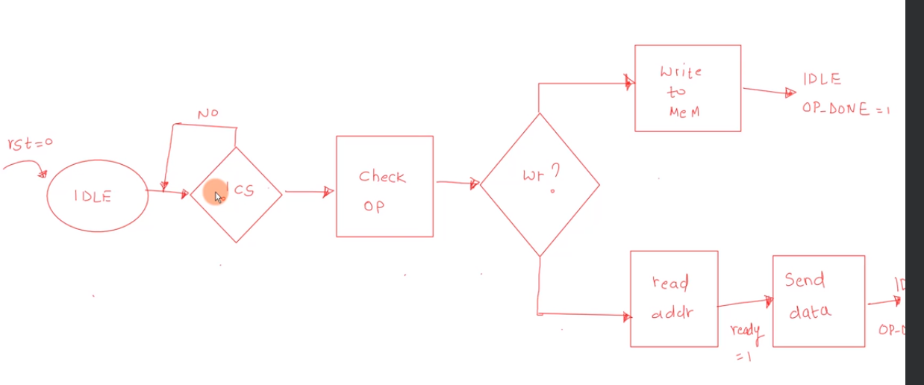
→ when the SPI controller send cs = 0, start the operation.
→ the first bit received is the read/write operation
→ if operation is read, start read the addr and send ready signal back to spi intf → that means mem is ready for sending data back to master.

