References for building Scoreboard and Golden Model:
[1] what is a reference model and how to build it: https://verificationacademy.com/forums/t/reference-model/34936/4
Summery: Lots of company in the industry use C to make a golden model (C-based Golden Model), some use Matlab also.

[2] Connect golden reference model (verilog) to scoreboard for comparison?
https://verificationacademy.com/forums/t/can-u-please-provide-any-reference-to-connect-golden-reference-model-verilog-to-scoreboard-for-comparison/42354/4

SV DPI
[1] Systemverilog DPI tutorial with codes (also comewith image processing project): https://github.com/adki/DPI_Tutorial
[2] SV DPI tutorial (quite good explained): https://www.project-veripage.com/dpi_tutorial_1.php
[3] SV DPI tutorial (TESTBENCH.IN): http://www.testbench.in/DP_00_INDEX.html
[4] another DPI tutorial (not so good explained): https://www.doulos.com/knowhow/systemverilog/systemverilog-tutorials/systemverilog-dpi-tutorial/

Verification Planning
- Thay doi cach verify, khong verify datapath nua ma verify khoi pe_conv_mac
Ly do: Khong control duoc khi nao output valid vi tin hieu valid do controller dieu khien

+ Phuong phap hien thuc:
- Moi 12 cycles, gui mot goi data (co do rong 9 * 8 bits) vao (khoi nay di vao buffer_in)
- data_out cua khoi pe_mac se duoc sample khi valid_out = 1
- Thuc hien kiem tra sau khi sample thanh cong
- Tin hieu done duoc tich cuc sau khi 28 * 28 goi tin duoc dua vao DUT (according to design)
- rang buoc data_in:
+ <inject error> truong hop data_in random
+ <ideal case> dua vao du lieu thuc su cua mot tam hinh → stride = 1 goi tin thu 2 phu thuoc vao goi tin dau (goi tin thu 2 chi thay doi vi tri pixel 2 5 va 8, cac pixel con lai chinh la pixel 124578 cua packet lien truoc)

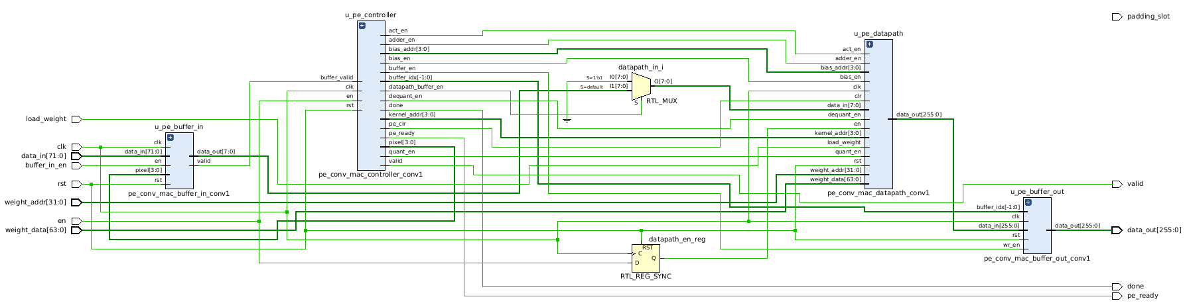
Ideal state:
* load weight must assert during the load weight process
* en = 0 when loading weight, en = 1 when start doing convolution

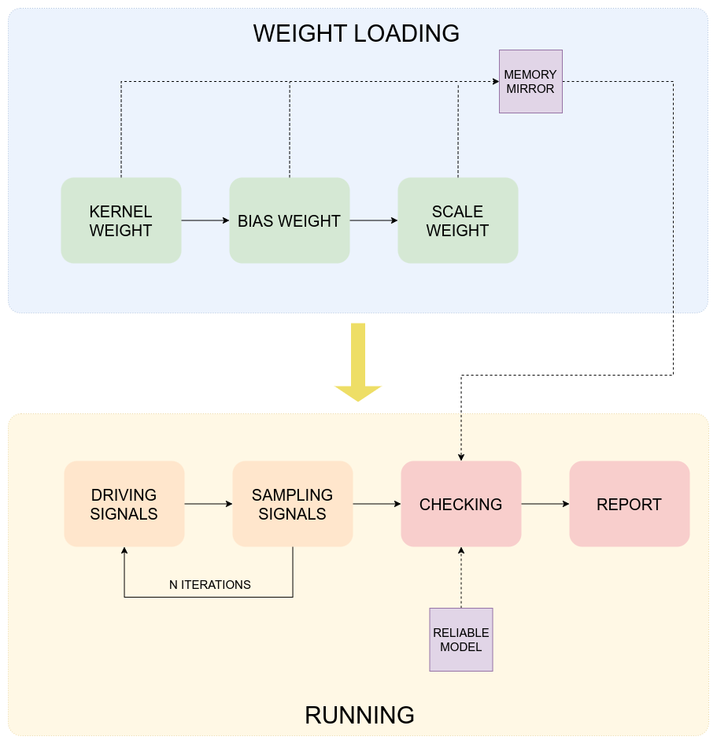

* In running process, first buffer_in_en = 1 in one cycle to start loading data_in

PE_CON_MAC Reference Model
+ pe_conv_mac_datapath schematic:
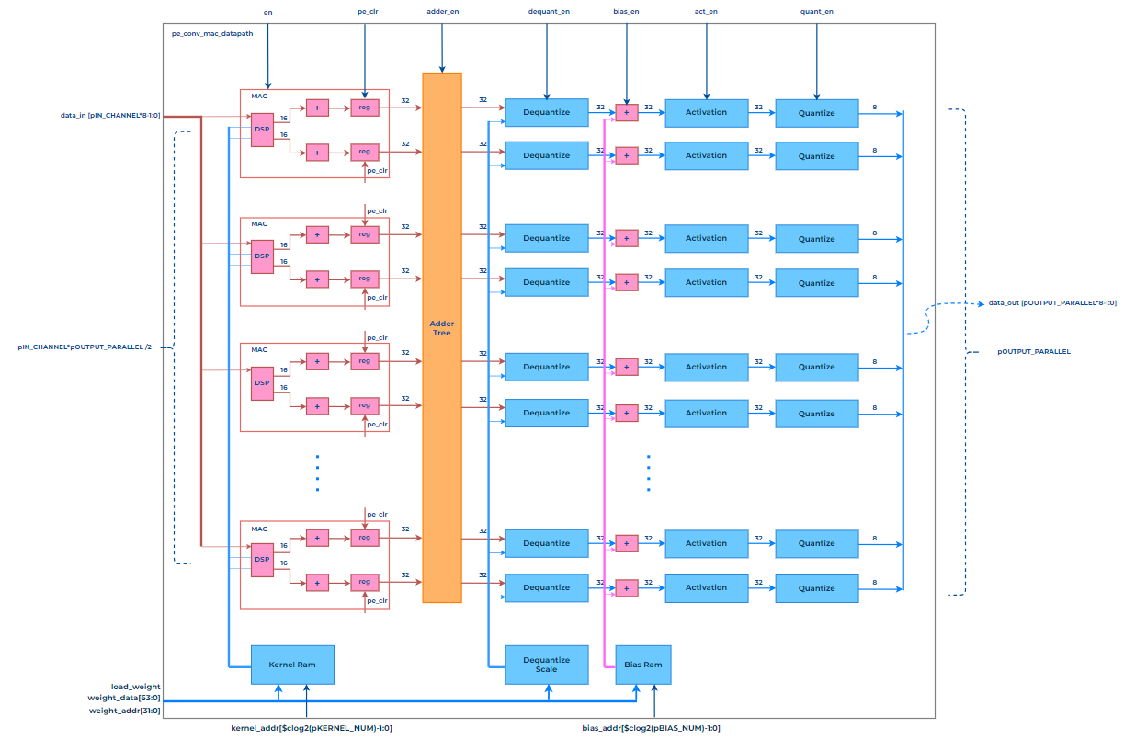
+ Below is Flow chart of the Reference Model:

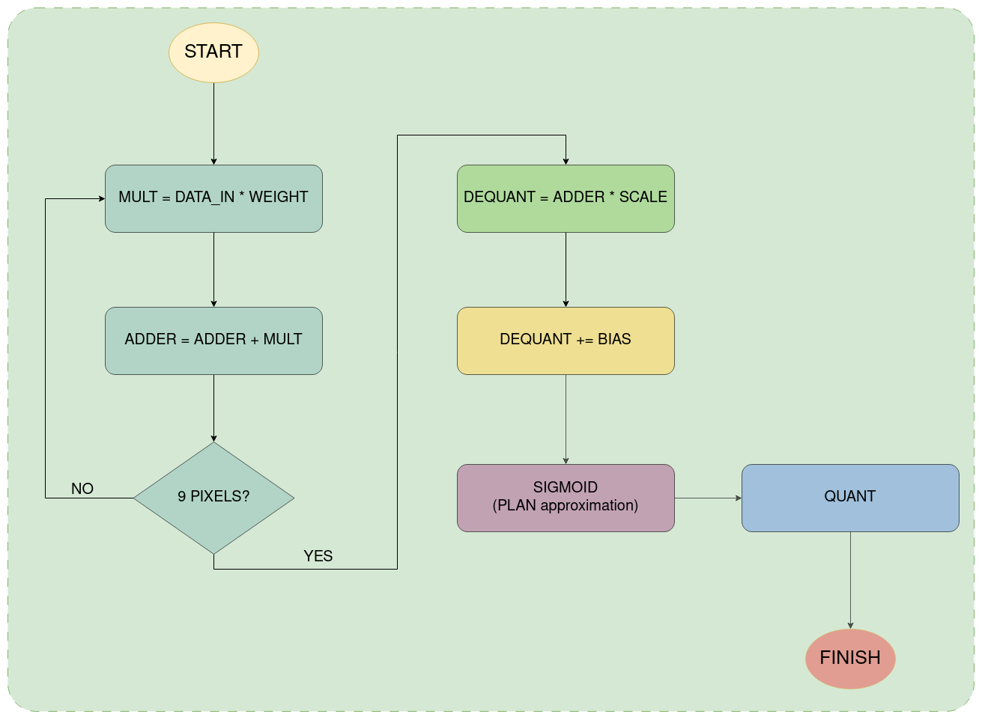
+ SIGMOID using PLAN approximation flow chart:
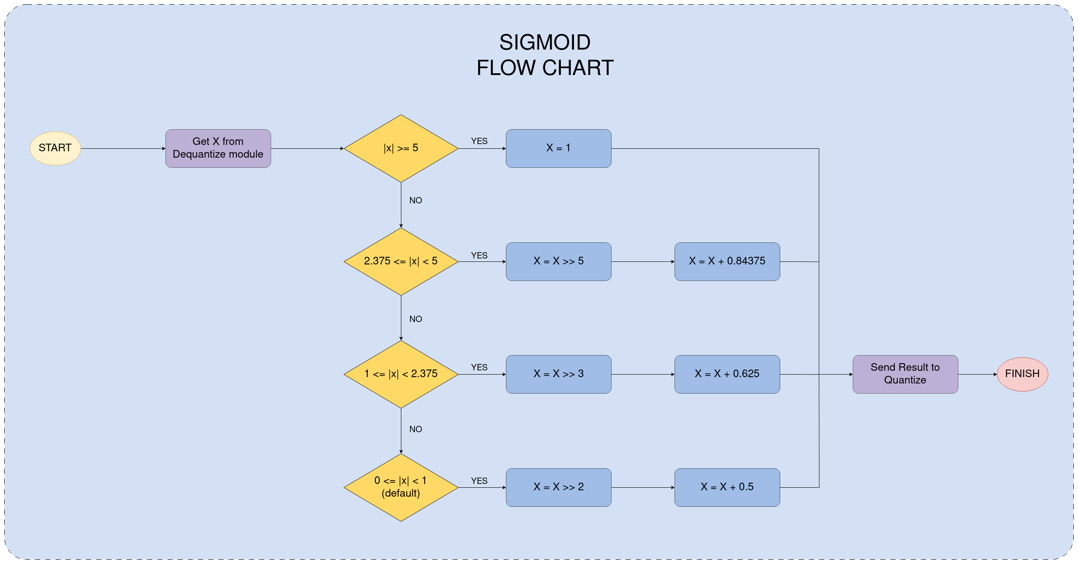
+ Bit witdh flow (for golden model):
- data_in of pe_conv_mac_datapath is 8 bits wide
- after go through dual_mult it becomes 16 bits wide
- then go through adder_tree becomes 32 bits wide
- only comback 8 bits after the quantize

+ golden model using C:
* which datatype should I use base on the calculation of convolution?
- Int?
- Char (mapping from logic in SV)?
- Real (fixed point in the design)?
* Should I split the C function into each step of convo flow or should I calculate it from top to toes?

Idea: using Int because it kinda same to fixed point real and cast from C to SV as logic?

+ SV testbench intergrated with DPI-C:
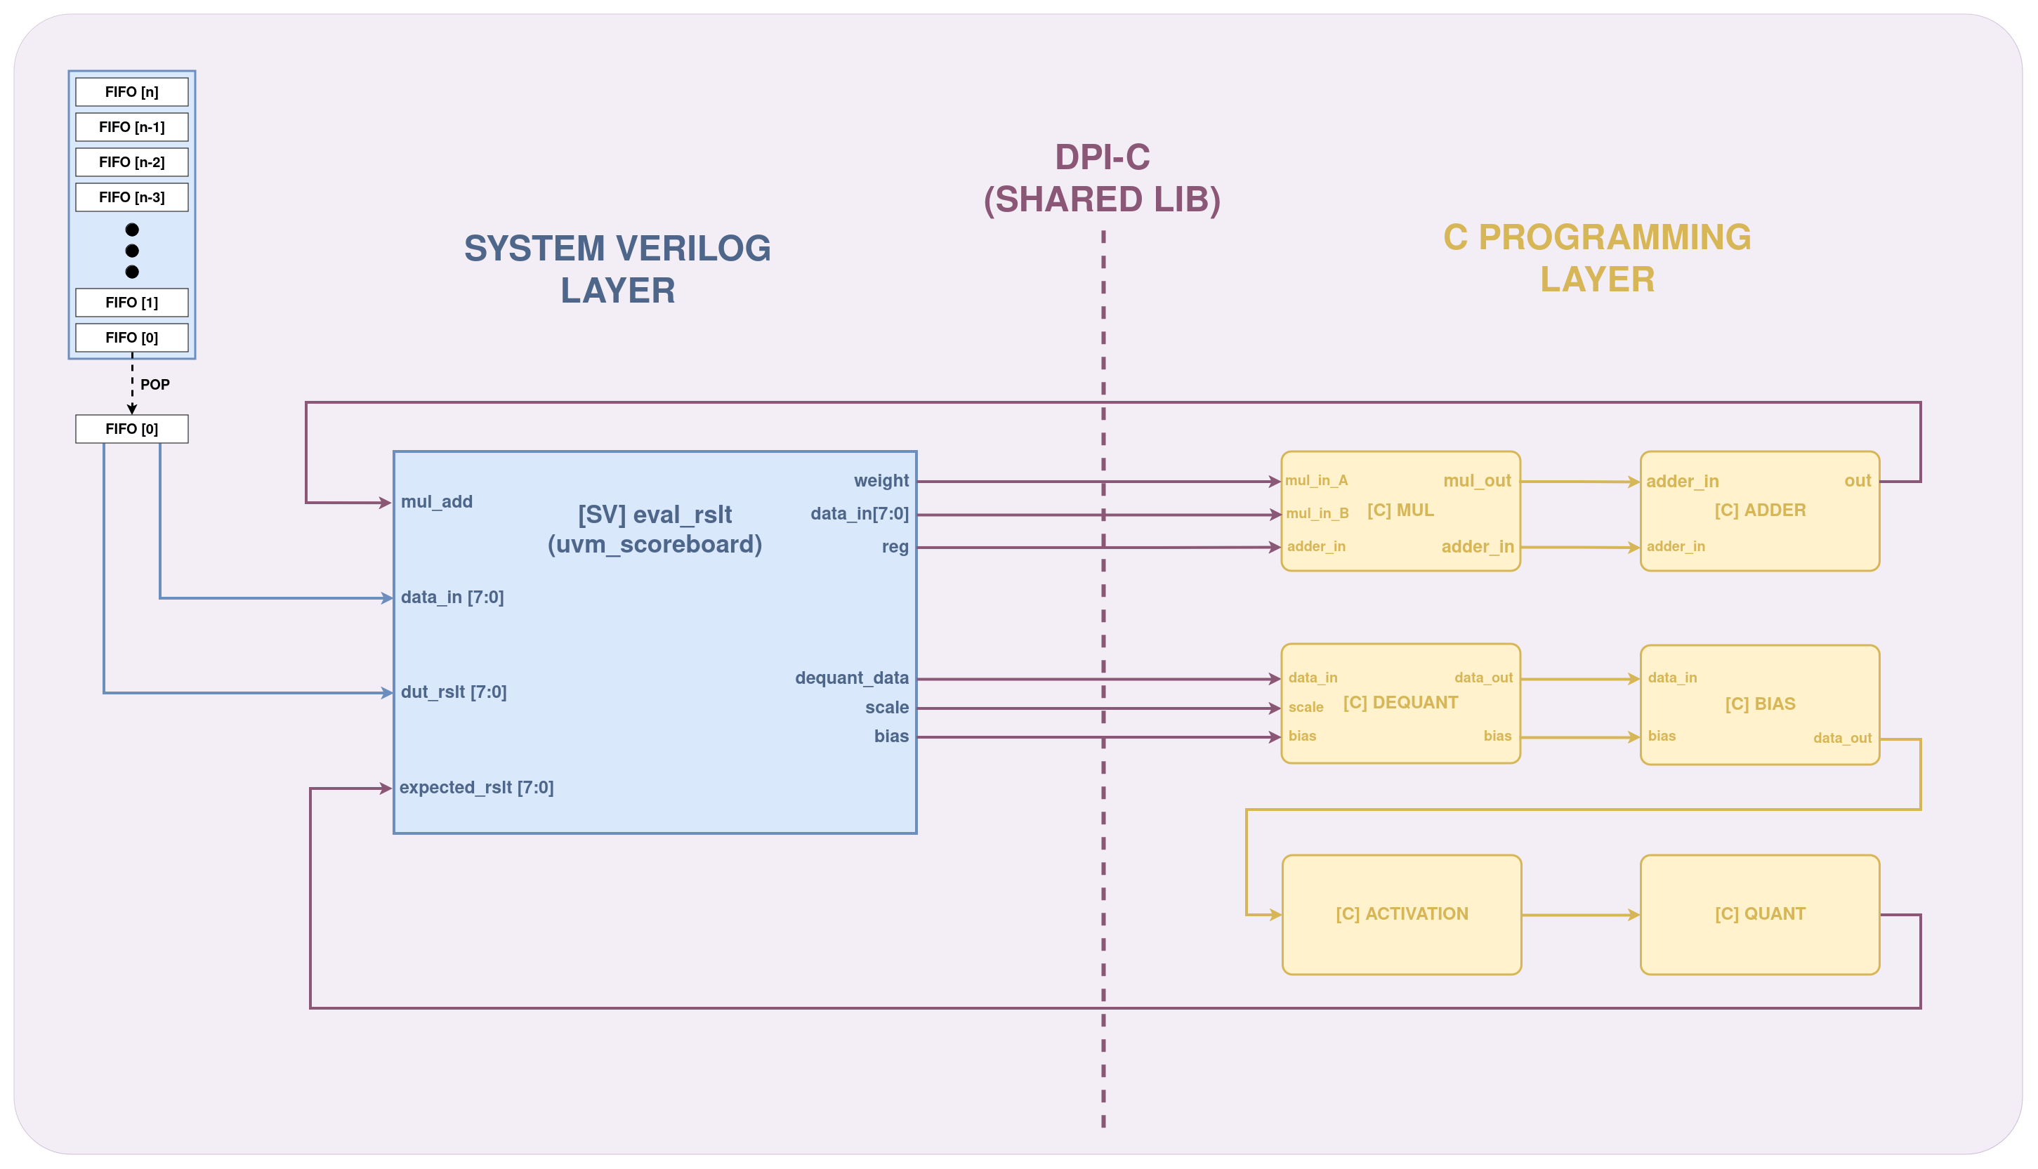
+ Flow chart for implementing the golden model (communicate action of SV and C)
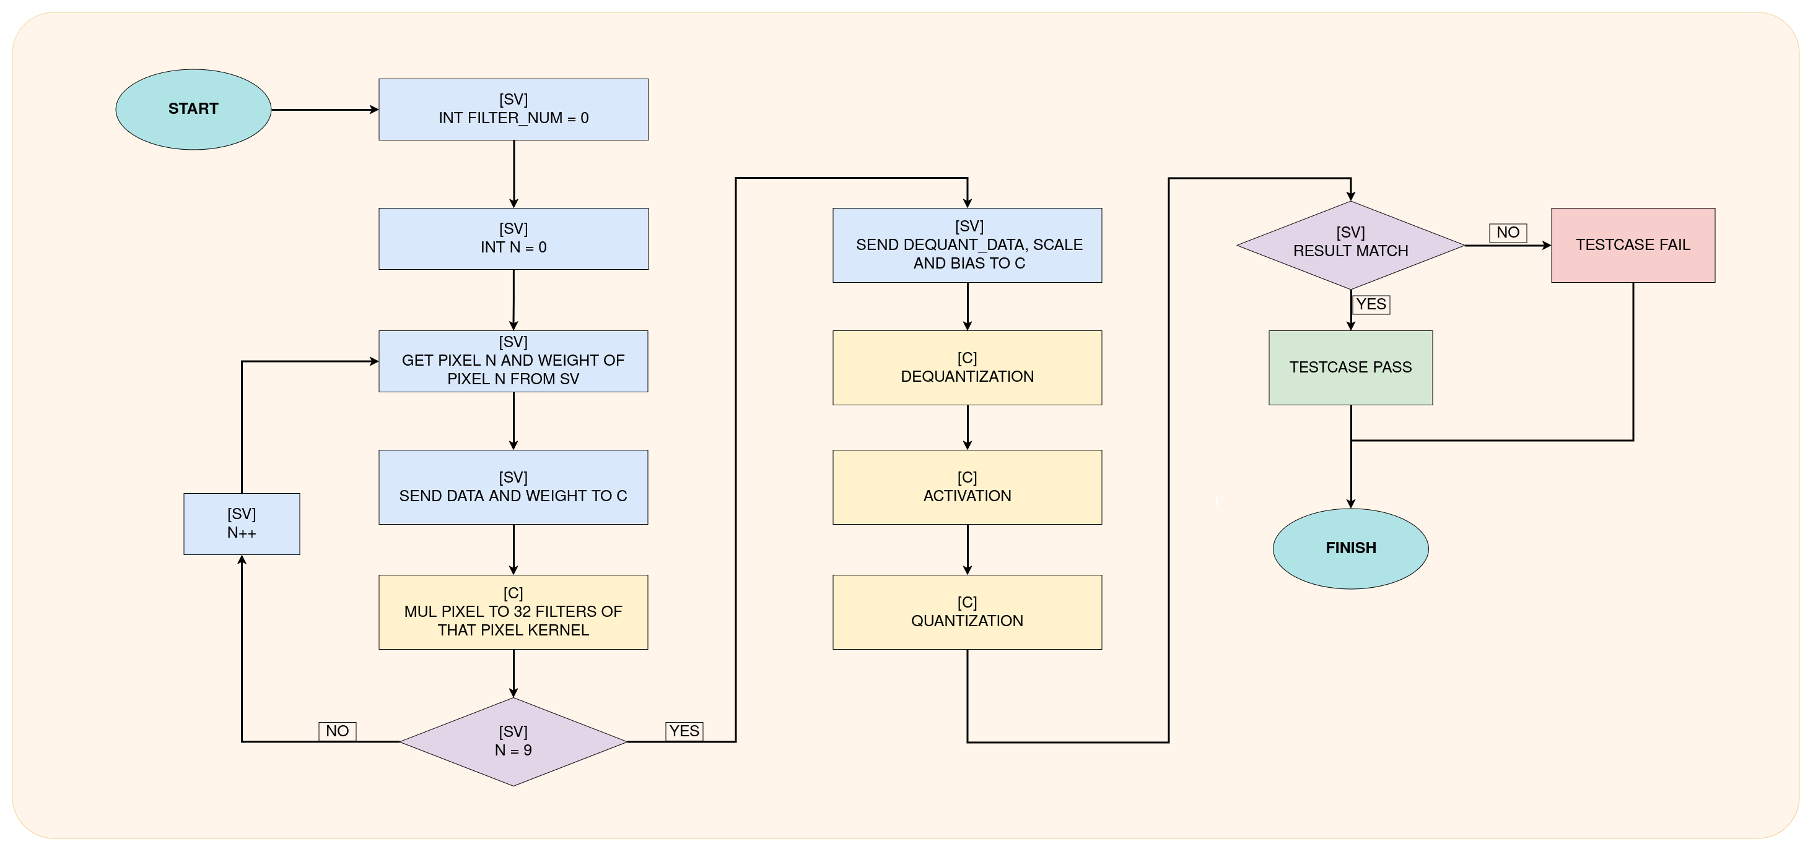

+ data_in and kernel_weight bits order:

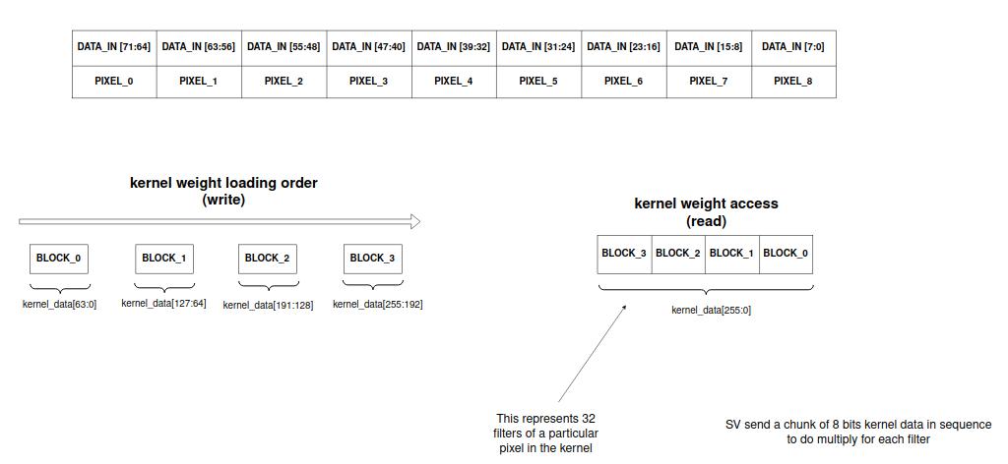
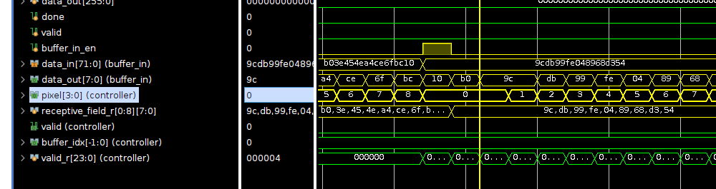
* 32 parallel channel → 32 filters order is:
weight_data [7:0] =================> channel 0
weight_data [15:8] =================> channel 1
weight_data [23:16] =================> channel 2
weight_data [31:24] =================> channel 3
...
weight_data [255:248] =================> channel 31

* scale value:
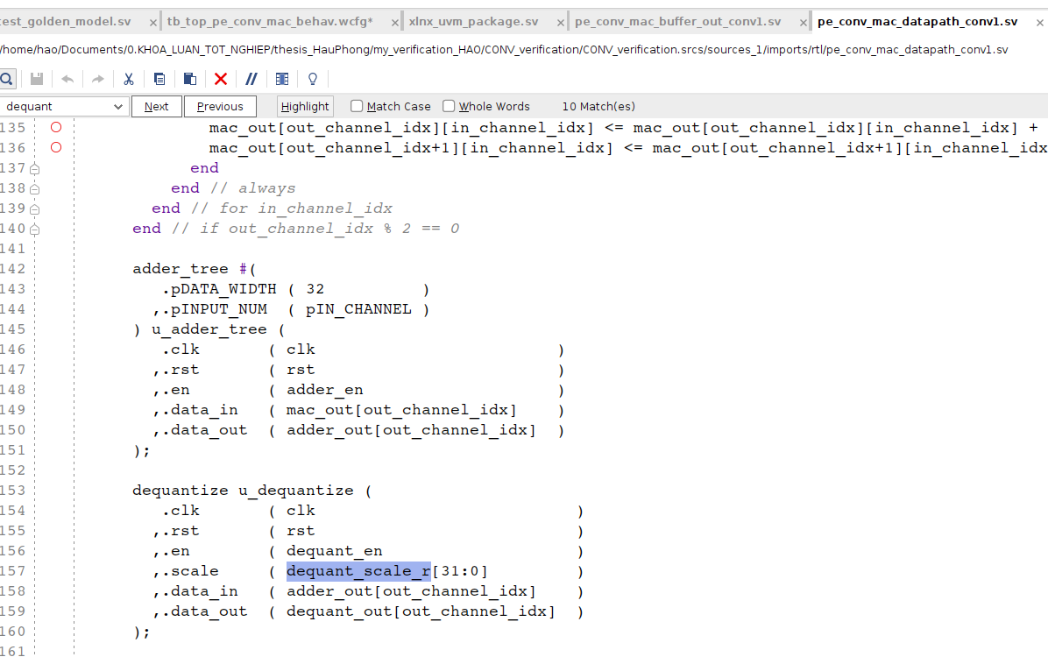

=> get the [31:0] of weight_data in weight loading process
ie: load weight process → f62ad20d_fef7f0d6 → scale = fef7f0d6
=> remember to flip the scale data after get it from the virtual mem (also mean scale = virtual_mem[scale][63:32])

+ bias data order:
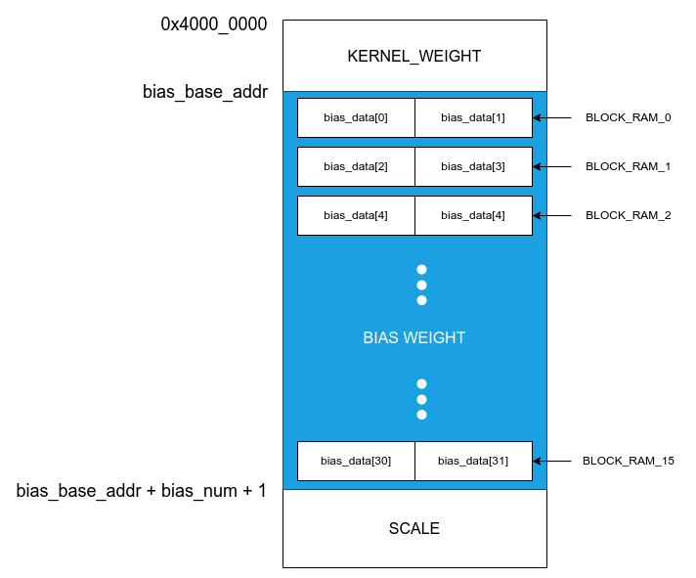

+ Dequantize block verification (32 bits multiplier)
Q2: why don’t use multiply * operator of systemverilog?
A: Because it’s tool dependant. The accurate model for multiplier is not tool dependant, hence more reliable.
* 2’s complement multiplier method: https://pages.cs.wisc.edu/~markhill/cs354/Fall2008/beyond354/int.mult.html
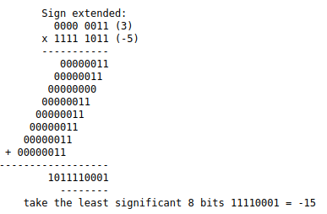

→ build a golden model using Systemverilog with the algorithm above (add and shift left) to verify the dequantize block is more reliable

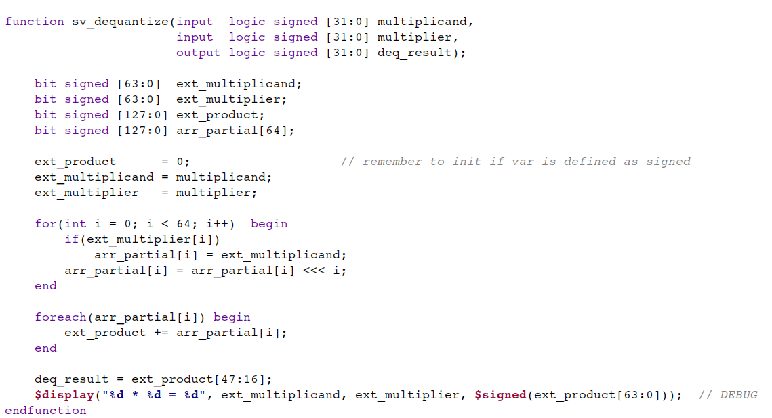
Step 1: extend the inputs (32 bit to 64 bit)
Step 2: do multiply result in double the input bit width → output has width of 64 * 2 = 128
Step 3: multiply 64 by 64 → need array with size of 64 to store all partial results
Step 4: sum all value of the array and get the lower part of the result (result [63:0])
Step 5: get the 32 bit of reulst(result [47:16]) to get the result of the dequantize
Q3: (Han che) why don’t use DPI-C to verify dequantize then?
A: svLogicVecVal can only store 32 bit, to do 32 bits mul need 64 bits to handle.

+ C QUANTIZE MODEL:
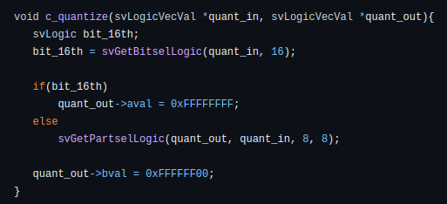

* turn 32 bit back to 8 bit through quantization
* if 16th bit of input is 1 → set 8 bits output = 0xFF else get the output = input [16:8]
* In C program, need to mask the upper 24 bit as F in aval and bval because X value in svLogicVecVal is aval = 1 and bval = 1. We only care about the lower 8 bit.

+ Procedure of sending signed bit to C programming:
Step 1: remember to add signed keyword to logic/bit variable
Step 2: assign that logic/bit signed var to int datatype
Step 3: pass it as argument to DPI-C

Systemverilog File:
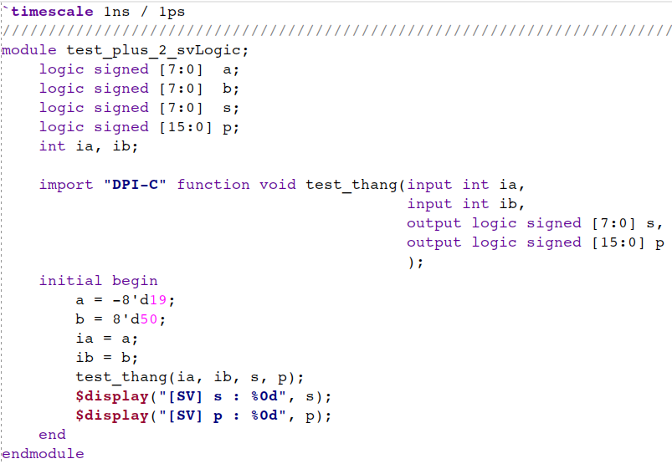
C File:

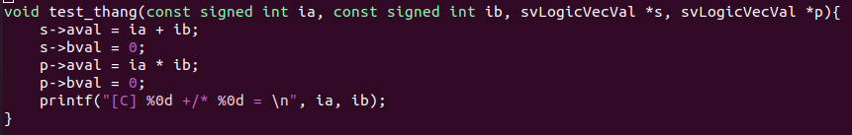
**why pass it as int instead of directly pass the logic packed array to C as svLogicVecVal as input
→ Because the svLogic datatype in svdpi.h lib is unsigned char → the aval of svLogicVecVal datatype is always unsigned number

Result:
