+ SIGMOID BLOCK (sim_for_test/sigmoid_scb.sv):
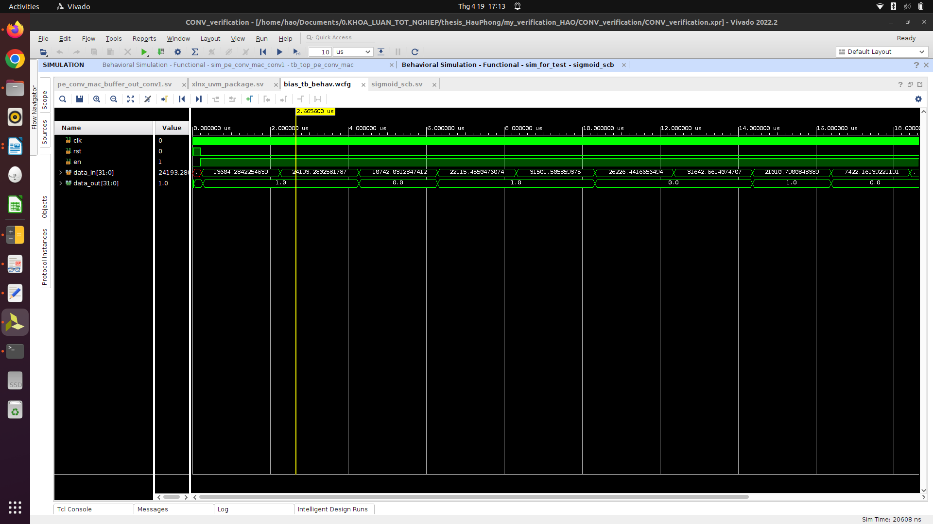
→ if the number is too large, some time data get value of 0, which is wrong because regarding the algorithm, if abs(data_in) >= 5, the data_out must be 1.

