Basic Convolution
+ Convolution input, output and kernel:
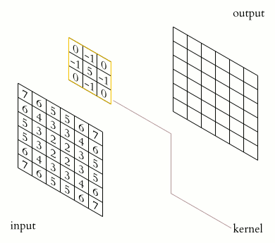

+ How to calculate:
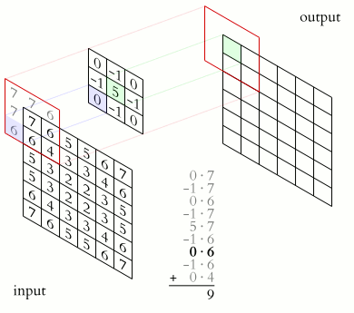

** Cong don:
theo hinh tren: 0*7 = 0 + (-1)*7 = -7 + 0*6 = -7 + (-1) * 7 = -14 + 5*7 = 21 + (-1)*6 = 15 + 0*6 = 15 + (-1)*6 = 9 + 0*4 = 9

** pe: processing element
** mac: multiply-accumulate
+ In channel:
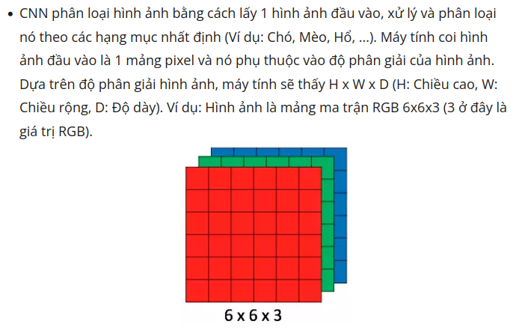

Mnist datase in_channel = 1 bc of grayscale image:
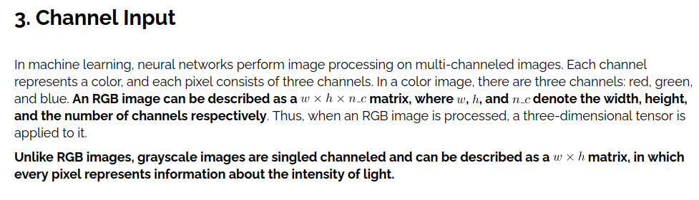
+ OUT CHANNEL:
Is the number of channel in the output feature map after applying the filters(kernels) to the input feature map.Each filter in a convolutional layer produces one channel in the output feature map. The number of out channels determines the depth of the output feature map.
IE: with an input feature map, if we apply different 32 filter into it, we will get 32 output feature map => that mean we have 32 out channel

Conv IP Memory structure & Address Parameter

Parameter | Description
pWEIGHT_BASE_ADDR | Kernel base address. Start from 0x4000_0000 to 0x4000_0000 + kernel_num (9 in typical)
pBIAS_BASE_ADDR | Bias ram base address, start after last address of kernel memory
pSCALE_ADDR | Dequantize’s Scale base address, start after last address of bias memory
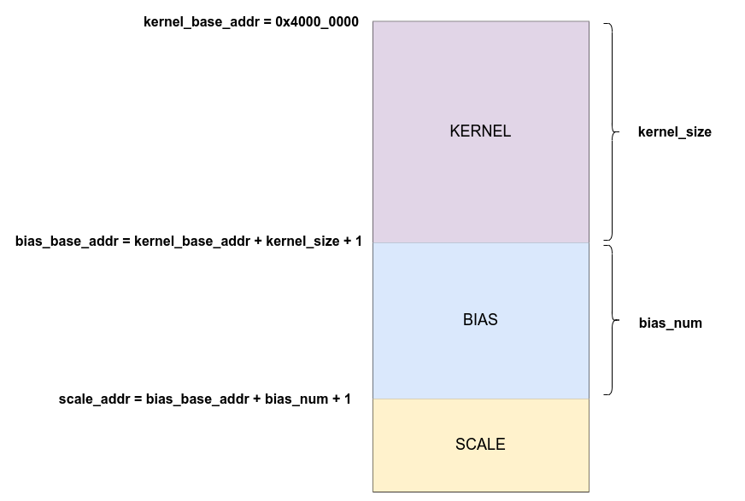
→ Load weight process has 3 memory to load in order:
- 1st is KERNEL memory (start at 0x4000_0000)
- 2nd is BIAS memory
- 3rd is SCALE memory

+ Cycles to store data:
- Kernel need 4 cycles per address to store 256 bits of data (4 ULTRA RAM)
- Bias need 1 cycle per address to store 64 bits of data (1 BLOCK RAM)

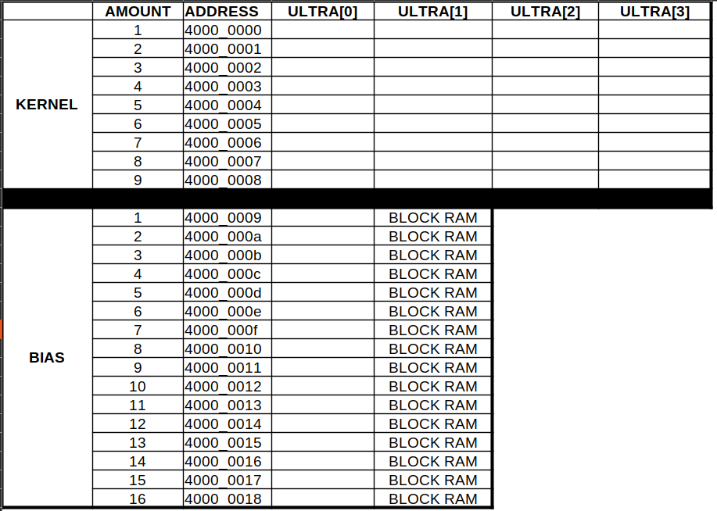

* each cell contains 64 bits of data

CONVOLUTION MODULE VERIFICATION

+ MNIST cnn top level:

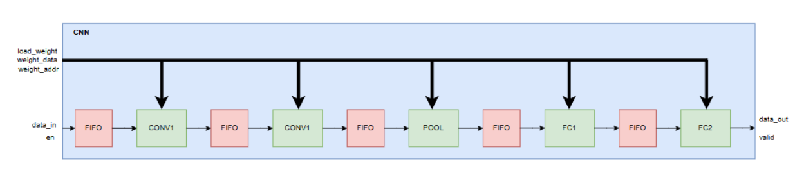
+ CONV Module verification
1. Funtionality:
2. Schematic:

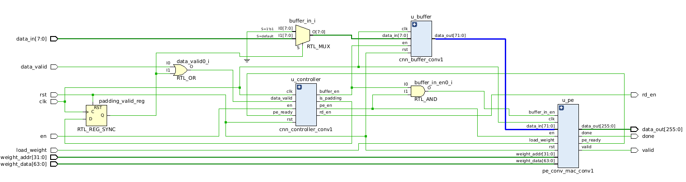

3. I/O specification:

INPUT | OUTPUT
clk:  data_in[7:0]:  rst:  en:  load_weight:  weight_addr[31:0]:  weight_data[63:0]: | rd_en:  data_out[255:0]:  done:  valid:
4. submodules:
- cnn_controller_conv1
- cnn_buffer_conv
- pe_conv_mac_conv1

+ CONV1.pe_conv_mac_conv1:
1. Funtionality:
2. Schematic:
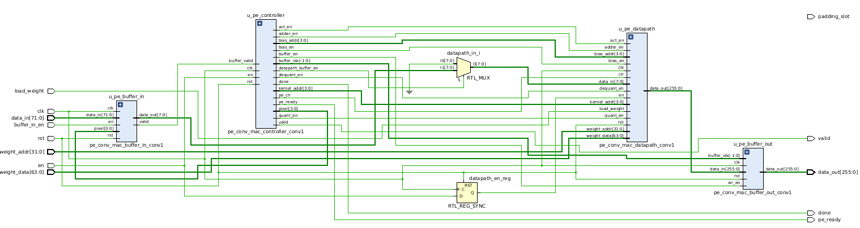
3. IO:

INPUT | OUTPUT
clk:  data_in[71:0]:  buffer_in_en:  rst:  en:  load_weight:  weight_addr[31:0]:  weight_data[63:0]: | valid:  data_out[255:0]:  done:  pe_ready:

4. Submodules:
- pe_conv_mac_buffer_in_conv1
- pe_conv_mac_controller_conv1
- pe_conv_mac_datapath_conv1
- pe_conv_mac_buffer_out_conv1

+ CONV1.pe_conv_mac_conv1.pe_conv_mac_datapath_conv1:
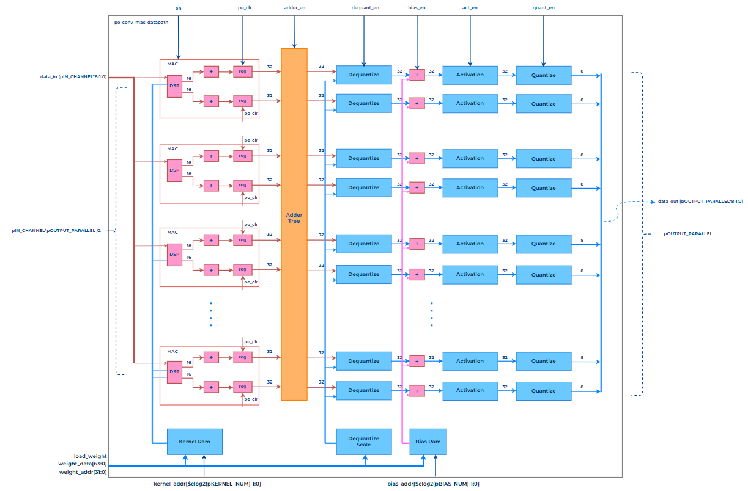
1. Funtionality:
Vi du kernel = 9 diem anh, tung diem anh lan luot di vao input. Diem anh thu nhat di vao → diem anh nay duoc nhan voi 32 kernel song song (su dung 16 bo DSP) → co duoc 32 ket qua cua (diem anh 1 * kernel weight position 1) → 32 ket qua duoc luu vao reg → diem anh thu 2 di vao → tuong tu nhu diem anh thu 1 co duoc 32 ket qua cua diem anh thu 2 → 32 ket qua cua diem anh thu 2 duoc cong voi gia tri co san trong 32 thanh ghi song song (ket qua cua diem anh thu nhat) → gia tri nam trong 32 thanh ghi duoc cap nhat → lam lan luot toi diem anh thu 9
→ sau do ket qua cua adder tree (data trong 32 thanh ghi) duoc dua qua cac block dequantize → bias → activation → quantize

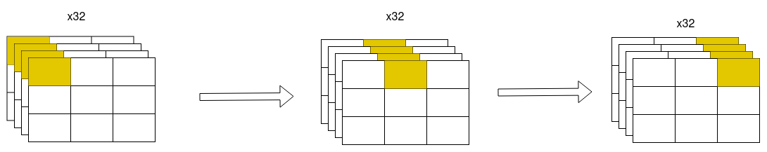
2. IO:

Signal | I/O | Description
data_in | IN | Dữ liệu đầu vào (Thức report)
load_weight | IN | Tín hiệu cho phép nạp trọng số (Thức report)
weight_data | IN | Dữ liệu trọng số (Thức report)
weight_addr | IN | Địa chỉ trọng số (Thức report)
kernel_addr | IN | Địa chỉ kernel để load weight
bias_addr | IN | NO CONNECTION [design flawn]
en  pe_clr  adder_en  dequant_en  bias_en  act_en  quant_en | IN | Khối pe_conv_mac_datapath_conv1 chỉ họat động khi các tín hiệu này được bật (Hậu Phong report)
data_out | OUT | Dữ liệu đầu ra (Thức report)

ISSUE:
* bias_addr not connect to anything: → bias address is decide by address parameter, not bias_addr input (design flawn)
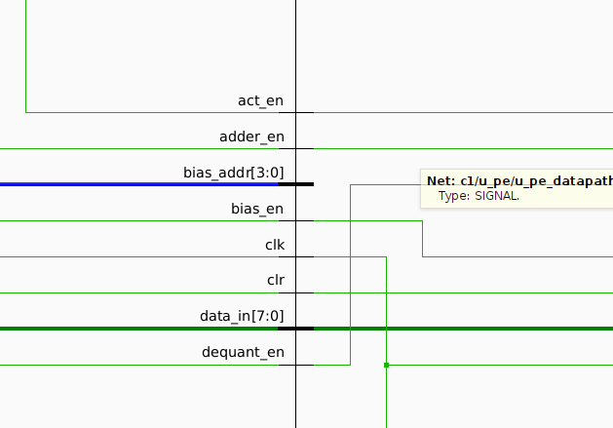

+ Schematic connectivity of kernel ram and adder reg (between dequantize and activation):
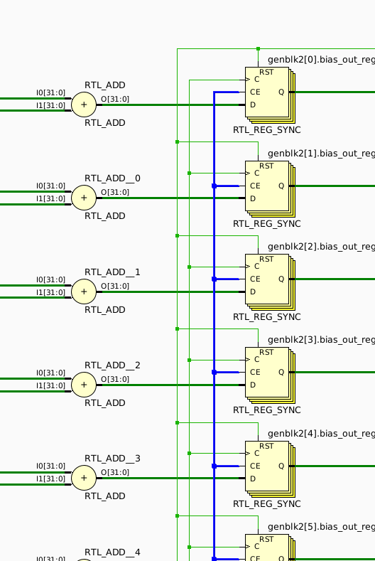

=> no bias_addr pins found, blue wire is bias_en signal

3. Parameter:
PARAMETER | FUNCTIONALITY
pDATA_WIDTH | ###########################
pINPUT_WIDTH | Chiều rộng của đặc trưng đầu vào
pINPUT_HEIGHT | Chiều cao của đặc trưng đầu vào
pIN_CHANNEL | Số lượng kênh của đặc trưng đầu vào
pOUT_CHANNEL | Số lượng kênh của đặc trưng đầu ra
pKERNEL_SIZE | Kích thước bộ lọc (pKERNEL_SIZE x  pKERNEL_SIZE)
pPADDING | Kích thước vùng đệm (Gía trị đệm luôn là 0)
pSTRIDE | Bước nhảy
pOUTPUT_PARALLEL | Số lượng kênh đầu ra được tính cùng một lúc
pWEIGHT_DATA_WIDTH | Độ rộng đường địa chỉ của trọng số
pWEIGHT_BASE_ADDR | Độ rộng đường dữ liệu của trọng số
pACTIVATION | Hàm kích hoạt (Relu, Sigmoid)

+ So luong DSP (dual_mult_dsp) su dung duoc xac dinh dua tren so pIN_CHANNEL va pOUTPUT_PARALLEL theo cong thuc:

No. of DSP = (pIN_CHANNEL * pOUTPUT_PARALLEL) / 2

+ So luong bo add trong adder_tree, dequantize, bias, activation, quantize duoc xac dinh dua tren pOUTPUT_PARALLEL

KERNEL_RAM

1. IO Specification:
Signal | I/O | Description
clk | IN | Clock
rst | IN | Reset
wr_en | IN | Write enable
weight_addr | IN | Addr to write weight to kernel
weight_data | IN | Data to write to kernel
kernel_addr | IN | Addr to read from kernel
kernel_data | OUT | Data read from kernel_addr
2. Funtionality
- Kernel ram contain 9 channel corresponding to filter size.
- Each channel store weight_data of 32 filter, each weight is 8-bits width => each channel has the size of 32 * 8 = 256 bits
- 4 Ultra RAM are used => each channel is devided into 4 chunks, 1 chunk = 64 bits seperated in 2 part (following to the design)
- base address of kernel ram is 32’h4000_0000
- Writting weight_data to each channel needs 4 cycles, 256-bits of each channel are devided into 4 part and get wrote to memory in each cycle in position of weight_addr (each channel need to be written in full 4 cycles in order to has meaningfull data, otherwise the weight_data will be lost)
- Reading data from each kernel is done by sending kernel_addr input signal (0 to 8 corresponding to kernel size) and wr_en = 0
- 256 bits of weight_data is sent to output is weight of 32 filter of a particular filter position, 8 bits each
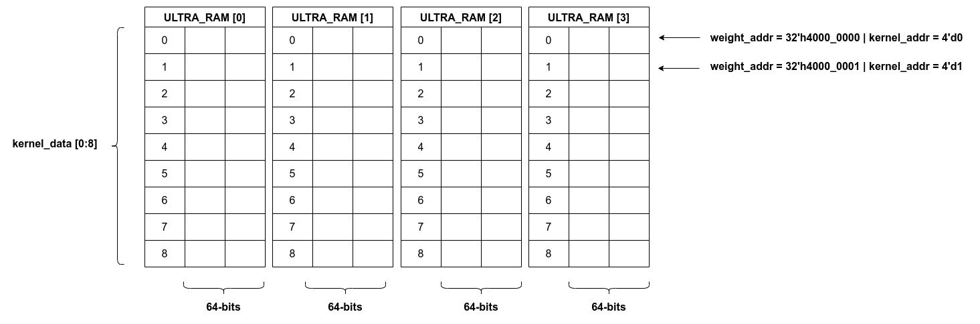
Kernel ram structure
Data read from kernel ram;
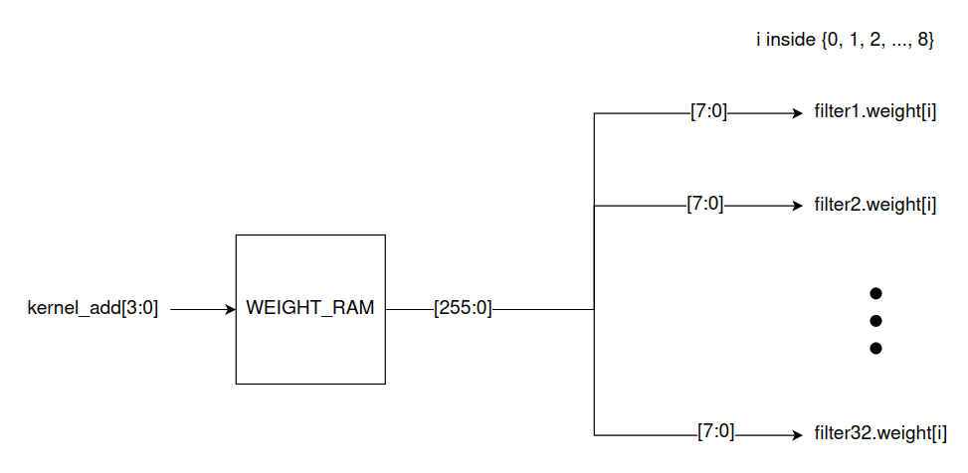

→ Kernel weights at same position go to DSP and get result parallel

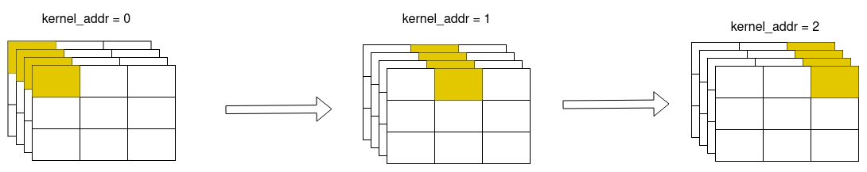
* After loading weight for kernels, next is loading weight for bias

*** QUESTION:
- How to choose kernel weight? [solved]
→ mnist kernel weight in software folder: /home/hao/Documents/0.KHOA_LUAN_TOT_NGHIEP/thesis_HauPhong/fpga-resnet-main/design/software/weights/mnist_weights.bin
*** ALSO, check the testbench folder ***
- What the fk is bias? [need more research]
- How to choose scale for dequantization? [solved]
→ scale for dequantization and bias is from result of training model process
- Activation? (sigmoid, relu) [kinda]

DEQUANTIZE BLOCK
1. IO Specification:

Signal | I/O | Description
clk | IN | Clock
rst | IN | Reset
en | IN | Enable signal
data_in | IN | Data in to calculate
scale | IN | Scale parameter
data_out | OUT | Result

2. Functionality:
- Turn INT8 to real for calculating step (Activation step)
- when en = 1, data_in & scale data is pushed to dequantize’s memory
- There is a multiplier inside dequantize and gonna multiply data_in by scale parameter.
- dequantize Scale memory has same input as kernel ram which use weight_data [31:0] signal
→ weight_data need to goes to testbench during both load weight process and data_in process. but in data_in process, the value of weight_data (dequant scale) must not be changed.

- Dequantize need 9 cycles according to design specification:

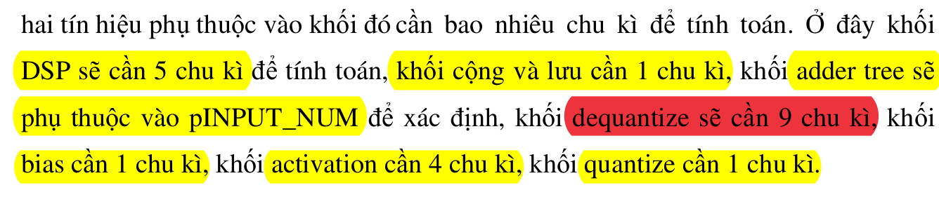

→ In vivado, change mult_gen_1 IP (Kriva board built-in IP) pipeline stages to 8:
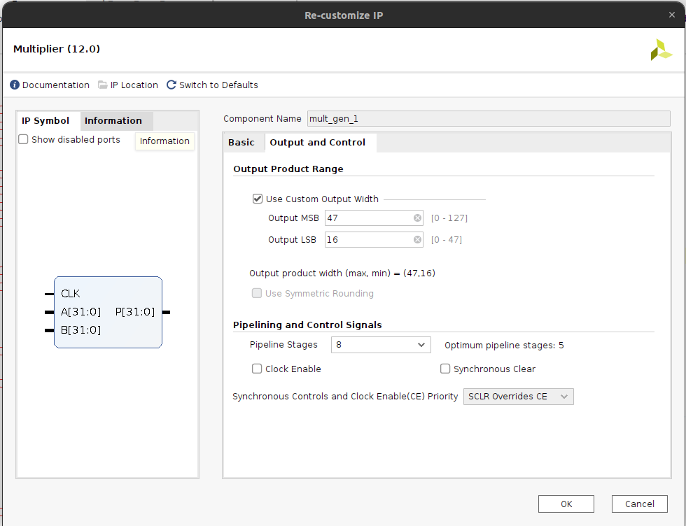

The result of mult IP will get at the output after 9 clock cycles:

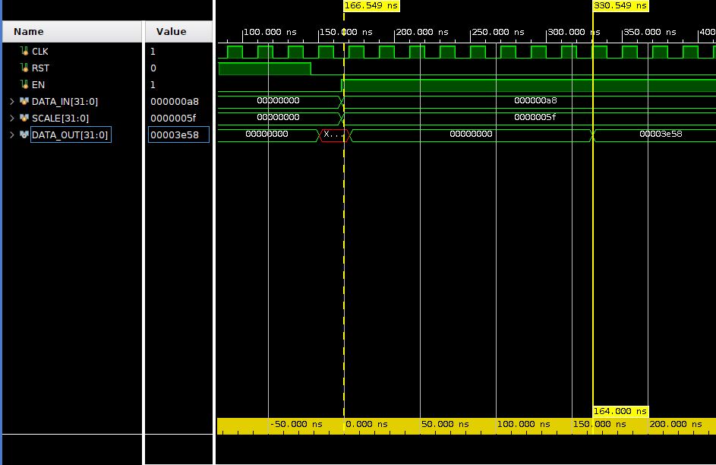

* In the convolution process, dequantization scale parameter must be fixed.
=> the value of weight_data (dequantization scale) must not be changed in data_in process because kernel_ram IP and dequantization IP share the weight_data[31:0] input signal
* BUT, because in datapath testbench we only need to check functionality of the DUT, we can send random value to weight_data.
* weight_addr must be a specific number for the weight_data (scale parameter) be stored in dequantize’s memory (check parameter address part above)
* loading scale value also use weight_addr and weight_data, scale value only need 32 bit but the weight data is 64 bits → get the lower bit of weight_data (as defined in the designn)
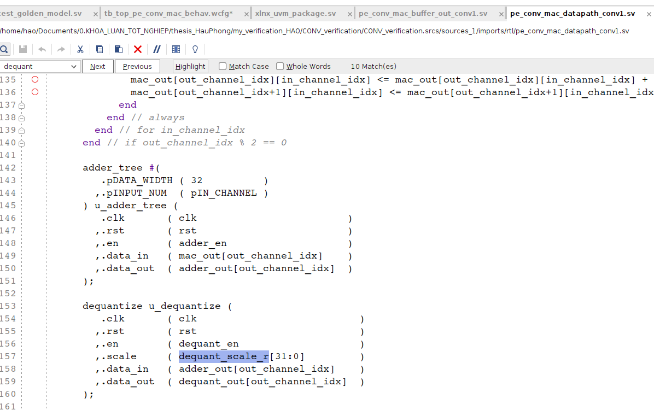

* Check the word file “verification_planning.docx” for more information

BIAS RAM
1. IO:
Signal | I/O | Description
clk | IN | Clock
rst | IN | Reset
wr_en | IN | Write enable
weight_addr | IN | Weight address to write data into
weight_data | IN | Weight data to write
bias_addr | IN | Bias address to access data
bias_data | OUT | Data access of bias address

2. Funtionality:
- each kernel has a specific bias value, these value is read from bias memory and add to output of dequantize block. Same as 32 kernel is conv calculated concurrently in the previous part, 32 bias values also get added concurrently in this step.’
- number of bias depend on pOUTPUT_PARALLEL
- weight_data (data_in) is 64 bit and bias_data (data_out) is 32 bits → meaning that in write process, store 2 weight at a time.
- if bias_num = 32 → 16 register need to store 32 bias weight → each register has 2 part one is high and one is lower
- bias memory structure:
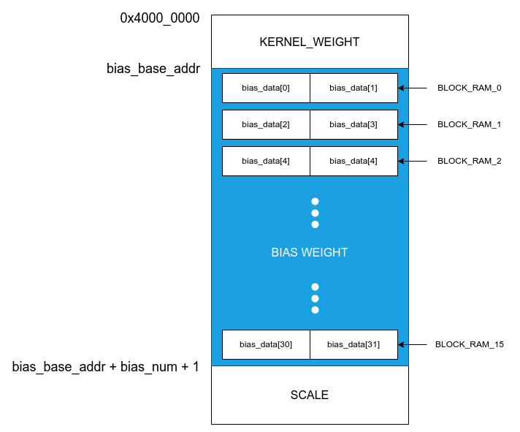

* Bias memory is a stack of 16 block ram (if bias_num = 32), each block store 32 bit high and 32 bit low, also the input of bias memory is 64 bits → bias ram only need 1 clock cycle per address, unlike kernel ram which need 4 cycles per address to fully store 256 bits data
→ bias values is stored in load weight process after kernel is fully loaded
→ if kernel size = 9 → base address of bias is 4000_0000 + 9 = 4000_0009
→ if bias_num = 32 → end address of bias is base_bias_addr + 16 = 4000_0025

SIGMOID BLOCK

1. IO:
Signal | I/O | Description
clk | IN | Clock
rst | IN | Reset
en | IN | Enable signal
data_in | IN | Data in to calculate
data_out | OUT | Result

2. Funtionality:
* data_in and data_out have width of 32 bit represent fixed point number (16 bit fraction)
* calculate f(x) = 1 / ( 1 + e^(-x) )

+ Quantize block:
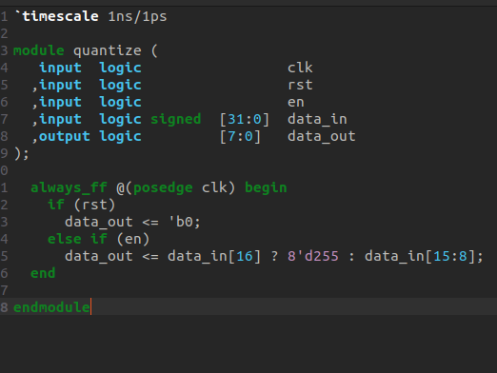

Input: 32 bit FP
Output: 8 bit INT

Funtionality: if bit 16 of input = 1 → data out = 255
else (bit 16 = 0) → data_out = data_in [15:8]

* dequantize scale & bias value is generated by training process

MEMORY MIRROR APPROACH
+ Kernel memory:
- Data is store in order of kernel_0 to kernel_8 → ultra_ram_0 to ultra_ram_3
- Weight Data is split into 2 part: higher and lower (higher are MSB and lower are LSB) → position of higher and lower are swap when store into the memory cell.
Ie: weight_data = b50124ca_b3a6d23a
higher = b50124ca , lower = b3a6d23a
after store in the cell kernel_0_ultra_ram_0 the data is b3a6d23a_b50124ca
* the reason of this is because the kernel_r structure is declared in the design as:
* so we got the cell structure like this (when kernel_num = 9 and ultra_ram = 4):

+ Bias memory:
- 16 block ram is use, each block need one cycle to store data → 16 cycle to fully stored bias data into bias memory
- Data is store in order of bias_0 to bias_15
- Swap higher haft and lower haft of the weight_data before write to ram same as kernel ram
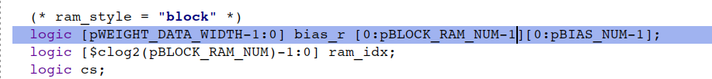
+ Scale memory: same as bias memory

→ Memory mirror: Using an associative array which:
key: weight_addr – datatype: int
value: weight_data – datatype: queue of logic [63:0]
→ Using a associative array which datatype is queue and key is int
→ Turn weight_addr to int
→ Modify weight_data (swap lower haft bits with the high haft bits)
→ Push_back to queue at the “key – weight_addr”
→ pros: easier to implement | cons: hard to control the size of the bias mem queue (because bound size of queue is 4 but the bias mem only need one block ram per address)

DUAL MULT IP TEST
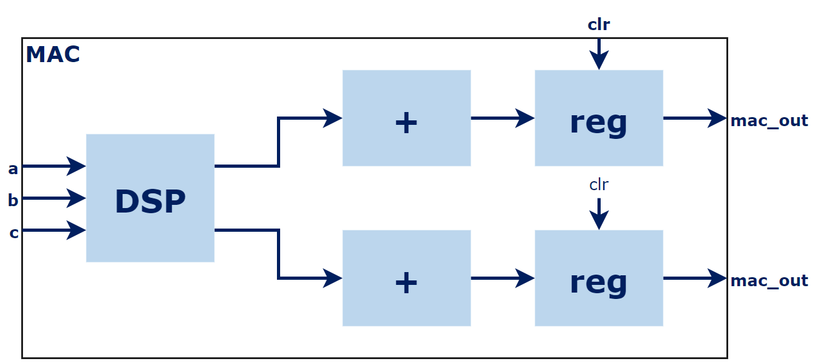

1. IO:

Signal | I/O | Description
clk | IN | Clock
rst | IN | Reset
en | IN | Enable signal
a [7:0] | IN
b [7:0] | IN
c [7:0] | IN
ac [15:0] | OUT
bc [15:0] | OUT
valid out | OUT

2. Funtionality:
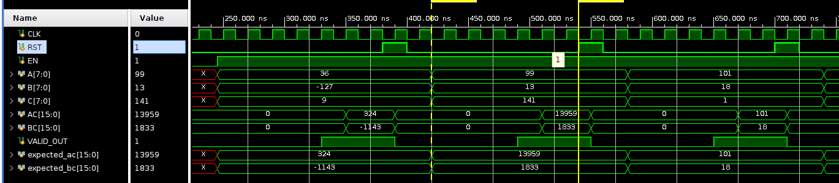
- PIPE LINE 5 STAGE MULTIPLIER
- assert en signal to enable mult ip
- rst signal need to be assert before sending a, b and c to the input
- Input: a, b (for kernel data) are signed 8 bits number, c (for data in) is unsigned 8 bits number
- Output: ac and bc are signed 8 bits number
- the ip start after rst is asserted, at the next posedge clock
- first clock the input is store into regs
- take the ip 5 cycles to get the output (the valid_out signal toggle at 4 cycles, sooner than result 1 cycle)

PIPE LINE 5 stage multiply:
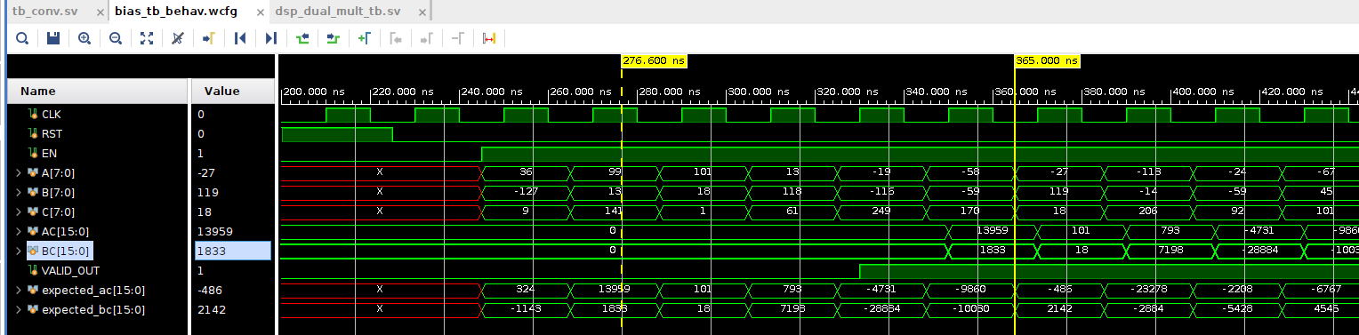
=> Result available after 5 cycles

3. Verification process:
* the problem is C is unsigned number while A and B is signed numbers → when use * operator on A * C and B * C will get the unsigned (systemverilog rule: unsign * sign = unsign) → if using * operator without sign extend the input, we’ll get error when C > 127 (because 8 bit signed can be represent from -128 to 127, ie in 8 bit: 129 unsigned = -127 signed, 131 unsigned = -125 signed)

Step to build a reliable model (2’s complement number multiply steps):
1. sign extend for input: a and b
2. multiply sign extend of a and b
3. result is the lower haft of of the result of multiply sign extend of a and b

ie:

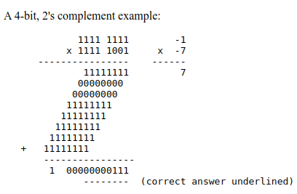

Apply to testbench:
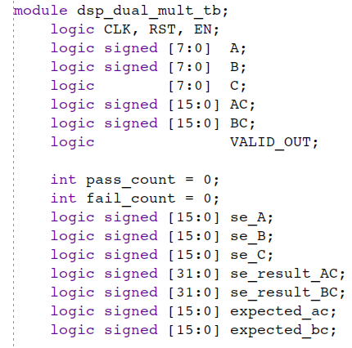

→ step1: make sign extending for the input
* C is unsigned
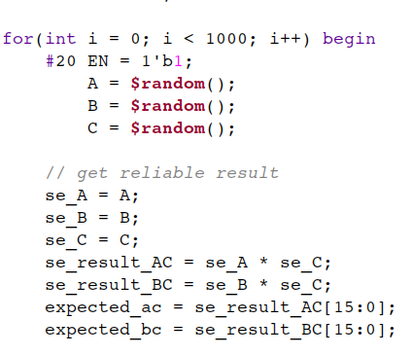

step 2: multiply the sign extend inputs
step 3: the correct result is the lower haft of the sign extended result

PE_CONV_MAC_CONTROLLER

1. Local Parameters:
Index | Local Parameter | Value
1 | pPE_CLR_STAGE_NUM | 1 | Not used anywhere in design
2 | pMAC_PIPE_STAGE_NUM | 7 | Stages of pipeline MAC
3 | pDEQUANT_PIPE_STAGE_NUM | 9 | Number of cycles of Dequantize
4 | pBIAS_PIPE_STAGE_NUM | 1 | Number of cycles of Bias
5 | pQUANT_PIPE_STAGE_NUM | 1 | Number of cycles of Quantize
6 | pSIGMOID_PIPE_STAGE_NUM | 4 | Number of cycles of Sigmoid activation
7 | pRELU_PIPE_STAGE_NUM | 1 | Number of cycles of Relu activation
8 | pADDER_PIPE_STAGE_NUM = $clog2(pIN_CHANNEL) + 1; | 1
9 | pACT_PIPE_STAGE_NUM = pACTIVATION == "sigmoid" ?  pSIGMOID_PIPE_STAGE_NUM :  pACTIVATION == "relu" ?  pRELU_PIPE_STAGE_NUM : 'b0; | 4 | Number of cycles of Activation base on choosing Sigmoid or Relu
10 | pPIPE_STAGE_NUM = pMAC_PIPE_STAGE_NUM +  pADDER_PIPE_STAGE_NUM +  pDEQUANT_PIPE_STAGE_NUM +  pBIAS_PIPE_STAGE_NUM +  pACT_PIPE_STAGE_NUM +  pQUANT_PIPE_STAGE_NUM + 1; | 7 +  1 +  9 +  1 +  4 +  1 + 1 = 24 | Total of cycles of Pipeline MAC
11 | pADDER_STAGE_NUM = pMAC_PIPE_STAGE_NUM; | 7
12 | pDEQUAN_STAGE_NUM = pADDER_STAGE_NUM +  pADDER_PIPE_STAGE_NUM; | 7 +  1 = 8
13 | pBIAS_STAGE_NUM = pDEQUAN_STAGE_NUM +  pDEQUANT_PIPE_STAGE_NUM; | 8 +  9 = 17
14 | pACT_STAGE_NUM = pBIAS_STAGE_NUM +  pBIAS_PIPE_STAGE_NUM; | 17 +  1 = 18
15 | pQUANT_STAGE_NUM = pACT_STAGE_NUM +  pACT_PIPE_STAGE_NUM; | 18 +  4 = 22
16 | pBUFFER_STAGE_NUM = pQUANT_STAGE_NUM +  pQUANT_PIPE_STAGE_NUM; | 22 +  1 = 23
17 | pVALID_STAGE_NUM = pBUFFER_STAGE_NUM + 1; | 23 + 1 = 24

2. IO

SIGNAL | IO | DESCRIPTION
clk | IN | Clock
rst | IN | Reset
en | IN | Enable signal
buffer_valid | IN | Valid signal from buffer_in module
pixel | OUT | Signal to get particular pixel (data_out) from buffer_in module
kernel_addr  bias_addr  buffer_idx  pe_ready  pe_clr  datapath_buffer_en  adder_en  dequant_en  bias_en  act_en  quant_en  buffer_en | OUT | Control signals for datapath
valid | OUT | Valid signal, valid = 1 when finish when one convolution is done
done | OUT | Done signal, done = 1 when all convolutions (28 * 28 = 784) are done

3. Functionality
* There is a counter inside that count from 0 to 9 represent 9 pixels to convolution with kernel
* rst = 1to make the counter ready (cnt_out = 0, otherwise cnt_out = x)
* counter start counting when buffer_valid = 1
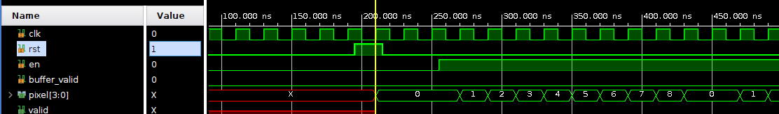
* each time the counter reach max and reset back to 0, valid_r[lsb] = 1 → then each next cycle the the valid_r shift left (24 register represent 24 stage in the convolution process)
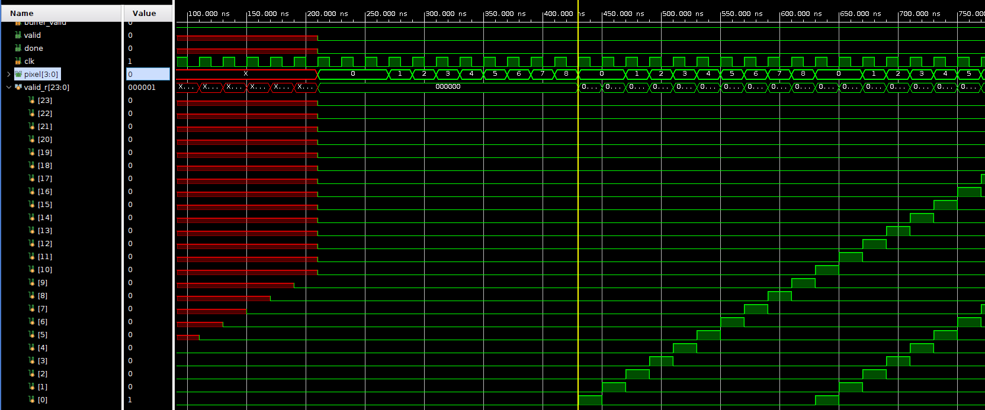

* valid = 1 when valid_r[msb] = 1
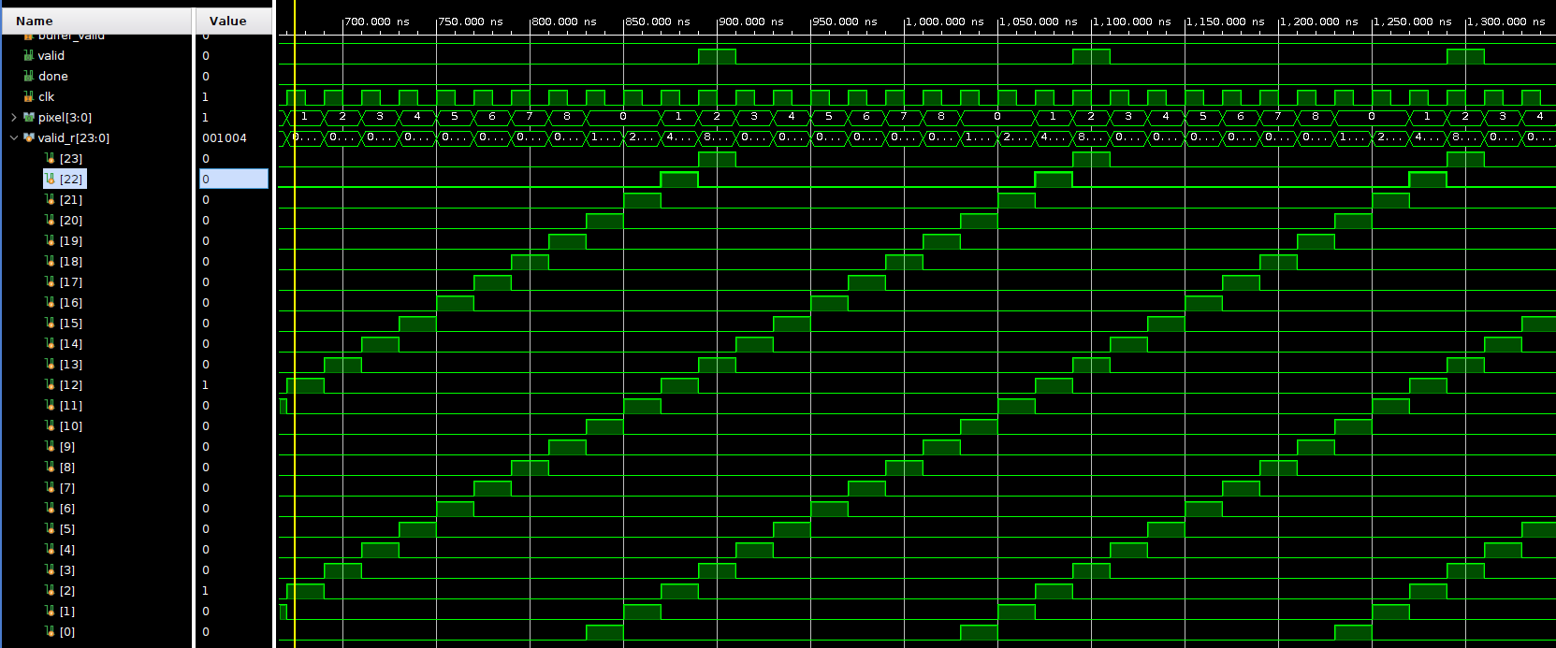
* when en = 1, the first valid = 1 is got after 24 cycles

* aint understand shit

kinda now, 11 cycles for valid to be on, 1 to write to buffer_in, one to write to buffer out, 9 for 9 pixel
PE_CONV_MAC_BUFFER_IN
1. IO:

Signal | I/O | Description
clk | IN | Clock
rst | IN | Reset
en | IN | Buffer write enable signal
data_in [71:0] | IN | 9 pixels of image to do convolution
pixel [3:0] | IN | Which pixel to go to output
data_out [7:0] | OUT | Data of pixel corresponding to the input pixel[3:0]
valid | OUT | Valid is connect to en input

2. FUNCTIONALITY
Assert en = 1 signal to write input, write in one cycles. Deassert en to start reading, data is read base on the pixel input (from 0 to 8). Read data is independent to “en” signal.

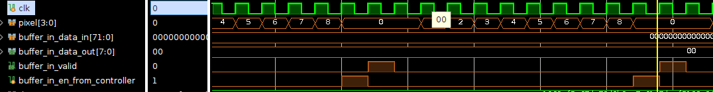
valid output is connected to en input → en = 1 → valid = 1

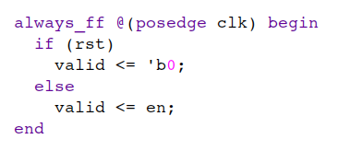

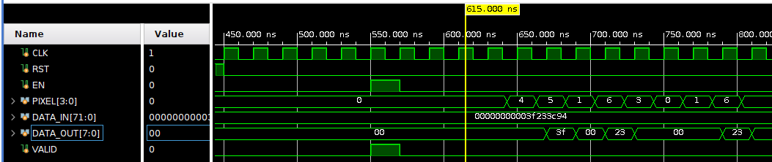
* output is read each posedge of clock depent on pixel input (synchronous read)
ie: above figure: pixel = 4 → data_out 3f at output at posedge clock
pixel = 5 → data_out at output at posedge clock

PE_MAC_CONV_DATAPATH VERIFICATION PLAN
Interface & Sequence Item
SIGNAL | WIDTH | STATUS
data_in | [7:0] | rand
load_weight |  | rand
weight_data | [63:0]
weight_addr | [31:0]
kernel_addr | [3:0]
bias_addr | [3:0] | rand
en  pe_clr  adder_en  dequant_en  bias_en  act_en  quant_en | Datapath | rand
data_out | [255:0]
dataset_path: /home/hao/Documents/0.KHOA_LUAN_TODSPT_NGHIEP/thesis_HauPhong/fpga-resnet-main/design/software/dataset/
mnist weight: /home/hao/Documents/0.KHOA_LUAN_TOT_NGHIEP/thesis_HauPhong/fpga-resnet-main/design/software/weights/mnist_weights.bin

- 10000 mnist images
- what if changing parameters: stride, pad, kernel size
how mnist_weight.bin is stored inside kernel ram? → [solved] check kernel ram part

CYCLES:
dual_mult: 5 cycles
adder tree: 1 cycle
dequantize: 9 cycles
bias: 1 cycle
activation: 3 cycles
quantize: 1 cycle
→ 5 + 1 + 9 + 1 + 3 + 1 = 20 cycle to get the valid data_out
DSP

