Place to put assertion into:
https://verificationacademy.com/forums/t/assertions-appropriate-place/34871

https://stackoverflow.com/questions/40052695/assertion-module-in-an-uvm-testbench

https://www.quora.com/While-creating-a-verification-environment-using-UVM-where-should-we-include-coverage-monitors-and-assertions

How to get the signal of submodule of DUT in testbench:
https://verificationacademy.com/topics/systemverilog/the-missing-link-the-testbench-to-dut-connection/
→ “The Missing Link: The Testbench to DUT Connection” Part 1, pg. 7 – Whitebox verification – B. Bind

SystemVerilog Bind Structure

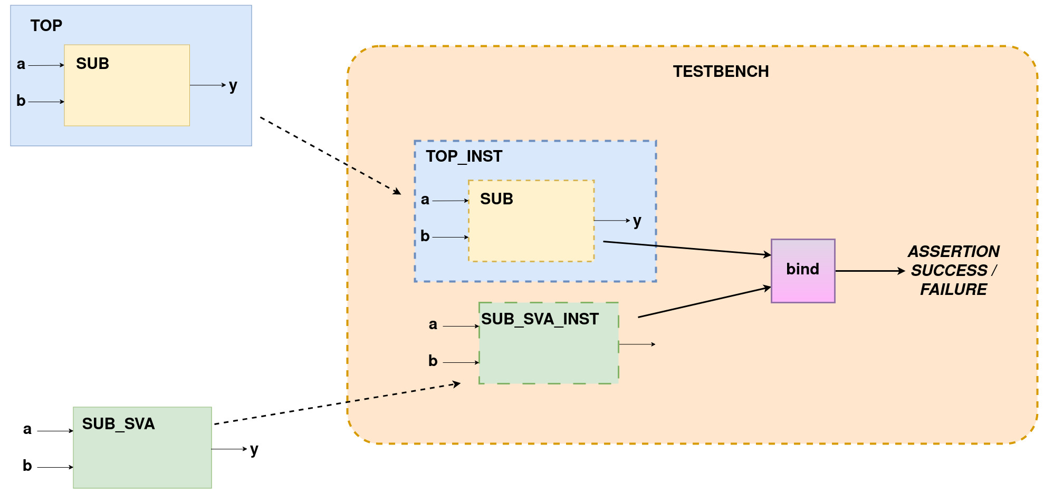
SUB_SVA module is a dumy module which:
+ have the same input and output of SUB module
+ have assertion inside

Step 1: create instance of TOP module inside Testbench (SUB module instance will also be created when TOP module instance is created)
Step 2: create instance of SUB_SVA module inside Testbench
Step 3: bind the instance of SUB to instance of SUB_SVA inside Testbench

→ All the signal run inside instance of SUB (which inside instance of TOP) when the simulation running will be reference into signal of the dummy instance, the SVA will be performed

*** Alternative ways ***
- Create temp signals inside testbench, these temp signals will be assign signals of the instance of submodule using “assign”

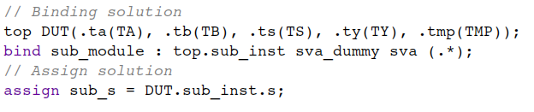
*** NOTE: read the source document for the syntax of bind construct ***

+ Types of assertions
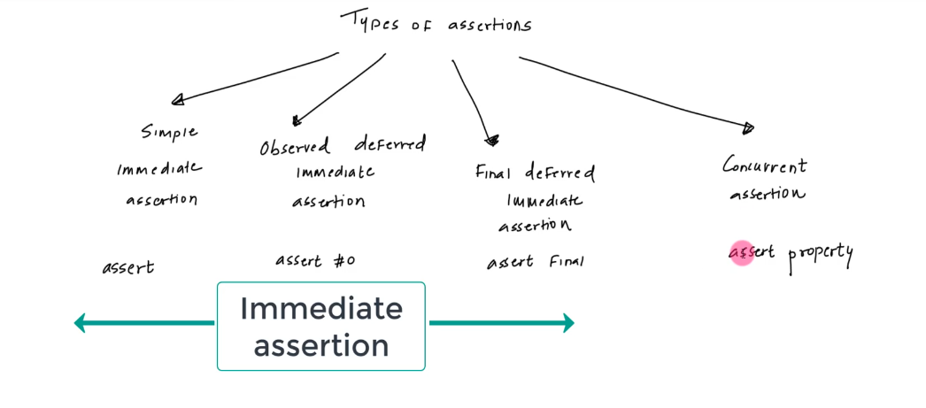
assert = Immediate assertion
assert #0 = Immediate assertion
assert final = Immediate assertion
assert property = Concurrent assertion

+ SV regions:

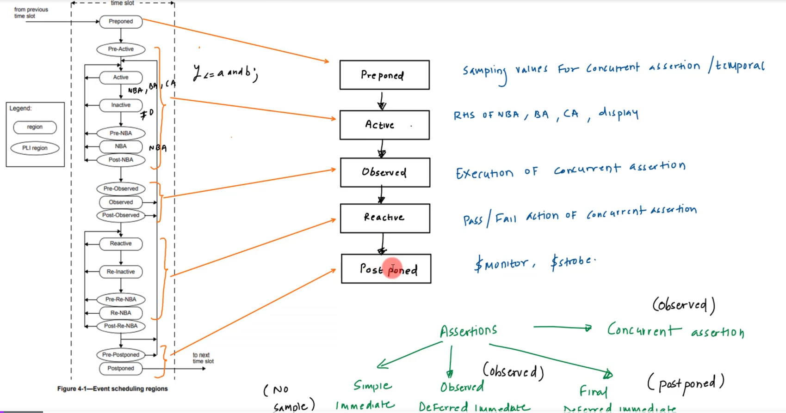
+ Rules for Immediate assertions:
- sia: require procedure block (initial or always block)
- odia + fdia: require procedure block for sequential
pass / fail action:
- sia: multiple pass / fail action
- odia + fdia: single pass / fail action

Simple Immediate Assertion:
assert (s == a ^ b) $info(“pass action”); else $error(“fail action”);
Observe Deffered Immediate Assertion:
assert #0 (s == a ^ b) $info(“pass action”); else $error(“fail action”);
Final Deffered Immediate Assertion:
assert final (s == a ^ b) $info(“pass action”); else $error(“fail action”);

+ Disabling assertion:

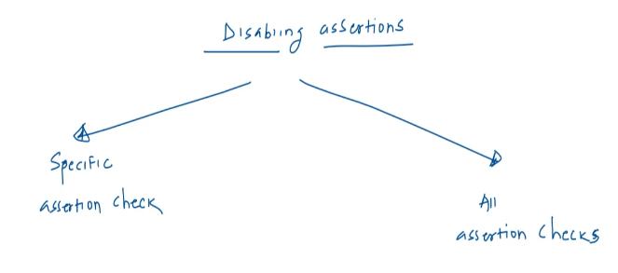
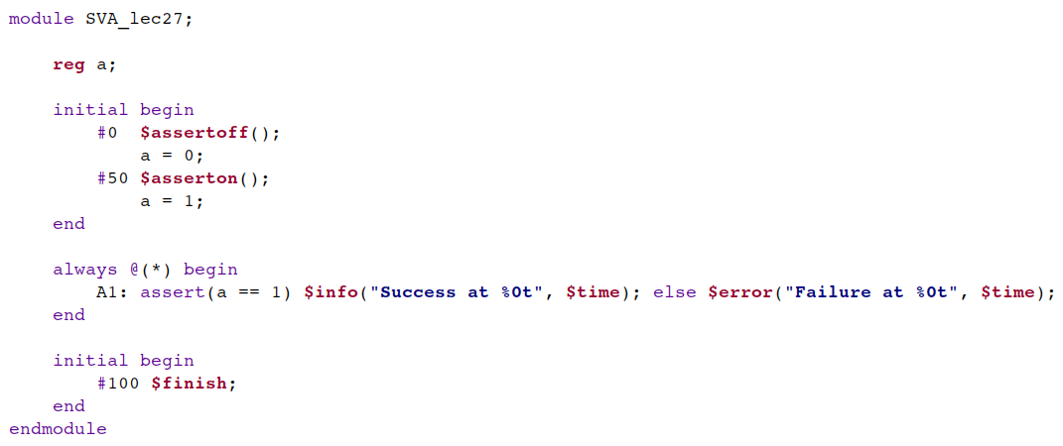
→ turn off all assertions for 50ns, then turn them on again.

+ Fundemental of Immediate Assertion
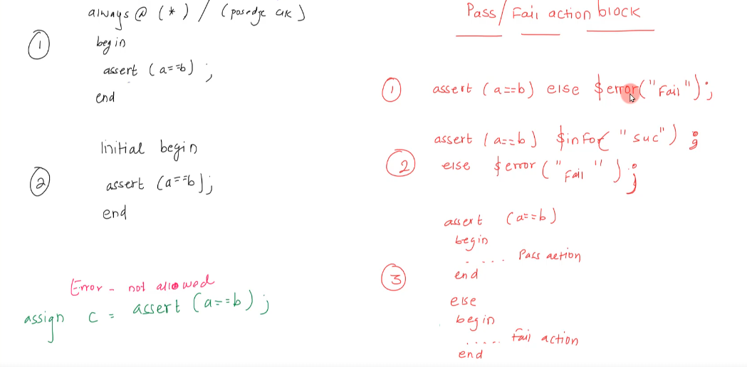
+ Concurrent Assertion:
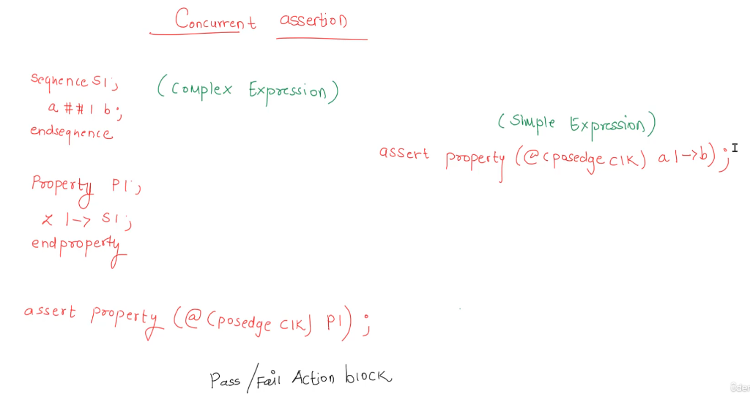

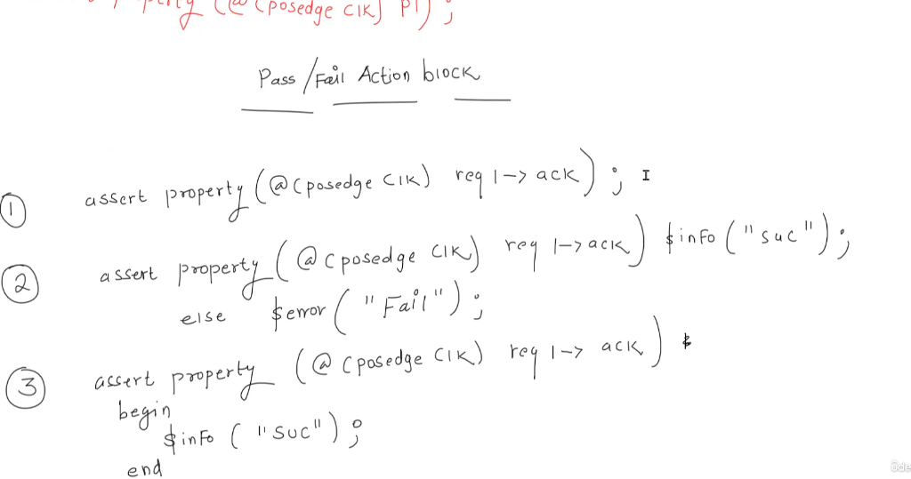
+ assert / deassert for different type of signal:
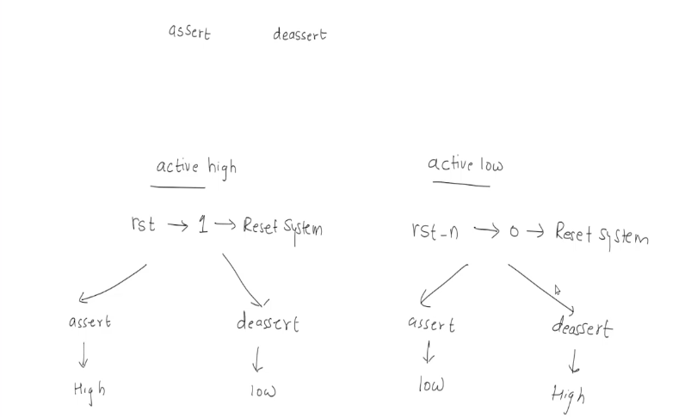

CONCURRENT ASSERTION LAYERS
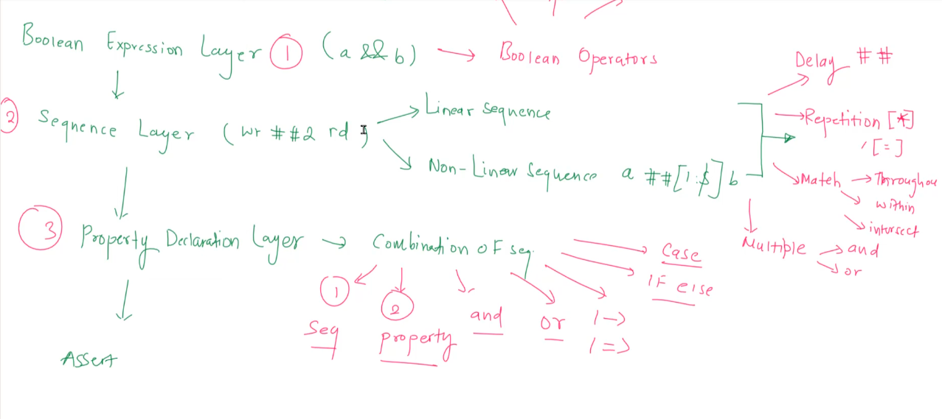
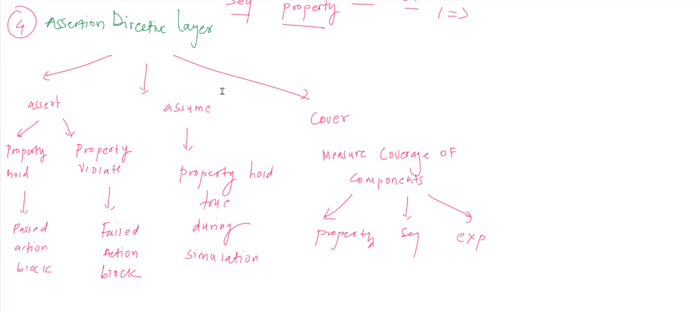

1. Boolean Layer: (for comb components)
Operators: and, or, xor, not, etc

2. Sequence Layer: (for sequential components)
- Linear layer: know exactly the timing (ie: B = 1 after 2 cycles when A = 1)
- Non-linear layer: don’t know the exact timing (ie: A = 1, expecting somewhere in the simulation B will be high)

Operators: delay [##], repetition [*], match (throughout, withing, intersect), multiple (and, or)

3. Property Declaration Layer:
→ Combination of seq combine of:
- sequence
- sub-property
- and
- or
- ( |-> ) / (|=>)
- if else
- case

4. Assertion Directive Layer:
- assert:
+ Property hold → Passed action block
+ Property violation → Failed action block
- assume → Property hold true during simulation
- Cover → Measure coverage of compinent:
+ property
+ sequence
+ expression

* System task: $error, $fatal, $info, $warning, $countones, $countbits, $isunknown

HANDLING OPERATOR TRICKS

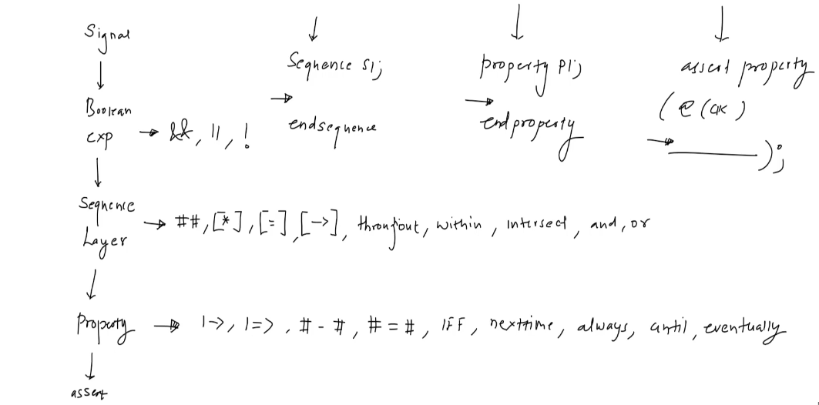

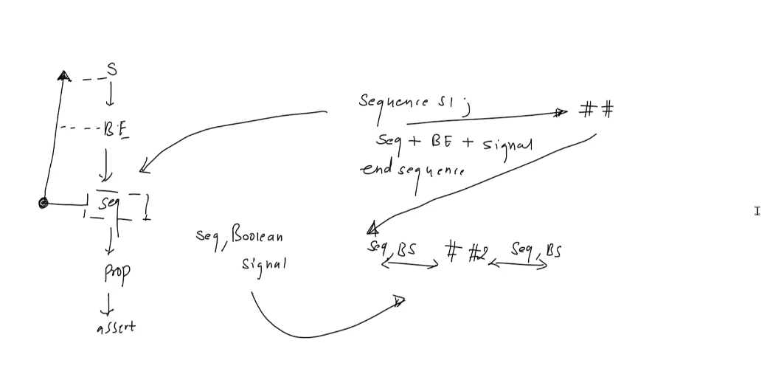
→ sequence layer chart

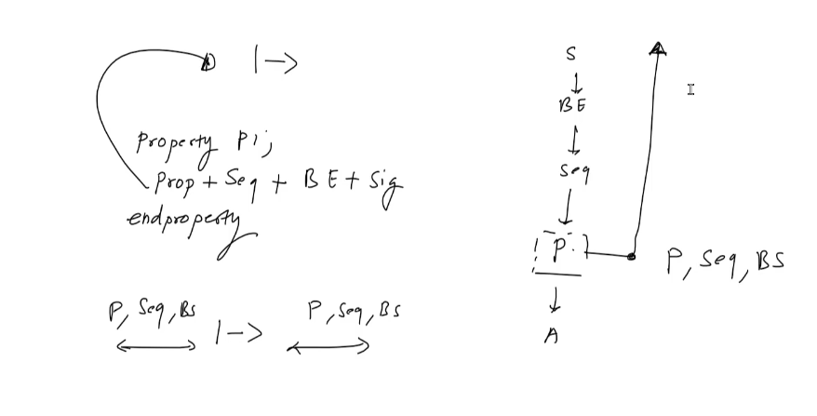
→ Property layer chart

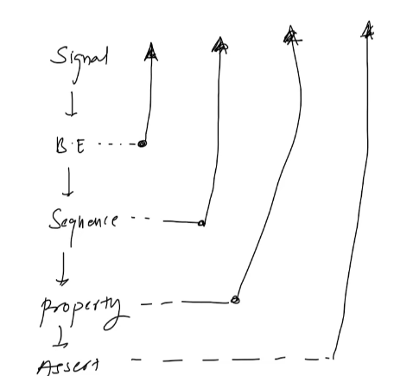

→ assert layer chart

→ Assert Decalrative Layer is the top layer that can use other layer: property, seq, boolean expression and signal. Property Layer can use the lower layer: seq, BE, signal, and also other property layer. Sequence Layer can use the BE layer and signals

OPERATOR
Fundamentals of Implication Operators

Property:
- Implication
+ overlapping ( symbold |-> )
+ non-overlapping ( symbol |=> )
- Followed by:
+ overlapping ( symbold #-# )
+ non-overlapping ( symbol #=# )

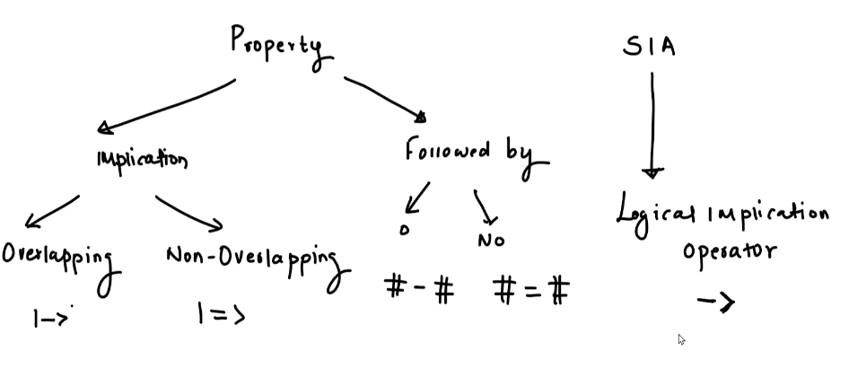
Usage: Implication operator is used whene you want to evaluate if a signal/expression become true or not

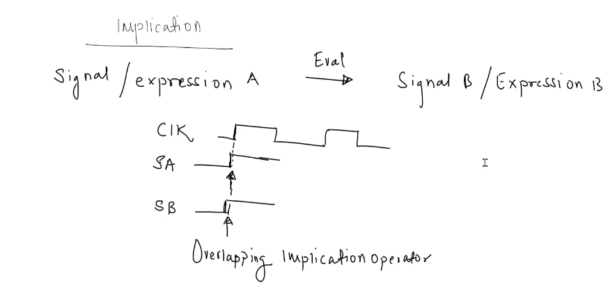
→ Overlapping implication operator: in the same edge

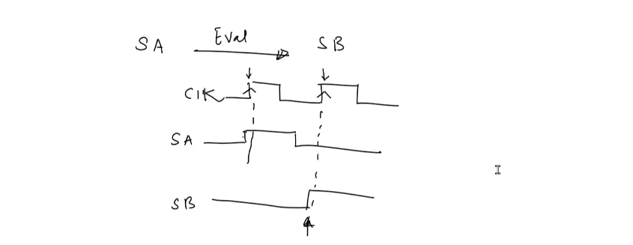
→ Non-overlapping implication operator: not on the same edge

+ In same clock tick, check signal A is true → signal B is true: use overlapping operator
+ In different clock tick, check signal A is true → signal B is true: use non-overlapping operator
+ Signal A is true, signal B is true after some clock cycle, use overlapping + delay or non-overlapping + delay

Overlapping Implication Operator
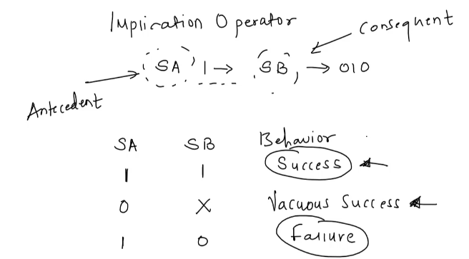

Non-Overlapping Implication Operator
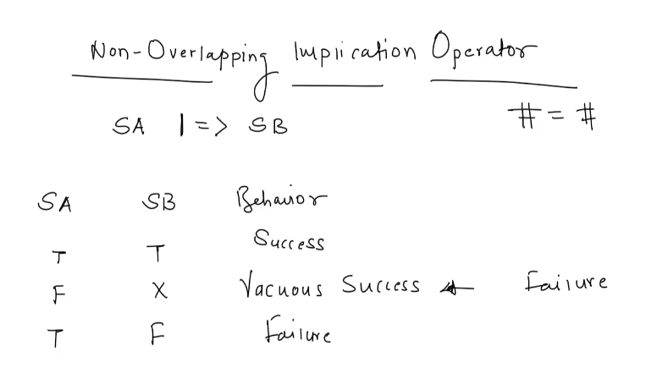
Thread with Level and Edge of the signal
Level:

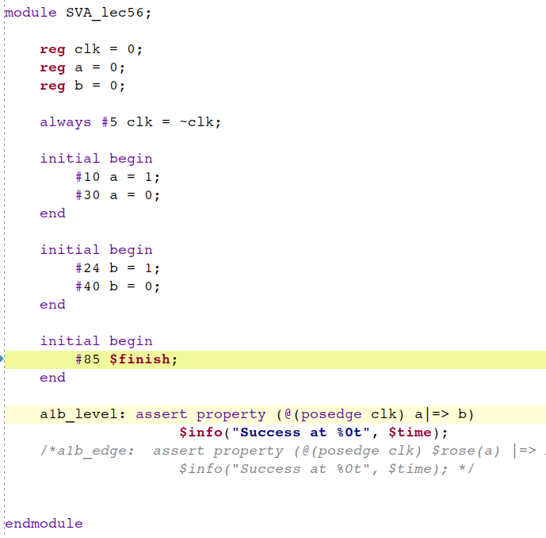

→ check if when a = 1, one cycles after b = 1 or not

Edge:
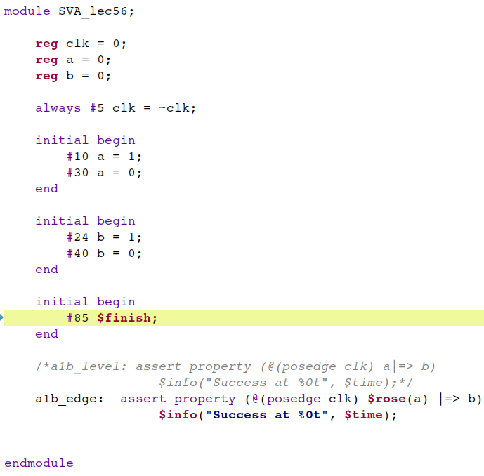
→ $rose(a) check if after signal a rise, after one clock cycles will there be b = 1 ?

Used of $sampled

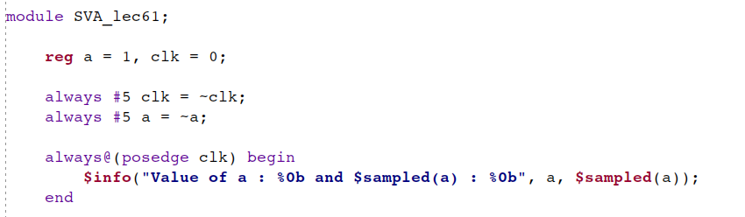
→ check the above code, reporting mechanism using 2 ways to get the value of signal a at each posedge of clk. 1st is the traditional way and 2nd is the $sampled() systemtask of concurrent assertion

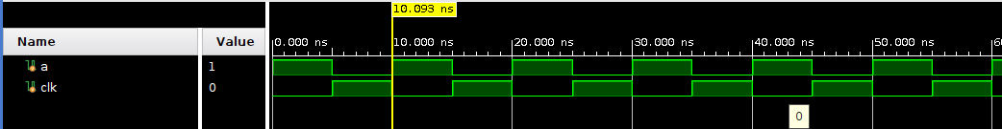

→ the waveform looks like this

Here is the result:
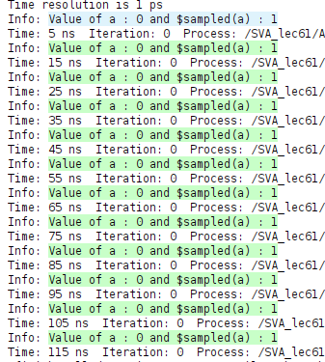

→ we got 2 different result of each ways. The reason is bc traditional way which using function is call in the Reactivce Region. In the other hand, the $sampled() which system task of assertiono sample the value from the Preponed Region of SystemVerilog.
→ CONCURRENT ASSERTION IS PERFORMED IN THE PREPONE REGION → Does not need to use $sample in a concurrent assertion expression bc it’s default perform in the preponed region already.
** $rose() and $fell() are also does not need to add $sampled() because they are already perform in the preponed region

Using $rose in Single bit and Multi-bit signal

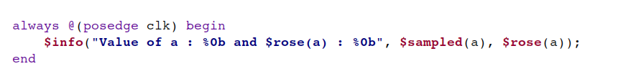
→ Check the return value of $rose(a) of the below waveform
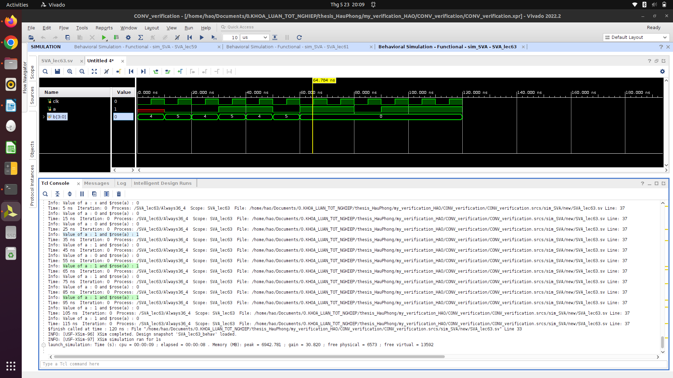
→ the return of $rose(a) got value of 1 at 35, 65 and 95ns. $rose(a) task check if the value of a change from 0 to 1 before at each posedge of clock. It returns 1 if a change from 0 to 1 in the cycle before the checking pos (posedge of clk)
→ the above is true with single bit signal, if using $rose() with a multibit signal, $rose only return 1 if the lsb of the bus change from 0 to 1, other bits are not considerd by the $rose. ** Only LSB of bus is considered when using $rose to a multi-bits signal **.
** signal from Z, X, 0 to 1 are all considered as pass of $rose, same as $fell when 1, X or Z turn to 0 **

Getting Started witj $past
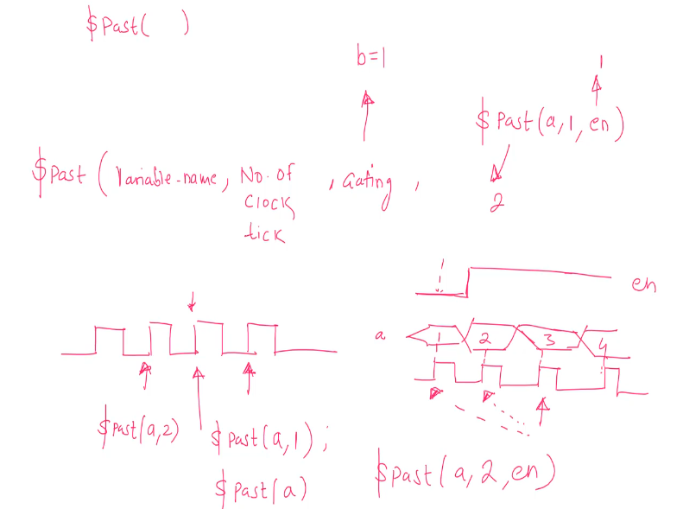
+ if gating = 0 → $past() will return the previouse success value of $past, if that $past has no previous call successfully, the return value will be X.
Ie:
if the first $past successfully return value of 2. If the second $past() has the gating value = 0, the return value of it will be 2 (previous result).
If the $past() is call the first time and the gating = 0, meaning there is no previous successfully call of $past → it will return value of X

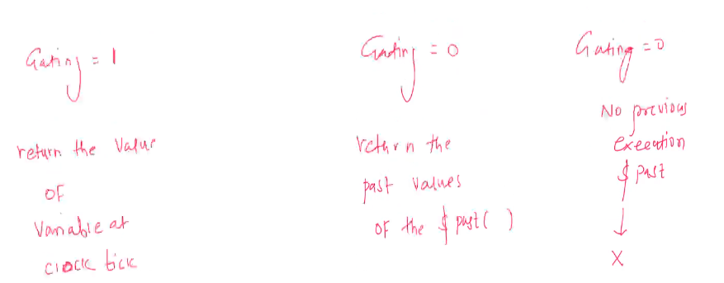
*** NOTE: 1st argument of $past can be either be single-bit or multi-bits signal. The return value will be single-bit or multi-bits regarding to that argument

USED CASES
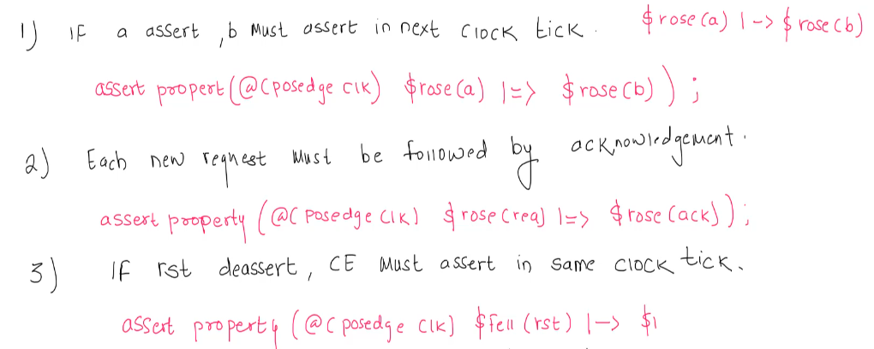
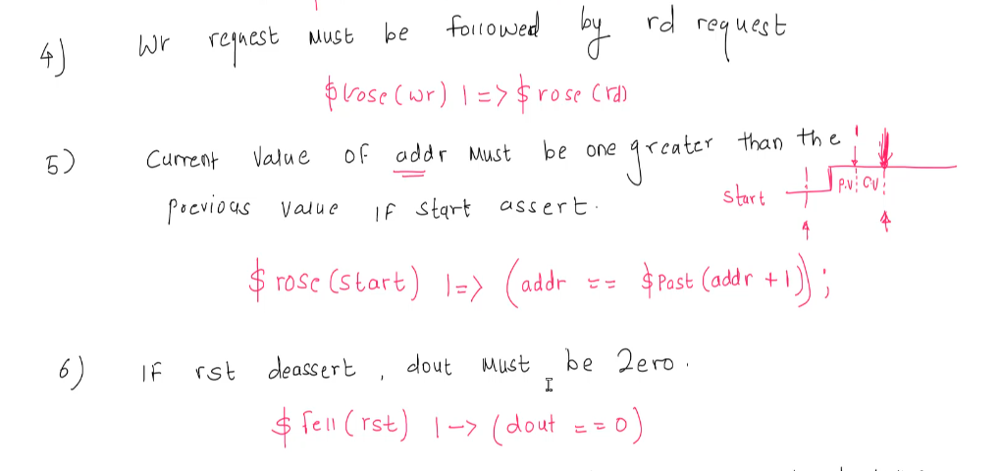
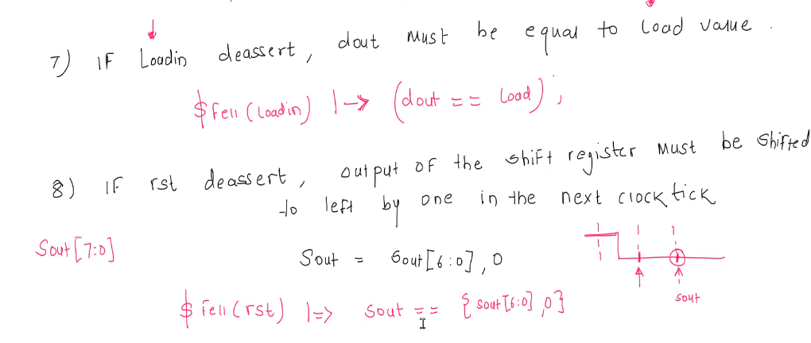
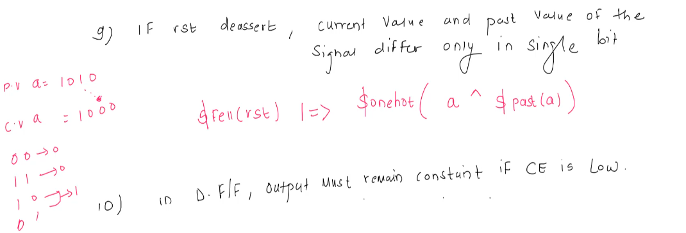
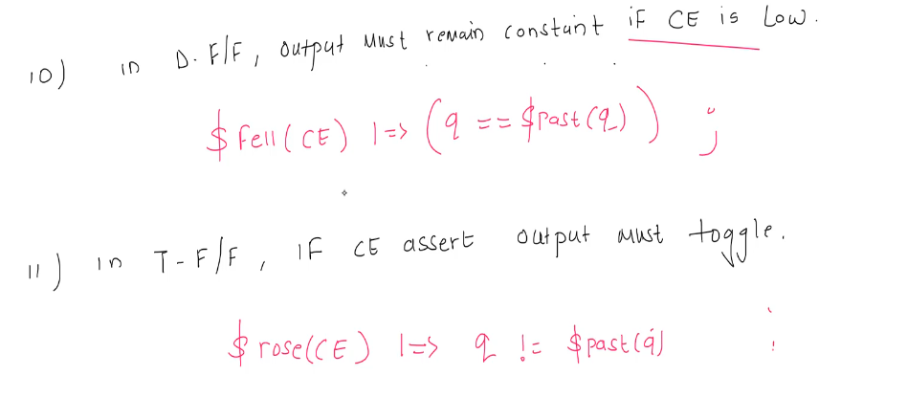

DELAY OPERATOR ##
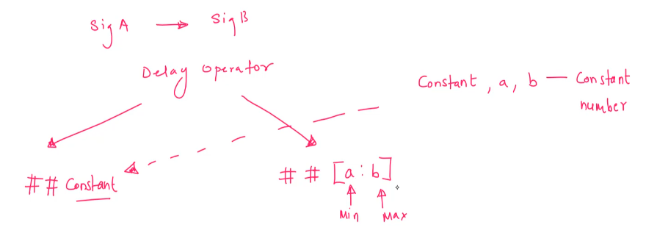
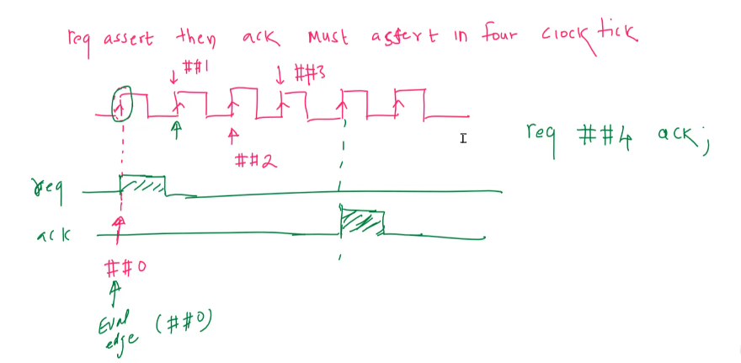
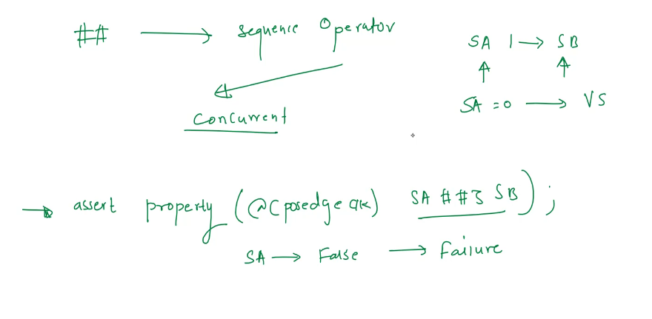

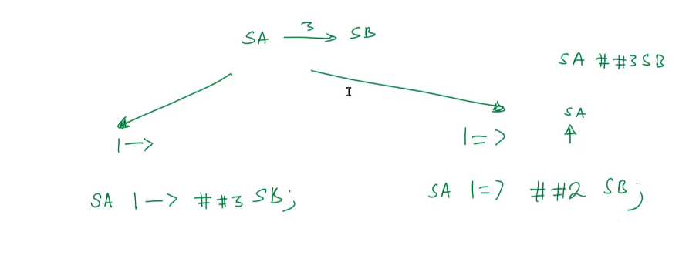
→ Check if when SA asserts, SB assert after 3 cycles
→ There is 2 ways to do that:
SA |→ ##3 SB
SA |=> ##2 SB
→ The reason the non-overlapping way need to sub the delay by 1 is by default, the valuating point of non-overlapping assertion is the clock edge after SA asserts → reduce number of delay behind ## by 1 if using non-overlapping style
*** just use the overlapping way for delay, it’s simpler

+ Using ## with and without |->
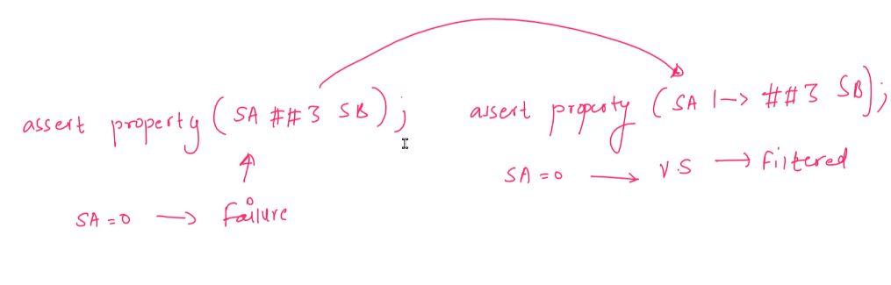
→ in the left, SA = 0 is considered as failure
→ in the right, SA = 0 is considered as a vacuous success → be filtered

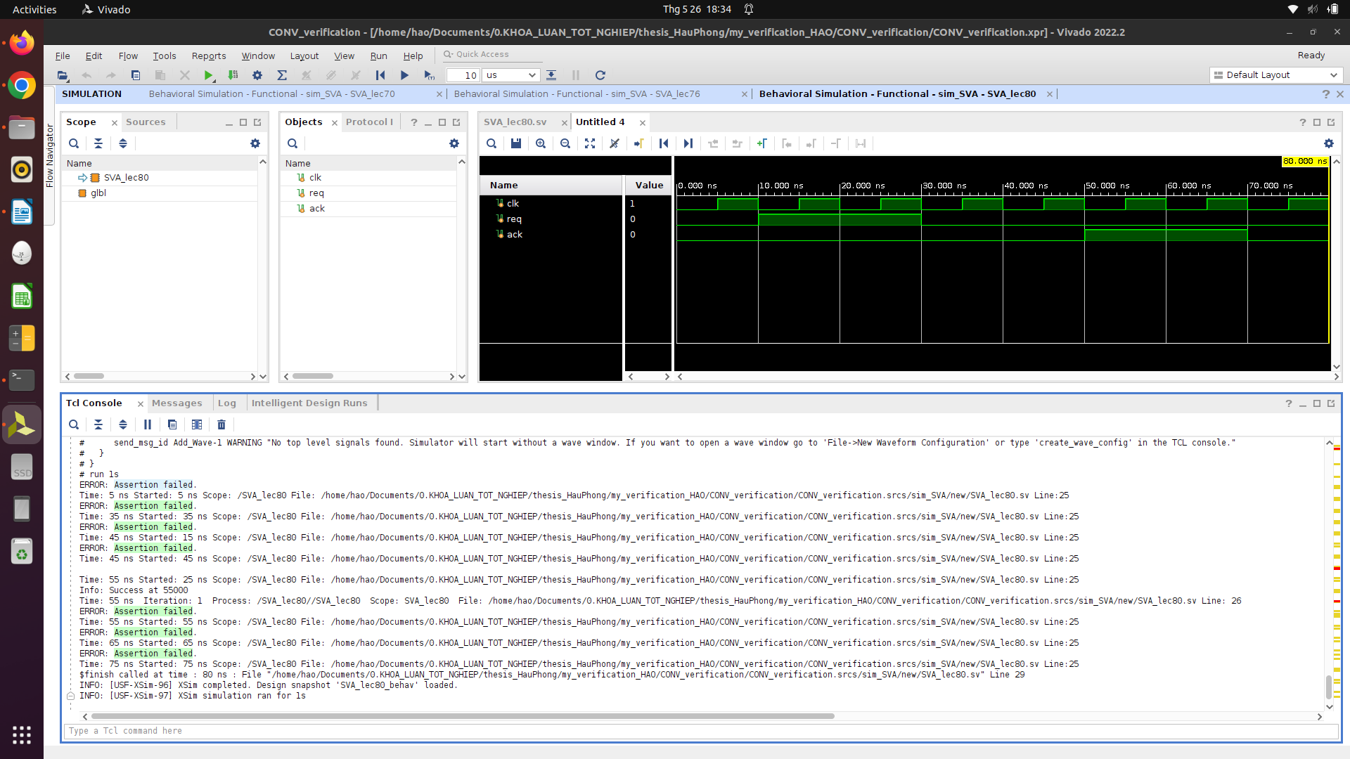
→ without |-> all edge where req = 0 will be considered as an failure and got error from simulator

+ Delay with range
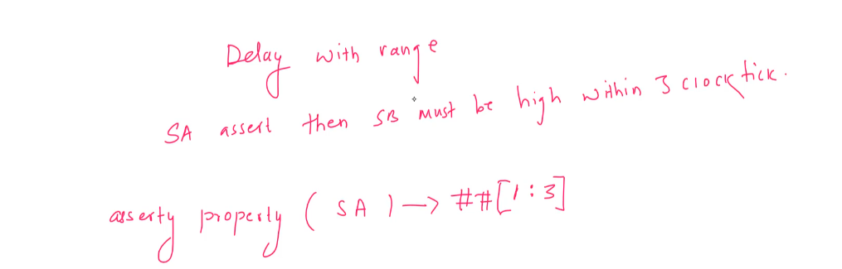
Bug of delay with range:
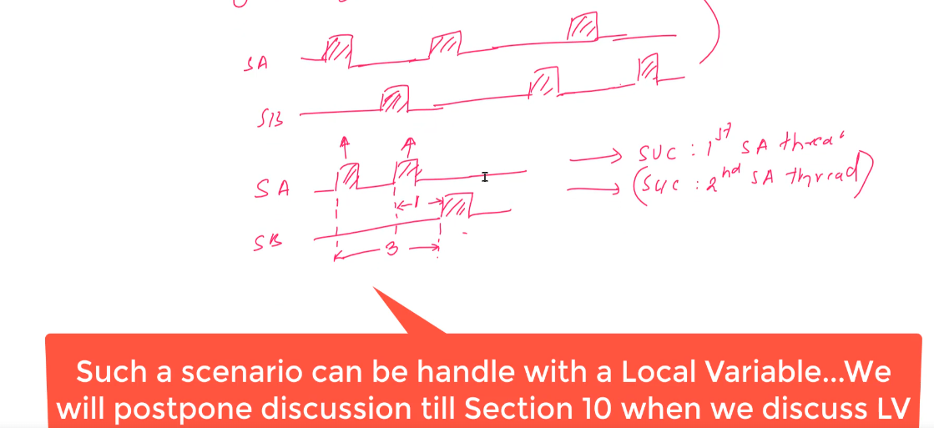
→ the below figure where there is 2 SA before 1 SB is asserted, meaning 2 threads are created but the result of these 2 thread are both success → this is an unexpectedresult

+ Unbound Delay:

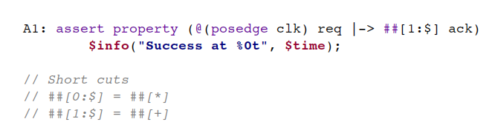
→ expect when req assert, somewhere in the simulation after at least one cycles, ack will be asserted

2 ways to resolve the issue that the simulation don’t announce error even when there is no ack asserted throughout simulation when using “req |-> ##[1:$] ack” (vivado does not support strong() operation)
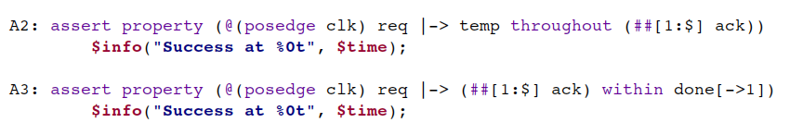
→ using temp signal such as temp or done with the use of “throughout” and “within”
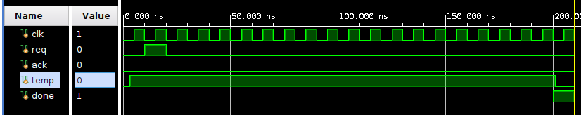
→ how temp signals should be set (throughout way seem more intuiative)

REPEATITION OPERATORS
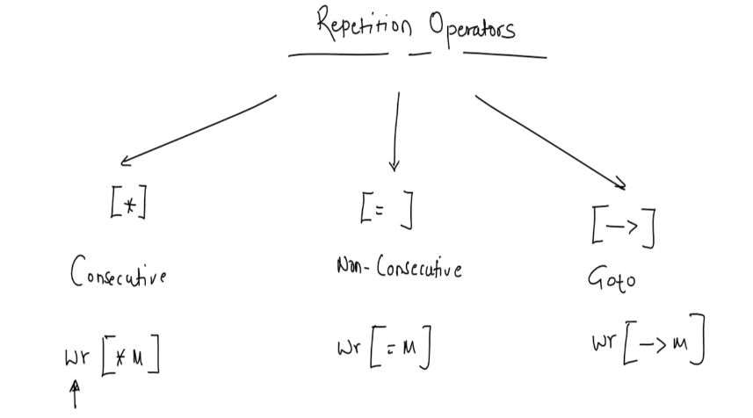
* non-consecutive = signal CAN scaterd throughout the timespan
ie: wr[=M] ##1 !wr
→ above example means when we found out the match somewhere during the simulation, we expecting wr deassert

ie: wr[->M] ##1 !wr
→ as soon as we found out match, the wr must be deassert after the specific delay, else failure will be announced
** NOTE: applying non-consecutive rst[=2], the below waveform of rst still count as a Success → rst =1 twice does not need to be separated, it still can be consecutive. In the other hand, using rst[*2] will got failure if rst = 1 twice seperately (1st posedge of clk rst=1, 2nd clk’s posedge rst=0, 3rd clk’s posedge rst =1)**
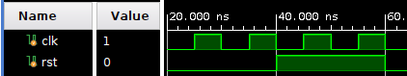

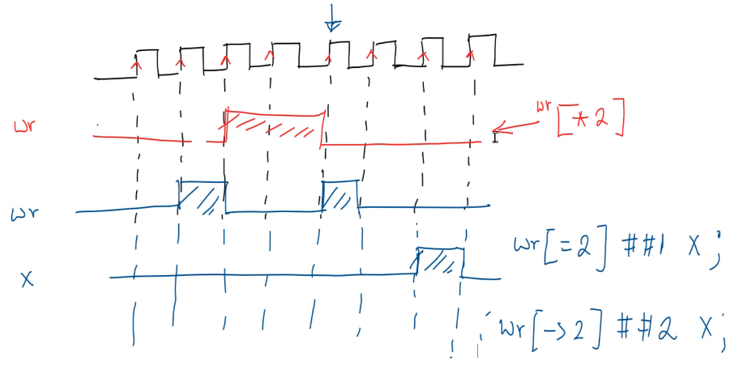
→ wr[=2] ##1 X → after wr =1 in 2 non-consecutive clock edge, X expected to be asserted sometime after the match in the simulation
→ wr[->2] ##2 X → after wr =1 in 2 non-consecutive clock edge, X expected to be asserted right after 2 clock after the match in the simulation

+ We can also set a range for the repetition with min and max:
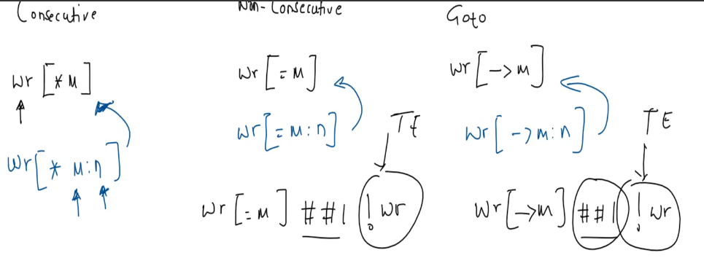

SUMMERY
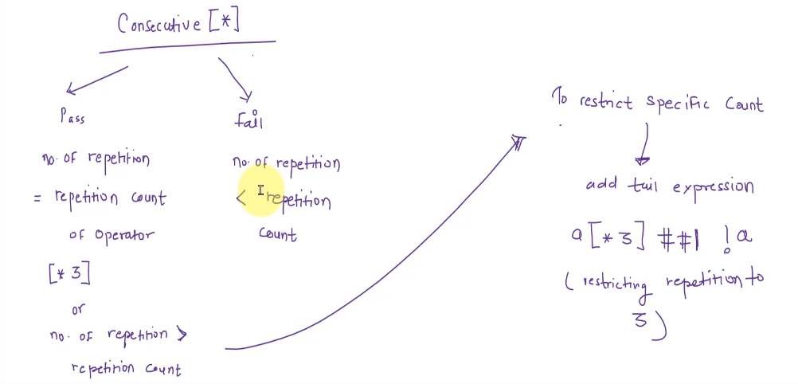
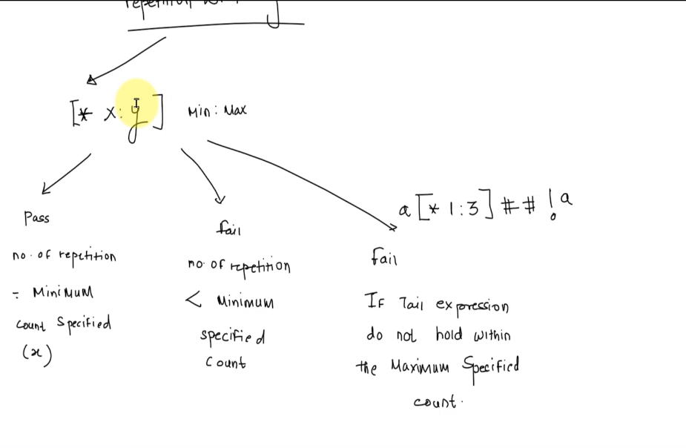

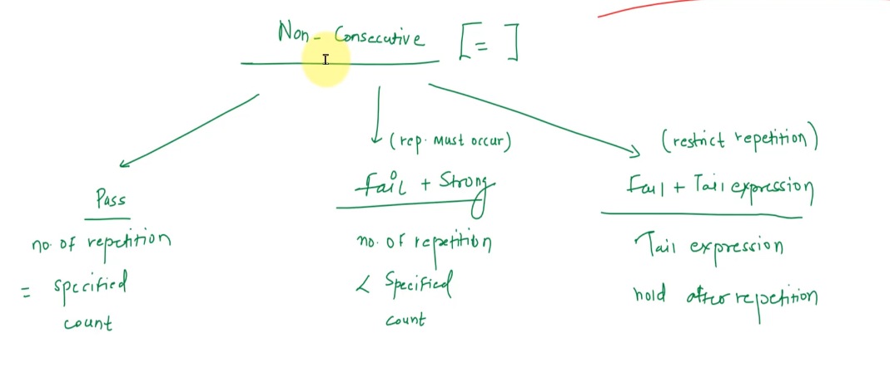
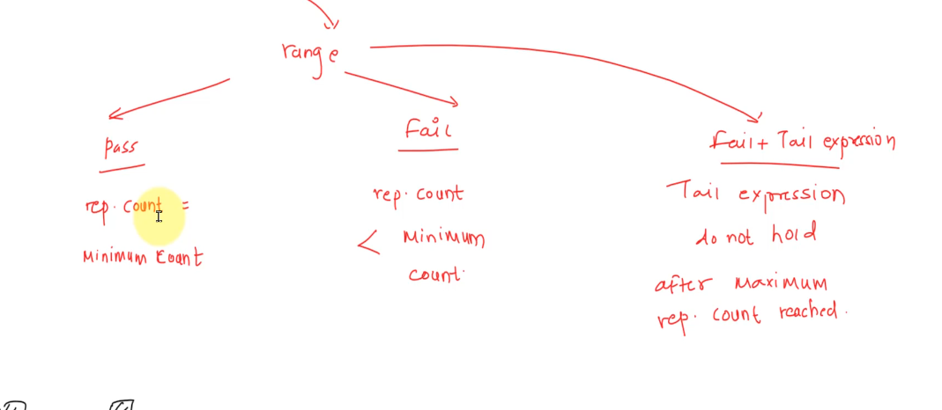
Go to vs Non-consecutive repetition

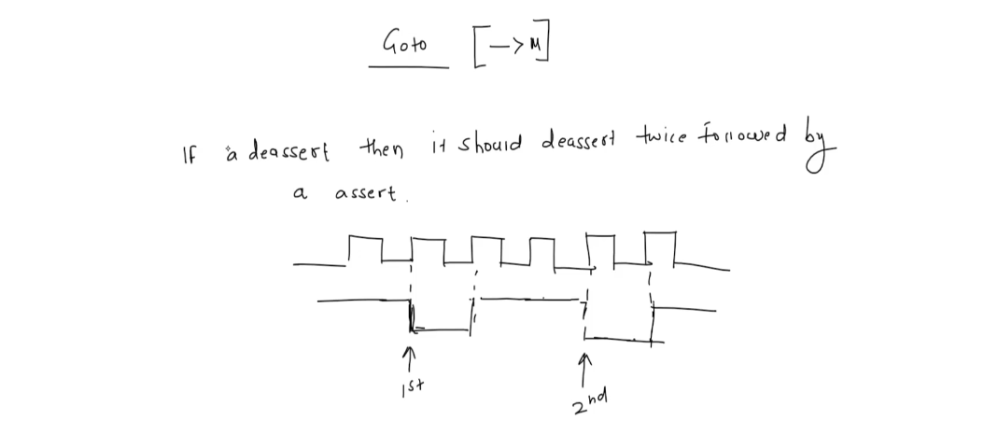

→ De bai: Neu a kich canh xuong thi no phai kich canh xuong 2 lan ko can lien tuc, o lan kich canh xuong thu hai no phai kich canh len tai xung clock ke tiep

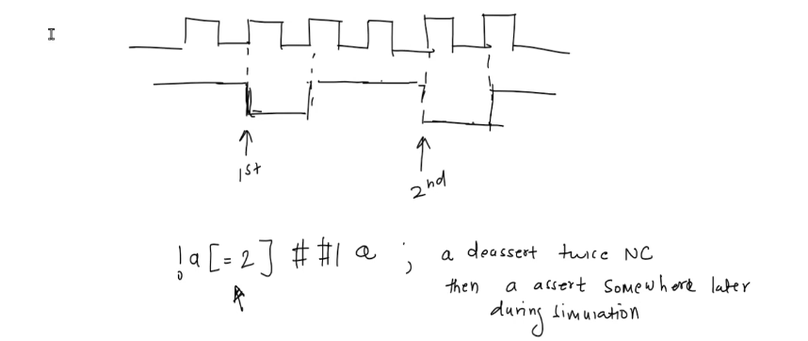
→ the non-consecutive repetition assertion above is not suitable boi vi dien giai theo assertion ben tren: a kich canh xuong 2 lan ko lien tiep sau do kich canh len O MOT THOI DIEM BAT KY trong qua trinh mo phong sau do.

→ In this situation we need to use the goto repetition

MAIN DIFFERENT BETWEEN GOTO AND NON-CONSECUTIVE REPEATITION

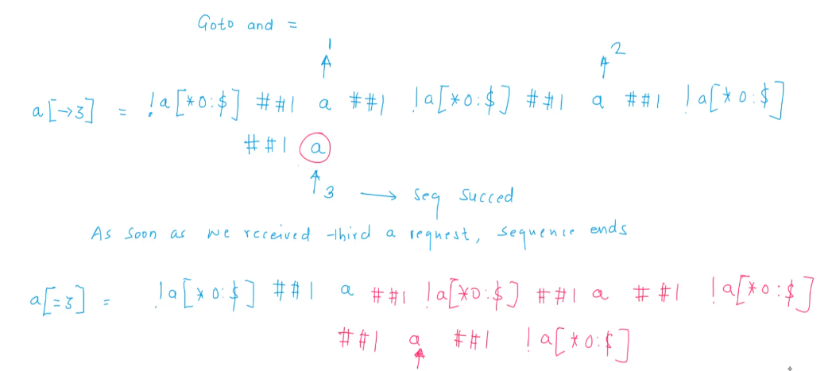
→ Observe the above figure, with the GOTO repetition, seq success as soon as the 3rd asserted a arrive, the sequence end. In the other hand, using the NON-CONSECUTIVE repetition, the sequence does not necessarily end when the 3rd asserted a arrive

another examples:
1. example 1
a[->2] ##b //goto - a is true immediately followed by b is true
a[=2] ##1 b // non-consecutive - 'a' could be false any number of clock cycle before b is true
2. example 2:
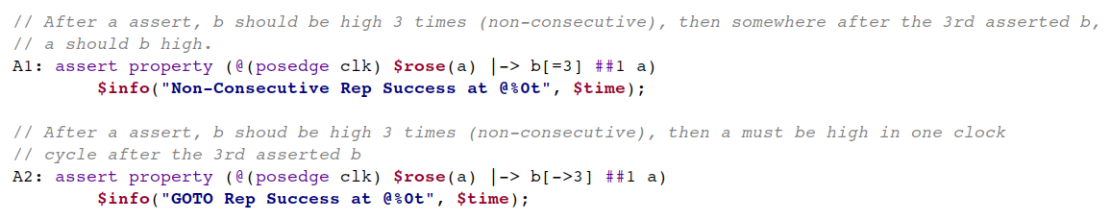
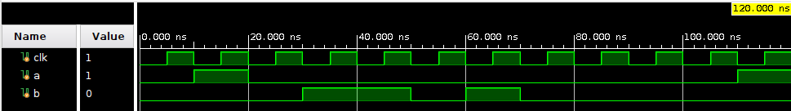
→ A1 pass, A2 fail

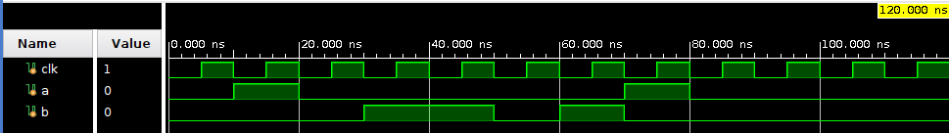
→ A1 pass, A2 pass

→ With the Goto repetition, the tail expression must be match exactly after the delay
→ with the non-consecutive repetition, the tail expression can go true in anytime after the delay

USED CASES
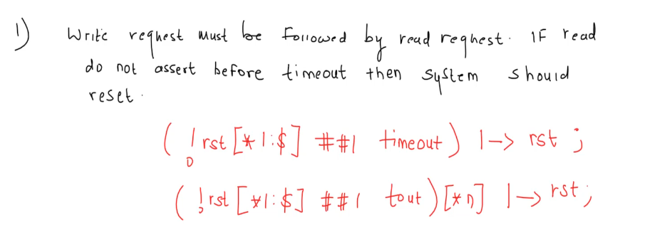
→ don’t quite get it
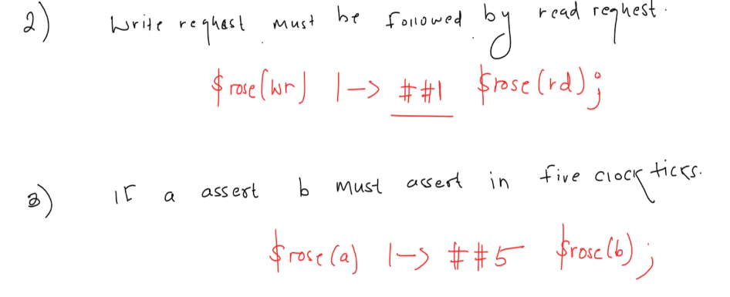
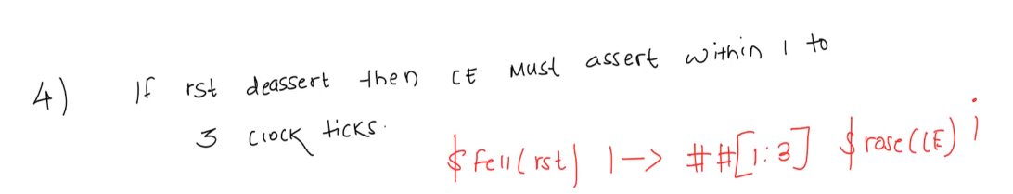
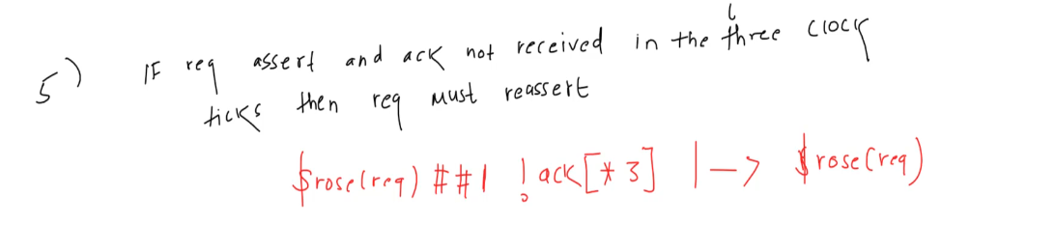
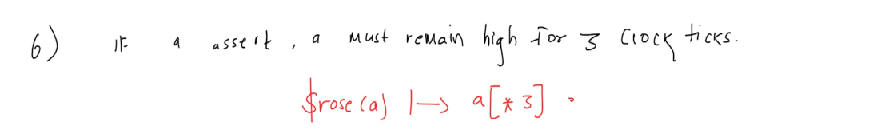
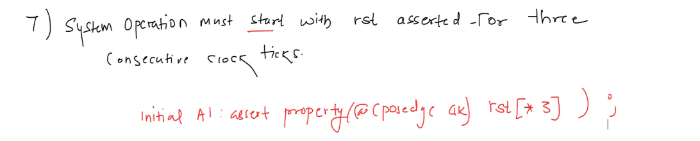
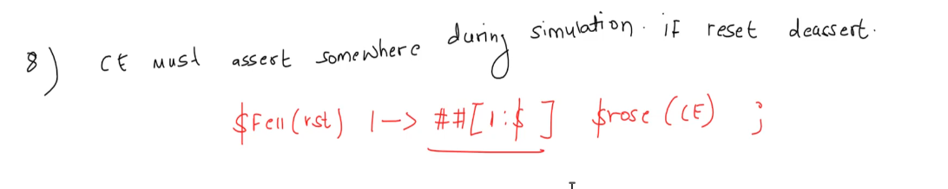
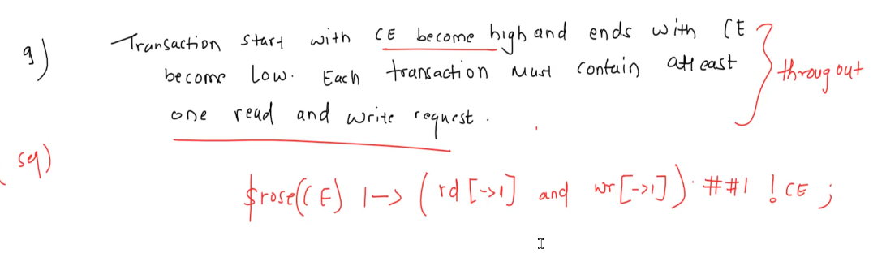
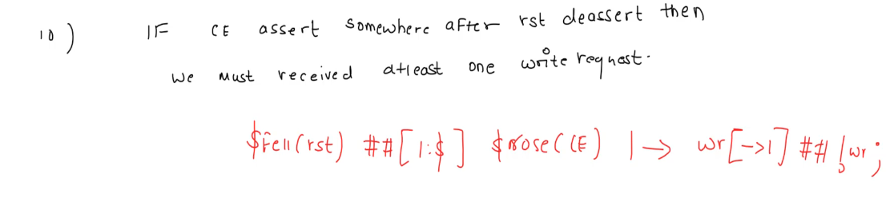

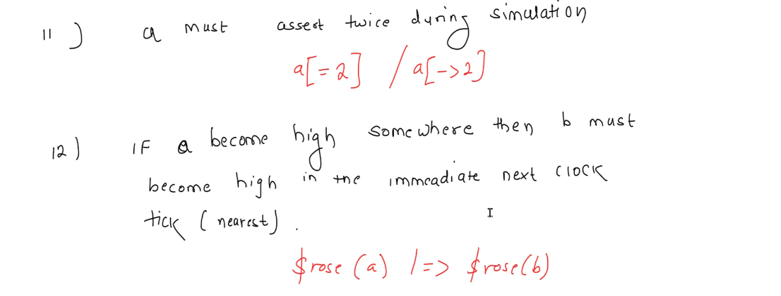
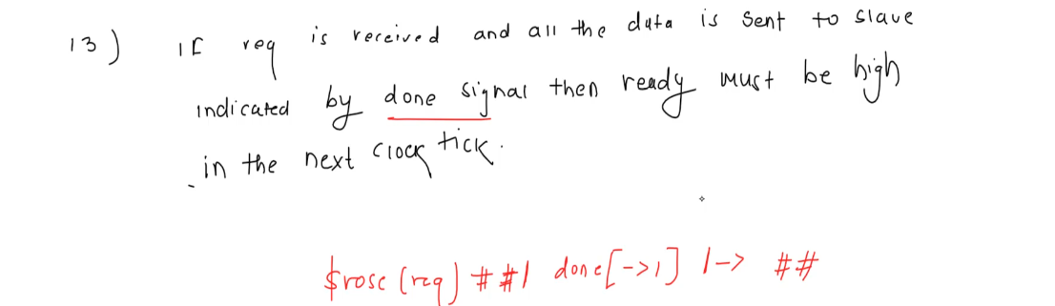
→ ex13 could be replace the ##1 with the unbound delay too

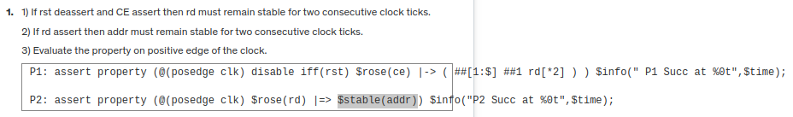

FUNDAMENTAL OF BOOLEAN OPERATOR
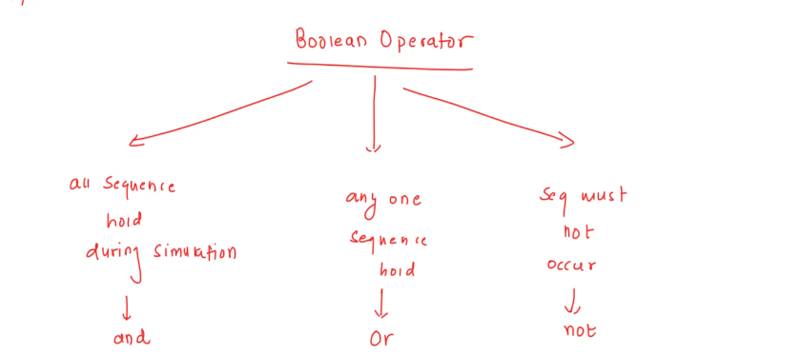
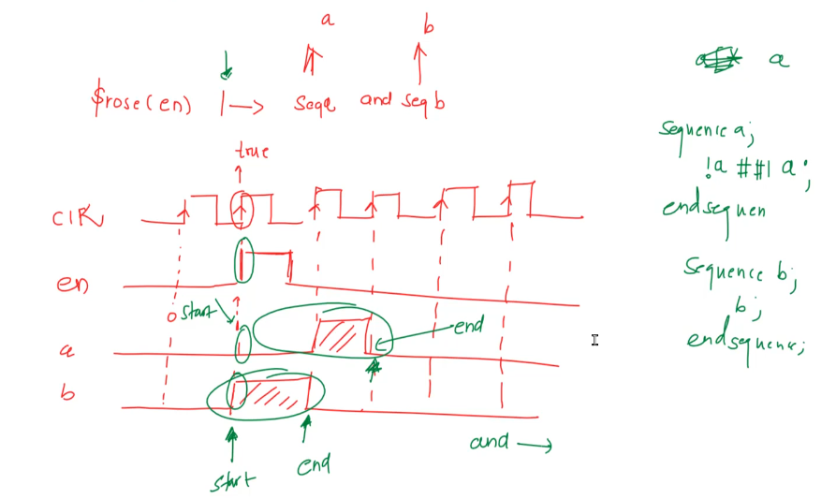
** the sequences of AND/OR boolean need to have the same starting point, although they can have different end points **
→ with the AND operator, the sequence success when the longer seq success (the shorter seq need to be success to)
→ with the OR operator, the sequence success when the shorter seq success, fail when both seq fail
** NOT operator is usefull in situation when we declare some behavior that must not happen in the simulation → use NOT for a sequence, when the declared sequence success (happen), the error will be announced **

strong qualifier alternative
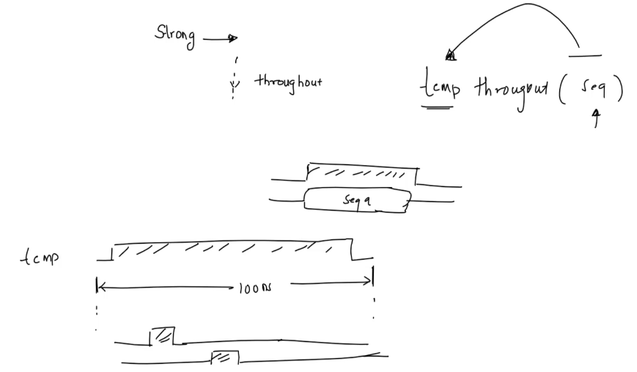
*** temp before throughout can only be signal, not sequence

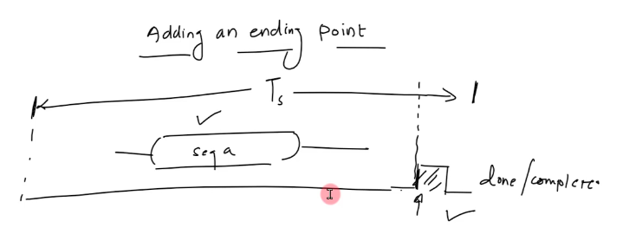
USED CASES
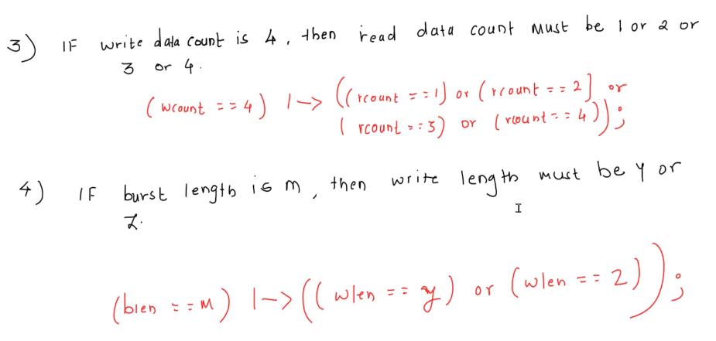
FUNDAMENTAL OF THROUGHT, WITHIN AND INTERSECT

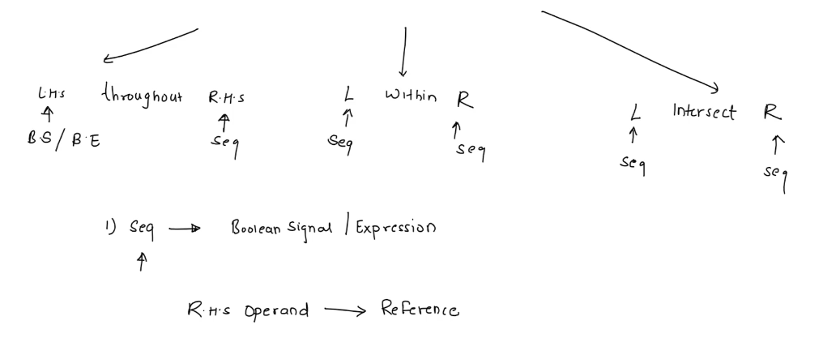
→ LHS: left hand side | RHS: right hand side
→ LHS of throughout muse be boolean signal or boolean expression

Success and Failure of throughout
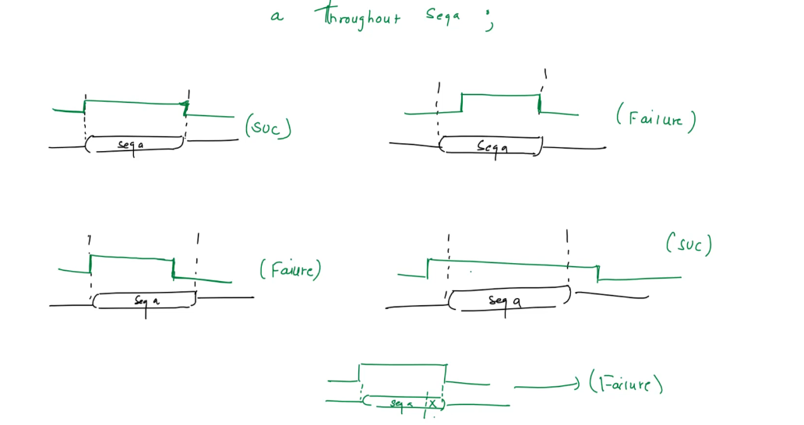
*** in the success case, the success will be announce at the end of sequence


