Apache JMeter
V0.1
Cai
Document Maintained
The latest version of this document will be found in the <\\dell\Document Archive>. All other softcopy or hardcopy versions are invalid and are not to be used. It is the responsibility of the document owner to update this document.
Revision History
Date of this revision: 2013-12-12 | Date of next revision: <Date>

Revision Number | Revision Date | Summary of Changes | Author | Reviewed by
1 | 2013-12-12 | Draft | Cai
Acronyms & Definitions
Acronym | Definition

TABLE OF CONTENTS
1 Assumption 1
1.1 Hardware/Software Information 1
1.2 <Dependency Software Name 1> 1
1.3 <Dependency Software Name x> 1
1.4 <Target Software Name> 1
1.5 Notes 1
1.6 Conventions 1
2 Download <Target Software>/How to get <Target Software> 3
2.1 Download Apache JMeter 2.10 3
2.2 Download JUnit 4.10 3
3 Install Apache JMeter 4
3.1 Install Required Software 4
3.2 Install Apache JMeter 4
4 Install Eclipse plugin (Optional) 6
4.1 Install Eclipse plugin for <Target Software> 6
4.2 <Other Configure Details> 6
5 Create a HelloWorld Project 7
5.1 Target 7
5.2 Extract installation packages 7
5.3 Import into Eclipse 8
5.4 Configure Apache JMeter 12
6 JUnit with JMeter 18
6.1 Target 18
6.2 Configure Runtime Classpath 18
6.3 Prepare JUnit 25
6.4 Run JUnit with JMeter 26

Assumption

Hardware/Software Information
OS: Windows 7 Ultimate
DB2: DB2 Enterprise Server Edition v9.7.0.0
WAS: WebSphere Application Server Edition v7.0.0.13
Eclipse: Eclipse Indigo Service Release 2
MDM: Master Data Management Server v9.0.1/Master Data Management Server v10.0.0
MDS: Master Data Service v10.0.0
Apache JMeter: v2.10
JUnit: v4.10

JUnit
JUnit 4.10

Apache JMeter
Apache JMeter 2.10

Notes
OS is out of the box.
Java environment is required. Java Home is NOT required.
Authority of root user for OS is required

Conventions
Italic
Indicates sample contents and references

Constant
Used for Linux/Windows command

Bold
Stands for important tips

Download <Target Software>/How to get <Target Software>

Download Apache JMeter
<Download URL>
<img: Screenshots />
In Windows, choose <Target Software>.zip
In Linux, choose <Target Software>.tar.gz

Download JUnit
<Download URL>
<img: Screenshots />
In Windows, choose <Target Software>.zip
In Linux, choose <Target Software>.tar.gz

Install Apache JMeter

Install Required Software
Install <Required Software 1>
<img: Screenshots />
Configure JAVA_HOME
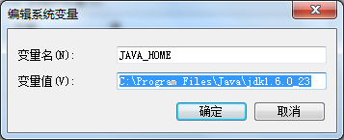
Configure CLASSPATH
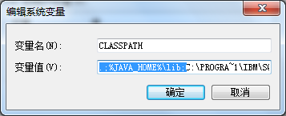
Configure Path
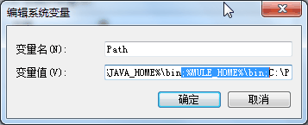
Test < Required Software 1> installation
<img: Screenshots />

Install Apache JMeter
<Installation details 1>
<img: Screenshots />
<Installation details x>
<img: Screenshots />

Install Eclipse plugin (Optional)

Install Eclipse plugin for <Target Software>
Click Help > Install New Software…
Enter <Plugin URL> and press Enter.
Select the <Plugin Name> check box and click Next.
Review the <Plugin Name> license, select the option to accept the license, and then click Finish.
Restart Eclipse.

<Other Configure Details>
<Configure Detail 1>
<img: Screenshots />
<Configure Detail x>
<img: Screenshots />

Create a Hello World Project

Target
This demo will illustrate how to launch Apache JMeter from Eclipse.

Extract installation packages
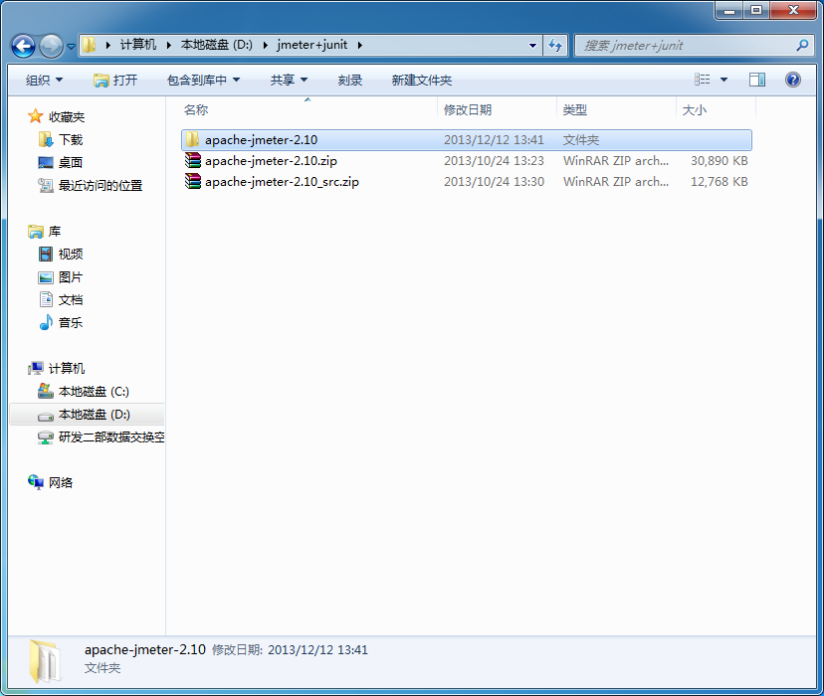
Extract apache-jmeter-2.10.zip and apache-jmeter-2.10-src.zip into the same folder, in our case, we will extract them into apache-jmeter-2.10.
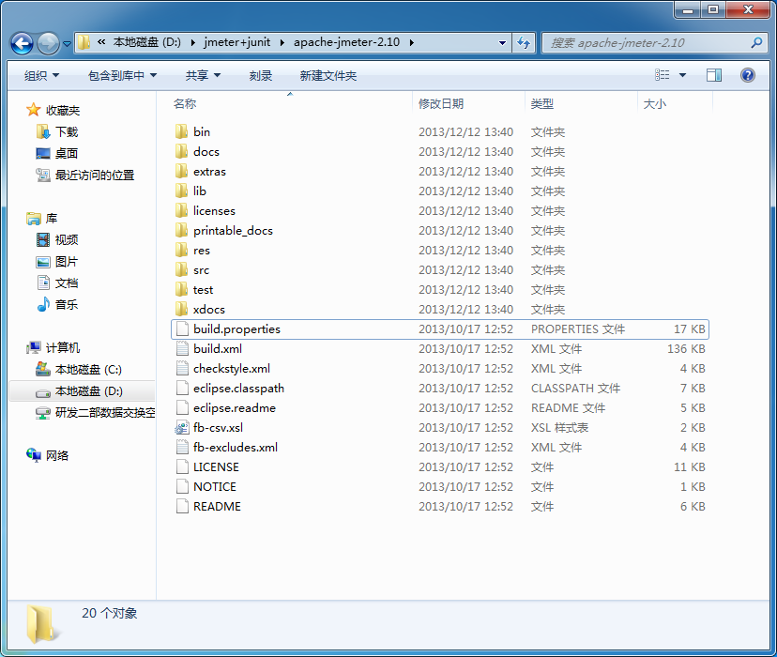

Import into Eclipse
Open Command Line and change director to apache-jmeter-2.10.
Type ren eclipse.classpath .classpath.
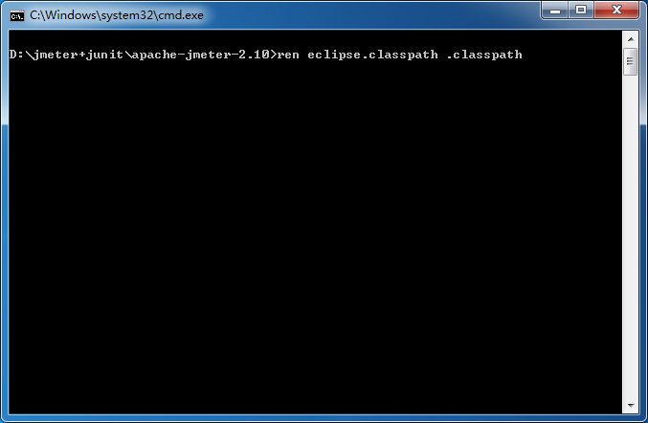
Type ren eclipse.readme .readme
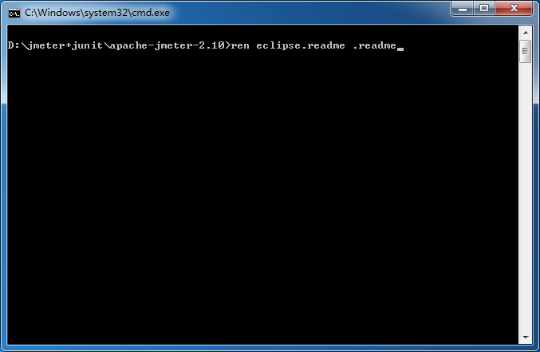
Create a Java Project in Eclipse. Then copy all content from apache-jmeter-2.10 into your eclipse project folder, this will replace bin folder, src folder and .classpath file.
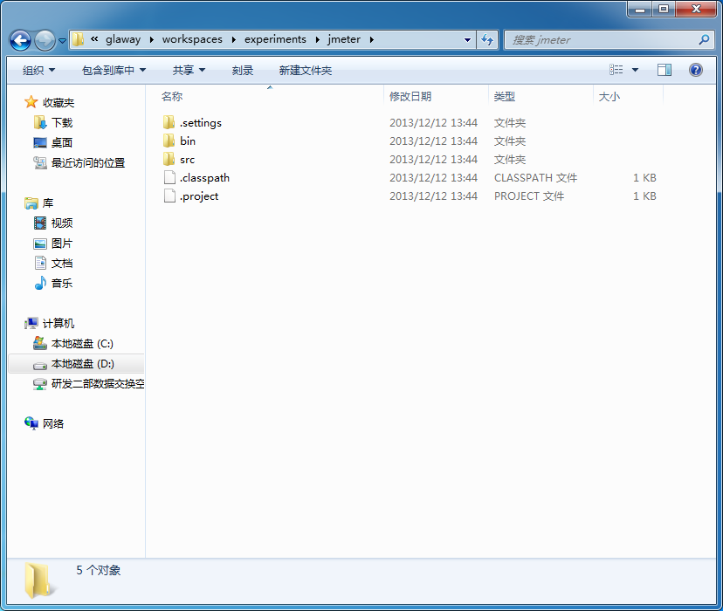
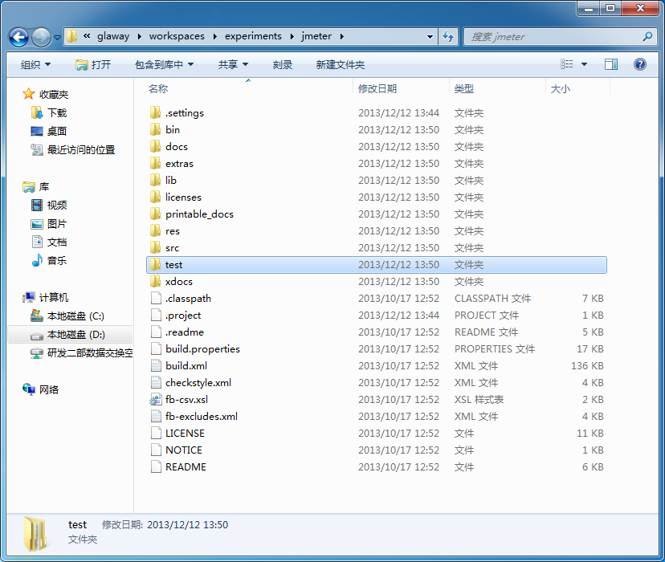
Back to Eclipse, refresh your project, and you will see a red exclamation mark.
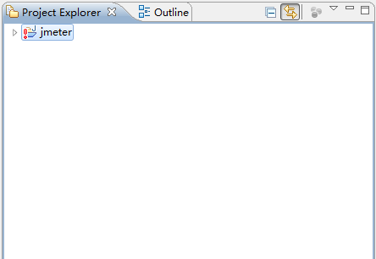

Configure Apache JMeter
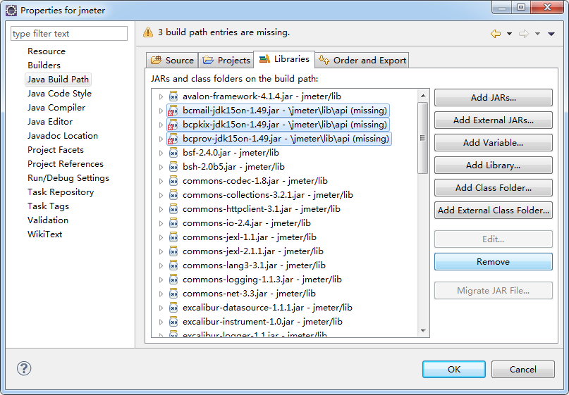
Right click on your eclipse project > Properties > Java Build Path. Switch to Libraries tab, select bcmail-jdk15on-1.49.jar, bcpkix-jdk15on-1.49.jar and bcprov-jdk15on-1.49.jar and click Remove to exclude them from build path.
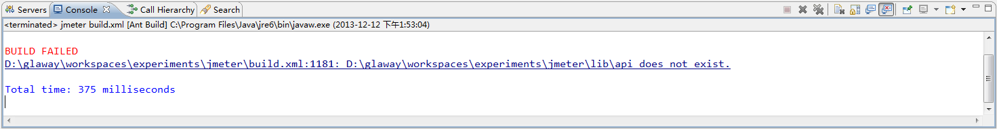
Right click on build.xml within your eclipse project, and click Run As > Ant Build. You will get a BUILD FAILED as above.
To fix this issue, expand lib folder, and create a api folder.
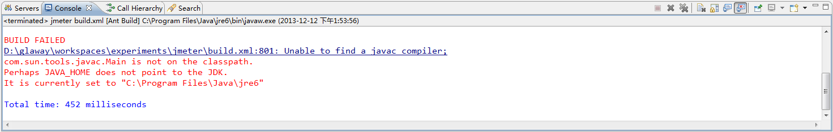
If you get an error message about JAVA_HOME. Click Window > Preferences > Java > Installed JREs. Select jre6 or other corresponding setting and click Edit…
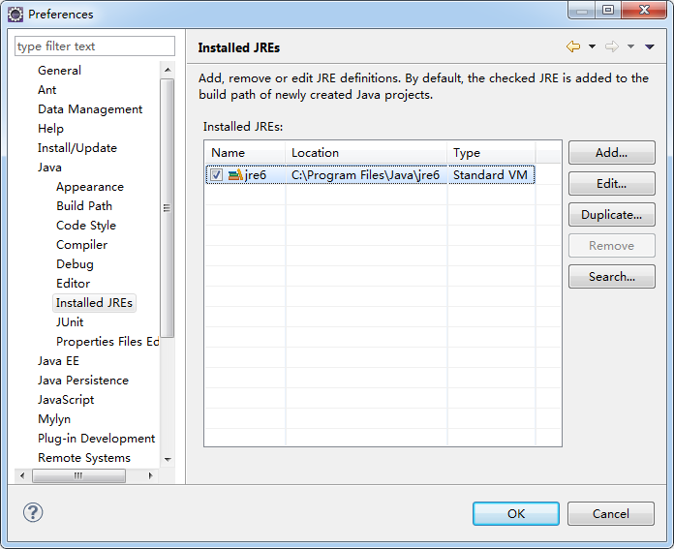
Change JRE home pointing to you JDK installation path, and click Finish.
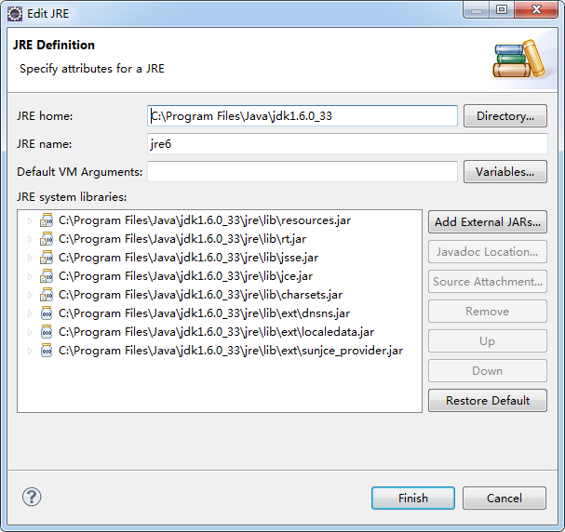
Again, right click build.xml and click Run As > Ant Build. Make sure you get the same BUILD SUCCESSFUL message.
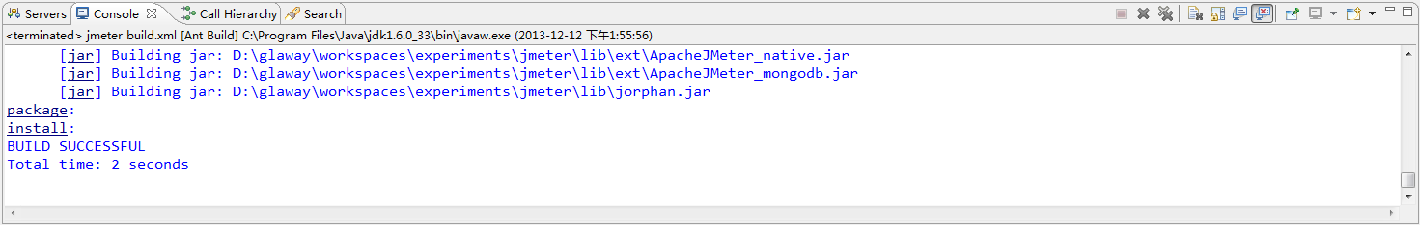
To run JMeter from eclipse, click Run > Run Configurations… Double click Java Application, change Name to jmeter or any meaningful name you like. The project field should be populated automatically.
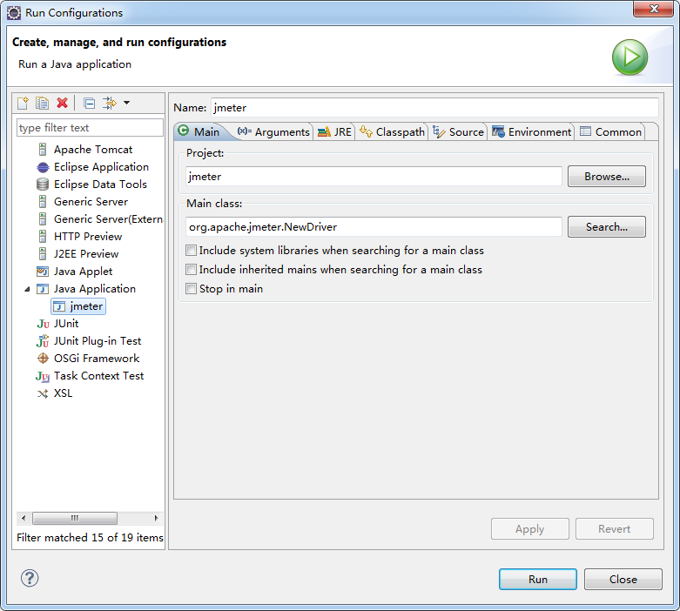
Click Search… and choose org.apache.jmeter.NewDriver as Main class.
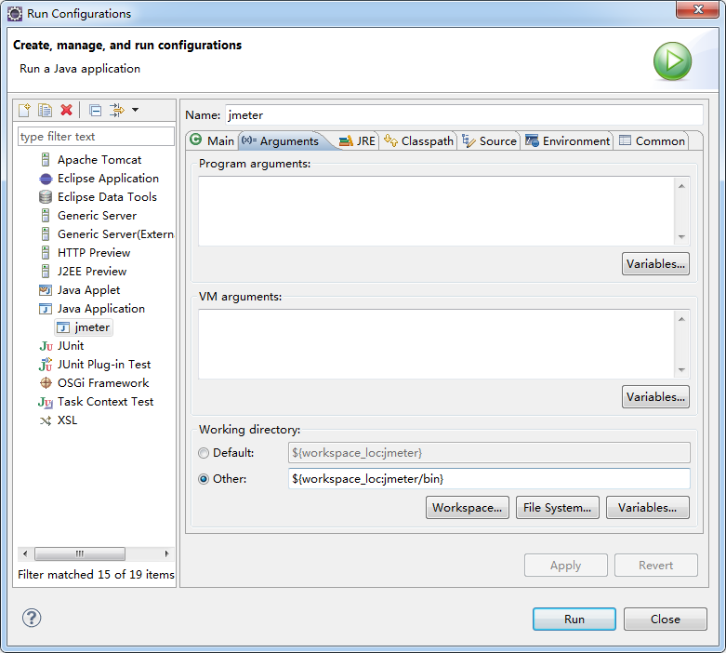
Switch to Arguments tab, and change Working directory from Default to Other.
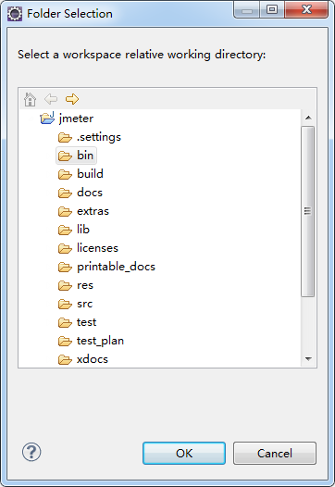
Click Workspace… and specify jmeter/bin as Working directory. Click Apply and click Run.
All thing set, enjoy it!

JUnit with JMeter

Target
This demo will illustrate how to run JUnit test within Apache JMeter from Eclipse.

Configure Runtime Classpath
First, we need to add lrds project into JMeter’s runtime classpath.
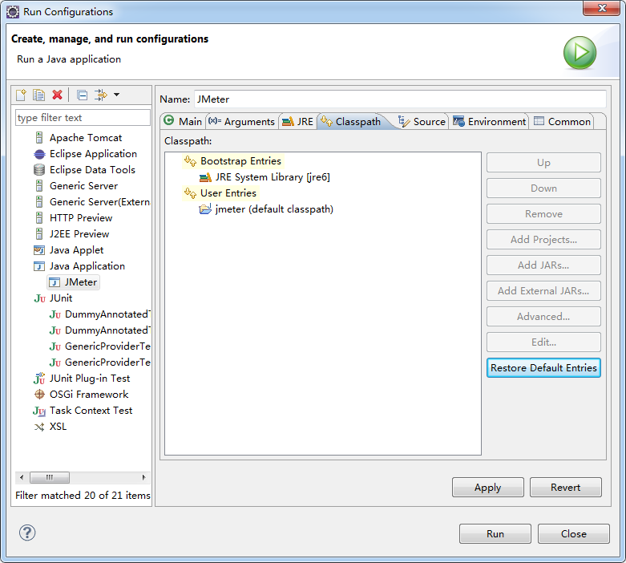
Swith to Classpath tab, and select User Entries. Clcik Add Projects… and choose lrds. Leave other settings as default and click OK.
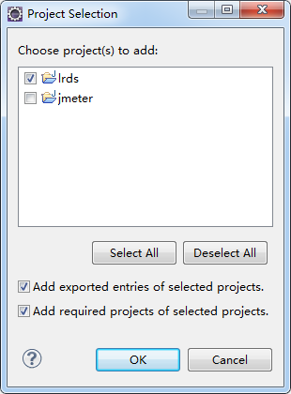
Since lrds depends on Apache Tomcat, we need to add Apache Tomcat as Server Runtime.
To add Apache Tomcat Server Runtime, click Advanced… and choose Add Library, click OK.
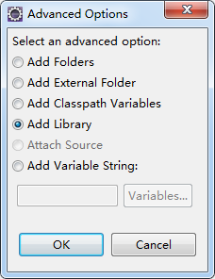
Select Server Runtime and click Next.
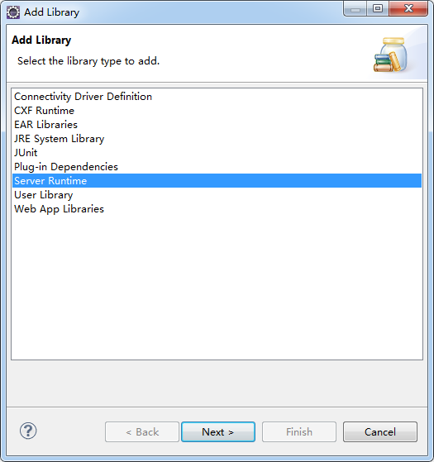
Choose Apache Tomcat v7.0 and click Finish.
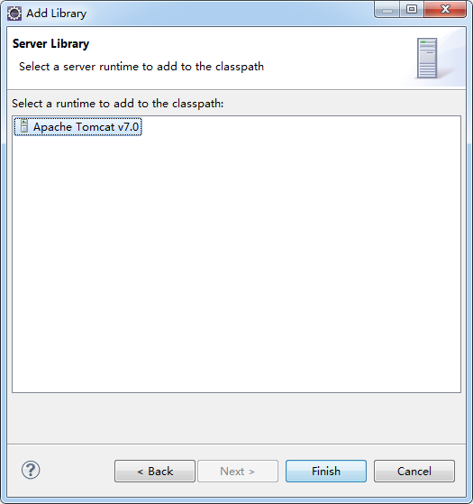
Besides, lrds also needs a lot of 3rd party jar, to add those jar files, click Advanced… and choose Add Library.
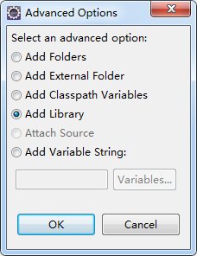
Click OK and choose Web App Libraries, click Next.
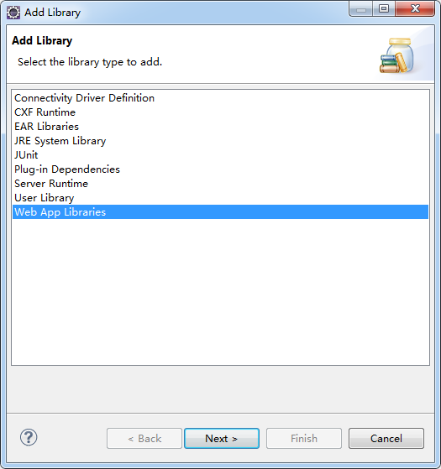
Select lrds from Project and click Finish.
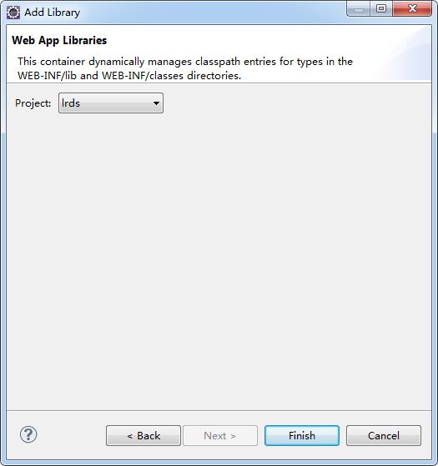
Make sure you have the same setting as below screenshot.
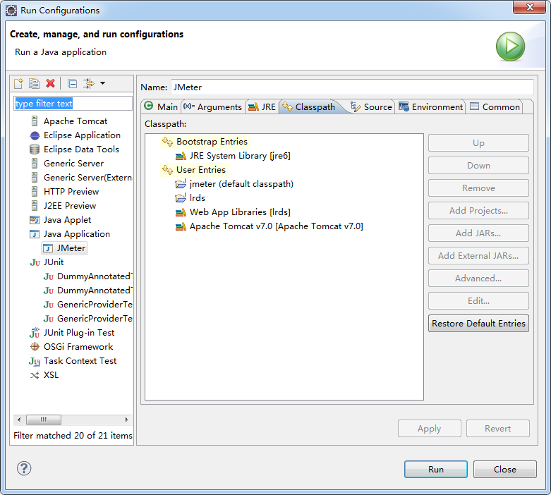
Click Apply and click Run.

Prepare JUnit
Junit is already prepared for you, it is distributed with this doc. Feel free to modify it.
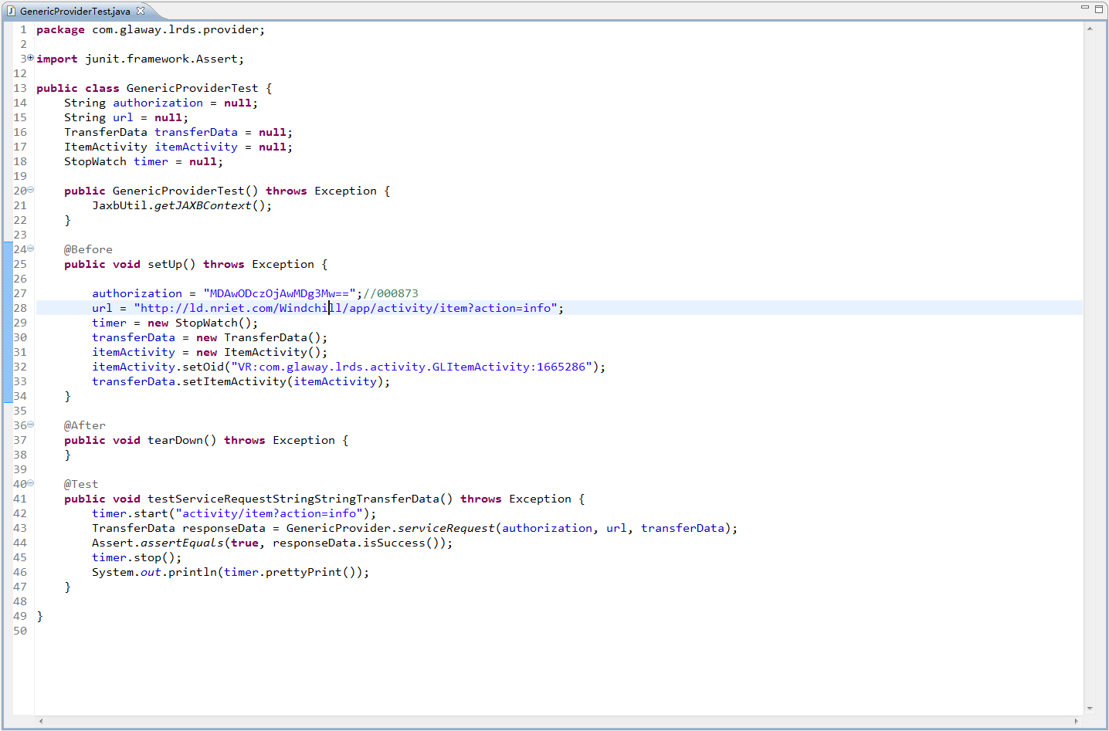

Run JUnit with JMeter
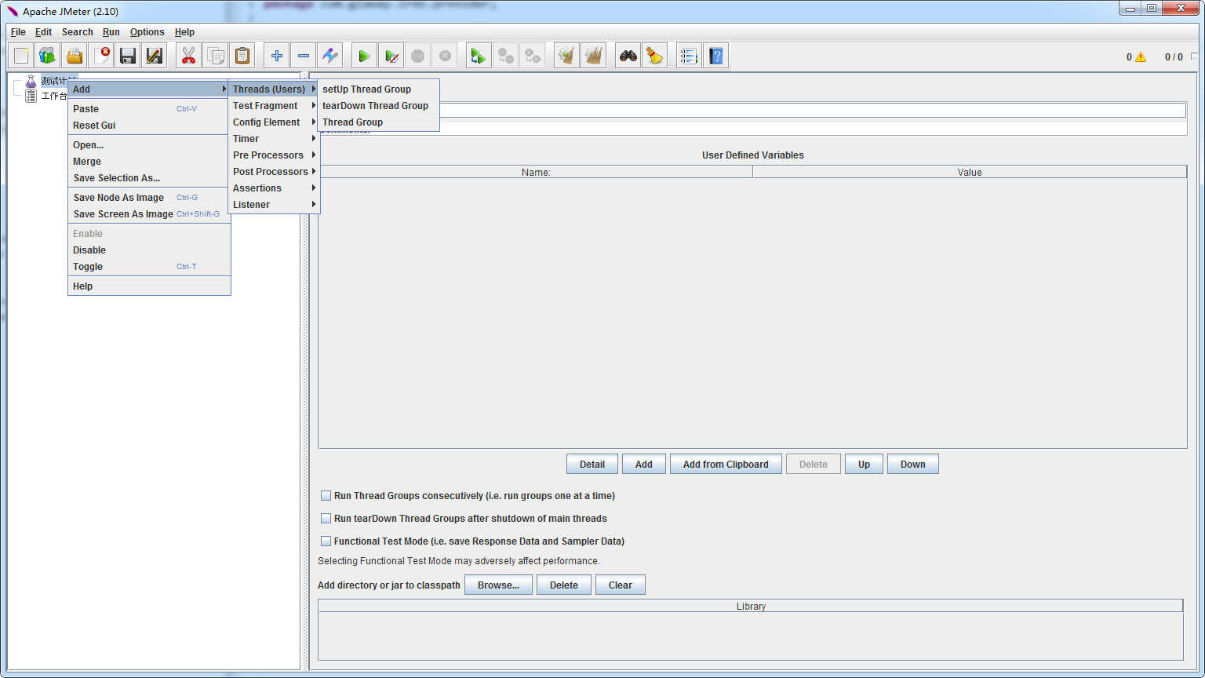
Right click on Test Plan > Add > Threads (Users) > Thread Group.
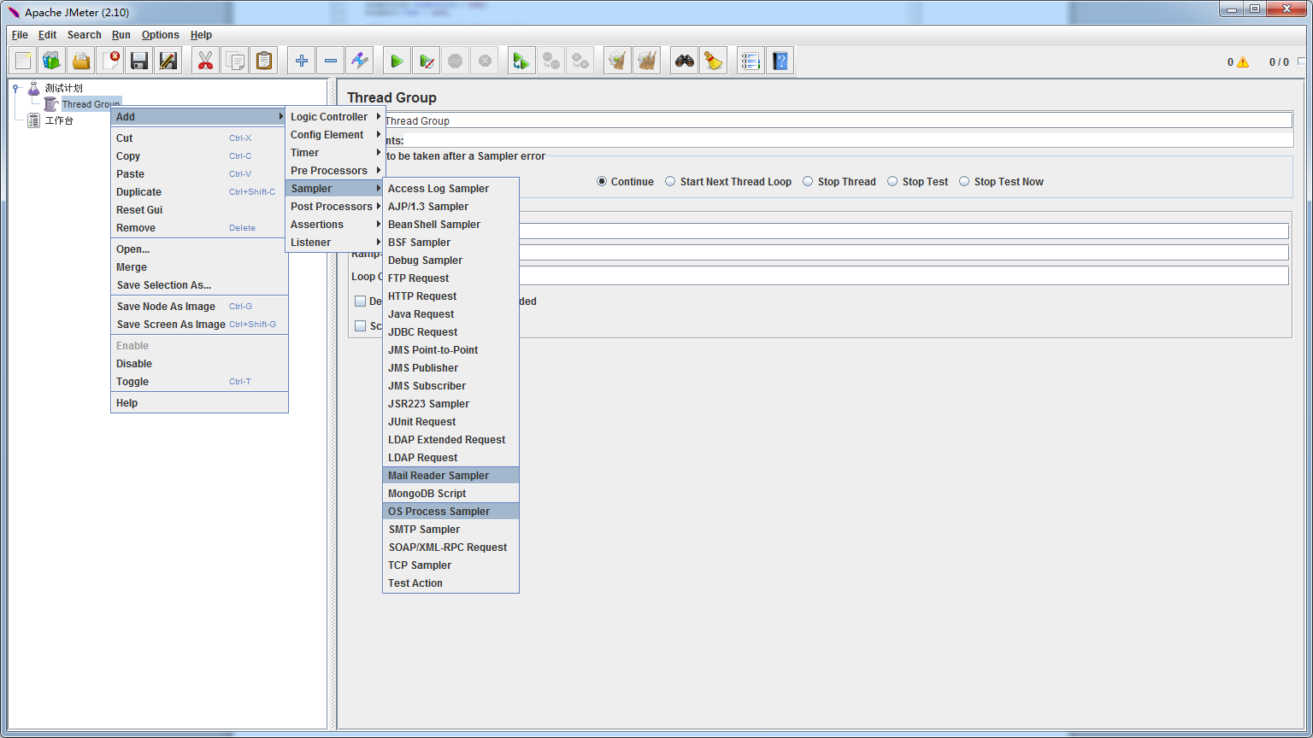
Right click on Thread Group > Add > Sampler > JUnit Request.
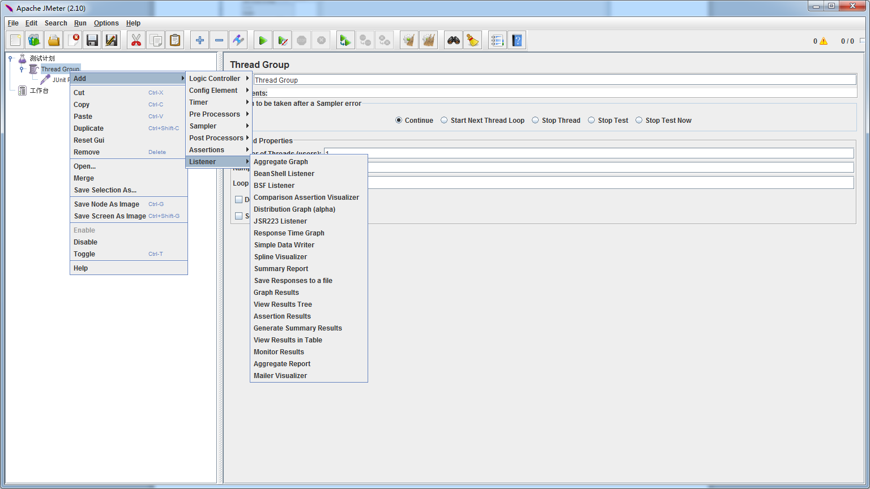
You can also add Graph Results in Thread Group, this will generate a straightforward fancy result chart. To add Graph Result, right click on Thread Group > Add > Listener > Graph Results.
Back to JUnit Request, if you did not do any configuration, our test class will NOT appear in Classname.
Open bin/jmeter.properties from eclipse or any text editor you like, find user.classpath (it is commented out of the box), remove hash marks or manually add user.classpath=../../lrds/WebContent/WEB-INF/classes
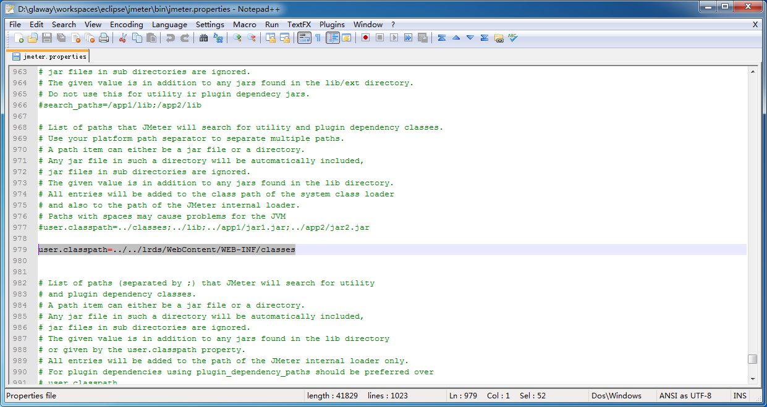
Note: if you are using relative path, make sure you give the right number ../
Back to JMeter and check Search for JUnit 4 annotations (instead of JUnit3) and our JUnit test should appear in Classname.
Click Thread Group, set Number of Threads (users), Ramp-Up Period (in seconds) and Loop Count.
Click the  button to save your test plan.
Click the  button to run JUnit test with JMeter.

