Ant

CAI
Document Maintained
The latest version of this document will be found in the <\\dell\Document Archive>. All other softcopy or hardcopy versions are invalid and are not to be used. It is the responsibility of the document owner to update this document.
Revision History
Date of this revision: <Date> | Date of next revision: <Date>

Revision Number | Revision Date | Summary of Changes | Author | Reviewed by
1 | 2011-10-25 | New | CAI
Acronyms & Definitions
Acronym | Definition

TABLE OF CONTENTS
1 Assumption 1
1.1 OS 1
1.2 Ant Version 1
1.3 CollabNet Subversion Client Version 1
1.4 SVNANT Version 1
2 Get Started 2
2.1 Get Ant from Dell Data Server 2
2.2 Configure Ant 2
2.3 Test Ant 4
3 Checkout from SVN server with Ant script 6
3.1 Install CollabNet Subversion Client 6
3.2 Install SVNANT 6
3.3 Test Ant script 7

Assumption

OS

This document is based on Microsoft Windows 7 Home Basic.

Ant Version

This document use Apache Ant 1.8.2.

CollabNet Subversion Client Version

This document use CollabNet Subversion Client 1.7.1.

SVNANT Version

This document use SVNANT 1.3.1.

Get Started

Get Ant from Dell Data Server

You can download Apache Ant 1.8.2 from \\dell\shared\software\ANT\apache-ant-1.8.2-bin.zip.

Unzip this zip file; you will get a folder named apache-ant-1.8.2-bin. The structure will be ..\apache-ant-1.8.2-bin\apache-ant-1.8.2\

Copy apache-ant-1.8.2 to C:\Program Files\, and rename it as ant.

Configure Ant

Right click on My Computer, click Advance System Setting.
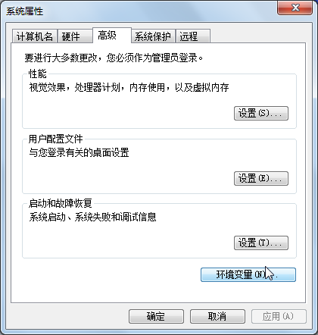

Click Environment Variables
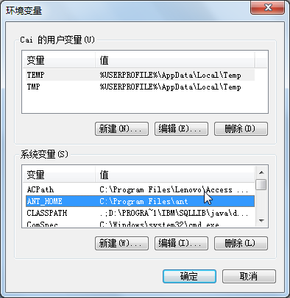

Click New under System Variables, and add a variable like below. And click OK.
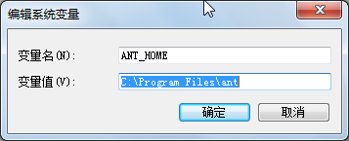

Find Path, check it and click Edit.
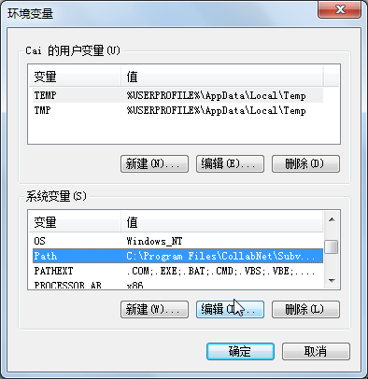

At the end of Path string, add a string like below. And click OK. Notice the semicolon.
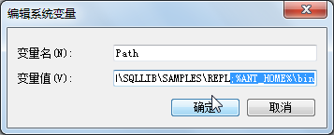

Test Ant

Get xml file from http://dell/svn/twdoc/Document Archive/TW_ANT/build_installation_test.xml.

Copy it to C:\ and rename it to build.xml.

Open command line, and change path to C:\.

Type ant, if you see the same screen shot like below. This means your Ant configuration is right.
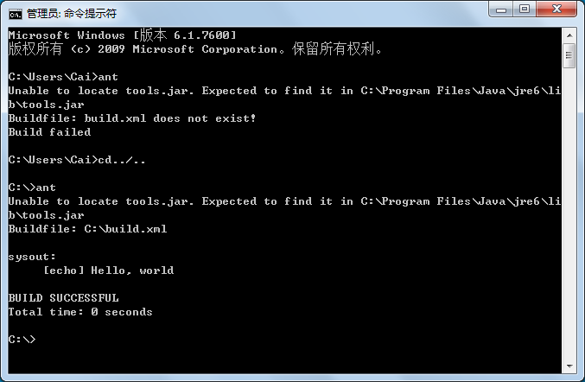

Checkout from SVN server with Ant script

Install CollabNet Subversion Client

You can download CollabNet Subversion Client from \\dell\shared\software\SVN\CollabNetSubversion-client-1.7.1-1-Win32.exe

Right click on it and run as administrator.

After installation completed, open command line and type svn --version. If you can see the same screen shot like below, this means your CollabNet Subversion Client installation is right.
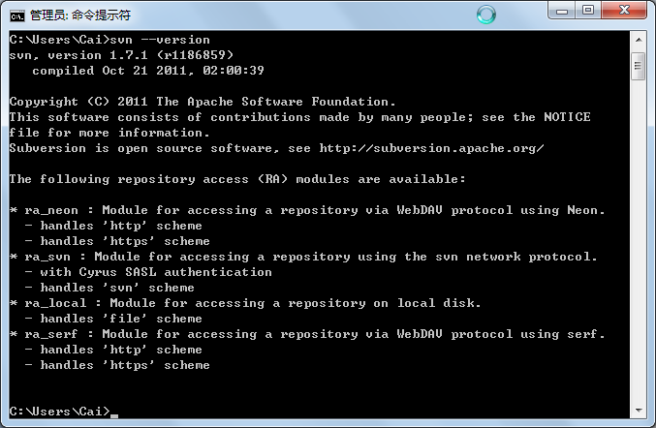

Install SVNANT

This plugin is used for Ant to corporate with SVN server. It’s different from Ant.

You can download SVNANT from \\dell\shared\software\ANT\svnant-1.3.1.zip.

Copy it to local path, and unzip this zip file. You will get a folder named svnant-1.3.1, expand this folder and find lib folder, copy svnant.jar, svnClientAdapter.jar, svnjavahl.jar, and svnkit.jar. Paste them to the lib folder under your Ant installation path.

Test Ant script

You can get the build template from http://dell/svn/twdoc/Document Archive/TW_ANT/build_svn_template.xml

Copy it to local path, in this document; we copy it to local path C:\.

Edit the place holders in this template file; populate these values with your own value.

Change template xml name to build.xml.

Open command line, change path to your build.xml location. In our case, we change path to local C:\.

Type ant to see if it works.

Command Line

Trigger specific target

Use ant <targe_name>

For example, ant svncheckout will checkout from svn

Generate Ant script with RSA

Right click on your project

Export, choose Ant Buildfiles
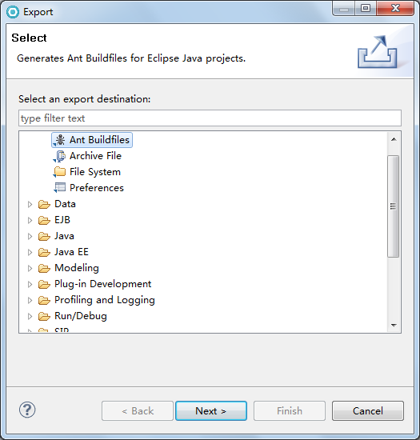

Choose a project, click Finish.

