# Pre-install Activity

## Download software packages needed

(May need the license or Passport Advantage access)

Primary software packages used for MDM installation:

List of software packages for MDM installation:

The list of all software packages:

/opt/ibm/Software/MDMSoftware

-bash-3.00$ pwd

/opt/ibm/Software/MDMSoftware

-bash-3.00$ cd ..

-bash-3.00$ ls -rlt

total 8

drwxr-xr-x 2 mdmadmin mdmadmin 512 Nov 5 10:48 WAS61

drwxr-xr-x 2 mdmadmin mdmadmin 512 Nov 5 10:49 WAS61Updater

drwxr-xr-x 2 mdmadmin mdmadmin 512 Nov 5 10:50 WAS61FP61011

drwxr-xr-x 2 mdmadmin mdmadmin 512 Nov 5 10:50 MDMSoftware

-bash-3.00$ ls WAS61

C88SRML.tar

-bash-3.00$ ls WAS61Updater

download.updii.61019.solaris.sparc.zip

-bash-3.00$ ls WAS61FP61011

6.1.0-WS-WAS-SolarisSparc-FP0000011.pak

-bash-3.00$ ls MDMSoftware

C1E48ML.tar.gz

## Setup X-Server on Workstation

Xterm or an X-Server is needed to launch MDM InstallShield from your telnet session. Exceed or Cygwin or Reflection can be used.

Export display to workstation or setup your putty tunnel session with X-term support.

>export DISPLAY=<workstation_hostname_or_ip>:0.0

## Set environment variables in .profile

* Set up the profile variables before executing MDM Installer. For example:

The original .profile for mdmadmin user:

-bash-3.00$ ls -la

total 14

drwxr-xr-x 3 mdmadmin mdmadmin 512 Nov 3 16:10 .

drwxr-xr-x 5 root root 512 Oct 6 11:43 ..

-rw------- 1 mdmadmin mdmadmin 1864 Oct 29 11:05 .bash_history

-rwxr-xr-x 1 mdmadmin mdmadmin 608 Oct 28 11:25 .profile

-rw------- 1 mdmadmin mdmadmin 50 Nov 3 16:10 .sh_history

drwxr-xr-x 2 mdmadmin mdmadmin 512 Oct 21 15:23 SQL

-bash-3.00$ cat .profile

PATH=/usr/bin:/usr/local/bin:/etc:/usr/ccs/bin:/usr/openwin/bin:/usr/local/sbin:/usr/sbin:/usr/ucb

LD_LIBRARY_PATH=/lib:/usr/lib:/usr/local/lib:/usr/dt/lib:/usr/openwin/lib

MANPATH=/usr/man:/usr/local/man:/usr/openwin/man:/opt/VRTS/man

export PATH LD_LIBRARY_PATH MANPATH

ORACLE_BASE=/u01/app/oracle; export ORACLE_BASE

ORACLE_HOME=${ORACLE_BASE}/product/10.2.0; export ORACLE_HOME

PATH=${ORACLE_HOME}/bin:${PATH}; export PATH

LD_LIBRARY_PATH=${ORACLE_HOME}/lib:$LD_LIBRARY_PATH; export LD_LIBRARY_PATH

# set ulimit open files

ulimit -n 8192

-bash-3.00$

To add into mdmadmin .profile:

# added for MDM installation

export BROWSER=/usr/sfw/bin/mozilla

export WAS_HOME=/opt/ibm/WebSphere/AppServer

export JAVA_HOME=/opt/ibm/WebSphere/AppServer/java

export ANT_HOME=/opt/ibm/WebSphere/AppServer/deploytool/itp/plugins/org.apache.ant_1.6.5

export ORACLE_JDBC_DRIVER_PATH=/u01/app/oracle/product/10.2.0

export PATH=$WAS_HOME/bin:$JAVA_HOME/bin:/opt/mqm/bin:$PATH

## Installer ID information

WebSphere Application Server ND Edition may be installed as root,

Before we run the installer, we changed the ownership of all files under $WAS_HOME to the ID: <WASADMIN> user.

<MDMMQ> user was created on application server and MQ server as well. MQUSERS group was created on the MQ server and <MDMMQ> is part of MQUSERS group.

# WebSphere Application Server Installation

To install WAS ND v6.1.0.11, there are three steps: 1) install WAS6.1 2) install WAS 6.1.0.19 Updater Installer 3) install WAS 6.1 Fixpack v6.1.0.11

## WebSphere Application Server ND v6.1 installation

* Install WAS ND 6.1 :

-bash-3.00$ pwd

/opt/ibm/Software/WAS61

-bash-3.00$ tar -xvf C88SRML.tar

-bash-3.00$ cp responsefile.nd.txt responsefile.nd.txt.orig

-bash-3.00$ pwd

/opt/ibm/Software/WAS61/WAS

* Update response file for WAS 6.1 install

-bash-3.00$ diff responsefile.nd.txt.orig responsefile.nd.txt

42c42

< -OPT silentInstallLicenseAcceptance="false"

---

> -OPT silentInstallLicenseAcceptance="true"

67a68

> -OPT allowNonRootSilentInstall="true"

195c196

< #-OPT installLocation="/opt/IBM/WebSphere/AppServer"

---

> -OPT installLocation="/opt/ibm/WebSphere/AppServer"

204c205

< -OPT installLocation="C:\Program Files\IBM\WebSphere\AppServer"

---

> #-OPT installLocation="C:\Program Files\IBM\WebSphere\AppServer"

260c261

< -OPT PROF_enableAdminSecurity="true"

---

> -OPT PROF_enableAdminSecurity="false"

282c283

< -OPT PROF_adminUserName=

---

> #-OPT PROF_adminUserName=

289c290

< -OPT PROF_adminPassword=

---

> #-OPT PROF_adminPassword=

328a330

> -OPT PROF_dmgrProfileName=Dmgr01

342a345

> -OPT PROF_appServerProfileName=AppSrv01

354a358

> -OPT PROF_profilePath=/opt/ibm/WebSphere/AppServer/profiles

378a383

> -OPT PROF_hostName=mtdevuha1-cci-mdm

392a398

> -OPT PROF_nodeName=MDMCellManager01

406a413

> -OPT PROF_appServerNodeName=MDMCellNode01

419a427

> -OPT PROF_cellName=MDMCell01

480a489

> -OPT PROF_defaultPorts="true"

492a502

> -OPT PROF_validatePorts="true"

-bash-3.00$

* To install WAS 6.1 using silent mode:

/opt/ibm/Software/WAS61/WAS

-bash-3.00$ ls

docs readme was.embed.common.pak was.ndonly.common.pak

framework readme.html was.embed.pak was.ndonly.pak

install responsefile.nd.txt was.expressonly.pak was.primary.pak

installRegistryUtils responsefile.nd.txt.orig was.installconfig.pak was.samples.beenthere.pak

lafiles setup.jar was.itlm.base.pak was.samples.common.pak

lib swg_info_common.css was.itlm.express.pak was.samples.pak

pakdef version.txt was.itlm.nd.pak was.server.common.pak

panels was.baseonly.pak was.license.pak was.server.pak

-bash-3.00$ pwd

/opt/ibm/Software/WAS61/WAS

**-bash-3.00$ ./install -options "responsefile.nd.txt" –silent**

* Check WAS6.1 was installed successfully as showed in the log:

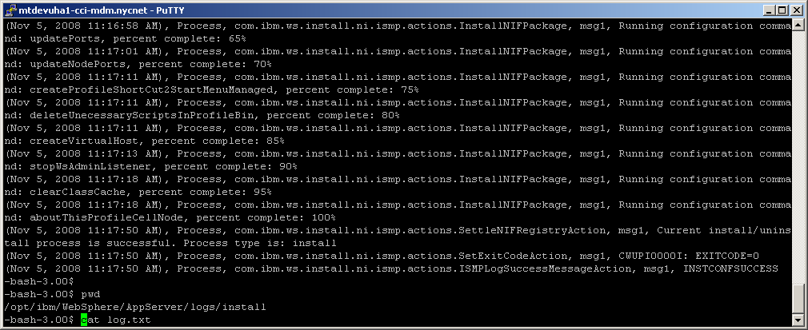

To double check the profiles were created:

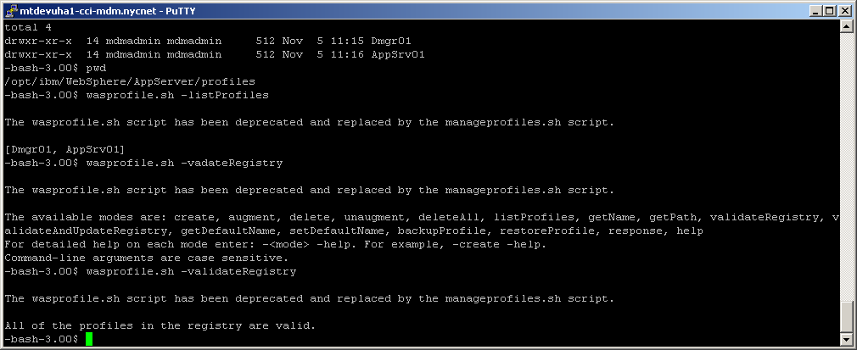

To start the Cell (Dmgr01 profile and AppSrv01 profile):

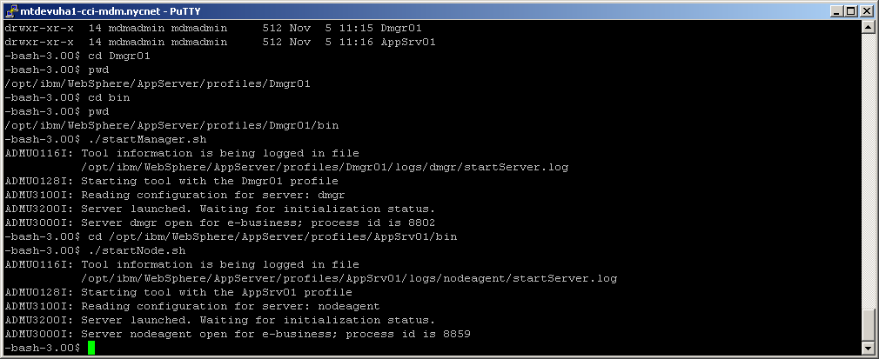

To login WAS admin console:

<http://mtdevuha1-cci-mdm:9060/ibm/console>

Go to System Administration -> Cell -> Local Topology. Expand the cell and make sure they are federated cell:

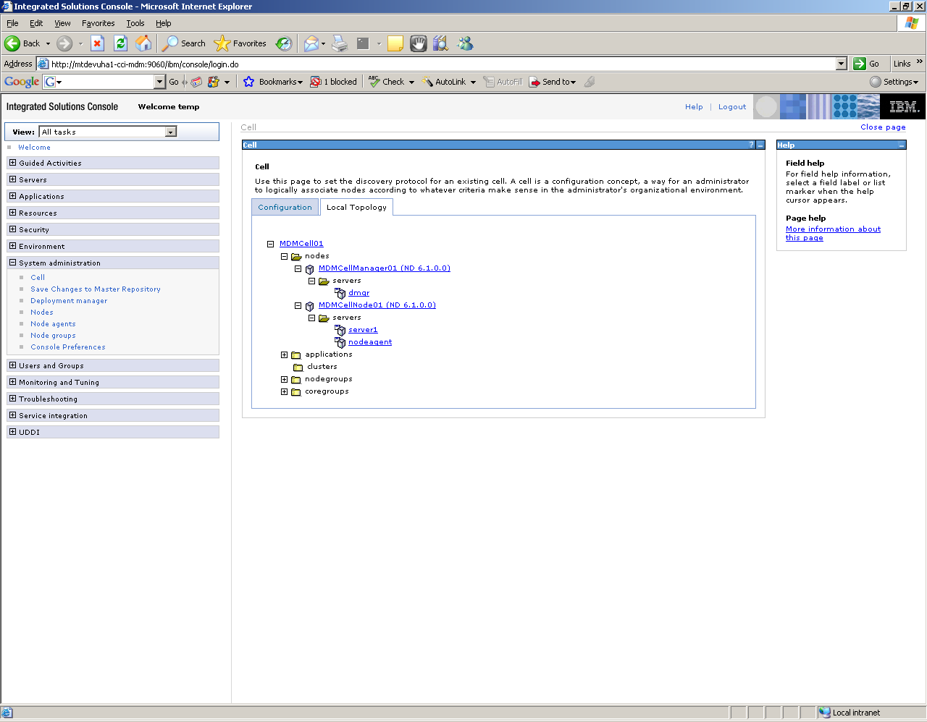

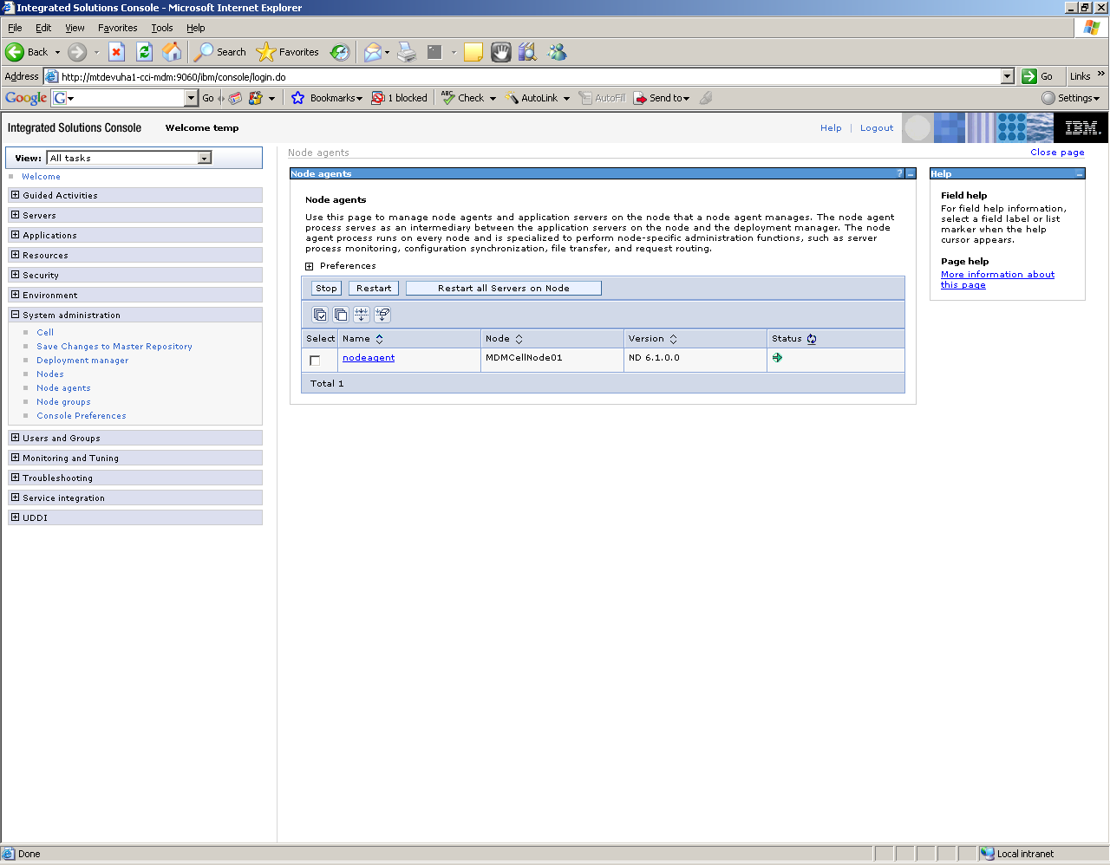

Now you need to shutdown the cell (stop dmgr and stop node agent)

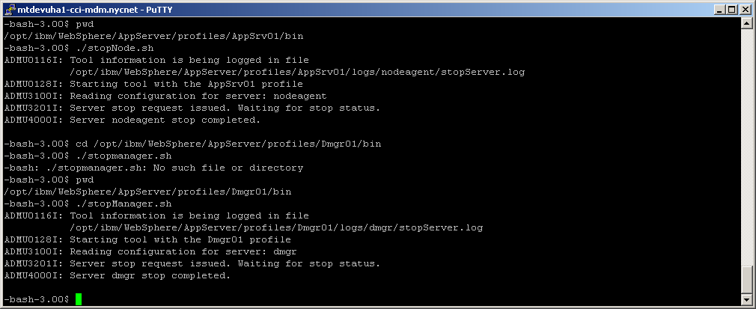

## WAS ND v6.1.0.19 Updater installation

* To install WAS v6.1.0.19 Update Installer:

-bash-3.00$ pwd

/opt/ibm/Software/WAS61Updater

-bash-3.00$ ls -rlt

total 156192

-rw-r--r-- 1 mdmadmin mdmadmin 79920716 Nov 4 13:27 download.updii.61019.solaris.sparc.zip

-bash-3.00$ pwd

/opt/ibm/Software/WAS61Updater

-bash-3.00$ jar xvf download.updii.61019.solaris.sparc.zip

Make a backup of response file for Updater:

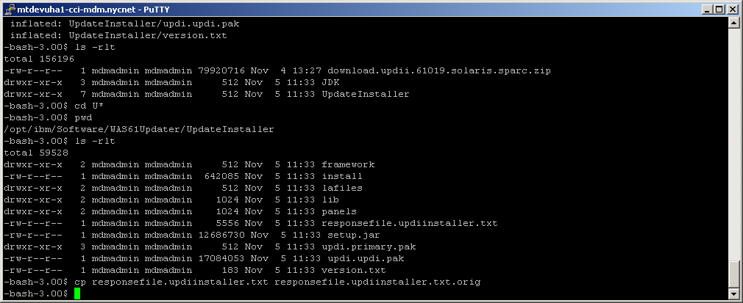

Modify as showed bellow:

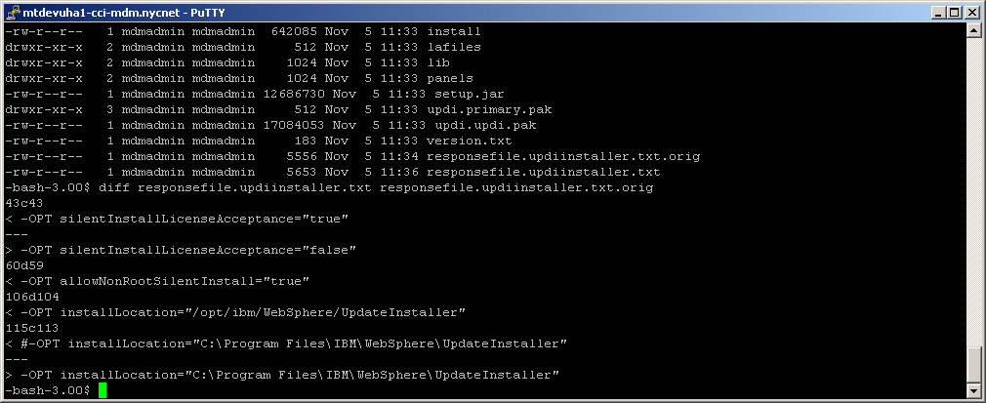

To install Updater:

-bash-3.00$ pwd

/opt/ibm/Software/WAS61Updater/UpdateInstaller

-bash-3.00$ ls

framework panels updi.primary.pak

install responsefile.updiinstaller.txt updi.updi.pak

lafiles responsefile.updiinstaller.txt.orig version.txt

lib setup.jar

**-bash-3.00$ chmod +x install**

**-bash-3.00$ ./install -options "responsefile.updiinstaller.txt" –silent**

To check the Updater was installed successfully:

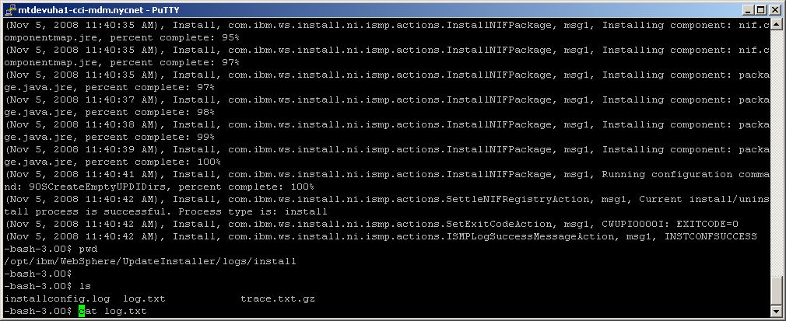

## WAS ND Fixpack v6.1.0.11 installation

* To install WAS 6.1.0.11 Fixpack using Updater:

Copy the fixpack to maintenance folder:

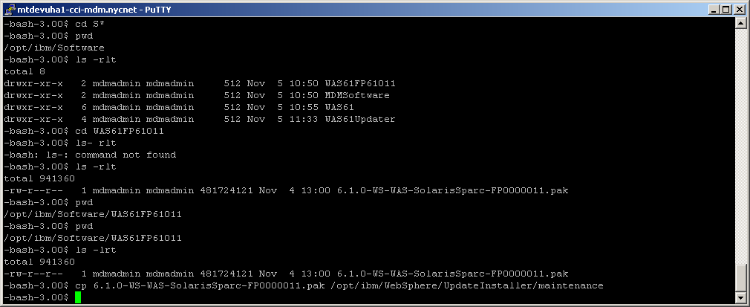

To backup response file for Fixpack:

-bash-3.00$ pwd

/opt/ibm/WebSphere/UpdateInstaller/responsefiles

-bash-3.00$ ls -rlt

total 14

-rwxr-xr-x 1 mdmadmin mdmadmin 3679 Nov 5 11:40 install.txt

-rwxr-xr-x 1 mdmadmin mdmadmin 2516 Nov 5 11:40 uninstall.txt

-bash-3.00$ cp install.txt install.txt.orig

Modify the response file for Fixpack:

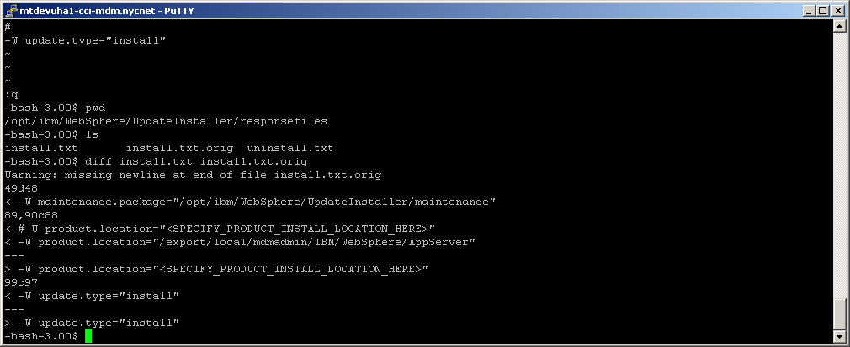

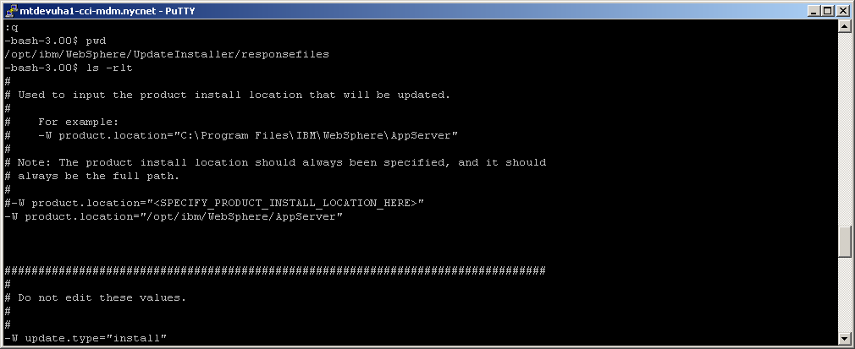

To install fixpack:

-bash-3.00$ pwd

/opt/ibm/WebSphere/UpdateInstaller

-bash-3.00$ ls

bin framework lafiles logs properties uninstall update.sh

docs java lib maintenance responsefiles update.jar version.txt

**-bash-3.00$ ./update.sh -options responsefiles/install.txt –silent**

Double check the WAS version and profiles after applied the fixpack:

-bash-3.00$ wasprofile.sh -listProfiles

The wasprofile.sh script has been deprecated and replaced by the manageprofiles.sh script.

[Dmgr01, AppSrv01]

-bash-3.00$ wasprofile.sh -validateRegistry

The wasprofile.sh script has been deprecated and replaced by the manageprofiles.sh script.

All of the profiles in the registry are valid.

-bash-3.00$ versionInfo.sh

WVER0010I: Copyright (c) IBM Corporation 2002, 2005; All rights reserved.

WVER0012I: VersionInfo reporter version 1.15.1.14, dated 11/17/06

--------------------------------------------------------------------------------

IBM WebSphere Application Server Product Installation Status Report

--------------------------------------------------------------------------------

Report at date and time November 5, 2008 1:02:23 PM EST

Installation

--------------------------------------------------------------------------------

Product Directory /opt/ibm/WebSphere/AppServer

Version Directory /opt/ibm/WebSphere/AppServer/properties/version

DTD Directory /opt/ibm/WebSphere/AppServer/properties/version/dtd

Log Directory /opt/ibm/WebSphere/AppServer/logs

Backup Directory /opt/ibm/WebSphere/AppServer/properties/version/nif/backup

TMP Directory /var/tmp

Product List

--------------------------------------------------------------------------------

ND installed

Installed Product

--------------------------------------------------------------------------------

Name IBM WebSphere Application Server - ND

Version 6.1.0.11

ID ND

Build Level cf110734.37

Build Date 8/31/07

--------------------------------------------------------------------------------

End Installation Status Report

--------------------------------------------------------------------------------

-bash-3.00$

Start the dmgr and node agent again:

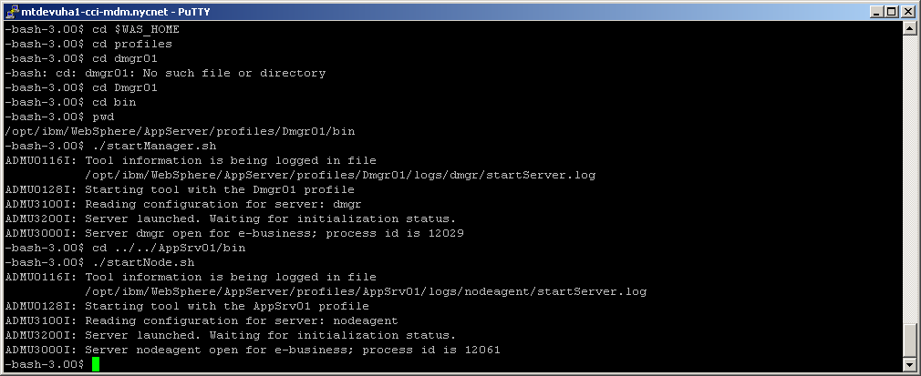

* (Optional ) server1 was created by installer. We can remove it.