  The main aim of this project is to create an application that is helpful while selling cars.

In the existing System it is difficult to maintain the car information individually and to supply for the customers who are eager to buy them. Customer has to face difficulty in order to know the information of car like manufacturing year, car model and other valuable information in a single domain. Our main idea is to develop a system where we can have all the required information for the user in order to effectively interest him in the process of buying a car.

                In the Proposed System, application can maintain car details like manufacturer, year of manufacturing, price and model etc. We can also view all the car details which are kept for sale effectively and we can search for our desired car. With this Customer can get the information quickly like car details which have been entered clearly.

This application mainly consists of 5 modules: user module, admin module, dealer module, viewing all cars module, adding cars module.

1. INTRODUCTION

1.1 OVERVIEW OF THE PROJECT

The proposed project is developed to manage the automobile in the automobile dealer company. The main module in this project is login, automobile management, customer management, sales, complaints and reports. The first module is the login. The automobileshowroom owner should login to the project for usage. The username and password areverified and if it is correct, next form opens. If the username and password are not correct, itshows the error message.When a customer search for a automobile, if the automobile is available, they will betaken to a page that shows the details of the automobile including automobile name,automobile ID, uantity, price etc. !"utomobile #anagement $ystem% is useful for maintaining automobiles, customers effectively and hence helps for establishing good relation between customer and automobile organi&ation. It contains various customi&ed modules for effectively maintaining automobiles and stock information accurately and safely. When the automobile is sold to the customer, stock will be reduced automatically.When a new purchase is made, stock will be increased automatically. While selectingautomobiles for sale, the proposed software will automatically check for total number of available stock of that particular item, if the total stock of that particular item is less than ',software will notify the user to purchase the particular item. "lso when the user tries to sale items which are not in stock, the system will promptthe user that the stock is not enough. (ustomers of this system can search for a automobile)can purchase a automobile easily by selecting fast. *n the other hand the stock of automobiles can be maintained perfectly by the automobile shop manager overcoming thedrawbacks of existing system.

1

https://html2-f.scribdassets.com/2cmj3rbt6o57w5gd/images/1-0ee7755276.jpg

1. **Narrow margins**. Most new car dealers earn a 1-4% margin, depending upon the brand(s) they carry and the marketplace. This narrow margin means that there's very little room for error. If your inventory doesn't turn fast enough, if you're employee compensation is out of line with your revenue, if you're not hitting your sales volume, things can go bad very quickly.
2. **Bad management**. A shockingly high percentage of dealers have poor managers in key positions. Often times, dealership general managers have no formal business background and only a very basic understanding of dealership operations. These people are then asked to oversee entire departments, make key budgeting decisions that can have long-term impacts, etc. It is truly baffling to me that so many dealers have such poor managers in place.
3. **Difficulty meeting manufacturer expectations**. Auto manufacturers have a love-hate relationship with dealers. On one hand, the manufacturers value their dealers for selling all the cars they make, even when the cars aren't very good. On the other, manufacturers get annoyed at dealers who can't deliver good customer service, can't (or won't) invest in their facilities, etc. As a result, there's a near constant battle between the dealers and the manufacturer, with manufacturers telling dealers what they should be doing and dealers demanding support from manufacturers.
4. **A constantly shifting marketplace**. It's amazing just how fast any given model can go from "hot" to sitting unsold on dealer lots. A new sports car might only be hot for a few months before it's supplanted by another competing car. A larger than expected seasonal increase in gas prices can kill the market for large SUVs, while a couple of severe winter storms can be a boom for large SUV sales. New car demand can dry up after a manufacturer changes incentive programs, or it can take off. Dealers have to know what their products are doing, what they're competitors are up to, AND keep an eye on the used car market too. There's a lot to pay attention to...if you screw up and miss a shift, you can lose a lot of money fast.

* To bring the best quality of automobiles from worldwide for Myanmar market.
* To work easily and reduce mistakes.
* To get the higher achievement.
* To meet the customer’s need to care and cost-effectiveness.

At the point of a sale, your business receives cash or allows payment on account in exchange for goods. This creates in inflow of cash or revenue and a corresponding outflow of product inventory. The primary objective of an extensive sales and inventory software solution is to optimize efficiency in recording each factor in the exchange. Historically, companies would have to complete separate record-keeping processes for the income and the inventory change. With this solution, each factor is coordinated with a single entry in the software

* Ethical approach towards customers and foster the need of the customers.
* An aggressive customer satisfaction programmed from showroom to parts and to workshop to foster customer relationship.
* To enhance customer satisfaction by providing high quality service and value for money.
* Selling brand new cars at reasonable and affordable prices
* Selling various brands of imported automobiles with intention for our customer to be able to make choice directly and easily for the brand, quality and price as their wish and affordability.
* Providing auction services to make choices and purchases directly from auto sale center in Japan by smooth and reliable service arranged by our company.

Agile

The client is preferably available through the PJ CUS AVAILABLE

It requires the involvement of the xustomer only

In milestones

Working very well with time and materials or other non-fixed f FUNDING

Funding can increase stress in fixed price scenarios.

Reduces the risk of fixed price agreemenets with the earlier

Agreements.

It prefers smaller,dedicated teams with a high degree of TEAM

Coordination and synchronization.

Coordination/group synch is limited to reference points

|  |  |
| --- | --- |
| **Advantages**  The project can be planned using the stages as indicators of progress.  It helps in producing a project plan.  Aids project management.  Waterfall  **Drawbacks**  Stages are not always clearly defined-there is often overlap between them.  Does not allow for repetition of stages-often the need to re-visit past stages. | **Advantages**  A well proven methodology.  Freely available.  Ease of testing.  Member of team work in same way.  New member of team likely to understand methodology.  **Drawbacks**  .There is lack of emphasis on necessary designing and documentation.  Can be very demanding on the user time.  Potential for scope creep.  Costs can increase as testers required all the time instead of at the end. |

Lower cost

Encourages open communication among team members, and clients.

Speeds up time spent on evaluation is only on a small part of the whole project.

HP runs on the server, and PHP reads the HTML functionally from the browser.  
PHP code that can only be used after the server interprets it.  
PHP is integrated with HTML so PHP can not be combined with XML.  
PHP is used to create moving web pages, read and distribute databases, import available files from the server, and retrieve data files from multiple domains.  
PHP does not work in the browser window.  
PHP generally uses MYSQL as the database.

Java can only process certain local tasks.

In Java you can view the code directly after output parsing.Java can be combined with HTML,XML, and AJAX.

Java can retrieve an information file by pointing to the URL of the browser.

Java is executed in a browser window.

MySQL is not widely used in Java.

|  |  |
| --- | --- |
| **PHP** | **Java** |
| **Advantages**  Open source  Easy to use  Can be run on many platforms  Stable  **Drawbacks**  Not suitable for large applications  Weak type  Security | **Advantages**  Ease to learn  Object-oriented  Distributed  Platform-independent  **Drawbacks**  Security issues  JavaScript rendering varies |

PHP runs on various platforms

PHP is compatible with almost all servers used today

PHP supports a wide range of databases

Why

PHP is easy to learn and runs efficiently on the server side.

|  |  |
| --- | --- |
| **SQL** | **Access** |
| **Advantages**  High Speed  No Coding required  Well Defined Standards Exist  **Drawbacks**  Difficulty in interfacing  More features implemented in proprietary way | **Advantages**  Easy to install use  Ease to integrate  Widely popular  Save your money  **Drawbacks**  Finite  Multiple user limited  Static Friendly |

**Why Use**

SQL a highly desirable skill

Client/Server language

Easy to learn and understand

Complete language for a database

* MS Access works only on Windows whereas MySQL works on almost all platforms.
* MS Access does not support Partitioning feature whereas MySQL has composite, Range partitioning support.
* MySQL is opensource so no cost involved.
* Performance in MySQL is way better than MS Access
* MS Access database is more suitable for desktop use with a small number of users accessing it simultaneously. One reason you might choose to use Microsoft Access over SQL Server is for compatibility/sharing. You might need to email someone a copy of your database. People are more likely to have Access on their desktop computer than SQL Server.
* Security - MS Access is limited to security in terms of user-name/password on the database. Where as MySQL is much more secured and you can configured it with SSL support.
* MySQL is the most famous or rather more loved amongst the professional folks because of it's multiple choice in custom storage engines. You can have custom storage engines developed in MySQL based on your requirements or choose amongst the inbuilt ones
* Actually there is no comparison between MySQL as a real commercial heavy duty database, and MS Access which is typically a local use, giveaway in Microsoft Office. It is no good for remote access, its' connection system is not solid. It is generally useless for multiple user purposes.And you are far better using a web based interface for mysql, VB is also limited in functions and power. Consider using one of the free distributions of the Apache Web server which carries php as the scripting language, and the mysql database pre-configured.

Purchase

Our website must have this system because sale manager order from supplier.

**Inadequate Controls on External Providers** – Any external provider depended upon for success of the project must be monitored. Never assume a supplier will deliver simply because they always have or because there is a forfeiture clause in their contract. They don’t have skin in the game. You do.

**frequent extreme weather -** you may have increased insurance costs, more damage to property and resources, and disruption of power and water. Customers may be unable to visit or contact your business, or suppliers may be unable to deliver goods or services.

Failure

Furthermore, this type of risk will cause the software house to lose its customers. Furthermore, the image of the house can be destroyed. And then the software house could also be used as a client. This type of error should never be committed by a software company if they do not want to lose their reputation. To minimize this risk, the development team must allow the user to participate in the development of the system in the context of specific requests.

Inadequate

Not enough time to test the program can generate a program with lots of errors. It is a different way of being irresponsible. If the program gets worse, the risk is greater. This type of risk should be avoided by testing at the end of each module. Therefore the whole system needs to be tested with different test tactics. Shold test time is also planned by the project manager to overcome this risk.

Budget

This often the most important factor for many projects. In the end, did you stick to the budget? Did you come in way under budget? Your team should always know where they stand in terms of money spent. We regularly give clients a quote before they start and once we do so, we need to stick to it, or come in under. Otherwise we’re not a profitable business.

Quality of Work

The quality of one project often affects another, so it’s important to always track quality and make adjustments to future projects accordingly. Remember, recommendations are like free advertising. If you deliver a strong product, your client will tell people about it, and that’s where your next project should come from.

Experienced Skillful

Involving experienced experts in development team is critically one of the most important factors. Because they are sophisticated at guessing the needs of client and of system. And because of them , correspondent risks can be estimated and project duration is reduced and the project can be done successfully .Stakeholder should be experienced skill in a development team.

Process/Management

Wrong process or internal managing is most common to e-commerce and it can affect to both customers and the business itself. It is required to make sure to meet the exact demand and information for customer and additionally, the internal functions must be more qualified in managing the functions to gain successful trading.

Inadequate control`

Although the theory of online shopping is very clear and basic, it is difficult to make it become practically .Every process and functions ,manually or technically ,should be adjust and kept on procedures as failure in one single step can decrease customer’s trust or satisfaction and even, the business’s procedure for further processing.

Problem and errors detected late

It hinders a lot of procedures and the costs when the action is taken only after the problem or error is occurred. Human and even the logically invented devices can be wrong, the business must be more careful in processes to prevent consequences by checking every single function repeatedly. Like prevention is better than treatment.it will benefit to customers, to customers, the business costs and the profile of the business itself.

**Personal**

Wrong Grade

When it comes to ecommerce and online retail, most products are virtually available that is , the products may be not released yet or out of stock or still shipping or even limited.The responsible staffs must have strong awareness between customers’ demand and supplier’s availability not to make over trade. If not the business will be gained misunderstands as untrustworthy or unreliable.

Wrong Training

Since the human resources are still very responsible to every functions of the organization or business, it is required to have reasonable staffs or give them proper training in their specific fields. Besides, the ecommerce is very sensitive in both manually and technically , the administration should focus on individuals’ training. Every staffs need to be available or qualified in developing business sectors.

Wrong Expertise

Although one person may have many talents for different fields ,the positions should be given by determining the most skilled field of individuals.For example,IT experts for system maintaining ,accountant for recording income and outcome and so on.

Too many/few people

Some business needs a lot of human resources while some needs a few.Thus it is important to have certain amount or adequate staffs by considering and estimating effectively.Too many staffs will mainly affect the expenditure of the business and very few of them will hinder the functions or processes which can even lead to failure in business.

**Technical**

Requirement Changes

For the long term businesss,maintaining the present system may not be enough. The website itself needs to be changed or developed from time to time and the requirements will be more and more.There may also changes is staff requirements,payments system and especially in technical requirements.The whole business team must aware these kinds of changes to fulfill customers’ demand and develop the business.

Failure to meet requirement

Furthermore, this type of risk will cause the software house to lose its customers. Furthermore, the image of the house can be destroyed. And then the software house could also be used as a client. This type of error should never be committed by a software company if they do not want to lose their reputation. To minimize this risk, the development team must allow the user to participate in the development of the system in the context of specific requests.

Problem Error Detected – inconsistent Design, missing component, inadequate time for testing

Not enough time to test the program can generate a program with lots of errors. It is a different way of being irresponsible. If the program gets worse, the risk is greater. This type of risk should be avoided by testing at the end of each module. Therefore the whole system needs to be tested with different test tactics. Should test time is also planned by the project manager to overcome this risk.

|  |  |
| --- | --- |
| This website is very simple for customers.  But this page is not complete for about information.  In this website, do not have other information except car photo.  Search box is clear and easy to find.  This page cannot give the customer satisfaction. | This website is a few complex.  This page describe for about special offer so customers want to know in short time.  This website describe the car all about detail information of cars.  This page can give the customer satisfaction. |

I found many errors when the coding. So I try to solve the coding error and if I don’t know how to solve the problem I asked to my supervisors. A lot of pages are easy for me such as register page, login page .But purchase page and a lots of pages are too difficult of fix the errors.

I learnt a lot of while developing the project with PHP language, I know to create a webpage with PHP code and how to add CSS code and how to find error when errors are occurring.

The problem is I do not know well about the MYSQL database, so I searched the about that database at website and in learn about this. Therefore, many errors occur, time waste and program is delay.

I have no experience before so I know many things than before .Now, I knew how to develop a database and how to connect the database with program and how to implement the whole project. Moreover, how to insert the data into database. Moreover, I knew that important fact is that MySQL database is one of the usability database and can easily use with many programming language.

The problem that we faced is I choose the right methodology carefully. Therefore, I search about many methodology and learn carefully. In all of that methodology, this methodology is match with this program and best methodology.

I learned how to choose the right methodology carefully and how to negotiate and respond to change over following plan

Design web page is very simple and no attractive for the user. Web page is not functionally due to my technical weakness and management drawbacks and have not experience. If I have more time, I will writing email confirm coding and search by the product name or brand name or fuel or price coding. Email confirm is customer click the payment button in payment page, the confirm email are auto send. In the confirm email first installment price, first installment date, second installment price, second installment date, third installment price, third installment date, total price, car picture, car name and plate number. And then search by the product name or brand name or fuel or price is customers will be search the product. Customers will be search by product name or brand or fuel or type or price in the search box.

If I have more time, I will writing about the security. Add the more function about the security. I will better about the security. Personal detail will be protected more secure from hacker. Political factors judge politic control on an organization. Economic factors judge national, global and local control. An organization can be controlled by sociological factors judges away. An organization is judged by technological factors the impact of new and emerging technology.

This project gives me a lot of experience. If I can have more time, we want to

Add more performance. I want to add more process such as payment from ban Account process, auto send up to date information to customer if customer had sing in into our website. In addition, I want to add more attributes to know customer information to promote according to their data. I want to add more code process to get unique interface

To be able to increase ID number automatically in desired format, this function is used .But correspondent tables, attributes, prefix and count on length have to be substituted in the function .This function makes the system more standard, neat and tidy.

This function could be used to add items quantity. To be more systematic and to reduce error, this function is required. The function can be called from purchasing process and other respective forms.

This function actually is used to remove items from shopping cart if customer change their mind to order. Not only for removing items, this function could also be used for other similar processes in effective way without removing important data accidentally.

If a customer or a staff doesn’t want to see the correspondent records forever, he/she can click clear link on respective form .So to be able to work that link, this Clear() function is required. This will help the system to reduce unnecessary records storing in database.

If a customer or a staff doesn’t want to see the correspondent records forever, user can click clear link on respective form .So to be able to work that link, this Clear() function is required. This will help the system to reduce unnecessary records storing in database

In collecting item in shopping cart, it is important to know total amount to pay. The system is standard and the system is sensitive. Using this function, calculating total amount will be correct without exception.

This function also is used to calculate total quantity when a customer collect items in shopping cart. Just like the above one, this function is also important to be able to know how many item a customer order.

I have not experience about the PHP language and MySQL. I can’t solve when the error was

Occurred. It wastes of my time look for the error and study the how to explain the error. So I have many problem make the project. But I receive the many skill. I In this project I have electricity of risk. I used the UPS for my PC and every time I saved the coding after the coding writing done .And then I have Problem Error Detected risk. I searched the error quickly before the project deadline. And then the project will have Inadequate technical approaches risk. Because the project developer will be lack time and developer have many to do for this project.

And then I have virus problem. My program is missing. But I backup the program other hard drive before virus problem.

When the project is finished I know to write the coding and know how to find the coding errors .I also know how to create the database. The program designs must be robustness before the start writing the codes. The relation between the components musts be thought and linked more focus before developing the website.

Data migration is the process of transferring [data](http://searchdatamanagement.techtarget.com/definition/data) between data [storage](http://searchstorage.techtarget.com/definition/storage) systems, data formats or computer [systems](http://searchwinit.techtarget.com/definition/system). A data migration project is done for numerous reasons, which include replacing or upgrading servers or storage equipment, moving data to [third-party](http://whatis.techtarget.com/definition/third-party) [cloud providers](http://searchcloudprovider.techtarget.com/definition/cloud-provider), website consolidation, infrastructure maintenance, application or database migration, software upgrades, company mergers or data center relocation.

Before we change the computerized system the staff record the product in the book .After changing the computerized system the staff can record easily in computer. And a lots of people know about our products because of the online system. The programs will be better if the payments system include the online system .And in the real business there are still manual process are included. Now a new computerized system was merged so it’s better than the old manual system and it more useful than before. And then the programs have to show a user guide line which they show what to do in this process during the website show as a help menu boss. And the main purpose is bringing the website into global range is better for the Business and an Organization to develop more and more quickly. However, the system should now be perfectly used for better and better perfect inclusion in the future.

Since human resources are truly responsible for all organizations or commercial responsibilities, they have reasonable staff or provide them with appropriate training in their specific areas. In addition, e-commerce is very sensitive both manually and technically, management should focus on individual education. Every employee must be available or qualified to develop business lines.

This is often the most important thing in many projects. Are you going to the end of the budget? Did you come to the budget? Your staff should always know where they are connected to the money used. We regularly provide customers before starting, and if we do, we must continue or stay there. Otherwise, it is not a profitable business. The quality of a project often affects others, so it is important always to monitor the quality and to make changes to future projects accordingly. Remember, recommendations are like free ads. If you deliver a strong product, your customer will tell people and know where your next project will be. The participation of experienced experts in development teams is one of the most important factors. Because they are filtered to bully the needs of customers and systems. And because of them, the associated risks can be considered as far as possible while the projects can be reduced while the project can be successfully completed. Interesting development needs to be experienced.

Environmental risk may become if the fire case become, the software house has no fire preventers and they know the fire case lately, they can lose their valuables materials such as computers, hard disk, their customer information and their finance data if they do not back up the data on other place. Therefore, they can lose their ongoing project and they can become problems with customer for ongoing project. The property and data steal by staff is another risk. If the staff is, steal the property such as computers, they can lose detention data from that computer if that data did not make back up so the project is delay and not finish in right time scope. If the staff is, steal the company data, sell that data for another company, they can lose their opportunity, and lose reliable from customers. That is the some environmental risk in project.

**Overview of Remaining Chapter**

1. **The following chapters**

* Chapter (2) Analysis
* Chapter (3) Design
* Chapter (4) Risk Management
* Chapter (5) Testing
* Chapter (6) Implementation
* Chapter (7) Conclusion

1. **Chapters and Descriptions**

Chapter (2) Analysis –chapter 2 is about the Analysis of the project. It include Functional and Nonfunctional requirements, Global, Moscow prioritization, Use Case diagrams, initial class diagrams and Component diagrams.

Chapter (3) Design – chapter 3 is about the Design of the project. It include Class diagrams and sequence diagram of the project.

Chapter (4)Risk Management and Configuration Management–chapter 4 is about the risk management of the project. It include Class diagrams and Sequence diagram of the project.

Chapter (5) Testing –chapter 5 is about the Testing of the project. It include Test scripts which tests the program and write about its test schedule.

Chapter (6) Implementation –chapter 6 is about the Implementation of the project. It include deployment diagrams and data migration diagram. And also staff training plan.

Chapter (7) Implementation –chapter 7 is about the conclusion of the project. It include the evolution, problems met and future amendments of this project.

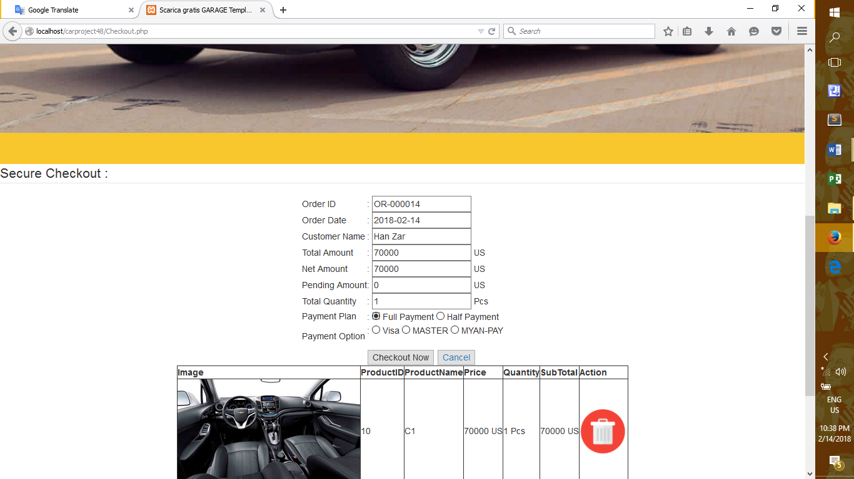

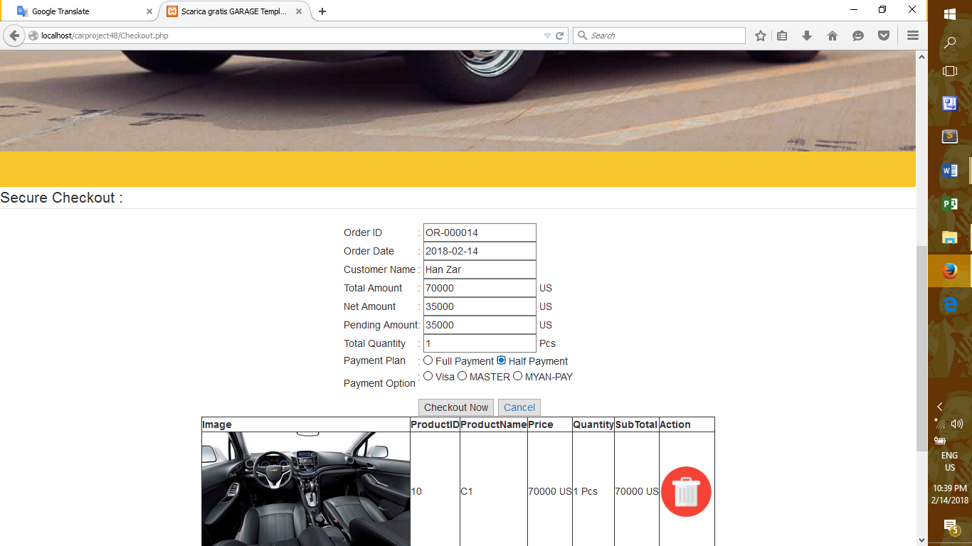

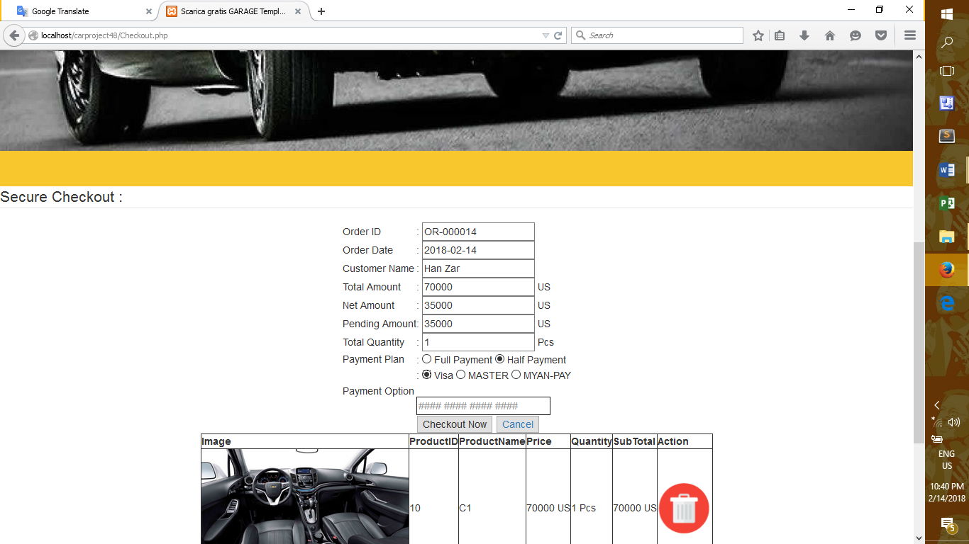



**Source;** [**www.agilenutshell.com**](http://www.agilenutshell.com)

[**www.slideshare.com**](http://www.slideshare.com)

Source; [www.codecademy.com](http://www.codecademy.com)

[www.w3schools.com](http://www.w3schools.com)

Source; [www.codeproject.com](http://www.codeproject.com)

[www.sqlteam.com](http://www.sqlteam.com)