Extended Compat ID OS Feature Descriptor Specification
July 2, 2007
Abstract
Windows® uses class and subclass values to select a default driver for a USB device if a specific match is not available. However, this option works only if the USB Device Working Group has defined appropriate class and subclass codes. The extended compat ID OS feature descriptor can be used by independent hardware vendors (IHVs) to store one or more compatible IDs and subcompatible IDs in their device firmware on a per-interface or per-function basis. Windows can then use these values much like class and subclass values to select an appropriate driver.
This information applies for the following operating systems:
Windows Server® 2008
Windows Vista®
Windows Server 2003
Windows XP SP2
Future versions of this preview information will be provided in the Windows Driver Kit.
The current version of this paper is maintained on the Web at:
http://www.microsoft.com/whdc/device/connect/OS_Desc.mspx
References and resources discussed here are listed at the end of this paper.
Contents
Introduction 3
How to Retrieve an Extended Compat ID OS Descriptor 4
Extended Compat ID Descriptor Format 5
The Header Section 6
The Function Section 7
Example: RNDIS + MTP + HID Device 8
The Header Section 9
Function Section 1 9
Function Section 2 10
Function Section 3 10
Resources 10
Appendix 1. Compatible and Subcompatible ID Values 11
Appendix 2. Extended Compat ID Descriptor Example 12

License Agreement
The Microsoft OS Descriptor Specification and any accompanying materials (the “Specification”) provided by Microsoft is for your personal use only, and may be used solely for the purpose of implementing the Microsoft OS Descriptor set to interface with (i) a Microsoft OS Descriptor enabled operating system or (ii) other systems authorized by Microsoft to retrieve and use this information. THE SPECIFICATION (OR ANY OF ITS CONTENTS) MAY NOT BE COPIED OR DISTRIBUTED.
Microsoft may have copyrights, patents or pending patent applications covering subject matter in the Specification. To the extent Microsoft has such copyrights, patents or applications, Microsoft agrees to grant a nonexclusive, royalty-free, world-wide license under these copyrights, patents or applications solely to implement the Microsoft OS Descriptor Specification to interface with (i) a Microsoft OS Descriptor enabled operating system or (ii) other systems authorized by Microsoft to retrieve and use this information, on condition that you agree not to assert any intellectual property rights against Microsoft or other companies for their implementation of the Specification. Microsoft reserves all other rights it may have in the Specification. The furnishing of this document does not give you any license to any other Microsoft patents, trademarks, copyrights, or other intellectual property rights.
The Specification is provided "AS IS" without warranty of any kind. To the maximum extent permitted by applicable law, Microsoft further disclaims all warranties, including without limitation any implied warranties of merchantability and fitness for a particular purpose, as well as warranties of title and noninfringement. The entire risk arising out of the use or performance of the Specification remains with you.
To the maximum extent permitted by applicable law, in no event shall Microsoft or its suppliers be liable for any consequential, incidental, direct, indirect, special, punitive, or other damages whatsoever (including, without limitation, damages for loss of business profits, business interruption, loss of business information, or other pecuniary loss) arising out of the use of or inability to use the Specification, even if Microsoft has been advised of the possibility of such damages. Because some states/jurisdictions do not allow the exclusion or limitation of liability for consequential or incidental damages, the above limitation may not apply to you.

Disclaimer

This is a preliminary document and may be changed substantially prior to final commercial release of the software described herein.

The information contained in this document represents the current view of Microsoft Corporation on the issues discussed as of the date of publication. Because Microsoft must respond to changing market conditions, it should not be interpreted to be a commitment on the part of Microsoft, and Microsoft cannot guarantee the accuracy of any information presented after the date of publication.

This White Paper is for informational purposes only. MICROSOFT MAKES NO WARRANTIES, EXPRESS, IMPLIED OR STATUTORY, AS TO THE INFORMATION IN THIS DOCUMENT.

Complying with all applicable copyright laws is the responsibility of the user. Without limiting the rights under copyright, no part of this document may be reproduced, stored in or introduced into a retrieval system, or transmitted in any form or by any means (electronic, mechanical, photocopying, recording, or otherwise), or for any purpose, without the express written permission of Microsoft Corporation.

Microsoft may have patents, patent applications, trademarks, copyrights, or other intellectual property rights covering subject matter in this document. Except as expressly provided in any written license agreement from Microsoft, the furnishing of this document does not give you any license to these patents, trademarks, copyrights, or other intellectual property.

Unless otherwise noted, the example companies, organizations, products, domain names, e-mail addresses, logos, people, places and events depicted herein are fictitious, and no association with any real company, organization, product, domain name, email address, logo, person, place or event is intended or should be inferred.

© 2007 Microsoft Corporation. All rights reserved.

Microsoft, Windows, Windows Server, and Windows Vista are either registered trademarks or trademarks of Microsoft Corporation in the United States and/or other countries.

The names of actual companies and products mentioned herein may be the trademarks of their respective owners.

Introduction
A primary goal of USB devices is to minimize the amount of user interaction that is required to install and configure a device. To support this goal, USB devices store a variety of information in their firmware as descriptors. Descriptors are accessible through the device’s control endpoint, and Windows® applications or Windows itself can retrieve the descriptors by issuing an appropriate control request. However, standard descriptors can store only a limited range of information. Independent hardware vendors (IHVs) must typically include media with their device—such as CDs or DVDs—that contain vendor-specific information such as icons, custom drivers, or help files, and the user must use the medium to install the features.
Microsoft OS descriptors provide a way for IHVs to store a variety of vendor-specific information in device firmware as OS feature descriptors, rather than distributing it to users on a CD. Versions of Windows or Windows applications that are aware of OS descriptors can obtain the data without any user interaction by using control requests to retrieve the descriptors from the device. In particular, these descriptors allow Windows to automatically retrieve the information when the device is initially plugged in and to use it to give the user a smoother Plug and Play experience. For a general discussion of Microsoft OS Descriptors, see “Microsoft OS Descriptors Overview,” which is also included in this package.
When a USB device is connected to a computer, Windows compares the hardware identifiers with the available INFs to determine the most appropriate driver for the device. These INFs can be on the system, on vendor media, on Windows update, and so on. Windows selects the most appropriate driver as follows:
1. Windows attempts to match the device to a specific driver based on the product ID entry. This is typically a custom driver that the IHV implements.
2. If Windows cannot find a specific match, it matches the device with a generic class driver based on the device’s designated class and subclass. IHVs whose devices work well with generic drivers can use this option to distribute their devices without being required to implement a custom driver and INF.

Class and subclass values greatly improve end-user satisfaction, by helping Windows to select an appropriate default driver if it cannot find a specific match. However, this option works only if the USB Device Working Group has defined appropriate class and subclass codes for the device. The time that the working group process requires can be a severe limitation for hardware vendors who are implementing cutting-edge technology that cannot use the currently available class and subclass codes.
The extended compat ID OS feature descriptor allows IHVs to store one or more compatible IDs and subcompatible IDs in their device firmware on a per-interface or per-function basis. IHVs can also use Interface Association Descriptors (IADs) to associate an extended compat ID descriptor with a single-function group of interfaces. Windows can then retrieve the IDs from the device and use them—much like it uses class and subclass values—to select appropriate default drivers. Compatible and subcompatible ID values are defined by Microsoft and are not the same as the class and subclass values that the USB Device Working Group defines. For a list of compatible ID and subcompatible ID values, see Appendix 1 to this paper.
Note: If your device has suitable class and subclass values, you should use those values. Extended compat ID descriptors are intended for those devices that do not yet have suitable class or subclass values.

How to Retrieve an Extended Compat ID OS Descriptor
To retrieve a device’s OS feature descriptor, Windows:
1. Sends a control request to the device, to retrieve its OS string descriptor.
2. Examines the returned descriptor to verify that it is a valid OS string descriptor.
3. Uses the data in the OS string descriptor’s bMS_VendorCode field to send one or more control requests to retrieve the device’s OS feature descriptors.

A device can have only one extended compat ID OS descriptor, which consists of a fixed-length header section followed by one or more function sections. Each function section is associated with a particular interface, function, or single-function group of interfaces. The length of an extended properties OS feature descriptor can therefore vary, depending on the number and size of the custom properties sections. For this reason, Windows must use multiple control requests to retrieve the descriptor, as follows:
1. Sends a GET_MS_DESCRIPTOR control request to the device to request the descriptor’s header section The parameters for this request are set as follows:
- bmRequestType
0xC0. The request type used to retrieve any OS feature descriptors.
- bRequest
The bMS_VendorCode value from the OS string descriptor.
- wValue
High Byte = InterfaceNumber. InterfaceNumber is set to the number of the interface or function that is associated with the descriptor, typically 0x00. Because a device can have only one extended compat ID descriptor, it should ignore InterfaceNumber, regardless of the value, and simply return the descriptor.
Low Byte = 0. PageNumber is used to retrieve descriptors that are larger than 64 KB. The header section is 16 bytes, so PageNumber is set to 0 for this request.
- wIndex
0x04. Indicates that the request is for an extended compat ID OS descriptor.
- wLength
0x10. The length of the header section for version 1.00. Setting wLength to this value causes the device to return only the descriptor’s header section.

2. Validates the header section and determines the length of the entire descriptor and the number of function sections. These values are in the header section’s dwLength and bCount fields, respectively.
3. Sends a GET_MS_DESCRIPTOR control transfer request to the device to request the complete descriptor. The request parameters are the same as for the header request, with one and possibly two exceptions:
- wLength is set to dwLength, the total length of the descriptor.
- The low byte of wValue is typically set to 0. However, if the complete descriptor is larger than 64 KB, Windows uses the low byte of wValue to retrieve the descriptor by using multiple control requests. For the details of this procedure, see “Microsoft OS Descriptors Overview,” which is included in this package.
4. Parses the descriptor and extracts the data. The first field in each function section contains the length of the section. Windows uses the section lengths and the wCount value from the header section to walk through the custom properties descriptors and extract the associated data.

For more details on how to use a GET_MS_DESCRIPTOR control transfer request to retrieve an OS feature descriptor, see “Microsoft OS Descriptors Overview”, which is included in this package. Appendix 1 to this paper includes a detailed example of this procedure, using a sample extended compat ID feature descriptor.
Figure 1 shows the portion of a bus trace that retrieves an extended compat ID OS descriptor.
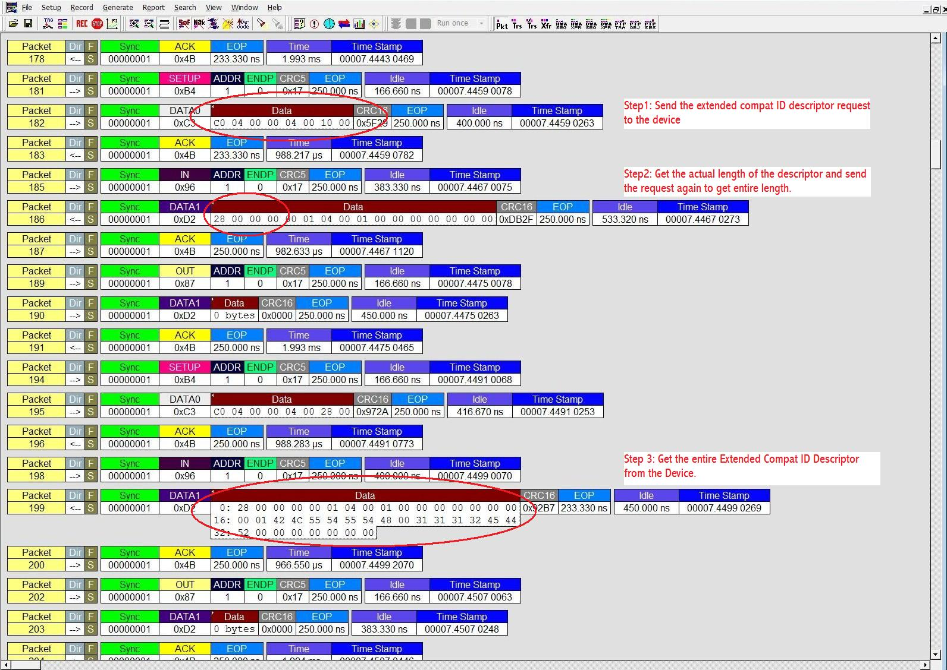
Figure 1. Bus trace for an extended compat ID OS feature descriptor request

Extended Compat ID Descriptor Format
The extended compat ID OS descriptor has two components:
- A fixed-length header section, which contains information about the entire descriptor including the version number, the number of function sections, and the descriptor’s total length.
- One or more fixed-length function sections, which follow the header section. Each function section contains the data for the device, or a single interface, function, or single-function group of interfaces. It is not necessary to define IDs for every function or interface, but each of them must still have an associated function section.

The length of the extended compat ID OS descriptor can vary, but the format is fixed and vendors must not deviate from it. Figure 2 shows the general layout of the descriptor.
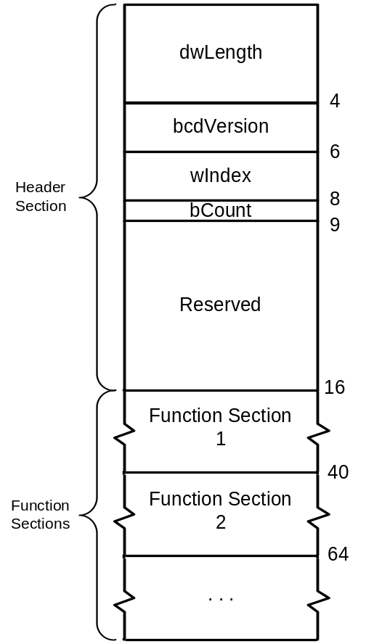
Figure 2. Extended compat ID OS feature descriptor

The Header Section
The header section contains information about the complete descriptor. It has a fixed length and a layout as shown in Table 1.
Table 1. Header Section
Offset | Field | Size  (bytes) | Type | Description
0 | dwLength | 4 | DWORD | The length, in bytes, of the complete extended compat ID descriptor
4 | bcdVersion | 2 | BCD | The descriptor’s version number, in binary coded decimal (BCD) format
6 | wIndex | 2 | WORD | An index that identifies the particular OS feature descriptor
8 | bCount | 1 | BYTE | The number of custom property sections
9 | RESERVED | 7 | BYTEs | Reserved

dwLength
The length of the entire descriptor, including the header section. Windows uses this value to retrieve the complete descriptor.
bcdVersion
The version number. This field allows Windows to differentiate between different OS descriptor versions. For version 1.00, bcdVersion is set to 0x0100.
wIndex
The descriptor index. This value is used to distinguish between different OS feature descriptors. It’s the same value that’s used to request the descriptor and is set to 0x04 for extended compat ID descriptors.
bCount
The number of function sections. This value, combined with dwLength, allows Windows to parse the descriptor.
Note: The header sections for future versions of the extended compat ID OS feature descriptor might contain additional fields following bCount. IHVs must ensure that their device contains the correct version number so that Windows can correctly parse the descriptor.

The Function Section
A function section defines the compatible ID and a subcompatible ID for a specified interface or function. Table 2 shows the function section format.
Table 2. Function Section
Offset | Field | Size  (bytes) | Type | Description
0 | bFirstInterfaceNumber | 1 | BYTE | The interface or function number
1 | RESERVED | 1 | BYTEs | Reserved
2 | compatibleID | 8 | BYTEs | The function’s compatible ID
10 | subCompatibleID | 8 | BYTEs | The function’s subcompatible ID
18 | RESERVED | 6 | BYTEs | Reserved
Note: The offsets in this table are given from the beginning of the section. To calculate the offset of a field from the beginning of the entire descriptor, add the length of the header section and the lengths of any function sections that precede this section to the value in the table.

bFirstInterfaceNumber
This field specifies the interface or function that is associated with the IDs in this section. To use this function section to associate a single-function group of interfaces with a single pair of IDs, set bFirstInterfaceNumber to the first interface in the group. Then use an IAD in that interface’s interface descriptor to specify which additional interfaces should be included in the group. The interfaces in the group must be consecutively numbered. For details, see “Support for USB Interface Association Descriptor in Windows.”
RESERVED
Reserved for system use. Set this value to 0x01.
compatibleID
This field contains the value of the compatible ID to be associated with this function. Any unused bytes should be filled with NULLs. If the function does not have a compatible ID, fill the entire field with NULLs.
subCompatibleID
This field contains the value of the subcompatible ID to be associated with this function. Any remaining bytes should be filled with NULLs. If the function does not have a subcompatible ID, fill the entire field with NULLs.
RESERVED
Reserved. Fill this value with NULLs.
Function sections should follow the header section in increasing order of interface number, so the first function section should have bFirstInterfaceNumber set to zero and so on.
The compatibleID and subcompatibleID fields must be assigned one of the values defined by Microsoft. These values should not be confused with class and subclass codes, which are defined by the USB Device Working Group. If a device defines compatible and subcompatible IDs, they override any existing class, subclass, or protocol values. Windows attempts to match the IDs in the following order:
1. USB\MS_COMP_xxxxxxxx&MS_SUBCOMP_xxxxxxxx
2. USB\MS_COMP_xxxxxxxx
3. USB\CLASS_aa&SUBCLASS_bb&PROT_cc
4. USB\CLASS_aa&SUBCLASS_bb
5. USB\CLASS_aa

MS_COMP and MS_SUBCOMP correspond to the compatible and subcompatible IDs in the function section. The xxxxxxxx part of the value is the 8-byte value extracted from the corresponding field in the function section. The last three items in the list are based on the function’s protocol, class, and subclass IDs. aa, bb, and cc are defined in the interface descriptor. Devices that define compatible and subcompatible IDs in an extended compat ID descriptor can set the interface descriptor’s protocol, class, and subclass fields to zero.
The compatibleID and subCompatibleID values can contain only the ASCII values for capital letters, numbers, underscores, and NULL values. The last byte in the ID must be 0x00. Appendix 1 to this paper contains the current list of Microsoft-defined values, including the exact binary values that must be used to allow Windows to generate a compatible ID match.
If a compatible or subcompatible ID is not required by a particular function, it must still have a function section but the ID fields should be filled with NULLs. For more details on how the compatible IDs are generated, refer to “Support for USB Interface Association Descriptor in Windows.”

Example: RNDIS + MTP + HID Device
This example shows how an extended compat ID descriptor is used to store compatible IDs in the firmware of a Remote Network Driver Interface Standard (RNDIS) device. The device has four interfaces grouped into three functions, as shown in Table 3.
Table 3. Layout of Example Device's Interfaces
Function number | Interface number | Interface properties
0 | 0 | RNDIS – first interface
0 | 1 | RNDIS – second interface
1 | 2 | Media Transfer Protocol (MTP) interface
2 | 3 | HID interface

Note: The two RNDIS interfaces are grouped into one function by using an IAD, which is not discussed here. For details, see “Support for USB Interface Association Descriptor in Windows.”
The following sections describe the layouts of the individual components of the descriptor. For the layout of the entire descriptor as a single table, see Appendix 2 to this paper.

The Header Section
This section illustrates the layout of the header section, which includes the length of the entire descriptor, the number of function sections, and the version number.
Table 4. Header Section
Offset | Field | Value | Value
0 | dwLength | 0x58 | Descriptor length (88 bytes)
4 | bcdVersion | 0x0100 | Version 1.00
6 | wIndex | 0x0004 | Extended compat ID descriptor
8 | bCount | 0x03 | Number of function sections
9 | RESERVED | 0x000000 | Reserved

Function Section 1
The first function section is associated with the RNDIS function, which consists of interfaces 0 and 1.
Table 5. Function 1: RNDIS Function
Offset | Field | Value
0 | bFirstInterfaceNumber | 0x00
1 | RESERVED | 0x01
2 | compatibleID | “RNDIS”
10 | subCompatibleID | ∅∅∅∅∅∅∅∅
18 | RESERVED | ∅∅∅∅∅∅∅
Note: ∅ represents a NULL character (0x00). Any unused bytes at the end of the compatibleID and subCompatibleID values should be filled with NULLs.

bFirstInterfaceNumber
Interfaces 0 and 1 are defined as a single-function group. bFirstInterfaceNumber is set to the first interface number in this function, and an IAD is included in the interface 0 descriptor to define interfaces 0 and 1 as a single-function group.
RESERVED
This field is set to 0x01.
compatibleID
The compatible ID for this function is “RNDIS” (0x52 0x4E 0x44 0x49 0x53 0x00 0x00 0x00).
subCompatibleID
This function does not have a subcompatible ID, so the field is filled with NULLs.
RESERVED
This field is filled with NULLs.
The protocol, class, and subclass IDs are defined in the interface descriptor, which is not shown here. Those values will be lower ranked than the ID values defined in this section.

Function Section 2
The second function section is associated with interface 2, an MTP interface.
Table 6. Function 2: MTP Interface
Offset | Field | Value
0 | bFirstInterfaceNumber | 0x02
1 | RESERVED | 0x01
2 | compatibleID | “MTP”
10 | subCompatibleID | ∅∅∅∅∅∅∅∅
18 | RESERVED | ∅∅∅∅∅∅∅

This function section defines “MTP” as the compatible ID. There is no subcompatible ID for MTP devices.

Function Section 3
The third function section is associated with interface 3, a HID interface.
Table 7. Function 3: HID Interface
Offset | Field | Value
0 | bFirstInterfaceNumber | 0x03
1 | RESERVED | 0x01
2 | compatibleID | ∅∅∅∅∅∅∅∅
10 | subCompatibleID | ∅∅∅∅∅∅∅∅
18 | RESERVED | ∅∅∅∅∅∅∅

The HID function does not require a compatible or subcompatible ID. However, all functions must have a function section, so the compatibleID and subCompatibleID fields are filled with NULLs to indicate that they not defined. The interface 3 descriptor contains class, subclass, and protocol codes that Windows can use to load a driver for the HID function if a default driver is required.

Resources
The following list contains links to documents that contain related information.
Microsoft OS Descriptors
http://www.microsoft.com/whdc/device/connect/OS_Desc.mspx
USB 2.0 Specification
http://www.usb.org/developers/docs
Support for USB Interface Association Descriptor in Windows
http://www.microsoft.com/whdc/system/bus/USB/IAD.mspx
USB Interface Association Descriptor
http://msdn2.microsoft.com/en-us/library/aa475772.aspx

Appendix 1. Compatible and Subcompatible ID Values
Table 8 contains a list of available compatible and subcompatible IDs that Microsoft defined at the time this specification was published. This list will probably change, so check Microsoft OS Descriptors for the currently available set of IDs.
Table 8. Compatible and Subcompatible ID values
Compatible ID | Subcompatible ID | Description
∅∅∅∅∅∅∅∅  (0x00 0x00 0x00 0x00 0x00 0x00 0x00 0x00) |  | No compatible or subcompatible ID
RNDIS  (0x52 0x4E 0x44 0x49 0x53 0x00 0x00 0x00) |  | RNDIS
PTP  (0x50 0x54 0x50 0x00 0x00 0x00 0x00 0x00) |  | Picture Transfer Protocol (PTP)
MTP  (0x4D 0x54 0x50 0x00 0x00 0x00 0x00 0x00) |  | Media Transfer Protocol
XUSB20  (0x58 0x55 0x53 0x42 0x32 0x30 0x00 0x00) |  | XNACC (Krypton)
BLUTUTH  (0x42 0x4C 0x55 0x54 0x55 0x54 0x48 0x00) | 11  (0x31 0x31 0x00 0x00 0x00 0x00 0x00 0x00) | Bluetooth radios compliant with V1.1 and compatible with the Microsoft driver stack
BLUTUTH  (0x42 0x4C 0x55 0x54 0x55 0x54 0x48 0x00) | 12  (0x31 0x32 0x00 0x00 0x00 0x00 0x00 0x00) | Bluetooth radios compliant with V1.2 and compatible with the Microsoft driver stack
BLUTUTH  (0x42 0x4C 0x55 0x54 0x55 0x54 0x48 0x00) | EDR  (0x45 0x44 0x52 0x00 0x00 0x00 0x00 0x00) | Bluetooth radios compliant with V2.0 + EDR and compatible with the Microsoft driver stack

Note: ID values must be 8 bytes long and contain only the ASCII values for uppercase letters, numbers, underscores, and the NULL character. No other characters are allowed, and the last byte in the ID must be the NULL 0x00.
Microsoft reserves all other compatible and subcompatible ID values for future use. If you need an ID that is not on the current list, do not create one without prior approval from Microsoft. Instead, work with your Microsoft Technical Account Manager to reserve an ID. You will need to provide the following information:
- The compatible ID value
- The subcompatible ID value
- A description of the ID, in ten words or less
- The INF file name that will match the ID

Appendix 2. Extended Compat ID Descriptor Example
Table 9 displays the complete extended compat ID descriptor for the RNDIS example earlier in this paper and includes the numerical values assigned to the various fields. The different sections are indicated by shading. For a description of the fields and their values, see “Example: RNDIS + MTP + HID Device” earlier in this paper.
Table 9. RNDIS Example: Complete Compat ID Descriptor
Offset | Field | Size | Value
0 | dwLength | 4 | 0x00000058
4 | bcdVersion | 2 | 0x0100
6 | wIndex | 2 | 0x04
8 | bCount | 1 | 0x03
9 | RESERVED | 7 | 0x00000000000000
16 | bFirstInterfaceNumber | 1 | 0x00
17 | RESERVED | 1 | 0x01
18 | compatibleID | 8 | 0x524E444953000000
26 | subCompatibleID | 8 | 0x0000000000000000
34 | RESERVED | 6 | 0x000000000000
40 | bFirstInterfaceNumber | 1 | 0x02
41 | RESERVED | 1 | 0x01
42 | compatibleID | 8 | 0x4D54500000000000
50 | subCompatibleID | 8 | 0x0000000000000000
58 | RESERVED | 6 | 0x000000000000
64 | bFirstInterfaceNumber | 1 | 0x03
65 | RESERVED | 1 | 0x01
66 | compatibleID | 8 | 0x0000000000000000
74 | subCompatibleID | 8 | 0x0000000000000000
82 | RESERVED | 6 | 0x000000000000

