Microsoft OS Descriptors Overview
July 2, 2007
Abstract
USB devices store standard descriptors in firmware for the device and its interfaces and endpoints. Independent hardware vendors (IHVs) can also store class and vendor-specific descriptors. However, the types of information that these descriptors can contain is limited. IHVs typically must use Windows® Update or media such as CDs to provide their users with a variety of device-specific information such as pictures, icons, and custom drivers.
To help IHVs address this issue, Microsoft has defined Microsoft OS descriptors. IHVs can use these descriptors to store in firmware much of the information that is now typically provided to customers separately. Versions of Windows that are aware of Microsoft OS descriptors use control requests to retrieve the information and use the information to install and configure the device without requiring any user interaction. This white paper provides an introduction to Microsoft OS descriptors, including a discussion of how they are stored and retrieved.
This information applies for the following operating systems:
Windows Server® 2008
Windows Vista®
Windows Server 2003
Windows XP
Future versions of this preview information will be provided in the Windows Driver Kit.
The current version of this paper is maintained on the Web at:
http://www.microsoft.com/whdc/device/connect/OS_Desc.mspx
References and resources discussed here are listed at the end of this paper.
Contents
Introduction 3
Microsoft OS Descriptors 3
The OS String Descriptor 4
How to Retrieve an OS String Descriptor 5
The OS String Descriptor Format 6
OS Feature Descriptors 7
How to Retrieve an OS Feature Descriptor 8
How to Retrieve a Lengthy OS Feature Descriptor 9
How Microsoft OS Descriptors Are Retrieved: A Bus Trace 10
Resources 10
Appendix: Example of OS String and Feature Descriptors 11

License Agreement
The Microsoft OS Descriptor Specification and any accompanying materials (the “Specification”) provided by Microsoft is for your personal use only, and may be used solely for the purpose of implementing the Microsoft OS Descriptor set to interface with (i) a Microsoft OS Descriptor enabled operating system or (ii) other systems authorized by Microsoft to retrieve and use this information. THE SPECIFICATION (OR ANY OF ITS CONTENTS) MAY NOT BE COPIED OR DISTRIBUTED.

Microsoft may have copyrights, patents or pending patent applications covering subject matter in the Specification. To the extent Microsoft has such copyrights, patents or applications, Microsoft agrees to grant a nonexclusive, royalty-free, world-wide license under these copyrights, patents or applications solely to implement the Microsoft OS Descriptor Specification to interface with (i) a Microsoft OS Descriptor enabled operating system or (ii) other systems authorized by Microsoft to retrieve and use this information, on condition that you agree not to assert any intellectual property rights against Microsoft or other companies for their implementation of the Specification. Microsoft reserves all other rights it may have in the Specification. The furnishing of this document does not give you any license to any other Microsoft patents, trademarks, copyrights, or other intellectual property rights.

The Specification is provided "AS IS" without warranty of any kind. To the maximum extent permitted by applicable law, Microsoft further disclaims all warranties, including without limitation any implied warranties of merchantability and fitness for a particular purpose, as well as warranties of title and noninfringement. The entire risk arising out of the use or performance of the Specification remains with you.

To the maximum extent permitted by applicable law, in no event shall Microsoft or its suppliers be liable for any consequential, incidental, direct, indirect, special, punitive, or other damages whatsoever (including, without limitation, damages for loss of business profits, business interruption, loss of business information, or other pecuniary loss) arising out of the use of or inability to use the Specification, even if Microsoft has been advised of the possibility of such damages. Because some states/jurisdictions do not allow the exclusion or limitation of liability for consequential or incidental damages, the above limitation may not apply to you.

Disclaimer

This is a preliminary document and may be changed substantially prior to final commercial release of the software described herein.

The information contained in this document represents the current view of Microsoft Corporation on the issues discussed as of the date of publication. Because Microsoft must respond to changing market conditions, it should not be interpreted to be a commitment on the part of Microsoft, and Microsoft cannot guarantee the accuracy of any information presented after the date of publication.

This White Paper is for informational purposes only. MICROSOFT MAKES NO WARRANTIES, EXPRESS, IMPLIED OR STATUTORY, AS TO THE INFORMATION IN THIS DOCUMENT.

Complying with all applicable copyright laws is the responsibility of the user. Without limiting the rights under copyright, no part of this document may be reproduced, stored in or introduced into a retrieval system, or transmitted in any form or by any means (electronic, mechanical, photocopying, recording, or otherwise), or for any purpose, without the express written permission of Microsoft Corporation.

Microsoft may have patents, patent applications, trademarks, copyrights, or other intellectual property rights covering subject matter in this document. Except as expressly provided in any written license agreement from Microsoft, the furnishing of this document does not give you any license to these patents, trademarks, copyrights, or other intellectual property.

Unless otherwise noted, the example companies, organizations, products, domain names, e-mail addresses, logos, people, places and events depicted herein are fictitious, and no association with any real company, organization, product, domain name, email address, logo, person, place or event is intended or should be inferred.

© 2007 Microsoft Corporation. All rights reserved.

Microsoft, Windows, Windows Server, and Windows Vista are either registered trademarks or trademarks of Microsoft Corporation in the United States and/or other countries.

The names of actual companies and products mentioned herein may be the trademarks of their respective owners.

Introduction
A primary goal of USB devices is to minimize the amount of user interaction that is required to install and configure a device. To support this goal, USB devices store a variety of information in their firmware as descriptors. Descriptors are accessible through the device’s control endpoint, and Windows® applications or Windows itself can retrieve the descriptors by issuing an appropriate control request.
Devices that are compatible with USB Specification 2.0 must have standard descriptors for the device itself and for each of its interfaces and endpoints. Independent hardware vendors (IHVs) can also store class and vendor-specific descriptors. However, the types of information that these descriptors can contain is limited. IHVs typically must use Windows Update or media such as a CDs to provide their users with device-specific information such as pictures, icons, and custom drivers.
Microsoft OS descriptors provide a way for IHVs to store a variety of vendor-specific information in device firmware as OS feature descriptors, rather than distributing it to users separately from the device. Versions of Windows or Windows applications that are aware of Microsoft OS descriptors can use control requests to retrieve the descriptors from the device without requiring any user interaction. In particular, Windows can automatically retrieve the descriptors when the device is initially plugged in and use the information to give the user a smoother Plug and Play experience.
This white paper introduces Microsoft OS descriptors. It includes a specification for the OS string descriptor format and describes how to retrieve the OS string descriptor and the associated OS feature descriptors from a USB device.

Microsoft OS Descriptors
There are two types of Microsoft OS descriptor:
- A standard USB string descriptor, referred to as an OS string descriptor.
Each device that supports Microsoft OS descriptors must store one OS string descriptor in its firmware at a standard index. This descriptor identifies the device as supporting Microsoft OS descriptors and includes the data that is required to retrieve the associated feature descriptors.
- OS feature descriptors.
Devices can have one or more OS feature descriptors, which contain the detailed feature information.

To retrieve a device’s feature descriptors, Windows:
1. Sends a control request to the device, to retrieve its OS string descriptor.
2. Examines the returned descriptor to verify that it is a valid OS string descriptor.
3. Uses the data in the OS string descriptor’s bMS_VendorCode field to retrieve the device’s OS feature descriptors.

For a more detailed description of the process of retrieving the OS string descriptor, see “How to Retrieve an OS String Descriptor” later in this paper. For a detailed picture of the request process, see “How Microsoft OS Descriptors are Retrieved: A Bus Trace” later in this paper.
Any information to be stored as a feature descriptor must comply with one of the standard formats that Microsoft has defined. Additional feature descriptors cannot be defined or implemented without Microsoft consent. Microsoft has defined the following feature descriptors.
Extended Compat ID
Windows uses class and subclass codes to help locate the appropriate default driver for a USB device. However, the USB Device Working Group must allocate these codes. This means that devices that implement new types of features often do not yet have appropriate class and subclass codes, so Windows cannot use the codes to select a default driver. IHVs can circumvent this problem by storing the information in firmware as an extended compat ID OS feature descriptor. Windows can then retrieve this information when the device is plugged in and use it to help determine which default driver to load. For details, see “Extended Compat ID OS Feature Descriptor Specification,” which is included in this package
Extended Properties
Currently, there are two levels at which properties can be declared for a USB device: class level or devnode level. The extended properties OS feature descriptor allows a vendor to store additional properties— such as help pages, URLs, and icons—in device firmware. For details, see “Extended Properties OS Feature Descriptor Specification,” which is included in this package
Genre
This descriptor is used by HID devices, such as game controllers, to provide detailed configuration data. A typical game controller, for example, includes a report descriptor that provides basic information about the controls. However, the data is often not sufficient for an optimal mapping between control and action in the different contexts that the game controller might be used. IHVs can use a genre descriptor to store detailed mapping information in the device firmware, along with related information such as the physical location of the controls and images that can be used to configure the device. This descriptor is being considered for future versions of Windows, and no specification is currently available.
For detailed descriptions of these descriptors, see the individual specifications, which are included in this package.
Table 1 shows which versions of Windows support the various descriptors.
Table 1. Microsoft OS Descriptor Support
Descriptor | Windows versions
OS string descriptor | Windows XP SP1 and later
Extended compat ID OS feature descriptor | Windows XP SP2 and later
Extended properties OS feature descriptor | Windows XP SP2 and later
Genre OS feature descriptor | Might be supported by future Windows versions

The OS String Descriptor
A device that supports Microsoft OS descriptors must contain an OS string descriptor, stored at string index 0xEE. The OS string descriptor is a standard USB string descriptor that serves several purposes:
- Its presence indicates that the device contains one or more OS feature descriptors.
- It contains the data that is required to retrieve the associated OS feature descriptors.
- It contains a signature field that differentiates the OS string descriptor from other strings that IHVs might choose to store at 0xEE.
- It contains a version number that allows for future revisions of Microsoft OS descriptors.

Important: OS string descriptors must satisfy the following constraints:
- A device that contains an OS string descriptor can be low, high, or full speed, but it must be compatible with USB 2.0 or later specifications and BCDVersion must be set to 2.0 or larger.
- A USB device can store only one OS string descriptor.
- Windows does not attempt to retrieve OS feature descriptors from a device if the OS string descriptor does not comply with the format defined by Microsoft and described in this paper.
- IHVs can assign any value they choose to the OS string descriptor’s bMS_VendorCode field, but the field must be 1 byte in length.

The following sections discuss how to retrieve an OS string descriptor from a device and describe the OS string descriptor format.

How to Retrieve an OS String Descriptor
To retrieve a device’s OS string descriptor, send a standard GET_DESCRIPTOR control request to the device. The request must have the format shown in Table 2.
Table 2. OS String Descriptor Request Format
bmRequestType | bRequest | wValue | wIndex | wLength | Data
1000 0000B | GET_DESCRIPTOR | 0x03EE | 0x0000 | 0x12 | Returned String

bmRequestType
IN. This 1-byte field is divided into three parts that indicate the data transfer direction, the descriptor type, and the recipient. To retrieve a USB string descriptor, bmRequestType should be set to 10000000B (0x80).
bRequest
IN. This field specifies the request type. It should be set to the standard GET_DESCRIPTOR request code.
wValue
IN. This field is split into two parts for GET_DESCRIPTOR requests.
- The high byte contains the descriptor type. To retrieve a string descriptor, set this byte to 0x03.
- The low byte contains the descriptor’s string index, which indicates where the descriptor is stored in firmware. To retrieve an OS string descriptor, set this byte to 0xEE.
wIndex
IN. This field specifies the descriptor’s language ID. It must be set to 0 for OS string descriptors.
wLength
IN. This field specifies the length of the buffer, in bytes, that is to receive the string descriptor. The device should respond to values ranging from 0x02-0xFF. wLength should be set to 0x12 for OS string descriptors.
Data
OUT. This field is a pointer to the buffer that will receive the requested descriptor. The format of the descriptor is described in the next section.

For more details on how to send control requests, see “USB 2.0 Specification.”
If a device does not have a valid string descriptor at 0xEE, it responds with a Stall or Request Error. If a device responds with a Request Error, Windows issues a single-ended Zero Reset. This ensures that the device recovers if it enters an unknown state. Figure 1 is a screen shot of a portion of a CATC USB Bus and Protocol Analyzer bus trace. It shows how a device that does not contain an MS OS descriptor should fail an OS string descriptor request.
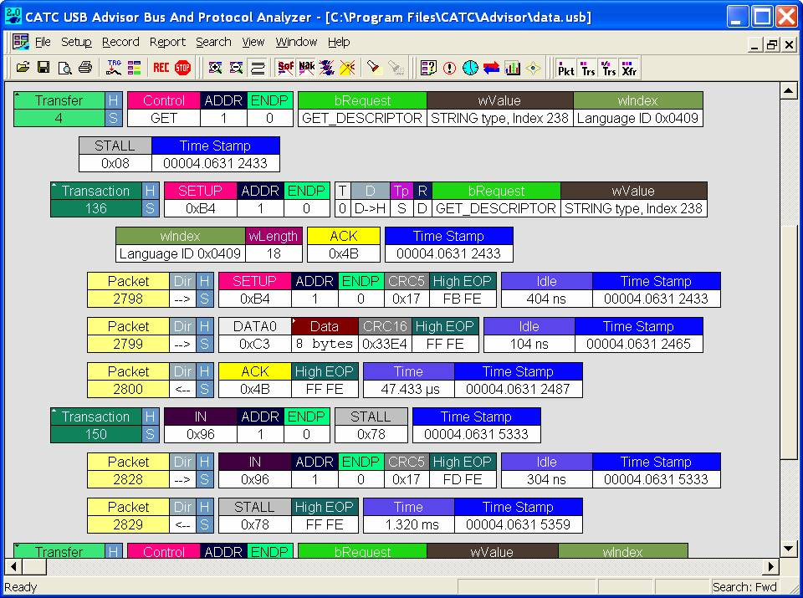
Figure 1. Bus trace of a failed OS string descriptor request

The OS String Descriptor Format
If an OS string descriptor request is successful, the device returns the descriptor in the request’s Data field. Version 1.00 of the OS string descriptor has a fixed length of 18 bytes, with a structure as shown in Figure 2. This format is defined by Microsoft and must be used by all OS string descriptors.
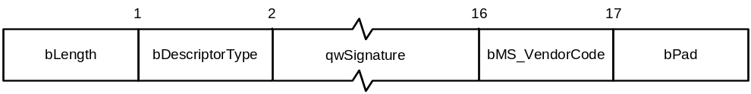
Figure 2. OS string format
Table 3 describes the OS string descriptor’s fields.
Table 3. OS String Descriptor Fields
Field | Length (Bytes) | Value | Description
bLength | 1 | 0x12 | Length of the descriptor
bDescriptorType | 1 | 0x03 | Descriptor type
qwSignature | 14 | ‘MSFT100’ | Signature field
bMS_VendorCode | 1 | Vendor-specific | Vendor code
bPad | 1 | 0x00 | Pad field

The key fields are qwSignature and bMS_VendorCode:
- qwSignature contains a Unicode character array that identifies the descriptor as an OS string descriptor and includes the version number. For version 1.00, this array must be set to ‘MSFT100’ (0x4D00 0x5300 0x4600 0x5400 0x3100 0x3000 0x3000).
- bMS_VendorCode is used to retrieve the associated feature descriptors. The vendor defines the format of this field. For further details, see “OS Feature Descriptors” later in this paper.

Because IHVs can store string descriptors at any index, there is no guarantee that a string descriptor stored at 0xEE is an OS string descriptor. To verify that the request has retrieved an OS string descriptor, Windows:
1. Examines the qwSignature value to ensure that it corresponds to a valid Microsoft OS descriptor string signature. If qwSignature does contain a valid signature, Windows does not parse the descriptor any further. Version 1.00 has only one valid signature: ‘MSFT100’.
2. Extracts the version number from qwSignature and verifies that the descriptor has the correct length for that version. For version 1.00, the descriptor must be 18 bytes long. Later versions might use different length descriptors.

If either test fails, Windows does not attempt to retrieve any OS feature descriptors.

OS Feature Descriptors
An OS feature descriptor contains data associated with a device feature. For version 1.00, Microsoft has defined standard formats for three OS feature descriptors. OS feature descriptors must satisfy the following constraints:
- Microsoft has defined and standardized the formats, and all descriptors must adhere to one of the available formats. Vendors must have explicit consent from Microsoft to modify, append to, or create OS feature descriptors.
- A device can store multiple descriptors, up to a maximum of 255.
- A descriptor can be associated with the device or with a particular interface or function.
- No more than one OS feature descriptor of each type is allowed. Some OS feature descriptors can be associated with a particular interface or function. In that case, a device can have as many descriptors of that type as it has interfaces or functions.
- A descriptor must include its size and version number and should always report that information correctly to Windows.
- The maximum size of a descriptor depends on the particular OS feature descriptor. The protocol allows feature descriptors to be as large as 16 MB, but as a practical matter, descriptor size is typically limited by firmware costs.

For details about the currently supported OS feature descriptors, see the individual specifications, which are included in this package.

How to Retrieve an OS Feature Descriptor
To retrieve an OS feature descriptor from a USB device, send a GET_MS_DESCRIPTOR control request. The request must have the format shown in Table 4.
Table 4. OS Feature Descriptor Request Format
bmRequestType | bRequest | wValue | wIndex | wLength | Data
1100 0000B | GET_MS_DESCRIPTOR | Interface/  Page | Feature Index | Length | Returned Descriptor

bmRequestType
IN. This field is divided into three parts that indicate the data transfer direction, the descriptor type, and the recipient. The OS feature descriptor is a vendor-defined descriptor, so bmRequestType is set to 11000000B (0xC0).
bRequest
IN. This field indicates the request type. This is a vendor-defined descriptor, so it takes a special GET_MS_DESCRIPTOR type, which is essentially a placeholder for a vendor-defined value that varies from device to device. The appropriate value is returned in the bMS_VendorCode field of the device’s OS string descriptor. To request a feature descriptor, set bRequest to the device’s bMS_VendorCode value.
wValue
IN. This field is split into two parts:
- High byte = InterfaceNumber. The high byte of wValue contains the number of the interface or function that is associated with the descriptor. This feature is particularly useful for composite devices. However, most descriptors are associated with the device rather than a particular interface, and some descriptors must be device level. For a device-level descriptor, set InterfaceNumber to 0.
- Low byte = PageNumber. The low byte of wValue contains a page number, which enables OS feature descriptors to exceed the 64-KB limit set by the maximum value for wLength. If the descriptor is smaller than 64 KB, set wValue to 0. The procedure for large descriptors is described later in this paper.
wIndex
IN. This field contains the index of the OS feature descriptor that is being requested. The indexes for the version 1.00 descriptors are:
- Genre: 0x0001
- Extended compat ID: 0x0004
- Extended properties: 0x0005
wLength
IN. This field specifies the length (in bytes) of the buffer assigned to the Data field. If the descriptor is larger than the buffer, only wLength bytes are returned. If the descriptor is shorter than wLength, the returned buffer contains the entire descriptor, padded with zeros. The maximum value for wLength is 64 KB (0xFF). If the requested descriptor is smaller than 64 KB, set wLength to the size of the descriptor. The procedure for large descriptors is discussed later in this paper.
Data
OUT. This field is a pointer to a buffer that will receive the requested descriptor.

If a particular OS feature descriptor is not present, the device issues a Request Error or a Stall.

How to Retrieve a Lengthy OS Feature Descriptor
The maximum amount of data that any single descriptor request can return is 64 KB, which is sufficient for most descriptors. However, version 1.00 OS feature descriptors can be as large as 16 MB. To retrieve a descriptor that might be larger than 64 KB:
1. Set wLength to its maximum value, 64 KB.
2. Set wValue to 0.
3. Send the request to the device.
4. When the request returns, examine the Data buffer:
- If the buffer contains less than 64 KB of data, then you have received the complete descriptor.
- If the buffer is full, then it contains only part of the descriptor. Increment the page number in the low byte of wValue by one and send the request again to retrieve the next 64 KB.
5. Repeat step 4 until the buffer returns with less than 64 KB of data.

How Microsoft OS Descriptors Are Retrieved: A Bus Trace
Figure 3 is a screen shot of a CATC bus trace that shows the requests that are used to retrieve an extended compat ID OS feature descriptor from a USB device.
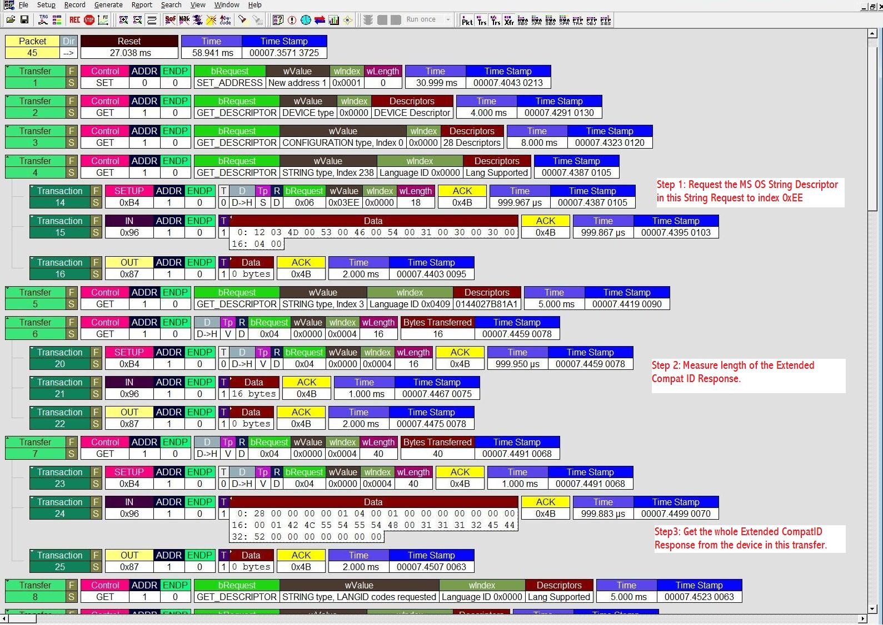
Figure 3. A bus trace of a request for an extended compat ID OS feature descriptor

Resources
For additional details, refer to the following documents:
Microsoft OS Descriptors Documentation
http://www.microsoft.com/whdc/device/connect/OS_Desc.mspx
USB 2.0 Specification
http://www.usb.org/developers/docs

Appendix: Example of OS String and Feature Descriptors
This appendix shows an example of how to use Microsoft OS descriptors for an RNDIS device that contains a simple extended compat ID OS feature descriptor.
When the device is plugged into a system that is running a version of Windows that is aware of OS descriptors, Windows sends a GET_DESCRIPTOR control request to the device to retrieve the OS string descriptor. Table 5 shows the contents of the descriptor that the device returns.
Table 5. RNDIS Example: OS String Descriptor
Offset | Field | Size  (bytes) | Value | Description
0 | bLength | 1 | 0x12 | Descriptor Length
1 | bDescriptorType | 1 | 0x03 | String Descriptor
2 | qwSignature | 14 | 0x4D 0x00, 0x53 0x00, 0x46 0x00, 0x54 0x00, 0x31 0x00, 0x30 0x00, 0x30 0x00 | ‘MSFT100’
16 | bMS_VendorCode | 1 | 0x01 | Vendor code to retrieve OS feature descriptors.
17 | bPad | 1 | 0x01 | Pad field

The OS string descriptor is valid, so Windows next uses the descriptor’s bMS_VendorCode value to retrieve the feature descriptors from the device. In this case, the vendor code is 0x01 and the descriptor is 40 bytes long. To retrieve the OS feature descriptor, Windows sends a GET_MS_DESCRIPTOR control request, with the following parameter values:
- bmRequestType: 0xC0
- bRequest: 0x01
- wValue: High byte = 0, Low byte = 0
- wIndex: 0x0004
- wLength: 0x28
Table 6 shows the returned descriptor. For a more detailed discussion of this type of OS feature descriptor, see “Extended Compat ID OS Feature Descriptors Specification” which is included in this package.
Table 6. RNDIS Example: Extended Compat ID Feature Descriptor
Offset | Field | Size  (Bytes) | Value | Description
0 | dwLength | 4 | 0x0028 | Length of this descriptor, in bytes
4 | bcdVersion | 2 | 0x0100 | Version 1.0
6 | wIndex | 2 | 0x0004 | Extended compat ID descriptor index
8 | bCount | 1 | 0x01 | Number of function sections
9 | RESERVED | 7 | 0x00000000000000 | Reserved
16 | bFirstInterfaceNumber | 1 | 0x00 | Interface number
17 | RESERVED | 1 | 1 | Reserved
18 | compatibleID | 8 | 0x52, 0x4E, 0x44, 0x49, 0x53, 0x00, 0x00, 0x00 | ‘RNDIS’
26 | subCompatibleID | 8 | 0x0000000000000000 | Secondary ID
34 | RESERVED | 6 | 0x000000000000 | Reserved

