MINISTRY OF EDUCATION ANDTRAINING

IRepair

Software Requirement Specification

Project Code: IR.3000

Document Code: DIR.10

* **Ho Chi Minh, 25/01/2021 -**

Record of change

*A - Added M - Modified D - Deleted

|  |  |  |  |  |
| --- | --- | --- | --- | --- |
| Effective Date | Changed Items | A* M, D | Change Description | New Version |
| 25/01/2021 | Initial | a | Add project over view |  |
|  |  |  |  |  |
|  |  |  |  |  |
|  |  |  |  |  |
|  |  |  |  |  |
|  |  |  |  |  |
|  |  |  |  |  |
|  |  |  |  |  |
|  |  |  |  |  |
|  |  |  |  |  |
|  |  |  |  |  |
|  |  |  |  |  |
|  |  |  |  |  |
|  |  |  |  |  |
|  |  |  |  |  |
|  |  |  |  |  |
|  |  |  |  |  |
|  |  |  |  |  |
|  |  |  |  |  |
|  |  |  |  |  |
|  |  |  |  |  |

SIGNATURE PAGE

**ORIGINATOR:** Nguyen Xuan Khanh Hoa 25/01/2020

<Position>

**REVIEWERS:** <Name> <Date>

<Position>

<Name, if it’s needed> <Date>

<Position>

**APPROVAL:** <Name> <Date>

<Position>

TABLE OF CONTENTS

1 Introduction 5

1.1 Purpose 5

1.2 Scope 5

1.3 Definitions, Acronyms, and Abbreviations 5

1.4 References 5

1.5 Overview 5

2 Overall Description 6

2.1 Product Perspective 6

2.2 Product features 6

2.3 Operating environment 6

3 FUNCTIONAL Requirements 7

3.1 Use Cases Diagram 7

3.2 Register 7

3.3 View Profile 9

3.4 Edit Profile 10

3.5 View the repairer’s information 10

3.6 Report problem 10

3.7 View order history 11

3.8 View detail of an order 11

3.9 Accept order 11

3.10 Login 12

3.11 Search a repairer 12

3.12 Remove a repairer 13

3.13 Rate repairer 13

3.14 Search the repair service 13

3.15 View the repair service information 14

3.16 View news 14

3.17 Book repairer 14

3.18 View the specific order 15

3.19 View list of current orders 15

3.20 View detail of a current order 16

3.21 View the list of suggested orders 16

3.22 Cancel booking 17

3.23 Logout 17

3.24 Post a new 17

3.25 Remove a news 18

3.26 Update a news 18

3.27 Ban a repairer 18

3.28 Warn a repairer 19

3.29 Cancel order 19

3.30 Reject order 19

4 NON-FUNCTIONAL Requirements 21

4.1 Usability 21

4.2 Reliability 21

4.3 Performance 21

4.4 Supportability 21

4.5 Design Constraints 21

5 Supporting Information 22

# Introduction

The IRepair is an application that helps users find repairers easily and vice versa.

User can quickly find and select a suitable repairer with the reasonable prices. Besides, the repairer has more customers and increase his/her income.

This software provides a clean and user-friendly interface for the users.

## Purpose

The purpose of thisapplicationis to help user find repairers easily and vice versa.

## Scope

The IRepair designed to run on mobile phone.

The user can book repairer by providing his/her problem, search the direct repair service/repairer and book repairer directly, Besides, the user can cancel the booking and rate the repairer.

The repairer can choose the repaired order, cancel and reject it.

## Definitions, Acronyms, and Abbreviations

IRepair: The name of the application

Repairer: a person that is paid to repair things

SRS: Software Requirement Specification

## References

## Overview

The rest of this SRS contains the following information:

* Overall Description
* Functional Requirements
* Non-functional Requirements
* Supporting Information

# Overall Description

## Product Perspective

A distributed booking repairer database system stores the following information:

* Repairer detail:

It includes repairer code, name, address and phone number…. This information may be used for keeping the records of the repairer for any emergency or for any other kind of information.

* Customer description:

It includes customer code, name, address and phone number…. This information may be used for keeping the records of the customer for any emergency or for any other kind of information.

* Booking description:

It includes customer details, code number, repairer number, date of booking, status.

## Product features

The major features of booking repairer database system are shown in below entity-relationship model (ERD)

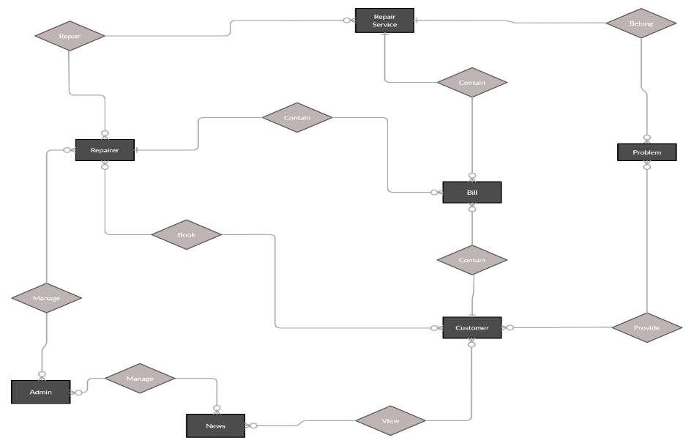

## Operating environment

Operating environment for the booking repairer management system is listed below.

* Client/server system
* Operating system: Android, IOS.
* Database: SQL server
* Platform: vb.net/Java/PHP

# FUNCTIONAL Requirements

## Use Cases Diagram

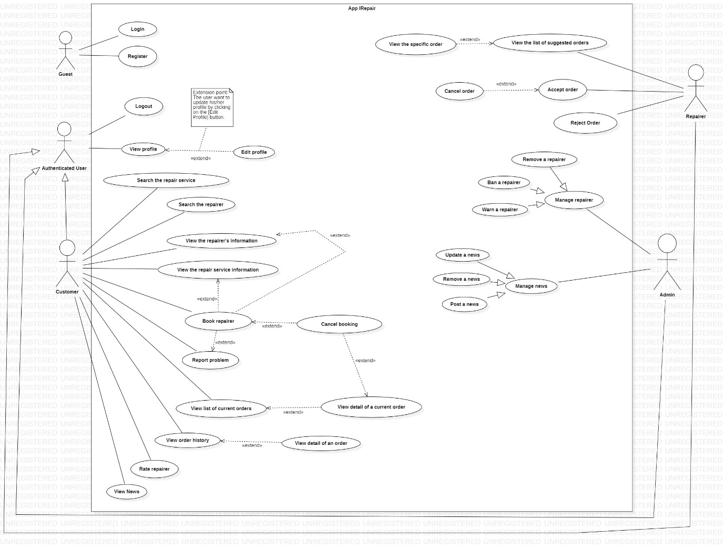

## Register

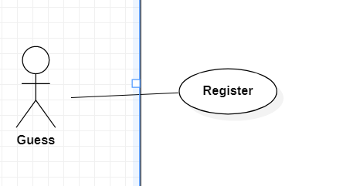

|  |  |  |  |
| --- | --- | --- | --- |
|  | Register |  |  |
| USE-UC001 | | | |
| Use Case No. | UC001 | Use Case Version | 1 |
| Use Case Name | Register | | |
| Author | Nguyen Xuan Khanh Hoa | | |
| Date | 20-01-2021 | Priority | Normal |
| Actor: - Guest Summary: - This use case allows guest to register to the system. Goal: - Guest can register to the system. Triggers: - Guest touches “Register” button. Precondition: N/A Post Conditions: - Success: Guest register an account to the system successfully. Show register successfully message. Main Success Scenario: | | | |
| Step | Actor Action | System Response | |
| 1 | Guest goes to register view (Guest registers to become a customer)  [Alternative 1] | System requires identity information from Guest:   * Name: textbox, required * Telephone Number: textbox, required * Address: textbox, required * Password: textbox, required | |
| 2 | Guest inputs information |  | |
| 3 | Guest press the register button | System will show a message, then add the data to the database. | |
| Alternative Scenario: | | | |
| Step | Actor Action | System Response | |
| 1 | Guest goes to register view (Guest registers to become a repairer) | System requires identity information from Guest:   * Name: textbox, required * Telephone Number: textbox, required * Repaired Major: textbox, required * Description: textbox, required * Password: textbox, required | |
| 2 | Password has been already in the system | The system shows message “The password is existed. Enter another password”. | |
| Exceptions: | | | |
| Step | Actor Action | System Response | |
| 1 |  | System show message the "System is busy" when the internet is lost | |
| Relationships: N/A | | | |
| Business Rules: - Password is encrypted before being sent to system. - New customer/repairer account will be created in the system with inputted information. | | | |

## View Profile

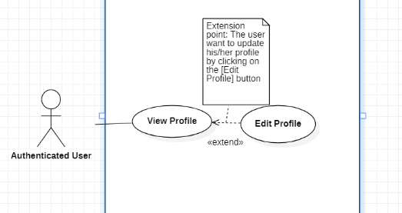

|  |  |  |  |  |  |
| --- | --- | --- | --- | --- | --- |
|  | View Profile | |  | |  |
| USE-UC002 | | | | | |
| Use Case No. | UC002 | | Use Case Version | | 1 |
| Use Case Name | View Profile | | | | |
| Author | Nguyen Xuan Khanh Hoa | | | | |
| Date | 26-01-2021 | | Priority | | Normal |
| Actor: - Authenticated User Summary: - This use case allows user to view his/her profile Goal: - User can view profile. Triggers: - User touches on "View Profile" to view his/her profile. Precondition:  - User must login into the system. Post Conditions: - Success: Show profile of user. Main Success Scenario: | | | | | |
| Step | Actor Action | | System Response | | |
| 1 | User (user is customer) touches on "View Profile"  [Alternative 1] | | System shows user's profile that contains following information: - Name - Telephone Number - Address | | |
| Alternative Scenario: | | | | | |
| Step | | Actor Action | | System Response | |
| 1 | | User (user is repairer) touches on "View Profile" | | System shows user's profile that contains following information: - Name - Telephone Number - Repairer Major   * Description | |
| Exceptions: | | | | | |
| Step | Actor Action | | System Response | | |
| 1 |  | | System show message the "System is busy" when the internet is lost | | |
| Relationships: Edit Profile | | | | | |
| Business Rules:  - User must be login to app before use this function  - System show user’s information from database | | | | | |

## Edit Profile

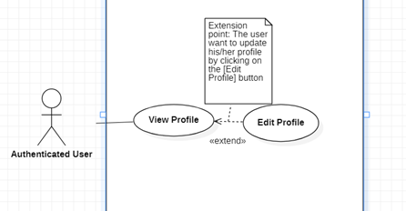

|  |  |  |  |
| --- | --- | --- | --- |
| USE-UC003 | | | |
| Use Case No. | UC003 | Use Case Version | 1.0 |
| Use Case Name | Edit profile | | |
| Author | Nguyen Xuan Khanh Hoa | | |
| Date | 26/02/2021 | Priority | Normal |
| Actor: - Authenticated User Summary: - This use case helps user edit profile Goal: - User can edit profile Triggers: - User touches on “Edit Profile” Precondition: - User must login to the system  - User touches on “View Profile” Post Conditions: - Success: User updates profile successfully. The system shows message “Update profile successfully”. Main Success Scenario: | | | |
| Step | Actor Action | System Response | |
| 1 | User touches on “View profile” | Show the profile | |
| 2 | User touches “Edit profile” (user is customer)  [Alternative 1] | Show editable table including information:   * Name: required textbox * Telephone Number: required textbox * Address: required textbox * Password: required textbox | |
| 3 | User edits information |  | |
| 4 | User chooses "Save" option  [Alternative 2] | * New profile information updated in database. * Show message: “Update profile successfully” | |
| Alternative Scenario: | | | |
| Step | Actor Action | System Response | |
| 1 | User touches “Edit profile” (user is repairer) | Show editable table including information:   * Name: required textbox * Telephone Number: required textbox * Required Major: required textbox * Description: required textbox * Password: required textbox | |
| 2 | User chooses "Save" option but some of required textbox is null | Show message “This field is not null” | |
| Exceptions: | | | |
| Step | Actor Action | System Response | |
| 1 |  | System show message the "System is busy" when the internet is lost | |
| Relationships: View Profile  Business Rules: - User must be login to app before use this function   * Password is encrypted before being sent to system * System updates new user's information in database | | | |

## View the repairer’s information

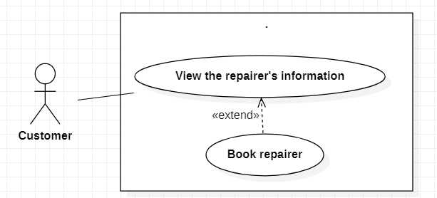

|  |  |  |  |
| --- | --- | --- | --- |
| USE-UC004 | | | |
| Use Case No. | UC004 | Use Case Version | 1.0 |
| Use Case Name | View repairer's information | | |
| Author | Nguyen Xuan Khanh Hoa | | |
| Date | 30/01/2021 | Priority | Normal |
| Actor: - Customer Summary: - This use case helps customer view repairer's information Goal: - Customer can view repairer's information Triggers: - Customer chooses a specific repairer in the list Precondition: - Customer must login to the system Post Conditions: - Success: Show repairer’s information Main Success Scenario: | | | |
| Step | Actor Action | System Response | |
| 1 | Customer touches on the list of repairers | Display the list of repairers | |
| 2 | Customer touches on a specific repairer | Show repairer's information which contains:   * Name * Telephone Number * Repaired Major * Description | |
| Alternative Scenario: N/A | | | |
| Exceptions: | | | |
| Step | Actor Action | System Response | |
| 1 |  | System show message the "System is busy" when the internet is lost | |
| Relationships: Book repairer  Business Rules: - This function is only for Customer - System shows repairer info from database | | | |

## Report problem

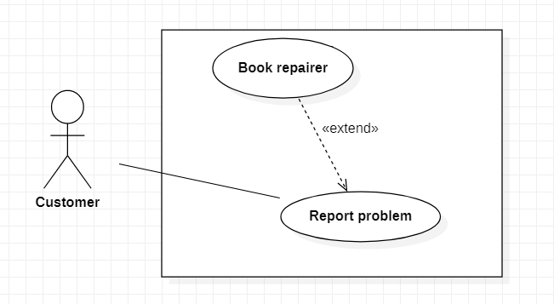

|  |  |  |  |
| --- | --- | --- | --- |
| USE-UC005 | | | |
| Use Case No. | UC005 | Use Case Version | 1.0 |
| Use Case Name | Report problem | | |
| Author | Nguyen Xuan Khanh Hoa | | |
| Date | 30/01/2021 | Priority | High |
| Actor: - Customer Summary: - This use case helps customer give information about problem that needs repairing to the system Goal: - Customer can report problem Triggers: - Customer touches on “Report Problem” Precondition: - Customer must login into the system Post Conditions: - Success: System suggests repairer that can solve customer’s problem Main Success Scenario: | | | |
| Step | Actor Action | System Response | |
| 1 | Customer touches on “Report problem” | Display the report problem view that includes information:   * Problem info: textbox * Problem image: camera image | |
| 2 | Customer provide information about problem by input problem info/send problem image |  | |
| 3 | Customer touches on “report” button  [Alternative 1] | System records that problem and  suggest the repairer | |
| Alternative Scenario: | | | |
| Step | Actor Action | System Response | |
| 1 | Both problem info and problem image are null | Show message “Problem information is empty” | |
| Exceptions: | | | |
| Step | Actor Action | System Response | |
| 1 |  | System show message the "System is busy" when the internet is lost | |
| Relationships: Book repairer  Business Rules: - This function is only for Customer   * Customer must input problem info or send image problem | | | |

## View order history

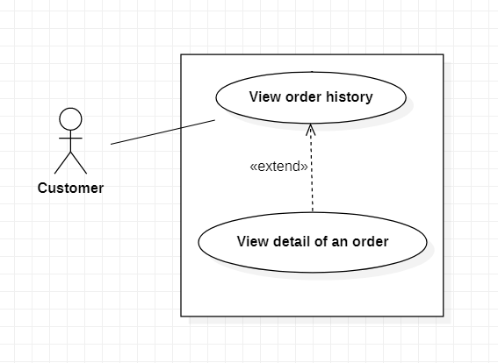

|  |  |  |  |
| --- | --- | --- | --- |
| USE-UC006 | | | |
| Use Case No. | UC006 | Use Case Version | 1.0 |
| Use Case Name | View order history | | |
| Author | Nguyen Xuan Khanh Hoa | | |
| Date | 30/01/2021 | Priority | Normal |
| Actor: - Customer Summary: - This use case helps customer view order history  Goal: - Customer can view order history Triggers: - Customer touches on “Order history” Precondition: - Customer must login into the system Post Conditions: - Success: System shows the list of orders that are done. Main Success Scenario: | | | |
| Step | Actor Action | System Response | |
| 1 | Customer touches on “Order history”  [Alternative 1] | Show the list of orders which are done | |
| Alternative Scenario: | | | |
| Step | Actor Action | System Response | |
| 1 | Customer touches on “Order history” but customer has not booking before | Show message “You don’t have any order” | |
| Exceptions: | | | |
| Step | Actor Action | System Response | |
| 1 |  | System show message the "System is busy" when the internet is lost | |
| Relationships: View detail of an order  Business Rules: - This function is only for Customer   * If customer hasn’t book repairer before, there is no order to view | | | |

## View detail of an order



|  |  |  |  |
| --- | --- | --- | --- |
| USE-UC007 | | | |
| Use Case No. | UC007 | Use Case Version | 1.0 |
| Use Case Name | View detail of an order | | |
| Author | Nguyen Xuan Khanh Hoa | | |
| Date | 30/01/2021 | Priority | Normal |
| Actor: - Customer Summary: - This use case helps customer view detail of an order  Goal: - Customer can view detail of an order Triggers: - Customer touches on an order in the order history Precondition: - Customer must login into the system   * Customer touches on “Order history” to view list of order   Post Conditions: - Success: System shows detail of an order  Main Success Scenario: | | | |
| Step | Actor Action | System Response | |
| 1 | Customer touches on “Order history”  [Alternative 1] | Show the list of orders which are done | |
| 2 | Customer touches on an order | Show detail of order:   * Problem name * Repairer * Repair Service * Date * Repairer Rate | |
| Alternative Scenario: | | | |
| Step | Actor Action | System Response | |
| 1 | Customer touches on “Order history” but customer has not booking before | Show message “You don’t have any order” | |
| Exceptions: | | | |
| Step | Actor Action | System Response | |
| 1 |  | System show message the "System is busy" when the internet is lost | |
| Relationships: View order history  Business Rules: - This function is only for Customer   * If customer hasn’t book repairer before, there is no order to view | | | |

## Accept order

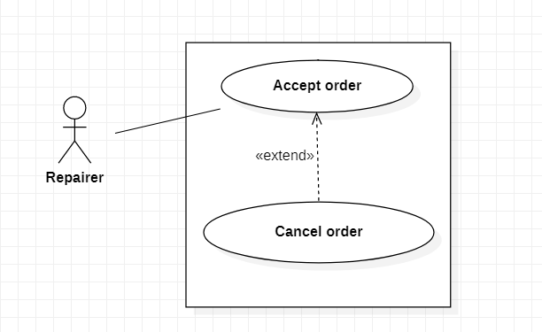

|  |  |  |  |
| --- | --- | --- | --- |
| USE-UC008 | | | |
| Use Case No. | UC008 | Use Case Version | 1.0 |
| Use Case Name | Accept order | | |
| Author | Nguyen Xuan Khanh Hoa | | |
| Date | 30/01/2021 | Priority | High |
| Actor: - Repairer Summary: - This use case helps repairer accept an order  Goal: - Repairer can accept order Triggers: - Repairer touches on “Accept order” Precondition: - Repairer must login into the system  Post Conditions: - Success: An order is accepted  Main Success Scenario: | | | |
| Step | Actor Action | System Response | |
| 1 | Repairer is on the order view  [Alternative 1] | Show the list of orders | |
| 2 | Repairer touches on “Accept order” on the line of an order | System show message “The order is accepted” | |
| Alternative Scenario: | | | |
| Step | Actor Action | System Response | |
| 1 | Repairer is on the order view but there is no order | Show message “Now you don’t have any suggest order” | |
| Exceptions: | | | |
| Step | Actor Action | System Response | |
| 1 |  | System show message the "System is busy" when the internet is lost | |
| Relationships: Cancel order  Business Rules: - This function is only for Repairer   * Repairer can only accept an order when does not have any other order | | | |

## Login

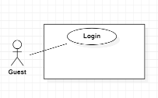

|  |  |  |  |
| --- | --- | --- | --- |
| USE-UC009 | | | |
| Use Case No. | UC009 | Use Case Version | 1.0 |
| Use Case Name | Login | | |
| Author | ChauVM | | |
| Date | 21/01/2021 | Priority | Low |
| Actor: - Guest Summary: - This use case allows guest to log in the system Goal: - Guest can log in the system Triggers: - Guest choose "Login" option  Precondition: - N/A Post Conditions: - Success: Guest login the system Main Success Scenario: | | | |
| Step | Actor Action | System Response | |
| 1 | Guest goes to login view | System requires identity information form Guest:  - Email or user code: free text input  - Password: free text input | |
| 2 | Guest inputs information |  | |
| 3 | Guest sends command to login to system | Guest will login system with their specific role [Alternative 1] [Exception 1] | |
| Alternative Scenario: | | | |
| Step | Actor Action | System Response | |
| 1 | Guest enter wrong identity information | Wrong identity information, System shows error message | |
| Exception: | | | |
| Step | Actor Action | System Response | |
| 1 |  | System show message “No Internet connection please try again later” when the internet is lost | |
| Relationships: N/A Business Rules: - Password are encrypted before being sent to server - After login to system, guest will redirect to specific view based on their role on the system: repairer or customer - If role is “Customer”, the system will display to Customer view - If role is “Repairer”, the system will display to Repairer view | | | |

## Search a repairer

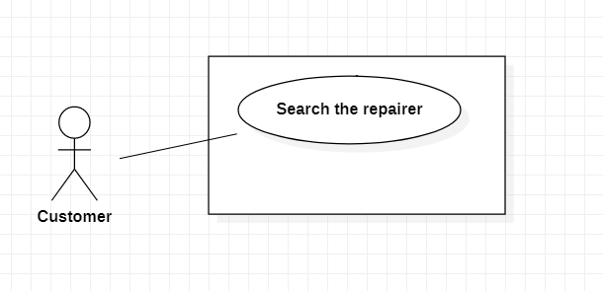

|  |  |  |  |
| --- | --- | --- | --- |
|  | Search the repairer |  |  |
| USE-UC010 | | | |
| Use Case No. | UC010 | Use Case Version | 1.0 |
| Use Case Name | Search the repairer | | |
| Author | ChauVM | | |
| Date | 20/01/2021 | Priority | Medium |
| Actor: - Customer Summary: - This use case help customer search repairer Goal: - Customer can search repairer info Triggers: - Customer choose "Search" option Precondition: - Customer must login Post Conditions: - Success: Show repairer's info Main Success Scenario: | | | |
| Step | Actor Action | System Response | |
|  | Customer goes to list of repairers | Display list of repairers | |
| 2 | Customer type repairer name | Display list of repairers have similar name | |
| 2 | Customer choose “Search” option |  | |
| 3 | Customer sends command to system | System will show repairer info [Alternative Scenario 1] [Exception 1] | |
| Alternative Scenario: | | | |
| Step | Actor Action | System Response | |
| 1 |  | System shows similar repairer info | |
| Exceptions: | | | |
| Step | Actor Action | System Response | |
| 1 |  | System show message the "System is busy" when the internet is lost | |
| 2 |  | System show message the "Not found" | |
| Relationships: View the list of repairers Business Rules: - This function is only for Customer - User must be login to app before use this function - Search request will be sent to the system - System show repairer info from database | | | |

## Remove a repairer

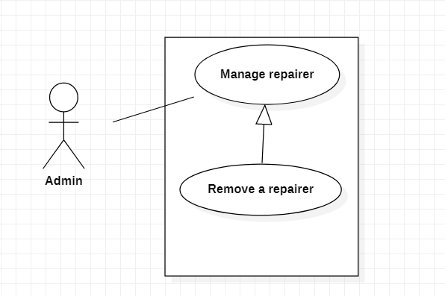

|  |  |  |  |
| --- | --- | --- | --- |
| USE-UC011 | | | |
| Use Case No. | UC011 | Use Case Version | 1.0 |
| Use Case Name | Remove a repairer | | |
| Author | ChauVM | | |
| Date | 20/01/2021 | Priority | High |
| Actor: - Admin Summary: - This use case help admin remove repairer Goal: - Admin can remove a repairer Triggers: - Admin sends request by choosing Remove option Precondition: - User must login in role "Admin" Post Conditions: - Success: Send the remove request Main Success Scenario: | | | |
| Step | Actor Action | System Response | |
| 1 | Admin goes to repairer info | Display repairer info | |
| 2 | Admin choose “Remove” option | The system will return 2 cases: - Show the profile screen - Show error message | |
| 3 | Admin sends command to system | System will remove repairer from database  [Exception 1] | |
| Alternative Scenario: N/A | | | |
| Exceptions: | | | |
| Step | Actor Action | System Response | |
| 1 |  | System show message the "System is busy" when the internet is lost | |
| Relationships: N/A Business Rules: -This function is only for Admin - User must be login to app before use this function - Remove request will be sent to the system - System remove repairer info from database - A message will be shown after the process is completed | | | |

## Rate repairer

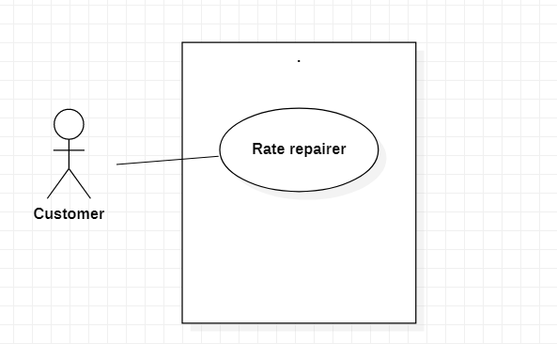

|  |  |  |  |
| --- | --- | --- | --- |
|  | Rate repairer |  |  |
| USE-UC012 | | | |
| Use Case No. | UC012 | Use Case Version | 1.0 |
| Use Case Name | Rate repairer | | |
| Author | ChauVM | | |
| Date | 20/01/2021 | Priority | Low |
| Actor: - Customer Summary: - This use case help customer rate a repairer Goal: - Customer can give their comment about a repairer Triggers: - Customer choose "Rate" option Precondition: - User must be Customer Post Conditions: - Success: Send report request to Admin Main Success Scenario: | | | |
| Step | Actor Action | System Response | |
| 1 | Customer goes to repairer info | Display repairer info | |
| 2 | Customer chooses “Rate” option | Display new view require user input some information: - Choose from 1 star to 5 stars - Comment: free text input, required, length 1 - 250 | |
| 3 | Customer inputs information |  | |
| 4 | Customer sends report request to system | Send request to system [Exception 1] | |
| Alternative Scenario: N/A | | | |
| Exceptions: | | | |
| Step | Actor Action | System Response | |
| 1 | User didn’t put any information | Show message to notify user that they have to input information | |
| 2 |  | System show message the "System is busy" when the internet is lost | |
| Relationships: N/A Business Rules: - This function is only for Customer - User must be login to app before use this function - Rate request will be sent with inputted information - A message will be shown after the process is completed | | | |

## Search the repair service

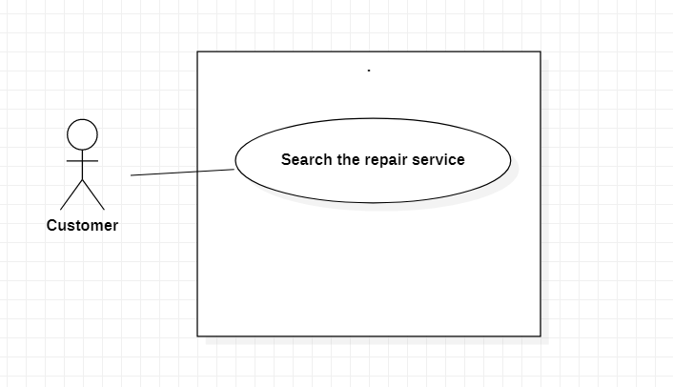

|  |  |  |  |
| --- | --- | --- | --- |
| USE-UC013 | | | |
| Use Case No. | UC013 | Use Case Version | 1.0 |
| Use Case Name | Search the repair service | | |
| Author | ChauVM | | |
| Date | 04/03/2021 | Priority | Medium |
| Actor: - Customer Summary: - This use case help customer search repair service Goal: - Customer can search repair service Triggers: - Customer choose "Search" option Precondition: - User must be Customer Post Conditions: - Success: Show repair service available Main Success Scenario: | | | |
| Step | Actor Action | System Response | |
|  | Customer goes to list of repair services | Display list of repair service | |
| 2 | Customer type repair service's name or problem | Display list of repair service have similar name or suitable to Customer's problem | |
| 2 | Customer choose “Search” option |  | |
| 3 | Customer sends command to system | System will show repair service [Alternative Scenario 1] [Exception 1] | |
| Alternative Scenario: | | | |
| Step | Actor Action | System Response | |
| 1 |  | System shows similar repair service | |
| Exceptions: | | | |
| Step | Actor Action | System Response | |
| 1 |  | System show message the "System is busy" when the internet is lost | |
| 2 |  | System show message the "Not found" | |
| Relationships: N/A Business Rules: - This function is only for Customer - User must be login to app before use this function - Search request will be sent to the system - System show repair service info from database | | | |

## View the repair service informati

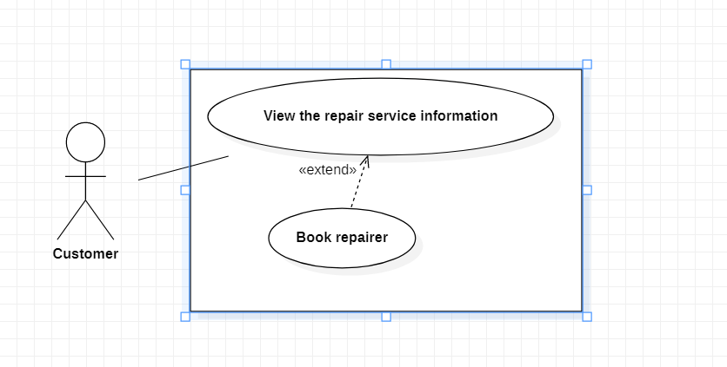

|  |  |  |  |
| --- | --- | --- | --- |
| Use Case No. | UC014 | Use Case Version | 1.0 |
| Use Case Name | View repair service information | | |
| Author | ChauVM | | |
| Date | 03/03/2021 | Priority | Low |
| Actor: - Customer Summary: - This use case allows customer to view repair service information Goal: - Customer can view repair service information Triggers: - Customer click on a category - Customer click on a specific repair service Precondition: - User must be Customer  Post Conditions: - Success: System show details of repair service Main Success Scenario: | | | |
| Step | Actor Action | System Response | |
| 1 | Customer click on service category | System show the list of repair service | |
| 2 | Customer click on a repair service | System show details of repair service [Exception 1] | |
| Alternative Scenario: N/A | | | |
| Exception: | | | |
| Step | Actor Action | System Response | |
| 1 |  | System show message “No Internet connection please try again later” when the internet is lost | |
| Relationships: Book repairer Business Rules: - This function is only for Customer - User must be login to app with the role Customer before use this function - This function only show valid services | | | |

## View news

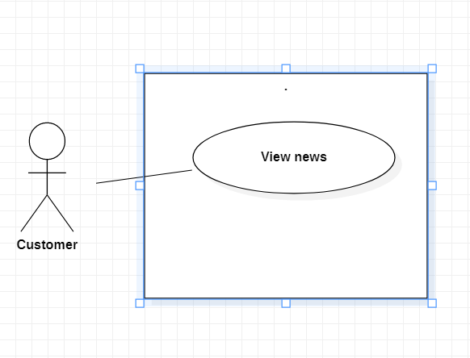

|  |  |  |  |
| --- | --- | --- | --- |
| USE-UC015 | | | |
| Use Case No. | UC015 | Use Case Version | 1.0 |
| Use Case Name | View news | | |
| Author | ChauVM | | |
| Date | 04/03/2021 | Priority | Medium |
| Actor: - Customer Summary: - This use case help Customer view news post by Admin Goal: - Customer can view news Triggers: - Customer click on the news Precondition: - User must be Customer Post Conditions: - Success: Show the news details Main Success Scenario: | | | |
| Step | Actor Action | System Response | |
| 1 | Customer goes to list of news | Display list of news | |
| 2 | Customer click on a news | Display news details [Exception 1] | |
| Alternative Scenario: N/A | | | |
| Exceptions: | | | |
| Step | Actor Action | System Response | |
| 1 |  | System show message the "System is busy" when the internet is lost | |
| Relationships: N/A Business Rules: - This function can be use by both Customer and Admin - User must be login to app before use this function - System show news details from database | | | |

## Book repairer

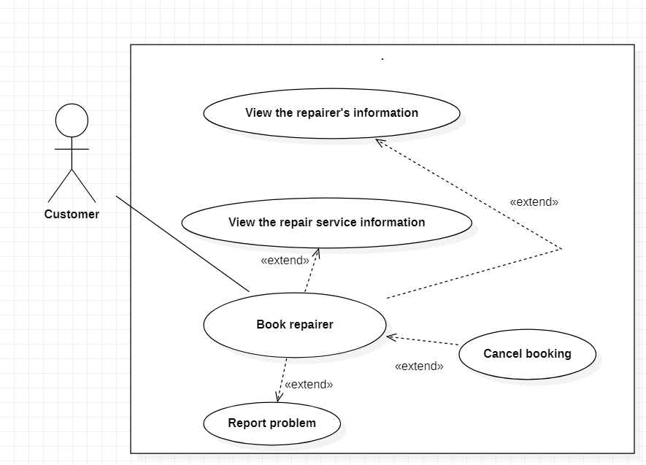

|  |  |  |  |
| --- | --- | --- | --- |
|  | Book Repairer |  |  |
| USE-UC016 | | | |
| Use Case No. | UC016 | Use Case Version | 1.0 |
| Use Case Name | Book repairer | | |
| Author | ThiLK | | |
| Date | 15/01/2021 | Priority | High |
| Actor: - Customer Summary: - Help customer to book repairer Goal: - Customer can book a repairman Triggers: - Customer login to the app - Customer click on the categories about repairer - Customer set location - Customer select repairer - Customer choose payment type Precondition: - User must be customer Post Conditions: - Success: Customer successful book repairer Main Success Scenario: | | | |
| Step | Actor Action | System Response | |
| 1 | Customer login to the app | The system will return 2 cases: -Show the main screen -Show login fail message | |
| 2 | Customer Click on the categories about repairer | The system will return 2 cases: -Show the list of categories about repairer - Show error message | |
| 3 | Customer enters filed about address | The system will return 2 cases: -Show the successful message -Show login fail message | |
| 4 | Customer click on the repairer they like | The system will return 2 cases: -Show payment request message -Show login fail message | |
| 5 | Customer choose on payment type | The system will return 2 cases: -Show the successful message -Show login fail message | |
| Alternative Scenario: | | | |
| Step | Actor Action | System Response | |
| 1 | Customer are not logged in | The System can’t let customer to book repairer | |
| Exceptions: | | | |
| Step | Actor Action | System Response | |
| 1 |  | System show message the "System is busy" when the internet is lost | |
| 2 | If payment failed | Show message to notify user that payment failed and the renew request has been aborted | |
| Relationships: View the repairer's information, View the repair service information, Cancel Booking, Report problem  Business Rules:  -This function is only for customer - User must be login to app to use this function -The bill detail will save to the database - Booking date must not be earlier than the current date. | | | |

## View the specific order

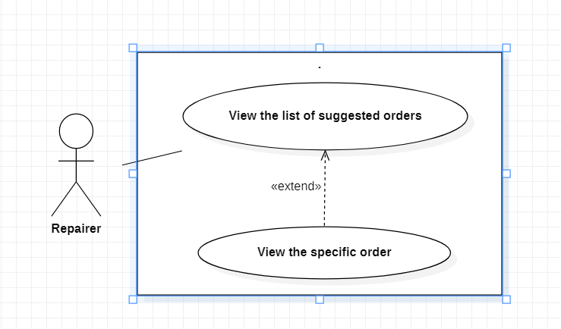

|  |  |  |  |
| --- | --- | --- | --- |
| USE-UC017 | | | |
| Use Case No. | UC017 | Use Case Version | 1 |
| Use Case Name | View the specific order | | |
| Author | ThiLK | | |
| Date | 15/01/2021 | Priority | Normal |
| Actor: | | | |
| -Repairer | | | |
| Summary: | | | |
| -Help repairer to view the specific order | | | |
| Goal: | | | |
| -Show the specific order to repairer | | | |
| Triggers: | | | |
| -Repairer login to the app | | | |
| -Repairer click view the list of suggested orders | | | |
| -Repairer choose the specific order | | | |
| Precondition: | | | |
| -User must be Repairer | | | |
| -The order has not been canceled by the system due to too long time | | | |
| Post Conditions: | | | |
| -Success: Repairer see the specific order | | | |
| Main Success Scenario: | | | |
| Step | Actor Action | System Response | |
| 1 | Repairer login to the app |  | |
| The system will return 2 cases: | |
| -Show the main screen | |
| -Show login fail message | |
| 2 | Repairer Click view the list of suggested orders | The system will return 2 cases: | |
| -Show the list of suggested orders | |
| - Show error message | |
| 3 | Repairer Click to the specific order | The system will return 2 cases: | |
| -Show the specific order | |
| - Show error message | |
| Alternative Scenario: | | | |
| Step | Actor Action | System Response | |
| 1 | Repair workers are not logged in | The System can’t show the list of suggested orders | |
|  |
| Exceptions: | | | |  |
| Step | Actor Action | System Response | |  |
| 1 |  | System show message the "System is busy" when the internet is lost | |  |
| 2 | Repairer don’t have any orders | System show message “You don’t have any orders” | |  |
| Relationships: View the list of suggested orders | | | |  |
| Business Rules: | | | |  |
| -This function is only for repairers | | | |  |
| -User must be login to app to use this function | | | |  |
| -User must have at least 1 order | | | |  |
| -This function only shows the valid orders | | | |  |

## View list of current orders

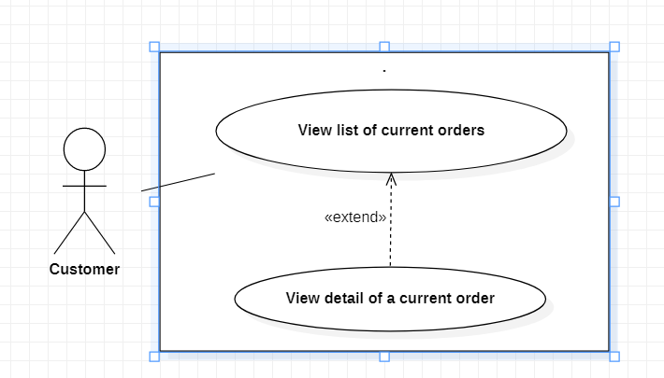

|  |  |  |  |
| --- | --- | --- | --- |
|  | View the List of current order(s) |  |  |
| USE-UC018 | | | |
| Use Case No. | UC018 | Use Case Version | 1.0 |
| Use Case Name | View the list of current orders | | |
| Author | ThiLK | | |
| Date | 15/01/2021 | Priority | High |
| Actor: - Customer Summary: - Help customer to view the list of current orders Goal: - Show the list of current orders to customer Triggers: - Customer clicks on current orders Precondition: - User must be Customer - The order has not been canceled by the system due to too long time Post Conditions: - Success: Customer see the list of current orders Main Success Scenario: | | | |
| Step | Actor Action | System Response | |
| 1 | Customer login to the app | The system will return 2 cases: -Show the main screen -Show login fail message | |
| 2 | Customer clicks on the profile icon | The system will return 2 cases: -Show the profile screen - Show error message | |
| 3 | Customer clicks on current orders | The system will return 2 cases: -Show the list of current orders - Show error message | |
| Alternative Scenario: | | | |
| Step | Actor Action | System Response | |
| 1 | Customer workers are not logged in | The System can’t show the list of current orders | |
| Exceptions: | | | |
| Step | Actor Action | System Response | |
| 1 |  | System show message the "System is busy" when the internet is lost | |
| 2 | Customer don’t have any orders | System show message “You don’t have any orders” | |
| Relationships: View detail of current order Business Rules: - This function is only for Customer - User must be login to app before use this function - User must have at least 1 order - This function only shows the valid orders | | | |

## View detail of a current order



|  |  |  |  |
| --- | --- | --- | --- |
| USE-UC019 | | | |
| Use Case No. | UC019 | Use Case Version | 1 |
| Use Case Name | View detail of current order | | |
| Author | ThiLK | | |
| Date | 15/01/2021 | Priority | Normal |
| Actor: | | | |
| -Customer | | | |
| Summary: | | | |
| -Help Customer to view detail of current order | | | |
| Goal: | | | |
| -Show the detail of current order | | | |
| Triggers: | | | |
| - Customer login to the app | | | |
| -Customer clicks on the profile icon | | | |
| -Customer clicks on show current orders | | | |
| -Customer clicks on one current order | | | |
| Precondition: | | | |
| -User must be Customer | | | |
| -The order has not been canceled by the system due to too long time | | | |
| Post Conditions: | | | |
| -Success: Customer see the list of current orders | | | |
| Main Success Scenario: | | | |
| Step | Actor Action | System Response | |
| 1 | Customer login to the app |  | |
| The system will return 2 cases: | |
| -Show the main screen | |
| -Show login fail message | |
| 2 | Customer clicks on the profile icon | The system will return 2 cases: | |
| -Show the profile screen | |
| - Show error message | |
| 3 | Customer clicks on current orders | The system will return 2 cases: | |
| -Show the list of current orders | |
| - Show error message | |
| 4 | Customer clicks on one current order | The system will return 2 cases: | |
| -Show the detail of current order | |
| - Show error message | |
| Alternative Scenario: | | | |
| Step | Actor Action | System Response | |
| 1 | Customer workers are not logged in | The System can’t show the list of current orders | |
|  |
| Exceptions: | | | |  |
| Step | Actor Action | System Response | |  |
| 1 |  | System show message the "System is busy" when the internet is lost | |  |
| 2 | Customer don’t have any orders | System show message “You don’t have any orders” | |  |
| Relationships: View the list of current order(s), Cancel Booking | | | |  |
| Business Rules: | | | |  |
| -This function is only for Customer | | | |  |
| -User must be login to app before use this function | | | |  |
| -User must have at least 1 order | | | |  |
| -This function only shows the valid orders | | | |  |

## View the list of suggested orders



|  |  |  |  |
| --- | --- | --- | --- |
|  | View the List of suggested order(s) |  |  |
| USE-UC020 | | | |
| Use Case No. | UC020 | Use Case Version | 1.0 |
| Use Case Name | View the list of suggested orders | | |
| Author | ThiLK | | |
| Date |  | Priority | High |
| Actor: - Repairer Summary: - Help repairer to view the list of suggested orders Goal: - Show the list of suggested orders to repairer Triggers:  - Repairer press view the list of suggested orders Precondition: - User must be Repairer - The order has not been canceled by the system due to too long time Post Conditions: - Success: Repairer see the list of suggested orders Main Success Scenario: | | | |
| Step | Actor Action | System Response | |
| 1 | Repairer login to the app | The system will return 2 cases: -Show the main screen -Show login fail message | |
| 2 | Repairer Press view the list of suggested orders | The system will return 2 cases: -Show the list of suggested orders - Show error message | |
| Alternative Scenario: | | | |
| Step | Actor Action | System Response | |
| 1 | Repair workers are not logged in | The System can’t show the list of suggested orders | |
| Exceptions: | | | |
| Step | Actor Action | System Response | |
| 1 |  | System show message the "System is busy" when the internet is lost | |
| 2 | Repairer don’t have any orders | System show message “You don’t have any orders” | |
| Relationships: View the specific order | | | |
| Business Rules: -This function is only for repairers -User must be login to app to use this function -User must have at least 1 order -This function only shows the valid orders | | | |

## Cancel booking



|  |  |  |  |
| --- | --- | --- | --- |
|  | Cancel Booking |  |  |
| USE-UC021 | | | |
| Use Case No. | UC021 | Use Case Version | 1.0 |
| Use Case Name | Cancel Booking | | |
| Author | ThiLK | | |
| Date | 15/01/2021 | Priority | High |
| Actor: - Customer Summary: - Help customer to cancel booking Goal: - Customer cancel booking a repairer  Triggers: - Customer login to the app - Customer click view the list of current orders Precondition: - User must be Customer - The order has not been canceled by the system due to too long time Post Conditions: - Success: Customer successful cancel booking a repairer Main Success Scenario: | | | |
| Step | Actor Action | System Response | |
| 1 | Customer login to the app | The system will return 2 cases: -Show the main screen -Show login fail message | |
| 2 | Customer Click view the list of current orders | The system will return 2 cases: -Show the list of suggested orders - Show error message | |
| 3 | Customer click view detail of a current orders | The system will return 2 cases: - Show the detail of a current orders - Show error message | |
| 4 | Customer click cancel booking | The system will return 2 cases: - Show successful message - Show error message | |
| Alternative Scenario: | | | |
| Step | Actor Action | System Response | |
| 1 | Customer are not logged in | The System can’t show the list of suggested orders | |
| Exceptions: | | | |
| Step | Actor Action | System Response | |
| 1 |  | System show message the "System is busy" when the internet is lost | |
| 2 | Customer don’t have any orders | System show message “You don’t have any orders” | |
| Relationships: View the detail of a current orders, Book repairer, Report problem | | | |
| Business Rules: -This function is only for repairers -User must be login to app to use this function -User must have at least 1 order -This function only shows the valid orders -This function only cancels the valid orders | | | |

## Logout

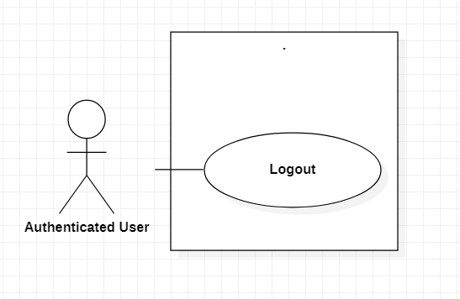

|  |  |  |  |
| --- | --- | --- | --- |
|  | Logout |  |  |
| USE-UC022 | | | |
| Use Case No. | UC022 | Use Case Version | 1.0 |
| Use Case Name | Logout | | |
| Author | ThiLK | | |
| Date | 15/01/2021 | Priority | Normal |
| Actor: - Authenticated User Summary: - Help Authenticated User to logout Goal: - Authenticated User logout the app  Triggers: - Authenticated User click Logout button Precondition: - Guest must be Login Post Conditions: - Success: Authenticated User successful logout the app Main Success Scenario: | | | |
| Step | Actor Action | System Response | |
| 1 | Guest login to the app | The system will return 2 cases: -Show the main screen -Show login fail message | |
| 2 | Authenticated User Click logout button | The system will return 2 cases: -Show logout successful message - Show error message | |
| Alternative Scenario: | | | |
| Step | Actor Action | System Response | |
| 1 | Customer are not logged in | The System can’t show the list of suggested orders | |
| Exceptions: | | | |
| Step | Actor Action | System Response | |
| 1 |  | System show message the "System is busy" when the internet is lost | |
| 2 | Customer didn’t login |  | |
| Relationships: N/A | | | |
| Business Rules: -This function is only for Authenticated User -User must be login to app to use this function | | | |

## Post a new

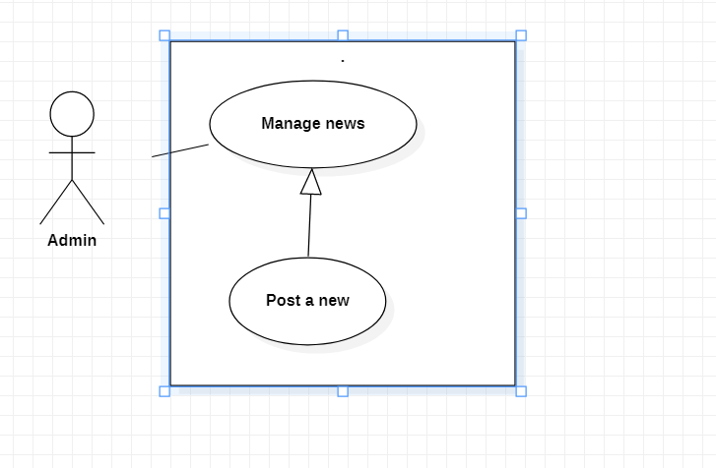

|  |  |  |  |
| --- | --- | --- | --- |
|  | Post a new |  |  |
| USE-UC023 | | | |
| Use Case No. | UC023 | Use Case Version | 1.0 |
| Use Case Name | Post a new | | |
| Author | LongNLT | | |
| Date | 20/01/2021 | Priority | Medium |
| Actor: - Admin Summary: - Post new(s) on the deals and new(s) Goal: - Show the user new deal(s) and new(s) Triggers: - Admin click Post Precondition: - User must be Admin - Deal(s) or New(s) that has been approved. Post Conditions: - Success: A new New/Deals has been uploaded Main Success Scenario: | | | |
| Step | Actor Action | System Response | |
| 1 | Admin clicks on the New icon | Display the list of News | |
| 2 | Admin clicks Add | Display the format of a new for input | |
| 3 | Admin input the news’ information | System will show if there is any wrong format input | |
| 4 | Admin click Post | Return to the list of news with the new news just added. | |
| Alternative Scenario: | | | |
| Step | Actor Action | System Response | |
| 1 |  | System show similar repairer info | |
| Exceptions: | | | |
| Step | Actor Action | System Response | |
| 1 |  | System show message the "System is busy" when the internet is lost | |
| 2 |  | System show message the "Not found" | |
| Relationships: N/A Business Rules: - This function is only for Admin - User must be login to app before use this function - Add request will be sent to the system - System will add the news’ information into database | | | |

## Remove a news

|  |  |  |  |
| --- | --- | --- | --- |
|  | Remove a new |  |  |
| USE-UC024 | | | |
| Use Case No. | UC024 | Use Case Version | 1.0 |
| Use Case Name | Remove a new | | |
| Author | LongNLT | | |
| Date | 21/01/2021 | Priority | Medium |
| Actor: - Admin Summary: - Delete a New Goal: - Delete a wrong or unnecessary new on the New List Triggers: - Admin click Delete Precondition: - User must be Admin Post Conditions: - Success: A new New/Deals will be deleted. Main Success Scenario: | | | |
| Step | Actor Action | System Response | |
| 1 | Admin clicks on the New icon | Display the list of News | |
| 2 | Admin clicks on a New | Display the news’ information | |
| 3 | Admin click Delete | System will show a confirm message | |
| 4 | Admin click Agree | Return to the list of news without the deleted new | |
| Alternative Scenario: | | | |
| Step | Actor Action | System Response | |
| 1 |  | System show other news that is old or unpopular | |
| Exceptions: | | | |
| Step | Actor Action | System Response | |
| 1 |  | System show message the "System is busy" when the internet is lost | |
| 2 |  | System show message the "Not found" | |
| Relationships: N/A Business Rules: - This function is only for Admin - User must be login to app before use this function - Add request will be sent to the system - System remove the news’ information into database | | | |

## Update a news

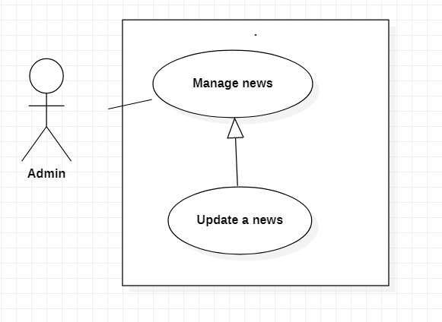

|  |  |  |  |
| --- | --- | --- | --- |
|  | Update a New |  |  |
| USE-UC025 | | | |
| Use Case No. | UC025 | Use Case Version | 1.0 |
| Use Case Name | Update a new | | |
| Author | LongNLT | | |
| Date | 21/01/2021 | Priority | Medium |
| Actor: - Admin Summary: - Update a New Goal: - Update the current wrong new Triggers: - Admin click Update Precondition: - User must be Admin Post Conditions: - Success: A new New/Deals will be updated. Main Success Scenario: | | | |
| Step | Actor Action | System Response | |
| 1 | Admin clicks on the New icon | Display the list of News | |
| 2 | Admin clicks on a New | Display the news’ information [Exception] | |
| 3 | Admin click Update | System let the Admin to change the news’ information | |
| 4 | Admin click Confirm | [Exception] System will show a confirm dialog | |
| 5 | Admin click Agree | Return to the list of news | |
| Alternative Scenario: | | | |
| Step | Actor Action | System Response | |
| 1 |  | System show other news | |
| Exceptions: | | | |
| Step | Actor Action | System Response | |
| 1 |  | System show message the "System is busy" when the internet is lost | |
| 2 |  | System show message the "Not found" | |
| Relationships: N/A Business Rules: - This function is only for Admin - User must be login to app before use this function - Add request will be sent to the system - System update the news’ information into database | | | |

## Ban a repairer

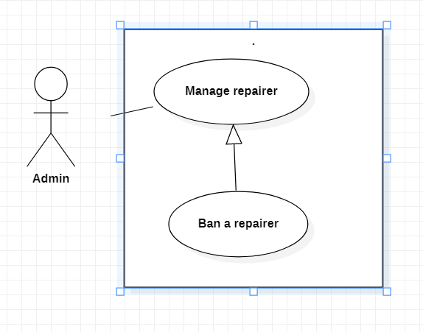

|  |  |  |  |
| --- | --- | --- | --- |
| USE-UC026 | | | |
| Use Case No. | UC026 | Use Case Version | 1.0 |
| Use Case Name | Ban a repairer | | |
| Author | LongNLT | | |
| Date | 22/01/2021 | Priority | High |
| Actor: - Admin Summary: - Ban a repairer Goal: - Ban a mistake making repairer Triggers: - Admin click Ban Precondition: - User must be Admin - Approved repairer's action has happen many time Post Conditions: - Success: A repairer has been Ban. Main Success Scenario: | | | |
| Step | Actor Action | System Response | |
| 1 | Admin search for repairer(s) | Display the list of related repairer | |
| 2 | Admin clicks on a repairer | Display the repairer's information | |
| 3 | Admin click Ban | Show reason(s) and message to send | |
| 4 | Admin input reason and click confirm | System will show a confirm dialog | |
| 5 | Admin click Agree | Return main page with success message | |
| Alternative Scenario: | | | |
| Step | Actor Action | System Response | |
| 1 |  | System show other repairer | |
| Exceptions: | | | |
| Step | Actor Action | System Response | |
| 1 |  | System show message the "System is busy" when the internet is lost | |
| 2 |  | System show message the "Not found" | |
| Relationships: N/A Business Rules: - This function is only for Admin - User must be login to app before use this function - Message request will be sent to the system - System will add the ban's record into database - The current banned repairer will be unactive for a period of time | | | |

## Warn a repairer

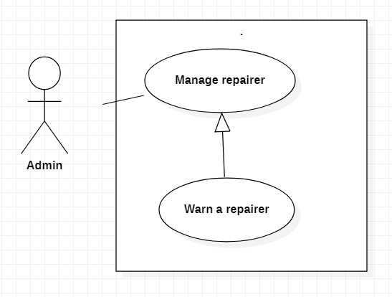

|  |  |  |  |
| --- | --- | --- | --- |
| USE-UC027 | | | |
| Use Case No. | UC027 | Use Case Version | 1.0 |
| Use Case Name | Warn a repairer | | |
| Author | LongNLT | | |
| Date | 22/01/2021 | Priority | Medium |
| Actor: - Admin Summary: - Warn a repairer Goal: - Warn a mistake making repairer Triggers: - Admin click Warn Precondition: - User must be Admin - Approved repairer's action Post Conditions: - Success: A repairer has been warned. Main Success Scenario: | | | |
| Step | Actor Action | System Response | |
| 1 | Admin search for repairer(s) | Display the list of related repairer | |
| 2 | Admin clicks on a repairer | Display the repairer's information | |
| 3 | Admin click Warn | Show reason(s) and message to send | |
| 4 | Admin input reason and click confirm | System will show a confirm dialog | |
| 5 | Admin click Agree | Return main page with success message | |
| Alternative Scenario: | | | |
| Step | Actor Action | System Response | |
| 1 |  | System shows other repairer | |
| Exceptions: | | | |
| Step | Actor Action | System Response | |
| 1 |  | System show message the "System is busy" when the internet is lost | |
| 2 |  | System show message the "Not found" | |
| Relationships: N/A Business Rules: - This function is only for Admin - User must be login to app before use this function - Message request will be sent to the system - System will add the warn record into database | | | |

## Cancel order

|  |  |  |  |
| --- | --- | --- | --- |
| USE-UC031 | | | |
| Use Case No. | UC031 | Use Case Version | 1 |
| Use Case Name | Cancel Order | | |
| Author | LongNLT | | |
| Date | 15/03/2021 | Priority | High |
| Actor: - Repairer Summary: - This use case allows repairer to cancel order Goal: - Repairer can cancel order Triggers: - Repairer press on the cancel order button. Precondition:  - User must login into the system with repairer role Post Conditions: - Success: Order accepted Main Success Scenario: | | | |
| Step | Actor Action | System Response | |
| 1 | Repairer views the list of accepted order | Display the list of accepted order | |
| 2 | Repairer press on the cancel order button | System show a reason chart | |
| 3 | Repairer choose the reason why he/she cancel the order. | System cancel the order and record it into database | |
| Alternative Scenario: none | | | |
| Exceptions: | | | |
| Step | Actor Action | System Response | |
| 1 |  | System show message the "System is busy" when the internet is lost | |
| Relationships: Cancel order | | | |
| Business Rules: -Repairer only cancel the order already been accepted. | | | |

## Reject order

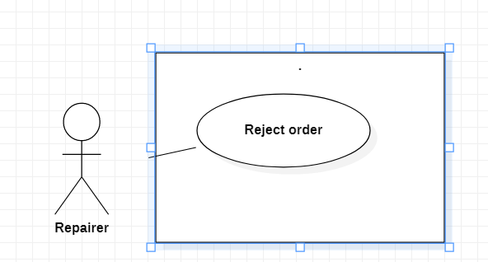

|  |  |  |  |
| --- | --- | --- | --- |
| USE-UC029 | | | |
| Use Case No. | UC029 | Use Case Version | 1.0 |
| Use Case Name | Reject order | | |
| Author | LongNLT | | |
| Date | 03/04/2021 | Priority | Medium |
| Actor: - Repairer Summary: - This use case is for repairer who want to reject customer's order Goal: - Repairer reject an order Triggers: - Repairer click reject Precondition: - User must be a Repairer Post Conditions: - Success: Reject and delete the out-going order Main Success Scenario: | | | |
| Step | Actor Action | System Response | |
| 1 | Repairer view the list of on-going order | Display list of on-going order | |
| 2 | Repairer Click the Reject button next to an order | Show a list of reasons why he/she reject the order | |
| 3 | Repairer choose the reason to reject | Select reason | |
| 4 | Repair click confirm | System will show repair service [Alternative Scenario 1] [Exception 1] | |
| Alternative Scenario: | | | |
| Step | Actor Action | System Response | |
| 1 |  |  | |
| Exceptions: | | | |
| Step | Actor Action | System Response | |
| 1 |  | System show message the "System is busy" when the internet is lost | |
| 2 |  | System show message the "Not found" | |
| Relationships: N/A Business Rules: - This function is only for Repairer. - User must be login to app before use this function. - Search request will be sent to the system. | | | |

# NON-FUNCTIONAL Requirements

## Usability

Repairer, Admin should need less than one day of training to be  
productive with the system.

## Reliability

A reliable application is one that meets the needs and expectations of everyone it serves. While those needs and expectations will vary from case to case, reliability is characterized by the ability of an app to: be accessible when needed and respond within the time frame needed. Our app guarantees all of that.

## Performance

The application’s load time should not be more than one second for users.

## Supportability

The application is design that it can be maintainable and extensible.

## Design Constraints

The application supports 2 main languages: Vietnamese and English.

The application is unified in selecting only 2 to 3 different programming languages and 1 type of structure to facilitate debugging and updating.

# Supporting Information

N/A