|  |  |
| --- | --- |
| ***Module*** | *CASA007 – Quantitative Methods* |
| ***Assignment*** | *Written Investigation* |
| ***Word Count*** | *1840* |

# Optimal Tube station locations with Linear Programming: The Bakerloo Line Extension case study

According to Transport for London’s report ‘Strategic Case for Metroisation in South and Southeast London’ (TfL, 2019), South London residents are missing out on opportunities because of inadequate public transit connectivity, with access to employment drops significantly in gaps between the few rapid transit lines that serve it such as the Northern Line, The Docklands Light Rail (DLR) and the London Overground – East London Line. The report also revealed that there are four times as many jobs within 45 minutes of Harrow (North London) compared to Sutton (South London). Consequently, residents are more likely to switch to the more environmentally unsustainable personal automobiles.

This unequal public transit access necessitated the proposal by the Mayor of London to extend the Bakerloo Line from its current terminus at Elephant & Castle to Lewisham, connecting it to other rail services together with two brand new stations along Old Kent Road (Figure 1). The Bakerloo Line Extension (BLE) is, therefore, one major component of a larger strategy to revitalise South London and improve its residents' lives.

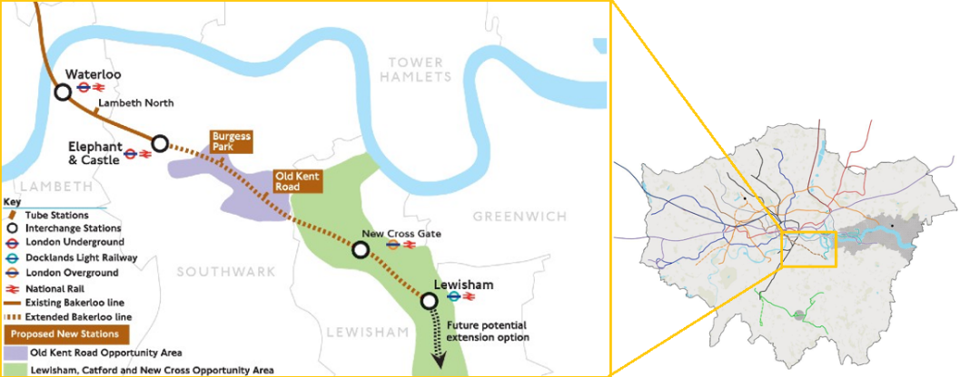

Figure 1 - Proposed Bakerloo Line Extension (Source: TfL)

With the BLE as our subject, this paper will use different Linear Programming models to determine the number and location of new stations along the new rail corridor needed to facilitate pedestrian access by minimising the time required to reach stations to a reasonable range. Finally, if found, the optimal solution for chosen station locations will be compared to TfL’s proposal to surface potential new location candidates.

## Methodology

Linear programming is a well-established methodology in transport planning, from service and employee scheduling (Gavish and Shlifer, 1979) to location planning (Jafari and Yaghini, 2019). When used in location planning, the main objective is to ensure that where the stations are located provides a positive effect on the travel experience compared to the status quo within the financial, technical, and operational constraints that all infrastructure projects need to contend with. In this study, the travel experience we seek to optimise will be how quick and easy it is for residents to access the new stations, one of many factors that motivate individuals to change their commute behaviour (Anwar, 2012). Research has shown that urban residents are only willing to walk up to around 10 minutes to reach a rapid transit station (Sarker, Mailer and Sikder, 2019).

A theoretical framework for determining station sites was outlined in detail by Hamacher et al. (2001), who defined two main objectives of this endeavour:

1. *Accessibility:* All or a predetermined share of the transit demand must be covered by at least a station. In the case of a single line segment, the problem will resemble the classic Location Set Covering Problem.
2. *Travel Time:* The station locations must also minimise both the time spent reaching them on foot and the incremental delays to passengers onboard with each additional stop added.[1]

This framework forms the foundation for our methodology, which involves formulating these two objectives as linear programming problems: First, to minimise stations built to cover all demand, the Location Set Covering Problem formulation was used (Church and Murray, 2018). Secondly, an adapted P-Median Problem formulation (Hakimi, 1965) was used to minimise the walking time. Here, the P-median Problem was chosen over the Maximum Coverage Location Problem for its focus on explicitly minimising population-weighted cost (or, in this context, walking time) rather than maximising population-weighted coverage (Karatas, Razi and Tozan, 2016).

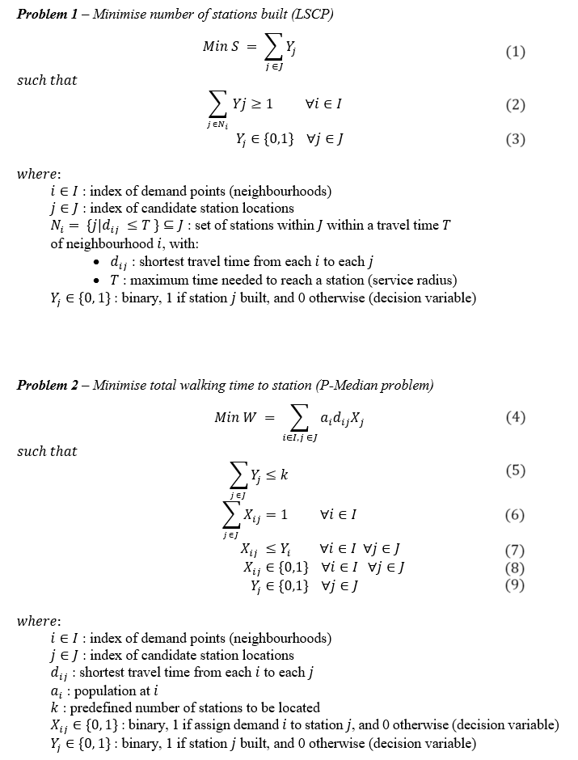

The mathematical formulation of the problems and their respective constraints may be verbally interpreted as follows:

Objective functions for the two problems.

Binary constraints for the decision variables.

Every neighbourhood *i* is within a max walking time T of min 1 station.

Maximum stations can be assigned.

Each neighbourhood is assigned only one station.

Each neighbourhood is assigned to station only if it’s built.

A note on our approach to problem formulation: As with most real-life problems with multiple interlocking objectives, the industry convention is to formulate the objectives as a Multi-objective Mathematical Programming (MMP) problem, commonly seen in transit planning research using linear programming (Benli and Akgün, 2023). In these instances, the objective functions are solved together with the others, producing a final set of Pareto-efficient solutions (i.e., Pareto front), from which decision-makers can weigh different options, each with its trade-off on one objective or another. (Chen and Zhou, 2022).

Due to our limited scope, we will instead explore a snapshot of the optimal solution universe by varying a key input parameter per problem within a manually set range. More specifically, we will explore all optimal solutions to **Problem 1** by varying (max walking time), and all optimal solutions to **Problem 2** by varying (max number of stations that can be built). However, such a brute-force approach would not be suitable for complex problems with more than two objectives.

## Data preparation

The neighbourhood and candidate location sets, and respectively, were acquired from the following workflow[2]:

1. Create a linestring for the corridor connecting Elephant & Castle with Lewisham, mainly following Old Kent Road (7.5 km)
2. Create a set of points 250m apart along the linestring as candidate stations.
3. Create the set of neighbourhoods (demand points) from the set of the Output Area centroids that intersect within a 1 km buffer area of the corridor.
4. Extract the population of all points in to population
5. Calculate the walking distance of all and pairs, or , using the publicly available OpenStreetMaps pedestrian routing server.

For BLE, we also designated candidate locations that must be included in the solution to allow connection with other lines at Elephant & Castle, New Cross Gate, and Lewisham stations. The candidates closest to the three locations above are . Therefore, we added the ad-hoc constraint to the two problems:

(10)

The resulting sets are visualised in Figure 2.

Figure 2 - Station candidate and neighbourhood sets

Finally, we need to address some oversimplifications made so far:

* The formation of the neighbourhood location set does not consider the propensity to use public transit, future transit demand, or local politics that might stipulate certain neighbourhoods to be included in (or excluded from) the catchment area, such as the designated Opportunity Areas in Southeast London. (*London City Hall*, 2023)
* The formation of the station candidate location set does not consider engineering feasibility, assuming all sites can accommodate an underground train station.
* Different routing services, such as that offered by Google or Mapbox, may yield a different cost matrix and, thus, different solutions to the problems.
* We assume that the BLE is a standalone line segment with no interactions with other current and future transit lines, whose stations might also cover the demand points in set . Without this assumption, the optimisation problem would be computationally prohibitive (Hamacher *et al.*, 2001).

To solve the two optimisation problems, we used the COIN-OR Linear Program solver deployed with pulp and spopt (specialised Python libraries for linear program and spatial optimisation, respectively)[3]

## Results

Figure 3 shows all optimal solutions for ***Problem 1*** *(Minimise station)* at different values (i.e., max walking time). From the graph we can see that, if is set below 1800 seconds (30 minutes), the problem is unsolvable. Therefore, if an average walking time of 10 minutes is used as a benchmark (Sarker, Mailer and Sikder, 2019), there are no feasible solutions.

*Figure 3 - Minimum stations needed at varying max walking time (Problem 1)*

Figure 4, on the other hand, shows all optimal solutions to ***Problem 2*** *(Minimise walking time)* at different values (i.e., number of stations). The problem is solvable at all values between 3 and 31, with a ‘knee’ at , at which the optimal solution is 586 seconds (~10 minutes) of average walking time[4]. Based on the external benchmark of 10 minutes, we can designate this optimal solution where to be a realistically viable option.

*Figure 4 - Minimum average walking time at varying numbers of stations given (Problem 2)*

## Discussion

When the chosen locations (k=7) are juxtaposed with the official proposal for the BEL, as shown in Figure 5, we can make several observations:

* The segments between Elephant & Castle and Burgess Park, and between New Cross Gate and Lewisham have no intermediary stations planned. As the solution suggests, adding infill stations here will benefit residents in these densely populated areas.
* The optimal solution also suggests that two stations 250m apart are needed between New Cross Gate and Lewisham, possibly due to this area’s density or poor pedestrian connection. Since such an alignment is unlikely to pass, stakeholders could consider adding only one station but with better pedestrian accessibility around the station.
* The planned Old Kent Road Station does not correspond to any chosen candidate in the solution, possibly because this area is sparsely populated but well connected on foot to other stations.

It is worth acknowledging various limitations in formulating the objective. For *Problem 1*, the construction cost of each station candidate can be added to serve as the weight parameter for the decision variable. (Church and Murray, 2018). For *Problem 2,*time delay to passengers on the trains as a function of additional stations could be added to the objective minimisation function. (Hamacher *et al.*, 2001).

To make the models more robust, more realistic operational constraints should also be considered, such as station capacity, project budget, minimum distances between two stations based on contemporary rail technology, etc. Lastly, the discrepancy around Old Kent Road station, addressed above, also reveals a shortcoming of the model of not accounting for the area's designation as an Opportunity Area (*London City Hall*, 2023), which is bound to see growth stemming from increased investments. Instead of the current population, the future projected population could be used to populate input parameter.

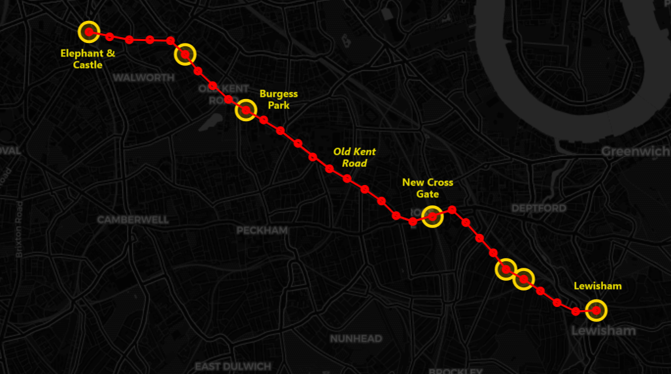

Figure 5 – Optimal solution with seven stations built (gold circles) vs. TfL proposal (station names)

## Conclusion

This has been an attempt to apply Linear Programming to determine where to build new stations for the Bakerloo Line Extension that can cover all neighbourhoods in a certain area and minimise walking time to the station to improve transit accessibility in South London.

Our findings suggest that a simple formulation of the Location Set Covering Problem (#1) yielded unsatisfactory results in terms of max walking time. On the other hand, an adapted P-Median Problem (#2) to minimise walking time as the primary objective while varying the parameter for the number of stations returned a more reasonable solution. Contrasting the solution with the official proposal for the BEL also reveals potential new station candidate locations that are not in the official proposal and the limitations of the models.

The formulation explored in this paper can be generalised for use by future research on station location planning. More specifically, there are merits in expanding the P-Median Problem (#2) into a Multi-objective Mathematical Programming (MMP) problem by combining with other secondary objectives to derive a more insightful set of Pareto-efficient solutions, and to make decision-making on complex problems more effective.

# References

Anwar, A. M. (2012). ‘Paradox between Public Transport and Private Car as a Modal Choice in Policy Formulation’. *Journal of Bangladesh Institute of Planners*, 2. doi: 10.3329/jbip.v2i0.9568.

Benli, A. and Akgün, İ. (2023). ‘A Multi-Objective Mathematical Programming Model for Transit Network Design and Frequency Setting Problem’. *Mathematics*, 11, p. 4488. doi: 10.3390/math11214488.

Church, R. L. and Murray, A. (2018). ‘Location Modeling and Covering Metrics’. in Church, R. L. and Murray, A. (eds) *Location Covering Models: History, Applications and Advancements*. Cham: Springer International Publishing (Advances in Spatial Science), pp. 1–22. doi: 10.1007/978-3-319-99846-6_1.

Gavish, B. and Shlifer, E. (1979). ‘An approach for solving a class of transportation scheduling problems’. *European Journal of Operational Research*, 3 (2), pp. 122–134. doi: 10.1016/0377-2217(79)90098-5.

Hakimi, S. L. (1965). ‘Optimum Distribution of Switching Centers in a Communication Network and Some Related Graph Theoretic Problems’. *Operations Research*. INFORMS, 13 (3), pp. 462–475. doi: 10.1287/opre.13.3.462.

Hamacher, H. W., Liebers, A., Schöbel, A., Wagner, D. and Wagner, F. (2001). ‘Locating New Stops in a Railway Network1 1This work was partially supported by the Human Potential Programme of the European Union under contract no. HPRN-CT-1999-00104 (AMORE).’ *Electronic Notes in Theoretical Computer Science*. (ATMOS 2001, Algorithmic MeThods and Models for Optimization of RailwayS (Satellite Workshop of ICALP 2001)), 50 (1), pp. 13–23. doi: 10.1016/S1571-0661(04)00162-8.

Jafari, H. and Yaghini, M. (2019). ‘Optimal Location of Subway Stations: A Case Study on Tehran Subway’. *International Journal of Railway Research*, 6 (2), pp. 123–131. doi: 10.22068/IJRARE.6.2.123.

Karatas, M., Razi, N. and Tozan, H. (2016). ‘A Comparison of p-median and Maximal Coverage Location Models with Q–coverage Requirement’. *Procedia Engineering*. (International Conference on Manufacturing Engineering and Materials, ICMEM 2016, 6-10 June 2016, Nový Smokovec, Slovakia), 149, pp. 169–176. doi: 10.1016/j.proeng.2016.06.652.

*London City Hall*. (2023). Available at: https://www.london.gov.uk/programmes-strategies/planning/implementing-london-plan/londons-opportunity-areas/oa-locations (Accessed: 17 January 2024).

Sarker, R. I., Mailer, M. and Sikder, S. K. (2019). ‘Walking to a public transport station: Empirical evidence on willingness and acceptance in Munich, Germany’. *Smart and Sustainable Built Environment*. Emerald Publishing Limited, 9 (1), pp. 38–53. doi: 10.1108/SASBE-07-2017-0031.

TfL. (2019). ‘Strategic case for metroisation in south and southeast London’.

1. Note that, for the sake of simplicity, in our model we will assume potential transit riders will only walk to stations instead of bus or car. The component of time delay for passengers onboard will also be omitted.
2. Data source: Office of National Statistics, Bing Maps
3. The codes used were based on PySAL library’s tutorials: <https://pysal.org/spopt/tutorials.html> and can be found in the GitHub repository: <https://github.com/hanukikanker/bakerloo-ext-lp>
4. Avg. walking time equals total walking time (objective function) divided by total population.