**HIPO Diagram**

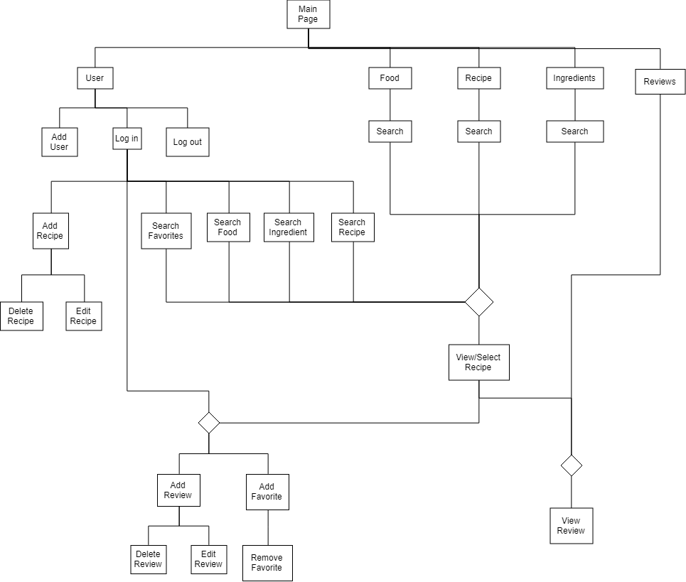

**Functions**

**Function:** Add User

**Inputs:** @UserID, @UserPassword

**Outputs:** None

**Pseudocode:**

Connect to the database

Query = INSERT INTO User(@UserId, @UserPassword);

Parse Query

Execute Query

Close connection to database

**Function:** User Log-in

**Inputs:** @UserID, @UserPassword

**Outputs:** Confirmation message???

**Pseudocode:**

Connect to the database

Query = EXIST FROM User(@UserId, @UserPassword);

Parse Query

Execute Query

Close connection to database

**Function:** Search Favorites

**Inputs:** @UserID, @FavoriteID???

**Outputs:** Rname, RID

**Pseudocode:**

Connect to the database

Query = SELECT r.Name, f.ID, u.ID

FROM Recipe as r , User as u, Favorite as f

WHERE u.ID = @UserID, f.ID = @FavoriteID, r.ID = f.ID

Parse Query

Execute Query

Close connection to database

**Function:** Search Food

**Inputs:** @FoodName

**Outputs:** r.No r.Name r.Time r.UserID

**Pseudocode:**

Connect to the database

Query = SELECT r.No r.Name r.Time r.UserID

FROM Recipe as r, Food as f

WHERE r.Name = @FoodName

Parse Query

Execute Query

Close connection to database

**Function:** Search Recipe

**Inputs:** @RecipeName

**Outputs:** r.No r.Name r.Time r.UserID

**Pseudocode:**

Connect to the database

Query = SELECT r.No r.Name r.Time r.UserID

FROM Recipe as r

WHERE r.Name = @RecipeName

Parse Query

Execute Query

Close connection to database

**Function:** Search Ingredient

**Inputs:** @IngredientName

**Outputs:** r.No r.Name r.Time r.UserID

**Pseudocode:**

Connect to the database

Query = SELECT r.No r.Name r.Time r.UserID

FROM Recipe as r, ConsistOf as c, Ingredient as i

WHERE (@IngredientName = i.name) AND (c.iname = i.name) AND (c.r_num = r.No)

Parse Query

Execute Query

Close connection to database

**Function:** View/Select Recipe

**Inputs:** @RecipeID

**Outputs:** rec.no, rec.name, rec.time, rec.userID, rec.info, rev.uID, rev.no, rev.rating

**Pseudocode:**

Connect to the database

Query = SELECT rec.no, rec.name, rec.time, rec.userID, rec.info, rev.uID, rev.rec_no, rev.rating

FROM Recipe as rec, Review as rev

WHERE (rec.no = @RecipeID) AND (rec.no = rev.rec_no)

Parse Query

Execute Query

Close connection to database

**Function:** Add Review

**Inputs:** @RecipeID, @UserID, @ReviewRating

**Outputs:** None

**Pseudocode:**

Connect to the database

Query = INSERT INTO Reivew(@UserID, @RecipeID, @ReviewRating);

Parse Query

Execute Query

Close connection to database

**Function:** Delete Review

**Inputs:** @RecipeID, @UserID, @ReviewRating

**Outputs:** None

**Pseudocode:**

Connect to the database

Query = DELETE FROM Reivew

WHERE (UserID = @UserID) AND (RecipeID = @RecipeID) AND (ReviewRating = @ReviewRating);

Parse Query

Execute Query

Close connection to database

**Function:** Edit Review

**Inputs:** @RecipeID, @UserID, @ReviewRating

**Outputs:** None

**Pseudocode:**

Connect to the database

Query = UPDATE Review

SET “attribute”

WHERE (UserID = @UserID) AND (RecipeID = @RecipeID) AND (ReviewRating = @ReviewRating);

Parse Query

Execute Query

Close connection to database

**Function:** Add Recipe

**Inputs:** @RNo, @RName, @RTime, @UserID

**Outputs:** None

**Pseudocode:**

Connect to the database

Query = INSERT INTO Recipe(@RNo, @RName, @RTime, @UserID);

Parse Query

Execute Query

Close connection to database

**Function:** Edit Recipe

**Inputs:** @RNo, @RName, @RTime, @UserID

**Outputs:** None

**Pseudocode:**

Connect to the database

Query = UPDATE Recipe

SET “attribute”

WHERE (RNo = @RNo) AND (RName = @RName) AND (RTime = @RTime) AND (UserID = @UserID);

Parse Query

Execute Query

Close connection to database

**Function:** Delete Recipe

**Inputs:** @RNo, @RName, @RTime, @UserID

**Outputs:** None

**Pseudocode:**

Connect to the database

Query = DELETE FROM Recipe

WHERE (RNo = @RNo) AND (RName = @RName) AND (RTime = @RTime) AND (UserID = @UserID);

Parse Query

Execute Query

Close connection to database

**Function:** Add Favorite

**Inputs:** @UserID, @RNo, @FName, @RRating

**Outputs:** None

**Pseudocode:**

Connect to the database

Query = INSERT INTO Favorite (@UserID, @RNo, @FName, @RRating)

Parse Query

Execute Query

Close connection to database

**Function:** Remove Favorite

**Inputs:** @UserID, @RNo, @FName, @RRating

**Outputs:** None

**Pseudocode:** Connect to the database

Query = DELETE FROM Favorite

WHERE (UserID = @UserID) AND (RNo = @RNo) AND (FName = @FName) AND (RRating= @RRating)

Parse Query

Execute Query

Close connection to database

**Data Flow Diagram**

