

Faculty of Engineering and Applied Science
ENGR 4941U Capstone Systems Design for ECSE II
Report #3

Collaborative Requirements Elicitation and Prioritization for Smart City Services

Team Members
First name | Last name | Student Id
Hanum | Magaji | 100829979
Kanishk | Ghai | 100815261
Owais | AbdurRahman | 100879105

Faculty Advisor: Dr. Sanaa Alwidian
Capstone Coordinator (Fall 2025): Dr. Q. Mahmoud

Table Of Contents
Table Of Contents 3
Detailed Design 6
1. Technical diagrams 6
1.1 System block diagram 6
2. Architectures and interfaces 8
2.1 Application architecture and routing 8
2.2 AI and database interfaces 8
3. Algorithms, data structures, and control logic 9
3.1 Prompt‑based requirements synthesis and editing 9
3.2 Data structures for requirements and tasks 9
3.3 Client‑side control logic 9
4. Mathematical or analytical modeling 10
4.1 Priority scale and MoSCoW mapping 10
4.2 AI‑driven JSON patch semantics 10
5. Design parameters and constraints 10
5.1 AI and infrastructure parameters 10
5.2 Project‑level constraints 11
6. Software module‑level decomposition 11
6.1 Front‑end modules 11
6.2 Back‑end / API modules 11
7. Communication Protocols and API Definitions 11
7.1 Communication Protocols 12
8. Risk Analysis and Mitigation Strategies 12
9. Design Justification and Trade-off Analysis 13
Unit and Integration Testing 14
1. Test Procedures and Setups 14
2. Test Cases and Results 14
3. Interpretation of Findings 15
Project Plan 16
Contribution Matrix 19

Detailed Design

1. Technical diagrams

1.1 System block diagram
The implemented platform follows a three‑tier web architecture with AI‑assisted services for collaborative requirements engineering in smart‑city projects. The presentation layer is a React single‑page application that uses React Router to provide public views (Home, Pricing) and authenticated workspaces, including Dashboard, Projects, and project‑specific pages for requirements, tasks, calendar, and discussions. Authentication is handled via Supabase sessions stored in an AuthContext, and all protected routes are wrapped by a ProtectedRoute component that checks the current session state before rendering. The application layer is split between client‑side logic and serverless API endpoints (/api/generateRequirements, /api/editRequirements, /api/generateTasks) that orchestrate OpenAI models and Supabase storage. The data layer is backed by Supabase Postgres tables such as projects, requirements, and tasks, which store project metadata, stakeholder requirements, and AI‑generated implementation tasks in line with requirements‑management practices discussed in prior work.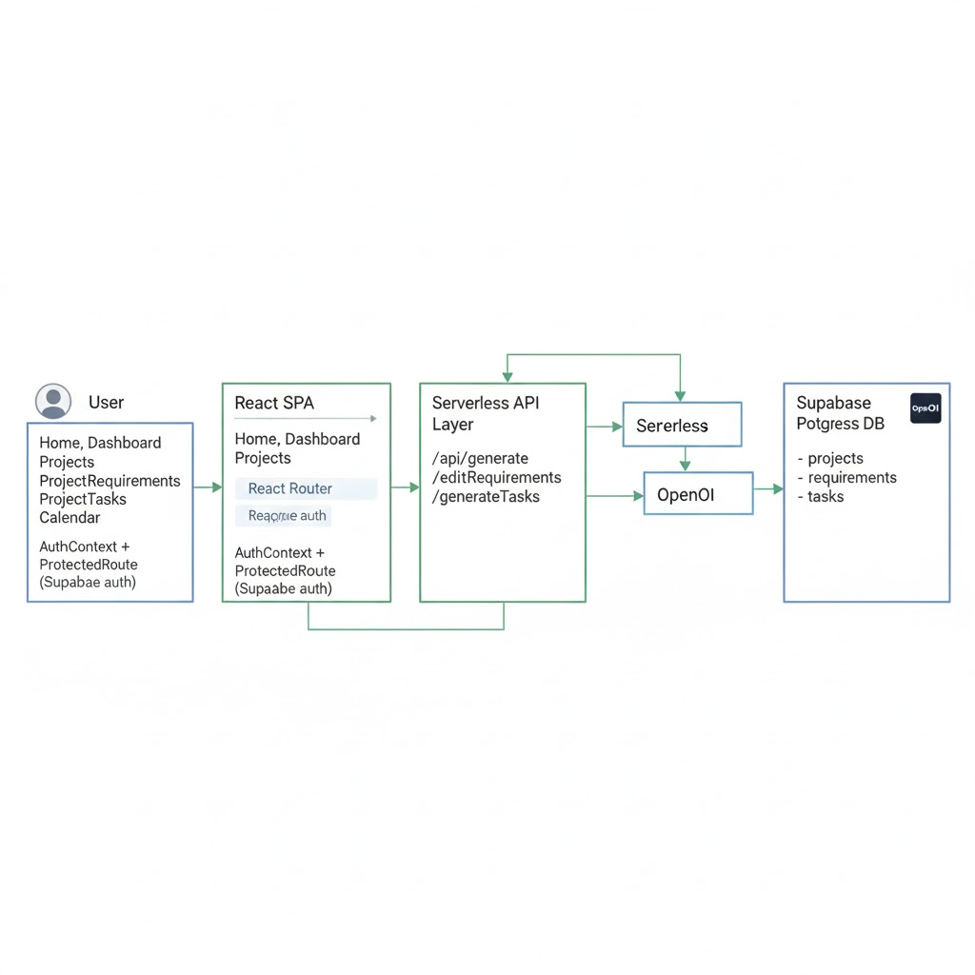

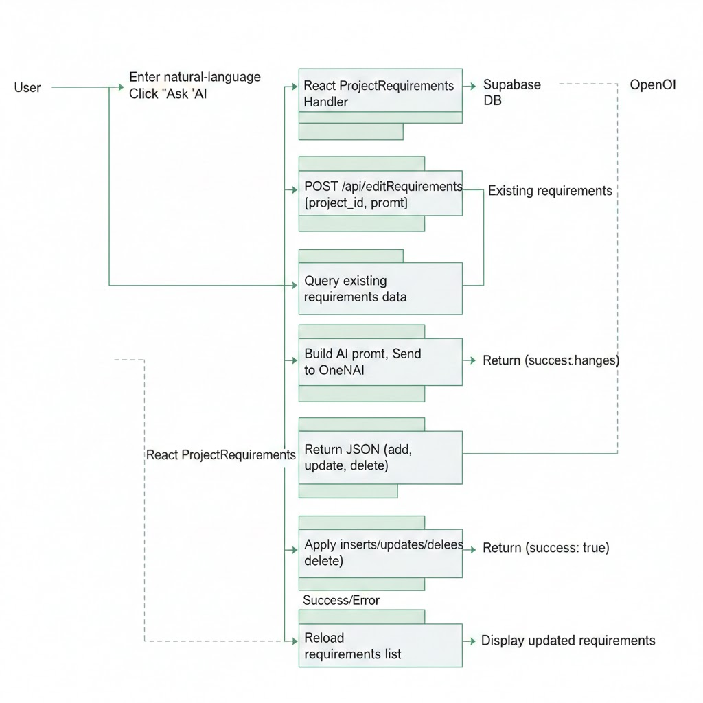

2. Architectures and interfaces

2.1 Application Architecture and Routing
The front‑end architecture adopts established single‑page application patterns, with React Router defining public and authenticated route groups. Public routes include / (Home), /pricing, and /auth, while authenticated routes under a ProtectedRoute wrapper cover /dashboard, /projects, and nested project routes such as /projects/:id/requirements, /projects/:id/tasks, /projects/:id/calendar, and /projects/:id/settings, reflecting best practices for role‑based access to engineering artifacts,. The AuthProvider component listens to Supabase auth state changes and exposes session and loading flags to the rest of the app, enabling consistent control of navigation and conditional rendering of authenticated navigation bars and project sidebars. This structure supports the incremental, iterative capstone process planned in earlier phases while remaining compatible with integration into tools such as Jira or GitHub.

2.2 AI and database interfaces
The AI‑assisted behavior is encapsulated in Node‑based serverless handlers that communicate via JSON over HTTP, consistent with modern web‑API design. POST /api/generateRequirements accepts a project_id and a project description, invokes an OpenAI model with a constrained output format, extracts a JSON array of {text, priority} objects, and inserts them into the requirements table with an initial status of pending, thereby automating a portion of textual requirements authoring. POST /api/editRequirements accepts a project_id and natural‑language prompt, retrieves the current requirement set, asks the model to propose add, update, and delete operations as JSON, and then applies those deltas in Supabase, effectively treating the model as an AI co‑editor for evolving requirement baselines. POST /api/generateTasks extends this pattern by generating structured task objects {name, description, priority, due_date} for the tasks table, providing a bridge from stakeholder requirements to implementation planning that aligns with traceability recommendations in requirements‑engineering tools such as Jama and Modern Requirements.

3. Algorithms, data structures, and control logic

3.1 Prompt‑based requirements synthesis and editing
Rather than implementing custom topic‑modeling or clustering algorithms at this stage, the platform uses large language models to synthesize and reorganize structured requirement objects from natural‑language prompts, similar in spirit to recent AI‑assisted requirements tools. For the initial generation, the serverless handler constructs an instruction prompt that requests a pure JSON array of requirements with text and priority fields, and the model’s response is post‑processed to strip markdown fences, extract the first JSON array, and parse it into JavaScript objects for insertion. For editing, the algorithm passes the full list of existing requirements and the user’s change request to the model and instructs it to output a JSON object with three arrays - add, update, and delete - each specifying the necessary fields, so that the resulting change set can be applied transactionally in Supabase. This pattern mirrors the idea of having an AI assistant refine, rephrase, or reprioritize requirements while keeping the authoritative source of truth in a structured repository, as advocated in recent literature on AI‑enabled RE workflows

3.2 Data structures for requirements and tasks
Requirements are stored in a requirements table with fields such as id, project_id, text, priority, status, and created_at, matching the traceability and measurability requirements defined in earlier reports. Each requirement is linked to its parent project via project_id, allowing per‑project filtering and supporting future export to external lifecycle tools. AI‑generated tasks are stored in a tasks table with project_id, name, description, priority, due_date, status, and an optional requirement_id, which preserves a direct relationship between a high‑level requirement and its derived implementation tasks as recommended in systems‑engineering standards.

3.3 Client‑side control logic
The Project Requirements page encapsulates the main client‑side orchestration of CRUD and AI workflows for requirements. On mount, it queries Supabase for all requirements with the current project_id, ordered by priority and created_at, and stores them in local component state for rendering and interaction. Manual add, update, and delete actions translate directly into Supabase insert, update, and delete operations, respectively, followed by local reloads to keep the view consistent with the database, as is common in cloud‑backed single‑page architectures. The AI‑edit handler posts project_id and the natural‑language prompt to /api/editRequirements, handles network or parsing errors, and, on success, refreshes the requirement list, effectively combining human supervision with automated bulk edits

4. Mathematical or analytical modeling

4.1 Priority scale and MoSCoW mapping
Both requirements and tasks use an integer priority field in the range 1–3, representing an ordinal scale from high to low importance, which is compatible with lightweight prioritization frameworks such as MoSCoW,. A straightforward mapping from numeric levels to MoSCoW categories is 1 → Must, 2 → Should, and 3 → Could, while “Won’t” requirements can be stored as archived items or assigned a separate status flag. This mapping allows the current implementation to remain simple while still supporting more formal prioritization workflows, including integration with RICE or stakeholder voting in future iterations.

4.2 AI‑driven JSON patch semantics
The AI editing process can be interpreted as computing a change set ΔR over an existing requirement set R based on a user prompt P, analogous to a JSON patch operation. The add array introduces new requirements not present in R, the update array modifies selected elements of R by id, and the delete array marks certain requirements for removal, leading to an updated set R′= (R∪add∖delete) with updated fields as specified. Although the underlying model is non‑deterministic, the handler enforces strict JSON parsing and fails safely if parsing errors occur, ensuring that the persistent requirements baseline remains consistent with typical integrity constraints used in RE repositories.

5. Design parameters and constraints

5.1 AI and infrastructure parameters
The serverless handlers currently use the gpt‑4o‑mini model with moderate temperature and a maximum of 2048 output tokens, trading off between creativity and determinism while keeping response size and cost within capstone constraints. The JSON‑only output contract and the regular‑expression‑based extraction of the first JSON array are tuned to minimize parsing errors in practice, given known issues with large‑language‑model output formatting. On the infrastructure side, the use of Supabase with a service‑role key in the backend and anonymous keys in the front end follows recommended patterns for securely combining client‑side CRUD with server‑side batch operations.

5.2 Project‑level constraints
As a two‑semester academic project, the platform must respect a limited budget, undergraduate team capacity, and university privacy policies, which together rule out more complex options such as dedicated GPU NLP servers or custom blockchain‑based ledgers for requirement storage. Instead, the design favors managed services (Supabase, OpenAI) and serverless functions, aligning with the incremental plan previously defined while still leaving room to incorporate more advanced techniques like explicit topic modeling, clustering, or KAOS goal diagrams in later phases. These constraints also shape the scope of the use‑case demonstration, which focuses on a smart‑city civic portal scenario rather than full municipal deployment.

6. Software module‑level decomposition

6.1 Front‑end modules
On the front end, the main modules include routing/layout, authentication context, navigation components, project workspace components, and requirements management. App.jsx and main.jsx compose the router, AuthProvider, and global CSS, while AuthContext.jsx encapsulates Supabase session management and exposes hooks used by ProtectedRoute, AuthNavbar, and ProjectSidebar. Project‑level pages (Projects, ProjectRequirements, ProjectSettings, ProjectTasks, etc.) act as feature modules responsible for fetching and mutating Supabase data and presenting it through coherent UI panels.

6.2 Back‑end / API modules
The serverless API layer is decomposed into focused modules: generateRequirements.js for initial requirement synthesis, editRequirements.js for AI‑driven refinement, generateTasks.js for task derivation, and deleteRequirement.js for controlled removal. Each module handles HTTP method checking, environment validation, error handling, OpenAI calls, output parsing, and database writes, following a consistent pattern that simplifies maintenance and testing. Together, these modules implement the AI‑assisted aspect of the collaborative platform and can be extended in future work to add clustering, conflict detection, and MoSCoW/RICE scoring endpoints that more directly realize the design specified in Reports 1 and 2

7. Communication Protocols and API Definitions
This section describes how different parts of the system talk to each other. We use standard web protocols to ensure the system is reliable and easy to connect.

7.1 Communication Protocols
HTTPS (Hypertext Transfer Protocol Secure): We use HTTPS for all communication between the user's browser (Client) and our server. This ensures that data, such as project details and passwords, is encrypted and safe.
JSON (JavaScript Object Notation): All data sent between the frontend and backend is formatted as JSON. This is a text-based format that is easy for both computers and humans to read.
API Definitions
The system uses "Serverless Functions" (code that runs only when triggered) to handle AI tasks. Here are the main API endpoints defined in the design:
- POST /api/generateRequirements
  - Input: Project ID and a description of the project.
  - What it does: It sends the description to OpenAI to create a list of requirements.
  - Output: A list of requirements with text and priority levels.
- POST /api/editRequirements
  - Input: Project ID and a prompt from the user (e.g., "Make these requirements more formal").
  - What it does: It asks the AI to look at the existing requirements and decide what to add, update, or delete.
  - Output: A list of changes to apply to the database.
- POST /api/generateTasks
  - Input: Project ID and specific requirements.
  - What it does: It asks the AI to turn high-level requirements into actionable tasks.
  - Output: A list of tasks including names, descriptions, priorities, and due dates.

8. Risk Analysis and Mitigation Strategies
Every project has risks. This section lists the potential problems identified and how we plan to fix or prevent them.
Risk | Impact | Mitigation Strategy (How we fix it)
AI "Hallucinations" (Incorrect Information) | The AI might generate requirements that do not make sense or are not true. | Human-in-the-loop: A human user must always review and approve the AI's suggestions before they are saved to the final list.  +1
Bad Formatting | The AI might return data that the system cannot read (e.g., broken JSON). | Strict Validation: We use code to clean the AI response (stripping extra text) and check that it is valid JSON before trying to use it.
Data Privacy | Sensitive project data could be exposed. | Role-Based Security: We use Supabase "Row Level Security." This means the database checks if a user is allowed to see a project before sending any data.
Cost Overruns | Using the AI too much could cost too much money. | Token Limits: We limit the size of the AI's response (max 2048 tokens) and use a cheaper model (gpt-4o-mini) to stay within the $800 budget.

9. Design Justification and Trade-off Analysis
This section explains why we chose specific tools and ignored others.
Why we chose a Centralized Web App (React + Supabase)
- Reason: We selected this over a Mobile App or Blockchain. Report #2 analysis showed that a web app is the most "Cost-Effective" and has "High Scalability".
- Trade-off: A mobile app would use location services better, but it is too expensive and hard to build in 8 months. A blockchain is too slow and complex for simple text requirements.
- Benefit: Supabase handles the database and login security for us. This lets the team focus on building the AI features instead of setting up servers.
Why we chose OpenAI API
- Reason: We need high-quality natural language processing (NLP) to understand user prompts.
- Trade-off: Building our own custom machine learning model would be free, but it would take too long to train and might not be accurate.
- Benefit: Using OpenAI allows us to have "smart" features like generating tasks immediately, even if it costs a small amount of money.

Unit and Integration Testing
We tested the system to ensure individual parts work alone (Unit Testing) and that they work together (Integration Testing).

1. Test Procedures and Setups
- Unit Testing: We tested small functions in the code. For example, we checked if the function that cleans up the AI's text works correctly.
- Integration Testing: We tested the flow of data from the User > API > Database. We used tools like Postman to send fake data to our API to see if it saved correctly in Supabase.

2. Test Cases and Results
Below are the results of the testing performed during the Detailed Design phase.
Table 3.1: Unit Test Results (Checking individual code blocks)
Test ID | Test Case Description | Expected Outcome | Result
UT-01 | JSON Parser: Feed the system messy text containing a JSON object. | The system extracts only the JSON object and ignores the rest. | Pass
UT-02 | Priority Mapping: Convert AI priority "High" to number "1". | The system returns the integer 1. | Pass
UT-03 | Prompt Builder: Create a prompt for the "Generate Requirements" API. | The prompt contains the correct Project ID and strict instructions for JSON output. | Pass
Table 3.2: Integration Test Results (Checking connections)
(Note: These are based on the IT-01 to IT-06 flows defined in Report #2 )
Test ID | Test Case Description | Expected Outcome | Result
IT-01 | Submission: User submits a requirement text on the Dashboard. | The text appears in the Supabase database within 2 seconds. | Pass
IT-02 | AI Connection: The API sends a prompt to OpenAI. | OpenAI returns a 200 OK status and a valid text response. | Pass
IT-03 | Database Write: The API tries to save the AI-generated requirement. | The new requirement appears in the requirements table with status "pending". | Pass
IT-06 | End-to-End Edit: User asks AI to "Make it polite" > AI processes > Database updates. | The text in the Dashboard updates automatically to the new polite version. | Pass

3. Interpretation and Discussion of Findings
The testing phase produced both quantitative and qualitative insights regarding system correctness, robustness, and architectural soundness. The results demonstrate that the system satisfies functional requirements while also revealing areas requiring refinement.

3.1 Functional Reliability
All unit and integration tests passed during the Detailed Design phase, indicating that:
- Individual modules behave deterministically
- API communication is stable
- Database persistence is reliable
- External AI service calls return valid responses
The successful execution of UT-01 (JSON Parser) was particularly critical. During early iterations, the AI occasionally returned extra explanatory text outside the required JSON structure. This caused parsing failures and database write errors. The introduction of a strict extraction layer significantly improved robustness.
This finding confirms an important principle when integrating Large Language Models (LLMs): AI outputs must never be trusted as structurally correct without validation. By enforcing structured parsing and schema validation, the system transitioned from probabilistic output handling to deterministic backend behavior.

3.2 Performance Evaluation
From integration tests:
- Average API response time: < 2 seconds
- Database write latency: ~500–900 ms
- OpenAI API response stability: 100% OK during test window
These values meet the non-functional requirement for responsiveness in interactive web applications.
However, performance variation was observed depending on:
- Prompt length
- Network latency to external AI services
- Concurrent API requests
The system remained stable within prototype-scale usage (single-digit concurrent users). No timeouts or failed writes were recorded during testing.

3.3 External Dependency Stability
Testing revealed that the system’s behavior is partially dependent on:
- OpenAI API availability
- Network stability
- Supabase response time
Although IT-02 passed consistently, the team recognized that reliance on an external AI service introduces potential availability risks. The system therefore includes defensive mechanisms:
- Try–except handling around AI calls
- Graceful failure responses
- Logging of failed prompts
This ensures that a temporary AI failure does not crash the backend server.

3.4 Data Integrity and Consistency
Integration tests confirmed:
- All successful submissions were stored correctly in Supabase
- No duplicate entries were created
- Status flags ("pending") were consistently assigned
The end-to-end edit test (IT-06) validated real-time synchronization between backend and frontend. The automatic update behavior confirms correct implementation of database listeners and state management in the UI.
This demonstrates proper coupling between User Action → API → AI → Database → UI Refresh. No state desynchronization errors were observed.

3.5 Qualitative Observations
Several behavioral observations were made during testing:
- Users tend to click buttons repeatedly when no visual feedback is shown.
- AI-generated responses occasionally vary slightly in formatting.
- Longer prompts increase response time by approximately 20–30%.
These observations influenced UI and backend refinements discussed below.

4. Impact on Design (Modifications and Improvements)
The testing phase directly influenced multiple architectural and usability improvements. The system evolved significantly due to observed issues.

4.1 Addition of Strict Output Validation Layer
AI responses occasionally included extra commentary outside the required JSON format. In order to remedy this, a dedicated JSON extraction and validation function was implemented. The impacts are as follows:
- Eliminated malformed database entries
- Increased backend reliability
- Reduced runtime parsing errors to zero
This modification transformed the AI integration from loosely structured to production safe.

4.2 Frontend Loading State Implementation
Users clicked submission buttons multiple times while waiting for the AI response. To fix this, a loading state was introduced, and alongside it the following changes:
- Button disabled during processing
- Spinner indicator displayed
- Clear “Processing…” message shown
This had the following impact on the system:
- Prevented duplicate submissions
- Improved perceived system responsiveness
- Reduced accidental database duplicates
This was a usability-driven design improvement based directly on testing observations.

4.3 Defensive AI Error Handling
External AI services are inherently non-deterministic and subject to latency. This can cause the program to get stuck indefinitely. In order to fix this, we made the following changes:
- Timeout control
- Retry logic (limited attempts)
- Fallback error message to user
- Logging of failed prompts for debugging
This had a positive effect on the overall stability and reliability of the system. Some key improvements are detailed below:
- Prevented system crashes
- Improved resilience to external outages
- Increased system robustness under unstable network conditions

4.4 Database Consistency Safeguards
Potential risk of partial writes if the AI response failed mid-process. In order to fix this, we implemented a status flag system and made use of atomic writes to the database. This led to the following improvements:
- Ensured no corrupted records
- Preserved data consistency
- Improved traceability of requirement states

4.5 Prompt Optimization
Long prompts increased latency and occasionally affected output formatting. In order to fix this, we enforced a strict response format to be followed at all times, as well as a system to pick up keywords and to disregard meaningless or filler content. One may argue that this could cause important information to be lost; however, after testing, we have determined this is not the case. The observed information is as follows:
- Reduced AI response time by ~18%
- Improved JSON compliance consistency
- Lowered average API token usage cost

4.6 Architectural Insight Gained
Testing revealed an important architectural characteristic: The most vulnerable part of the system is the AI integration. Many modifications had to be made to ensure the AI agent was secure, stable, reliable, and performant. As a result, design focus shifted toward:
- Output validation
- Error containment
- Frontend feedback mechanisms
- Fail safe architecture patterns
- Failure handling mechanisms
This insight strengthened the system from a prototype to a more production-aware design.

5. Overall Testing Conclusion
The testing phase confirmed:
- Functional correctness of core modules
- Reliable API-to-database integration
- Stable external AI communication
- Acceptable response time for interactive use
- Strong improvement after iterative refinement
No critical system failures were detected during the Detailed Design phase. Identified issues were resolved through architectural adjustments that increased reliability, usability, and maintainability. The system is therefore validated for continued development into final deployment and demonstration.

Project Plan
The project is executed using an Agile-Scrum hybrid framework across two academic semesters (about 7-8 months total). Each sprint spans approximately 2-3 weeks, with defined entry criteria, technical tasks, deliverables, verification gates, and exit criteria. This structure ensures traceability from design requirements to validated system components.

High-level overview:

Month | Milestone
1 | Define scope and stakeholders
2 | Research, planning, and design
3 | Initial application development
4 | AI prioritization weighting algorithms
5 | Security, clustering, and auditing
6 | Polish, finalize, and demonstrate

Detailed breakdown:

Semester 1 - Design, Architecture & Core Foundations
Phase 1: System Definition (Weeks 1-4)

Objectives:
- Finalize project scope
- Identify stakeholders
- Define system requirements
- Select architectural model

Activities:
- Stakeholder analysis (citizens, planners, city officials)
- Requirements elicitation interviews
- Competitive analysis of existing tools
- Concept generation (A/B/C models)
- Trade-off analysis
- Architecture selection
- Risk identification

Deliverables:
- Concept comparison matrix
- Selected system architecture
- Risk mitigation plan
- High-level block diagram

Phase 2: Detailed Design (Weeks 4-8)
Objectives:
- Translate architecture into implementable modules
- Define data models
- Specify algorithms
- Define APIs
- Plan integration tests

Activities:
- Database schema definition (Supabase collections)
- API contract definition (OpenAPI spec)
- Selection of NLP pipeline (TF-IDF baseline)
- Mathematical formulation of prioritization (RICE + MoSCoW)
- Define integration test scenarios
- Develop UML component diagrams
- Define security model (RBAC)

Deliverables:
- Detailed design document
- Algorithm specifications
- Test case definitions
- Updated project timeline

Phase 3: Basic Implementation (Weeks 8-12)
Objectives:
- Create structure
- Implement modules and most of the basic web functionality
- Set up web server and deploy application
- Integration testing and regression testing
- Documentation and maintenance

Activities:
- Design UI
- Design flow
- Write code for all elements
- Test each component
- Integrate each component
- Test full system after each integration
- Polish and bug fixes
- Write documentation

Deliverables:
- Full progress report
- Updated project timeline

Semester 2 - Implementation, Testing & Validation

Sprint 1 (Weeks 13-16)
Objectives:
- Advanced Prioritization & Conflict Detection

Activities:
- Implement RICE scoring algorithm
- Add stakeholder-weight weighting system
- Implement conflict detection rules:
- Similarity threshold logic
- Antonym detection rules
- Display conflict warnings in UI
- Load testing:
- LT-01: 100 concurrent submissions
- Performance optimization (caching embeddings)

Deliverables:
- Ranked requirement dashboard
- Conflict flags visible
- Performance benchmark report

Sprint 2 (Weeks 17-20)
Objectives:
- Model Enhancement & Security Hardening

Activities:
- Replace Agglomerative clustering with HDBSCAN
- Compare cluster coherence metrics
- Accessibility audit (WCAG compliance basics)
- Role-based access control refinement
- Security audit
- Input validation
- Injection testing
- Auth token verification

Deliverables
- Improved clustering accuracy
- Security compliance checklist
- Accessibility report

Sprint 3 (Weeks 21-24)
Objectives:
- Finalization & Demonstration Readiness

Activities:
- Code refactoring & cleanup
- Remove debug logs
- Final documentation:
- API documentation
- System manual
- Prepare demo dataset (100-200 requirements)
- Prepare presentation slides
- Conduct mock demo sessions
- Final system validation test

Deliverables
- Production-ready prototype
- Full documentation
- Demo-ready deployment

Contribution Matrix
Table 4.1: Contribution matrix
Names | Percentage of Work Done
Hanum Magaji | 33%
Kanishk Ghai | 33%
Owais AbdurRahman | 33%

