PROJECT REVIEW REPORT
On
AN AI AND PARTICIPATORY-SENSING BASED CIRCULAR ECONOMY PLATFORM FOR MUNICIPAL SOLID WASTE MANAGEMENT
Submitted for Partial Fulfillment of Award of
BACHELOR OF TECHNOLOGY
In
Information Technology
Submitted by
Name of the Student Register No.
M. Hanumantha Rao <Reg No>
K. Prabhu Kumar <Reg No>
M. Chiranjeevi Raju <Reg No>
K. Dhanush Kumar <Reg No>

Under the Guidance of
<Project Supervisor>
<Designation of the project supervisor>
Department of Information Technology
Sagi Rama Krishnam Raju Engineering College (A)
SRKR Marg, Bhimavaram, Pin: 534204, West Godavari, Andhra Pradesh, India
Affiliated to
JAWAHARLAL NEHRU TECHNOLOGICAL UNIVERSITY, KAKINADA
<Academic Year>

RECOMMENDATION
I hereby recommend that the project titled “An AI and Participatory-Sensing Based Circular Economy Platform for Municipal Solid Waste Management” submitted by M. Hanumantha Rao, K. Prabhu Kumar, M. Chiranjeevi Raju and K. Dhanush Kumar be accepted in partial fulfillment of the requirement for the Degree of B. Tech. in Information Technology from the Department of Information Technology, Sagi Rama Krishnam Raju Engineering College, SRKR Marg, Bhimavaram, Pin: 534204, West Godavari, Andhra Pradesh, India.
Place: __________________
Date: Project Supervisor

ABSTRACT
Municipal solid waste management fails at the point of segregation. Once wet waste has soaked the paper in a mixed bag, the recyclable fraction loses most of its value, and no downstream process recovers it. The decision that determines this outcome is taken at the bin, by a person who is frequently unsure which category an item belongs to. Collection compounds the problem: a fixed circuit empties containers that are a quarter full while overflowing containers two streets away are missed, because no fill-level signal exists and sensor hardware imposes a recurring cost on every bin.
This project presents LifeLoop, a software-only platform that combines artificial intelligence with participatory sensing to address both problems. A photograph of a mixed pile is processed by a two-stage vision pipeline: a class-agnostic detector locates every discardable object in the frame, and a separate convolutional classifier identifies the material of each cropped object. This separation is what makes pile segregation possible, because a single classifier presented with several objects returns one label for the entire frame.
Fill level is obtained from geotagged citizen reports rather than from bin-mounted sensors. Each report is screened by four anti-gaming rules and weighted by the historical accuracy of the reporter. Accepted reports drive a clustering and route-improvement stage that plans collection from containers actually reported full. Two further modules complete the circular loop: an exchange through which reusable items find a second owner with a scanned handover, and a hash-chained work ledger that gives informal waste collectors a tamper-evident record of the work they have completed.
The classifier attains 0.848 accuracy and 0.835 macro-F1 across nine material classes on a held-out test set of 3,170 images, with expected calibration error reduced from 0.073 to 0.018 by temperature scaling. The class-agnostic detector attains 0.746 mAP50 over 670 annotated photographs. Route simulation shows a 26.5 per cent mean reduction in collection distance against a fixed circuit at realistic occupancy.
These figures are measured on public dataset photographs and therefore represent an upper bound rather than a field measurement. The report states this limitation explicitly, together with the absence of training data for the Wood class and the present lack of an end-to-end evaluation of the two-stage pipeline.

TABLE OF CONTENTS
RECOMMENDATION BY SUPERVISOR i
ABSTRACT ii
LIST OF FIGURES iii
LIST OF TABLES iv
1. Introduction 1
2. Literature Survey 3
3. Research Gaps 5
4. Objectives 6
5. Hardware / Software Requirement with Specifications 7
6. Methodology 8
7. Architecture (Implementation and Testing) 10
8. Result and Analysis 13
9. Conclusion and Future Scope 16
10. References 18

LIST OF FIGURES
Figure 6.1 Images available per class 8
Figure 7.1 Two-stage vision pipeline 10
Figure 7.2 System architecture, deployment view 11
Figure 8.1 Per-class F1 on the test set 14
Figure 8.2 Confusion matrix over nine classes 15
Figure 8.3 Detector precision and recall against confidence 16
Figure 8.4 Training and validation curves per epoch 17
Figure 8.5 Coverage against accuracy under abstention 15

LIST OF TABLES
Table 1.1 Problems addressed and the module addressing each 2
Table 2.1 Comparative analysis of related work 3
Table 3.1 Research gaps and the design response 5
Table 4.1 Objectives, deliverables and verification 6
Table 5.1 Hardware requirements 7
Table 5.2 Software requirements 7
Table 6.1 Training configuration 9
Table 7.1 Modules and their principal mechanisms 11
Table 7.2 Anti-gaming rules applied to bin reports 12
Table 7.3 Calibrated thresholds and their basis 12
Table 7.4 Testing performed at three levels 13
Table 8.1 Classifier results on the held-out test set 14
Table 8.2 Class-agnostic detector results 16
Table 8.3 Stated limitations 18
Table 9.1 Future work 19

1. Introduction
Urban India generates municipal solid waste faster than collection systems absorb it, and the material reaching a transfer station is usually mixed. Mixing is what destroys value: paper that has absorbed moisture from food waste cannot be recycled, and separating a contaminated load by hand rarely repays the effort.
Three failures compound each other. The segregation decision is taken at the bin by a person with no reference to hand. Collection follows a fixed circuit because no fill-level signal exists. And the informal collectors who perform most actual recovery have no record of the work they do.
LifeLoop addresses all three in software, with no hardware installed on any bin.
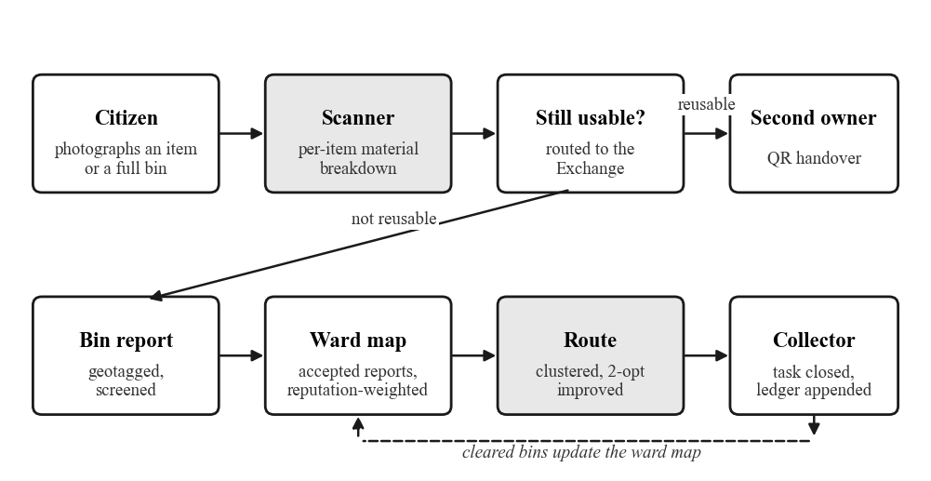
Figure 1.1: The circular loop. A scan either routes an item to the Exchange or produces a bin report; cleared bins feed back into the ward map.
Problem | Consequence | Addressed by
Segregation is decided at the bin | A mixed bag destroys the recyclable fraction; nothing downstream recovers it | M1 — two-stage scanner returning a per-item material breakdown
No fill-level signal exists | Fixed circuits empty quarter-full bins and miss overflowing ones | M2 and M5 — citizen reports drive clustering and route improvement
Recovery work is undocumented | Collectors cannot evidence income to a lender, employer or contractor | M4 — hash-chained, append-only work ledger
Table 1.1: Problems addressed and the module addressing each

2. Literature Survey
The works below span waste image datasets, efficient classification backbones, object detection, calibration, and participatory sensing with dynamic routing. Each is a work this project builds on directly; the final column states what it leaves unresolved for segregating a photographed pile.
S.No | Title | Author | Journal Name & Year | Methodology Adapted | Key Findings | Gaps
1 | Classification of Trash for Recyclability Status (TrashNet) | M. Yang, G. Thung | Stanford CS229 Project Report, 2016 | CNN and SVM over 2,527 hand-photographed images across six material classes | Established the reference benchmark for waste image classification | Studio photographs on a white background with one clean item per frame; no detection stage
2 | TACO: Trash Annotations in Context for Litter Detection | P. F. Proença, P. Simões | arXiv:2003.06975, 2020 | 1,500 crowd-sourced litter photographs annotated with COCO-style segmentation masks | Provides litter in real outdoor scenes, dirty, crushed and partly occluded | Detection-only; the long tail leaves most categories with too few boxes to learn a material from
3 | The Open Images Dataset V4 | A. Kuznetsova et al. | International Journal of Computer Vision, 2020 | 9M images with 600 boxable object classes and human-verified labels | Large everyday-object coverage usable as negative and auxiliary training data | Objects are photographed in use rather than discarded; material is implicit in the class name
4 | Searching for MobileNetV3 | A. Howard et al. | IEEE/CVF ICCV, 2019 | Neural architecture search with squeeze-and-excitation and hard-swish activation | High accuracy at phone-scale compute and memory | Emits a single label per image, so it cannot separate several materials in one frame
5 | MobileNetV2: Inverted Residuals and Linear Bottlenecks | M. Sandler et al. | IEEE/CVF CVPR, 2018 | Inverted residual blocks with linear bottlenecks for efficient inference | Established the efficient-backbone family used for on-device vision | Same single-label limitation; no mechanism to decline an out-of-distribution input
6 | You Only Look Once: Unified, Real-Time Object Detection | J. Redmon, S. Divvala, R. Girshick, A. Farhadi | IEEE CVPR, 2016 | Single-stage regression of boxes and class scores over a grid | Made real-time detection practical on modest hardware | Per-class detection needs many boxes per class, which waste datasets do not provide
7 | Ultralytics YOLOv8 | G. Jocher, A. Chaurasia, J. Qiu | Ultralytics software release, 2023 | Anchor-free single-stage detector with decoupled head | Strong detection accuracy at low latency; nano variant suits constrained serving | Default NMS IoU merges poorly for overlapping items at different scales
8 | Microsoft COCO: Common Objects in Context | T.-Y. Lin et al. | European Conference on Computer Vision, 2014 | 330K images with instance segmentation over 80 everyday categories | Defined mAP as the standard detection metric and the common annotation format | mAP measures ranking rather than absolute confidence, so it cannot set a serving threshold
9 | On Calibration of Modern Neural Networks | C. Guo, G. Pleiss, Y. Sun, K. Q. Weinberger | International Conference on Machine Learning, 2017 | Temperature scaling of logits, measured by expected calibration error | Modern networks are systematically overconfident; a single parameter largely corrects it | Demonstrated on benchmarks; not connected to a deployed abstention rule
10 | ImageNet: A Large-Scale Hierarchical Image Database | J. Deng et al. | IEEE CVPR, 2009 | 14M labelled images organised on the WordNet hierarchy | Enabled transfer learning, on which small-dataset vision work depends | Domain gap: ImageNet objects are intact and well lit, unlike discarded waste
11 | Participatory Sensing | J. Burke et al. | Workshop on World-Sensor-Web, ACM SenSys, 2006 | Framework for treating citizens with mobile devices as a distributed sensor network | Showed that population-scale sensing is achievable without dedicated hardware | Predates smartphone cameras; no treatment of data quality or contributor gaming
12 | Challenges and Opportunities of Waste Management in IoT-Enabled Smart Cities | T. Anagnostopoulos et al. | IEEE Transactions on Sustainable Computing, 2017 | Survey of sensor-instrumented bins with dynamic collection routing | Dynamic routing reduces collection distance against fixed circuits | Assumes a fill-level sensor on every bin, which is a recurring per-bin cost
Table 2.1: Comparative analysis of related work
Taken together the literature supplies strong components and no assembled system. Datasets photograph one clean item at a time, detectors need more boxes per class than waste datasets contain, calibration is rarely connected to a deployed abstention rule, and dynamic routing continues to presume instrumented bins.

3. Research Gaps
Gap | Position in the literature | Approach taken here
One label per frame | Waste classifiers are trained and evaluated on single isolated objects | Detection precedes classification, so each object is labelled on its own crop
Benchmarks do not resemble bins | Public sets are studio or stock photographs under even lighting | Stated as a limitation; the reported score is declared an upper bound
Fill sensing presumes hardware | Routing work assumes a sensor on every container | Geotagged citizen reports, weighted by reporter accuracy, replace the sensor
Confidence reported, not calibrated | Softmax scores are treated as probabilities despite known overconfidence | Temperature scaling plus a fitted cutoff below which the answer is withheld
Recovery work undocumented | No verifiable record exists of informal collection activity | Append-only ledger, hash-chained per collector and verified on read
Table 3.1: Research gaps and the corresponding design response

4. Objectives
The primary objective is a software-only platform that segregates a photographed pile of municipal waste into material classes and converts citizen observations into collection decisions, without hardware on any bin.
No. | Objective | Deliverable | Verified by
1 | Separate detection from classification | Class-agnostic detector feeding a per-crop classifier | mAP50 on a held-out detection split
2 | Classify nine materials plus a not-waste class | MobileNetV3-Small over 3,170 images | Accuracy and macro-F1 on a held-out test set
3 | Calibrate confidence and abstain when weak | Temperature scaling and a per-class cutoff | Expected calibration error before and after
4 | Replace fill sensors with citizen reports | Geotagged reports under four screening rules | Accepted and rejected report counts
5 | Route from the reports accepted today | K-means clustering with 2-opt improvement | Mean distance against a fixed circuit
6 | Transfer usable items to a second owner | Listing exchange with scanned QR handover | Completed transaction records
7 | Record collector work verifiably | Hash-chained append-only ledger | Chain verification on every read
8 | Report results with their conditions | Stated limits alongside every figure | Section 8.6
Table 4.1: Objectives, deliverables and verification

5. Hardware / Software Requirement with Specifications

5.1 Hardware Requirements
Training was performed on a cloud GPU runtime because local CPU training did not complete on the assembled dataset. Serving and development require no specialised hardware.
S. No. | Hardware component | Specification
1 | Processor | Intel Core i5 or equivalent
2 | RAM | Minimum 8 GB; 16 GB for local experimentation
3 | Hard Disk | Minimum 256 GB
4 | Training accelerator | NVIDIA T4 GPU (Google Colab)
5 | Capture device | Smartphone camera, 8 MP or above
6 | System type | 64-bit operating system
Table 5.1: Hardware requirements

5.2 Software Requirements
S. No. | Software component | Specification
1 | Operating system | Windows 11 / Linux
2 | Languages | Python 3.13, JavaScript (ES2022)
3 | Deep learning | PyTorch 2.6, Torchvision 0.21
4 | Detection | Ultralytics YOLOv8
5 | Model serving | FastAPI, Uvicorn, ONNX Runtime
6 | Application backend | Node.js, Express, Socket.IO
7 | Database | MongoDB with 2dsphere geospatial indexing
8 | Frontend | React 18, Vite, Tailwind CSS, TanStack Query, Leaflet
9 | Supporting libraries | NumPy, Pandas, Pillow, scikit-learn
10 | Environment | Visual Studio Code, Google Colab
11 | Version control | Git and GitHub
Table 5.2: Software requirements

6. Methodology
Images were drawn from four public sources under one labelling policy: an item is labelled by what it is predominantly made of. Nine material classes are used, with a tenth NotWaste class for photographs holding no discardable item.
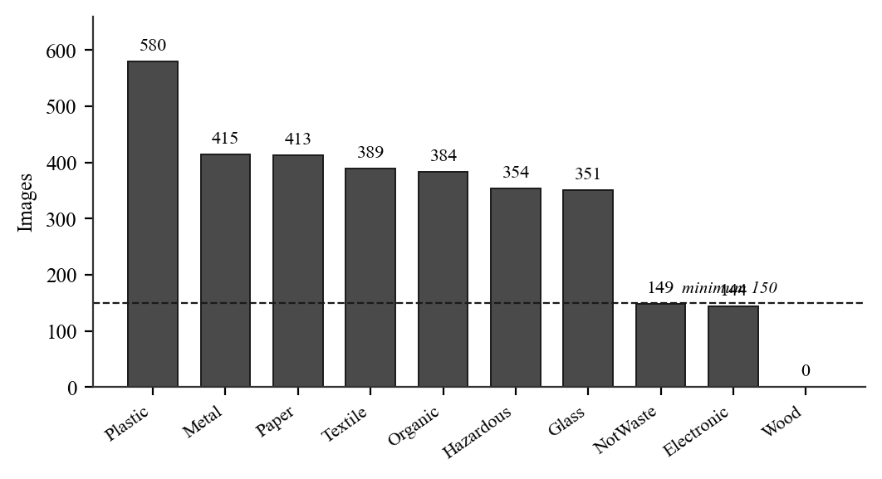
Figure 6.1: Images available per class. Wood is hatched because it holds no training data; the dashed line marks the 150-image minimum below which a class cannot be evaluated meaningfully.
Splitting is stratified by class and grouped by object identity. Several photographs of one physical object are near-duplicates, and allowing them into different partitions would make the test score measure memorisation rather than generalisation.
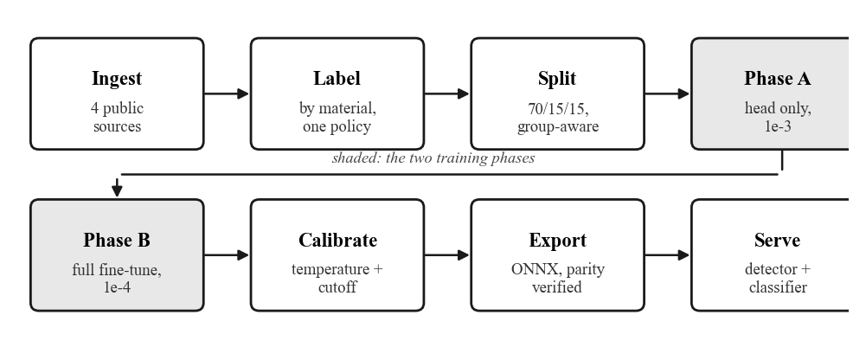
Figure 6.2: Training workflow from ingestion to serving. The two shaded stages are the training phases.
Parameter | Value | Remark
Backbone | MobileNetV3-Small | ImageNet-pretrained, classification head replaced
Input resolution | 224 × 224 | Shortest side resized, then centre crop
Split ratio | 70 / 15 / 15 | Stratified by class, grouped by object identity
Phase A | 5 epochs at 1e-3 | Backbone frozen; the head trains alone
Phase B | 20 epochs at 1e-4 | Full fine-tune at a ten times smaller rate
Early stopping | patience 5 | Stopped at epoch 10 of phase B
Batch size | 64 | On the T4; 32 locally
Class weighting | inverse frequency | Compensates for class imbalance
Detector | YOLOv8n, 640 px | 40 epochs, batch 16, class-agnostic
Table 6.1: Training configuration
After training, one temperature parameter is fitted on the validation partition and applied to the logits before the softmax. The detector serving threshold is derived from a measured precision-recall curve rather than chosen as a round number, because mean average precision measures the ranking of boxes and is indifferent to the absolute scores attached to them.

6.3 Backbone Selection
Two efficient backbones were trained on identical splits before the classifier was fixed. The comparison is reported here because the tiebreaker was not accuracy.
Model | Accuracy | Macro-F1 | Params | Size | Latency | Licence
mobilenet_v3_small | 0.8319 | 0.8353 | 1.53 M | 6.2 MB | 12.4 ms | BSD (torchvision)
yolov8n-cls | 0.8142 | 0.8357 | 1.45 M | 3.0 MB | 12.3 ms | AGPL-3.0 (Ultralytics)
Table 6.2: Backbone comparison on identical splits. Figures are from the earlier training run, before the dataset was extended to 3,170 images, and are not the results reported in Section 8.
A macro-F1 difference of 0.0004 on this test size is noise: as classifiers the two are equivalent in accuracy, parameter count and latency. The deciding factor was licensing. Ultralytics releases under AGPL-3.0, which would extend its copyleft obligations to the platform that links against it, whereas torchvision is BSD. MobileNetV3-Small was therefore selected for the classifier. YOLOv8 is still used for detection, where it runs as a separate service rather than being linked into the application.

7. Architecture (Implementation and Testing)

7.1 Two-Stage Vision Pipeline
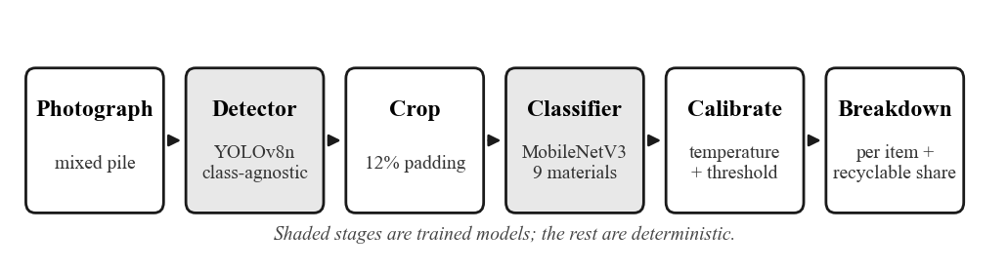
Figure 7.1: The scan pipeline. A classifier shown several objects returns one label for the whole frame; locating the objects first is what makes a per-item breakdown possible.
Crops classified as NotWaste are discarded, since such a crop is a false positive from the detector. Duplicate detections are suppressed twice: non-maximum suppression at IoU 0.5, then a pass removing any box whose intersection covers more than 75 per cent of the smaller of two boxes. The second pass is necessary because two boxes around one object at different scales can fall below any IoU cutoff while one is almost entirely inside the other.

7.2 System Architecture
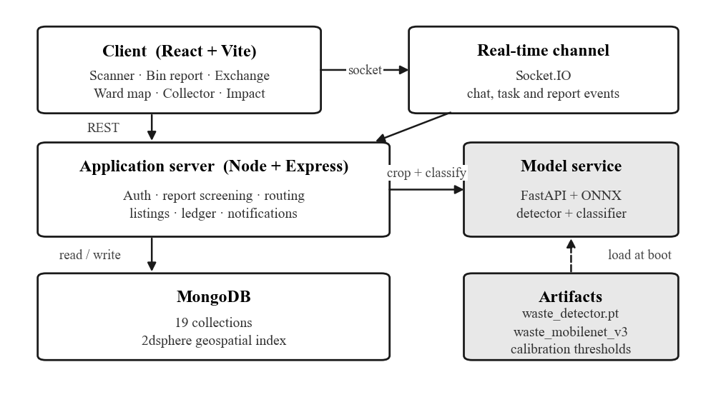
Figure 7.2: Deployment view. Shaded components are the trained models and their artifacts, versioned and loaded separately from the application.

7.3 Modules
Module | Function | Key mechanism
M1 Waste Scanner | Segregates a photographed item or pile into materials | Two-stage pipeline with calibrated abstention
M2 Bin Network | Collects fill information from citizens | Geotagged reports, four screening rules, reputation weighting
M3 Exchange | Transfers usable items to a second owner | Listings with scanned QR handover
M4 Collector Ledger | Records completed collection work | Append-only hash chain, verified on read, updates blocked at the model
M5 Routing | Plans collection from current reports | K-means clustering, nearest-neighbour insertion, 2-opt improvement
Table 7.1: Modules and their principal mechanisms

7.4 Report Screening
Rule | Condition checked | Action on failure
Duplicate image | Perceptual hash matches an earlier submission | Stored with accepted = false
Location distance | Reported position is far from the bin | Stored with accepted = false
Report frequency | The same user reports the same bin too often | Stored with accepted = false
Reporter reputation | Share of that user's previous reports accepted | Weight reduced rather than blocked
Table 7.2: Anti-gaming rules. Rejected reports are retained and marked, so the rejection rate itself stays measurable.
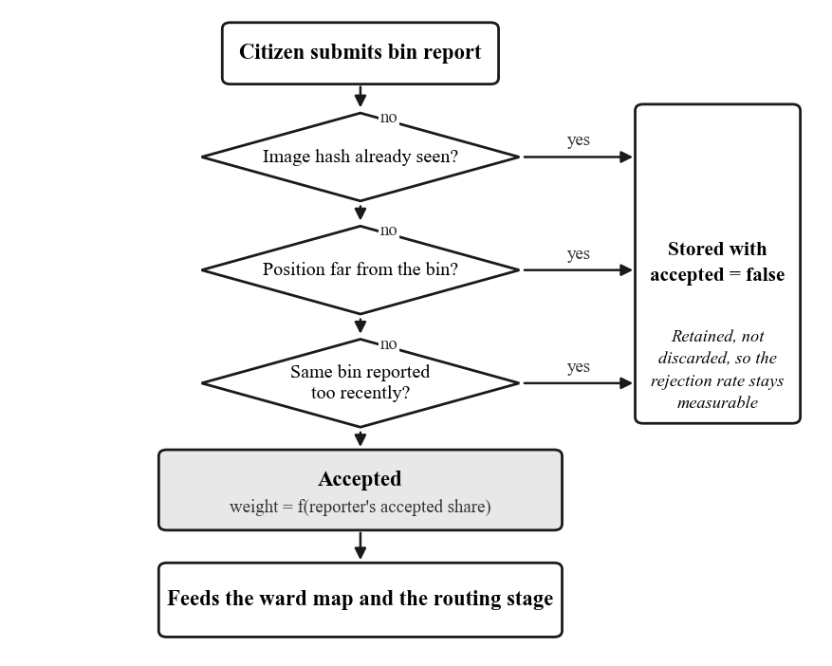
Figure 7.3: Screening decision flow. A report failing any rule is stored as rejected rather than discarded.

7.5 Calibrated Thresholds
Threshold | Value | Basis
Classifier temperature | 0.781 | Fitted on the validation partition
Classifier abstention | 0.55 | Below this the item is reported as uncertain
Detector box confidence | 0.15 | Highest recall with precision at or above 0.55
NMS IoU | 0.50 | Tightened from the 0.7 default, which passed duplicates
Containment suppression | 0.75 | Removes a box mostly inside a higher-scoring one
Table 7.3: Thresholds, each derived from measurement rather than convention

7.6 Work Ledger Construction
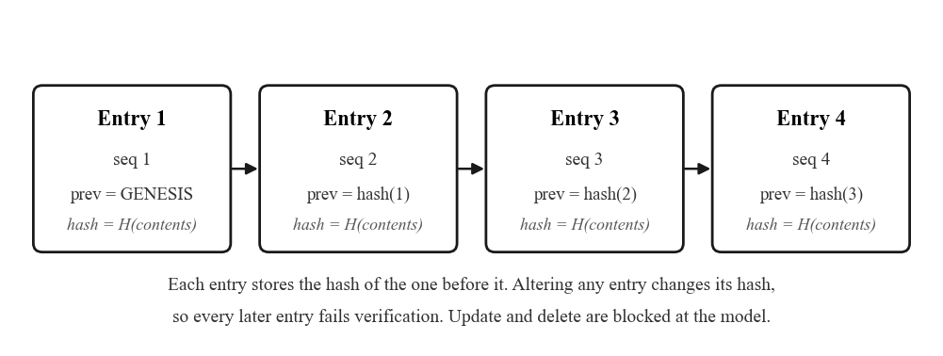
Figure 7.4: Each ledger entry stores the hash of the entry before it, so altering any record invalidates every record after it.

7.7 Testing
Level | Scope | Outcome
Model | Held-out test partition; per-class precision, recall, F1 and confusion matrix | Reported in Section 8
Export | ONNX output compared against PyTorch on a held-out sample | Prediction agreement 1.000; maximum logit difference 3.7e-5
Application | 16 authenticated routes at 1280 px and 390 px under three user roles | No JavaScript exceptions, failed API calls or layout overflow
Table 7.4: Testing performed at three levels

7.8 Data Model
Nineteen Mongoose models back the platform. Those carrying the core behaviour are listed below. Geospatial queries use 2dsphere indexes on the location field throughout, in GeoJSON longitude-latitude order.
Collection | Purpose | Principal fields
User | Accounts and role | userType (donor / recipient / both / collector / admin), reputation, location
WasteAnalysis | Saved scan results | material, confidence, isRecyclable, deviceType, createdAt
BinReport | M2 citizen report | status, location (2dsphere), imageHash, accepted, weight, ward
CollectionTask | M4 assigned work | source, sourceRef (polymorphic), status, assignedTo, verifiedBy
WorkLedgerEntry | M4 tamper-evident record | collector, sequence, previousHash, hash, completedAt
Listing | M3 item offered | category, quantity, status, pickupLocation, interested queue
Transaction | M3 QR handover | qrCode, qrCodeHash, expiresAt, status, impact
EcoPoints | Points and per-user statistics | totalPoints, level, stats, recentTransactions
Chat / Message | Conversations on a listing | participants (unique index), lastMessage, content
Schedule | Pickup arrangement | listing, donor, recipient, proposedDateTime, status
Table 7.5: Principal collections and their fields

7.9 Security Posture
Measure | Implementation | Rationale
Transport headers | helmet | Standard defensive response headers
Origin control | Strict CORS allowlist | An unknown browser origin receives 403 rather than a blanket allow. Requests with no Origin header are permitted, because CORS is a browser mechanism and non-browser clients are gated by authentication instead
Rate limiting | Global ceiling, tighter on authentication | Limits credential guessing and scan abuse
Authentication | JWT bearer token | A 401 clears the client session
Password storage | bcrypt hashing | Passwords are never stored or logged in clear
Ledger immutability | Mongoose hooks reject update and delete | An appended work record cannot be altered after the fact
Request logging | morgan | combined in production, dev locally
Table 7.6: Security measures applied at the application layer

7.10 Application Screens
The client exposes twenty routes. Access is gated by user type, so a donor reaching an administrator route is redirected rather than shown an error.
Role | Screens available
All authenticated users | Scan, Scan history, Exchange, Listing detail, Create listing, My items, Report bin, Ward map, Drop-off centres, Messages, Pickups, Impact, Profile
Collector | Collect (task queue), Handover (QR verification), Schedules
Administrator | Admin (user and report moderation), Municipal (ward pressure and routing)
Unauthenticated | Landing, Sign in, Register, Forgot password, Reset password
Table 7.7: Screens by role

8. Result and Analysis

8.1 Classifier Performance
Metric | Value | Remark
Test accuracy | 0.848 | Nine material classes
Macro-F1 | 0.835 | Equal weight per class
Expected calibration error | 0.073 → 0.018 | After temperature scaling
Fitted temperature | 0.781 | Below 1: the model was under-confident
Inference latency | 4.7 ms | ONNX, single image, CPU
Exported model size | 6.1 MB | Parity with PyTorch verified
Table 8.1: Classifier results on the held-out test set (n = 454)
Macro-F1 is reported in preference to accuracy because the classes are imbalanced; accuracy would be dominated by the largest class, whereas an error on Hazardous carries a greater practical consequence than one on Plastic.
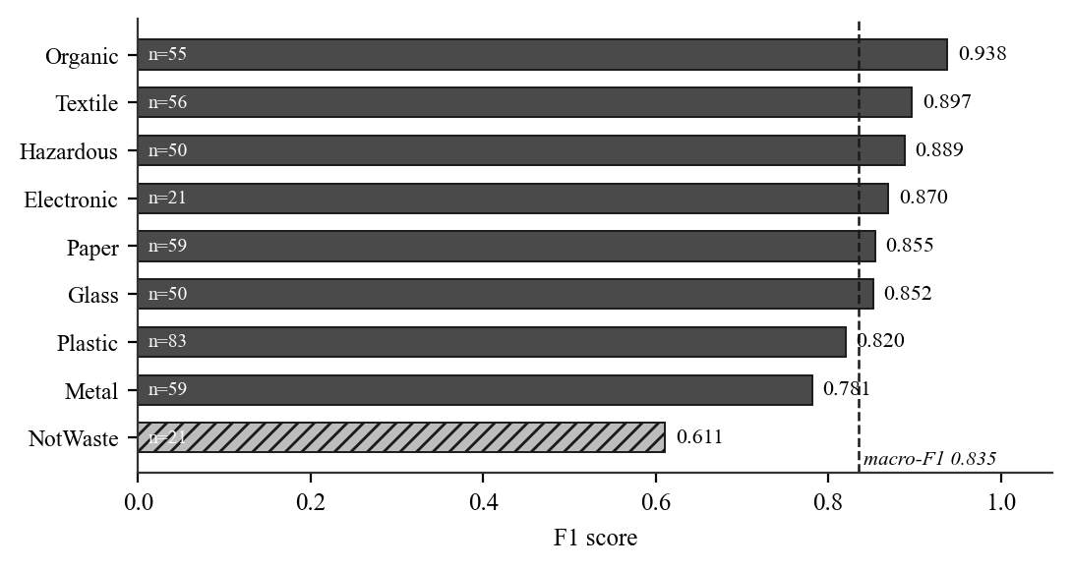
Figure 8.1: Per-class F1. NotWaste is hatched as the weakest class; the dashed line marks the macro average.
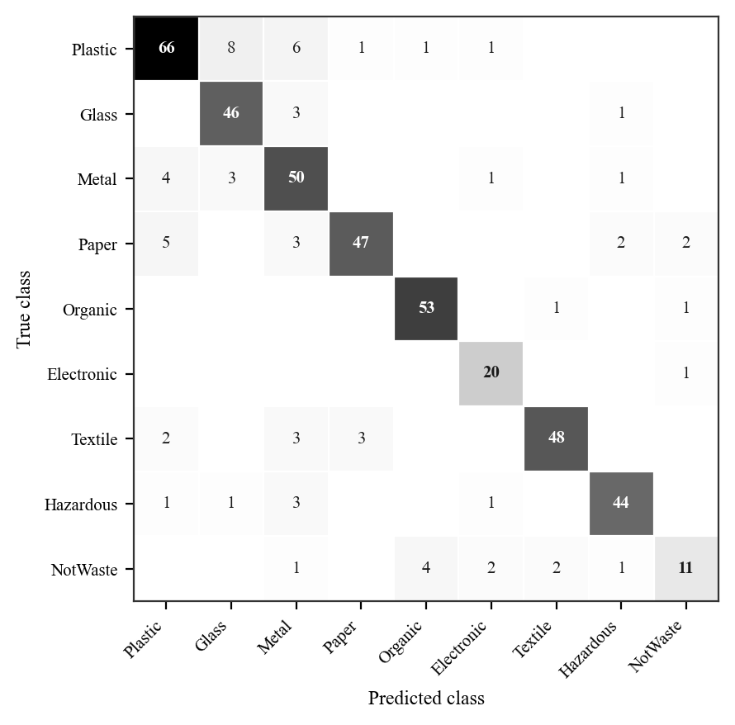
Figure 8.2: Confusion matrix. Rows are the true class, columns the prediction. The largest single error is eight Plastic items predicted as Glass.
Transparent plastic and glass are genuinely hard to separate from a photograph, since the discriminating cues are specular highlight behaviour and edge thickness rather than colour or shape. NotWaste is the weakest class at 0.611 F1 and 0.524 recall, which matters more than its position suggests: the class exists so the model can decline, and at that recall it declines roughly half as often as it should.

8.2 Calibration and Abstention
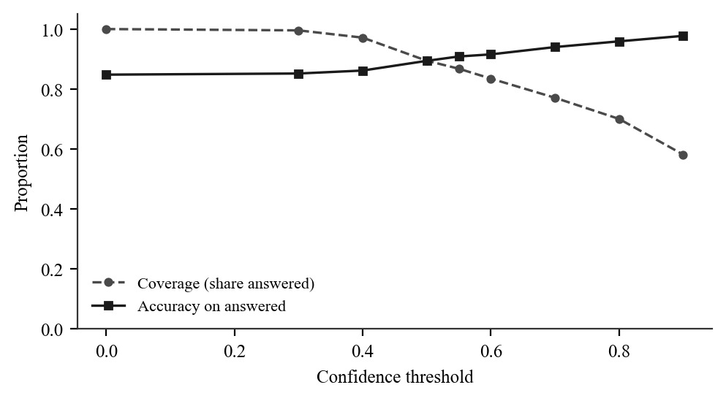
Figure 8.5: Coverage against accuracy. Raising the threshold makes the model answer less often and be right more often when it does.

8.3 Detector Performance
Metric | Value | Remark
mAP50 (test) | 0.746 | 670 annotated photographs
mAP50-95 (test) | 0.479 | Stricter overlap criterion
Precision | 0.841 | At the operating threshold
Recall | 0.627 | A missed item remains unsorted
Serving threshold | 0.15 | Derived from the curve in Figure 8.3
Table 8.2: Class-agnostic detector results
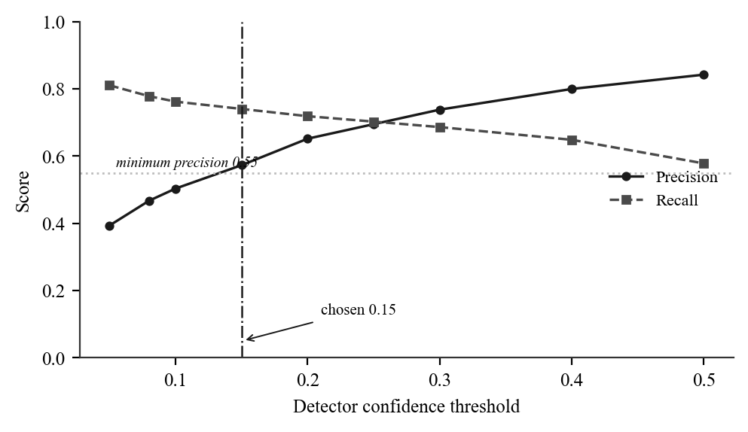
Figure 8.3: Precision and recall against detector confidence. The chosen 0.15 is the highest-recall point at which precision remains at or above 0.55.
Choosing the threshold by measurement proved necessary. A checkpoint with better mean average precision was found to detect fewer items at a fixed 0.25, because mAP measures the ranking of boxes and is indifferent to their absolute scores. Recall, not precision, is the binding limitation: roughly one item in four is missed, and a missed item is waste that goes unsorted.

8.4 Training Behaviour
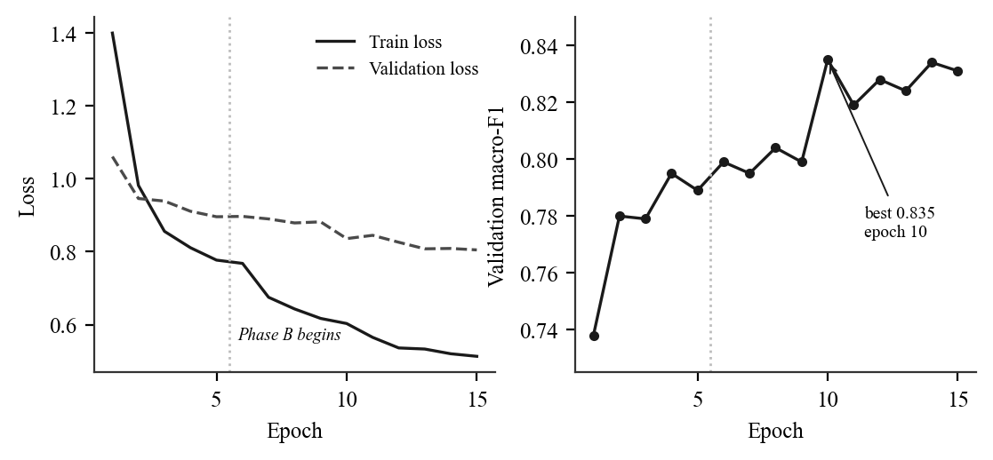
Figure 8.4: Training and validation loss, and validation macro-F1 per epoch. The dotted line marks the transition from head-only training to full fine-tuning.

8.5 Route Optimisation
Routing was evaluated in a seeded simulation against a fixed circuit over the same containers. At 20 to 50 per cent bin occupancy, the realistic operating range, mean travel distance fell by 26.5 per cent. Above roughly 60 per cent occupancy a fixed circuit performs better: when nearly every container needs emptying there is little left to optimise. Crowd-sensing pays off precisely when bins are not uniformly full.

8.6 Limitations of the Measurement
Limitation | Effect on the reported figures
All images are from public datasets | The dataset preparation stage refused to build a held-out partition on this basis and had to be overridden explicitly. Every score above is therefore an upper bound measured on studio and stock photographs, not a field measurement.
Wood has no training data | No public dataset covers wood waste consistently with the labelling policy, so the model is trained on nine of the ten declared classes and cannot predict Wood.
The stages are evaluated separately | No score yet exists for the complete task: a photograph of a mixed pile in, a correct material breakdown out.
Table 8.3: Stated limitations

9. Conclusion and Future Scope

9.1 Conclusion
Separating detection from classification allows one photograph of a mixed bin to yield a per-item material breakdown, which a single-label classifier cannot produce. The classifier attains 0.848 accuracy and 0.835 macro-F1 over nine classes; the class-agnostic detector attains 0.746 mAP50.
Calibration changed the character of the system's failures. Reducing expected calibration error from 0.073 to 0.018 and fitting an abstention threshold means a weak prediction now presents as weak. The effect was observed directly: a printed document that the earlier model classified as Plastic is now identified as Paper and flagged uncertain, which is the correct behaviour when the evidence is thin.
Participatory sensing substitutes successfully for per-bin hardware. Screened, reputation-weighted citizen reports drive routing that saves 26.5 per cent of collection distance in simulation with no sensor installed. Five modules operate on one stack, and the hash-chained ledger gives informal collectors a tamper-evident record of completed work.

9.2 Future Scope
Item | Reason | Expected effect
Collect waste photographs locally | The held-out set is presently public studio images | Turns the reported accuracy into a field measurement
Close the Wood class | No public dataset covers wood waste honestly | Makes the model genuinely ten-class
Raise NotWaste recall | At 0.524 the model declines half as often as it should | Fewer confident answers on photographs holding no item
End-to-end evaluation set | The two stages are measured only in isolation | First score for the task the platform performs
Export to TFLite | ONNX is 6.1 MB at 4.7 ms per image | Scanning without a network connection
Municipal ward pilot | Routing is validated only in simulation | Savings measured against real collection logs
EPR certificate register | M4 already demonstrates the hash-chain technique | Recovered volumes attributable to producers
Table 9.1: Future work

10. References
[1] M. Yang and G. Thung, “Classification of Trash for Recyclability Status,” Stanford University CS229 Project Report, 2016.
[2] P. F. Proença and P. Simões, “TACO: Trash Annotations in Context for Litter Detection,” arXiv preprint arXiv:2003.06975, 2020.
[3] A. Kuznetsova, H. Rom, N. Alldrin, J. Uijlings, I. Krasin, J. Pont-Tuset, S. Kamali, S. Popov, M. Malloci, A. Kolesnikov, T. Duerig and V. Ferrari, “The Open Images Dataset V4,” International Journal of Computer Vision, vol. 128, no. 7, pp. 1956–1981, 2020.
[4] A. Howard, M. Sandler, G. Chu, L.-C. Chen, B. Chen, M. Tan, W. Wang, Y. Zhu, R. Pang, V. Vasudevan, Q. V. Le and H. Adam, “Searching for MobileNetV3,” in Proc. IEEE/CVF International Conference on Computer Vision (ICCV), 2019, pp. 1314–1324.
[5] M. Sandler, A. Howard, M. Zhu, A. Zhmoginov and L.-C. Chen, “MobileNetV2: Inverted Residuals and Linear Bottlenecks,” in Proc. IEEE/CVF Conference on Computer Vision and Pattern Recognition (CVPR), 2018, pp. 4510–4520.
[6] J. Redmon, S. Divvala, R. Girshick and A. Farhadi, “You Only Look Once: Unified, Real-Time Object Detection,” in Proc. IEEE Conference on Computer Vision and Pattern Recognition (CVPR), 2016, pp. 779–788.
[7] G. Jocher, A. Chaurasia and J. Qiu, “Ultralytics YOLOv8,” software release, 2023. [Online]. Available: https://github.com/ultralytics/ultralytics
[8] T.-Y. Lin, M. Maire, S. Belongie, J. Hays, P. Perona, D. Ramanan, P. Dollár and C. L. Zitnick, “Microsoft COCO: Common Objects in Context,” in Proc. European Conference on Computer Vision (ECCV), 2014, pp. 740–755.
[9] C. Guo, G. Pleiss, Y. Sun and K. Q. Weinberger, “On Calibration of Modern Neural Networks,” in Proc. 34th International Conference on Machine Learning (ICML), 2017, pp. 1321–1330.
[10] J. Deng, W. Dong, R. Socher, L.-J. Li, K. Li and L. Fei-Fei, “ImageNet: A Large-Scale Hierarchical Image Database,” in Proc. IEEE Conference on Computer Vision and Pattern Recognition (CVPR), 2009, pp. 248–255.
[11] J. Burke, D. Estrin, M. Hansen, A. Parker, N. Ramanathan, S. Reddy and M. B. Srivastava, “Participatory Sensing,” in Workshop on World-Sensor-Web, ACM SenSys, 2006.
[12] T. Anagnostopoulos, A. Zaslavsky, K. Kolomvatsos, A. Medvedev, P. Amirian, J. Morley and S. Hadjieftymiades, “Challenges and Opportunities of Waste Management in IoT-Enabled Smart Cities: A Survey,” IEEE Transactions on Sustainable Computing, vol. 2, no. 3, pp. 275–289, 2017.
[13] A. Paszke et al., “PyTorch: An Imperative Style, High-Performance Deep Learning Library,” in Advances in Neural Information Processing Systems (NeurIPS), 2019, pp. 8024–8035.
[14] F. Pedregosa et al., “Scikit-learn: Machine Learning in Python,” Journal of Machine Learning Research, vol. 12, pp. 2825–2830, 2011.
[15] G. A. Croes, “A Method for Solving Traveling-Salesman Problems,” Operations Research, vol. 6, no. 6, pp. 791–812, 1958.

