.

**Hotel Management Database Documentation**

**1. Table: Employee**

Stores employee details, including managers and staff.

CREATE TABLE Employee (

employee_id INT PRIMARY KEY,

name VARCHAR(100),

role VARCHAR(50),

hotel_code INT,

shift_details VARCHAR(100),

FOREIGN KEY (hotel_code) REFERENCES Hotel(hotel_code)

);

**Foreign Key:**

* hotel_code references Hotel(hotel_code)

**DESCRIPTION:**

Creating a Employee Table and the columns are employee_id data type int (Primary key), name data type varchar, role data type varchar, hotel_code data type Int shift_details data type varchar.

**2. Table: Hotel**

Stores hotel information.

CREATE TABLE Hotel (

hotel_code INT PRIMARY KEY,

name VARCHAR(100),

city VARCHAR(100),

manager_id INT,

num_rooms INT,

star_rating INT,

FOREIGN KEY (manager_id) REFERENCES Employee(employee_id)

);

**Foreign Key:**

* manager_id references Employee(employee_id);

**DESCRIPTION:**

Creating Hotel table and the colums are hotel_code int (primary key), name data type varchar, city data type varchar, manager_id data type int

Num_rooms data type int, star_rating int.

**3. Table: Room**

Represents individual rooms in a hotel.

CREATE TABLE Room (

room_number INT,

hotel_code INT,

type VARCHAR(50),

price_per_night DECIMAL(10,2),

availability_status VARCHAR(20),

PRIMARY KEY (room_number, hotel_code),

FOREIGN KEY (hotel_code) REFERENCES Hotel(hotel_code)

);

**Foreign Key:**

* hotel_code references Hotel(hotel_code)

**DESCRIPTION:**

Create a Room table and the colums are room_number data type is int(primary key), hotel_code data type int(primary key), type varchar, price_per_night data type DECIMAL(10,2), availability_status data type varchar.

**4. Table: Guest**

Stores guest information.

CREATE TABLE Guest (

guest_id INT PRIMARY KEY,

name VARCHAR(100),

loyalty_level VARCHAR(50)

);

**Foreign Keys:**

* guest_id references Guest(guest_id)
* hotel_code references Hotel(hotel_code)
* *(Optional FK on room_number, depending on normalization strategy)*

**DESCRIPTION:**

*Create a Guest table and the columns are guest_id data type int(primary key), name data type varchar, loyalty_level data type varchar.*

**6. Table: Feedback**

Stores guest feedback after a stay.

CREATE TABLE Feedback (

feedback_id INT PRIMARY KEY,

booking_id INT,

guest_id INT,

rating INT,

comments VARCHAR(255),

FOREIGN KEY (booking_id) REFERENCES Booking(booking_id),

FOREIGN KEY (guest_id) REFERENCES Guest(guest_id)

);

**Foreign Keys:**

* booking_id references Booking(booking_id)
* guest_id references Guest(guest_id)

**DESCRIPTION:**

Create a Feedback table and the columns are feedback_id data type int(primary key), booking_id data type int, guest_id int, comments data type varchar.

**7**. **Table** : **Booking**

Strong guest booking after a stay

CREATE TABLE Booking (

booking_id INT PRIMARY KEY,

guest_id INT,

hotel_code INT,

room_number INT,

check_in_date DATE,

check_out_date DATE,

total_bill DECIMAL(10,2),

FOREIGN KEY (guest_id) REFERENCES Guest(guest_id),

FOREIGN KEY (hotel_code, room_number) REFERENCES Room(hotel_code, room_number)

);

**Foreign key :**

**.** FOREIGN KEY (guest_id) REFERENCES Guest(guest_id),

**.** FOREIGN KEY (hotel_code, room_number) REFERENCES Room(hotel_code, room_number);

**DESCRIPTION:**

Create a Booking table and the columns are booking_id data type int(primary key), guest_id data type int, hotel_code data type int, room_number data type int,

Check_in_date data type DATE, Check_out_date data type DATE, total_bill data type DECIMAL(10,2).

INSERTING DATA

NSERT INTO Employee VALUES (101, 'Amit Rao', 'Manager', 1, 'Day');

INSERT INTO Employee VALUES (102, 'Priya Singh', 'Receptionist', 1, 'Night');

INSERT INTO Employee VALUES (103, 'Rahul Verma', 'Manager', 2, 'Day');

INSERT INTO Employee VALUES (104, 'Neha Kapoor', 'Housekeeping', 2, 'Day');

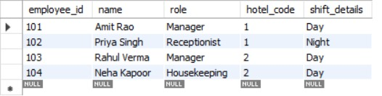

INSERT INTO Hotel VALUES (1, 'Grand Palace', 'Delhi', 101, 50, 5);

INSERT INTO Hotel VALUES (2, 'Seaside Resort', 'Mumbai', 103, 30, 4);

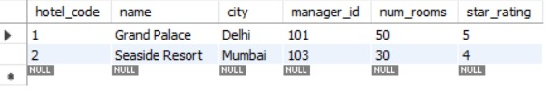

INSERT INTO Room VALUES (101, 1, 'Deluxe', 3500.00, 'Available');

INSERT INTO Room VALUES (102, 1, 'Suite', 5000.00, 'Occupied');

INSERT INTO Room VALUES (201, 2, 'Standard', 2500.00, 'Available');

INSERT INTO Room VALUES (202, 2, 'Deluxe', 3200.00, 'Available');

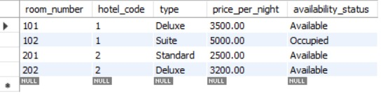

INSERT INTO Guest VALUES (1001, 'Karan Mehta', 'Silver');

INSERT INTO Guest VALUES (1002, 'Sneha Reddy', 'Gold');

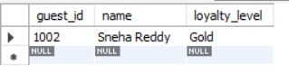

INSERT INTO Booking VALUES (501, 1001, 1, 102, '2025-06-10', '2025-06-13', 15000.00);

INSERT INTO Booking VALUES (502, 1002, 2, 201, '2025-06-12', '2025-06-14', 5000.00);

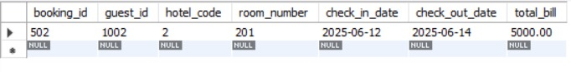

INSERT INTO Feedback VALUES (301, 501, 1001, 4, 'Great experience!');

INSERT INTO Feedback VALUES (302, 502, 1002, 5, 'Loved the hospitality!');

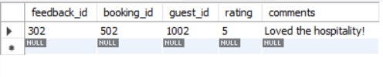

**ER DIAGRAM:**

