1. Write SQL to show the 10 coldest countries that have never medaled at the winter Olympics. Show them in order of population – largest to smallest.

**Solution:**

with countries_won_medals as ( select distinct country

from olympics.medals

)

select t.*

from (

select t.country

, p.population

, t.ave_temp

from olympics.population p

inner join olympics.temperature t

on p.country = t.country

and p.country not in ( select cwm.country

from countries_won_medals cwm

)

order by t.ave_temp asc

limit 10

) as t

order by t.population desc

;

**Output:**

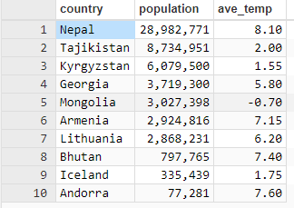

2. Write SQL to show the top 10 performing countries of all time at the winter Olympics where a gold medal is worth 3 points, a silver medal 2 points and a bronze medal 1 point.

**Solution:**

select m.country

, sum (

case

when m.medal = 'gold'

then 3

when m.medal = 'silver'

then 2

when m.medal = 'bronze'

then 1

end

) as points

from olympics.medals m

group by m.country

order by 2 desc

limit 10;

**Output:**

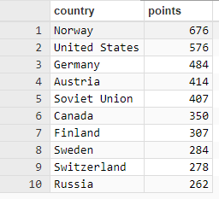

1. We know how much Britain spent on winter Olympics funding for some years. Write SQL to show the cost per medal for Britain – by year - where the data exists.

**Solution:**

with

funds

as (

select f.country

, unnest(array[2002, 2006, 2010, 2014]) as years

, unnest(array[f.y2002, f.y2006, f.y2010, f.y2014]) funding

from olympics.funding f

)

select t.country

, t.year

, t.num_of_medals

, t.cost_per_year

, cost_per_year/num_of_medals as cost_per_medal

from (

select f.country

, m.year

, count(m.medal) num_of_medals

, max(f.funding) as cost_per_year

from olympics.medals m

inner join funds f

on m.year = f.years

where f.country = 'Britain'

group by f.country , m.year

) t

;

**Output:**

