Virtual key foryourrepository

# ProjectContains:

1. Project details
2. Developer details
3. Project Outcomes
4. Core-concepts used for the project
5. Github Files

# ProjectDetails:

Make an E-commerce Website for Sporty Shoes .

Course-end Project 1

DESCRIPTION

Project objective:

As a Full Stack Developer, complete the features of the application by planning the development and pushing the source code to the GitHub repository.

Background of the problem statement:

Sporty Shoes is a company that manufactures and sells sports shoes. They have a walk-in store, and now, they wish to launch their e-commerce portal sportyshoes.com.

You’re asked to develop a prototype of the application. It will be then presented to the relevant stakeholders for budget approval. Your manager has set up a meeting where you’re asked to do the following:

● Presenting the specification document which has the product’s capabilities, appearance, and user interactions

● Setting up Git and GitHub account to store and track your enhancements of the prototype

● Explaining the Java concepts used in the project

● Discussing the generic features of the product:

● There will be an admin to manage the website. An administrator login will be required to access the admin page.

The admin should be able to change his password if he wants, he should be able to:

● Manage the products in the store including categorizing them

● Browse the list of users who have signed up and be able to search users

● See purchase reports filtered by date and category

# DeveloperDetails:

* Hanuman Prasad (https://github.com/hanumanprasadvishwa/Administrative-portal-for-Learner-Academy-main)
* hanumanprasad0108@gmail.com

## **Technologies and tools Used :**

• Servlet: To impliment the business logic and works a controller for the project.

• JSP: To handle the presentation view.

• MYSQL: To Create Database and its objects.

• JDBC: To make operations on the database for the project.

• Springboot: To write and run the code.

• Tomcat: To run and deploy servlet application.

**Project Outcomes :-**

**1-Signup Page**

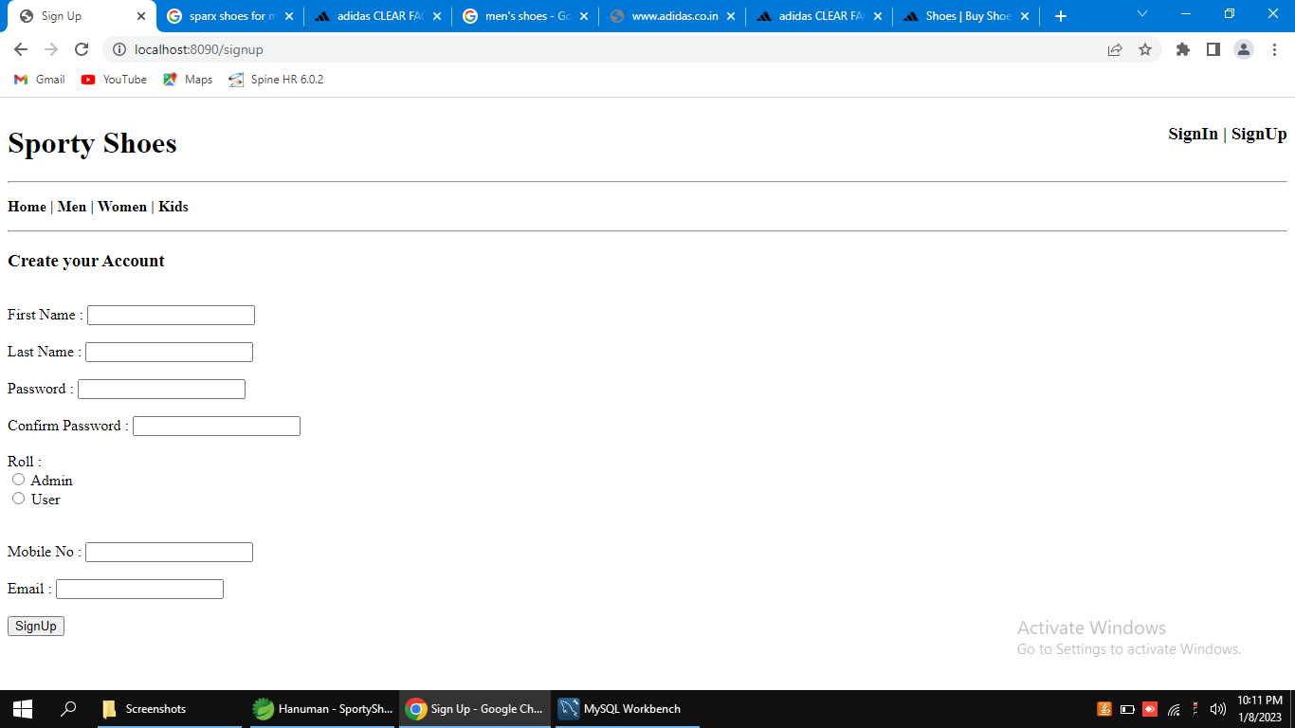

**2-Admin Login Page**

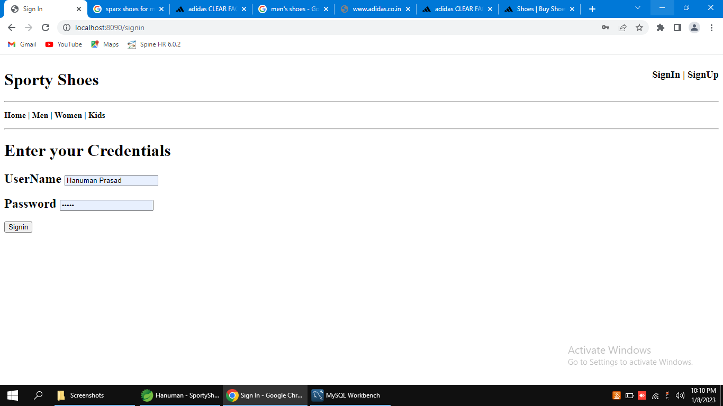

**3-Men's Product List**

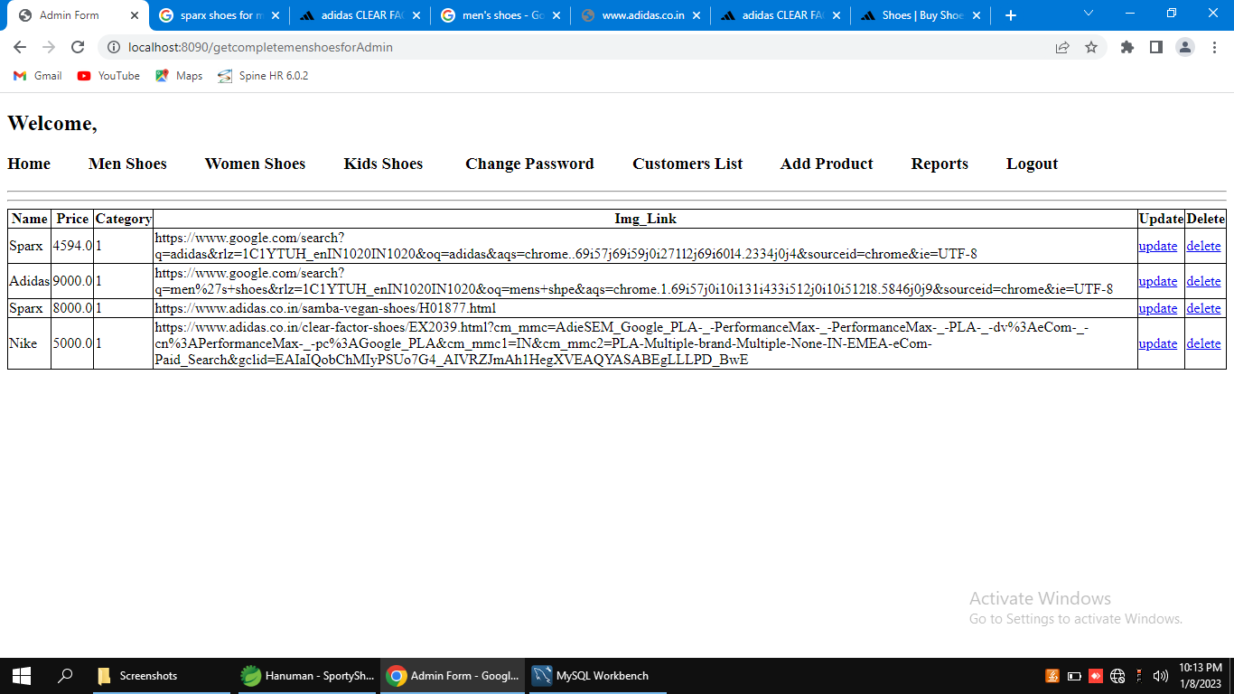

**4-Women's Product List**

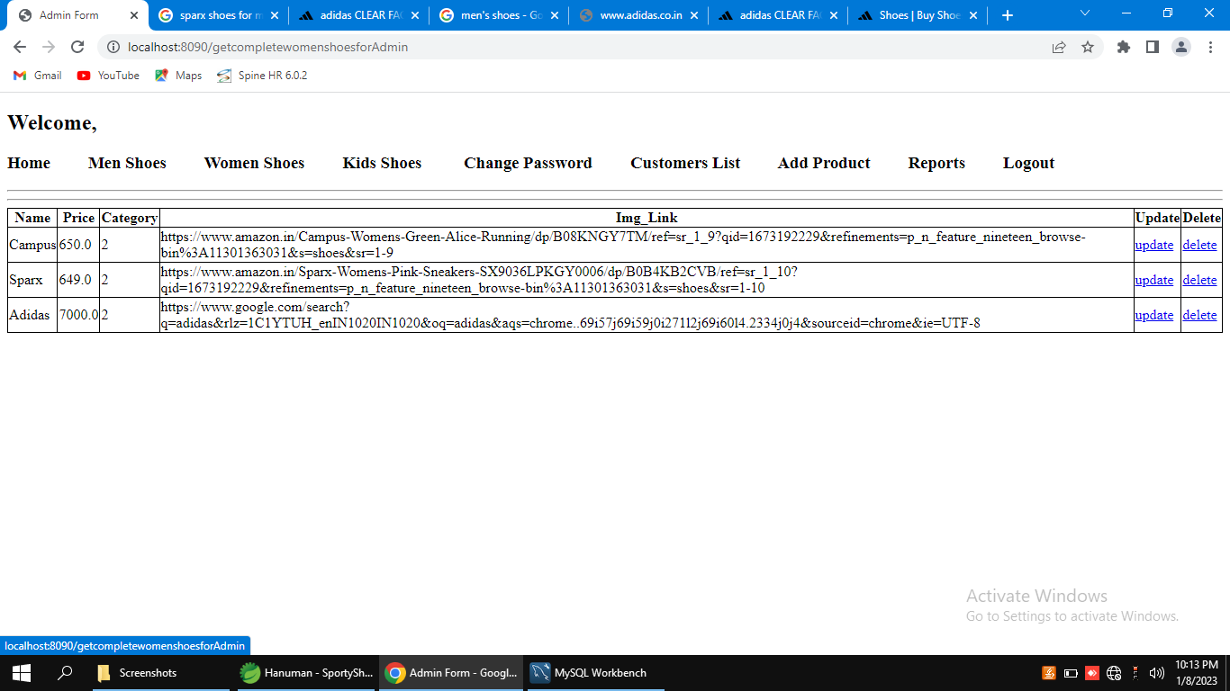

**5-Kid's Product List**

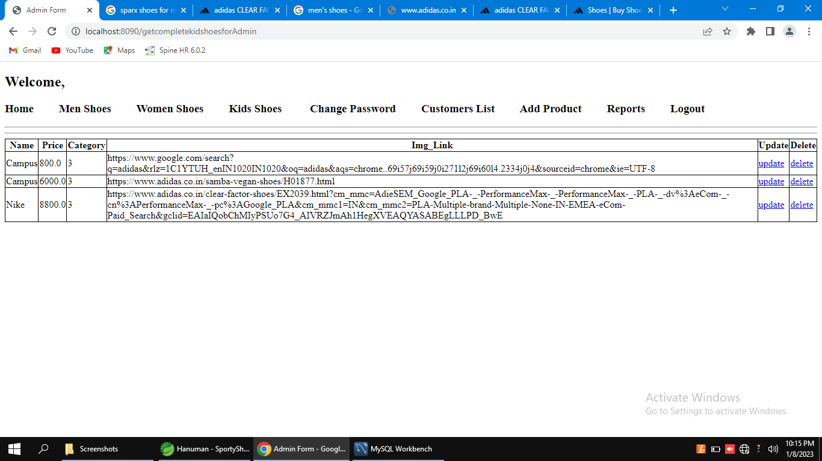

**6-Option to Change Admin Password**

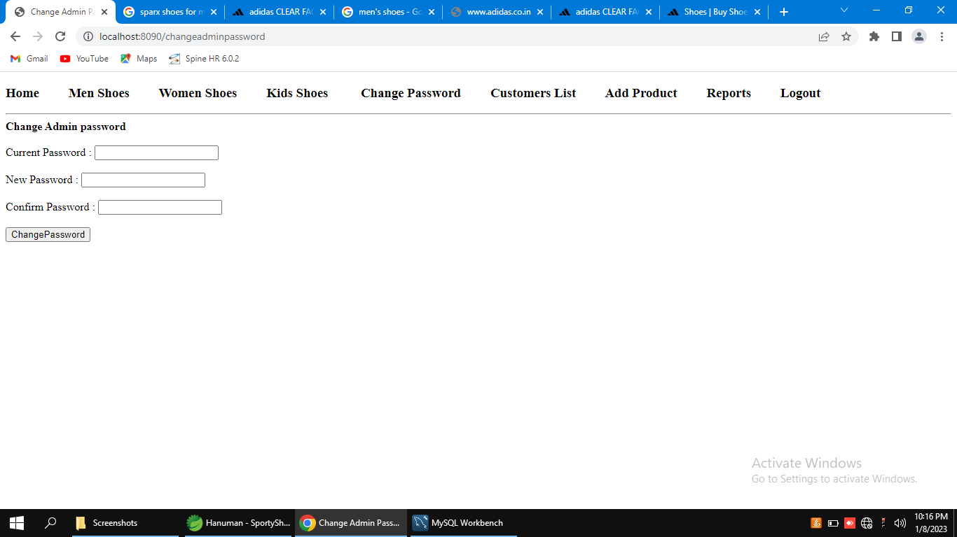

**7-List of Customers**

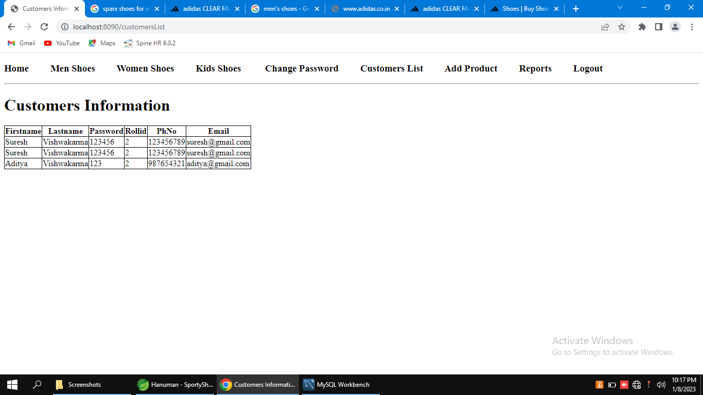

**8-Option to Add Products**

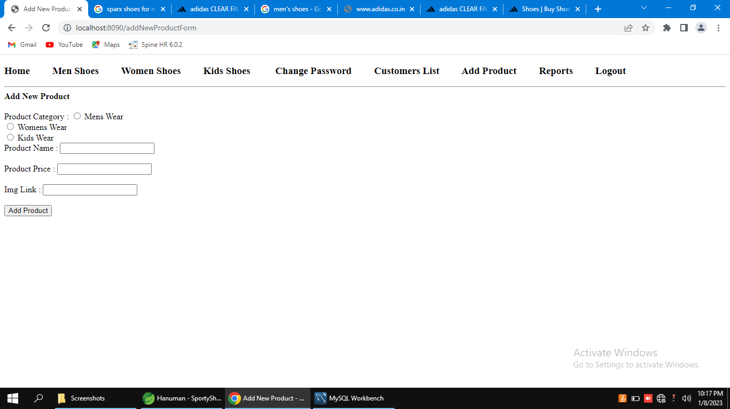

**9-Sale's details**

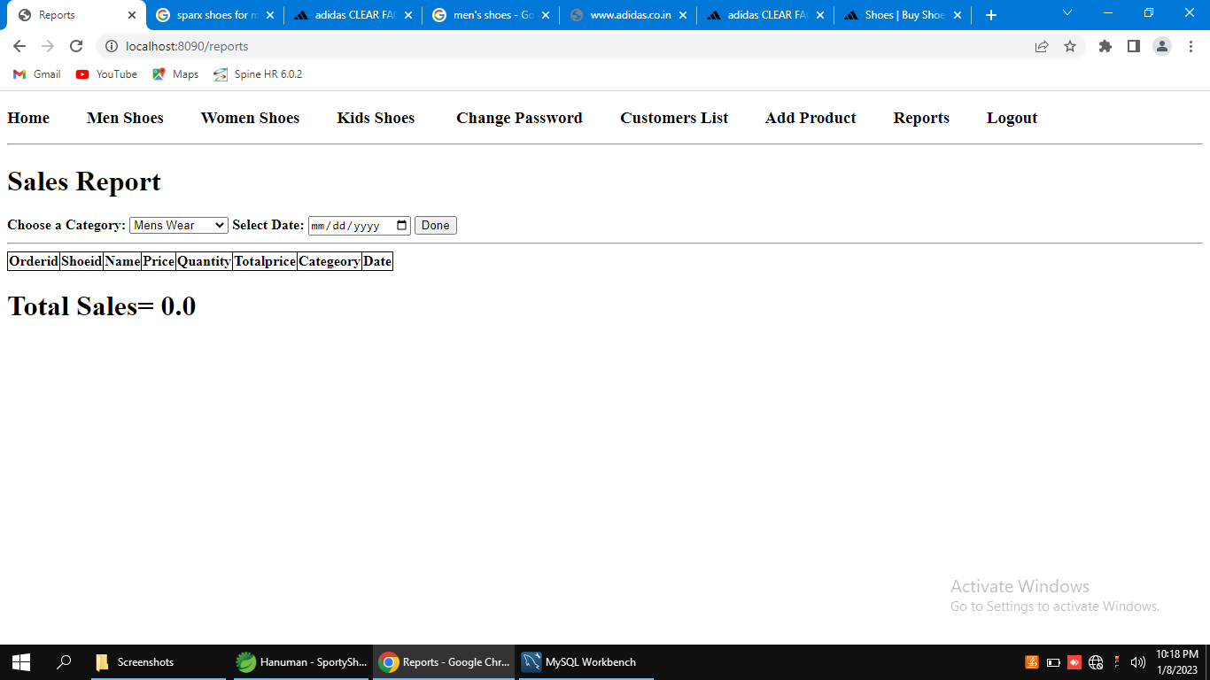

## Coreconceptsused:

Thefollowingconceptsareusedintheproject,

• Object-Oriented: used to create and model objects for users and their credentials.

• Databases: used to store and retrieve data.

• Data Sources: used to define a set of properties required to identify and access the database.

• Collections: used some collections such array list to store collection of data.

• Exception Handling: used to catch problems that arises in the code especially in I/O blocks.

## LinktoGithub:

**https://github.com/hanumanprasadvishwa/Project-2.git**

## 

## Conclusion:

Applicationispreparedaccordingtorequiredfeatures.Also,consideringtediousnessforsomeoftheaskedfeaturestheyaresimplifiedinordertoincreasetheproductivity.