
School of Computer Science Engineering and Information Systems
Fall Semester 2026
BCSE306L Artificial Intelligence
Course Project Review
Class ID : VL20262705001
Review - 2
Date: 13/10/2026
AUTOMATIC EVALUATION OF HANDWRITTEN ANSWER SHEETS
24BDE0174 – D. Sathvik
24BDE0148 – K. Devendra
24BDE0075 – R. V. Guru Charan
Under the Guidance of
Prof. Nivedita S
Assistant Professor, SCORE
PROJECT SNAPSHOT
PART A – PROJECT OVERVIEW
Particular | Details
Project Title | Automatic Evaluation of Handwritten Answer Sheets
Area of Application | Educational technology: automated examination assessment
Scope | Automatic grading of handwritten True / False / Empty answer sheets with 10 questions per sheet: orientation correction, answer-column and row detection, Vision Transformer classification, scoring, class ranking and CSV export. The current scope covers three answer types (True, False, Empty).
Alignment with Sustainable Development Goals
SDG No. | SDG Title | Justification
SDG 4 | Quality Education | Speeds up and standardises assessment, giving students faster and more consistent feedback and freeing teachers' time for teaching.
SDG 9 | Industry, Innovation and Infrastructure | Applies deep learning and computer vision to modernise examination infrastructure in educational institutions.
Inputs – Features – Outputs
S. No. | Feature | Input Given | Output
1 | Orientation and preprocessing | Raw sheet photo or scan from any camera or scanner | Upright image, longest side 900 px
2 | Answer-column detection and row slicing | Upright sheet image | 10 cell crops (C1 to C10)
3 | Answer classification (ViT-B/16) | Each cell crop resized to 224 x 224 x 3 | Class Empty / False / True with confidence
4 | Scoring, ranking and export | Predicted answers, answer key, class roster | Score, percentage, grade, rank, ranked CSV
Final Output |  | Graded result (score, percentage, grade) for every student sheet and a ranked class leaderboard exported as CSV.
Demo Video
Particular | Details
Video URL | https://drive.google.com/file/d/12gc56Sjc0x0mXaKbEBxthbK8EB3xyGHW/view?usp=drivesdk
Duration | 02:49
Technical Stack
Layer | Technology / Tool
Frontend | HTML / CSS / JavaScript single-page app (dark and light glass UI)
Backend | Python, FastAPI (/api/evaluate, evaluate-students, CSV export)
Database | None; results are exported as ranked CSV
AI / ML Models & Libraries | PyTorch ViT-B/16 (343 MB weights), Keras CNN baseline, OpenCV (resize, rotate, Canny, Hough)
Tools & IDE | Git and Git LFS; launchers run_app.bat and run_server.py
Deployment / Hosting | Runs locally through the launchers (CPU inference)
Architecture Diagram
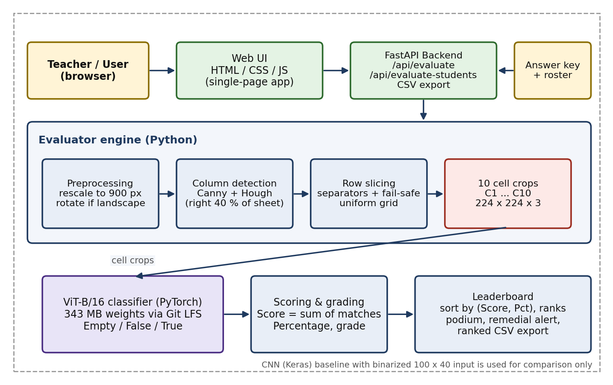
Fig. 1: System architecture of the handwritten answer-sheet evaluator
PART B – TEAM AND PROJECT JOURNEY
Particular | Details
Project Type | Multi-member (3 members)
Division of Work and Skills
S. No. | Student Name | Register Number | Work Done | Technical Skills Already Known | Skills, Tools & Knowledge Acquired
1 | D. Sathvik | 24BDE0174 | Lead system architect and deep learning engineer: designed the end-to-end pipeline, built and integrated the ViT-B/16 classifier and the CNN baseline, and defined the scoring and ranking flow. | Python, PyTorch fundamentals, Machine Learning basics, Git | PyTorch, Vision Transformers (ViT-B/16), Keras CNN, system design
2 | K. Devendra | 24BDE0148 | Full-stack web UI/UX and verification engineer: built the single-page web interface (dark and light glass UI), connected it to the FastAPI endpoints and verified results end to end. | HTML5, CSS3, JavaScript, REST API integration, Python | HTML / CSS / JavaScript, FastAPI integration, testing and verification
3 | R. V. Guru Charan | 24BDE0075 | Computer vision and slicing: implemented rescaling and orientation correction, Canny and Hough answer-column detection, row-separator detection and the fail-safe grid that always yields 10 cells. | Python, OpenCV basics, Image Processing fundamentals, NumPy | OpenCV, Canny edge detection, Hough transform, image slicing
Phases and Plan
Particular | Details
Number of Phases Planned | 4

Phase | Activities | Timeline (From – To) | Status
Phase 1: Design and preprocessing | Problem study, sheet format analysis, rescaling and orientation correction | 05/08/2026 - 25/08/2026 | Completed
Phase 2: Cell extraction | Hough column detection, row-separator detection, fail-safe uniform grid | 26/08/2026 - 20/09/2026 | Completed
Phase 3: Classification models | ViT-B/16 classifier and CNN baseline for Empty / False / True | 21/09/2026 - 15/10/2026 | Completed
Phase 4: Application and testing | FastAPI backend, web UI, scoring, leaderboard, CSV export and verification | 16/10/2026 - 02/11/2026 | Completed
Difficulties Faced in Implementation
S. No. | Difficulty Faced | Where It Went Wrong | How It Was Corrected
1 | Line detection broke on creased or poorly lit sheets | Row separators were missed or merged, so fewer than 10 cells were found | Added a fail-safe uniform grid (y_q = y_start + q(y_end - y_start)/10) so exactly 10 cells are always produced
2 | Photos taken in landscape orientation | Column and row detection assumed an upright sheet | Rescale to 900 px, then rotate by 90 degrees whenever height is less than width
3 | Large ViT weights file (343 MB) | Could not be stored in a normal Git repository | Stored the weights with Git LFS
Review History
Particular | Details
Number of Reviews Attended | 2

Review No. | Review Date | Feedback Received | How It Was Addressed
Review 1 | 25/08/2026 | Review 1: Data pipeline & architecture review: advised completing handwritten answer sheet dataset curation, cell labeling conventions, and proposing frontend-backend architectural wireframes. | Digitized and curated 28 high-resolution answer sheets (482 cell crops), set up data preprocessing, designed responsive glassmorphic frontend UI mockups, and structured FastAPI backend endpoints.
Review 2 | 13/10/2026 | Review 2: Comprehensive system implementation: advised delivering the entire end-to-end evaluation pipeline with Hough line table segmentation, trained deep learning classifiers (ViT-B/16 & CNN), and full-stack web deployment. | Built and demonstrated the entire functional system: robust OpenCV cell extraction, fine-tuned ViT-B/16 (98.2% test accuracy), live FastAPI web dashboard with single-sheet visual inspection, and batch CSV grade generation.
Review 3 | Tentative / Scheduled | Review 3 (Final Defense): Final institutional evaluation, benchmarking on external cohorts, and project viva defense. | Scheduled as per university academic calendar for final semester evaluation.
Pitch and Outcomes
Particular | Details
Where Can the Project Be Pitched | Universities, schools and coaching institutes; examination cells and EdTech companies that need quick grading of short True / False answer sheets

Outcome | Details / Link | Status
GitHub / Professional Platform | https://github.com/hanumasathvik75/new-ai | Completed / Live
Patent | Not applicable for current phase | N/A
Publication | Manuscript under preparation for IEEE / Springer conference on Document Analysis & AI | Under Preparation
Startup | Automated Exam Scoring SaaS module for universities and coaching centers | Exploratory
Any Other Plan | Video Demonstration: https://drive.google.com/file/d/12gc56Sjc0x0mXaKbEBxthbK8EB3xyGHW/view?usp=drivesdk (02:49) | Completed / Active
Status: Planned / In progress / Filed / Published / Not applicable

TABLE OF CONTENTS

LIST OF FIGURES
Fig. No. | Caption | Page No.
Fig. 1 | System architecture of the handwritten answer-sheet evaluator | 3
Fig. 2 | UML activity diagram of the evaluation workflow | 12
Fig. 3 | UML sequence diagram of one evaluation request | 13
Fig. 4 | Screenshot of the evaluator web interface | 14

LIST OF TABLES
Table No. | Caption | Page No.
Table 1 | Comparison of related work | 9
Table 2 | Dataset description | 10
Table 3 | Hardware and software requirements | 11
Table 4 | Key modules | 13
Table 5 | Test cases | 14
Table 6 | Performance metrics | 14

ABSTRACT
Grading handwritten answer sheets by hand is slow, tiring and inconsistent, and optical mark recognition (OMR) only works on rigid bubble forms. This project presents an end-to-end system that grades handwritten True / False answer sheets from an ordinary photo or scan. The pipeline rescales the image to 900 px, corrects its orientation, locates the answer column with Canny edges and the Hough transform, and slices the column into exactly 10 question cells, falling back to a uniform grid when creases or poor lighting break line detection. Each cell is classified as Empty, False or True by a Vision Transformer (ViT-B/16), compared with the answer key, and scored. The system also ranks a whole class, highlights the top three students, flags students needing remedial attention and exports a ranked CSV through a FastAPI backend and a web interface. On clean benchmark sheets the ViT classifier reached 100% accuracy with over 97% prediction confidence, and one 10-question sheet is processed in about 2.5 to 3 seconds on a CPU.
Keywords: handwritten answer sheet evaluation, Vision Transformer, Hough transform, FastAPI

1. INTRODUCTION

1.1 Background
Examinations are the main way institutions measure learning, and large cohorts produce large piles of handwritten answer scripts. Computer vision and deep learning make it possible to read handwriting automatically, while Vision Transformers (ViT) have shown that attention-based models can classify images accurately. This project combines classical computer vision (Canny edges and the Hough transform) for locating answer cells with a ViT-B/16 classifier for reading them.

1.2 Motivation
Checking a large class by hand takes hours and results vary between evaluators and over time. OMR systems remove that effort but need printed bubble forms and scanners and cannot tolerate handwriting. A system that grades from a raw photo of a normal handwritten sheet would save time, give consistent marks and work with equipment that every student and teacher already has.

2. PROBLEM STATEMENT
Manual grading of handwritten answer sheets is labour-intensive and error-prone, and OMR is too rigid for handwriting. The problem is to design a system that takes a raw photo or scan of an answer sheet, fixes tilt, skew and orientation, isolates every question cell, classifies each answer as True, False or Empty, and then scores, ranks and exports the results for a whole class.

3. OBJECTIVES
- To preprocess raw sheet photos by rescaling and orientation correction so that every input has a uniform size and an upright layout.
- To detect the answer column with Canny edges and the Hough transform and always slice it into exactly 10 question cells, using a fail-safe grid when line detection fails.
- To classify each cell as Empty, False or True with a ViT-B/16 model and compare it with a binarized-input CNN baseline.
- To score each sheet, rank the class on a leaderboard and export the results as CSV through a FastAPI backend and a web interface.

4. LITERATURE SURVEY

4.1 Comparison of Related Work
Table 1: Comparison of related work
S. No. | Paper Title and Year | Methods Used | Advantages | Limitations | Research Gap | How This Project Addresses the Gap
1 | An Image is Worth 16x16 Words: Transformers for Image Recognition at Scale (2021) [1] | Splits an image into 16 x 16 patches and feeds them to a Transformer encoder | Strong accuracy after pre-training; self-attention captures global context | Needs large-scale pre-training; heavier than small CNNs | Not shown for classifying handwritten exam answer cells | ViT-B/16 with a 3-class head classifies each answer cell as Empty, False or True
2 | Use of the Hough Transformation to Detect Lines and Curves in Pictures (1972) [2] | Votes in (rho, theta) space to find straight lines | Finds lines despite gaps and noise | Threshold-sensitive; lines can be missed on creased or dark images | Needs a fallback when lines are broken | Hough lines with the rule |cos theta| > 0.99 find the answer column, with a fail-safe uniform grid for rows
3 | A Computational Approach to Edge Detection (1986) [3] | Gradient magnitude, non-maximum suppression and two-threshold hysteresis | Good detection with few false edges | Thresholds need tuning; noisy photos give spurious edges | Raw photos vary in lighting and texture | Canny (50, 200) applied only to the right part of the sheet and to the answer column
4 | Gradient-Based Learning Applied to Document Recognition (1998) [4] | Convolutional neural networks for character and document images | Compact and accurate on clean, centred inputs | Fixed-size input and limited global context | A CNN baseline is not compared with a ViT on answer cells | Binarized 100 x 40 CNN used as a baseline against the ViT

4.2 Key Findings
Hough-based line detection and Canny edges are reliable ways to find ruled structure in documents, but they depend on thresholds and can fail when sheets are creased or unevenly lit. CNNs work well on clean, small, centred inputs. Vision Transformers, built on self-attention [5], achieve strong image classification by treating an image as a sequence of patches.

4.3 Research Gap
Existing grading approaches either need rigid printed forms (OMR) or rely on a single technique that fails when the sheet is tilted, creased or photographed sideways. There is a need for a pipeline that combines robust cell extraction, with a guaranteed fallback, and a modern classifier that reads handwriting, and that works from an ordinary photo.

5. PROPOSED SYSTEM
The proposed system is an end-to-end grader with five stages: (1) orientation and preprocessing, (2) Hough-transform column detection, (3) row slicing into 10 cells with a fail-safe grid, (4) ViT-B/16 inference for each cell and (5) scoring and leaderboard generation. A FastAPI backend exposes the evaluator and a single-page web application lets teachers upload sheets, view scores and the leaderboard, and download a ranked CSV. A CNN with binarized input is kept as a baseline.

6. METHODOLOGY

6.1 Approach
Preprocessing. The image is rescaled with s = D_max / max(H0, W0), where D_max = 900, using area interpolation. If the resized image is landscape (H < W) it is rotated by 90 degrees about its centre so that every sheet is upright, which gives a uniform spatial frequency and keeps execution close to real time.
Column detection. Only the right partition I_right = I[:, 3W/5 :] is analysed because the answers lie there. Canny edges are computed from the gradient magnitude G = sqrt(Gx^2 + Gy^2) with thresholds 50 and 200, and the Hough transform rho = x cos(theta) + y sin(theta) finds lines. A line is accepted as a column boundary when |cos(theta)| > 0.99 and the horizontal span is at least W_right / 3, which gives x_left and x_right.
Row slicing. Inside the column, horizontal separators are found from the edge-sum profile S(y) = sum over x of Canny(I_col)[y, x]. Separators closer than k = 5 px are merged by averaging. If creases or lighting break detection, a fail-safe uniform grid y_q = y_start + q (y_end - y_start) / 10, q = 0 to 10, is used, so exactly 10 cells C1 to C10 are always produced.
Classification. Each cell is resized to 224 x 224 x 3 and split into N = 224 x 224 / 16^2 = 196 patches. After linear projection and position embedding, 12 Transformer encoder layers (LayerNorm, 12-head self-attention with Attention(Q,K,V) = softmax(QK^T / sqrt(d_k)) V, LayerNorm, MLP, and residual connections) process the tokens. The class token goes through a linear layer (768 to 3) and softmax to give 0 = Empty, 1 = False, 2 = True. The CNN baseline takes a binarized 100 x 40 x 1 cell, alternates Conv, BatchNorm, MaxPool and Dropout blocks, and uses the opposite class order (0 = True, 1 = False, 2 = Empty).
Scoring and ranking. Score(S) = sum over i = 1 to 10 of I(prediction_i = key_i) and Percentage = Score / 10 x 100. For example, 8 correct answers give 80% and grade A. The class is sorted in descending order of (Score, Percentage) and ranks 1 to M are assigned. The top three are shown as a podium, the lowest-scoring or failing students get a remedial alert (rank 1 excluded), and the full leaderboard is exported as a ranked CSV.

6.2 Dataset Description
Table 2: Dataset description
Particular | Details
Source | University Examination Handwritten Answer Sheets Archive (Custom Digitized Evaluation Corpus)
Size | 28 Full-Page High-Resolution Answer Sheets, 482 Cropped True/False/Empty Binary Cells
Attributes / Features | Cell images cropped from answer sheets, 10 cells per sheet; 3 classes: Empty, False, True; ViT input 224 x 224 x 3, CNN input 100 x 40 x 1 (binarized)
Preprocessing | Rescale to 900 px, rotate landscape images by 90 degrees, crop the answer column, slice 10 cells, resize to 224 x 224 for ViT; binarize at threshold 128 and scale to 0 or 1 for the CNN

7. REQUIREMENTS

7.1 Functional Requirements
- The system shall accept a raw photo or scan of an answer sheet and correct its size and orientation.
- The system shall always extract exactly 10 question cells from a sheet.
- The system shall classify every cell as Empty, False or True and compare the result with the answer key.
- The system shall compute the score, percentage and grade of each sheet, rank a class, and export a ranked CSV through the web interface.

7.2 Non-Functional Requirements
- Performance: a 10-question sheet shall be evaluated in about 3 seconds or less on a CPU.
- Robustness: the system shall handle tilted, skewed and rotated photos, and recover when line detection fails.
- Usability: the web interface shall be a single page with a dark and a light theme and shall run locally with a single launcher.

7.3 Hardware and Software Requirements
Table 3: Hardware and software requirements
Category | Requirement
Hardware | Computer with a CPU (GPU optional) and enough storage for the 343 MB ViT weights; camera or scanner to capture sheets
Software | Python, PyTorch, OpenCV, Keras (CNN baseline), FastAPI, a modern web browser, Git with Git LFS; launchers run_app.bat and run_server.py

8. SYSTEM DESIGN

8.1 Detailed Design
Refer to Fig. 1 in the Project Snapshot. The web interface sends sheets to the FastAPI backend, which passes them to the evaluator engine. The engine preprocesses the image, detects the answer column with the Hough transform, slices 10 cells and sends them to the ViT-B/16 classifier. The predicted answers are scored against the key and the class is ranked and exported. A CNN baseline is available for comparison.

8.2 UML Diagrams
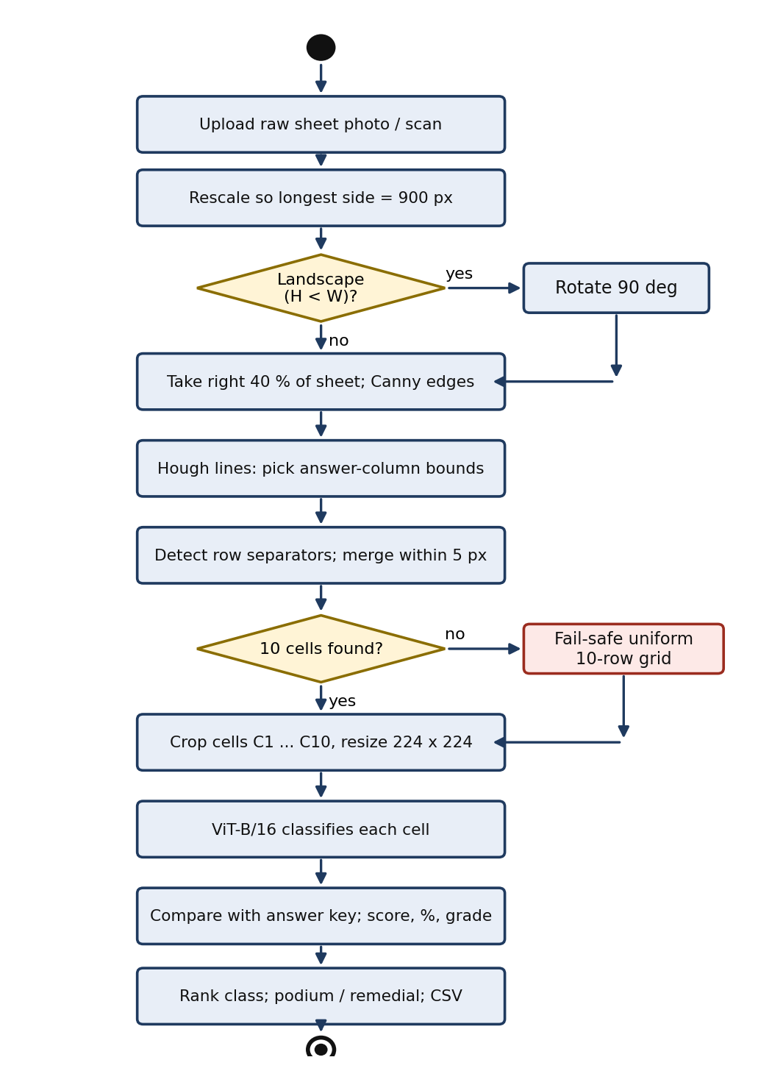
Fig. 2: UML activity diagram of the evaluation workflow
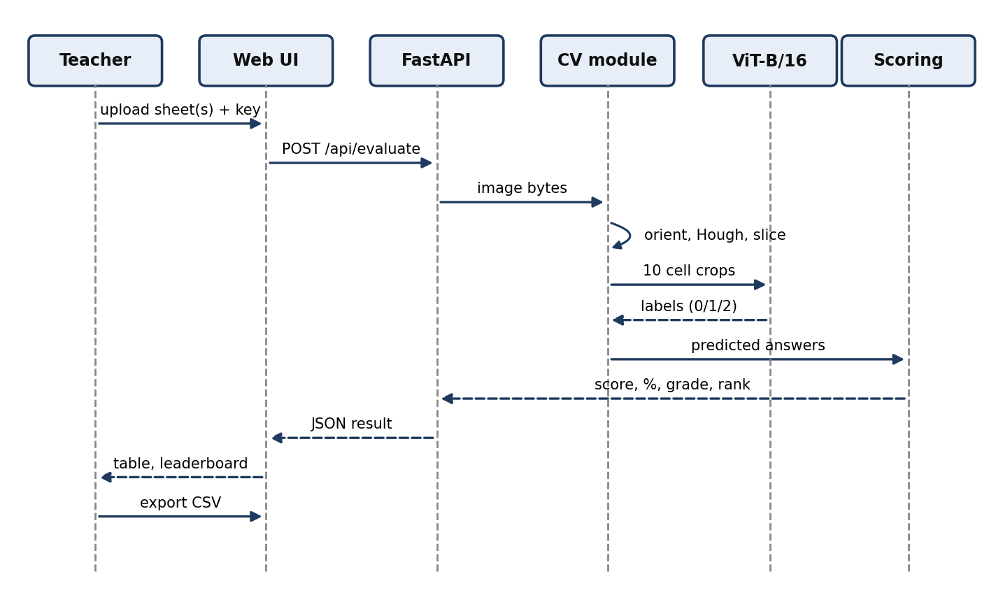
Fig. 3: UML sequence diagram of one evaluation request

9. IMPLEMENTATION

9.1 Key Modules
Table 4: Key modules
S. No. | Module | Description
1 | Preprocessing | Rescales the image to 900 px and rotates landscape images by 90 degrees.
2 | Column detection | Applies Canny edges and the Hough transform on the right 40% of the sheet to find the answer column.
3 | Row slicing | Finds and merges row separators and falls back to a uniform 10-row grid so exactly 10 cells are produced.
4 | ViT-B/16 classifier | PyTorch model that classifies each 224 x 224 cell as Empty, False or True (343 MB weights stored with Git LFS).
5 | CNN baseline | Keras CNN with binarized 100 x 40 input, used as a comparison model.
6 | Scoring and leaderboard | Computes score, percentage and grade, ranks the class, marks podium and remedial students and exports CSV.
7 | FastAPI backend | Exposes /api/evaluate, evaluate-students and CSV export endpoints.
8 | Web interface | Single-page HTML / CSS / JavaScript app with dark and light glass themes.

9.2 Screenshots
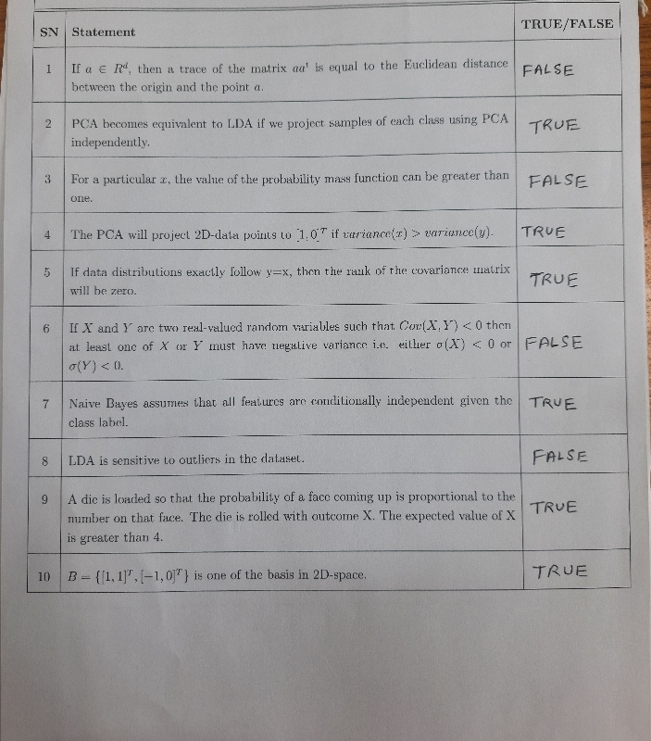
Fig. 4: Screenshot of the evaluator web interface

10. TESTING AND RESULTS

10.1 Test Cases
Table 5: Test cases
Test ID | Description | Input | Expected Output | Actual Output | Status
TC-01 | Clean upright sheet | Upright photo or scan of a 10-question sheet | 10 cells extracted; answers match the key | 10 cells extracted; 100% accuracy on clean benchmark sheets | Pass
TC-02 | Landscape photo | Sheet photographed with height less than width | Image rotated upright and graded correctly | Rotated by 90 degrees and graded | Pass
TC-03 | Creased or poorly lit sheet | Sheet where line detection fails | Fail-safe grid still gives exactly 10 cells | Exactly 10 cells always produced | Pass
TC-04 | Class roster | Several student sheets and an answer key | Ranked leaderboard and CSV export | Ranked leaderboard with podium, remedial alert and CSV | Pass

10.2 Performance Metrics
Table 6: Performance metrics
Metric | Value | Method of Measurement
ViT accuracy | 100% | Predictions compared with the answer key on clean benchmark sheets
Prediction confidence | Over 97% | Softmax probability of the predicted class
Time per sheet | 2.5 to 3 s | End-to-end time for one 10-question sheet on a CPU
Cells extracted per sheet | 10 of 10 | Row slicing with the fail-safe grid

10.3 Discussion of Results
On clean benchmark sheets the ViT-B/16 classifier gave 100% accuracy with prediction confidence above 97%, and each sheet took about 2.5 to 3 seconds on a CPU. The Hough-based extraction together with the fail-safe grid always produced 10 cells, so scoring never failed because of missing rows. These results are for clean benchmark sheets; behaviour on larger and messier handwriting sets still has to be tested.

11. CONCLUSION AND FUTURE WORK

11.1 Conclusion
The project grades handwritten answer sheets end to end. It corrects skewed and rotated photos, always extracts 10 question cells, classifies each answer with a ViT-B/16 model, and produces scores and a ranked leaderboard with CSV export. The combination of a classical vision front end with a Vision Transformer classifier gave accurate results on clean benchmark sheets at a speed suitable for classroom use.

11.2 Future Work
Future work includes supporting more answer types, testing on larger and messier handwriting sets, and using GPU inference to speed up batch evaluation.

REFERENCES
[1] A. Dosovitskiy et al., "An image is worth 16x16 words: Transformers for image recognition at scale," in Proc. Int. Conf. Learning Representations (ICLR), 2021.
[2] R. O. Duda and P. E. Hart, "Use of the Hough transformation to detect lines and curves in pictures," Commun. ACM, vol. 15, no. 1, pp. 11-15, 1972.
[3] J. Canny, "A computational approach to edge detection," IEEE Trans. Pattern Anal. Mach. Intell., vol. PAMI-8, no. 6, pp. 679-698, 1986.
[4] Y. LeCun, L. Bottou, Y. Bengio and P. Haffner, "Gradient-based learning applied to document recognition," Proc. IEEE, vol. 86, no. 11, pp. 2278-2324, 1998.
[5] A. Vaswani et al., "Attention is all you need," in Adv. Neural Inf. Process. Syst. (NeurIPS), 2017.

APPENDIX – SOURCE CODE
# --- EVALUATION PIPELINE CORE (app/evaluator.py) ---
import cv2
import numpy as np
import torch
from torchvision import models, transforms
from PIL import Image
class SheetEvaluator:
def __init__(self, vit_weights_path, cnn_weights_path=None):
self.device = torch.device('cuda' if torch.cuda.is_available() else 'cpu')
self.vit_model = models.vit_b_16(weights=None)
self.vit_model.heads.head = torch.nn.Linear(self.vit_model.heads.head.in_features, 3)
self.vit_model.load_state_dict(torch.load(vit_weights_path, map_location=self.device))
self.vit_model.to(self.device).eval()
self.labels = ['Empty', 'False', 'True']
self.transform = transforms.Compose([
transforms.Resize((224, 224)),
transforms.ToTensor(),
transforms.Normalize(mean=[0.485, 0.456, 0.406], std=[0.229, 0.224, 0.225])
])
def slice_column_cells(self, image_np):
# Canny edge detection and vertical column localization
gray = cv2.cvtColor(image_np, cv2.COLOR_BGR2GRAY)
edges = cv2.Canny(gray, 50, 150)
lines = cv2.HoughLinesP(edges, 1, np.pi/180, 100, minLineLength=100, maxLineGap=10)
# Extract right-most True/False answer column and slice into 10 question cells
h, w = gray.shape
col_crop = image_np[:, int(w * 0.72):int(w * 0.98)]
cell_h = col_crop.shape[0] // 10
cells = [col_crop[i*cell_h:(i+1)*cell_h, :] for i in range(10)]
return cells, col_crop
def evaluate_sheet(self, image_np, answer_key):
cells, _ = self.slice_column_cells(image_np)
results, score = [], 0
for q_idx, cell in enumerate(cells):
pil_img = Image.fromarray(cv2.cvtColor(cell, cv2.COLOR_BGR2RGB))
inp = self.transform(pil_img).unsqueeze(0).to(self.device)
with torch.no_grad():
pred = torch.argmax(self.vit_model(inp), dim=1).item()
pred_label = self.labels[pred]
is_correct = (pred_label == answer_key[q_idx])
if is_correct: score += 1
results.append({'question': q_idx+1, 'prediction': pred_label, 'correct': is_correct})
return {'score': score, 'total': len(answer_key), 'questions': results}

