Packaging design to create pstxref.dat

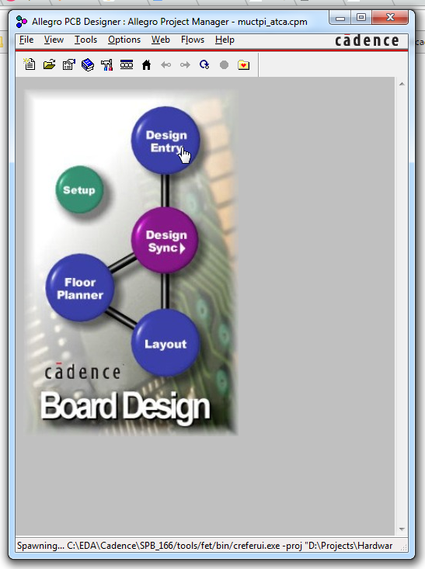

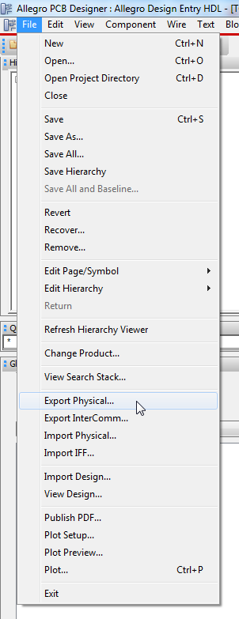

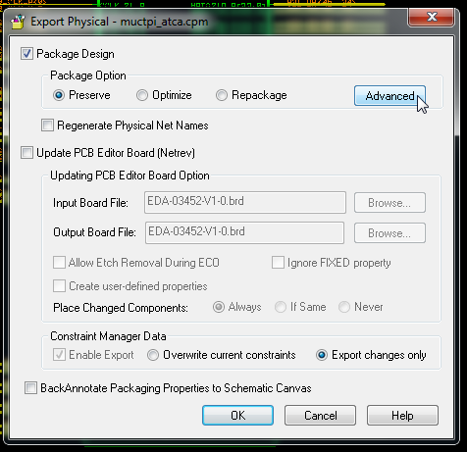

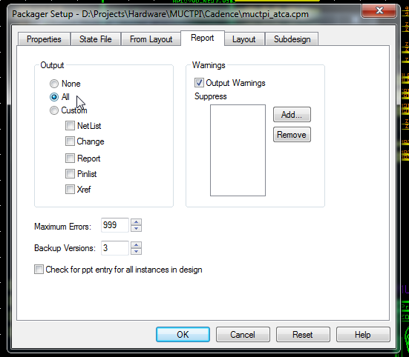

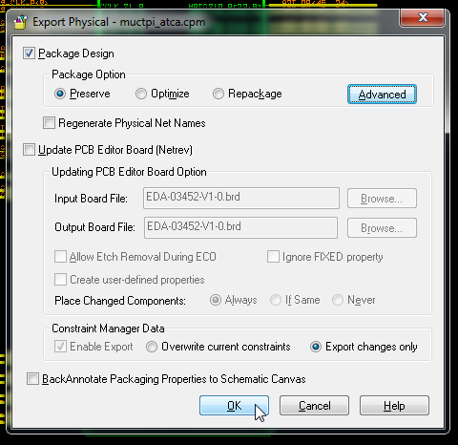

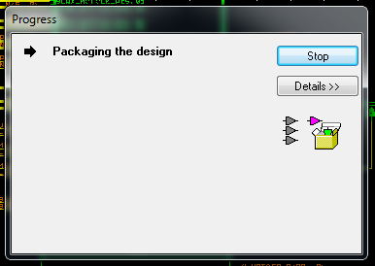

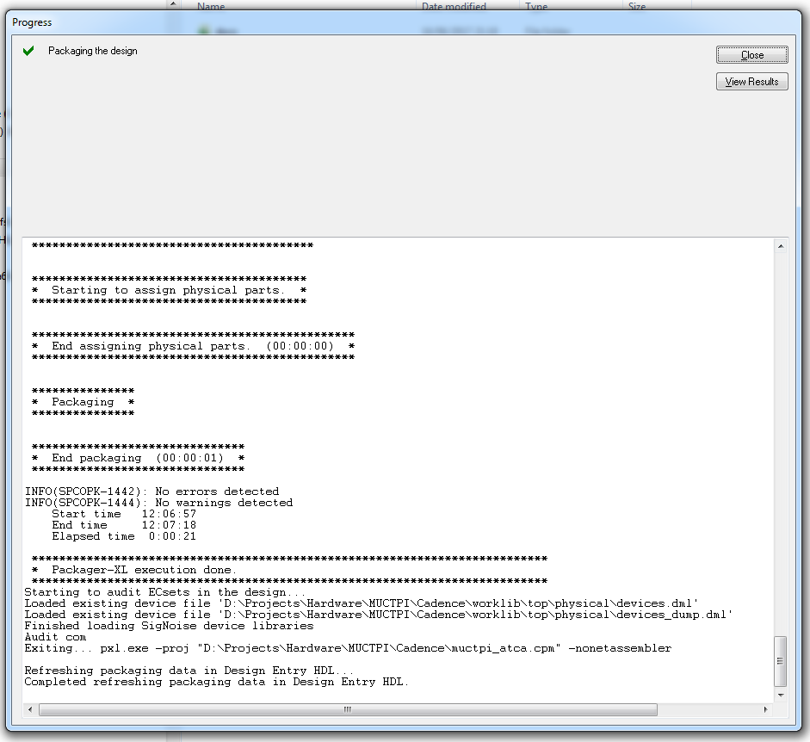

Running CRefer to create basenets.txt  
  
Note: If you find problem such as undefined versions of pages in the local cref.dat file, you can consider to use the installed cref.dat file in $CONCEPT_INST_DIR/share/local/creferhdl/cref.dat

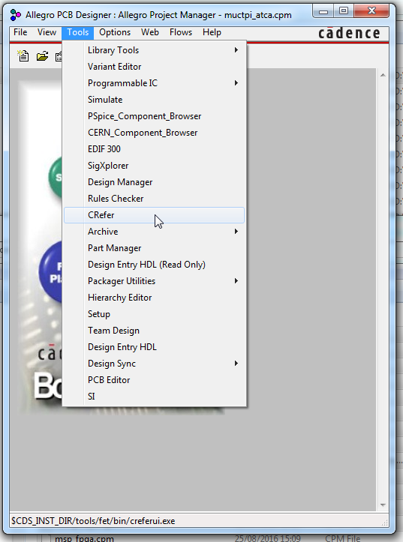

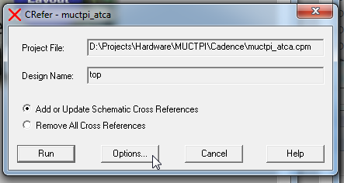

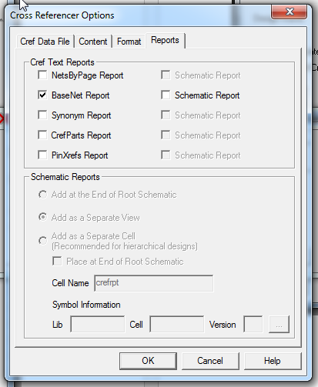 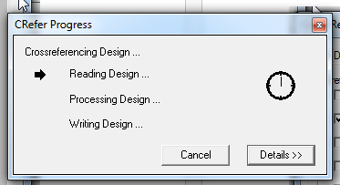

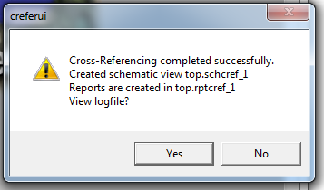

Look for the following two files: (search expression for both files on windows: basenets.txt OR pstxref.dat)

1. pstxref.dat  
   If you have an hierarchical design, make sure you get from the top-level worklib folder  
   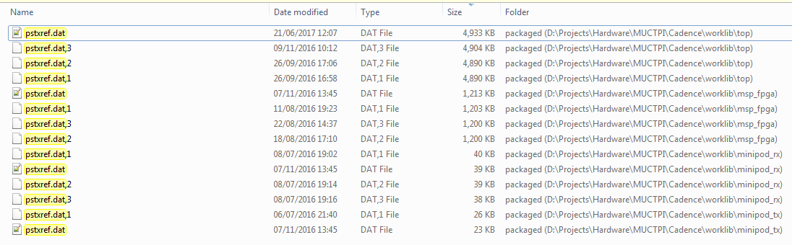
2. basenets.txt  
   