IRIS National Fair 2026 · Supporting technical document
Hidden Child Marriages in Odisha
Data platform, team workspace and fair map: technical report
Project: Detection-aware estimation of hidden child marriage, Odisha districts
Student researcher: Hanut Lal (individual project, Behavioral & Social Sciences)
Prepared by: Engineering team (engineer-side infrastructure only)
Date: 10 October 2026 · Version 1.1
Scope of this document. This report documents the engineering support built for the project: data collection, cleaning, district matching, the team workspace and the fair map. It is not the research paper. The research question, the model, the analysis, the findings and all writing of the paper are the student's own work and are reported separately by him. Help described here is declared on the ISEF forms (see Section 10).

Contents
1. Purpose and context
2. System overview
3. Technology stack
4. Data sources
5. Data pipeline
6. Out-of-time design and the NFHS-6 seal
7. Team workspace
8. Fair map
9. Hand-off to the student's model
10. Integrity and contribution statement
11. Limitations and open items
Appendix A. Source links
Appendix B. How to run

1. Purpose and context
Child marriage in India is measured in two very different ways. Household surveys (the National Family Health Survey, NFHS) estimate how common it is: in NFHS-5 (2019–21), the share of women aged 20–24 who were married before 18 ranged from 7.4% (Sambalpur) to 39.4% (Nabarangapur) across Odisha's 30 districts. Police records (NCRB, under the Prohibition of Child Marriage Act, 2006) count only the cases that reach the system: 164 cases in the whole state over 2016–2021.
The student's project separates how often child marriage happens (occurrence) from how often it is recorded (detection), so that a district with few recorded cases is not mistaken for a low-risk district. The design was to test the model out of time against NFHS-6. The NFHS-6 seal was removed on 10 October 2026 (Section 6).
To make that possible within an 11-day sprint (3–13 October 2026), the engineering team built:
- a reproducible data pipeline that turns public PDFs, spreadsheets and portal data into one district-by-year table;
- a district crosswalk that reconciles names and boundaries across sources;
- an encryption and audit process for NFHS-6 (the seal), used 9–10 October and then removed at the project lead's request;
- a team workspace (web application) to run all of this without a command line;
- an offline, trilingual district map for the fair (English, Hindi, Odia).

2. System overview
Figure 1 shows how data flows through the system. Public sources are extracted into tidy tables, matched to harmonised district units, and combined into a district panel. The student's model reads the panel and writes two files under a fixed contract; the fair map reads only those files. NFHS-6 fact sheets load in the same way as NFHS-4 and NFHS-5.
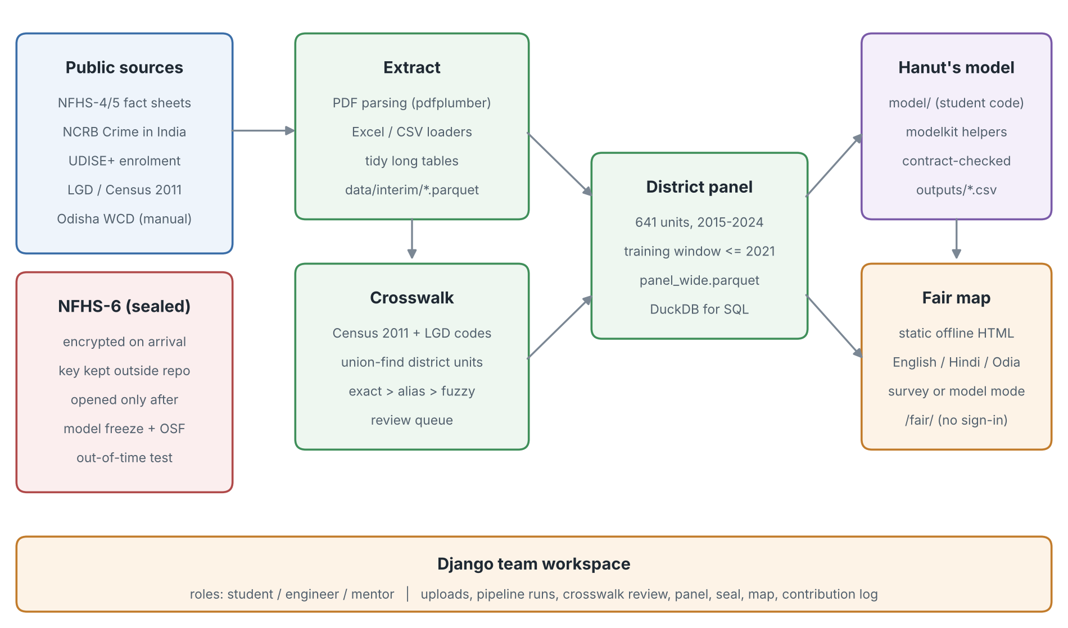
Figure 1. System architecture and data flow.
Everything runs locally on one laptop (macOS) with no cloud services and no personal data. All inputs are published, district-level aggregates.

3. Technology stack
The stack was chosen to be free, open-source, runnable offline on a school laptop, and readable by a student. Versions are those installed on the project laptop (Python 3.9.6).
Table 1. Technology stack
Layer | Technology (version) | Used for
Language | Python 3.9 (works on 3.9–3.13) | Everything: pipeline, web app, map builder, tests
Data handling | pandas 2.3, NumPy 2.0, PyArrow 21 | Tidy tables; Parquet storage
Analytical store | DuckDB 1.4 | SQL queries over the district panel
Geography | GeoPandas 1.0, Shapely 2.0 | District boundaries; SVG map paths
Rasters | rasterio 1.4 | Rainfall (CHIRPS) and night-lights (VIIRS) district averages
Document parsing | pdfplumber 0.11, openpyxl 3.1 | NFHS fact-sheet PDFs; NCRB/UDISE+ Excel files
Name matching | RapidFuzz 3.13 | Fuzzy matching of district spellings
Security | cryptography 50 (Fernet, AES-128 + HMAC) | Opening the former NFHS-6 sealed bundle (history only)
Web framework | Django 4.2 LTS, SQLite | Team workspace: logins, roles, uploads, pipeline runs, logs
Front end | Server-rendered HTML/CSS; vanilla JavaScript; inline SVG | Workspace pages; offline fair map (no external libraries)
Charts | Matplotlib 3.9 | Figures to the student's specification
Model layer (student) | PyMC 5 / ArviZ or NumPyro (student's choice) | Bayesian detection-aware model
Testing | pytest 8; Django test runner | 25 pipeline tests; 14 workspace tests
Configuration | YAML (sources.yaml, i18n.yaml) | Data sources, round years, translations
Launch | Bash script + macOS .command file | One double-click to install and start

4. Data sources
All data are public, district-level aggregates. No individual, household or village is identified anywhere in the system.
Table 2. Data sources loaded as of 10 October 2026
Source | What is used | Years | Coverage in Odisha
NFHS-4 district fact sheets (IIPS/MoHFW) | Women 20–24 married before 18; teen pregnancy | 2015–16 | 30 / 30 districts
NFHS-5 district fact sheets (IIPS/MoHFW) | Same indicators, plus men 25–29 married before 21 | 2019–21 | 30 / 30 districts
NCRB, Crime in India, district tables | Cases under the Prohibition of Child Marriage Act | 2014–2022 | 30 / 30 districts, every year
UDISE+ (Ministry of Education) | Girls' and boys' enrolment, Classes 8, 9, 10 | 2015-16 to 2024-25 | 30 / 30 districts, every year
CHIRPS v2.0 (UCSB Climate Hazards Center) | Annual rainfall; rainfall-shock z-score | 2000–2024 | 30 / 30 districts, every year (612 / 613 units all India)
Census 2011 / LGD | District codes, names, boundary changes | 2011 / current | All India: 785 LGD districts → 613 harmonised units
NFHS-6 district fact sheets | Out-of-time test (seal removed 10 Oct) | 2023–24 | State fact sheet only; district sheets not released
Odisha WCD reports, Assembly answers | Marriages prevented, CMPO cases | — | Not filled: no public district × year table

4.1 How the data were obtained
- NFHS-4 and NFHS-5: 60 PDF fact sheets downloaded from the new NFHS portal (nfhsiips.in, which replaced rchiips.org) and parsed with pdfplumber. District names are read from the text of each sheet, with the file name as a fallback.
- NCRB: the 'District-wise Crime against Children' workbooks for 2014–2022, downloaded from NCRB's own site (ncrb.gov.in, Crime in India additional tables). NCRB lays out each state as a block of rows; a small script (scripts/ncrb_tidy.py) turns them into one tidy table.
- UDISE+: class-wise enrolment by gender from the public UDISE+ dashboard: the archive report R43 for 2015-16 to 2020-21 and the current open-services data for 2021-22 onward, summed over all school types and social categories.
- CHIRPS rainfall: annual CHIRPS v2.0 rasters for 2000–2024 (Climate Hazards Center, UC Santa Barbara), cut to the India window and averaged over each district. A rainfall-shock z-score uses the 25-year baseline. Spot-checked pixels match the source files exactly.
- District codes: 785 LGD districts with Census 2011 codes, from a public concordance of the LGD export (github.com/vijayshree-jayaraman, August 2025). The 145 districts created after 2011 are linked to their 2011 parents; 22 have several parents, with population shares not published (assumed equal).

5. Data pipeline
The pipeline has three steps, each runnable from the workspace (Pipeline page) or the command line. Each step is deterministic: the same inputs always give the same panel.
- Extract. Raw files become tidy 'long' tables (state, district, year, variable, value, source) in data/interim/. NFHS-6 fact sheets are read like NFHS-4 and NFHS-5.
- Crosswalk. Districts that split or merged since 2011 are grouped into stable 'harmonised units' using Census 2011 and LGD codes (union-find). Each unit gets an ID such as U0370.
- Panel. Every source name is matched to a unit, in this order: exact name, then a reviewed alias list, then fuzzy spelling (RapidFuzz ratio ≥ 90). Unmatched names go to a review queue rather than being guessed. The result is one row per unit and year, 2015–2024, with a flag for the training window (year ≤ 2021).

5.1 Matching results
All 30 Odisha districts match in every source. Across India, every remaining name now matches a harmonised unit (613 units), using 260 reviewed aliases for police districts, city commissionerates and spelling variants. 724 NCRB rows from railway police, CID, cyber, STF and similar units have no district territory and are left out of district totals. The 2017 NCRB workbook labels Chhattisgarh's section as Bihar; this is corrected in scripts/ncrb_tidy.py.
For Odisha, four police districts are assigned to their revenue districts through the alias list: Berhampur → Ganjam, DCP Bhubaneswar → Khordha, DCP Cuttack → Cuttack, Rourkela → Sundargarh. State Railway Police, CID-Crime Branch and the Human Rights Protection Cell are kept as non-territorial.

5.2 Quality checks performed
- NFHS-4: parser fixed to read the Total column (not Urban/Rural); all 30 districts cross-checked against the 'NFHS-4' column printed in the NFHS-5 sheets.
- NCRB: Odisha totals from the children's tables match the separate SLL tables (2014: 0, 2015: 1, 2021: 64 cases).
- UDISE+: the 30 district totals for 2021-22 add up exactly to the state total (336,381 girls in Class 8); the two UDISE+ sources agree exactly for the overlapping year (Angul, 2021-22).
- Automated tests: 25 pipeline tests (extraction, crosswalk, panel, NCRB police units, model hand-off) and 14 workspace tests pass.
Table 3. Odisha totals in the panel (selected variables)
Year | PCM Act cases recorded (NCRB) | Girls enrolled in Class 8 (UDISE+)
2016 | 15 | 341,677
2017 | 17 | 339,575
2018 | 22 | 351,565
2019 | 22 | 338,828
2020 | 24 | 334,418
2021 | 64 | 365,251
2022 (outside training window) | 46 | 336,381

UDISE+ years are labelled by the year the school year ends (2015-16 → 2016).

6. Out-of-time design and the NFHS-6 seal (removed)
The original design tested whether a model trained only on data up to 2021 could anticipate NFHS-6 (2023–24). To make that provable, NFHS-6 files were to stay encrypted until the student froze and pre-registered the model.
9 October 2026: a key was created and the one NFHS-6 file then available was sealed (Fernet encryption, SHA-256 hashes logged); the mentor witnessed the seal.
10 October 2026: at the project lead's request the seal, freeze, witness and unseal steps were removed, and the student and mentor workspace accounts were deleted. The sealed file was opened without a model freeze; its SHA-256 matches the seal record. It is the Odisha state fact sheet only, so no district NFHS-6 values exist in the panel.
Consequence: results cannot be reported as a sealed, pre-registered out-of-time test against NFHS-6.
The full history stays in docs/seal_log.jsonl (keygen, seal, witness, seal_lifted), unchanged except for the new entry.
The pipeline still skips any NFHS round marked sealed in config/sources.yaml, which supports the no-go fallback if the team uses it.

7. Team workspace
A small web application (Django) lets the team do its work without the command line. It runs on the laptop at http://localhost:8000 and is started by double-clicking 'Start IRIS Workspace.command'.
Table 4. Roles in the workspace
Role | Person | Can do
Engineer | Engineering team | Upload data, run the pipeline, review the crosswalk and spot checks, upload model outputs, edit reason wording, checklist and contribution log
Admin | Project lead | Everything, including user accounts

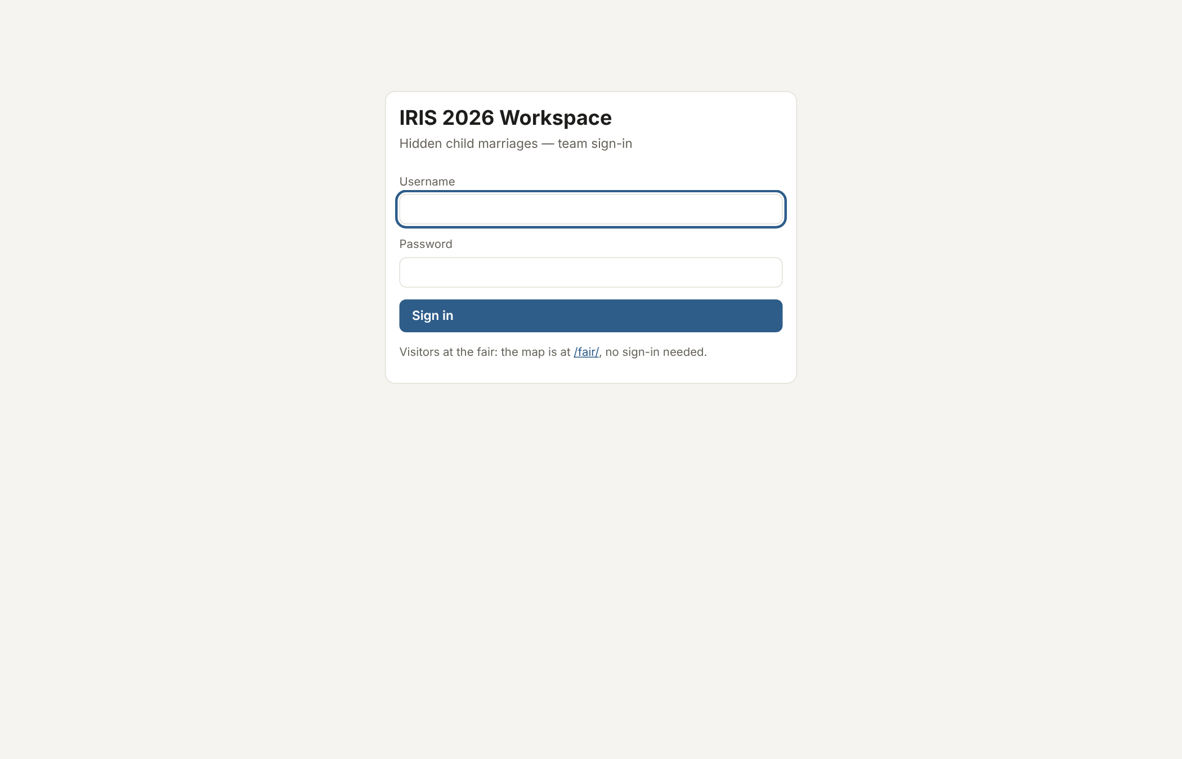
Figure 3. Team sign-in page. Visitors at the fair use /fair/ and need no sign-in.
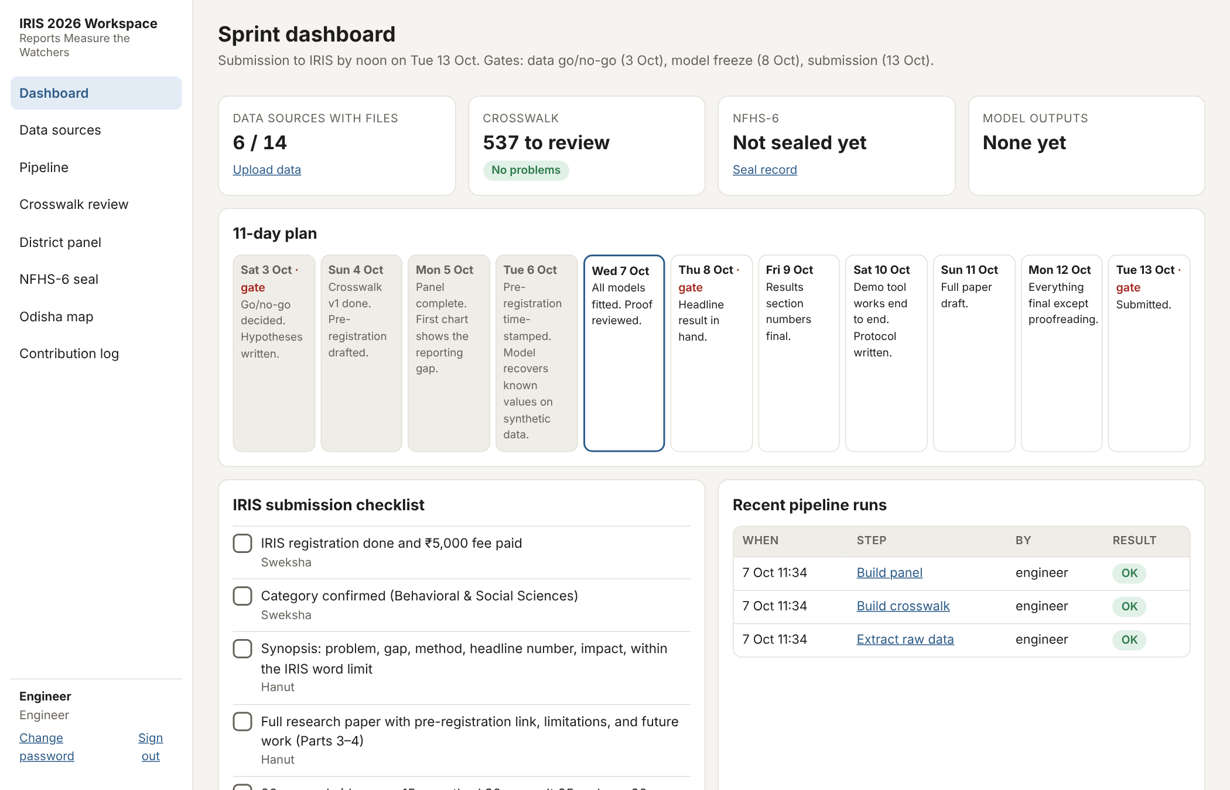
Figure 4. Sprint dashboard: data status, crosswalk and model-output cards; the 11-day plan with its three gates; the IRIS submission checklist.
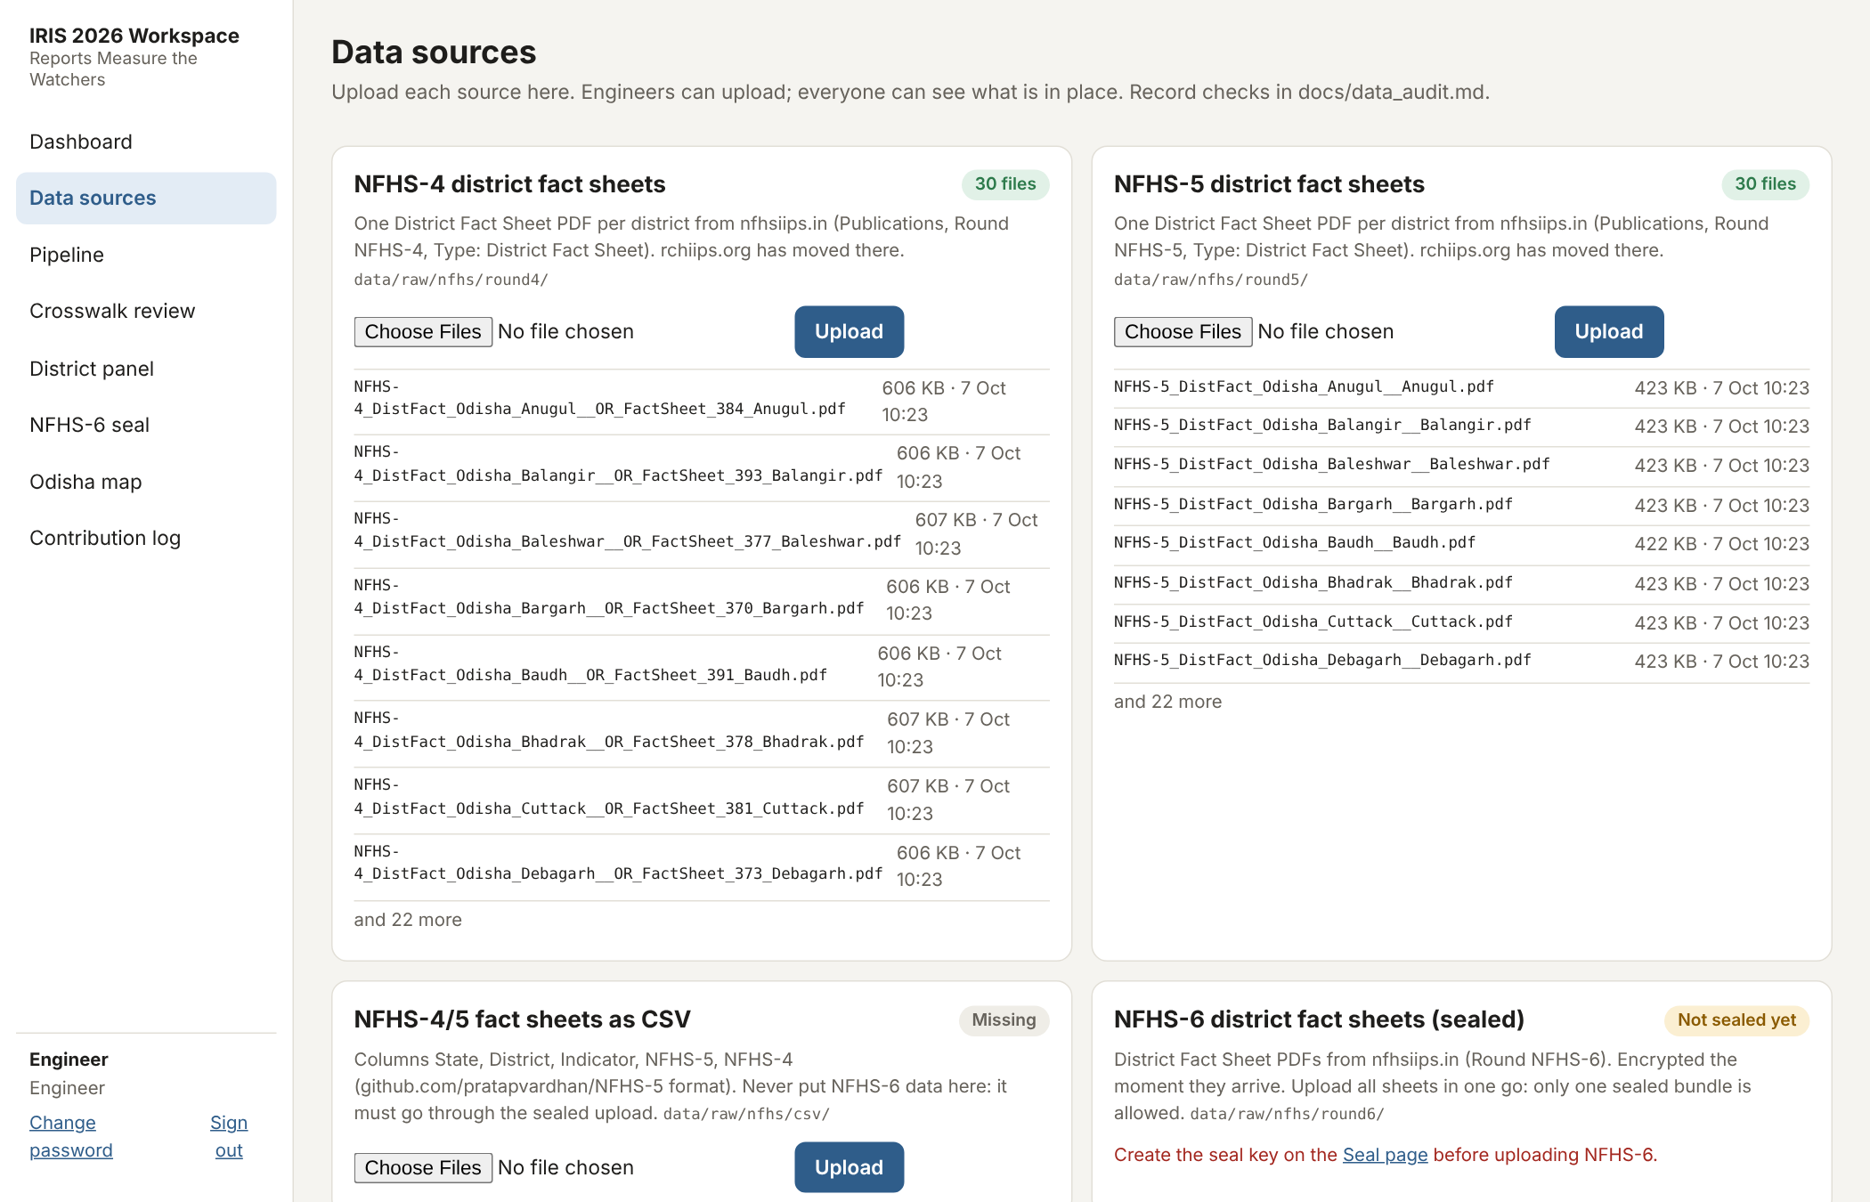
Figure 5. Data sources page: one upload card per source, with the files currently in place.
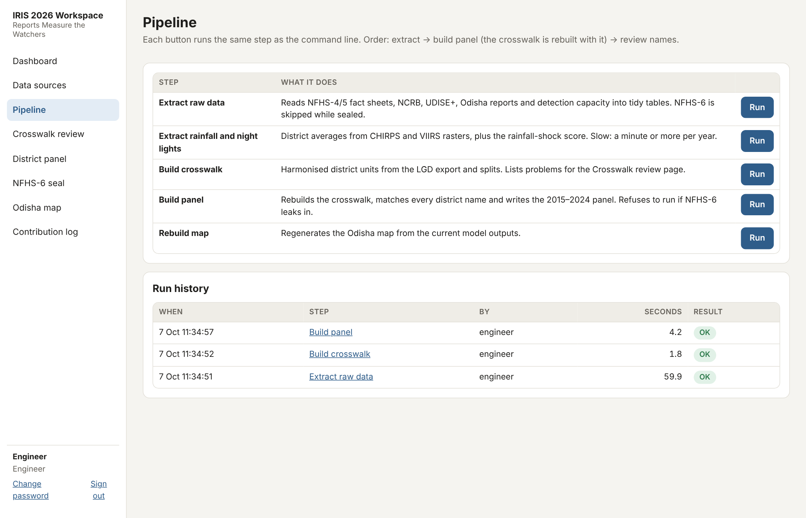
Figure 6. Pipeline page: each step can be run with one click; run history records who ran what and whether it succeeded.
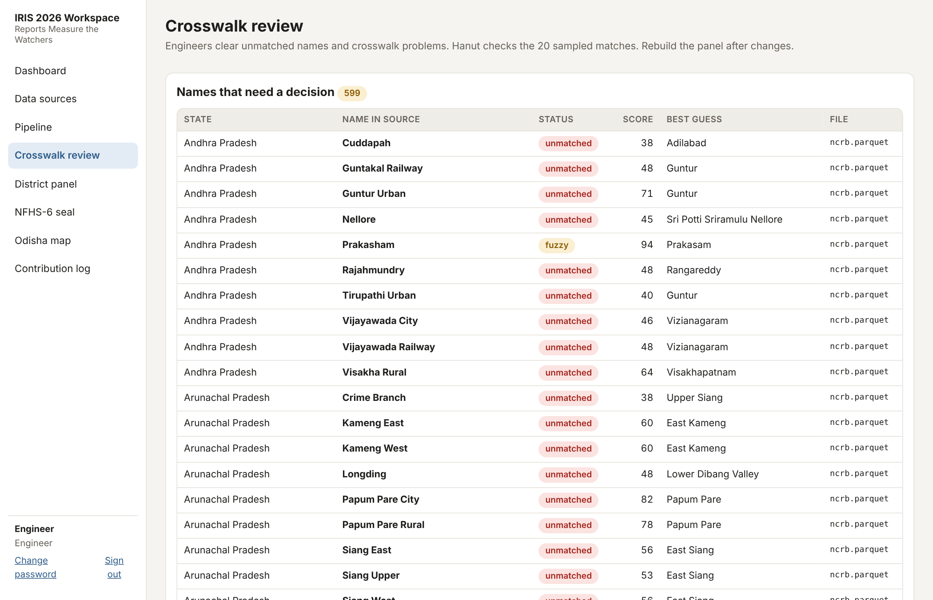
Figure 7. Crosswalk review: names that need a decision, with the best guess and score. Nothing is matched silently.
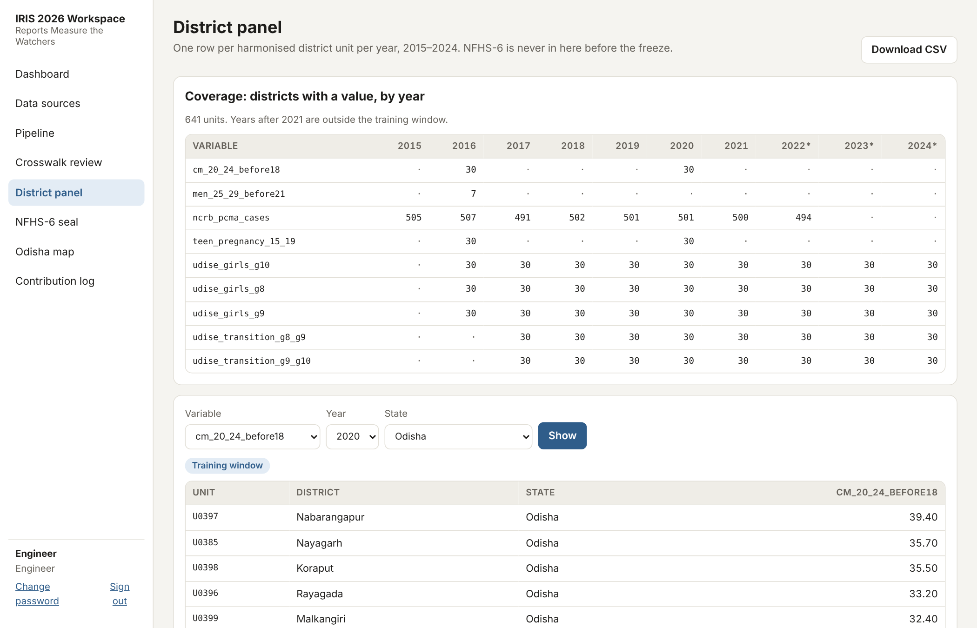
Figure 8. District panel: coverage of each variable by year, and the values for one variable, year and state.
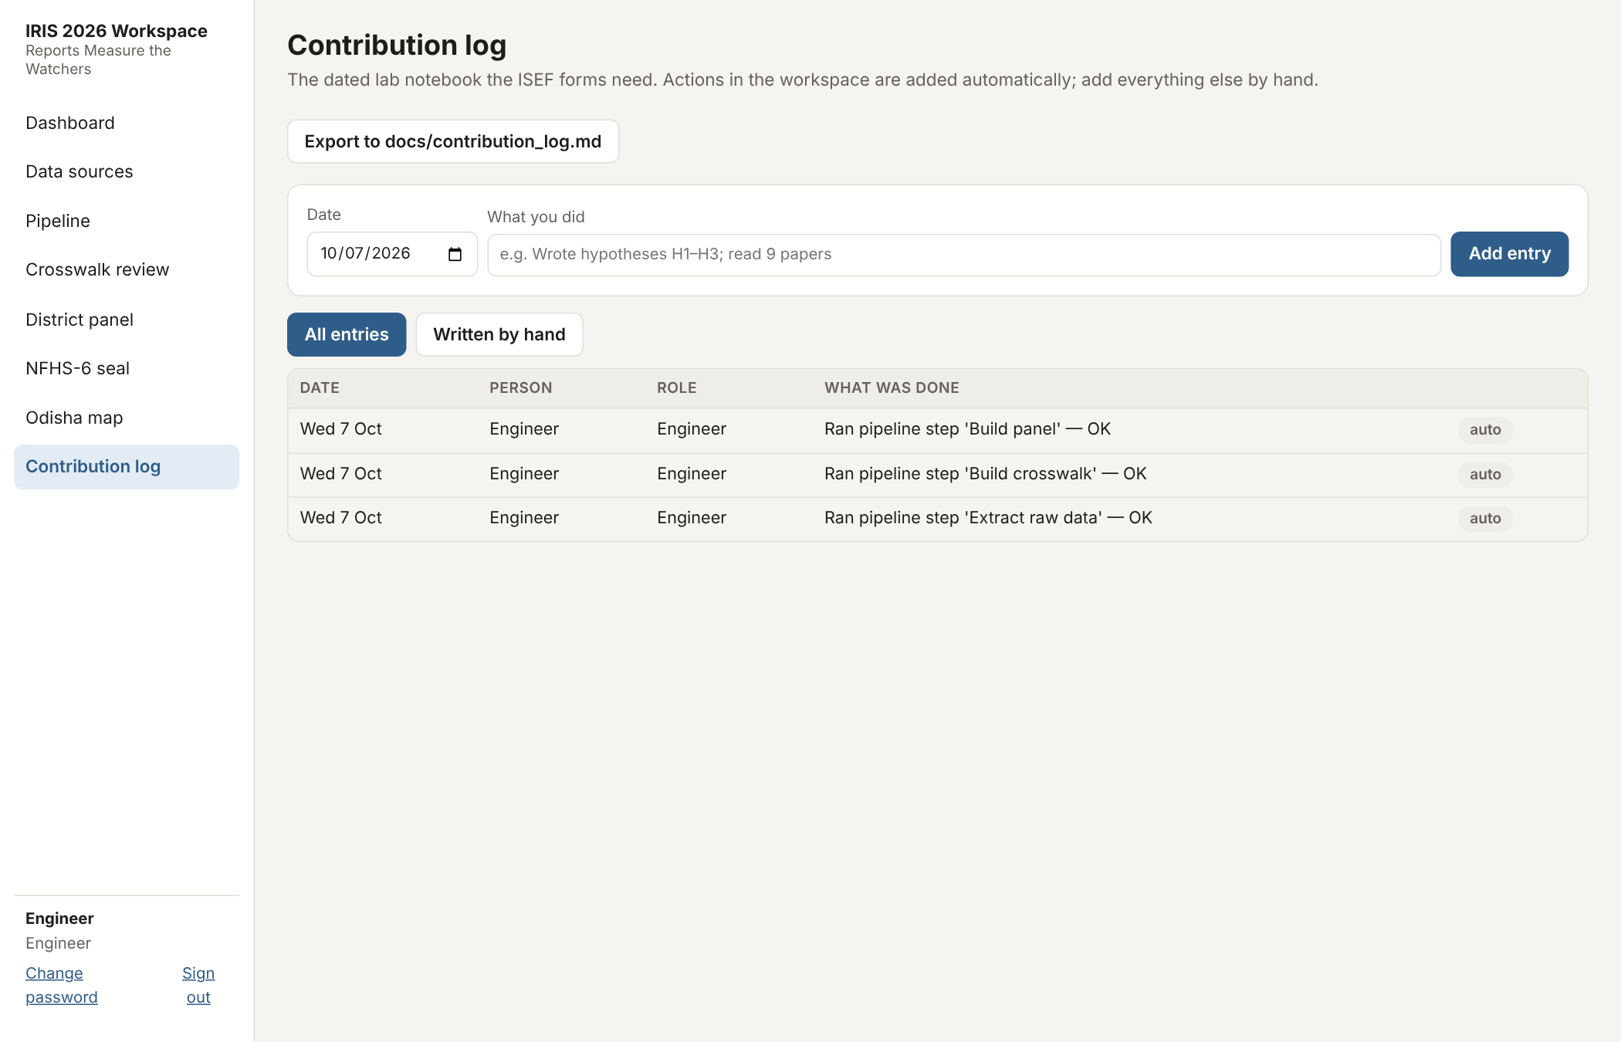
Figure 9. Contribution log: a dated lab notebook for the ISEF forms. Workspace actions are added automatically; other work is entered by hand.

8. Fair map
The fair map is a single offline HTML file (no internet needed, works from a USB stick) and is also served at /fair/. It is available in English, Hindi and Odia. Until the student's model outputs are uploaded it runs in 'survey mode' and shows only published figures, clearly labelled as such; once the outputs pass the contract checks it switches to the model view (estimated true rate, likely range, chance of a case being recorded, and outreach flags with reasons).
Every view carries the statement that the map is for welfare outreach only (school re-enrolment and links to government schemes) and never for policing.
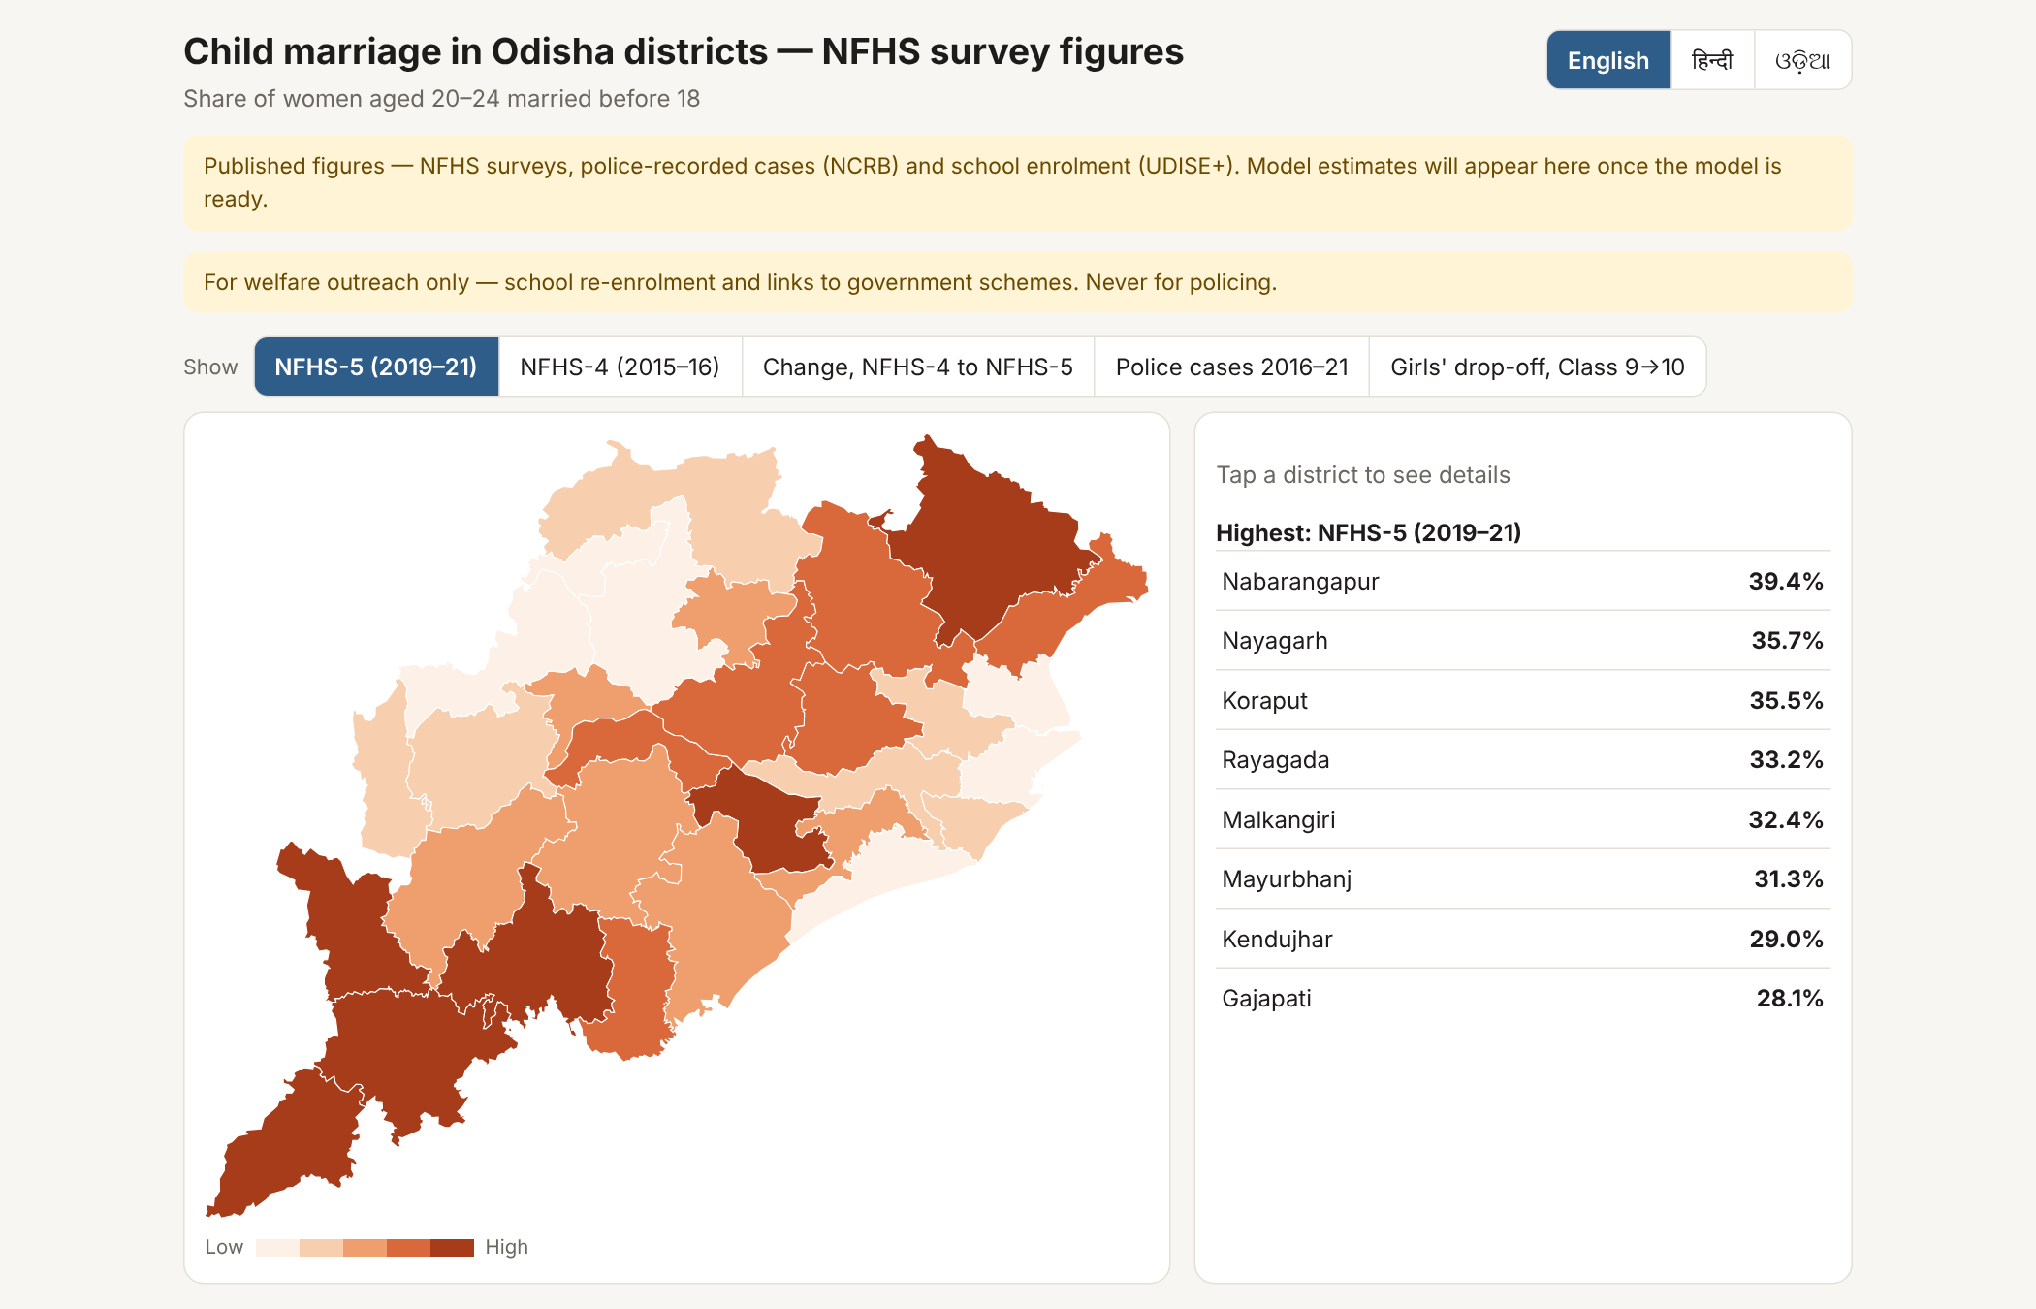
Figure 10. Fair map, NFHS-5 view: share of women aged 20–24 married before 18, by district.
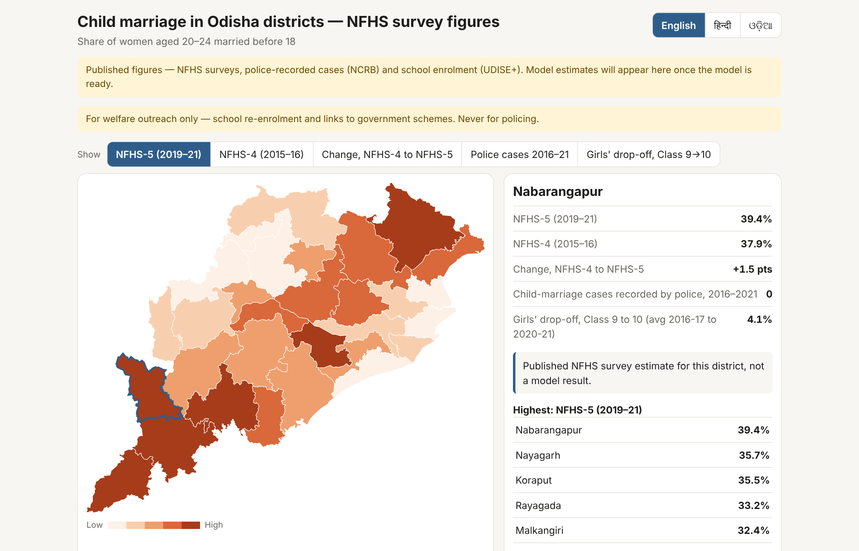
Figure 11. District detail (Nabarangapur): NFHS-5 and NFHS-4 figures, the change, police-recorded cases 2016–2021 and girls' Class 9→10 drop-off.
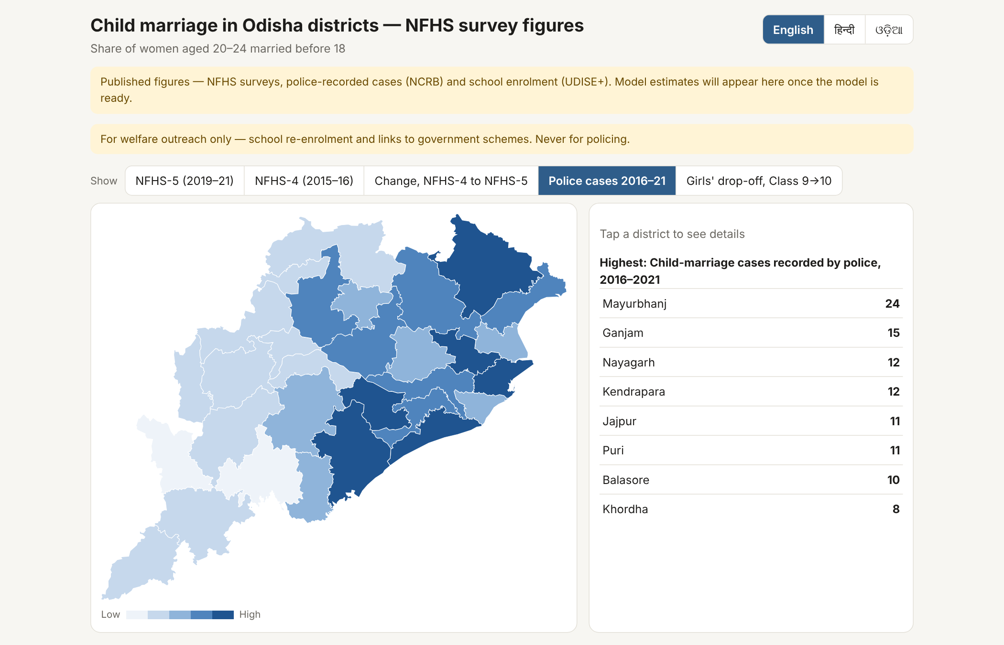
Figure 12. Police-recorded child-marriage cases, 2016–2021 (NCRB).
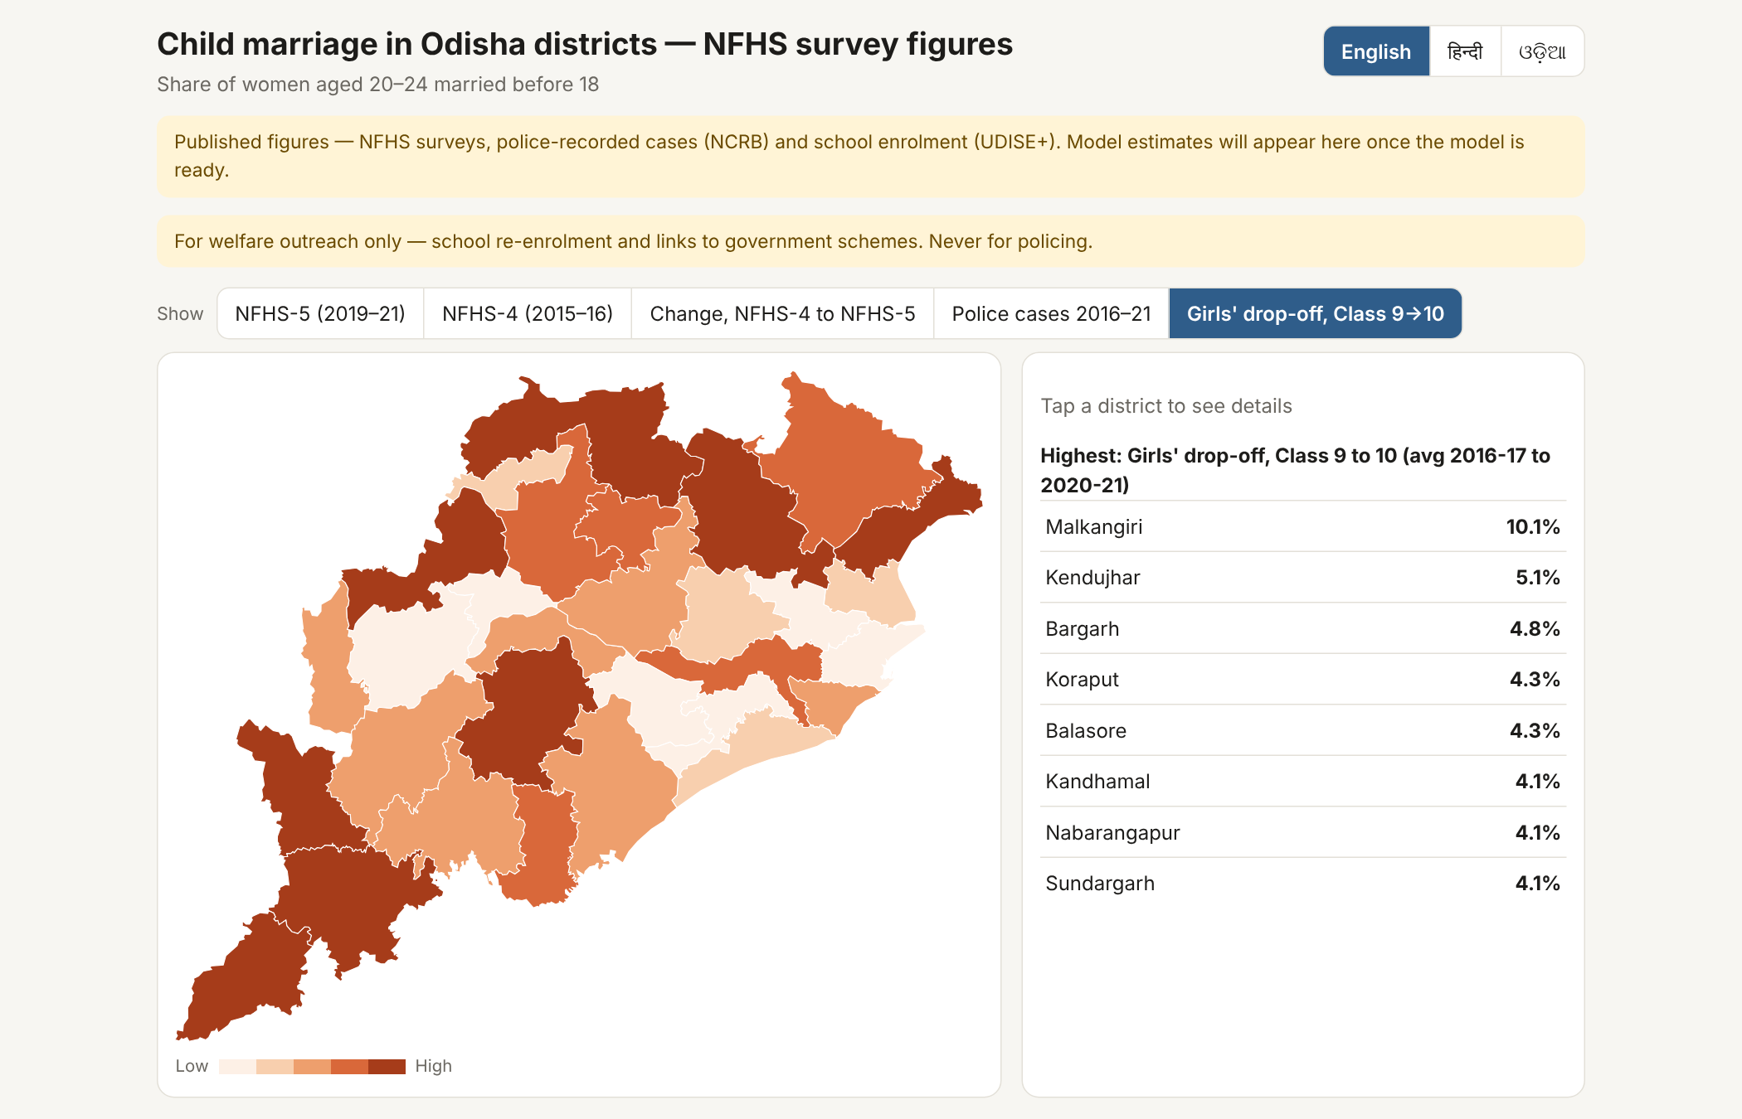
Figure 13. Girls' drop-off between Class 9 and Class 10, averaged over 2016-17 to 2020-21 (UDISE+).
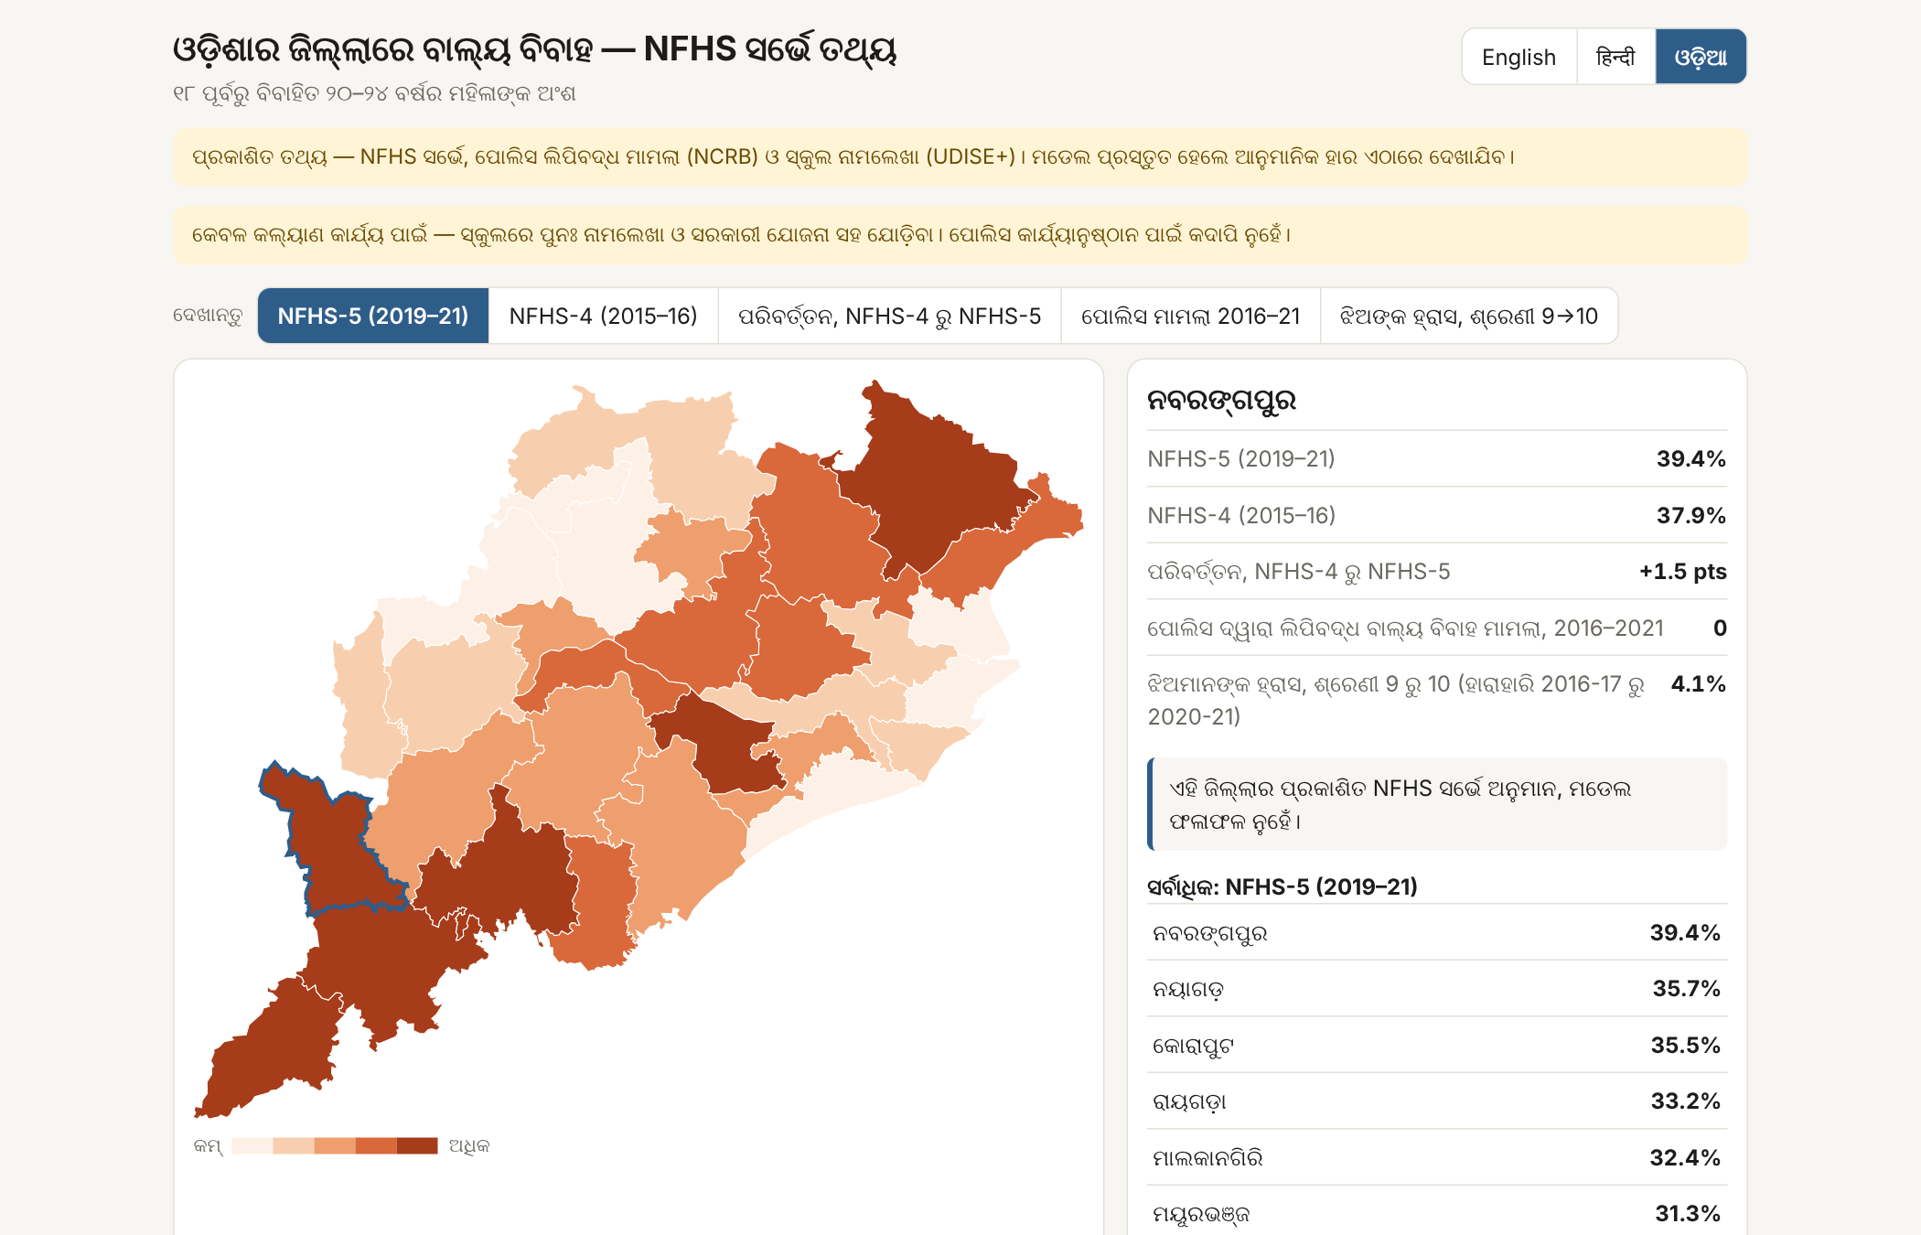
Figure 14. The same map in Odia. Hindi and Odia wording is being checked by a native speaker before the fair.
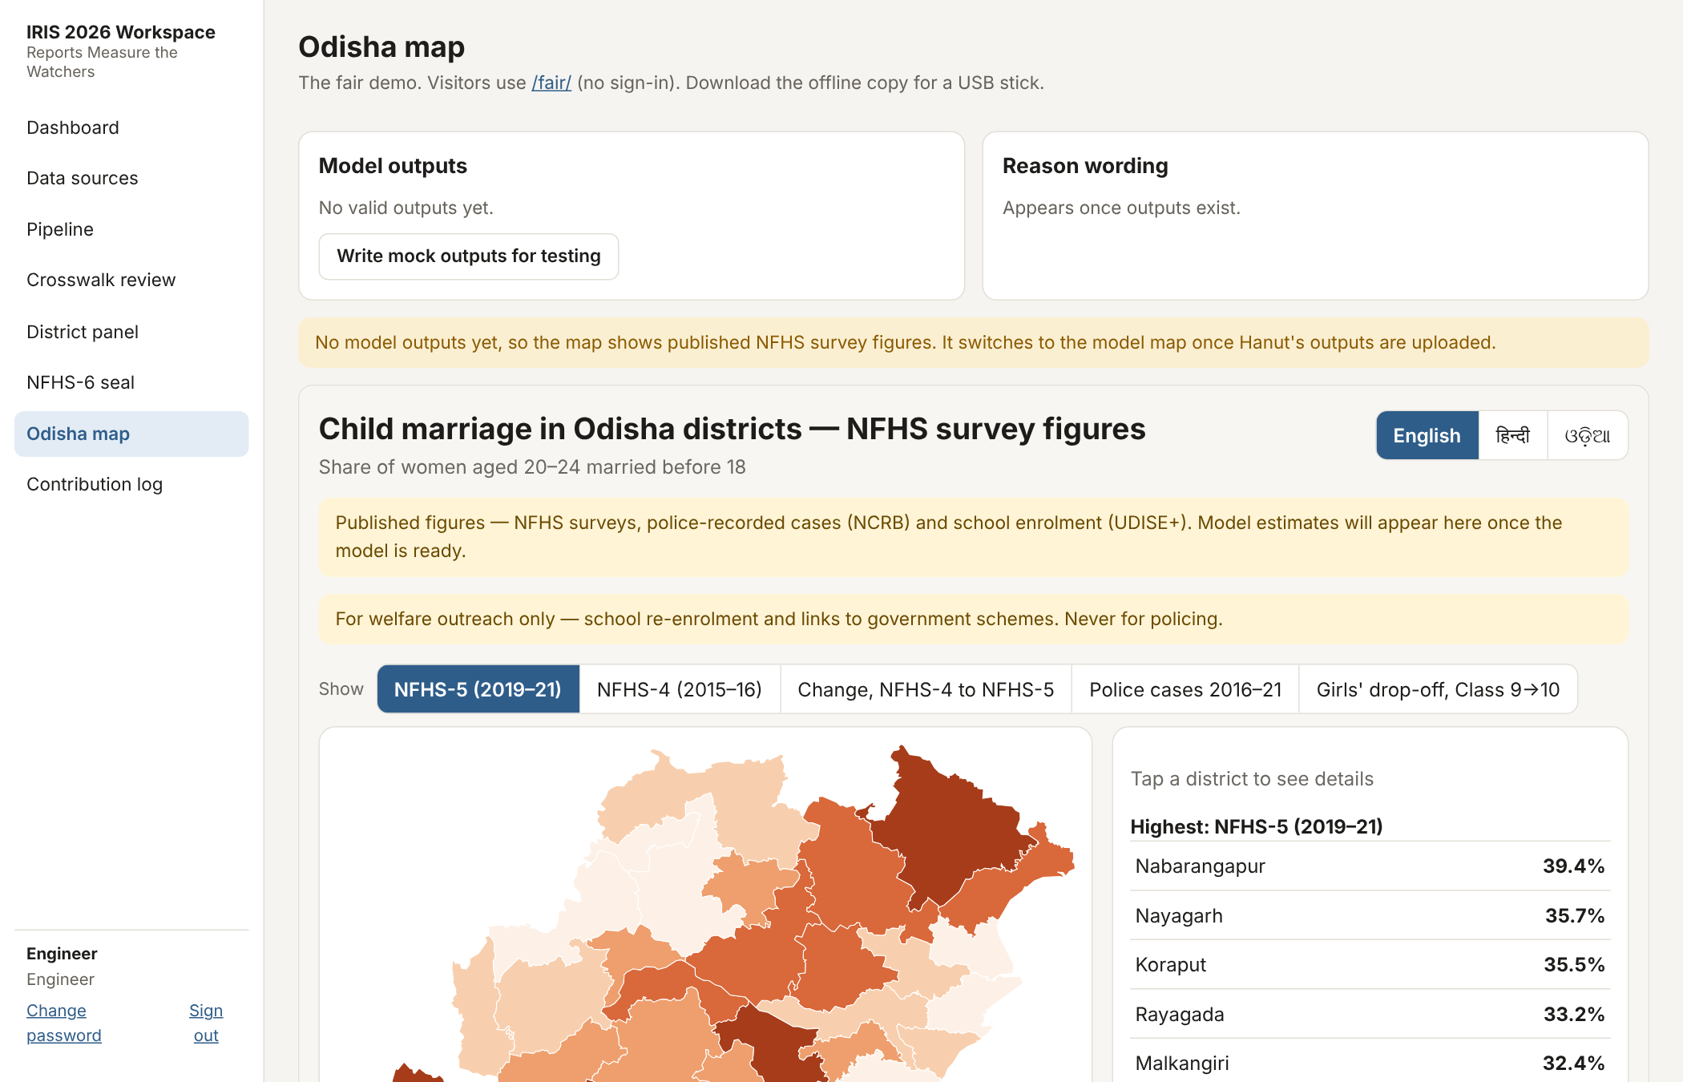
Figure 15. Workspace map page: where model outputs are uploaded and edits reason wording in three languages.

9. Hand-off to the student's model
The model is the student's work and lives in the model/ folder, which engineers review but do not write. The engineering side provides only plumbing:
- Data in: modelkit.load_training_data() returns the Odisha district-by-year table up to the 2021 cutoff.
- Results out: modelkit.write_outputs(estimates, reasons) checks the two output files against the contract and writes nothing if any check fails.
- Starter file: model/templates/run_model_template.py with four empty functions (prepare, fit, summarise, reasons) for the student to write.
Table 5. Output contract (outputs/district_estimates.csv)
Column | Meaning
census2011_code, district | District identity (Odisha: codes 370–399)
est_rate, est_lo, est_hi | Estimated true share married before 18, with credible interval (proportions 0–1)
recorded_cases | Recorded cases, all channels, same period
detection_prob | Estimated probability that a child marriage is recorded (0–1)
flag, reason_code | Pre-registered outreach flag and the reason shown to visitors
model_run_id | Commit of the model that produced the file (MOCK is reserved for test data)

10. Integrity and contribution statement
Table 6. Who did what
Hanut (student) | Engineering team | Sweksha (mentor)
Research question and hypotheses | Data collection and cleaning | IRIS registration and forms
Model design and model code | District crosswalk (checked by Hanut) | Mentor and reviewer outreach
Identifiability argument | Workspace; seal tooling (removed 10 Oct) | Pre-registration posting; seal witness
Analysis and interpretation | Fair-map front end | Odia wording check
All writing: paper, synopsis, video | Figures to Hanut's specification | Contribution log and timeline

- The NFHS-6 seal was removed on 10 October 2026 (Section 6); this is recorded in docs/INTEGRITY.md and docs/seal_log.jsonl.
- Mock outputs exist only for building the map; they are labelled MOCK and are never used in the paper, video or at the fair.
- AI-assisted engineering: parts of the engineer-side code (pipeline, crosswalk, seal tooling, workspace, map and this report) were drafted with an AI coding assistant and reviewed by the engineering team. This is declared on the ISEF forms alongside the engineers' help. None of the student's model code was produced this way.

11. Limitations and open items
- NFHS-6 district fact sheets have not been released or received; only the state fact sheet is in the project.
- Detection-capacity covariates (police per capita, Childline 1098, CMPO counts) have no public district-by-year source and are not filled.
- VIIRS night lights and Census 2011 covariates (SHRUG) need personal logins and are not loaded.
- The student's model (model/run_model.py) has not been written yet; the map therefore stays in survey mode.
- Odisha WCD figures (marriages prevented, CMPO cases) exist only in PDF reports and Assembly answers and must be entered by hand.
- NCRB has not yet published 2023 district tables. Police records count cases, not marriages; very small numbers (0–24 per district over six years) make district-level rates unstable.
- UDISE+ Class 9→10 drop-off is small in most districts and was affected by no-detention promotions in 2020-21; it is a weak signal on its own.
- There is no population column yet; the model needs an exposure measure (for example girls' enrolment or Census 2011 population).
- Hindi and Odia interface text is a first draft awaiting a native-speaker check.

Appendix A. Source links
Table 7. Where each source was obtained
Source | Address
NFHS fact sheets | https://www.nfhsiips.in/nfhsuser/publication.php
NCRB district tables | https://www.ncrb.gov.in/crime-in-india-additional-table.html
UDISE+ dashboard | https://dashboard.udiseplus.gov.in
Local Government Directory | https://lgdirectory.gov.in
Census 2011 district boundaries | DataMeet, github.com/datameet/maps
Open Government Data (alternate) | https://www.data.gov.in

Appendix B. How to run
On the project laptop, double-click 'Start IRIS Workspace.command' in the project folder, or in Terminal:
./run_web.sh
then open http://localhost:8000 (team) or http://localhost:8000/fair/ (visitors). The same steps from the command line:
python -m hcm extract && python -m hcm crosswalk && python -m hcm panel
python -m pytest -q

