# Team :- A.S. Teach

**Participants:-**

* Anjali singh 215/ICS/039
* Shatakshi 215/UCF/025
* Tanish Yadav 215/ICS/040

**Problem Statement:-**

A WebApp to reduce work of programmers by allowing them to upload the data set directly to the web app to train their model instead of writing ML codes and algorithms.

**Requirements:-**

* A computer system and a stable internet connection
* Web browser

**Technologies used:-**

* Virtual Studio Code
* Python compiler
* Streamlit Library
* Pandas profiling

**Project Description:-**

The Project is a WebApp model working on Python Programming Language using streamlit Library and Pandas profiling. The basic motive of the app is to eliminate the typing of Machine Learning codes to train the model and instead upload the Data set in the application.

Code:-

import profile

import streamlit as st

import pandas as pd

import os

import pandas_profiling

from streamlit_pandas_profiling import st_profile_report

from pycaret.classification import setup, compare_models,pull,save_model

with st.sidebar:

    st.image("https://www.onepointltd.com/wp-content/uploads/2020/03/inno2.png")

    st.title("AutoStreamML")

    choice=st.radio("Navigation",["Upload","Profiling","ML"])

    st.info("This app is used for making an automated ML pipline using Streamlit")

if os.path.exists("sourcedata.csv"):

    df= pd.read_csv("sourcedata.csv", index_col=None)

if choice== "Upload":

    st.title("Upload your DATA")

    file=st.file_uploader("Upload your dataset here")

    if file:

        df = pd.read_csv(file, index_col=None)

        df.to_csv("sourcedata.csv", index=None)    # type: ignore

        st.dataframe(df)

elif choice=="Profiling":

    st.title("Automated EDA")

    profile_report= df.profile_report()

    st_profile_report(profile_report)

elif choice=="ML":

    st.title("Machine Learning")

    target= st.selectbox("Select your Target",df.columns)

    if st.button("Train Model"):

        setup(df,target=target,silent=True)

        setup_df=pull()

        st.info("This is ML Expriment Setting")

        st.dataframe(setup_df)

        best_model=compare_models()

        compare_df=pull()

        st.info("This is the ML Model")

        st.dataframe(compare_df)

        best_model

        save_model(best_model,'best_model')

On running the code we can see the user interface of our application where on the home page we can upload our Data set

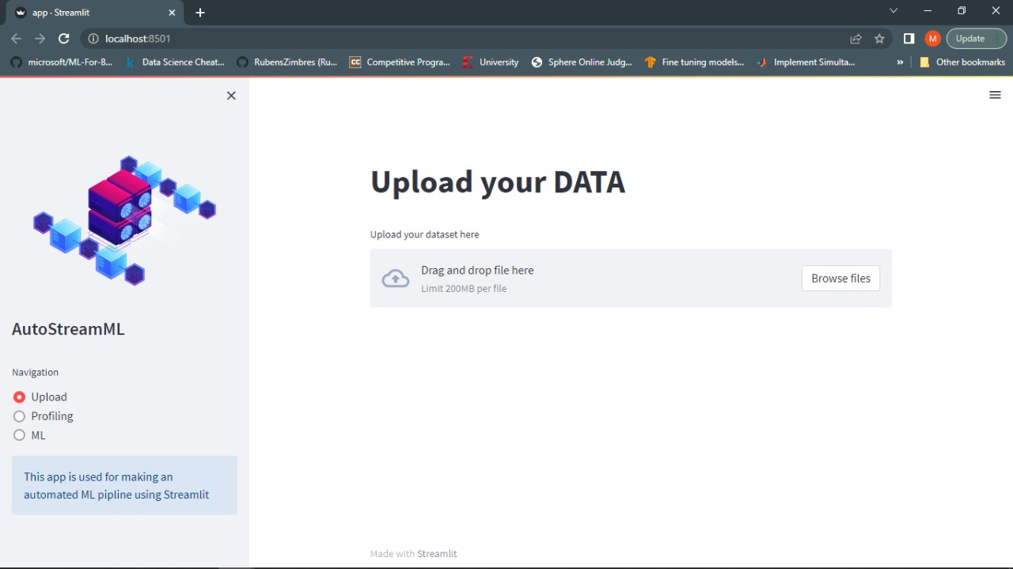

On profiling tab we can get the overview of the data set giving information about variables, interactions and correlations

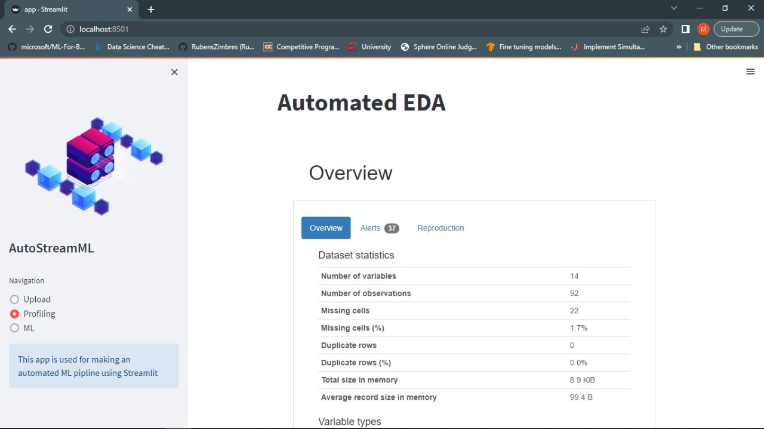

In machine learning tab we get the result of the trained model with accuracy of different training methods

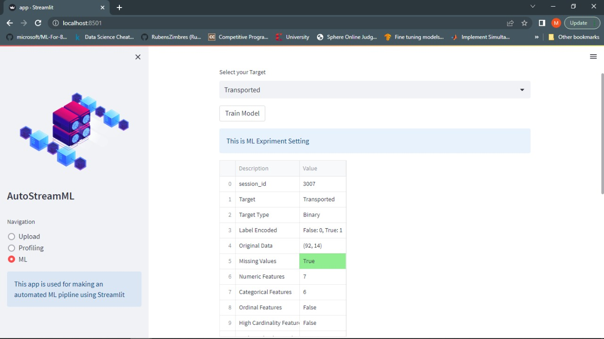

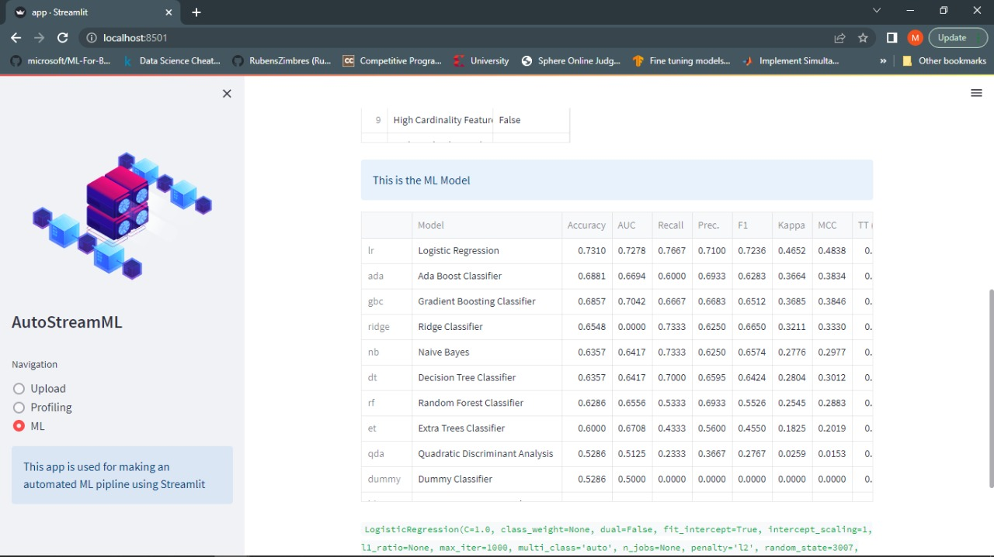

**Scope:-**

* Anyone who don’t know Machine Learning can also train their models
* Eliminates the writing of lengthy codes
* Easy for beginners to train models

**Conclusion:**

Thus, we have made a model that can reduce time complexity for training Machine learning models successfully.