**PHASE – 2:**

1) Write a SQL query to order records by a rental price column in ascending order.

**SELECT * FROM capstone.table1_capstone order by RentalPrice asc**

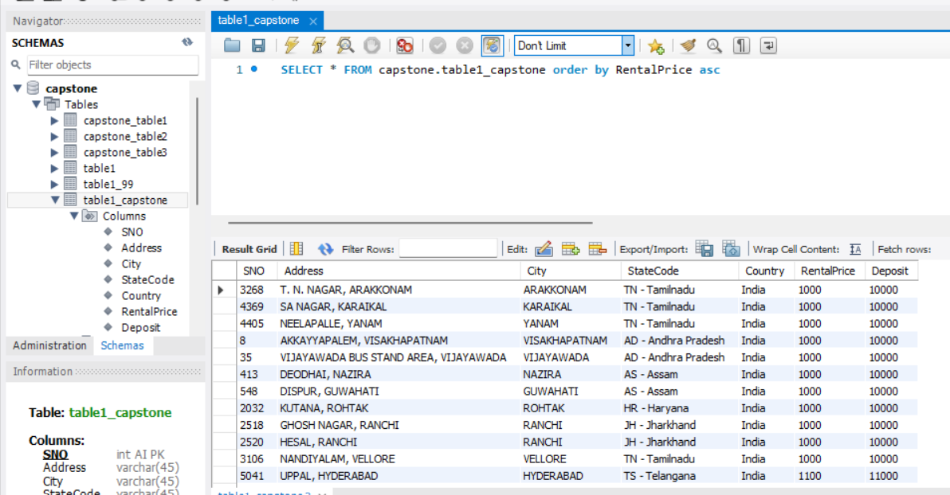

2) Write a SQL query to select unique combinations of City and State with their average Rental Price.

SELECT City, StateCode, AVG(RentalPrice) AS AverageRentalPrice

FROM table1_capstone

GROUP BY City, StateCode;

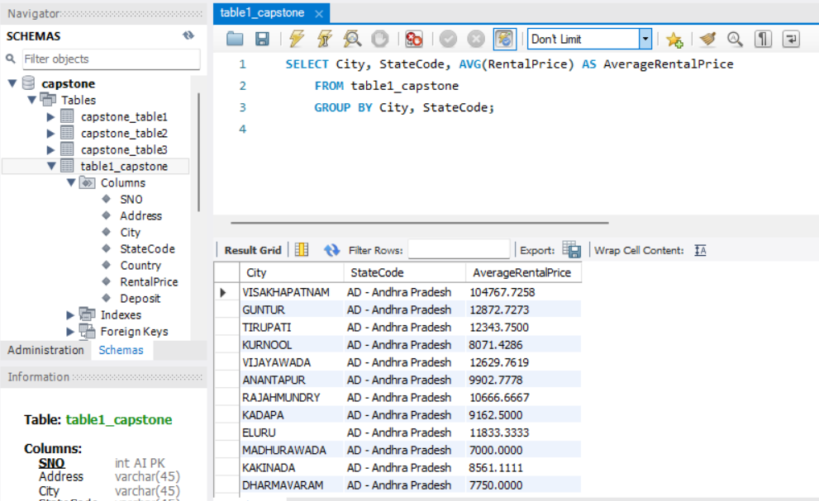

3) Write a SQL query to select the top 5 highest deposit amounts with corresponding Address and City .

**SELECT Address, City, StateCode,Deposit FROM table1_capstone ORDER BY Deposit DESC**

**LIMIT 5;**

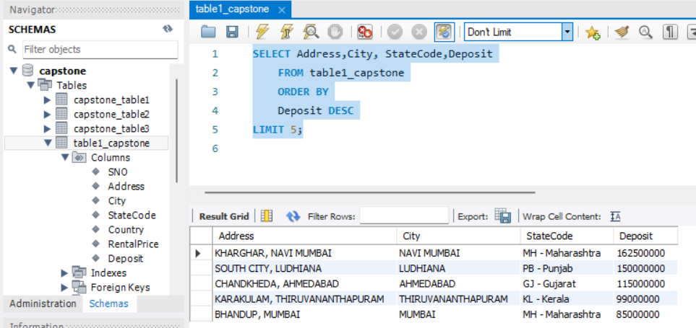

4) Write a SQL query to select the count of records for each Country along with the total deposit amount.

**SELECT Country, SUM(Deposit) AS TotalDeposit**

**FROM table1_capstone**

**GROUP BY Country;**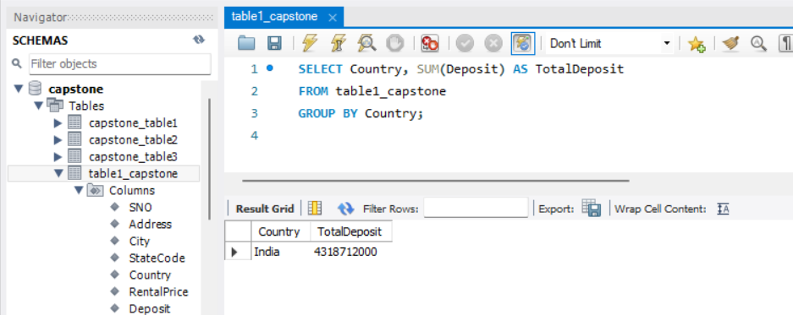

5) Write a SQL query to select records with a Rental Price higher than the average Rental Price across all records.

**SELECT \***

**FROM table1_capstone**

**WHERE RentalPrice > (SELECT AVG(RentalPrice) FROM table1_capstone);**

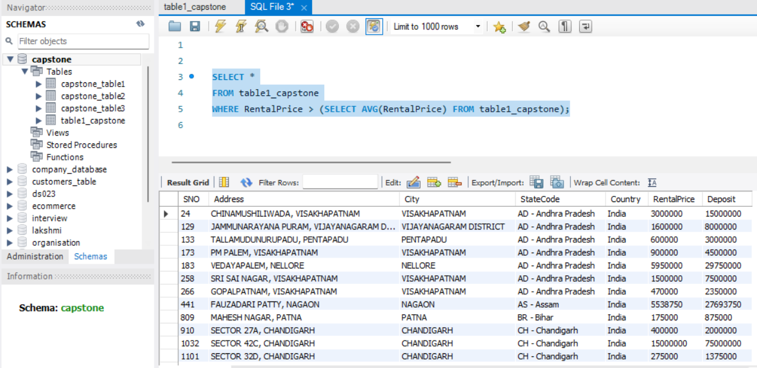

**Table2**

1) Write a SQL query to select the average area for each number of bedrooms.

**SELECT Num_bed, AVG(area) AS average_area FROM table2_capstone GROUP BY Num_bed;**

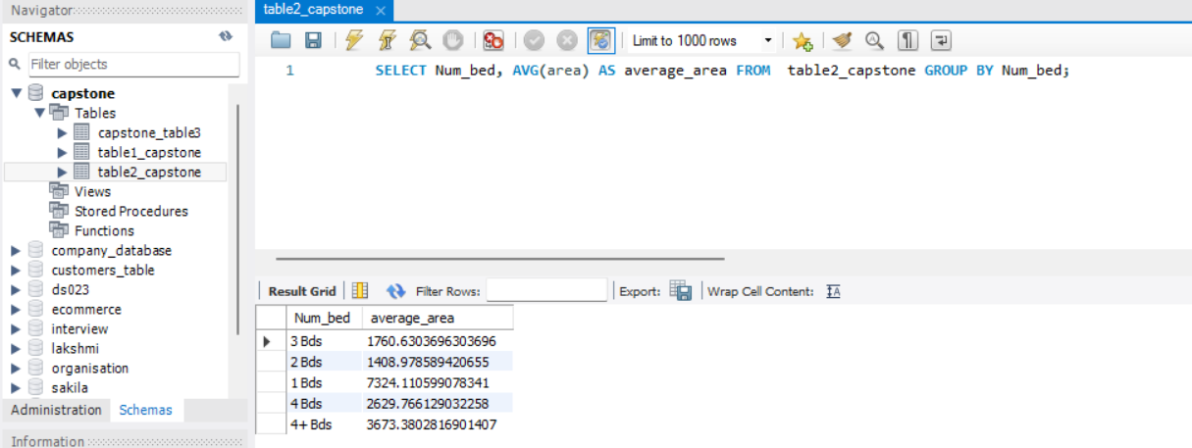

2) Write a SQL query to select records with more than one bathroom and pets allowed.

**SELECT * FROM table2_capstone WHERE Num_Bath > 1 AND PetsAllowed = 'YES';**

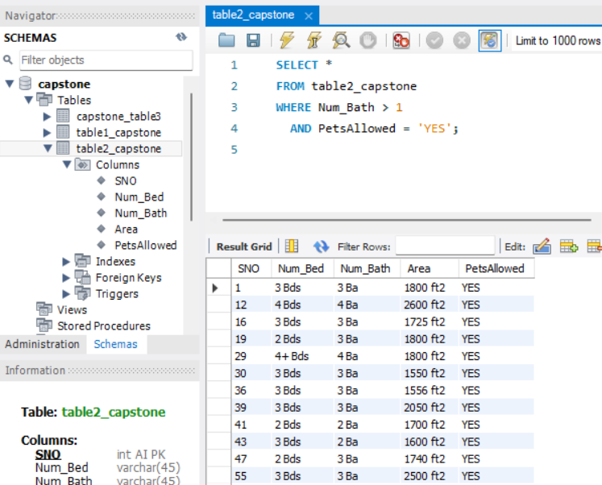

3) Write a SQL query to select the top 3 records with the highest total area (bedrooms + bathrooms).

**SELECT * FROM table2_capstone ORDER BY (Num_bed + Num_bath) DESC LIMIT 3;**

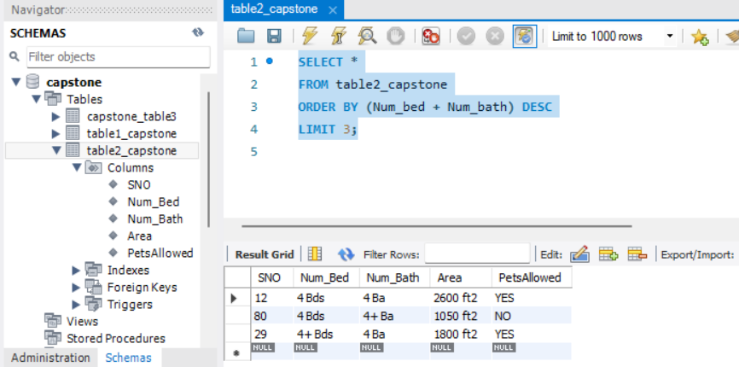

4) Write a SQL query to select the count of records for each combination of bedrooms and bathrooms.

**SELECT Num_bed, Num_bath, COUNT(*) AS record_count FROM table2_capstone GROUP BY Num_bed, Num_bath;**

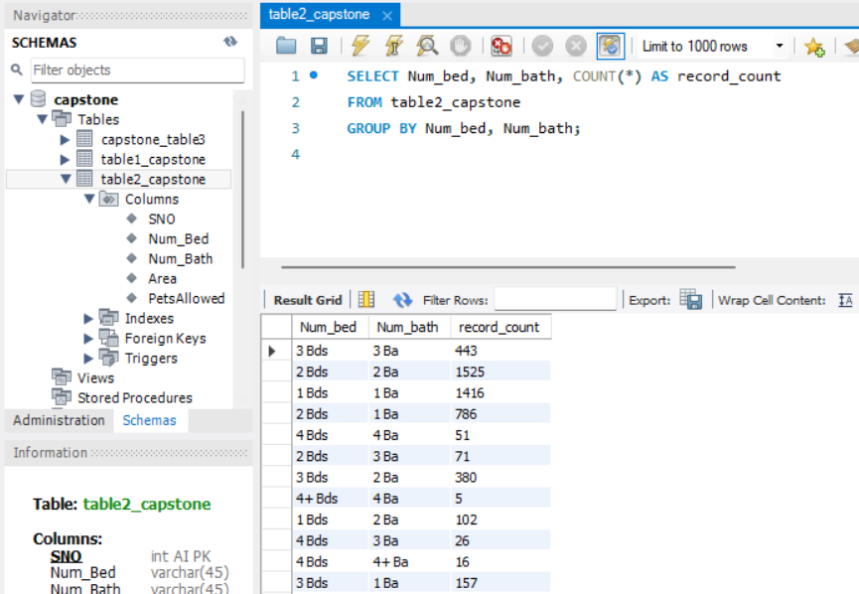

5) Write a SQL query to select records with the largest area where pets are allowed .

**SELECT \***

**FROM table2_capstone**

**WHERE area = (SELECT MAX(area) FROM table2_capstone) and PetsAllowed='YES'**

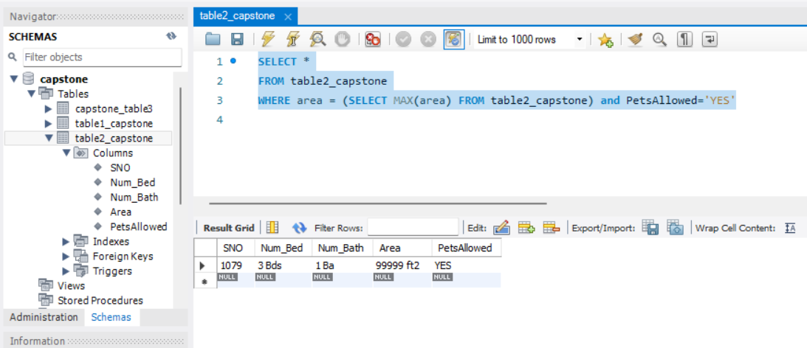

**Table3**

1) Write a SQL query to Select records where both Washer/Dryer and AC are available, and order by Sno.

SELECT * FROM table3_capstone WHERE Washer_Dryer = 'YES' AND AC = 'YES' ORDER BY Sno;

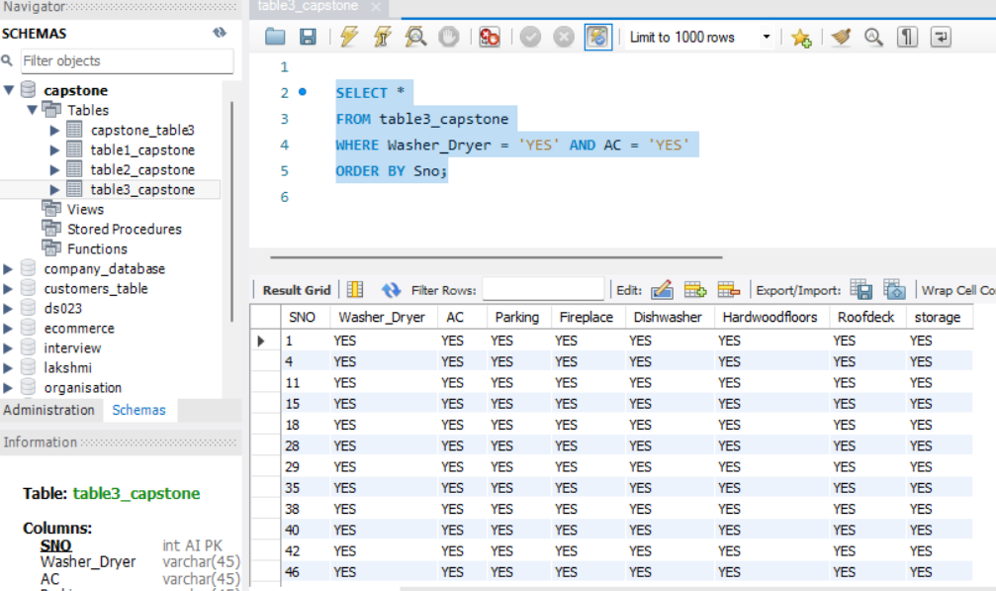

2) Write a SQL query to Select records where Hardwood floors are available but neither Roofdeck nor Storage is present, and order by Sno in descending order.

**SELECT * FROM table3_capstone WHERE HardwoodFloors = 'YES' AND (Roofdeck IS NULL OR Storage IS NULL) ORDER BY Sno DESC;**

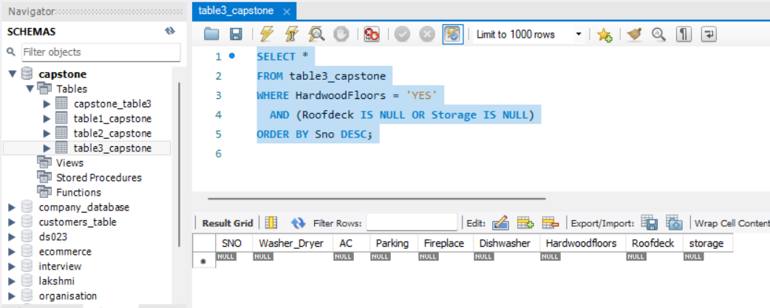

3) Write a SQL query to Select records where at least four amenities (AC, Parking, Dishwasher, Fireplace) are available, and order by Sno .

**SELECT * FROM table3_capstone WHERE AC = 'YES' AND Parking = 'YES' AND Dishwasher = 'YES' AND Fireplace = 'YES' ORDER BY Sno;**

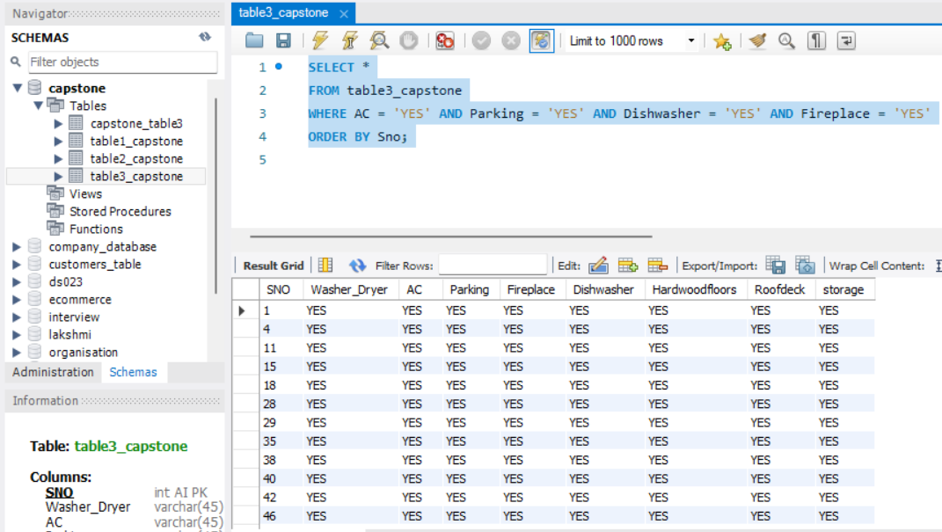

4) Write a SQL query to Select records where neither Roofdeck nor Storage is available, and include the count of such records.

**SELECT COUNT(*) AS RecordCount FROM table3_capstone WHERE Roofdeck IS NULL AND Storage IS NULL;**

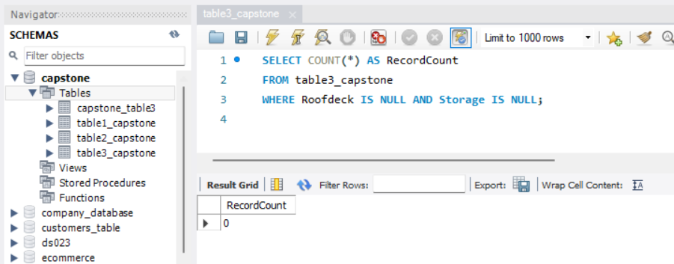

5) Write a SQL query to Select records with Parking and either Fireplace or Dishwasher, and include the count of records for each condition.

**SELECT**

**SUM(CASE WHEN Parking = 'YES' THEN 1 ELSE 0 END) AS Parking_Count,**

**SUM(CASE WHEN Fireplace = 'YES' OR Dishwasher = 'YES' THEN 1 ELSE 0 END) AS Fireplace_Dishwasher_Count**

**FROM table3_capstone;**

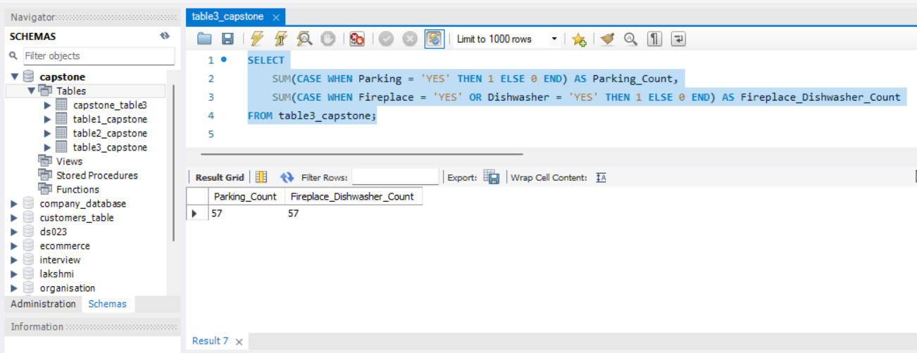

**7 Join SQL Queries using all 3 tables**

1) Write a SQL subquery to find records with more than the average area and related details using table 1 and table 2.

SELECT * FROM table1_capstone

WHERE AREA > (SELECT AVG(area) FROM table2_capstone);

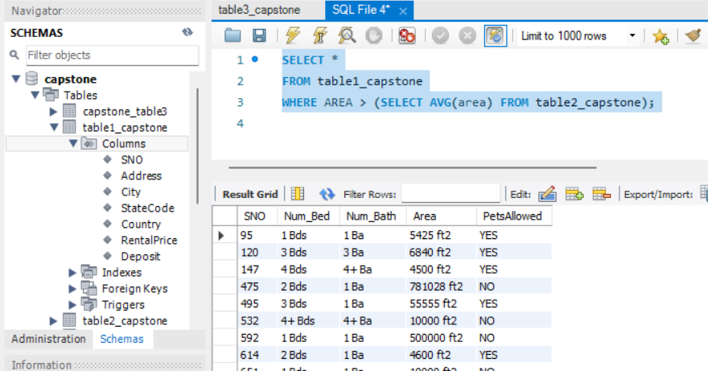

2) Write a subquery to find records in table1 based on conditions pets allowed is ‘YES’ and no of bed is greater than 3 in table2.

SELECT t1.* FROM table1_capstone t1 LEFT JOIN table2_capstone t2 ON t1.SNO = t2.sno

WHERE t2.petsallowed = 'YES' AND t2.Num_bed > 3;

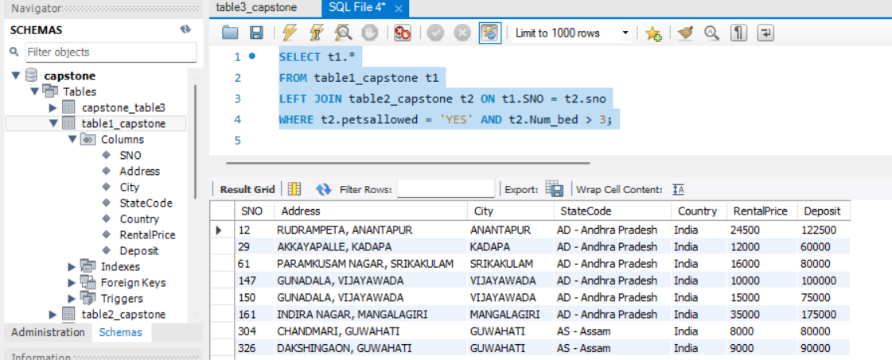

3) Write a SQL subquery using both tables (2 and 3) to find records in Table2 with more than 2 bedrooms and related details from Table3 where AC is present .

**SELECT t2.SNO, t2.Num_bed, t3.AC FROM table2_capstone t2 JOIN table3_capstone t3 ON t2.SNO = t3.SNO WHERE t2.Num_bed > 2 AND t3.AC = 'YES';**

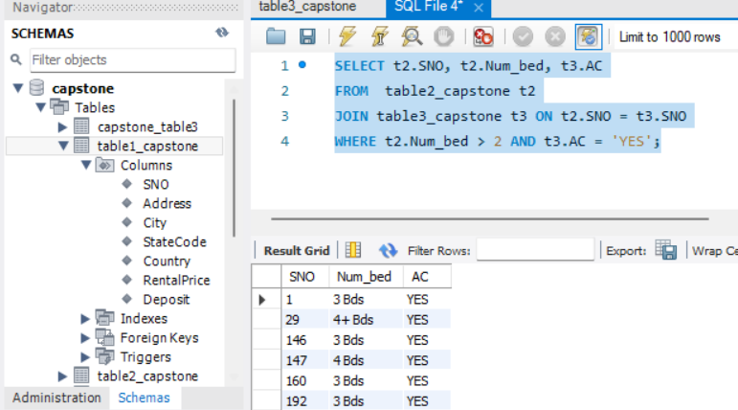

4) Write a sql subquery to find records in Table2 with pets allowed and a Dishwasher, and include related details from Table3.

SELECT t2.SNO, t2.Num_bed, t3.AC

FROM table2_capstone t2

JOIN table3_capstone t3 ON t2.SNO = t3.SNO

WHERE t2.Num_bed > 2 AND t3.AC = 'YES';

SELECT t2.*, t3.*

FROM table2_capstone t2

JOIN table3_capstone t3 ON t2.SNO = t3.SNO

WHERE t2.pets_allowed = 'YES'

AND t2.dishwasher = 'YES';

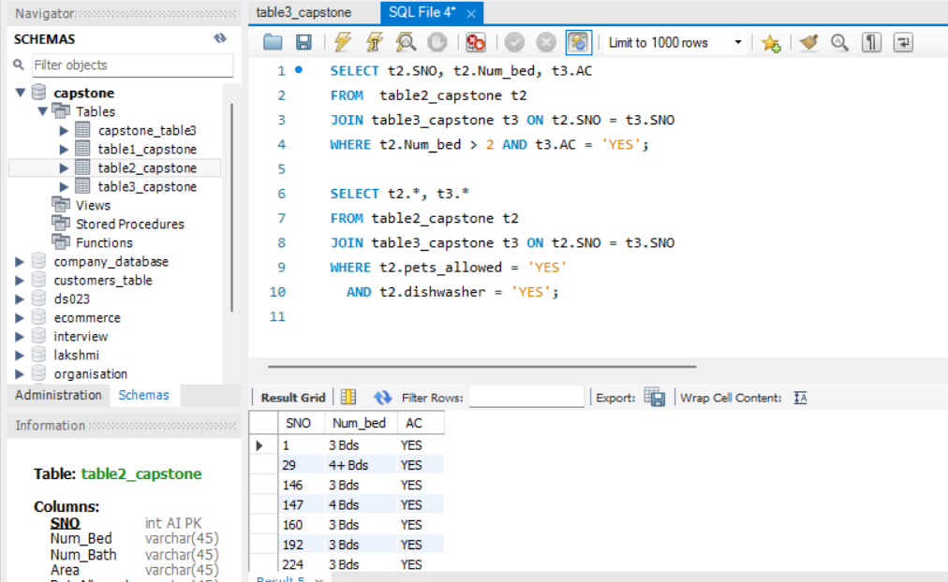

5) Write a subquery to find records in Table2 with the highest area and related details from Table3 where roofdeck is present.

**SELECT t2.*, t3.\***

**FROM table2_capstone t2**

**JOIN table3_capstone t3 ON t2.SNO = t3.SNO**

**WHERE t2.area = (SELECT MAX(area) FROM table2_capstone)**

**AND t3.roofdeck = 'YES';**

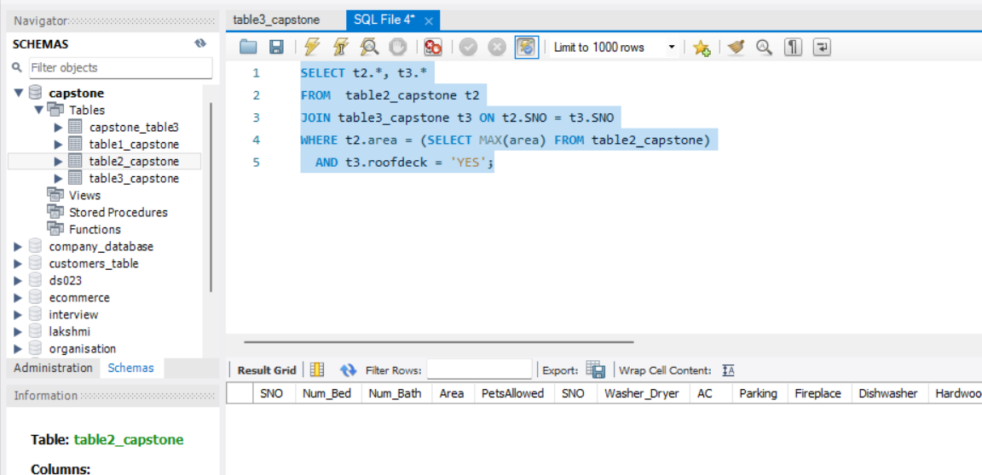

6) Write a sql Inner Join to combine information from table1 and table 2.

7) Write SQL Subquery to find records in table1 with pets allowed and a Washer/Dryer, and include details from table2 and table3 .