**DAILY ONLINE ACTIVITIES SUMMARY**

|  |  |  |  |  |  |  |  |  |
| --- | --- | --- | --- | --- | --- | --- | --- | --- |
| **Date:** | **16/06/2020** | | | | | **Name:** | **Madhushree.r** | |
| **Sem & Sec** | **6th A** | | | | | **USN:** | **4al16cs047** | |
| **Online Test Summary** | | | | | | | | |
| **Subject** | | **MI WORKSHOP** | | | | | | |
| **Max. Marks** | | **20** | | **Score** | | | **14** | |
| **Certification Course Summary** | | | | | | | | |
| **Pre placement training** | **9:00 am to 11:00 am - Programming in C**  **11:00 am to 1:00pm - Applications of python in DA and ML** | | | | | | | |
| **Faculty** | | | **Merlynmelita** | | **Duration** | | | **4hrs.** |
| **Coding Challenges** | | | | | | | | |
| **Problem Statement:**   1. C program to count number of distinct elements in an array. 2. Examples and Exercises on python.   .  **2.**    **..**  **2. Write a simple code to identify given linked list is palindrome or not by using stack. First take a Stack. Traverse through each node of the linked list and push each node value to Stack.** | | | | | | | | |
| **Status: Completed** | | | | | | | | |
| **Uploaded the report in Github** | | | | | **yes** | | | |
| **If yes Repository name** | | | | | <https://github.com/hanvita1/machinelearning> | | | |
| **Uploaded the report in slack** | | | | | **yes** | | | |

Python(workshop quiz):

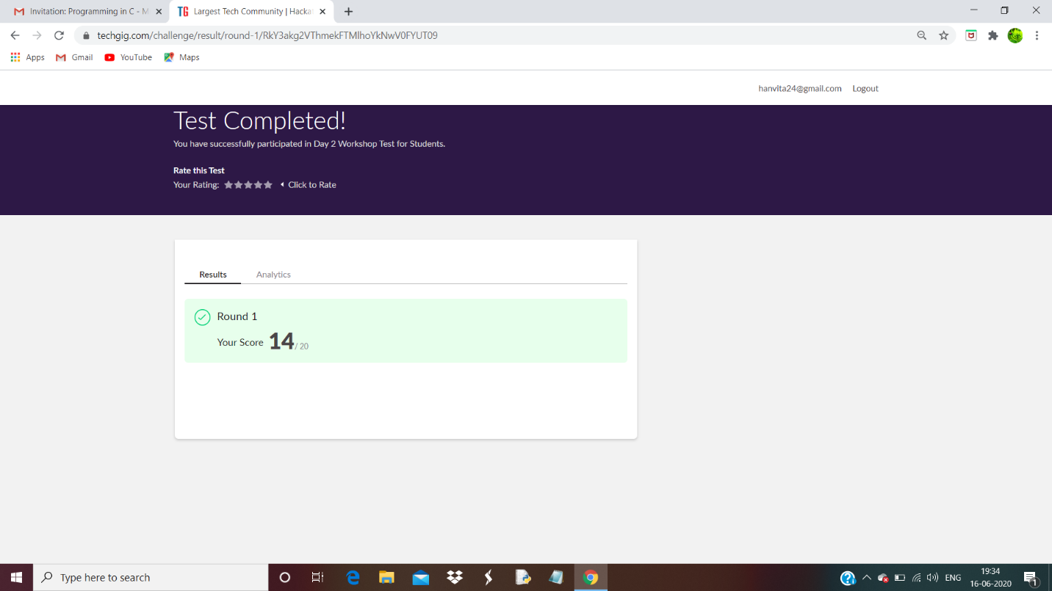

Training snapshot:

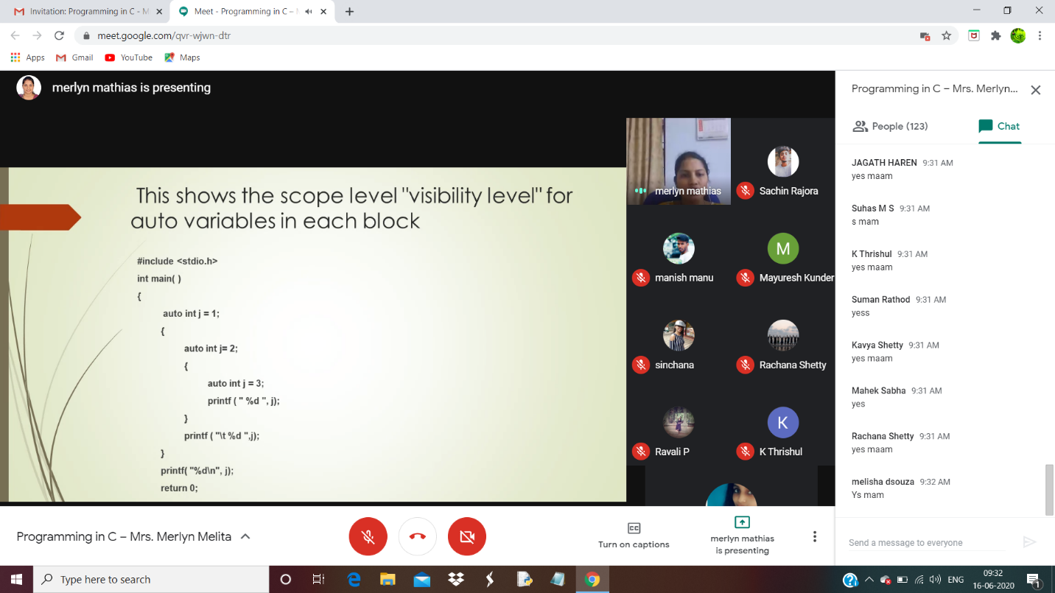

**Assessments:**

**Uploaded in Github account and respective links are provided.**

<https://github.com/hanvita1/machinelearning>