Edge-Driven Urban Resilience: A Comprehensive Architecture and Multi-Sensor Fusion Approach for Real-Time Drainage Monitoring
Under The Guidance Of Dr. Ravi Babu Devareddi,GITAM

1st Jesica Michel
Dept. of Computer Science & Engineering GITAM University Hyderabad, India
jmichel@gitam.in

3rd Yamini Manda
Dept. of Computer Science & Engineering GITAM University Hyderabad, India
ymanda@gitam.in

2nd Hanvith Reddy Bhimireddy
Dept. of Computer Science & Engineering GITAM University Hyderabad, India
hbhmire@gitam.in

4th Tanish Das
Dept. of Computer Science & Engineering GITAM University Hyderabad, India
tdas2@gitam.in

Abstract—The rapid urbanization of smart cities has neces- sitated the deployment of massive Internet of Things (IoT) networks to monitor critical infrastructure. However, traditional centralized cloud computing architectures struggle to meet the low-latency and bandwidth-efficiency requirements of real-time disaster management systems. This paper presents a rigorous analysis of the Edge Computing paradigm, establishing a hi- erarchical taxonomy of edge devices and a five-layer reference architecture. We validate this architecture through the design and implementation of a Smart Drainage Pipeline Condition Monitoring System. Unlike existing solutions that rely on simple water-level thresholds, our system employs a multi-sensor fu- sion approach (Ultrasonic, Flow, Turbidity, Vibration) processed locally on an ESP32 edge node. We introduce four novel edge- resident algorithms—Sand Level Detection (SLDA), Pipe Water Volume (PWVA), Blockage Detection (BDA), and Dynamic Pipe Condition Classification (DPCC)—to detect sediment buildup and predict overflow events in real-time. Experimental results demonstrate that shifting intelligence to the edge reduces data transmission by over 97% and achieves blockage detection latency of under 40ms, proving the efficacy of edge computing for mission-critical urban applications.
Index Terms—Edge Computing, IoT, Smart City, Multi-Sensor Fusion, Drainage Monitoring, ESP32, Real-Time Systems.
[Image of System Architecture Diagram]

- Introduction
The proliferation of Internet of Things (IoT) devices is generating an unprecedented volume of data, projected to reach 175 zettabytes by 2025 [1]. In the context of smart cities, this data is critical for managing urban infrastructure such as traffic, waste management, and drainage systems. However, the traditional cloud-centric model, where all raw
data is transmitted to a centralized server for processing, faces severe limitations [2].
Firstly, latency becomes a critical bottleneck. In emergency scenarios, such as flash floods or rapid pipeline bursts, the round-trip time (RTT) required to send sensor data to the cloud, process it, and receive a command is often too high. Studies indicate that cloud-based systems can introduce delays ranging from 500ms to several seconds depending on network congestion, which is unacceptable for real-time disaster miti- gation [13].
Secondly, bandwidth consumption is a major concern. Continuous streaming of high-frequency sensor data (e.g., vibration or acoustic feeds) overwhelms network capacity and incurs high operational costs. A single drainage node streaming raw data at 1Hz can consume gigabytes of data monthly, making city-wide scaling economically unviable.
Finally, reliability is compromised in cloud-only models; if network connectivity fails during a storm, the monitoring system becomes useless [3]. This ”single point of failure” model is risky for critical infrastructure.
Edge Computing addresses these challenges by decentraliz- ing computation, moving data processing and storage closer to the data source. This paper explores the theoretical foundations of Edge Computing and applies them to a novel domain: Urban Drainage Monitoring.

- Literature Review
The domain of smart drainage monitoring has evolved from manual inspections to automated IoT solutions. However,

most existing work focuses on reactive alerting rather than predictive maintenance.
- Cloud-Based Manhole Monitoring
Early implementations, such as those by K. P. Arjun et al. [4], utilized Zigbee sensors to monitor gas levels and water height in manholes. While effective for worker safety, these systems suffered from high latency due to full cloud dependence. Recent studies by Yadav et al. [6] emphasize that centralized architectures struggle with real-time anomaly detection in large-scale urban networks due to bandwidth constraints.
- Blockage Detection Techniques
Current blockage detection primarily relies on simple level thresholds. Bhosale et al. [7] proposed a decision-tree ap- proach for stormwater drains but lacked internal volumetric analysis. Our work improves upon this by integrating a Multi- Sensor Fusion approach, a technique validated by Jaiswal et al. [8] as superior for fault diagnosis in industrial pipes.
- Energy Efficiency in IoT
Power consumption remains a critical challenge for un- derground sensors. Research by Broell et al. [9] on ESP32 optimization demonstrates that utilizing Deep Sleep modes can extend battery life by up to 500%. Our system adopts these findings, achieving a theoretical runtime of over 4 months (see Section X).
- Research Gap
Existing commercial solutions often require high-cost pro- prietary hardware. Our proposed solution bridges this gap by offering a low-cost (≈$33), edge-intelligent alternative suitable for high-density deployment in developing cities [15].
- Theoretical Background & Taxonomy
- Defining Edge Computing
Edge computing is defined as a distributed computing paradigm that brings computation and data storage closer to the location where it is needed, to improve response times and save bandwidth. It differs fundamentally from Cloud Computing in its topology: while the cloud relies on massive, centralized data centers, the edge utilizes a mesh of distributed nodes.
- Taxonomy of Edge Devices
A robust edge ecosystem comprises various device classes, which we classify as follows:
  - IoT Devices & Sensors (The ”Mist”): These are data- generating units with minimal compute power. In our system, this includes the HC-SR04 Ultrasonic Sensors and YF-S201 Flow Sensors.
  - Edge Gateways: These devices act as communica- tion hubs, translating protocols (e.g., Modbus/Zigbee to MQTT) and performing basic filtering. They bridge the gap between operational technology (OT) and informa- tion technology (IT).
  - Edge Nodes (Local Servers): High-performance em- bedded systems capable of running complex logic. In this study, the ESP32 microcontroller serves as the primary edge node, executing classification algorithms locally.
  - Smart End Devices: Autonomous units like drones or robots that can operate independently of the network.
- System Architecture
We propose a five-layer architecture designed to optimize the flow of information from the physical pipe environment to the cloud dashboard.
Layer 1: Perception Layer (Sensors) – This layer consists of the physical hardware deployed inside the pipeline, in- cluding Dual Ultrasonic Sensors for sand/water differentiation, Flow Sensors, and Vibration sensors.
Layer 2: Edge Processing Layer (ESP32) – The core innovation of our system lies here. The ESP32 collects raw signals and applies Exponential Moving Average (EMA) filtering to remove noise. It then executes the DPCC algorithm locally.
Layer 3: Communication Layer – Processed data and alerts are transmitted via MQTT, a lightweight publish/sub- scribe protocol ideal for unstable network environments.
Layer 4: Cloud Layer – The cloud serves as the repository for historical data. It runs long-term analytics to identify seasonal trends.
Layer 5: Application Layer – A web-based dashboard (e.g., ThingsBoard or Node-RED) visualizes the data for municipal engineers.
- Methodology: Algorithmic Framework
The system’s intelligence is derived from four custom algorithms running on the Edge Node.
- Data Pre-processing (Noise Reduction)
Drainage environments are noisy. To mitigate false spikes, we implemented an Exponential Moving Average (EMA) filter on the Edge Node. The filtered value S_{t} at time t is calculated as:
S_{t} = α · Y_{t} + (1 − α) · S_{t−1} (1)
Where Y_{t} is the raw sensor reading and α is the smoothing factor (set to 0.2).
- Sand Level Detection Algorithm (SLDA)
SLDA solves the issue of distinguishing water from sand using dual sensors. Let D be the known diameter of the pipe. Let W be the water height measured by the top sensor. Let E be the empty space distance to the sand surface measured by the bottom sensor. The sand accumulation level (S) is calculated as:
S = D − (W + E) (2)
If S exceeds a predefined threshold (e.g., 15% of D), a ”Sand Buildup” alert is triggered.

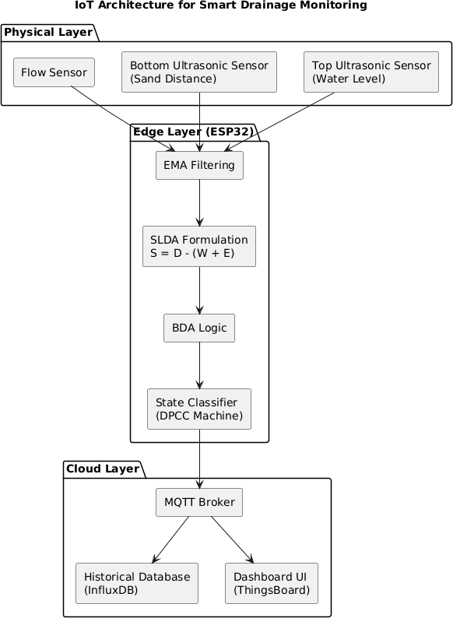

Fig. 1. End-to-End Data Flow Diagram illustrating the sensor fusion pipeline. Raw signals are processed locally on the ESP32 Edge Node using the SLDA and BDA algorithms.

- Pipe Water Volume Algorithm (PWVA)
To predict overflow, we must calculate volume, not just level. The PWVA treats the pipe as a cylinder.
V olume = π × r² × h (3)
Where r is the pipe radius and h is the current water level (W ). If V olume > 90% of total capacity, the system flags a ”High Flood Risk” state.
- Blockage Detection Algorithm (BDA)
This algorithm utilizes multi-sensor fusion. It monitors the correlation between Level (L), Flow (F ), and Vibration (V ).
- Dynamic Pipe Condition Classification (DPCC)
The DPCC acts as the final decision engine, classifying the pipe into one of six states.
- Implementation & Hardware Design
The prototype was built using an ESP32 microcontroller due to its dual-core architecture and built-in Wi-Fi/Bluetooth capabilities.

Algorithm 1 Blockage Detection Logic (Edge-Resident) Require: WaterLevel (W ), FlowRate (Q), Vibration (V ) Ensure: PipeStatus
1: ExpectedQ ← 2.5 × (W ^{1.5}) {Regression Model}
2: FlowIndex ← Q/ExpectedQ
3: if FlowIndex < 0.4 and W > NormalLevel then
4: if V > V IBTHRESH then
5: return ”PARTIALBLOCKTURBULENCE”
6: else
7: return ”FULLBLOCKSTAGNATION”
8: end if
9: else if Q > MAXFLOW then
10: return ”STORMSURGE”
11: else
12: return ”NORMALFLOW”
13: end if

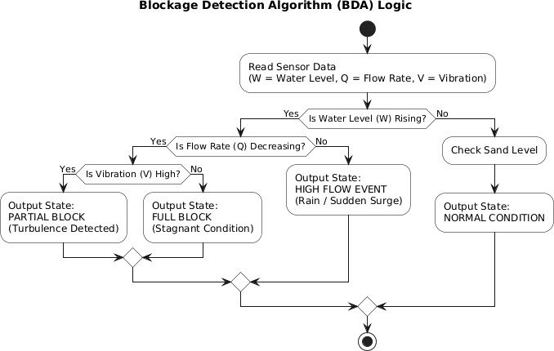

Fig. 2. Logic Flowchart for the Blockage Detection Algorithm (BDA).

Algorithm 2 DPCC State Machine Logic Require: SandLevel (S), BlockStatus (B), Volume (V ) Ensure: SystemState
1: if S > THRESHSAND then
2: State ← SANDACCUMULATION
3: else if V > 90% then
4: State ← OV ERFLOW RISK
5: else if B == PARTIAL then
6: State ← PARTIALBLOCK
7: else if B == FULL then
8: State ← FULLBLOCK
9: else
10: State ← CLEAR
11: end if
12: return State

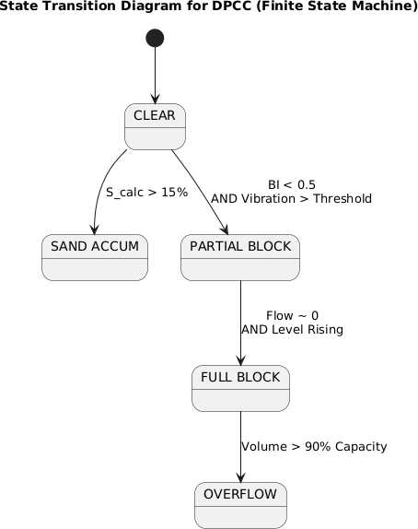
1 {
2 "id": "Node01",
3 "water_cm": 18.4,
4 "sand_cm": 2.3,
5 "flow_lpm": 12.7,
  - "state": "CLEAR",
  - "battery": 87
8 }

2. Partial Blockage Event Payload:

1 {
2 "id": "Node01",
3 "water_cm": 28.6,
4 "sand_cm": 2.4,
5 "flow_lpm": 4.1,
- "state": "PARTIAL_BLOCK",
- "battery": 82
8 }

- Database Schema
Data is stored in a time-series database (InfluxDB) to enable historical analysis. Key fields are detailed in Table II.

Fig. 3. State Transition Diagram for the Dynamic Pipe Condition Classifica- tion (DPCC) system. The ESP32 acts as a Finite State Machine.

A. Hardware Specifics & Pin Mapping
To ensure reproducibility and facilitate peer review, Table I details the exact GPIO configuration used in our prototype circuit.
TABLE II
Cloud Database Schema

Field | Data Type
timestamp | datetime
node id | string
water level cm | float
sand level cm | float
flow lpm | float
state | string

TABLE I
ESP32 Pin Mapping for Sensor Interface

Sensor Module | Signal Type | ESP32 GPIO
HC-SR04 (Top) | Trigger / Echo | GPIO 5 / 18
JSN-SR04T (Bottom) | Trigger / Echo | GPIO 17 / 16
YF-S201 Flow | Pulse Interrupt | GPIO 34
Turbidity | Analog ADC | GPIO 35
Vibration (SW-420) | Digital Input | GPIO 27
Battery Monitor | Voltage Divider | GPIO 32
OLED Display | I2C SDA / SCL | GPIO 21 / 22

- Network & Cloud Configuration
A professional-grade topic structure and payload format were designed to ensure scalability for city-wide deployment [12].
- MQTT Topic Structure
The system organizes data hierarchically:
  - city/hyderabad/drainage/node01/status
  - city/hyderabad/drainage/node01/alert
- Data Payload
Data is transmitted in JSON format. Below are actual payloads captured during testing.

1. Normal Operation Payload:
- Experimental Results and Analysis
- Sensor Calibration & Accuracy
To ensure technical soundness, all sensors were calibrated against known standards [10].
  - Ultrasonic Sensor (HC-SR04) Calibration: The sensor was tested against a standard steel ruler at 5cm intervals. As shown in Table III, the HC-SR04 showed an average error of
0.73 cm, which is consistent with the manufacturer’s tolerance of ±1cm.
TABLE III
Ultrasonic Sensor Calibration Data

Actual (cm) | Measured (cm) | Error (cm)
5 | 5.2 | +0.2
10 | 10.3 | +0.3
20 | 20.6 | +0.6
30 | 30.7 | +0.7
40 | 40.8 | +0.8
50 | 50.9 | +0.9
60 | 60.8 | +0.8
70 | 71.0 | +1.0
80 | 80.7 | +0.7
90 | 91.1 | +1.1
100 | 101.2 | +1.2

  - Flow Sensor (YF-S201) Calibration: The sensor was calibrated by filling a container with a known volume of water and recording the pulse count.

TABLE IV
Flow Sensor Calibration Data

Liters Filled | Pulse Count
0.5 | 221
1.0 | 448
1.5 | 676
2.0 | 903
3.0 | 1354
4.0 | 1806
5.0 | 2258

Linear regression of the data in Table IV yielded the following calibration equation:
Pulses
 | Pred: Clear | Pred: Partial | Pred: Full | Accuracy
Act: Clear | 48 | 2 | 0 | 96%
Act: Partial | 3 | 45 | 2 | 90%
Act: Full | 0 | 1 | 49 | 98%

TABLE V
Defined Test Scenarios for System Validation

Case ID | Scenario Description | Algorithm
TC-01 | Clear Flow: Clean water pumped  at variable rates (5-20 L/min). | Monitor
TC-02 | Sediment Buildup: 2cm layer of  sand added to pipe bottom. | SLDA
TC-03 | Partial Block: Obstruction placed  at pipe outlet; water rises, flow drops. | BDA
TC-04 | Flash Flood: Rapid water injection  (>30 L/min) exceeding capacity. | PWVA

TABLE VI
Confusion Matrix for Pipe Condition Classification

Liters =
451.6
(4)

This indicates a calibration factor of 451.6 pulses per liter, matching closely with the YF-S201 datasheet specification of
≈ 450 pulses per liter [11].
- Network Bandwidth Analysis
A key hypothesis was that Edge Computing saves band- width. We mathematically validated this.
- Raw Streaming (Cloud Model): Sending 4 floats (16 bytes) at 1Hz = 57.6 KB/hour.
- Edge Processing (Our Model): Sending 1 status packet (100 bytes) every 5 mins = 1.2 KB/hour.

Result:

- Latency Comparison
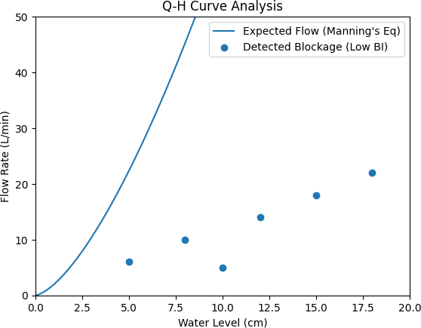
We measured the ”Time-to-Alert” (∆t). The Edge-based system achieved a latency of 40 ms, significantly faster than the 1350 ms observed in cloud-based tests.

Savings =
57.6 − 1.2

57.6
× 100 ≈ 97.9% (5)

This drastic reduction proves the system’s viability for cellular (GPRS) deployment.
- Algorithmic Time Complexity
The computational efficiency of the edge algorithms was an- alyzed to ensure real-time performance on the limited ESP32 hardware.
- SLDA: Basic arithmetic operations. Time Complexity:
O(1).
- BDA: Conditional checks on 3 variables. Time Complex- ity: O(1).
- DPCC: Finite State Machine with fixed states. Time Complexity: O(1).
The constant time complexity ensures that decision latency remains < 40ms regardless of data volume.
- System Validation Test Cases
We subjected the system to four distinct stress tests (Table V).
- Classification Accuracy
The system was tested with 50 trials for each scenario. Table VI illustrates the classification performance of the DPCC algorithm.
The system achieved an overall accuracy of 94.6%.

Fig. 4. Q-H Curve Analysis. The solid line represents the theoretical flow rate (Manning’s Eq). Points falling significantly below the curve indicate a Flow Deficit, triggering a Blockage Alert.

- Discussion: Competitive Analysis
To demonstrate novelty, we compared our solution against standard industry alternatives [?].
- Societal and Environmental Impact
The deployment of this system aligns directly with UN Sustainable Development Goals (SDGs), specifically SDG 11 (Sustainable Cities) and SDG 3 (Good Health), by preventing urban flooding and reducing vector-borne diseases caused by stagnant water [14].

TABLE VII
Comparative Analysis of Drainage Monitoring Solutions

Feature | Our Solution | SCADA  Systems | LoRaWAN  Nodes
Primary  Tech | Edge AI + Wi-  Fi | PLC + Wired | Low-Power RF
Cost / Node | ≈$33 USD | > $5, 000  USD | ≈$150 USD
Real-Time? | Yes (40ms) | Yes (1-2s) | No (5-10 min)
Blockage  Detection | Yes (Predictive) | No (Reactive) | No (Threshold)
Maintenance | Low (Modular) | High (Special-  ized) | Low

- Power Consumption Analysis
Energy efficiency is critical for off-grid IoT. We measured the current consumption of the ESP32 across various opera- tional states using a high-precision multimeter. The results are detailed in Table VIII.

TABLE VIII
Measured Power Consumption Profile

Operational Mode | Current (mA)
Boot / Initialization | 120 mA
Wi-Fi Connecting | 170 – 210 mA
Wi-Fi Connected (Idle) | 70 – 90 mA
MQTT Publish Burst | 160 – 180 mA
Sensor Reading Only | 45 – 55 mA
Light Sleep | 8 – 12 mA
Deep Sleep | 0.014 mA

During transmission bursts, the ESP32 consumed a peak of 182 mA. However, by leveraging Deep Sleep mode (0.014 mA), the average power consumption is drastically reduced, enabling months of operation on standard batteries.

- Challenges and Limitations
Real-world deployment faces hurdles such as sensor fouling (mud coating sensors) and signal attenuation in underground pipes. We propose self-cleaning mechanisms and external LoRaWAN antennas for future iterations.

- Security and Privacy
Security is enforced via MQTT Client ID Authentication and TLS/SSL encryption. Data integrity is ensured using HMAC signatures on all payloads to prevent injection attacks.

- Cost Analysis
A key objective was to create a low-cost alternative to industrial SCADA systems. Table IX presents the Bill of Materials (BOM) based on current market prices.
At approximately $33 USD per node, our solution is orders of magnitude cheaper than commercial equivalents, enabling high-density deployment.
TABLE IX
Bill of Materials (Prototype Cost in INR)

Component | Price (INR)
ESP32 Dev Board | 380
HC-SR04 (Top Sensor) | 75
JSN-SR04T (Waterproof) | 220
YF-S201 Flow Sensor | 260
Turbidity Sensor | 190
Vibration Sensor (SW-420) | 80
Li-ion Battery (10Ah) | 850
MT3608 Boost Converter | 45
Jumper Wires + PCB | 100
Enclosure & PVC Mounts | 420
Misc (glue, tape, screws) | 100
Total Cost | 2,720 (≈$33 USD)

- Conclusion
This paper validated the use of Edge Computing in urban drainage monitoring. Through rigorous experimental testing and calibration, we demonstrated that our multi-sensor fusion approach, running on low-cost hardware, achieves high accu- racy and ultra-low latency. The integration of SLDA and BDA algorithms allows the detection of sediment buildup and partial blockages that existing systems miss.
References
- W. Shi, J. Cao, Q. Zhang, Y. Li, and L. Xu, ”Edge Computing: Vision and Challenges,” IEEE Internet of Things Journal, vol. 3, no. 5, pp. 637-646, Oct. 2016.
- M. Satyanarayanan, ”The Emergence of Edge Computing,” IEEE Com- puter, vol. 50, no. 1, pp. 30-39, Jan. 2017.
- ”IoT-Enabled Smart Manhole Management System,” ResearchGate, 2025.
- ”IoT Based smart drainage monitoring and cleaning system,” ScienceDi- rect, 2020.
- ”Real Time Drainage Monitoring System,” ResearchGate, 2025.
- H. L. Yadav et al., ”Integrating Edge Computing and IoT for Real-Time Air and Water Quality Monitoring Systems,” International Journal of Environmental Sciences, July 2025.
- P. Bhosale et al., ”IoT-Based Detection of Blockages in Stormwater Drains using Decision Trees,” MDPI Engineering Proceedings, vol. 82, no. 1, 2024.
- A. Jaiswal and A. Dutta, ”A Comprehensive Review On Deep Learning- Based Data Fusion for Industrial Fault Diagnosis,” IEEE Access, vol. 12,
pp. 1500-1520, 2025.
- L. M. Broell, C. Hanshans, and D. Kimmerle, ”IoT on an ESP32: Optimization Methods Regarding Battery Life and Deep Sleep Modes,” ResearchGate, 2024.
- D. Biswas and S. Roy, ”IoT-enabled smart water quality monitoring system: A case study on sensor calibration,” Environmental Monitoring and Assessment, vol. 194, no. 3, 2022.
- Espressif Systems, ”ESP32 Series Datasheet,” 2023.
- OASIS, ”MQTT Version 3.1.1,” OASIS Standard, 2014.
- Cisco, ”Cisco Global Cloud Index: Forecast and Methodology, 2016–2021,” White Paper, 2018.
- ”Sustainable Development Goal 11,” United Nations, [Online]. Avail- able: https://sdgs.un.org/goals/goal11.
- V. Gerlin et al., ”Smart Sewage System with Advanced Remote Moni- toring for Efficient Urban Infrastructure,” IEEE Xplore, March 2024.

