Meal Agent — CS621 Final Report (draft)
Oct 24, 2026 · CS621 Agentic AI, group project · Zhou Hanwei and team

Summary
We built an agent that plans three days of home cooking and buys the groceries in a simulated store, and we defend supervised autonomy for ordering behind code gates: the agent plans, re-plans and interprets the user's words on its own, but money is spent only through gates the model cannot override.
The evidence, all on synthetic data with gold answers written from the policy before any run (Claude Haiku 5.5, 3 runs each, mean ± sample sd):
- Re-planning needs the loop. With store or user changes mid-run the agent scores 0.989 ± 0.019 against 0.678 for a single model call and 0.700 for a rule-based planner (v1, 30 cases); 0.833 vs 0.167 when the user speaks mid-run.
- Language needs the model. Constraints written in the user's own words: rule-based planner 0.312, both LLM systems ≥ 0.94.
- The gates are needed, not just working. With the gates on, 0 of 65 runs produced a critical error; with them switched off, 10 of 195 did (5.1 %) — including a peanut dish ordered for a peanut-allergic user whose allergies the agent guessed instead of asking.
- Where it was tested to work. Up to 5 store events, 7 days, 4 stated constraints at once: 135/135 after one engineering fix (output length).
Total API spend for the whole project: US$10.76. Code and every run: private repository hanwei918/cs621-meal-agent.

Problem and objectives
Planning a few days of meals and the shopping is a small job that people repeat every week, and the hard part is keeping many constraints at once: diet, allergies (sometimes someone else's), a budget, the time per meal, what is already at home, and changes that arrive mid-way (an item sold out, "no eggs either"). A chat assistant can suggest a menu, but it does not check stock, recompute a cart after a change, or stop itself from buying the wrong thing.
Objectives:
- Plan 3 days (up to 7 in stress tests) of meals and build a cart that satisfies every hard constraint, checked in code.
- Re-plan when the store or the user changes something mid-run, and turn the user's own words into constraints.
- Let the user choose how much to delegate — plan only, confirm every order, or order within standing limits — and never spend outside that choice.
- Measure each claim against baselines, with variance, failure modes and the conditions under which it stops holding.
Out of scope by design: real retailers or payments, and health advice. Weight management is offered only through synthetic sample people, with the energy target computed and gated by code (§3).

Autonomy level
Autonomy is set per action, not for the agent as a whole: everything that only reads or proposes is autonomous; the one action that spends money is supervised, and the user picks how supervised.
Action | Level | Who decides | Enforced by
Read profile, recipes, store, prices | L5 autonomous | Agent | —
Interpret the user's note and mid-run messages into constraints | L4 autonomous, checked | Agent declares; code enforces what it declared | G1
Plan, build the cart, re-plan after a change | L4 autonomous, checked | Agent | G1 constraint and total check
Ask for a missing or invalid fact | Required | Agent must ask; it cannot guess | G5
Weight target (sample people only) | Code only | energy.py; the model never computes it | G1 energy band
Approve a cart | L3 / L1 by mode | User (① ②), standing limits (③) | G2 approval hash
Place the order | L1 supervised | Only with the current approval's token | G3, G4
The three modes the user chooses between: ① plan only (a plan and list, never an order), ② confirm each order (the default), ③ within my limits (orders on its own inside a per-order limit, a period limit and an expiry date; any declared allergy sends the order back to the user).
The gates are plain code that the gate, the grader and the reference solver share, so they cannot disagree:
- G1 refuses an approval when any hard constraint fails or the total the agent reports differs from the computed one.
- G2 freezes plan and cart as a hash at approval; any later change or event revokes it.
- G3 accepts an order only with the token of the current approval; anything else is refused and counted.
- G4 one approval creates at most one order; retries are idempotent per intent; after a timeout the status must be queried.
- G5 a missing or invalid profile fact blocks approval until the agent has asked the user.
Why ordering stays supervised is measured, not assumed: §4 switches the gates off and counts what the agent then does.

Datasets
All data is synthetic; no real user data is used. Two catalogues sit behind every case:
- v1 — 24 ingredients (allergens, animal source), 12 recipes (grams per serving, cooking minutes), 25 store items (pack size, price in S$, stock).
- wm (weight management) — the same plus 5 breakfast ingredients and 3 breakfasts, per-100 g energy and macros written as labelled synthetic approximations of USDA values, and portions of 0.5 / 1 / 1.5 / 2.
Gold answers come from the written policy, never from an agent's output. For each case the author writes the expected outcome (a feasible plan exists or not, the binding constraint, a review status, the reading of a note) and a witness plan; a script checks the witness against every rule after all events, and an exhaustive reference solver must agree. Any disagreement stops the build and is recorded in the set's changelog. Each set is frozen with a SHA-256 fingerprint before formal runs, and every run records the fingerprint and the code version.

Eval sets and agent evaluation
The agent wins where a task needs the loop (events, mid-run messages, asking, checking an order) and ties where one well-informed call is enough; each set below was built to test one claim.
Set | Cases | Claim it tests
v1 | 30 | Hard constraints and re-planning after store and user events; naming the binding constraint when no plan exists
autonomy | 12 | The three modes: no order in ①, one ask in ②, no ask inside the limits in ③
nl | 16 | Constraints written in the user's own words (incl. Singlish), out-of-scope requests, injected store text
nl_events | 8 | The user speaks mid-run or at the moment of approval
ops | 8 | Missing or invalid facts, order timeouts and duplicates, a mode switch mid-run
wm | 11 | Weight management with sample people: energy band per day, review statuses
stress | 45 | Load: 0–5 store events, 3–7 days, 1–4 constraints, and combinations
Systems compared on the same cases, tools and gates: the agent (tool loop), a single call (the whole situation in one prompt, one structured answer applied by code), and a fixed planner (rules, no model). A case passes only if the final order or submission satisfies every rule against the truth and no order attempt was refused.
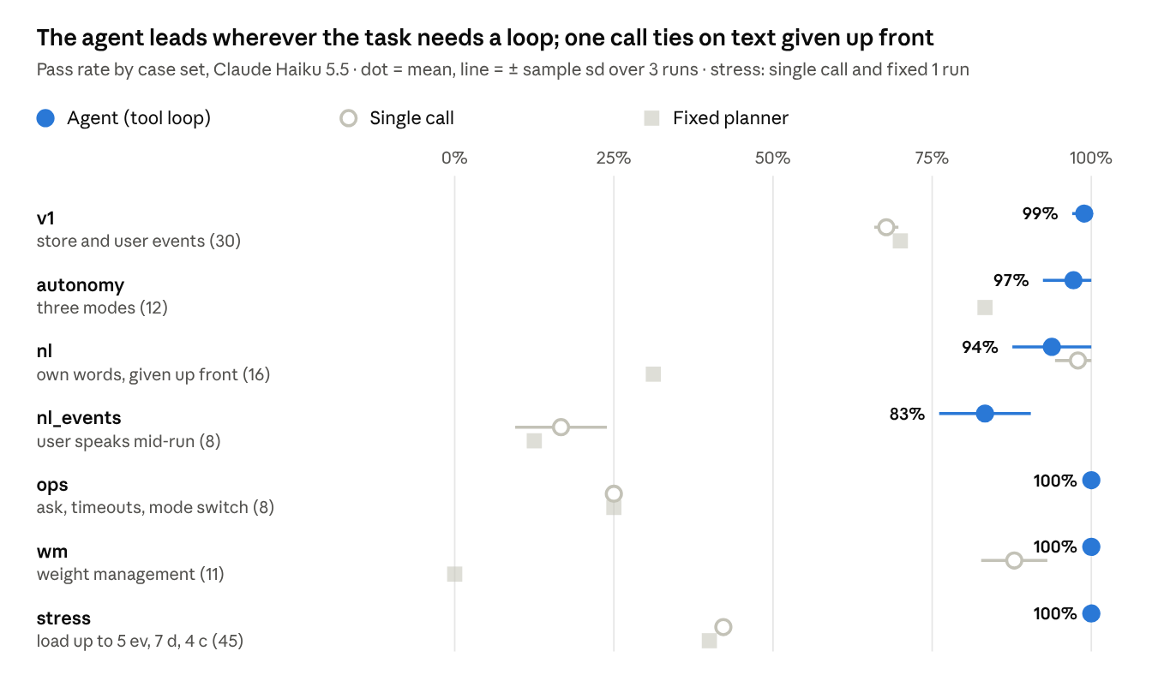
formal runs in runs/ledger.csv, 23–24 Oct 2026 · v1 single call: Haiku; autonomy has no single-call run
Where the single call ties or wins. On nl (text given up front) the single call scores 0.979 ± 0.036 against the agent's 0.938 ± 0.062 — within one sd. On wm the targets are computed by code and handed to both, so without events one call suffices (0.879); the agent's margin there is the stock-out at approval. Sonnet 5.5 on v1: agent 1.000, single call 0.711 ± 0.039 — the gap is the loop, not the model size.

Gate ablation: why ordering stays supervised
Same agent and cases, gates switched off so nothing is refused; every would-be refusal is counted as a critical error when an order is created.
Set | Gates on | Gates off | What happened with the gates off
v1 | 0/30 | 3/90 | Ordered on an approval voided by a stock-out (×2); under-bought an ingredient
nl | 0/16 | 1/48 | Ordered tofu curry for "cannot take spicy one lah"
ops | 0/8 | 6/24 | Guessed missing allergies instead of asking (×3), once ordering peanut noodles for a peanut-allergic user; ordered after the user switched to plan only (×3)
wm | 0/11 | 0/33 | —
All | 0/65 | 10/195 (5.1 %)
The model alone errs in about one run in twenty, exactly where the gates act: a stale approval and a guessed fact.

Stress: where it stops coping
Load (agent n = 9 per level) | Agent before fix | Agent after fix | Single call | Fixed
0–5 store events | 1.00 | 1.00 | 0 from 2 events | 0 from 2 events
7 days | 0.89 | 1.00 | 0 | 1.00
1–4 note constraints | 1.00 | 1.00 | 1.00 | 0 from 3
3 events + 7 days + 3 constraints | 0.56 | 1.00 | 0 | 0
5 events + 7 days + 4 constraints | — | 1.00 | 0 | 0
The only failure under load was a reply cut off at the 8,000-token output limit (§6). Within the tested envelope no boundary remains; beyond 5 events, 7 days and 4 constraints is untested. Single-call and fixed figures are one run each.

Failure modes (agent, with the gates on)
Mode | Where | Count
Idiom not mapped to an ingredient ("cannot take spicy one lah") | nl n09 | 2 of 3 runs
Quantity in words read differently from the catalogue ("10 eggs" as 500 g, catalogue 600 g) | nl_events e01 | 3 of 3 runs
Reported "no plan" although one existed (missed a dish, or over-excluded) | nl n07, nl_events e08 | 1 run each
Asked the user although a plan fitted the limit | autonomy a12 | 1 of 3 runs
Reply cut off at the output limit (fixed) | stress 7-day levels | 5 of 126 runs
None of these placed a wrong or unauthorized order: with the gates on, every failure ended in no order or a refused one.

User experiences
Who uses it (assumption, tested by the study). People in Singapore who cook at home on a budget and plan a few days at a time: a student in a shared flat (S$20–40 for three days, a flatmate's allergy), a young professional living alone (late evenings, food going off), someone cooking for two.
How it is applied. The person sets the hard facts once and writes the rest in their own words. The agent shows what it understood as a short list, plans breakfast/lunch/dinner or lunch/dinner, and builds the cart; then the chosen mode applies. They can message it while it works ("and no eggs either"); any change voids an approval. A shared demo (Firebase Hosting + Cloud Run, passcode, per-run and total spend caps) runs the same code and gates; a presenter mode can sell out an item, raise a price, switch to plan only or make an order time out, live.
What changes for them (claims to test).
Claim | Evidence so far | Measured in the study
Planning shrinks to a note and one cart review | User asks per case: ① 0, ② 1, ③ 0.67 (autonomy set) | Minutes per week now (self-report); seconds to decide on a cart
Their own words are understood | nl 0.94, nl_events 0.83 on our sentences | Participants judge the agent's reading of their sentences
They stay in control of money | 0 unauthorized orders with the gates on | "I knew what it would buy"; carts declined
Trust grows with limits, not blind delegation | — | Which mode they would use; what would make them delegate
Study status. Formative usability study, 5–8 participants, about 25 minutes, tasks T1–T6 across the three modes, a mid-run message and a blank field. The demo records each session and a 5-item questionnaire automatically; synthetic store, no real health data. No sessions yet — results go here from scripts/study_summary.py, reported as medians with n.

Challenges: how the gaps were found
Most gaps were found by a number that did not fit, then confirmed or refuted with a measurement before anything was changed. Every check that matters was first broken on purpose to see its test fail.
Gap | How it was found | What was done | Result
Structured input did not need an LLM | A rule-based solver with re-planning passed all of v1 | Built sets where the input is the user's own words (nl) and where they speak mid-run (nl_events) | Language: rules 0.31 vs LLM ≥ 0.94; loop: agent 0.83 vs single call 0.17
The "silent give-up" under load | 5 runs on the 7-day stress levels ended with no plan and no report | First fix (a nudge on stopping without a result) raised mixed 5/9 → 7/9 but the nudge never fired, so it was noise. Logging why each loop ended showed every failure was the 8,000-token output limit | Limit 16,000 and cut-off replies never executed: 135/135
Our own prompt contradicted itself | wm debug: a pregnant sample person was declined instead of sent for review | Found the clash between the nl rule ("decline") and the wm rule ("calculator decides"); fixed the prompt, kept the gold | Agent 1.000 on wm
A stale price could be approved | A run approved a total that no longer matched the cart | G1 checks the reported total against the computed one | Covered by tests and every later run
A case tested the wrong thing | autonomy a12: every run asked the user, arguably the better behaviour | Revised the input before freezing (limit S$13 with a two-dish plan) and recorded why | 0.972 ± 0.048
Ambiguous gold after the runs | nl_events e01: "10 eggs" read as 500 g; the catalogue's pack is 600 g | Kept: the set was frozen, and gold is never changed to fit outputs | Reported as a failure mode
Fingerprints that did not cover what they claimed | iCloud conflict copies changed the v1 hash; the wm hash omitted its own catalogue | Canonical-file filter; wm fingerprint now includes data_wm/ | Recorded in the changelogs
A teammate's broader v0.3 (weight management) | Two documents both called v0.3 | Adopted what is checkable in code (ask-never-guess, idempotent orders, mode switch, burden counts, then energy targets with sample people); kept health advice out | ops 1.000, wm 1.000
One-run debug scores were consistently optimistic (agent 16/16 and 8/8 on the nl sets fell to 0.94 and 0.83 over three runs); only three-run figures are reported.

Limitations, future work and contributions
Limitations.
- Synthetic catalogue of 15 recipes; real products would need label and cross-contact evidence before any allergy could be trusted to code.
- Every case was written by the team, and the prompt was revised after debug runs; a held-out set written blind by a teammate is the test this report still lacks.
- Three runs per system; small counts (10 critical errors) are reported with their denominators. Single-call and fixed stress figures are one run.
- Six sets were measured with the 8,000-token limit and without stop-reason logging; their figures stand as measured.
- Nutrient values are approximations; macros are reported, not gated; days are three meals without snacks. Not nutrition or medical advice.
- One model family (Claude Haiku 5.5; Sonnet 5.5 on v1 only).
Future work. A held-out case set; the user study (§5); persistent inventory and repeat weekly cycles; body-fat goals and progress tracking from the group's v0.3 proposal, each behind a reviewed nutrition rule and a new frozen benchmark.
Contributions.
Member | Contribution
Zhou Hanwei | Agent, environment and gates, case sets and builders, evaluation harness and runs, demo and deployment
宋姝槿 | Policy v0.2 and the v0.3 proposal: weight-management design (energy equation, 1,500 kcal floor, BMI gates), ask-never-guess, order idempotency, coordination-burden metrics
(teammate) | to fill: e.g. held-out cases, user study sessions
(teammate) | to fill
(teammate) | to fill

