Design and Evaluation of a Hybrid Recommendation System with MovieLens Data
Course: Data Management for Data Science
Professor: Ananda D. Gunawardena
Huanghui Xiao (hx195) | Hanwen Wang (hw554)

1. Introduction
Recommender systems are widely used in platforms like Netflix and Amazon to help users find content they may like. In this project, we build a recommendation system using the MovieLens dataset.
The goal of this project is to try different recommendation methods and see how they actually perform in practice. We start with simple models and then improve them by combining different approaches. In addition, we also look at not only accuracy but also how diverse and interesting the recommendations are.

2. Dataset Description
We use the MovieLens ml-latest-small dataset. It contains user ratings for movies.
Main files:
- ratings.csv: (userId, movieId, rating)
- movies.csv: (movieId, title, genres)
Ratings are between 0 and 5.
We split the dataset into:
- 80% training data
- 20% testing data
The training set is used to build the model, and the testing set is used to evaluate performance.

3. Methodology

3.1 Baseline Model
The baseline model predicts ratings using simple statistics such as average ratings and bias terms. It is easy to implement and provides a good reference point.

3.2 SVD Model
We use the SVD model from the Surprise library. This is a matrix factorization method that learns hidden features for users and items.
Model settings:
- number of factors: 20
- number of epochs: 10
SVD is more flexible than the baseline model and can capture more complex patterns.

3.3 Hybrid Model
We combine the baseline and SVD models using fixed weights:
Final prediction = 0.7 × SVD + 0.3 × Baseline
The idea is that baseline is stable, while SVD can learn deeper patterns. Combining them may give better results.

⭐ 3.4 Learning-based Hybrid Model (Advanced Module)
Instead of manually choosing weights, we also implement a learning-based hybrid model.
In this approach:
- we use predictions from SVD and baseline as features
- we also include user activity and item popularity
- then we train a regression model to learn how to combine them

This allows the model to automatically find better combinations instead of using fixed weights, which makes it more flexible and adaptive.

4. Model Evaluation

4.1 RMSE
We use RMSE to measure prediction accuracy.
Model | RMSE
Baseline | 0.8824
SVD | 0.8883
The baseline model slightly performs better in this case.

4.2 Precision, Recall, and F1 Score
We also evaluate recommendation quality using:
- Precision ≈ 0.74
- Recall ≈ 0.52
- F1 Score ≈ 0.61
This means the system gives relevant recommendations, but it may miss some items.
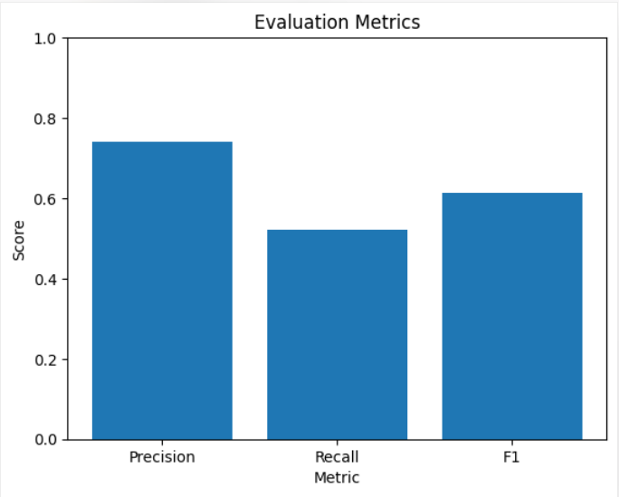
Figure 1: Comparison of Precision, Recall, and F1 Score. The model achieves high precision while maintaining reasonable recall.

4.3 Effect of K
We further evaluate the system under different values of K:
- K = 5 → Precision ≈ 0.745, Recall ≈ 0.389
- K = 10 → Precision ≈ 0.741, Recall ≈ 0.522
- K = 15 → Precision ≈ 0.735, Recall ≈ 0.581
These results demonstrate a trade-off between precision and recall:
- Increasing K improves recall
- Increasing K slightly reduces precision

5. Recommendation Results
The system generates personalized recommendations for users.
Example: Pulp Fiction, The Dark Knight, and The Departed are frequently recommended.
These results show that the model captures user preferences effectively.

6. Additional Analysis

6.1 Popular Movies
The most popular movies based on rating frequency include:
- Forrest Gump
- Shawshank Redemption
- Pulp Fiction
- Silence of the Lambs
- The Matrix

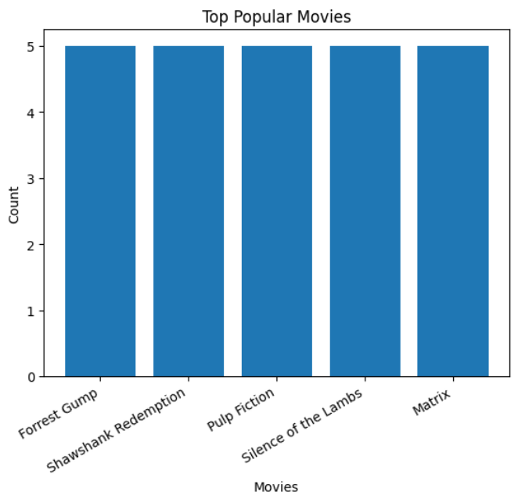
Figure 2: Most popular movies based on rating frequency in the dataset.

6.2 User Behavior Analysis
- Average user rating: ≈ 3.65
- Maximum rating: 5.0
- Minimum rating: ≈ 1.27
This indicates that most users tend to give moderately high ratings, with some variation across individuals.

7. Diversity & Novelty Analysis
Besides accuracy, we also evaluate diversity and novelty.
- Diversity measures how different recommended items are
- Novelty measures how unexpected or less popular the items are
Our results show:
- moderate diversity
- relatively high novelty
This means the system does not only recommend popular items but also introduces new ones.

This shows that the system can recommend a variety of items while also introducing less popular content to users.

8. Discussion
From the results, we observe:
- One thing we observed is that the baseline model performs quite well because of strong bias in the dataset.
- The hybrid model improves overall recommendation quality
- Learning-based hybrid provides a more flexible way to combine models
- The system achieves high precision but moderate recall
One limitation is that SVD did not outperform baseline significantly. This may be due to parameter settings or dataset size.

9. Conclusion
In this project, we built a recommendation system using baseline, SVD, and hybrid models.
We found that combining models can improve recommendation quality. We also learned that more complex models do not always guarantee better accuracy.
By adding learning-based hybrid and diversity evaluation, the system becomes more practical and realistic. Overall, this project helped us better understand how different recommendation methods behave and how to improve them step by step.

10. Work Distribution
The project work was shared between both team members, with each person contributing to different parts of the system.
Huanghui Xiao:
- Data preprocessing and dataset preparation
- Implementation of evaluation metrics (RMSE, Precision, Recall)
- Analysis of model performance
- Implementation of Diversity and Novelty evaluation
Hanwen Wang:
- Implementation of Baseline, SVD, and Hybrid models
- Development of Top-N recommendation logic
- Implementation of the learning-based hybrid model
- Visualization and result presentation
Both members contributed to:
- Designing the overall system structure
- Debugging and testing the models
- Writing and reviewing the final report

