I
USER MANUAL
IBM SKILLS BUILD

Last updated : 21/02/2024
Group 01
Kevin Han - jh892
Mikail Arioz - ma1002
Jahnavi Muniraj - jm958
Leandro De Noronha - ldn5
Enzo Brown - eb433
Miracle Ndu - mn303
Yash Parmar - yp114
Ben Millington - bm308

Purpose : This document was built to help a user understand the content inside IBM Skills Build. IBM Skills Build is designed to help develop valuable skills and career readiness. The platform tracks the progress and offers guidance so users can effectively develop skills that match their career goals.

Contents

Setting Up a MySQL Connection 3
Register Page 9
Login Page 11
Dashboard Feature 14
Streaks Feature 15
Record start times 16
Leaderboard Feature 17

Setting Up a MySQL Connection

To setup a MySQL connection, you will need a MySQL server installed and running on your machine, and some way to create a schema and user. For this manual, we will be using the MySQL Windows Installer (8.0.36) for the MySQL server and MySQL Workbench, available at https://dev.mysql.com/downloads/installer/ .

After installing your MySQL server and MySQL Workbench:

- Open Workbench and create a new connection.
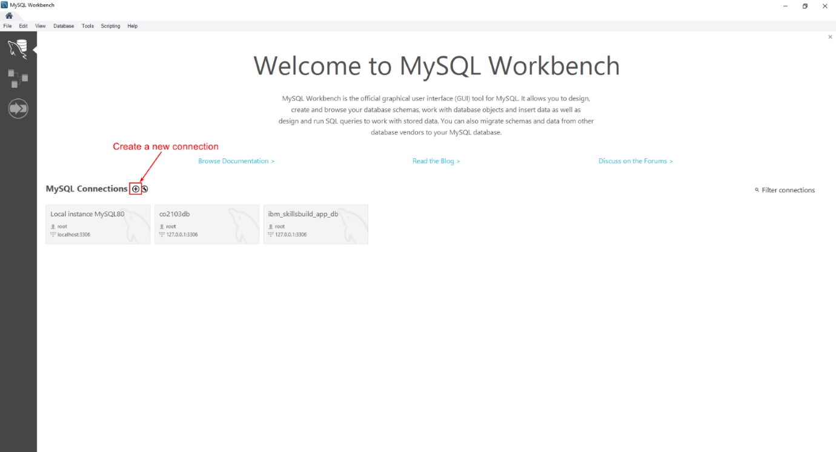
- Name your connection (something recognisable) and set a user to connect with (here we use root user). Click ‘Test Connection’ and login with the user to make sure the connection is working, then click ‘OK’.
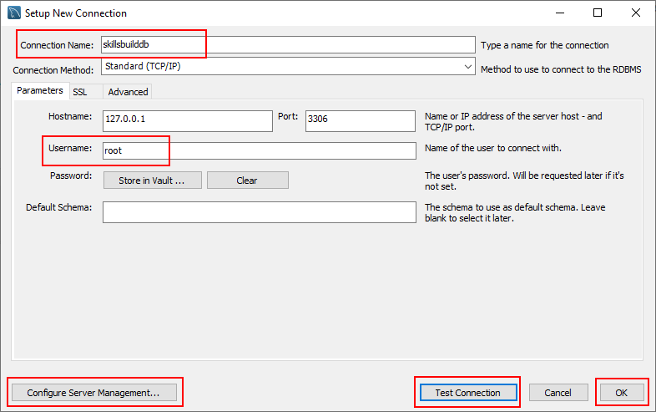
If the connection is not working, you can click ‘Configure Server Management...’ for more thorough testing.
- You should see the following popup after clicking ‘OK’.
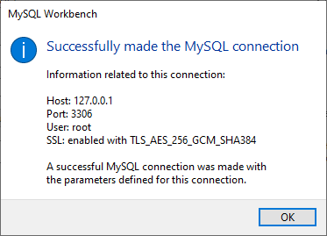
- Connect to your server by clicking on the connection and logging in.
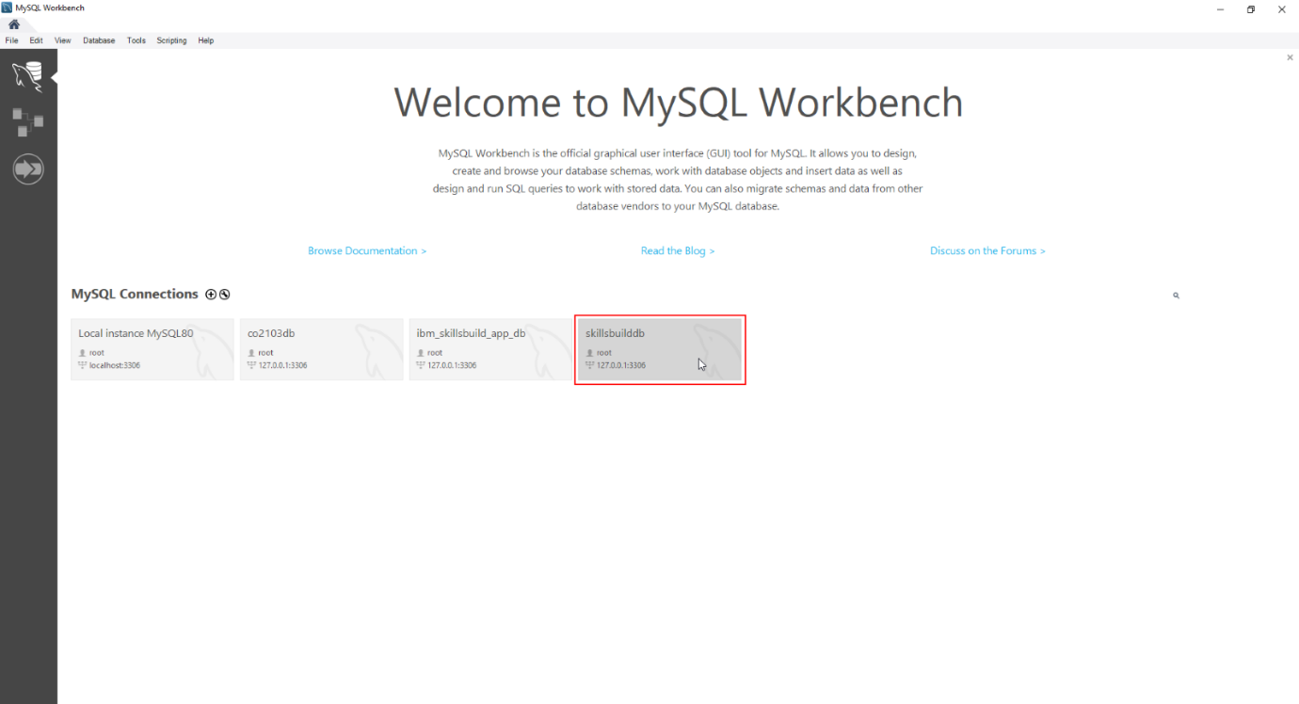
- Create a new schema with the following statement:
CREATE SCHEMA schemaname;
where schemaname is your chosen name for the schema. Here we use “skillsbuilddb”.
Next, execute the statement, either by pressing Ctrl + Enter, or by clicking the lightning button above the statement.
When the statement is executed, it will show at the bottom to say if it was successful or unsuccessful.
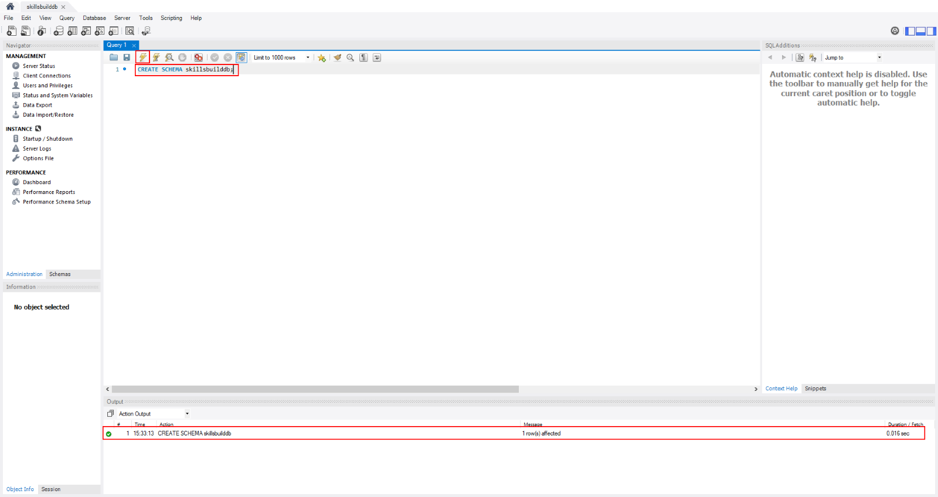
- Next, we create a new user for the schema. Click ‘Users and Privileges’ in the left-hand side ‘Administration’ menu.
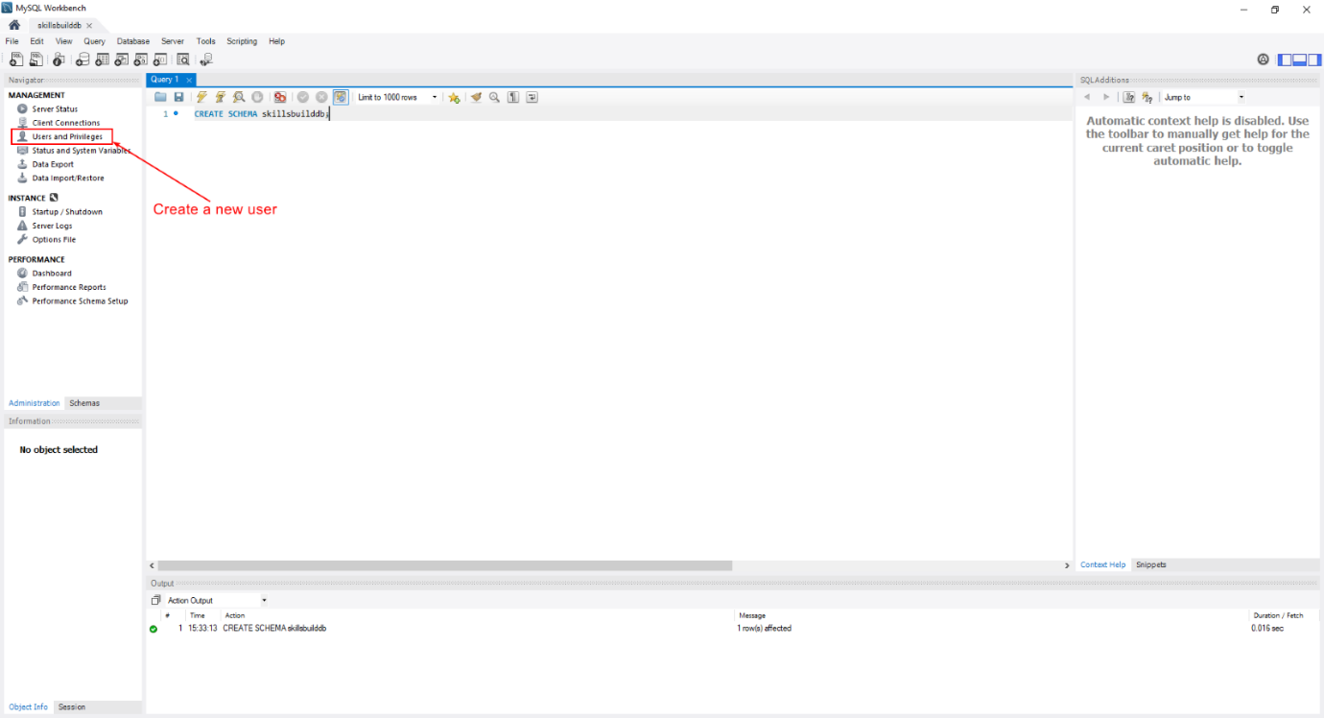
- From here, click ‘Add Account’ to create a new user.
Give it a name, here we use “skillsbuilduser”, and a password.
Then navigate to ‘Schema Privileges’.
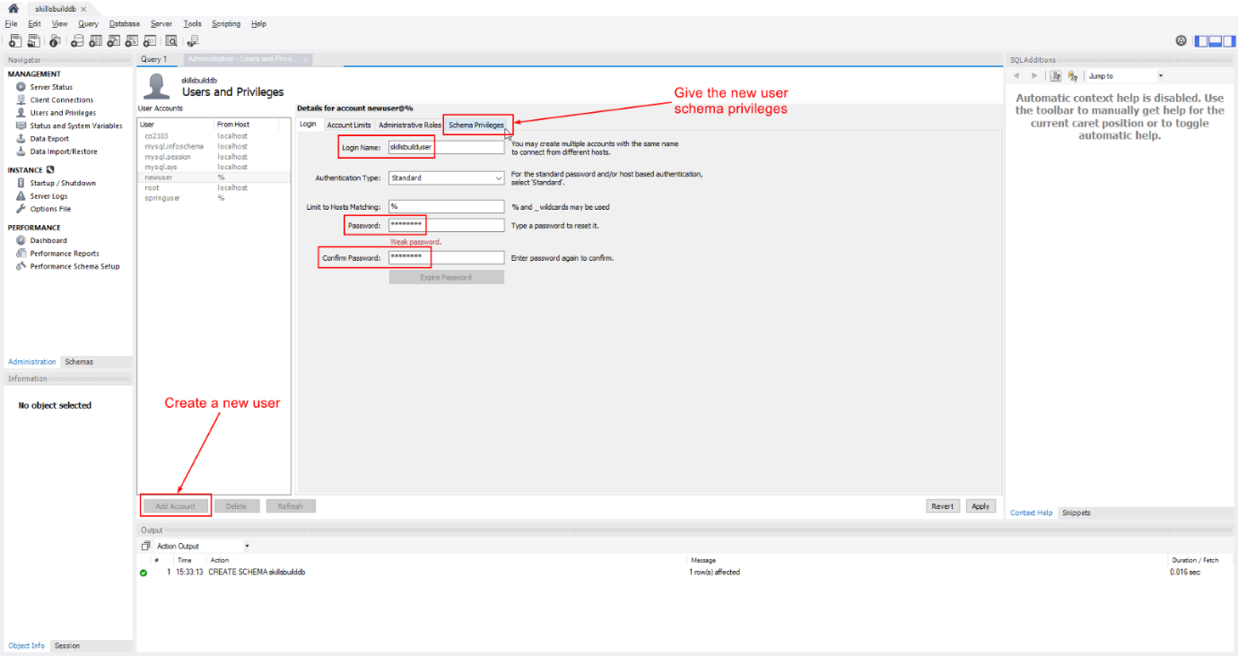
- Here, click ‘Add Entry...’ to create a new privilege entry.
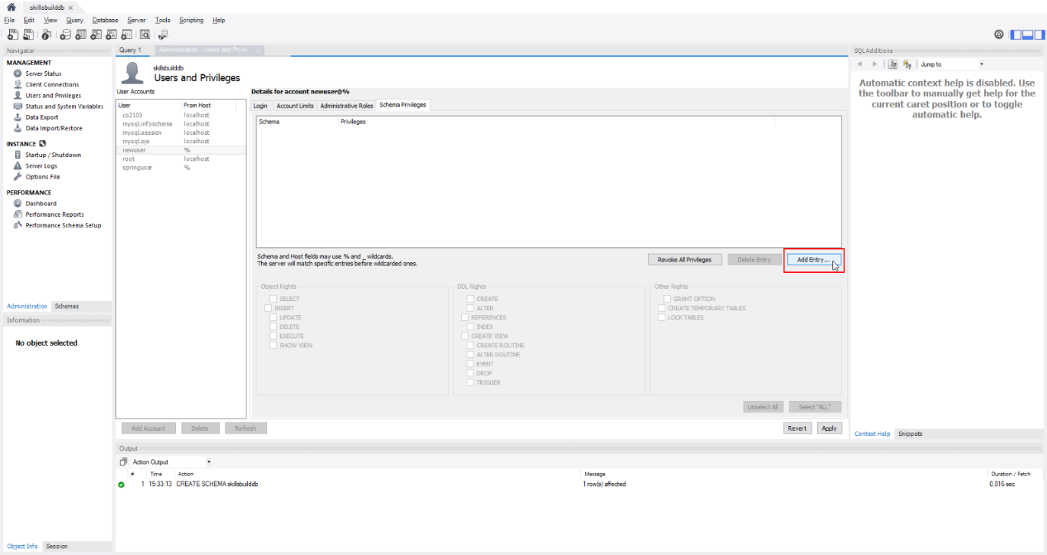
- Select your schema from the drop-down list under ‘Selected schema:’, and click ‘OK’.
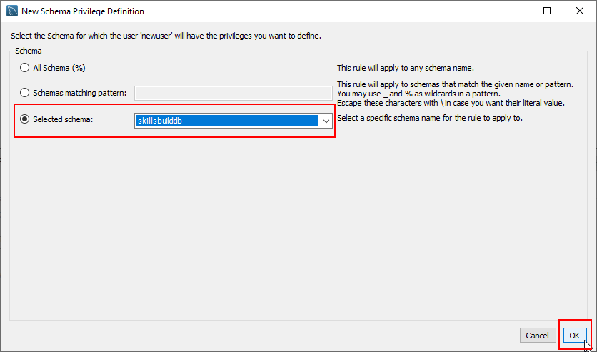
- Now you have created an entry, click ‘Select “ALL”’ to grant your user schema privileges, then click ‘Apply’.
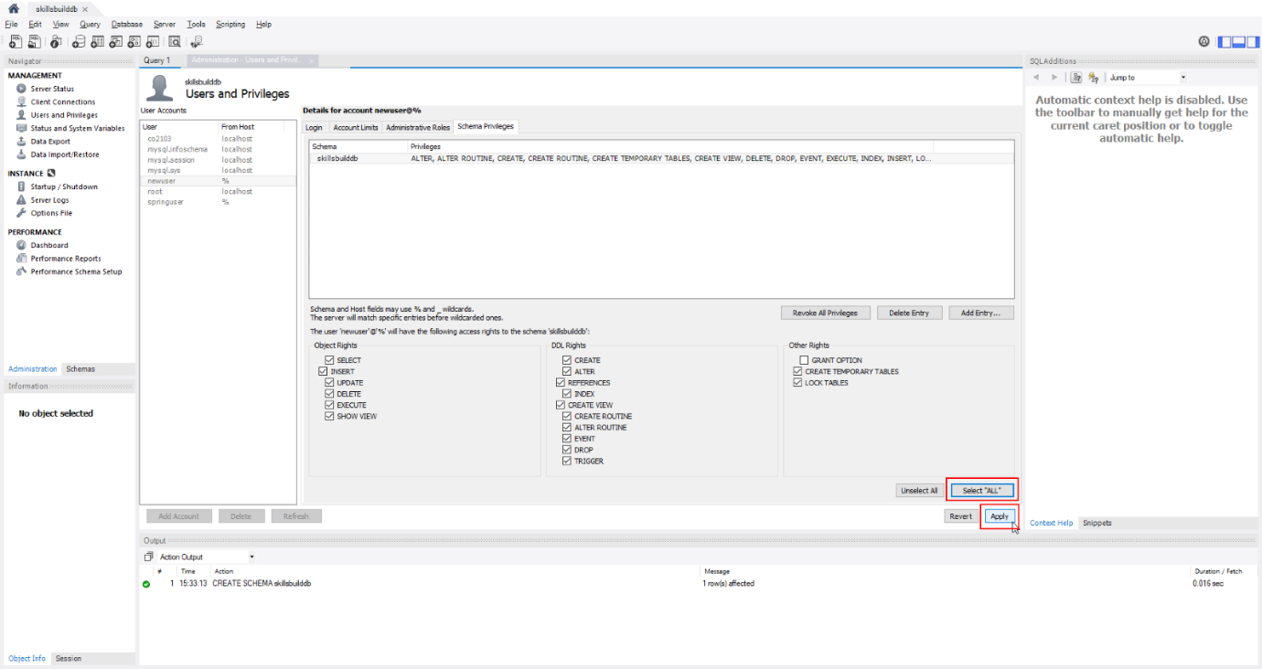
- Now you have successfully setup your MySQL connection and user!
Open up the ‘application.properties’ (located in ./ibm-skillsbuild-app/src/main/resources) file in your preferred file editor.
In this file, edit the shown 3 lines ‘spring.datasource.url’, ‘spring.datasource.username’, and ‘spring.datasource.password’ with your schema name, user username and password.
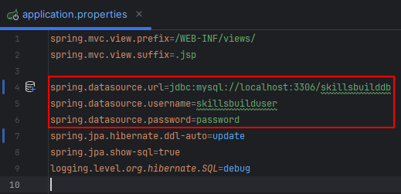
- You will now be able to run the project in your IDE of choice!

By Ben Millington

Register Page

Introduction

- Welcome to the user manual for the Register Page. This document will guide you through the process of accessing the Register Page and registering a new account.

Accessing the Register Page

- To access the Register Page, follow these steps:
- Open your web browser (e.g., Google Chrome, Mozilla Firefox, Safari).

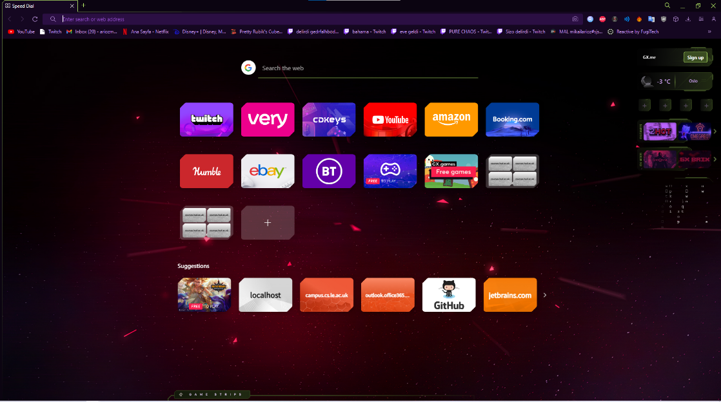

- In the address bar, enter the URL of the website (http://localhost:8080) where the Login Page is located. Then click on “Don’t Have An Account?”

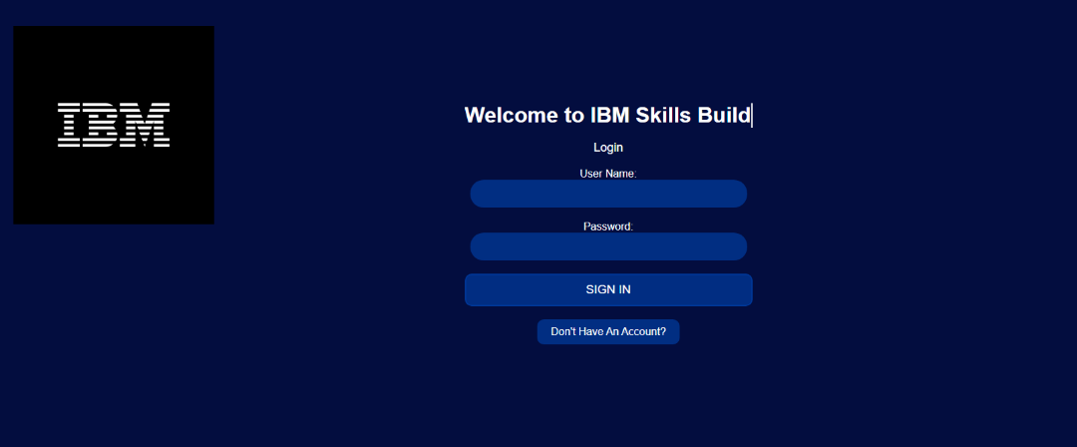

Registering
Once you've accessed the Register Page, you'll need to register a new account. Follow these steps to register:
- Enter your desired username and password in the “User Name” and “Password” field respectively.
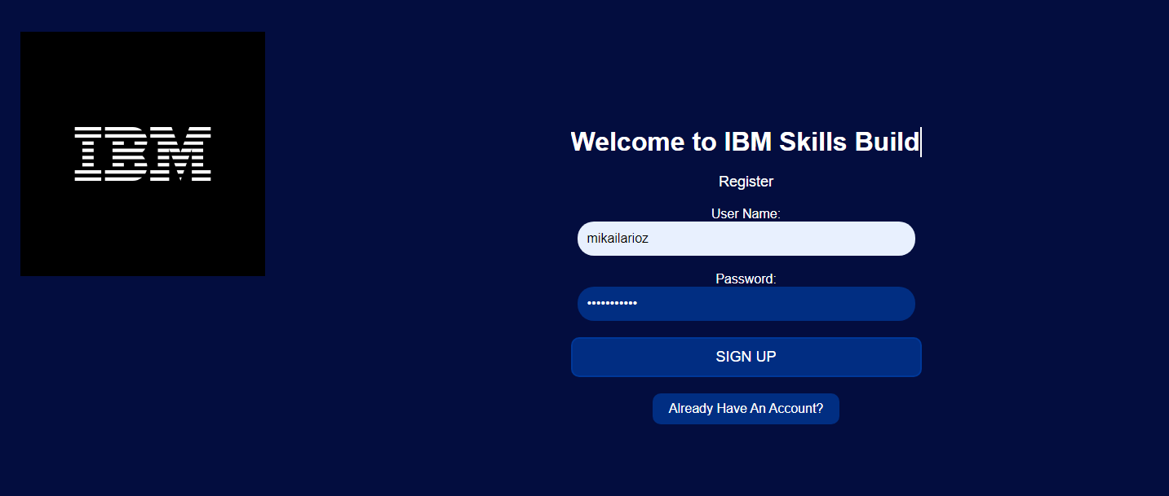

- After clicking “SIGN UP” you will be redirected to the login page where you will have to enter the credentials you have just created then you will have an access to the dashboard.

By Mikail

Login Page

Introduction

Welcome to the user manual for the Login Page. This document will guide you through the process of accessing the Login Page and logging in to your account.

Accessing the Login Page

To access the Login Page, follow these steps:

- Open your web browser (e.g., Google Chrome, Mozilla Firefox, Safari).
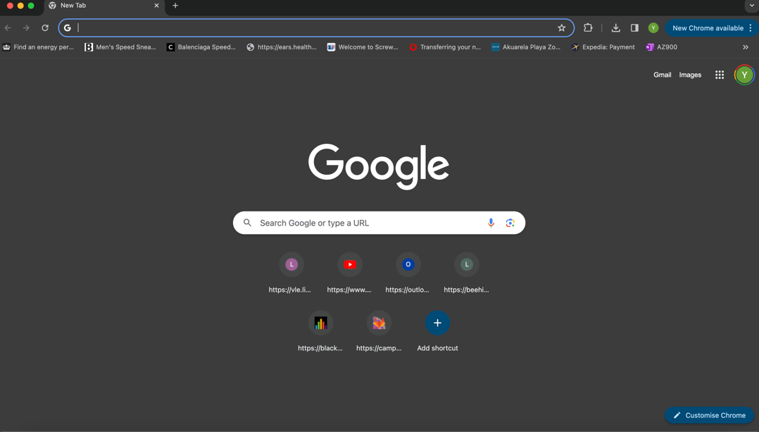

- In the address bar, enter the URL of the website (http://localhost:8080) where the Login Page is located.

- Press Enter or Return on your keyboard to navigate to the website.
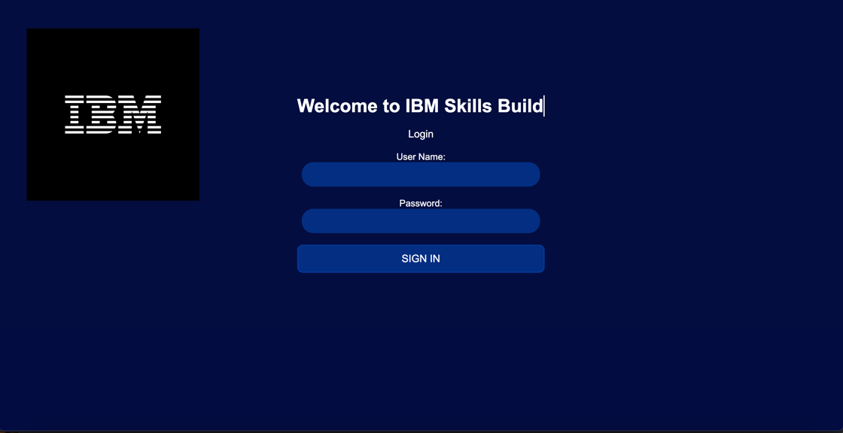
Once you've accessed the Login Page, you'll need to log in to your account. Follow these steps to log in:
- Enter your username in the "User Name" field.

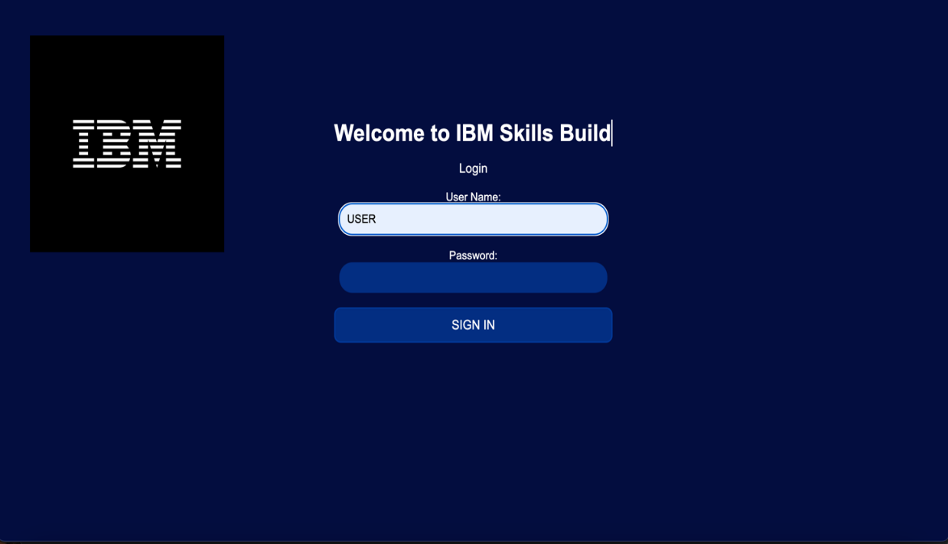

- Enter your password in the "Password" field.

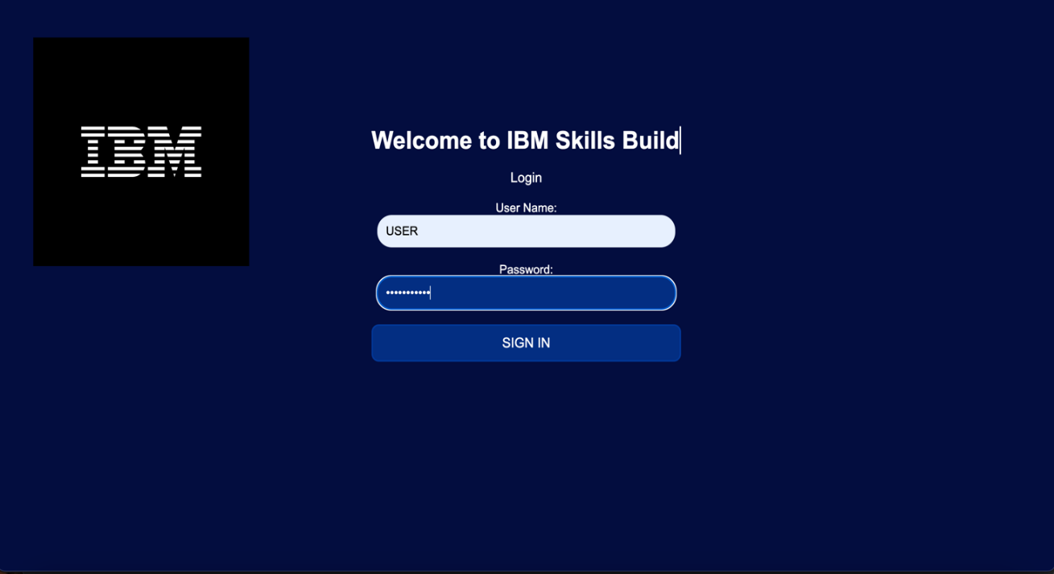

- Click or tap the "Sign In" button to submit your login credentials.

By Yash

Dashboard Feature

Introduction
The dashboard allows you to view key metrics and data visualisations to monitor the status and performance of the system . This user manual provides instructions on how to access and navigate the dashboard.

1.After logging in the with login credentials, the user will be redirected to the dashboard.

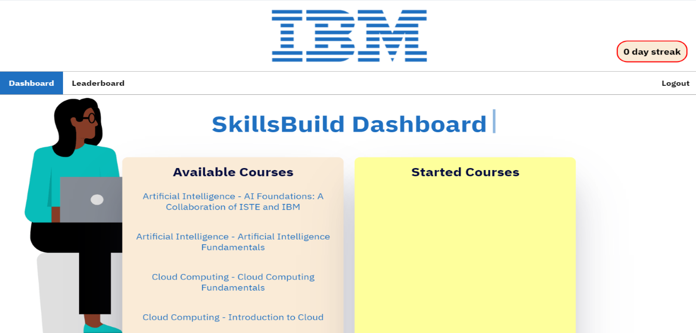

- The dashboard has 2 buttons, leaderboard and logout. The user can access the leaderboard and can see the streaks as well.
- If the user clicks on the courses, it expands and brings up a description, with a button to enrol/complete the course.

By Jahnavi and Ben

Streaks Feature
The streaks feature tracks the consecutive days a user logs into the system and updates their streak count accordingly.

- To see the streaks the user must have logged in using their credentials and their streak will be displayed on the dashboard.

- The key components of the streak include:
- It adds on when you log in for a consecutive day
- It resets when you fail to log on for a day
- It makes sure not to add on if you log in multiple times in a day.

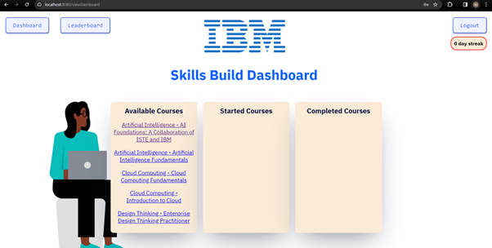

By Miracle

Record start times
Introduction

This is the user manual for recording start times. Following the user story, “As a Student, I want the app to record when I begin an IBM SkillsBuild Course so that I can pause and resume the courses”, the code contains all the features required.

How to find the pause and resume course function
- Open the web browser (Google Chrome, Firefox, Bing, etc.)
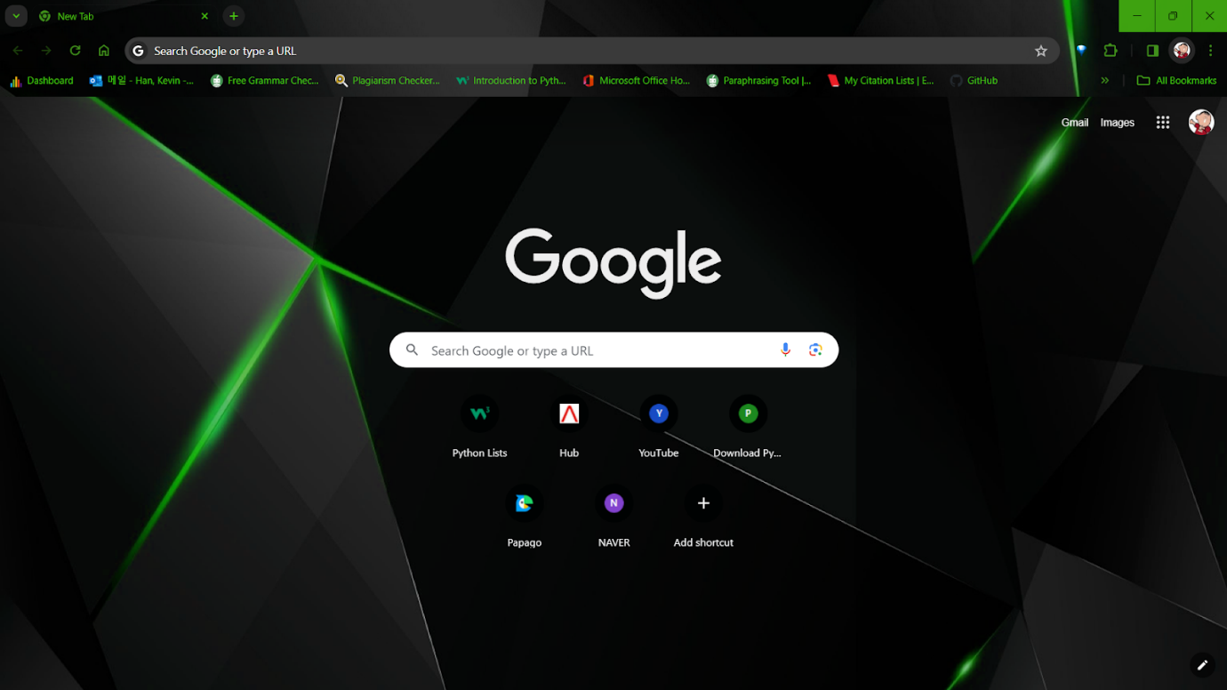
- In the search bar, type “localhost:8080/record-start” which will lead the user to the course time control page.
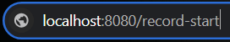

How to control the course time
- When you type the above URL to the search bar this webpage will be shown, and current time is shown in unit seconds.
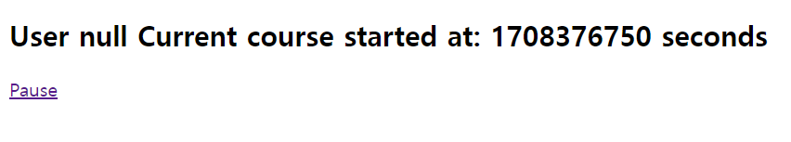
- If you are willing to stop the course now, you can click the pause button to stop recording the time (time will be recorded throughout the activity until the stop button is pressed).
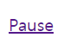
- If you are willing to resume the course, you can simply click the resume button to resume recording the time.
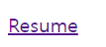

By Kevin

Leaderboard Feature

Introduction
Welcome to the user manual for the leaderboard feature. This manual will guide you on how to access the leaderboard.

1.First complete login manual to access dashboard. (Instructions for in Login Manual)

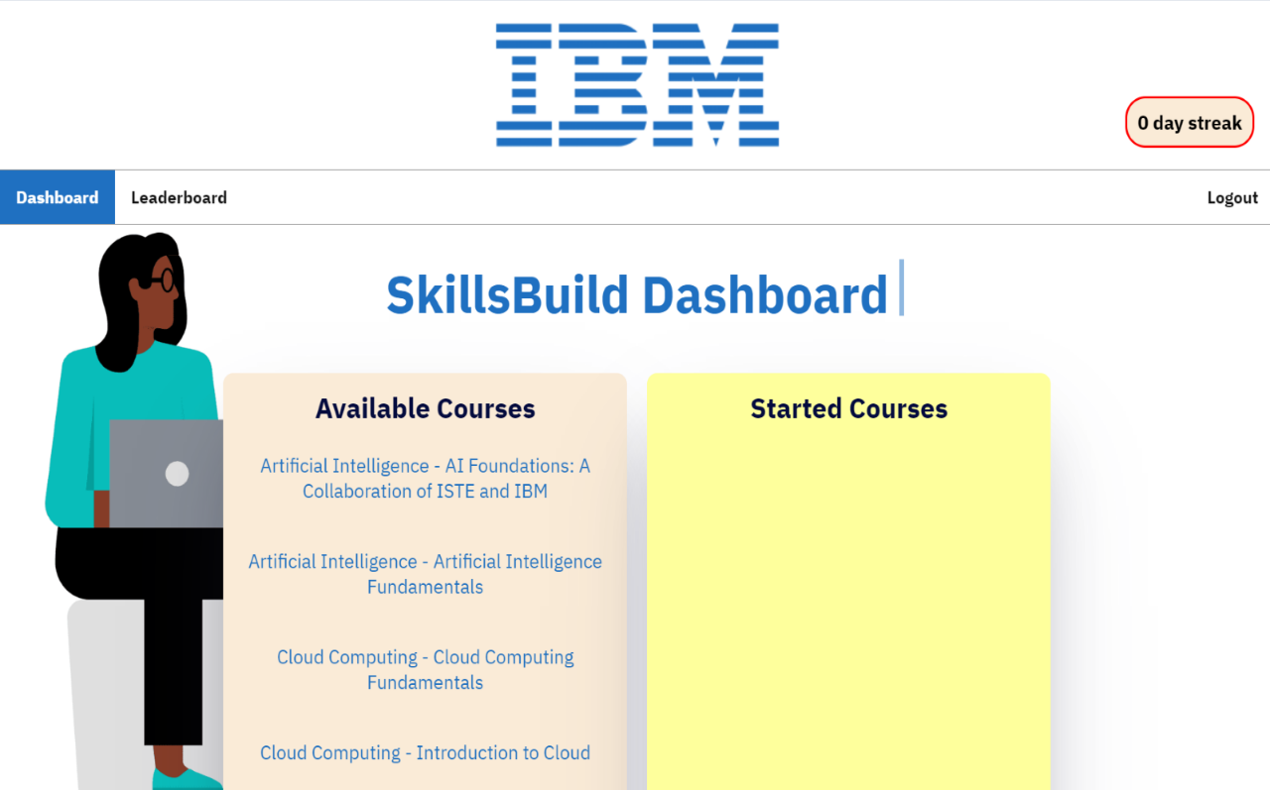
2. From the dashboard click leaderboard on the navigation bar

3.You will then be sent to the leaderboard page where you can view your global standing and then your standing with friends (if you have any on your account).
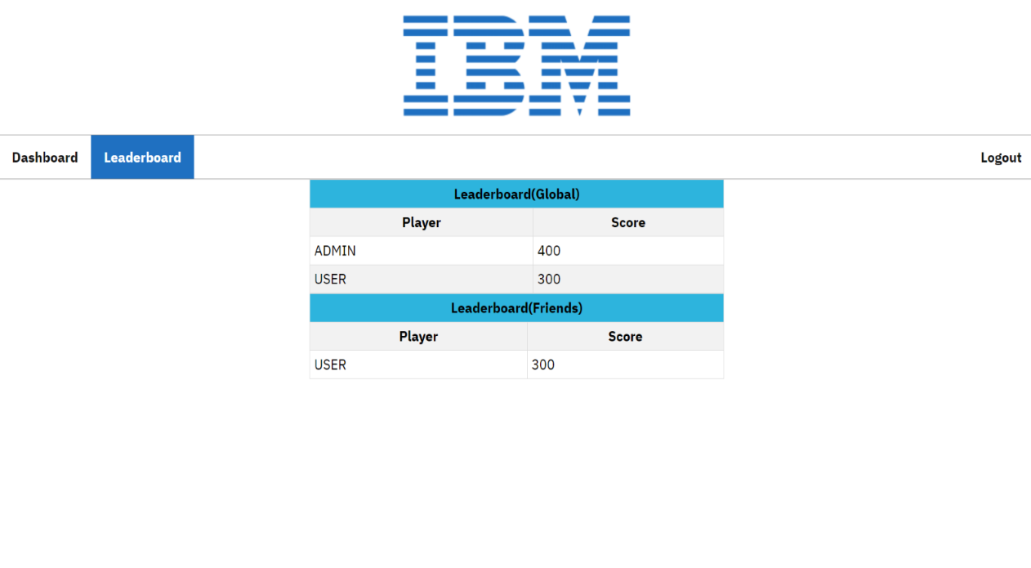

By Enzo

