[ 19 ] 회원인증, fileUpload, MyBatis

ch19_bookUpMember :

ch19_bookUpMember_search : 검색기능 추가 버전

1. 요구사항 : 회원가입(감사메일 자동 발송), 로그인, 로그아웃, 회원정보수정 가능

책이미지를 파일첨부하여 책등록, 책상세보기, 책정보수정, 책리스트(페이징처리)

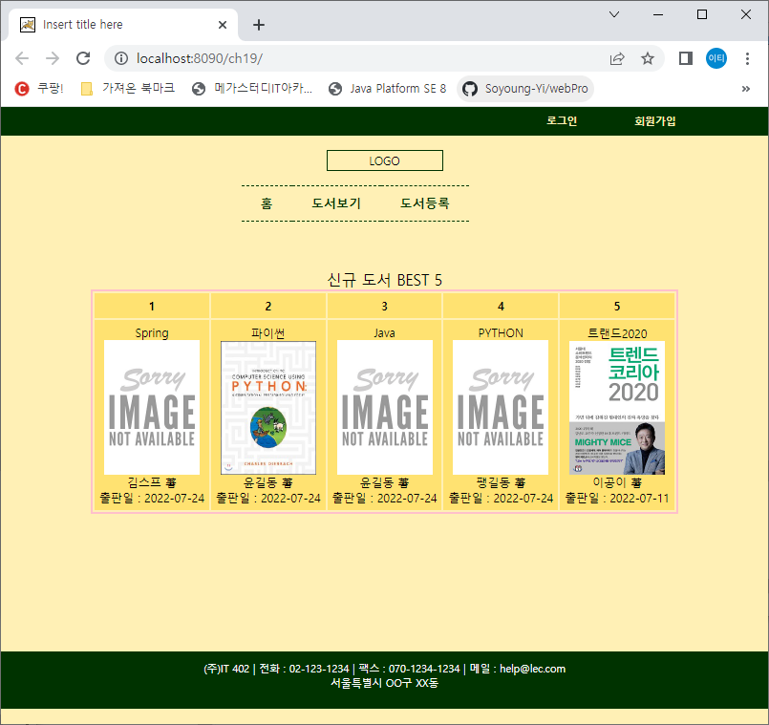 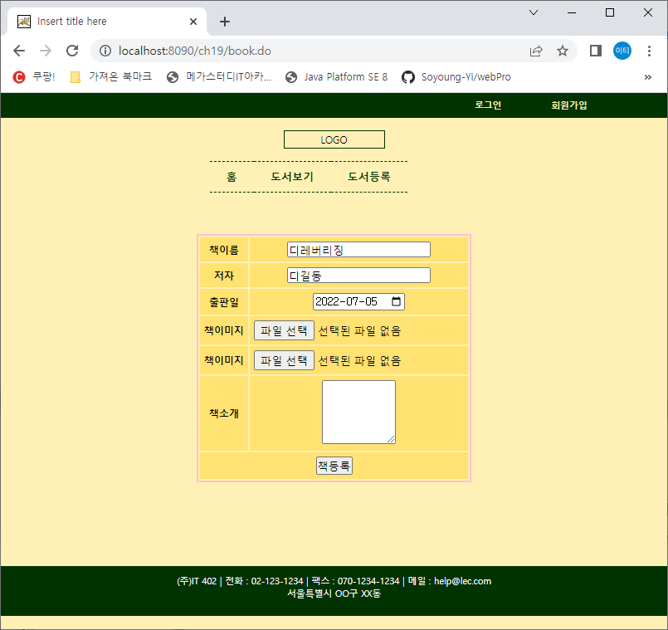

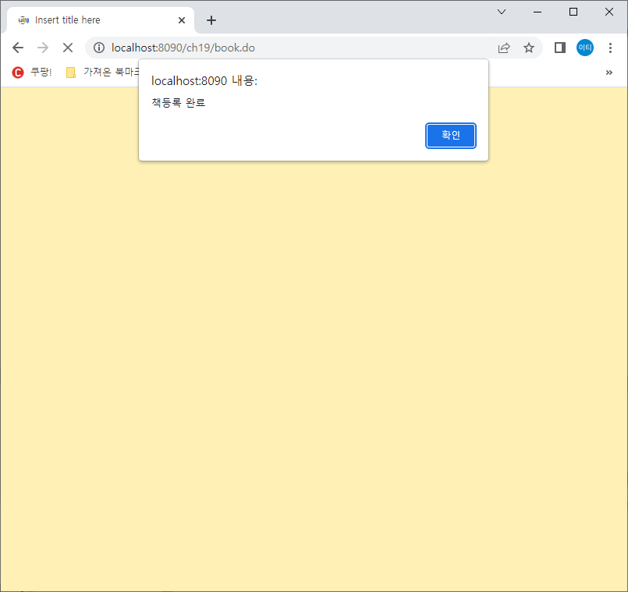 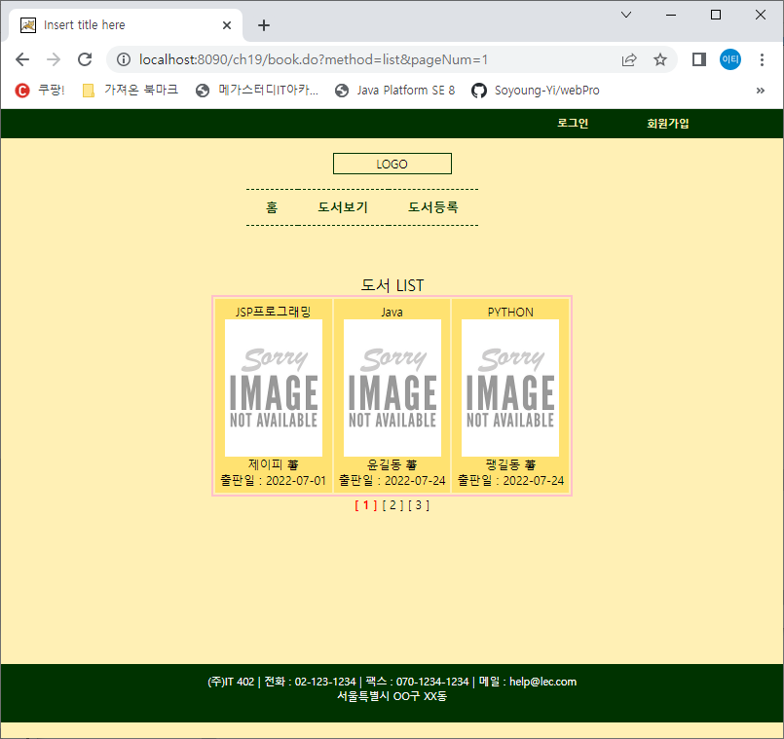

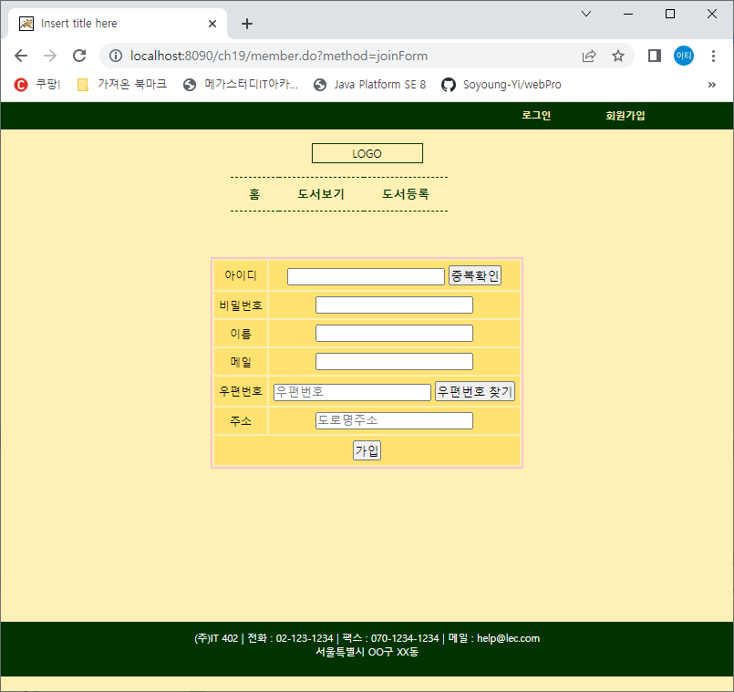 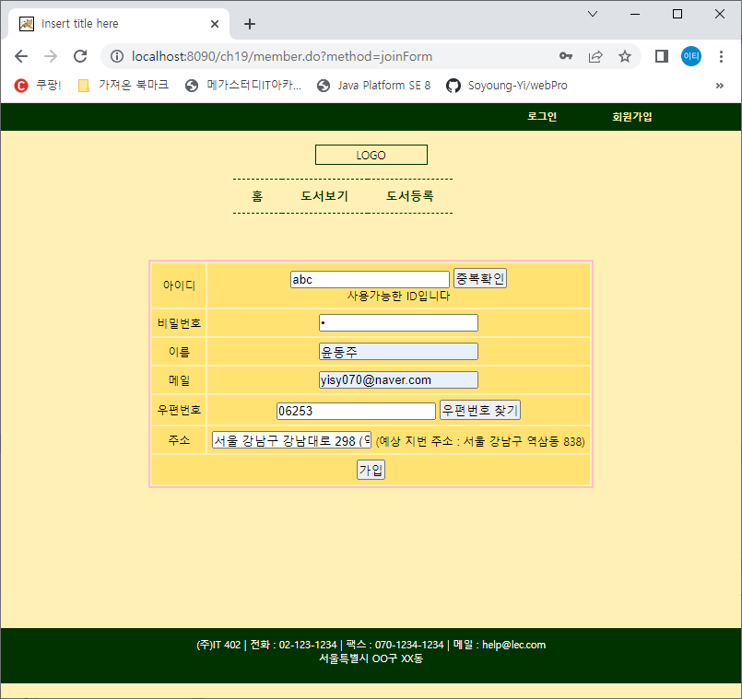

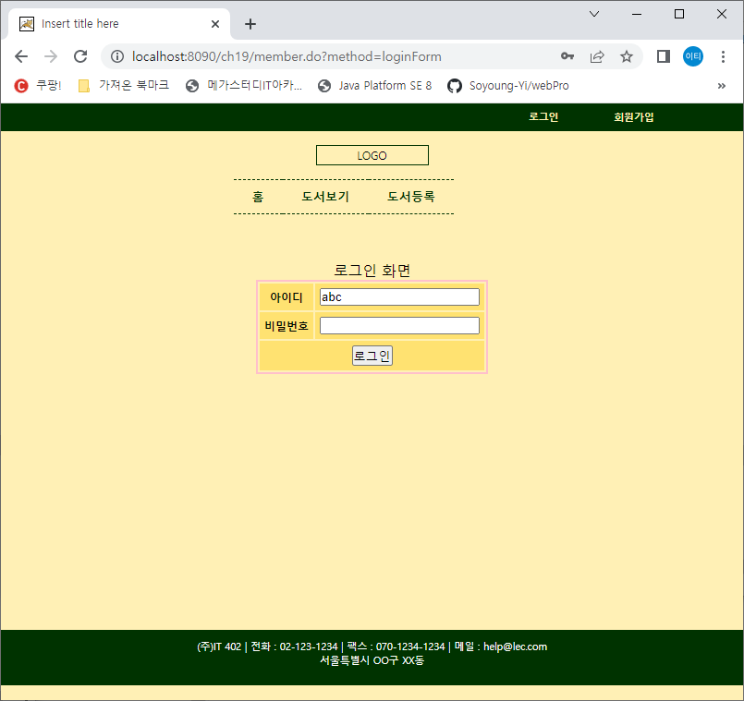 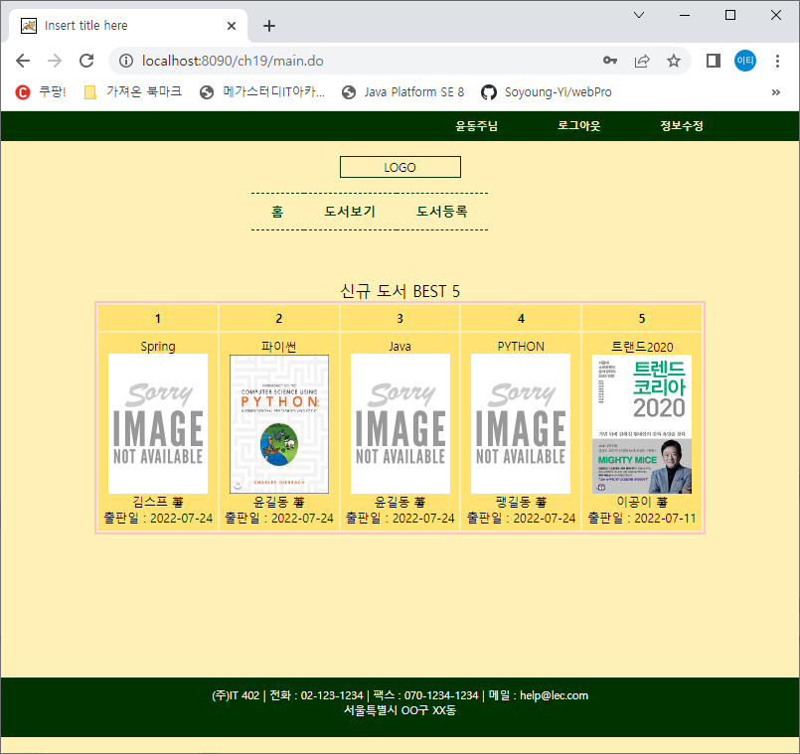

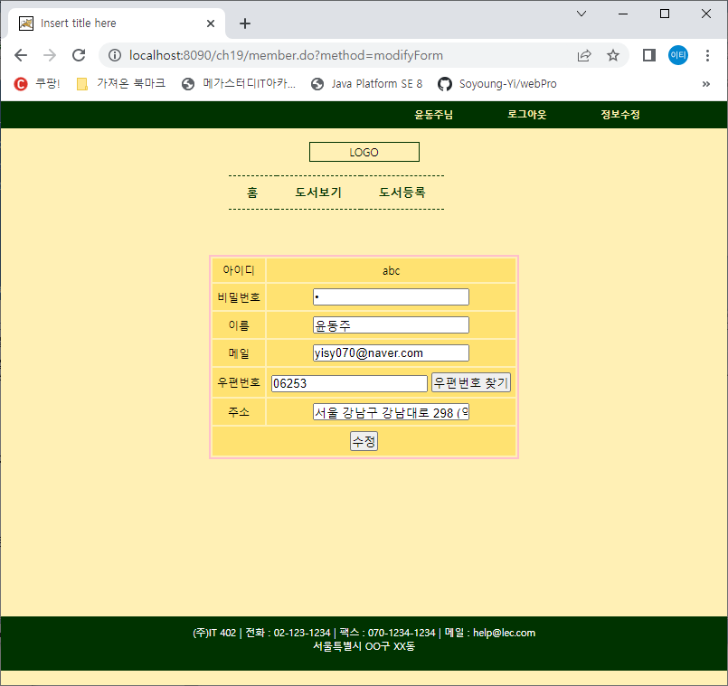 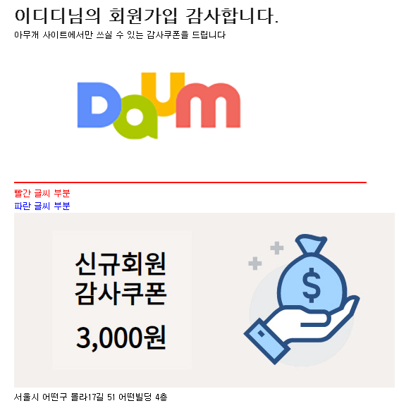

1. Query
2. Pom.xml에 dependency추가
3. Web.xml에 한글 필터링 및 *.do
4. Servlet-context.xml
   1. <resources mapping>지정 :css, bookImgFileUpload, js, img
   2. **<mybatis-spring:scan base-package=*" "*/>**
   3. **mailSender빈 생성, multipartResolver 빈 생성**
5. Dto
6. Mapper xml 과 Mapper dao interface
7. Mybatis-config.xml
   1. Root-contxt.xml(**DataSource빈 – sqlSessionFactoryBean – SqlSessionTemplate빈 생성**)
8. Service 인터페이스와 클래스, Paging
9. 컨트롤러와 View
10. 테이블생성 및 test 더미데이터 입력 ; src/main/resources/META-INF/db/initDB.sql

-- SEQUENCE & TABLE DROP/CREATE

DROP TABLE MEMBER CASCADE CONSTRAINTS;

DROP TABLE BOOK CASCADE CONSTRAINTS;

DROP SEQUENCE BOOK_SQ;

CREATE TABLE MEMBER(

mID VARCHAR2(100) PRIMARY KEY,

mPW VARCHAR2(100) NOT NULL,

mNAME VARCHAR2(100) NOT NULL,

mMAIL VARCHAR2(100) NOT NULL,

mPOST VARCHAR2(100), -- 우편번호

mADDR VARCHAR2(100) -- 주소

);

CREATE SEQUENCE BOOK_SQ MAXVALUE 99999999 NOCYCLE NOCACHE;

CREATE TABLE BOOK(

bNUM NUMBER(8) PRIMARY KEY,

bTITLE VARCHAR2(100) NOT NULL,

bWRITER VARCHAR2(100) NOT NULL,

bRDATE DATE DEFAULT SYSDATE NOT NULL,

bIMG1 VARCHAR2(1000) DEFAULT 'noImg.png' NOT NULL,

bIMG2 VARCHAR2(1000) DEFAULT 'noImg.png' NOT NULL,

bINFO VARCHAR2(4000)

);

-- DUMMY DATA INSERT

INSERT INTO MEMBER VALUES ('aaa','1','홍길동','hong@naver.com','12345','서울');

INSERT INTO BOOK VALUES (BOOK_SQ.NEXTVAL, 'SPRING','김작가',SYSDATE, 'noImg.png','noImg.png','스프링개념서');

INSERT INTO BOOK (bNUM, bTITLE, bWRITER, bRDATE, bIMG1, bINFO)

VALUES (BOOK_SQ.NEXTVAL, 'JSP','박제이',SYSDATE, 'noImg.png','jsp 개념서');

INSERT INTO BOOK (bNUM, bTITLE, bWRITER, bRDATE, bIMG2, bINFO)

VALUES (BOOK_SQ.NEXTVAL, 'ORACLE','홍작가',SYSDATE, 'noImg.png','스프링개념서');

INSERT INTO BOOK (bNUM, bTITLE, bWRITER, bRDATE, bINFO)

VALUES (BOOK_SQ.NEXTVAL, 'JAVA','이자바',SYSDATE, '스프링개념서');

1. Mapper에 들어갈 sql ; src/main/resources/META-INF/db/mappers.sql
2. pom.xml에 의존추가 부분

<properties>

<java-version>1.7</java-version>

<org.springframework-version>4.1.1.RELEASE</org.springframework-version>

<org.aspectj-version>1.6.10</org.aspectj-version>

<org.slf4j-version>1.6.6</org.slf4j-version>

</properties>

<!-- JDBC -->

<dependency>

<groupId>org.springframework</groupId>

<artifactId>spring-jdbc</artifactId>

<version>${org.springframework-version}</version>

</dependency>

<!-- mybatis -->

<dependency>

<groupId>org.mybatis</groupId>

<artifactId>mybatis</artifactId>

<version>3.5.5</version>

</dependency>

<!-- mybatis-spring -->

<dependency>

<groupId>org.mybatis</groupId>

<artifactId>mybatis-spring</artifactId>

<version>2.0.5</version>

</dependency>

<!-- lombok -->

<dependency>

<groupId>org.projectlombok</groupId>

<artifactId>lombok</artifactId>

<version>1.18.26</version>

<scope>provided</scope>

</dependency>

<!-- Mail sender -->

<dependency>

<groupId>javax.mail</groupId>

<artifactId>mail</artifactId>

<version>1.4.7</version>

</dependency>

<dependency>

<groupId>org.springframework</groupId>

<artifactId>spring-context-support</artifactId>

<version>3.0.5.RELEASE</version>

</dependency>

<!-- file upload -->

<dependency>

<groupId>commons-fileupload</groupId>

<artifactId>commons-fileupload</artifactId>

<version>1.3.1</version>

</dependency>

1. web.xml에 한글처리부분 및 *.do처리 부분

<servlet-mapping>

<servlet-name>appServlet</servlet-name>

<url-pattern>*.do</url-pattern>

</servlet-mapping>

<!-- 한글처리 -->

<filter>

<filter-name>encodingFilter</filter-name>

<filter-class>org.springframework.web.filter.CharacterEncodingFilter</filter-class>

<init-param>

<param-name>encoding</param-name>

<param-value>UTF-8</param-value>

</init-param>

<init-param>

<param-name>forceEncoding</param-name>

<param-value>true</param-value>

</init-param>

</filter>

<filter-mapping>

<filter-name>encodingFilter</filter-name>

<url-pattern>/*</url-pattern>

</filter-mapping>

1. index.jsp의 body

<body><jsp:forward page=*"main.do"*/></body>

1. MainController.java

@Controller

**public** **class** MainController {

@RequestMapping(value="main")

**public** String main() {

**return** "main/main";

}

}

1. main/main.jsp

<%@ page language=*"java"* contentType=*"text/html; charset=UTF-8"*

pageEncoding=*"UTF-8"*%>

<%@taglib prefix=*"c"* uri=*"http://java.sun.com/jsp/jstl/core"*%>

<%@taglib prefix=*"fmt"* uri=*"http://java.sun.com/jsp/jstl/fmt"*%>

<c:set var=*"conPath"* value=*"*${pageContext.request.contextPath }*"*/>

<!DOCTYPE html PUBLIC "-//W3C//DTD HTML 4.01 Transitional//EN" "http://www.w3.org/TR/html4/loose.dtd">

<html>

<head>

<meta *charset=UTF-8"*>

<title>Insert title here</title>

<link href=*"*${conPath }*/css/style.css"* rel=*"stylesheet"*>

<style>

*#content* {

width: *800px*; height:*350px*;

margin: *50px auto*;

}

**img**{width: *100px*;}

</style>

</head>

<body>

<c:if test=*"*${**not empty** modifyResult }*"*>

<script> alert("정보 수정이 돤료 되었습니다");</script>

</c:if>

<jsp:include page=*"header.jsp"*/>

<div id=*"content"*>

<table>

<caption>신규 도서 BEST 5</caption>

<tr><th>1</th><th>2</th><th>3</th><th>4</th><th>5</th></tr>

<tr>

<c:forEach var=*"book"* items=*"*${main }*"* begin=*"0"* end=*"4"*>

<td>

${book.btitle }<br>

<a href=*"*${conPath }*/book.do?method=detail&bnum=*${book.bnum}*&pageNum=1"*>

<img src=*"*${conPath }*/bookImgFileUpload/*${book.bimg1}*"*></a><br>

${book.bwriter } 著 <br>

출판일 : ${book.brdate }

</td>

</c:forEach>

</tr>

</table>

</div>

<jsp:include page=*"footer.jsp"*/>

</body>

</html>

1. main/header.jsp

<%@ page language=*"java"* contentType=*"text/html; charset=UTF-8"*

pageEncoding=*"UTF-8"*%>

<%@taglib prefix=*"c"* uri=*"http://java.sun.com/jsp/jstl/core"*%>

<%@taglib prefix=*"fmt"* uri=*"http://java.sun.com/jsp/jstl/fmt"*%>

<c:set var=*"conPath"* value=*"*${pageContext.request.contextPath }*"* />

<!DOCTYPE html>

<html>

<head>

<meta http-equiv=*"Content-Type"* content=*"text/html; charset=UTF-8"*>

<title>Insert title here</title>

<style>

* { padding: *0*; margin: *0*; }

**body** {background-color: *#FFF0B5*; font-size: *9pt*;}

**header** **a** {text-decoration: *none*; font-weight: *bold*;}

**header** **li** { list-style: *none*;}

**header** *.gnb* {width: *100%*; background-color: *#003300*;}

**header** *.gnb* **ul** {

overflow: *hidden*;

width: *700px*;

height: *30px*;

line-height: *30px*;

margin: *0 auto*;

}

**header** *.gnb* **ul** **li** {float: *right*; margin-right: *30px*;}

**header** *.gnb* **a** {

color: *#FFF0B5*;

font-size: *0.9em*;

display: *block*;

padding-left: *15px*;

padding-right: *15px*;

}

**header** *.logo* {

width: *120px*;

height: *20px*;

line-height: *20px*;

text-align: *center*;

margin: *15px auto*;

border: *1px solid #003300*;

cursor: *pointer*;

}

**header** *.lnb* { width: *100%*;}

**header** *.lnb* **ul** {overflow: *hidden*; width: *300px*; margin: *0 auto*;}

**header** *.lnb* **ul** **li** {

float: *left*;

padding: *5px 20px*;

line-height: *25px*;

border-top: *1px dashed #003300*;

border-bottom: *1px dashed #003300*;

}

**header** *.lnb* **a** {

height: *1.1em*;

color: *#003300*;

font-size: *1.1em*;

margin-bottom: *20px*;

}

</style>

</head>

<body>

<header>

<div class=*"gnb"*>

<c:if test=*"*${**empty** member}*"*>

<ul>

<li><a href=*"*${conPath }*/member.do?method=join"*>회원가입</a></li>

<li><a href=*"*${conPath }*/member.do?method=login"*>로그인</a></li>

</ul>

</c:if>

<c:if test=*"*${**not empty** member}*"*>

<ul>

<li><a href=*"*${conPath }*/member.do?method=modify"*>정보수정</a></li>

<li><a href=*"*${conPath }*/member.do?method=logout"*>로그아웃</a></li>

<li><a>${member.mname }님</a></li>

</ul>

</c:if>

</div>

<div class=*"logo"* onclick=*"location.href='*${conPath}*/main.do'"*>LOGO</div>

<div class=*"lnb"*>

<ul>

<li><a href=*"*${conPath}*/main.do"*>홈</a></li>

<li><a href=*"*${conPath }*/book.do?method=list&pageNum=1"*>도서보기</a></li>

<li><a href=*"*${conPath }*/book.do?method=register"*>도서등록</a></li>

</ul>

</div>

</header>

</body>

</html>

1. main/footer.jsp

<%@ page language=*"java"* contentType=*"text/html; charset=UTF-8"*

pageEncoding=*"UTF-8"*%>

<!DOCTYPE html>

<html>

<head>

<meta http-equiv=*"Content-Type"* content=*"text/html; charset=UTF-8"*>

<title>Insert title here</title>

</head>

<style>

**footer** {

height:*60px*; background-color: *#003300*;

}

**footer** *#footer_conts* {

color:*white*;

font-weight: *blod*;

margin:*0 auto*;

height: *60px*;

padding:*10px 30px 0*;

font-size:*0.9em*;

text-align: *center*;

}

</style>

<body>

<footer>

<div id=*"footer_conts"*>

(주)IT 402 | 전화 : 02-123-1234 | 팩스 : 070-1234-1234 | 메일 : help@lec.com

<br>

서울특별시 OO구 XX동 **빌딩 4층

</div>

</footer>

</body>

</html>

1. 여기까지 하고 index.jsp 나 프로젝트를 실행한다. 실행되면 다음을 진행
2. src/main/resources/META-INF/property/mail.properties

mail.host=smtp.gmail.com

mail.port=587

mail.username=

mail.passwoard=

1. servlet-context.xml (mailSender빈 생성, multipartResolver 빈 생성)

<?xml version=*"1.0"* encoding=*"UTF-8"*?>

<beans:beans xmlns=*"http://www.springframework.org/schema/mvc"*

xmlns:xsi=*"http://www.w3.org/2001/XMLSchema-instance"*

xmlns:beans=*"http://www.springframework.org/schema/beans"*

xmlns:context=*"http://www.springframework.org/schema/context"*

xmlns:mybatis-spring=*"http://mybatis.org/schema/mybatis-spring"*

xsi:schemaLocation=*"http://www.springframework.org/schema/mvc https://www.springframework.org/schema/mvc/spring-mvc.xsd*

*http://mybatis.org/schema/mybatis-spring http://mybatis.org/schema/mybatis-spring-1.2.xsd*

*http://www.springframework.org/schema/beans https://www.springframework.org/schema/beans/spring-beans.xsd*

*http://www.springframework.org/schema/context https://www.springframework.org/schema/context/spring-context.xsd"*>

<!-- DispatcherServlet Context: defines this servlet's request-processing infrastructure -->

<!-- Enables the Spring MVC @Controller programming model -->

<annotation-driven />

<!-- Handles HTTP GET requests for /resources/** by efficiently serving up static resources in the ${webappRoot}/resources directory -->

<resources mapping=*"/resources/**"* location=*"/resources/"* />

<resources mapping=*"/css/**"* location=*"/css/"* />

<resources mapping=*"/js/**"* location=*"/js/"* />

<resources mapping=*"/bookImgFileUpload/**"* location=*"/bookImgFileUpload/"* />

<!-- Resolves views selected for rendering by @Controllers to .jsp resources in the /WEB-INF/views directory -->

<beans:bean class=*"org.springframework.web.servlet.view.InternalResourceViewResolver"*>

<beans:property name=*"prefix"* value=*"/WEB-INF/views/"* />

<beans:property name=*"suffix"* value=*".jsp"* />

</beans:bean>

<context:component-scan base-package=*"com.lec.ch19"* />

<mybatis-spring:scan base-package=*"com.lec.ch19.dao"*/>

<context:property-placeholder location=*"classpath:META-INF/property/mail.properties"*/>

<!-- 메일발송 빈 -->

<beans:bean id=*"mailSender"*

class=*"org.springframework.mail.javamail.JavaMailSenderImpl"*>

<beans:property name=*"host"* value=*"${mail.host}"*/>

<beans:property name=*"port"* value=*"${mail.port}"*/>

<beans:property name=*"username"* value=*"${mail.username}"*/>

<beans:property name=*"password"* value=*"${mail.password}"*/>

<beans:property name=*"javaMailProperties"*>

<beans:props>

<beans:prop key=*"mail.smtp.auth"*>true</beans:prop>

<beans:prop key=*"mail.smtp.starttls.enable"*>true</beans:prop>

<beans:prop key=*"mail.debug"*>true</beans:prop>

<beans:prop key=*"mail.transport.protocol"*>smtp</beans:prop>

<beans:prop key=*"mail.smtp.ssl.trust"*>smtp.gmail.com</beans:prop>

<beans:prop key=*"mail.smtp.ssl.protocols"*>TLSv1.2</beans:prop>

</beans:props>

</beans:property>

</beans:bean>

<!-- 파일첨부 -->

<beans:bean id=*"multipartResolver"* class=*"org.springframework.web.multipart.commons.CommonsMultipartResolver"*>

<beans:property name=*"maxUploadSize"* value=*"10485760"*/>

</beans:bean>

</beans:beans>

1. Book.java(DTO)
2. Member.java(DTO)
3. mybatis-config.xml

<?xml version=*"1.0"* encoding=*"UTF-8"*?>

<!DOCTYPE configuration

PUBLIC "-//mybatis.org//DTD Config 3.0//EN"

"http://mybatis.org/dtd/mybatis-3-config.dtd">

<configuration>

<typeAliases>

<typeAlias type=*"com.lec.ch19.vo.Member"* alias=*"Member"*/>

<typeAlias type=*"com.lec.ch19.vo.Book"* alias=*"Book"*/>

</typeAliases>

<mappers>

<mapper resource=*"META-INF/sqlmap/mappers/member.xml"*/>

<mapper resource=*"META-INF/sqlmap/mappers/book.xml"*/>

</mappers>

</configuration>

1. member.xml

<?xml version=*"1.0"* encoding=*"UTF-8"*?>

<!DOCTYPE mapper

PUBLIC "-//mybatis.org//DTD Mapper 3.0//EN"

"http://mybatis.org/dtd/mybatis-3-mapper.dtd">

<mapper namespace=*"com.lec.ch19.dao.MemberDao"*>

<resultMap type=*"Member"* id=*"MemberResult"*>

<result property=*"mid"* column=*"mid"*/>

<result property=*"mpw"* column=*"mpw"*/>

<result property=*"mname"* column=*"mname"*/>

<result property=*"mmail"* column=*"mmail"*/>

<result property=*"maddr"* column=*"maddr"*/>

<result property=*"mpost"* column=*"mpost"*/>

</resultMap>

</mapper>

1. MemberDao.java

@Mapper

**public** **interface** MemberDao {

**public** **int** idConfirm(String mid);

**public** **int** joinMember(Member member);

**public** Member getDetailMember(String mid);

**public** **int** modifyMember(Member member);

}

1. book.xml

<?xml version=*"1.0"* encoding=*"UTF-8"*?>

<!DOCTYPE mapper

PUBLIC "-//mybatis.org//DTD Mapper 3.0//EN"

"http://mybatis.org/dtd/mybatis-3-mapper.dtd">

<mapper namespace=*"com.lec.ch19.dao.BookDao"*>

<resultMap type=*"Book"* id=*"BookResult"*>

<result property=*"bnum"* column=*"bnum"*/>

<result property=*"btitle"* column=*"btitle"*/>

<result property=*"bwriter"* column=*"bwriter"*/>

<result property=*"brdate"* column=*"brdate"*/>

<result property=*"bimg1"* column=*"bimg1"*/>

<result property=*"bimg2"* column=*"bimg2"*/>

<result property=*"binfo"* column=*"binfo"*/>

</resultMap>

</mapper>

1. BookDao.java

@Mapper

**public** **interface** BookDao {

**public** List<Book> mainList();

**public** List<Book> bookList(Book book);

**public** **int** totCntBook();

**public** Book getDetailBook(**int** bnum);

**public** **int** registerBook(Book book);

**public** **int** modifyBook(Book book);

}

1. src/main/resources/META-INF/property/db.properties

db.driverClassName=oracle.jdbc.driver.OracleDriver

db.url=jdbc:oracle:thin:@localhost:1521:xe

db.username=scott

db.password=tiger

1. root-context.xml

<?xml version=*"1.0"* encoding=*"UTF-8"*?>

<beans xmlns=*"http://www.springframework.org/schema/beans"*

xmlns:xsi=*"http://www.w3.org/2001/XMLSchema-instance"*

xmlns:context=*"http://www.springframework.org/schema/context"*

xsi:schemaLocation=*"http://www.springframework.org/schema/beans https://www.springframework.org/schema/beans/spring-beans.xsd*

*http://www.springframework.org/schema/context http://www.springframework.org/schema/context/spring-context-3.1.xsd"*>

<context:property-placeholder

location=*"classpath:META-INF/property/db.properties"* />

<bean id=*"dataSource"*

class=*"org.springframework.jdbc.datasource.DriverManagerDataSource"*>

<property name=*"driverClassName"* value=*"${db.driverClassName}"* />

<property name=*"url"* value=*"${db.url}"* />

<property name=*"username"* value=*"${db.username}"* />

<property name=*"password"* value=*"${db.password}"* />

</bean>

<bean class=*"org.mybatis.spring.SqlSessionFactoryBean"* id=*"sqlSessionFactory"*>

<property name=*"dataSource"* ref=*"dataSource"* />

<property name=*"configLocation"* value=*"classpath:META-INF/sqlmap/config/mybatis-config.xml"* />

</bean>

<bean id=*"sqlSessionTemplate"* class=*"org.mybatis.spring.SqlSessionTemplate"*>

<constructor-arg index=*"0"* ref=*"sqlSessionFactory"*/>

</bean>

</beans>

1. 여기까지 구현하고 실행
2. MemberService.java

**public** **interface** MemberService {

**public** **int** idConfirm(String mid);

**public** **int** joinMember(Member member, HttpSession httpSession);

**public** Member getMember(String mid);

**public** String loginCheck(String mid, String mpw, HttpSession httpSession);

**public** **int** modifyMember(Member member);

}

1. BookService.java

**public** **interface** BookService {

**public** List<Book> mainList();

**public** List<Book> bookList(String pageNum);

**public** Book getBook(**int** bnum);

**public** **int** registerBook(MultipartHttpServletRequest mRequest, Book book);

//public int registerBook(MultipartHttpServletRequest mRequest); 위나 아래 둘중에 하나

//public int modifyBook(MultipartHttpServletRequest mRequest, Book book);

**public** **int** modifyBook(MultipartHttpServletRequest mRequest);

**public** **int** cntBook();

}

1. MemberServiceImpl.java

**import** javax.mail.Message;

**import** javax.mail.internet.InternetAddress;

**import** javax.mail.internet.MimeMessage;

**import** javax.servlet.http.HttpSession;

**import** org.springframework.beans.factory.annotation.Autowired;

**import** org.springframework.mail.javamail.JavaMailSenderImpl;

**import** org.springframework.mail.javamail.MimeMessagePreparator;

**import** org.springframework.stereotype.Service;

**import** com.tj.ch18.dao.MemberDao;

**import** com.tj.ch18.dto.Member;

@Service

**public** **class** MemberServiceImpl **implements** MemberService{

@Autowired

**private** MemberDao memberDao;

@Autowired

**private** JavaMailSenderImpl mailSender;

@Override

**public** Member getMember(String mid) {

**return** memberDao.getMember(mid);

}

@Override

**public** **int** idConfirm(String mid) {

**return** memberDao.idConfirm(mid);

}

@Override

**public** **int** joinMember(**final** Member member, HttpSession httpSession) {

// member.getmmail()에게 가입감사메일 보내기

MimeMessagePreparator message = **new** MimeMessagePreparator() {

String content =

" <h1>"+member.getMname()+"님의 회원가입을 축하드립니다</h1>"+

" <div>" +

" <div>" +

" 아무개 싸이트에서만 쓰실 수 있는 쿠폰을 드립니다\n\n" +

" <hr color=\"red\"/>" +

" </div>" +

" <did>" +

" <p style=\"color:blue;\" >파란색 감사</p>" +

" <p style=\"color:red;\">빨간색 감사</p>" +

" </did>" +

" </div>" +

" <div>" +

" <img src=\"https://t1.daumcdn.net/daumtop_chanel/op/20170315064553027.png\" />\n" +

" </div>" +

" <div style=\"font-weight: blod; font-size: 1.2em;\">아무개 사이트 일동</div>\n" +

" <div style=\"color:red;\">서울시 종로구 수표로 육의전BD 803호</div>";

@Override

**public** **void** prepare(MimeMessage mimeMessage) **throws** Exception {

mimeMessage.setRecipient(Message.RecipientType.***TO***,

**new** InternetAddress(member.getMmail()));

mimeMessage.setFrom(**new** InternetAddress("comlec0703@gmail.com "));

mimeMessage.setSubject(member.getMname()+"님 회원가입감사합니다(HTML)");

mimeMessage.setText(content, "utf-8", "html");

}

};

mailSender.send(message);

httpSession.setAttribute("mid", member.getMid());

**return** memberDao.joinMember(member);

}

@Override

**public** String loginCheck(String mid, String mpw, HttpSession httpSession) {

String result = "로그인 성공";

Member member = memberDao.getMember(mid);

**if**(member == **null**) {

result = "유효하지 않은 아이디입니다";

}**else** **if**(!member.getMpw().equals(mpw)) {

result = "비밀번호가 맞지 않습니다";

}**else** {

// 로그인 성공

httpSession.setAttribute("member", member);

httpSession.setAttribute("mid", mid);

}

**return** result;

}

@Override

**public** **int** modifyMember(Member member) {

**return** memberDao.modifyMember(member);

}

}

1. BookServiceImpl.java

**import** java.io.File;

**import** java.io.FileInputStream;

**import** java.io.FileOutputStream;

**import** java.io.IOException;

**import** java.sql.Date;

**import** java.util.Iterator;

**import** java.util.List;

**import** org.springframework.beans.factory.annotation.Autowired;

**import** org.springframework.stereotype.Service;

**import** org.springframework.web.multipart.MultipartFile;

**import** org.springframework.web.multipart.MultipartHttpServletRequest;

**import** com.tj.ch18.dao.BookDao;

**import** com.tj.ch18.dto.Book;

@Service

**public** **class** BookServiceImpl **implements** BookService {

@Autowired

**private** BookDao bookDao;

String backupPath = "D:/mega_IT/source/9_Spring/ch18/src/main/webapp/bookImgFileUpload/";

@Override

**public** List<Book> mainList() {

**return** bookDao.mainList();

}

@Override

**public** List<Book> bookList(String pageNum) {

Paging page = new Paging(bookDao.totCntBook(), pageNum, 3, 3);

Book book = new Book();

Book.setStartRow(paging.getStartRow());

Book.setEndRow(paging.getEndRow());

**return** bookDao.bookList(book);

}

@Override

**public** Book getBook(**int** bnum) {

**return** bookDao.getBook(bnum);

}

@Override

**public** **int** registerBook(MultipartHttpServletRequest mRequest, Book book) {

String uploadPath = mRequest.~~getRealPath~~("bookImgFileUpload/");

Iterator<String> params = mRequest.getFileNames(); // temp_bimg1, ...

String[] bimg = {"",""};

**int** idx = 0;

**while**(params.hasNext()) {

String param = params.next();

MultipartFile mFile = mRequest.getFile(param); // 파라미터에 연결된 파일 객체

bimg[idx] = mFile.getOriginalFilename();

**if**(bimg[idx]!=**null** && !bimg[idx].equals("")) {

//파일첨부 했다

**if**(**new** File(uploadPath+bimg[idx]).exists()) {

//서버에 같은 파일이름의 있을 때 첨부한 파일이름을 교체

bimg[idx] = System.*currentTimeMillis*()+"_"+bimg[idx];

}//if

**try** {

mFile.transferTo(**new** File(uploadPath+bimg[idx])); //서버에 저장

System.***out***.println("서버파일 : "+uploadPath+bimg[idx]);

System.***out***.println("백업파일 : "+backupPath+bimg[idx]);

**int** result =

fileCopy(uploadPath+bimg[idx], backupPath+bimg[idx]); //파일 카피

System.***out***.println(result == 1? idx+"번째 백업성공":idx+"번째 백업실패");

} **catch** (IOException e) {

e.printStackTrace();

}

}**else** {

//파일첨부 안 하면 bimg[idx]는 ""가 됨

//bimg[idx] = "";

}//if

idx++;

}//while

book.setBimg1(bimg[0]);//첫번째 첨부한 파일이름

book.setBimg2(bimg[1]);//두번째 첨부한 파일이름

**return** bookDao.registerBook(book);

}

@Override

**public** **int** modifyBook(MultipartHttpServletRequest mRequest) {

String uploadPath = mRequest.~~getRealPath~~("bookImgFileUpload/");

Iterator<String> params = mRequest.getFileNames(); // temp_bimg1, ...

String[] bimg = {"",""};

**int** idx = 0;

**while**(params.hasNext()) {

String param = params.next();

MultipartFile mFile = mRequest.getFile(param); // 파라미터에 연결된 파일 객체

bimg[idx] = mFile.getOriginalFilename();

**if**(bimg[idx]!=**null** && !bimg[idx].equals("")) {

//파일첨부 했다

**if**(**new** File(uploadPath+bimg[idx]).exists()) {

//서버에 같은 파일이름의 있을 때 첨부한 파일이름을 교체

bimg[idx] = System.*currentTimeMillis*()+"_"+bimg[idx];

}//if

**try** {

mFile.transferTo(**new** File(uploadPath+bimg[idx])); //서버에 저장

System.***out***.println("서버파일 : "+uploadPath+bimg[idx]);

System.***out***.println("백업파일 : "+backupPath+bimg[idx]);

**int** result =

fileCopy(uploadPath+bimg[idx], backupPath+bimg[idx]); //파일 카피

System.***out***.println(result == 1? idx+"번째 백업성공":idx+"번째 백업실패");

} **catch** (IOException e) {

e.printStackTrace();

}

}**else** {

//파일첨부 안 하면 bimg[idx]는 ""가 됨

//bimg[idx] = "";

}//if

idx++;

}//while

Book book = **new** Book();

book.setBnum(Integer.*parseInt*(mRequest.getParameter("bnum")));

book.setBtitle(mRequest.getParameter("btitle"));

book.setBwriter(mRequest.getParameter("bwriter"));

book.setBrdate(Date.*valueOf*(mRequest.getParameter("brdate")));

book.setBinfo(mRequest.getParameter("binfo"));

book.setBimg1(bimg[0]);//첫번째 첨부한 파일이름

book.setBimg2(bimg[1]);//두번째 첨부한 파일이름

**return** bookDao.modifyBook(book);

}

@Override

**public** **int** cntBook() {

**return** bookDao.cntBook();

}

**private** **int** fileCopy(String serverFile, String backupFile) {

**int** isCopy = 0;

FileInputStream is = **null**;

FileOutputStream os = **null**;

**try** {

is = **new** FileInputStream(serverFile);

os = **new** FileOutputStream(backupFile);

File sFile = **new** File(serverFile);

**byte**[] buff = **new** **byte**[(**int**)sFile.length()];

**while**(**true**) {

**int** nRead = is.read(buff);

**if**(nRead== -1) **break**;

os.write(buff, 0, nRead);

}

isCopy = 1;

} **catch** (IOException e) {

System.***out***.println(e.getMessage());

} **finally** {

**try** {

**if**(os!=**null**) os.close();

**if**(is!=**null**) is.close();

} **catch** (Exception e) { }

}

**return** isCopy;

}

}

1. Paging.java

@Data

**public** **class** Paging {

**private** **int** currentPage = 1;

**private** **int** pageSize = 10;

**private** **int** blockSize= 10;

**private** **int** startRow;

**private** **int** endRow;

**private** **int** total;

**private** **int** pageCnt;

**private** **int** startPage;

**private** **int** endPage;

**public** Paging(**int** total, String pageNum) {

**this**.total = total;

**if**(pageNum!=**null**) {

currentPage = Integer.*parseInt*(pageNum);

}

startRow = (currentPage-1)*pageSize +1;

endRow = startRow + pageSize -1;

pageCnt = (**int**)Math.*ceil*((**double**)total/pageSize);

startPage = ((currentPage-1)/blockSize)*blockSize+1;

//startPage = currentPage - (currentPage-1)%blockSize;

endPage = startPage + blockSize -1;

**if**(endPage>pageCnt) {

endPage = pageCnt;

}

}// 생성자

**public** Paging(**int** total, String pageNum, **int** pageSize, **int** blockSize) {

**this**.total = total;

**if**(pageNum!=**null**) {

currentPage = Integer.*parseInt*(pageNum);

}

**this**.pageSize = pageSize;

**this**.blockSize = blockSize;

startRow = (currentPage-1)*pageSize +1;

endRow = startRow + pageSize -1;

pageCnt = (**int**)Math.*ceil*((**double**)total/pageSize);

startPage = ((currentPage-1)/blockSize)*blockSize+1;

//startPage = currentPage - (currentPage-1)%blockSize;

endPage = startPage + blockSize -1;

**if**(endPage>pageCnt) {

endPage = pageCnt;

}

}// 생성자

}

1. 요청경로들

요청경로들 :

main.do (메인페이지에서)

book/register.do (도서등록폼으로 가기)

book/register.do (도서등록 = 파일첨부)

book/list.do (도서 리스트보기)

book/detail.do (한 도서 상세보기)

book/modify.do (도서수정폼)

book/modify.do (도서수정 = 파일첨부)

위와 같은 요청 경로가 이 케이스에서는 더 효율적일 수 있으나 아래의 요청경로로 구현.

book.do?method=register (도서등록폼으로 가기)

book.do?method=register (도서등록 = 파일첨부)

book.do?method=list (도서 리스트보기)

book.do?method=detail (한 도서 상세보기)

book.do?method=modify (도서수정폼)

book.do?method=modify (도서수정 = 파일첨부)

member.do?method=join (회원가입폼)

member.do?method=idConfirm (id중복체크)

member.do?method=join (회원가입)

member.do?method=login (로그인폼)

member.do?method=login (로그인)

member.do?method=modify (정보수정폼)

member.do?method=modify (정보수정)

member.do?method=logout (로그아웃)

1. MainController.java

@Controller

**public** **class** MainController {

@Autowired

**private** BookService bookService;

@RequestMapping(value="main")

**public** String main(Model model) {

model.addAttribute("main", bookService.mainList());

**return** "main/main";

}

}

1. BookController.java
2. book/detail.jsp

<%@ page language=*"java"* contentType=*"text/html; charset=UTF-8"*

pageEncoding=*"UTF-8"*%>

<%@taglib prefix=*"c"* uri=*"http://java.sun.com/jsp/jstl/core"*%>

<%@taglib prefix=*"fmt"* uri=*"http://java.sun.com/jsp/jstl/fmt"*%>

<c:set var=*"conPath"* value=*"*${pageContext.request.contextPath }*"*/>

<!DOCTYPE html PUBLIC "-//W3C//DTD HTML 4.01 Transitional//EN" "http://www.w3.org/TR/html4/loose.dtd">

<html>

<head>

<meta http-equiv=*"Content-Type"* content=*"text/html; charset=UTF-8"*>

<title>Insert title here</title>

<link href=*"*${conPath }*/css/style.css"* rel=*"stylesheet"*>

<style>

*#content* {

width: *800px*; height:*350px*;

margin: *50px auto*;

}

**img**{width: *100px*;}

</style>

</head>

<body>

<jsp:include page=*"../main/header.jsp"*/>

<div id=*"content"*>

</div>

<jsp:include page=*"../main/footer.jsp"*/>

</body>

</html>

1. book/list.jsp

<%@ page language=*"java"* contentType=*"text/html; charset=UTF-8"*

pageEncoding=*"UTF-8"*%>

<%@taglib prefix=*"c"* uri=*"http://java.sun.com/jsp/jstl/core"*%>

<%@taglib prefix=*"fmt"* uri=*"http://java.sun.com/jsp/jstl/fmt"*%>

<c:set var=*"conPath"* value=*"*${pageContext.request.contextPath }*"*/>

<!DOCTYPE html PUBLIC "-//W3C//DTD HTML 4.01 Transitional//EN" "http://www.w3.org/TR/html4/loose.dtd">

<html>

<head>

<meta http-equiv=*"Content-Type"* content=*"text/html; charset=UTF-8"*>

<title>Insert title here</title>

<link href=*"*${conPath }*/css/style.css"* rel=*"stylesheet"*>

<style>

*#content* {width: *800px*; height:*350px*;margin: *50px auto*; }

**img**{width: *100px*;}

**a** {text-decoration: *none*; color:*black*;}

**b** {color:*red*;}

</style>

</head>

<body>

<jsp:include page=*"../main/header.jsp"*/>

<div id=*"content"*>

<div>

<jsp:include page=*"../main/footer.jsp"*/>

</body>

</html>

1. book/modify.jsp

<%@ page language=*"java"* contentType=*"text/html; charset=UTF-8"*

pageEncoding=*"UTF-8"*%>

<%@taglib prefix=*"c"* uri=*"http://java.sun.com/jsp/jstl/core"*%>

<%@taglib prefix=*"fmt"* uri=*"http://java.sun.com/jsp/jstl/fmt"*%>

<c:set var=*"conPath"* value=*"*${pageContext.request.contextPath }*"*/>

<!DOCTYPE html>

<html>

<head>

<meta http-equiv=*"Content-Type"* content=*"text/html; charset=UTF-8"*>

<title>Insert title here</title>

<link href=*"*${conPath }*/css/style.css"* rel=*"stylesheet"*>

<style>

*#content* {

width: *800px*; height:*350px*;

margin: *50px auto*;

}

</style>

<script src=*"https://code.jquery.com/jquery-1.12.4.js"*></script>

<!-- jquery-ui 이용한 캘런더api -->

<link rel=*"stylesheet"* href=*"//code.jquery.com/ui/1.12.1/themes/base/jquery-ui.css"*>

<script src=*"https://code.jquery.com/ui/1.12.1/jquery-ui.js"*></script>

<script>

$( **function**() {

$("#datepicker").datepicker({

dateFormat : 'yy-mm-dd',

monthNames : [ '1월', '2월', '3월', '4월', '5월', '6월', '7월', '8월', '9월', '10월', '11월', '12월'],

dayNamesMin : [ '일', '월', '화', '수', '목', '금', '토'],

showMonthAfterYear : **true**,

showOtherMonths : **true**,

selectOtherMonths : **false**,

yearSuffix : '년',

});

} );

</script>

</head>

<body>

<jsp:include page=*"../main/header.jsp"*/>

<div id=*"content"*>

</div>

<jsp:include page=*"../main/footer.jsp"*/>

</body>

</html>

1. book/register.jsp

<%@ page language=*"java"* contentType=*"text/html; charset=UTF-8"*

pageEncoding=*"UTF-8"*%>

<%@taglib prefix=*"c"* uri=*"http://java.sun.com/jsp/jstl/core"*%>

<%@taglib prefix=*"fmt"* uri=*"http://java.sun.com/jsp/jstl/fmt"*%>

<c:set var=*"conPath"* value=*"*${pageContext.request.contextPath }*"*/>

<!DOCTYPE html>

<html>

<head>

<meta http-equiv=*"Content-Type"* content=*"text/html; charset=UTF-8"*>

<title>Insert title here</title>

<link href=*"*${conPath }*/css/style.css"* rel=*"stylesheet"*>

<style>

*#content* {

width: *800px*; height:*350px*;

margin: *50px auto*;

}

</style>

</head>

<body>

<jsp:include page=*"../main/header.jsp"*/>

<div id=*"content"*>

</div>

<jsp:include page=*"../main/footer.jsp"*/>

</body>

</html>

1. MemberController.java
2. member/join.jsp

<%@ page language=*"java"* contentType=*"text/html; charset=UTF-8"*

pageEncoding=*"UTF-8"*%>

<%@taglib prefix=*"c"* uri=*"http://java.sun.com/jsp/jstl/core"*%>

<%@taglib prefix=*"fmt"* uri=*"http://java.sun.com/jsp/jstl/fmt"*%>

<c:set var=*"conPath"* value=*"*${pageContext.request.contextPath }*"*/>

<!DOCTYPE html>

<html>

<head>

<meta http-equiv=*"Content-Type"* content=*"text/html; charset=UTF-8"*>

<link href=*"*${conPath }*/css/style.css"* rel=*"stylesheet"*>

<style>

*#content* {width: *800px*; height:*350px*;margin: *50px auto*;}

</style>

<script src=*"http://dmaps.daum.net/map_js_init/postcode.v2.js"*></script>

<script src=*"*${conPath }*/js/address.js"*></script>

<script src=*"https://code.jquery.com/jquery-3.4.1.min.js"*></script>

<script>

$(document).ready(**function**(){

$('.idconfirm').click(**function**(){

$.ajax({

url : '${conPath}/member.do',

datatype : 'html',

data : "method=idConfirm&mid="+$('#mid').val(),

success : **function**(data, status){

$('#idConfirmMsg').html(data);

}

});

});

$('form').submit(**function**(){

**var** idConfirmResult = $('#idConfirmMsg').text().trim();

**if**(idConfirmResult!='사용가능한 ID입니다'){

alert('사용가능한 ID인지 중복확인후 가입가능');

$('input[name="mid"]').focus();

**return** **false**;

}

});

});

</script>

<title>Insert title here</title>

</head>

<body>

<jsp:include page=*"../main/header.jsp"*/>

<div id=*"content"*>

<form action=*"*${conPath }*/member.do?method=join"* method=*"post"*>

<table>

<tr><td>아이디</td><td><input type=*"text"* name=*"mid"* id=*"mid"*>

<input type=*"button"* class=*"idconfirm"* value=*"중복확인"*><br>

<span id=*"idConfirmMsg"*></span>

</td></tr>

<tr><td>비밀번호</td><td><input type=*"password"* name=*"mpw"*></td></tr>

<tr><td>이름</td><td><input type=*"text"* name=*"mname"*></td></tr>

<tr><td>메일</td><td><input type=*"text"* name=*"mmail"*></td></tr>

<tr><td>우편번호</td><td>

<input type=*"text"* id=*"sample4_postcode"* name=*"mpost"* class=*"text_box"* placeholder=*"우편번호"*>

<input type=*"button"* onclick="sample4_execDaumPostcode()" value=*"우편번호 찾기"*></td></tr>

<tr><td>주소</td><td>

<input type=*"text"* id=*"sample4_roadAddress"* name=*"maddr"* placeholder=*"도로명주소"*>

<input type=*"hidden"* id=*"sample4_jibunAddress"* placeholder=*"지번주소"*>

<span id=*"guide"*></span>

</td></tr>

<tr><td colspan=*"2"*>

<input type=*"submit"* value=*"가입"*>

</td></tr>

</table>

</form>

</div>

<jsp:include page=*"../main/footer.jsp"*/>

</body>

</html>

1. member/idConfirm.jsp
2. member/login.jsp

<%@ page language=*"java"* contentType=*"text/html; charset=UTF-8"*

pageEncoding=*"UTF-8"*%>

<%@taglib prefix=*"c"* uri=*"http://java.sun.com/jsp/jstl/core"*%>

<%@taglib prefix=*"fmt"* uri=*"http://java.sun.com/jsp/jstl/fmt"*%>

<c:set var=*"conPath"* value=*"*${pageContext.request.contextPath }*"*/>

<!DOCTYPE html>

<html>

<head>

<meta http-equiv=*"Content-Type"* content=*"text/html; charset=UTF-8"*>

<title>Insert title here</title>

<link href=*"*${conPath }*/css/style.css"* rel=*"stylesheet"*>

<style>

*#content* {

width: *800px*; height:*350px*;

margin: *50px auto*;

}

</style>

</head>

<body>

<c:if test=*"*${**not empty** result}*"*>

<script>alert('${result}');</script>

</c:if>

<jsp:include page=*"../main/header.jsp"*/>

<div id=*"content"*>

<form action=*"*${conPath }*/member.do"* method=*"post"*>

<input type=*"hidden"* name=*"method"* value=*"login"*>

<table>

<caption>로그인 화면</caption>

<tr><th>아이디</th><td><input type=*"text"* name=*"mid"* required=*"required"* value=*"*${mid }*"*></td></tr>

<tr><th>비밀번호</th><td><input type=*"password"* name=*"mpw"* required=*"required"* value=*"*${mpw }*"*></td></tr>

<tr><td colspan=*"2"*>

<input type=*"submit"* value=*"로그인"*>

</td></tr>

</table>

</form>

</div>

<jsp:include page=*"../main/footer.jsp"*/>

</body>

</html>

1. member/modify.jsp

<%@ page language=*"java"* contentType=*"text/html; charset=UTF-8"*

pageEncoding=*"UTF-8"*%>

<%@taglib prefix=*"c"* uri=*"http://java.sun.com/jsp/jstl/core"*%>

<%@taglib prefix=*"fmt"* uri=*"http://java.sun.com/jsp/jstl/fmt"*%>

<c:set var=*"conPath"* value=*"*${pageContext.request.contextPath }*"*/>

<!DOCTYPE html>

<html>

<head>

<meta http-equiv=*"Content-Type"* content=*"text/html; charset=UTF-8"*>

<title>Insert title here</title>

<link href=*"*${conPath }*/css/style.css"* rel=*"stylesheet"*>

<style>

*#content* {width: *800px*; height:*350px*;margin: *50px auto*;}

</style>

<script src=*"http://dmaps.daum.net/map_js_init/postcode.v2.js"*></script>

<script src=*"*${conPath }*/js/address.js"*></script>

</head>

<body>

<c:if test=*"*${modifyResult==0 }*"*>

<script> alert("정보 수정이 실패되었습니다");</script>

</c:if>

<jsp:include page=*"../main/header.jsp"*/>

<div id=*"content"*>

<form action=*"*${conPath }*/member.do"* method=*"post"*>

<input type=*"hidden"* name=*"method"* value=*"modify"*>

<input type=*"hidden"* name=*"mid"* value=*"*${member.mid }*"*>

<table>

<tr><td>아이디</td><td>${member.mid }</td></tr>

<tr><td>비밀번호</td><td><input type=*"password"* name=*"mpw"* value=*"*${member.mpw }*"*></td></tr>

<tr><td>이름</td><td><input type=*"text"* name=*"mname"* value=*"*${member.mname }*"*></td></tr>

<tr><td>메일</td><td><input type=*"text"* name=*"mmail"* value=*"*${member.mmail }*"*></td></tr>

<tr><td>우편번호</td><td>

<input type=*"text"* id=*"sample4_postcode"* name=*"mpost"* class=*"text_box"* value=*"*${member.mpost }*"*>

<input type=*"button"* onclick="sample4_execDaumPostcode()" value=*"우편번호 찾기"*></td></tr>

<tr><td>주소</td><td>

<input type=*"text"* id=*"sample4_roadAddress"* name=*"maddr"* value=*"*${member.maddr }*"*>

<input type=*"hidden"* id=*"sample4_jibunAddress"* name=*"X"* placeholder=*"지번주소"*>

<span id=*"guide"*></span>

</td></tr>

<tr><td colspan=*"2"*>

<input type=*"submit"* value=*"수정"*>

</td></tr>

</table>

</form>

</div>

<jsp:include page=*"../main/footer.jsp"*/>

</body>

</html>

1. 다음의 화면과 같이 검색기능을 추가할 경우

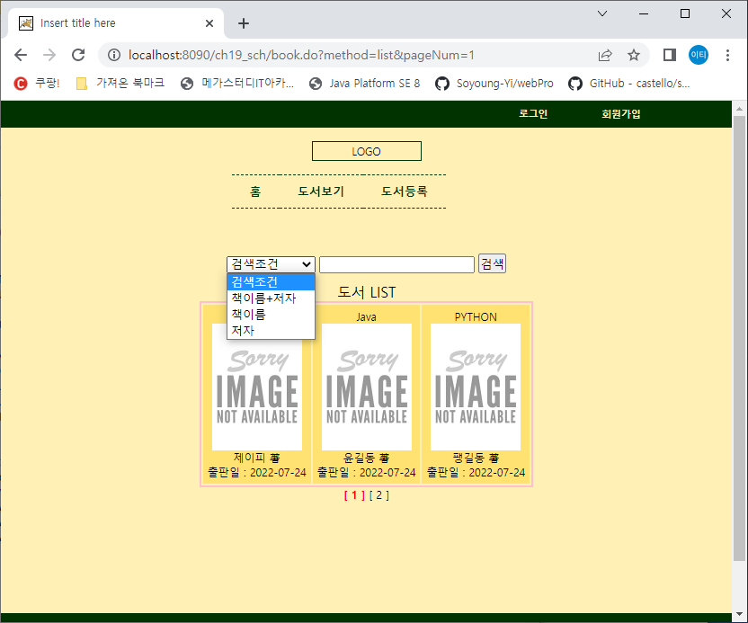

webapp/WEB-INF/views/book/list.jsp에 검색부분 form태그 추가

<%@ page language=*"java"* contentType=*"text/html; charset=UTF-8"*

pageEncoding=*"UTF-8"*%>

<%@taglib prefix=*"c"* uri=*"http://java.sun.com/jsp/jstl/core"*%>

<%@taglib prefix=*"fmt"* uri=*"http://java.sun.com/jsp/jstl/fmt"*%>

<c:set var=*"conPath"* value=*"*${pageContext.request.contextPath }*"*/>

<!DOCTYPE html PUBLIC "-//W3C//DTD HTML 4.01 Transitional//EN" "http://www.w3.org/TR/html4/loose.dtd">

<html>

<head>

<meta http-equiv=*"Content-Type"* content=*"text/html; charset=UTF-8"*>

<title>Insert title here</title>

<link href=*"*${conPath }*/css/style.css"* rel=*"stylesheet"*>

<style>

*#content* {

width: *800px*; height:*350px*;

margin: *50px auto*;

}

**img**{width: *100px*;}

**a** {text-decoration: *none*; color:*black*;}

**b** {color:*red*;}

</style>

</head>

<body>

<jsp:include page=*"../main/header.jsp"*/>

<div id=*"content"*>

**<div>**

**<form action=*"*${conPath }*/book.do"*>**

**<input type=*"hidden"* name=*"method"* value=*"list"*>**

**<select name=*"schItem"*>**

**<option value=*""***

**<c:if test="${param.schItem=='' }">selected="selected"</c:if>**

**>검색조건</option>**

**<option value=*"all"***

**<c:if test="${param.schItem=='all' }">selected="selected"</c:if>**

**>책이름+저자</option>**

**<option value=*"btitle"***

**<c:if test="${param.schItem=='btitle'}">selected="selected"</c:if>**

**>책이름</option>**

**<option value=*"bwriter"***

**<c:if test="${param.schItem=='bwriter'}">selected="selected"</c:if>**

**>저자</option>**

**</select>**

**<input type=*"text"* name=*"schWord"* value=*"*${param.schWord }*"*>**

**<input type=*"submit"* value=*"검색"*>**

**</form>**

**</div>**

<table>

<caption>도서 LIST</caption>

<tr>

<c:forEach var=*"book"* items=*"*${list }*"*>

<td>

${book.btitle }<br>

<a href=*"*${conPath }*/book.do?method=detail&bnum=*${book.bnum}*&pageNum=*${paging.currentPage}*"*>

<img src=*"*${conPath }*/bookImgFileUpload/*${book.bimg1}*"*></a><br>

${book.bwriter } 著 <br>

출판일 : ${book.brdate }

</td>

</c:forEach>

</tr>

</table>

<div>

<c:if test=*"*${paging.startPage>paging.blockSize}*"*>

[ <a href=*"*${conPath }*/book.do?method=list&pageNum=*${paging.startPage+1 }***&schItem=*${param.schItem }*&schWord=*${param.schWord}***"*>이전</a> ]

</c:if>

<c:forEach var=*"i"* begin=*"*${paging.startPage}*"* end=*"*${paging.endPage }*"*>

<c:if test=*"*${paging.currentPage==i }*"*>

<b>[ ${i } ]</b>

</c:if>

<c:if test=*"*${paging.currentPage != i }*"*>

[ <a href=*"*${conPath }*/book.do?method=list&pageNum=*${i }***&schItem=*${param.schItem }*&schWord=*${param.schWord}***"*>${i }</a> ]

</c:if>

</c:forEach>

<c:if test=*"*${paging.endPage<paging.pageCnt }*"*>

[ <a href=*"*${conPath }*/book.do?method=list&pageNum=*${paging.endPage+1 }***&schItem=*${param.schItem }*&schWord=*${param.schWord}***"*>다음</a> ]

</c:if>

</div>

</div>

<jsp:include page=*"../main/footer.jsp"*/>

</body>

</html>

**public** **class** Book {

**private** **int** bnum; // 책번호

**private** String btitle; // 책이름

**private** String bwriter;// 책저자

**private** Date brdate; // 출판일

**private** String bimg1; // 책이미지1 (첨부안하면 noimg.jpg로 할 예정)

**private** String bimg2; // 책이미지2 (첨부안하면 noimg.jpg로 할 예정)

**private** String binfo; // 책소개

**private** **int** startRow;

**private** **int** endRow;

**private** String schItem; // 검색하려고 선택된 항목 (책이름=btitle or 저자=bwriter)

**private** String schWord; // 검색할 단어

}

Book.xml

<!-- 책이름 가나다순으로 PAGING처리 -->

<select id=*"bookList"* parameterType=*"Book"* resultMap=*"BookResult"*>

<if test=*"schItem=='all'"*>

SELECT * FROM (SELECT ROWNUM RN, A.* FROM (SELECT * FROM BOOK where btitle like '%'||#{schWord}||'%' or bwriter like '%'||#{schWord}||'%' ORDER BY BTITLE) A)

WHERE RN BETWEEN #{startRow} AND #{endRow}

</if>

<if test=*"schItem=='btitle'"*>

SELECT * FROM (SELECT ROWNUM RN, A.*

FROM ( SELECT * FROM BOOK WHERE BTITLE LIKE '%'||#{schWord}||'%' order by btitle) A)

WHERE RN BETWEEN #{startRow} AND #{endRow}

</if>

<if test=*"schItem=='bwriter'"*>

SELECT * FROM (SELECT ROWNUM RN, A.*

FROM ( SELECT * FROM BOOK WHERE bwriter LIKE '%'||#{schWord}||'%' order by btitle) A)

WHERE RN BETWEEN #{startRow} AND #{endRow}

</if>

<if test=*"schItem=='' or schItem==null"*>

SELECT * FROM (SELECT ROWNUM RN, A.*

FROM ( SELECT * FROM BOOK order by btitle) A)

WHERE RN BETWEEN #{startRow} AND #{endRow}

</if>

</select>

<!-- 페이징 때 쓰려고 등록된 책 갯수-->

<select id=*"cntCntBook"* parameterType=*"Book"* resultType=*"int"*>

<if test=*"schItem=='all'"*>

SELECT COUNT(*) FROM BOOK WHERE BTITLE LIKE '%'||#{schWord, jdbcType = VARCHAR}||'%' or BWRITER LIKE '%'||#{schWord}||'%'

</if>

<if test=*"schItem=='btitle'"*>

SELECT COUNT(*) FROM BOOK WHERE BTITLE LIKE '%'||#{schWord}||'%'

</if>

<if test=*"schItem=='bwriter'"*>

SELECT COUNT(*) FROM BOOK WHERE BWRITER LIKE '%'||#{schWord}||'%'

</if>

<if test=*"schItem=='' or schItem==null"*>

SELECT COUNT(*) FROM BOOK

</if>

</select>

</mapper>

@Repository

**public** **class** BookDaoImpl **implements** BookDao{

@Autowired

**private** SqlSession sessionTemplate;

@Override

**public** List<Book> mainList() {

**return** sessionTemplate.selectList("mainList");

}

@Override

**public** List<Book> bookList(Book book) {

**return** sessionTemplate.selectList("bookList", book);

}

@Override

**public** Book getBook(**int** bnum) {

**return** sessionTemplate.selectOne("getBook", bnum);

}

@Override

**public** **int** registerBook(Book book) {

**return** sessionTemplate.insert("registerBook", book);

}

@Override

**public** **int** modifyBook(Book book) {

**return** sessionTemplate.update("modifyBook", book);

}

@Override

**public** **int** cntCntBook(Book book) {

**return** sessionTemplate.selectOne("cntBook", **book**);

}

}

@Controller

@RequestMapping(value="book")

**public** **class** BookController {

@Autowired

**private** BookService bookService;

@RequestMapping(params="method=list", method= {RequestMethod.***GET***, RequestMethod.***POST***})

**public** String list(String pageNum, Model model, Book book) {

model.addAttribute("bookList", bookService.bookList(pageNum, book));

model.addAttribute("paging", **new** Paging(bookService.totCntBook(book), pageNum, 3, 3));

**return** "book/list";

}

}

**public** **interface** BookService {

**public** List<Book> mainList();

**public** List<Book> bookList(String pageNum, **Book book**);

**public** **int** totCntBook(Book book);

**public** Book getDetailBook(**int** bnum);

**public** **int** registerBook(MultipartHttpServletRequest mRequest, Book book);

**public** **int** registerBook(MultipartHttpServletRequest mRequest); // 비추

**public** **int** modifyBook(MultipartHttpServletRequest mRequest, Book book);

//public int modifyBook(MultipartHttpServletRequest mRequest);

}

@Service

**public** **class** BookServiceImpl **implements** BookService {

@Autowired

**private** BookDao bookDao;

@Override

**public** List<Book> bookList(String pageNum, **Book book**) {

Paging paging = **new** Paging(bookDao.totCntBook(book), pageNum, 3, 3);

book.setStartRow(paging.getStartRow());

book.setEndRow(paging.getEndRow());

**return** bookDao.bookList(book);

}

}