

|  |
| --- |
| **Group X: Hanxin Fan, ABC**  **11-18-2020**  **BUS 510 MANAGEMENT OF INFORMATION TECHNOLOGY**  **By Dr. CBA** |

|  |
| --- |
| **University of La Verne** |
| **Digital Transformation Analysis Report** |
| **Delta Air Lines** |

# **Table of Contents**

**Abstract 2**

**Keywords 2**

**Part I Problem/Opportunity 2**

1.1 History 3

1.2 Industry Overview and Market Structure 3

1.3 Threats to the Delta Air Lines 3

**Part II Goals 3**

2.1 Reduce Fixed and Variable Costs 4

2.2 Increase Revenue 4

2.3 Improve the Loyalty Rate and Customer Satisfaction 5

**Part III Objectives 5**

3.1 Predictive Maintenance 6

3.2 Optimize Flight Utilization 7

3.3 Cross-Industry Marketing 7

3.4 Increase the Comfort of the Seat 8

3.5 Use Some Effective Statistical tools to Track Customer Groups 9

3.6 Onboarding and Employee Training to Improve Standardized Management 10

**Part IV Success Criteria 12**

4.1 Financial Competitiveness 12

4.2 Operational Competitiveness 12

**Part V Assumptions, Risks and Obstacles 12**

5.1 System Security Risk 12

5.2 Information Security Risk 13

5.3 Economic Property Security Risk 13

**Part VI Conclusion 13**

**Reference 15**

# **Abstract**

Ever since the concept of digital transformation was proposed, the aviation industry has been looking for the right way to turn it on. This paper mainly analyzes the current threat of Delta Airlines and uses digital to find a way to help Delta weather the storm. Digitization will not only reduce Delta's operating costs but also increase its profits and customer loyalty. Then through the predictive maintenance, optimization of flight utilization, cross-industry marketing, and a series of practical applications of digitization, to illustrate that digitalization is the necessary trend of Delta Air Lines. Also, we test the results of digital applications from the two dimensions of financial competitiveness and operational competitiveness. Finally, it analyzes the possible risks of digitization and provides development suggestions for Delta Air Lines.

*Keywords: Airlines, Digital Transformation, Delta, Digitization, IT***Digital Transformation Analysis Report: Delta Air Lines**

**Part I. Problem/Opportunity**

**1.1 History**

Delta Air Lines founded in 1928 as Delta Air Service. It merged with Northwest Airlines in 2008 to form Delta Air Lines. Delta is the second-largest airline in the United States, headquartered in Atlanta, with nearly 700 aircraft and more than 75,000 employees worldwide. Today, Delta serves more than 13,000 passengers per day and operates delta hubs at many airports around the world.

**1.2 Industry Overview and Market Structure**

Aviation resources are expensive and highly affected by the economic environment, so the aviation market is a market with high entry barriers, high operating costs, and high market risks. Meanwhile, the airline industry's profit margins are low. Across the development of the world's aviation, there is a cyclical adjustment almost every decade. The U.S. airline industry has enjoyed strong earnings in the past decade as a result of massive mergers.

As a result of mergers and acquisitions among large airlines, the market concentration is increasingly high, and CR4(Delta, UA, AA, and SA) in the U.S. has exceeded 65%. It has a very large oligopoly advantage. There are obvious barriers to entry in the oligopoly market, which is also a necessary condition for a few enterprises to occupy the majority market share. Large companies continue to grow, small companies cannot survive, and eventually a small number of enterprises to form the situation of fierce competition.

**1.3 Threats to the Delta Air Lines**

In many countries, the speed advantage of air travel has been greatly diminished by government-funded high-speed rail.Besides, many companies are now using online meetings instead of meeting in person. Airlines often pay more attention to direct operational challenges, but they cannot fully differentiate their products and services to meet the specific needs of diverse customers. In oligopolistic markets, focusing on direct operational challenges is not a good strategy for Delta. This strategy will simply not be sustainable if the threat of alternative travel continues to rise, or if competitors start to offer truly differentiated, attractive, and targeted service-based products. The cornerstone of any defensive strategy to guide the industry through a period of economic uncertainty must be a focus on maintaining the law of cost -- a fundamental step that must be taken before any change plan can be pushed through.

As travelers gain a better experience through other transportation, their expectations of what airlines can offer and how they can deliver will grow higher. Failure to meet those expectations will cause airlines to lose potential customers and make them more willing to use other transportation. Besides, airlines have seen customer satisfaction decline despite their efforts to improve the customer experience over the years. In fact, the airline industry consistently scores the lowest in customer satisfaction surveys in the United States. Airlines were the first to introduce loyalty programs, but the inability of many airlines to redeem frequent flier points has been a real cause of declining customer satisfaction. Clearly, these programs are designed to foster brand loyalty, not to drive customers away.

**Part II. Goals**

Almost all of the innovations in business models, from the low-cost operations of the U.S. airlines to the marketing revolution of the European airlines, are based on digitization. Digitization will help Delta Air Lines create real value in three ways. First, digitization can help Delta reduce their fixed and variable costs. It will reduce the cost of front and back office by 8 to 10 percent. Secondly, digitization could help Delta increase revenue. Digital transformation could boost Delta's revenue by 5 to 10 percent. For airlines, an industry with a low Return of Equity. 5 to 10 percent is a very attractive number. Thirdly, digitization can improve the overall customer experience and customer satisfaction. For airlines, customers are very important to serve. It is very important to improve the customer service experience. The digitization could boost Delta's net recommendation by 5 to 10 percent.

**2.1 Reduce Fixed and Variable Costs**

Cost management must be related to customer experience. If the company focuses on reducing costs, it will inevitably lead to the decline of customer experience; therefore, the cost reduction should start from the expectation management.

From an operational point of view, better data applications enable airlines to have more accurate forecasts for maintenance, replacement of parts, and so on. Therefore, engineers can anticipate and take early action, including when flight lights appear, and which parts need to be replaced.

From a cost management perspective, in terms of passenger processes, work should be done around getting through the mismatched nodes between these processes. For example, when a company launches a new product, the development, sales, and operation processes are relatively close to each other. Digitization can completely break through all the barriers between those processes and form the concept of integrated delivery.

Delta is outfitting most of its employees with phablets that make data about airline operations and passenger portraits available to front-line personnel on a digital platform. This allows them to feedback to each other as quickly as possible.

**2.2 Increase Revenue**

Intercity flight density is very high, but many business travelers change their travel decisions at the last minute, and they are willing to pay a higher premium for the change. The digital application could help Delta Air Lines identify which flights or customers are most likely to be in this situation. Airlines always encounter several problems. How many high-value customers are on this flight? How do managers pass on these opportunities to passengers willing to pay a premium so that overall revenues rise? As Delta go digital, it gains more customer insights and grow revenue. Moreover, digitization can further optimize the revenue management of high-utilization flights.

From the statistical data, there is a gap of 2 to 4 times between the income of companies with good ancillary revenue and those with average ancillary revenue. There are three factors that have a particularly strong impact on ancillary revenue. The first is customer loyalty programs. For example, selling miles to third parties. Secondly, the flexibility of tickets. For example, cancellation fee and change fee. The last one is the upgrade fee. Digitization will help Delta increase ancillary revenue across the board.

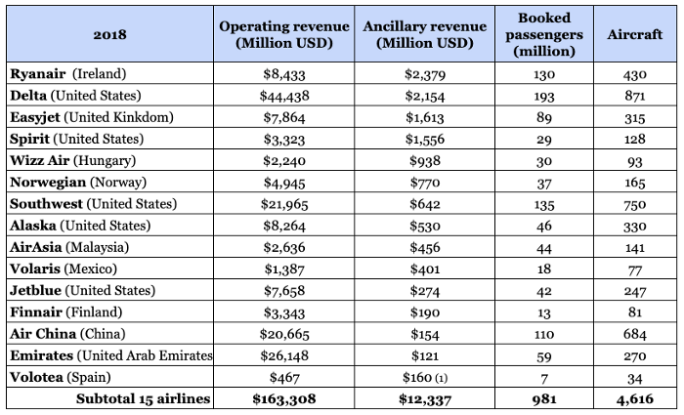

**2.3 Improve the Loyalty Rate and Customer Satisfaction**

The biggest pain point for airlines' customers is the condition of irregular flights. In the case of abnormal flight conditions, digital can be a good way to help customers make predictions. For example, when passengers are still an hour away from the airport due to traffic jams, Airlines can push them in advance and even recommend some plans. This can help customers relieve their nervous, angry feelings.

When it comes to solving customer experience problems digitally, there's a keyword called the whole journey concept. This is very important for airlines, but most airlines rarely take a whole journey perspective. There are a lot of touchpoints in a traveler's journey from exploring the future, to searching for flights, to departure, to airport, to plane, to the end of the journey. Delta should start from this aspect, improve customer experience and customer satisfaction to expand its competitive advantage.

**Part III. Objectives**

**3.1 Predictive Maintenance**

Faced with the changes in customer demand, the first thing airlines need to do is to reduce their costs. This will ensure that the ticket price can remain stable while developing new products. Predictive maintenance can significantly reduce the cost of maintenance, which accounts for 13 percent of all aircraft operating costs.

A large amount of data will be generated in the whole life cycle of aircraft from design birth to operation and maintenance, especially in the new generation of aircraft. Certainly, even the collection and utilization of data generated by critical systems of older aircraft and engines can drive maintenance programs forward. All kinds of manufacturers and data operators are working on data acquisition, machine learning, model analysis, and sensors to enrich their predictive maintenance systems and achieve better health monitoring. Airline has accumulated a lot of data over the years, but it has not been organically linked to form a model to connect all the nodes. From pilot reports to maintenance logs to Aircraft Communications Addressing and Reporting Systems (ACARS) is often distributed over networks in isolation. Now a new idea is to string all the data together and capture the model through algorithm-based analysis and machine learning. Although there is a lot of work to be done, digitization can enhance aircraft availability, reduce turnaround time, reduce maintenance delays and save operating costs.

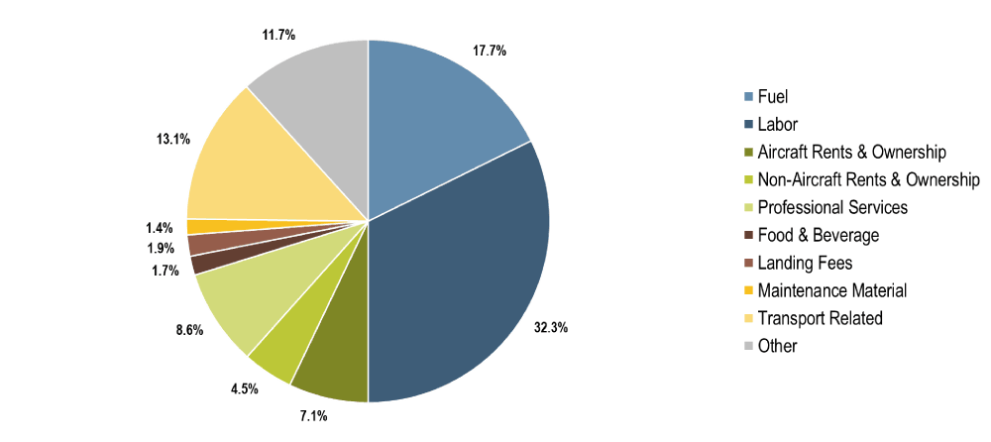

As well as working with the original manufacturer to develop analytical tools, Delta currently has a team of 18 people monitoring different data sources to predict when parts are close to failure, from the old Boeing 757 to the latest Airbus A350. Delta indicates that each component or system has distinctive features, whether electrical features such as current resistance or other features such as operating frequency. Delta technology also adds electrical, mechanical, or acoustic sensors to some parts to help monitor. Over the past two years, Delta Technology has prevented 3,000 flight cancellations or delays through these efforts. More importantly, the test results showed that the accuracy of failure prediction has reached 95 percent. This shows that Delta does not change parts for no reason, reducing maintenance costs.

Delta is currently integrating airbus's Skywise platform into its daily operations, tracking and analyzing operational and performance data for its Airbus A320 and A330 fleet, and seeking joint ventures or partnerships with Airbus and Boeing. In a word, the comprehensive application of new aircraft needs to be supported by data analysis, and the old aircraft also need to be constantly updated data service, so that Delta can make better use of maintenance data. Delta believes that in the next 10 years, airframe and structural repairs will still take a lot of time, but components and systems will be largely converted to on-condition repairs due to anticipated repairs, which will significantly reduce the cost of both money and time.

Not only will predictive maintenance significantly reduce maintenance costs, but it will also help Delta operate more efficiently. With the predictive maintenance system, managers can decide whether to wait for the aircraft to be serviced or to use a standby aircraft. This will help reduce flight delays and improve the customer experience.

**3.2 Optimize Flight Utilization**

Moving flexible passengers with lower returns between flights can unlock new revenue opportunities, and digitization can help identify appropriate opportunities while optimizing costs. In general, there are three stages in identifying opportunities with data and reasonably mobilizing customers. The first stage is to identify opportunity flights. Let's say now Delta has two flights to the same destination, flight A leaving at 8 a.m. and flight B leaving at midnight Then the system will analyze the two flights based on the statistical model and conclude that the best opportunity flight is Flight A. This is because flight A is fully booked and flight B has some seats left. Then it is the second stage, which is to identify potential customers and solutions. Assumes that 10 people suddenly decide to take Flight A, and they are willing to pay the high full price. The system then analyzes the number of passengers currently on board to estimate the cost of relocating passengers and determine how many seats will eventually be released. The system found that some passengers had already booked discounted tickets in advance, so shifting those customers to Flight B would boost Flight A's revenue. Not only that, the system will use the user's historical flight data to determine which customers are more likely to be adjusted. Once the customers have been identified, the system can contact customers automatically by text or email and offer incentives such as upgrades and coupons to get them to accept adjustments. The third stage is customer decision. The customer can choose to rebook or choose a new trip, and the reward will be given to the customer electronically.

Digital adjustment can not only improve the revenue of high-utilization flights but also optimize the cost of flights. By shifting full-fare customers to flights that are fully booked, it also shifts those who accept the change to flights that with low attendance. Whether it's an emergency reservation or an adjustment, customers get what they need in the process, which further improves the customer experience. This was very difficult to achieve in the past because there were so many departments and procedures involved, and it required a lot of time. And now the revenue from high-utilization flights has been further boosted by digitization.

**3.3 Cross-Industry Marketing**

From the perspective of the global aviation industry, the leading airlines are trying to adopt different strategies to meet the challenge of substitution and commoditization. Through the adoption of digitalization, open cooperation with pan-tourism and even cross-industry partners by taking advantage of its unique advantages and even providing customers with more personalized and flexible services in addition to a single ticket is a key factor to improve the market position. One possible response to the threat of substitution and commoditization would be greater trip integration between Delta and other travel service providers. By adopting this strategy, Delta will work more closely with other industries, such as hotels, airports, and public transport providers, to provide a more integrated travel experience for customers.

In order to increase profits, airlines may reduce their operating costs, but doing so will not create new revenue opportunities and will not change the business model. Costs cannot be reduced indefinitely, and airlines must develop new revenue sources that can generate higher profits. The profit structure of the tourism ecosystem shows that airlines make the least profit compared to other players in the ecosystem, while travel agents make the most net profit. Customers tend to spend more on travel services because they value more personalized travel advice and one-to-one user experience rather than just the transport company that gets them from point A to point B. If Delta wants to develop more revenue opportunities and increase their profits, they need to explore and expand services across the industry to increase their share of passenger spending. Digital gives them that opportunity.

With the rise of the Internet, service providers have found a whole new way of communicating with their customers. They can communicate directly with customers through the intermediate links. As customers gain more control through digital devices, their behavior is changing as never before. Today's travelers have more options than ever before on their entire journey, as customers have direct access to many professional service providers via their smartphone. They offer tailor-made products that will cater to the needs of different customers, and this is the perfect time for Delta to launch data marketing. Big data can connect the whole journey of customers, conduct labeling processing of consumer behavior and user portrait analysis. The big data of Delta is not limited to the simple use of promotion, customer maintenance, and product notification. Instead, it aims to achieve the accuracy, personalization, and relevance of corresponding advertising products through the analysis of a large amount of behavioral data on the Internet, and it improves customer experience. Through the mining of customer demand, Delta can deliver the products of cooperative service providers to target customers more precisely and receive commissions. In addition, Delta can also provide new flights through the customer data of its partner service providers. They can also collect food reviews to select the right catering company and offer a more diverse menu. This will not only increase the revenue but also improve the customer experience. Only in this way, Delta can build product and service differentiation and gain a competitive advantage.

**3.4 Increase the Comfort of the Seat**

Aircraft cockpits with folding seats can be equipped with seat backs and backrests. The cockpit includes control and observation devices to increase comfort. The folding seat is installed in the corridor so that it can pivot and be in the first position, in which it can close the corridor to form a locking cover with the access door, and the folded second position can be accessed from the corridor at least a seat. According to the article “Passenger-centric factors influencing the experience of aircraft comfort” from Wilson Online library, more and more large airlines are increasingly aware of the significance of comfort in fascinating and keeping customers. According to the article “Passenger-centric factors influencing the influence from University of La Verene’s online website, People have different understandings of comfort in daily life. There are many disputes about the exact definition and understanding of its components and their relationship with discomfort. Fundamentally speaking, comfort refers to meeting people's needs. It is the ideal result or best state in a given environment. Everyone has different needs, and their comfort experience is subjective, influenced by internal or personal factors, and external stimulation. (Vink & Hallbeck, p.271) The manufacturers of Airlines and aircraft are also growingly researching ways to personalized customization for passenger experience. For example, the concept of carbon is separated from different activity areas like entertainment, leisure, and work areas to meet specific needs based on different activity areas. Meanwhile, nerve sensors and fiber optic blankets are used to weigh the mental state of passengers during the whole flight. Improving cabin service for every single passenger’s blanket will show different colors based on the individual’s degree of relaxation to make a suitable response (cabin design, interior, etc.) There are psychosocial interventions to improve comfort such as playing videos or signs throughout the air transportation system to assist a general passenger code of conduct to improve service delivery and passenger comfort. (Chang & Yeh, [26]) By improving the comfort of airplane seats, Delta can better improve customer experience and customer loyalty.

**3.5 Use some Effective Statistical Tools to Track Customer Groups**

Nowadays, the majority of companies use different statistical tools to track target customer groups in order to earn more profits, of course, including almost airline companies such as Delta, Southwest Airlines, American Airlines, etc. (www.qualtrics.com)

* **Benchmarking**
* Benchmarketing is a standardized approach to fair competition to make your data and results meaningful in context. It involves considering external factors so that you can adjust the research parameters and get a more accurate understanding of what is going on right now. Benchmarking techniques use weighting to adjust for variables that have an impact on seasonal changes and ticket sales. For example, during the peak travel season or major diseases. For example, during the impact of the COVID-19 pandemic, passenger flow has been imperceptibly affected due to airline control, private ticket vendors. Therefore, with the aid of benchmarking, any abnormalities that may occur can be adjusted.
* **T-test**
* T-test is a tool used to compare two data sets with different means. For example, is the number ratio of men and women differ in the economic level of the family? The T-test allows the user to explain whether the difference is statistically significant or just accidental. The result of the T-test is expressed as a probability (p-value). If the p-value is below a certain threshold (usually 0.05), then you can be very confident that the two groups are indeed different, and this is not just an accidental change between sample data. Sometimes, the calculation of the P-value will also be reduced. Compared with the previous drop in the direct cost of Delta Airlines, it can more reflect the efficiency of digitalization.
* **Analysis of variance (ANOVA) test**
* Like the T-test, ANOVA (analysis of variance) is a way of testing the differences between groups to see if they’re statistically significant. However, ANOVA allows you to compare three or more groups rather than just two such as men and female’s income level, family education background, working condition, and so on.
* **Cluster Analysis**
* Cluster analysis is a method of processing data sets by identifying the degree of correlation between individual data points. Under cluster analysis, you can determine whether there are defined groups (clusters) in a certain data pool, or whether the data is fairly evenly distributed.

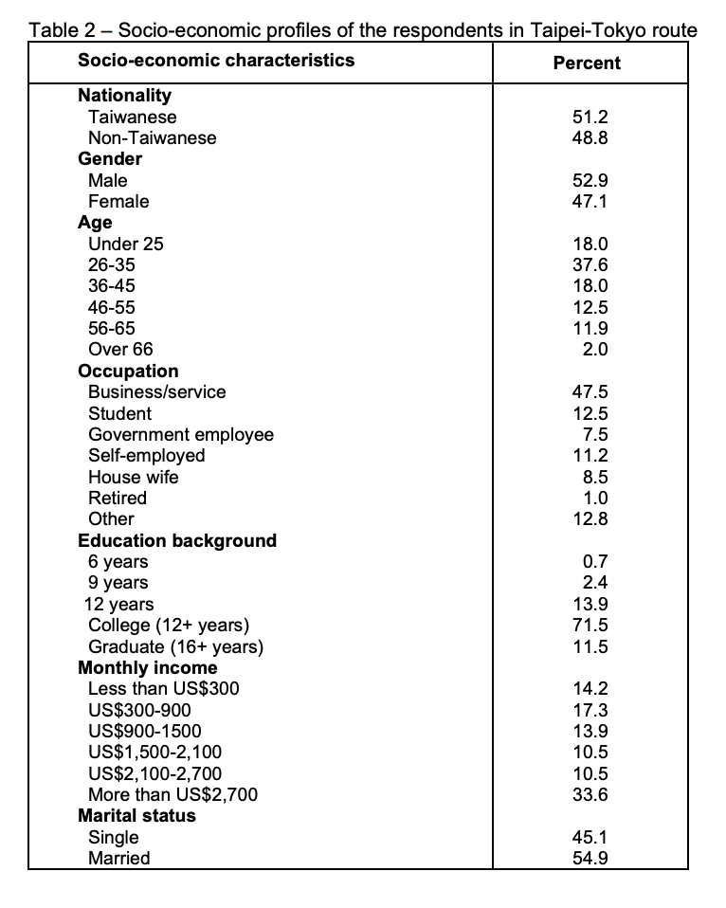

(Myers, J.H. and G.M. Muller,2003)

The new analytics provide delta with a new way to analyze unstructured data, and we will see more analytics applications in the aviation industry in the coming days.

**3.6 Onboarding and Employee Training to Improve Standardized Management**

Nowadays, the awareness of airline business management is weak. The relevant persons in charge of airlines have insufficient understanding of the importance of corporate management. These persons in charge simply value the improvement of airlines' economic efficiency but do not realize the importance of strengthening airline management. When formulating production and development strategies, the planning of airline management is often neglected; secondly, airline staff has weak corporate management awareness. They simply believe that corporate management is optional. They seldom pay attention to corporate management in the process of work and ignore the important role of corporate management. This will result in low economic benefits for aviation companies, which is not conducive to aviation. The development of technology can indeed enhance employee management. (Chreene, L.,2020)

* **Flight Training- Without the Simulators**
* The majority of pilots training who use aviation simulators are a detailed, piece of equipment built to look and feel as much like the real thing as possible. Virtual reality is beginning to offer an alternative to physical flight simulators. A French technology company called Go Touch VR is developing virtual flight simulators that use sensors on the fingertips to give trainees the feeling of touching the controls on the instrument panel. For example, Japan Airlines is using Microsoft’s HoloLens, a mixed reality application to train flight crew as co-pilots. HoloLens gives those trainees detailed hologram displaying the cockpit instrument panel with visual and voice guidance provided through HoloLens.
* **Renewal Training**
* Pilots must complete several hours of training and evaluation each year to obtain a permit. Flight attendants must also update their training every year. In most cases, this means that pilots will go to a training center for courses, while flight attendants must return to the academy for a one or two-day refresher course. Keeping track of renewal requirements and remaining employees when it is time for training is also significant. In this way, this continuous and regular training of airline employees, can not only increase Delta's passenger flow and attendance but also bring greater profits to Delta's future development.
* **Customer Experience**
* Customer experience is one of the most important factors in all industries, but on airplanes — where customers are seated together for hours on end, sometimes in stressful situations — customer experience is paramount. And when situations are handled badly, footage of incidents often go viral. Training is a good way to ensure those incidents don’t happen. Delta Airlines, for example, recently responded to an incident in which a passenger was forcibly removed from a plane by rolling out “compassion training.” Also, Delta Airlines has launched de-escalation training last year after a confrontation between a passenger and a flight attendant was posted online. Meanwhile, United Airlines has also launched a module in concert with the Special Olympics to train airline crews on how best to serve passengers with intellectual disabilities.
* **Airlines and the Remote Workforce**
* Training remote workers is a new problem in many industries, but not for business. It has employed remote mobile hydraulics for nearly a century, and it took decades to figure out how to deal with sudden changes or new regulations. Training and communication with these workers during training are necessary. Interestingly, according to a conversation I had with a senior airline pilot, airlines used to use a three-ring binder filled with memos to meet this challenge. Workers had to initial each page to prove they had read the information. That was in the 1980s. In the 90s, email took over. Now airlines use apps and internal social networks to communicate vital information to remote employees.
* **Spotting Crime**
* The United Nations’ aviation agency, for example, is proposing mandatory training for personnel to recognize the signs of human trafficking. In order to combat international trafficking in wildlife, this crime often uses airlines to transport wildlife or other contraband ivory. Therefore, a new online plan was announced by Delta Airlines in February 2020. The company said that the new plan "targets those roles in airlines that are most likely to take place in illegal activities" and will help employees understand smugglers' routes, methods, and how to report and respond to illegal activities.

**Part IV Success Criteria**

Competitiveness is the most basic survivability of airlines in the competitive allocation of market resources, as well as the basic operation ability of airlines. The composition of competitiveness has many factors, but not every factor can become the dominant competitiveness. Among them, financial competitiveness and operational competitiveness are closely related to digitalization. The competitiveness number is a good reflection of the impact of digitization on Delta's costs, profits, and customer satisfaction.

**4.1 Financial Competitiveness**

Operating profit, net profit, operating margin, net profit margin, and total revenue are commonly used indicators to reflect a company's financial competitiveness. Passenger revenue of main routes is the performance of financial competitiveness of airlines, and it is an important indicator to reflect whether airlines are in an advantageous position in competition. Delta's profits should improve through a range of digital applications and those improvements should ultimately increase Delta's financial competitiveness. By examining the rankings of Delta's financial competitiveness, it could show whether the digital revolution at Delta has been successful.

**4.2 Operational Competitiveness**

Occupation Rate of Flight Guest Seats is an important indicator to reflect the capacity utilization rate of an airline company. If this index is high, it means that the airline company has fully explored its operation ability, indicating its strong competitiveness in the market. Through cross-industry marketing and optimizing flight utilization will ultimately affect Delta's operational competitiveness. By examining the rankings of Delta's operational competitiveness, it could show whether the digital revolution at Delta has been successful.

**Part V Assumptions, Risks and Obstacles**

Airlines use digital transformation to seek new development, but they are also introducing many security risks brought by digital. The digital transformation of airlines requires a lot of Information Technology construction. In addition to the necessary infrastructure and application systems, airlines are facing a lot of risks in terms of IT-related security. It is a worrying challenge for airline management to manage these risks. Specifically speaking mainly is system security risk, information security risk, and economic property security risk. Delta needs to carefully identify all these risks, develop risk control plans one by one, and develop treatment plans for each risk point.

**5.1 System Security Risk**

In recent years, there have been many incidents in which airlines have been unable to operate due to IT failures. On August 8, 2016, Delta Airlines' entire computer system crashed, including its departure system, grounding 2,000 flights. By September, Delta was claiming $150 million in losses as a direct result of the computer system failure.

With the continuous progress of the digital transformation of airlines, the paperless strategy has been gradually implemented, and airline operations are increasingly dependent on IT systems. No matter network, server, or application system failure will cause the corresponding airline business to stop, thus bringing huge losses.

Also, as airlines are not specialized in IT, their IT capabilities often rely on outsourcing, which also leads to a lot of potential risks. For example, when an outsourcing provider fails to operate properly or changes its business focus, the information system will lose its maintenance. For some airlines with their own data centers, there may be problems due to inadequate security technology capabilities, such as the ransomware virus that has plagued many companies in recent years, including some airlines.

**5.2 Information Security Risk**

Recently, there have been some large information leakage cases of airlines. In September 2018, British Airways parent International Aviation Group announced that hundreds of thousands of customers who booked BA's tickets via the Internet had had their financial data stolen in recent weeks. The British Airways data breach occurred between August 21 and September 5, around 380,000 bank card payments were hacked.

In the process of digital transformation of airlines, a large number of information systems will be built quickly due to the need to give priority to meet the needs of business transformation. Due to the lack of unified security architecture design and security standard management, there are many information security vulnerabilities. In terms of information security, IT departments of airlines generally lack their professionals but need the support of professional suppliers, including the support of protection systems and professional technical personnel.

**5.3 Economic Property Security Risk**

During the COVID-19 Pandemic, global aviation companies like Delta have regarded supply chain management as the second biggest threat to the aviation industry in 2019 and beyond. The recorded delivery of new aircraft will make the supply chain extremely busy in the next 8-10 years. To meet demand, the entire supply chain must improve investment to make sure timely delivery while maintaining high quality and controlling costs. A difficult task may leave many suppliers in a financially vulnerable state. At the same time, the demand for the A&D department is growing significantly. The increase in demand has increased the pressure on the production capacity of Original Equipment Manufacturers (OEMs) and their suppliers. For critical parts and components, the number of available suppliers is small. For such parts, there is a greater risk of production interruption due to supply failures, said Bill Colbert (Bill Colbert), an American consulting partner at Ernst & Young. According to Ernst & Young, as far as the civil aviation industry is concerned, political stability and sustained economic growth are the main potential factors driving the long-term growth of air traffic because of the US-China trade dispute is causing instability in global markets, and economies are beginning to show signs of a potential slowdown, including China. The world’s largest economy, which recently lowered its GDP growth target. (blog.satair.com) Of course, everything is like a coin that has two sides, appropriate investment in Delta Airline’s stocks and sells it a timely can also bring significant benefits to the entire company.

**Part VI Conclusion**

With the covid-19 outbreak, airlines around the world are starting to re-examine the support of informatization for their business. The digital transformation of aviation enterprises is of great significance in terms of commercial emergency response. On the other hand, covid-19 is also accelerating the process of digital transformation of aviation enterprises. When the hard times are over, the airline industry's recovery will accelerate, and its practitioners will be hoping for a recovery. After the outbreak subsides, the airline industry will face a relatively big rebound. In the face of such a trend, passenger flow will rise again. Airlines can make intelligent adjustments from flight recovery, crew scheduling, and network optimization through digital solutions, and establish relatively reasonable resource allocation, to ensure the highest efficiency and cost optimization of aviation operation. At the same time, based on the analysis and prediction of market demand, airlines need digital tools to judge the future market and optimize the transport capacity structure to achieve revenue protection. The impact of covid-19 has completely broken the existing global economic pattern, changing the supply structure and cost structure. Therefore, the digital transformation of airlines is no longer an option, the emergence of digital airlines is also an inevitable result.

# **References**

Becker, G., Bouwer, J., John, D., & Toutaoui, J. (2020, November 05). Walk before you fly--capturing the digital opportunity in airlines. Retrieved November 18, 2020, from https://www.mckinsey.com/industries/travel-logistics-and-transport-infrastructure/our-insights/walk-before-you-fly-capturing-the-digital-opportunity-in-airlines

Bouwer, J., Esque, A., & Riedel, R. (2020, November 05). Leading from the front line: How airlines can boost ancillary revenues. Retrieved November 18, 2020, from <https://www.mckinsey.com/industries/travel-logistics-and-transport-infrastructure/our-insights/leading-from-the-front-line-how-airlines-can-boost-ancillary-revenues>

Chang, Y.-H., & Yeh, C.H. (2002). A survey analysis of service quality for domestic airlines. European Journal of Operational Research doi: 10.1016/S0377-2217(01)00148-5

Chreene, L. (2020, September). An Onboarding Makeover to Match a Hiring Boom: A rapid increase in district managers at Securitas necessitated a program revamp, which is showing early promise. TD Magazine, 74(9), 21+. https://link.gale.com/apps/doc/A635546264/PROF?u=ulv_gvrl&sid=PROF&xid=3cd180b9

Delta Air Lines. (2020, November 15). Retrieved November 18, 2020, from <https://en.wikipedia.org/wiki/Delta_Air_Lines>

Hannigan, T., Hamilton, R., & Mudambi, R. (2015, March). (PDF) Competition and competitiveness in the US airline industry. Retrieved November 18, 2020, from https://www.researchgate.net/publication/276927107_Competition_and_competitiveness_in_the_US_airline_industry

Low, T. (2020, August 07). COVID-19: Strategizing airport operations for the new norm: ACI World Blog. Retrieved November 18, 2020, from https://blog.aci.aero/covid-19-strategizing-airport-operations-for-the-new-norm/

Mazareanu, E. (2020, October 19). U.S. airline industry market share 2019. Retrieved November 18, 2020, from <https://www.statista.com/statistics/250577/domestic-market-share-of-leading-us-airlines/>

Murphy, R. (2019, September 06). The Cybersecurity Risks Within the Aviation Industry. Retrieved November 18, 2020, from <https://www.blackstratus.com/risks-of-cybersecurity-within-aviation/>

Myers, J. H. and G. M. Mullet (2003). Managerial Applications of Multivariate Analysis in Marketing, American Marketing Association, Chicago.

Safaei, N. (n.d.). Fleet Utilization Optimization - Aircraft IT. Retrieved November 18, 2020, from https://www.aircraftit.com/articles/fleet-utilization-optimization/

Torres, C. (2018, June 17). Digitalization of Predictive Maintenance. Retrieved November 18, 2020, from <https://power-mi.com/content/digitalization-predictive-maintenance>

Vink, P.,& Hallbeck, S. (2012). Editorial: Comfort and discomfort studies demonstrate the need for a new model. Applied Ergonomics, 43, 271- 276. doi: 10. 1016/j. apergo.2011.06.001

Wright, G., Robinson, D., & Commentator, E. (2016, December 01). Digital Marketing in the Airline industry. Retrieved November 18, 2020, from <https://www.smartinsights.com/b2b-digital-marketing/b2b-strategy/digital-marketing-in-the-airline-industry/>