**AlexNet应用于cifar数据集实验报告**

15331416 赵寒旭

**目录**

**1. 修改的AlexNet结构** 2

1）AlexNet详细结构 2

2）参数初始化 2

3）测试及网络参数调整 3

（1）增强数据集 3

（2）修改学习率 3

4）结果对比展示 3

（1）无数据增强，无学习率调整 3

（2）无数据增强，有学习率调整 4

（3）有数据增强，无学习率调整 6

（4）有数据增强，有学习率调整 7

**2. 全连接层结构调整** 9

1）AlexNet详细结构 9

2）参数初始化 9

3）测试及网络参数调整 9

（1）增强数据集 9

（2）修改学习率 10

4）结果对比展示 10

（1）无数据增强，无学习率调整 10

（2）无数据增强，有学习率调整 11

（3）有数据增强，无学习率调整 12

（4）有数据增强，有学习率调整 14

**1. 修改的AlexNet结构**

1）AlexNet详细结构

|  |  |  |  |  |  |
| --- | --- | --- | --- | --- | --- |
| Modified AlexNet for Cifar(3FC) | | | | | |
| input | 32*32*3 | | | | |
| layer1 | Conv2d | kernel | channel | padding | stride |
| 11*11*3 | 64 | 5 | 4 |
| Relu | inplace=True | | | |
| MaxPool2d | kernel_size | | stride | |
| 2*2 | | 2 | |
| layer2 | Conv2d | kernel | channel | padding | stride |
| 5*5*64 | 192 | 2 | default |
| Relu | inplace=True | | | |
| MaxPool2d | kernel_size | | stride | |
| 2*2 | | 2 | |
| layer3 | Conv2d | kernel | channel | padding | stride |
| 3*3*192 | 384 | 1 | default |
| Relu | inplace=True | | | |
| layer4 | Conv2d | kernel | channel | padding | stride |
| 3*3*384 | 256 | 1 | default |
| Relu | inplace=True | | | |
| layer5 | Conv2d | kernel | channel | padding | stride |
| 3*3*256 | 256 | 1 | default |
| Relu | inplace=True | | | |
| MaxPool2d | kernel_size | | stride | |
| 2*2 | | 2 | |
| fully-connected | Dropout | | | | |
| Linear | 256->4096 | | | |
| Relu | inplace=True | | | |
| Dropout | | | | |
| Linear | 4096->4096 | | | |
| Relu | inplace=True | | | |
| Linear | 4096->10 | | | |

2）参数初始化

learning_rate = 0.1

momentum = 0.9

weight_decay = 0.0005

损失函数使用交叉熵，训练过程使用带动量的随机梯度下降法。

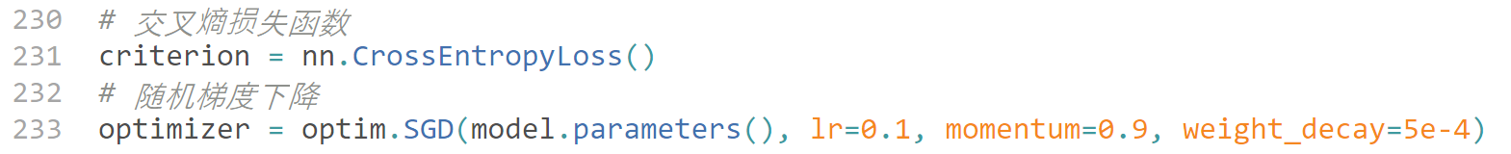

3）测试及网络参数调整

（1）增强数据集

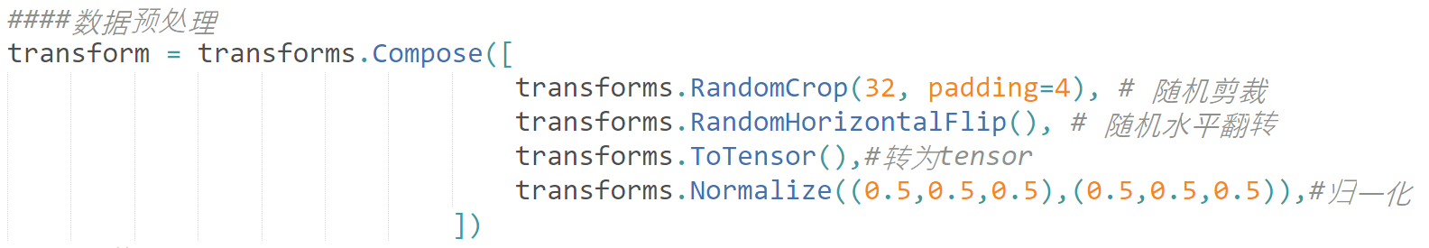

（2）修改学习率

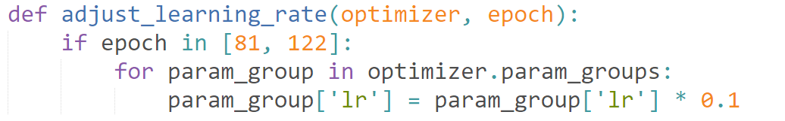

4）结果对比展示

（1）无数据增强，无学习率调整

|  |  |  |
| --- | --- | --- |
| Best Accuracy | | |
| train | Top-1 | 79.48 |
| Top-5 | 98.044 |
| test | Top-1 | 67.65 |
| Top-5 | 96.01 |

（2）无数据增强，有学习率调整

|  |  |  |
| --- | --- | --- |
| Best Accuracy | | |
| train | Top-1 | 100 |
| Top-5 | 100 |
| test | Top-1 | 72.17 |
| Top-5 | 96.46 |

（3）有数据增强，无学习率调整

|  |  |  |
| --- | --- | --- |
| Best Accuracy | | |
| train | Top-1 | 64.344 |
| Top-5 | 95.28 |
| test | Top-1 | 65.25 |
| Top-5 | 95.73 |

（4）有数据增强，有学习率调整

|  |  |  |
| --- | --- | --- |
| Best Accuracy | | |
| train | Top-1 | 92.35 |
| Top-5 | 99.904 |
| test | Top-1 | 77.61 |
| Top-5 | 98.43 |

**2. 全连接层结构调整**

1）AlexNet详细结构

|  |  |  |  |  |  |
| --- | --- | --- | --- | --- | --- |
| Modified AlexNet for Cifar(1FC) | | | | | |
| input | 32*32*3 | | | | |
| layer1 | Conv2d | kernel | channel | padding | stride | |
| 11*11*3 | 64 | 5 | 4 | |
| Relu | inplace=True | | | | |
| MaxPool2d | kernel_size | | stride | | |
| 2*2 | | 2 | | |
| layer2 | Conv2d | kernel | channel | padding | stride | |
| 5*5*64 | 192 | 2 | default | |
| Relu | inplace=True | | | | |
| MaxPool2d | kernel_size | | stride | | |
| 2*2 | | 2 | | |
| layer3 | Conv2d | kernel | channel | padding | stride | |
| 3*3*192 | 384 | 1 | default | |
| Relu | inplace=True | | | | |
| layer4 | Conv2d | kernel | channel | padding | stride | |
| 3*3*384 | 256 | 1 | default | |
| Relu | inplace=True | | | | |
| layer5 | Conv2d | kernel | channel | padding | stride | |
| 3*3*256 | 256 | 1 | default | |
| Relu | inplace=True | | | | |
| MaxPool2d | kernel_size | | stride | | |
| 2*2 | | 2 | | |
| fully-connected | 256 -> 10 | | | | |

2）参数初始化

learning_rate = 0.1

momentum = 0.9

weight_decay = 0.0005

损失函数使用交叉熵，训练过程使用带动量的随机梯度下降法。



3）测试及网络参数调整

（1）增强数据集



（2）修改学习率



4）结果对比展示

（1）无数据增强，无学习率调整

|  |  |  |
| --- | --- | --- |
| Best Accuracy | | |
| train | Top-1 | 84.674 |
| Top-5 | 99.444 |
| test | Top-1 | 67.31 |
| Top-5 | 96.51 |

（2）无数据增强，有学习率调整

|  |  |  |
| --- | --- | --- |
| Best Accuracy | | |
| train | Top-1 | 100 |
| Top-5 | 100 |
| test | Top-1 | 72.26 |
| Top-5 | 96.96 |

（3）有数据增强，无学习率调整

|  |  |  |
| --- | --- | --- |
| Best Accuracy | | |
| train | Top-1 | 67.524 |
| Top-5 | 96.974 |
| test | Top-1 | 67.33 |
| Top-5 | 96.9 |

（4）有数据增强，有学习率调整

|  |  |  |
| --- | --- | --- |
| Best Accuracy | | |
| train | Top-1 | 95.164 |
| Top-5 | 99.984 |
| test | Top-1 | 78.2 |
| Top-5 | 98.56 |