X.509

Give me an example of X.509 certificate and tell me how it works.

1. X.509结构

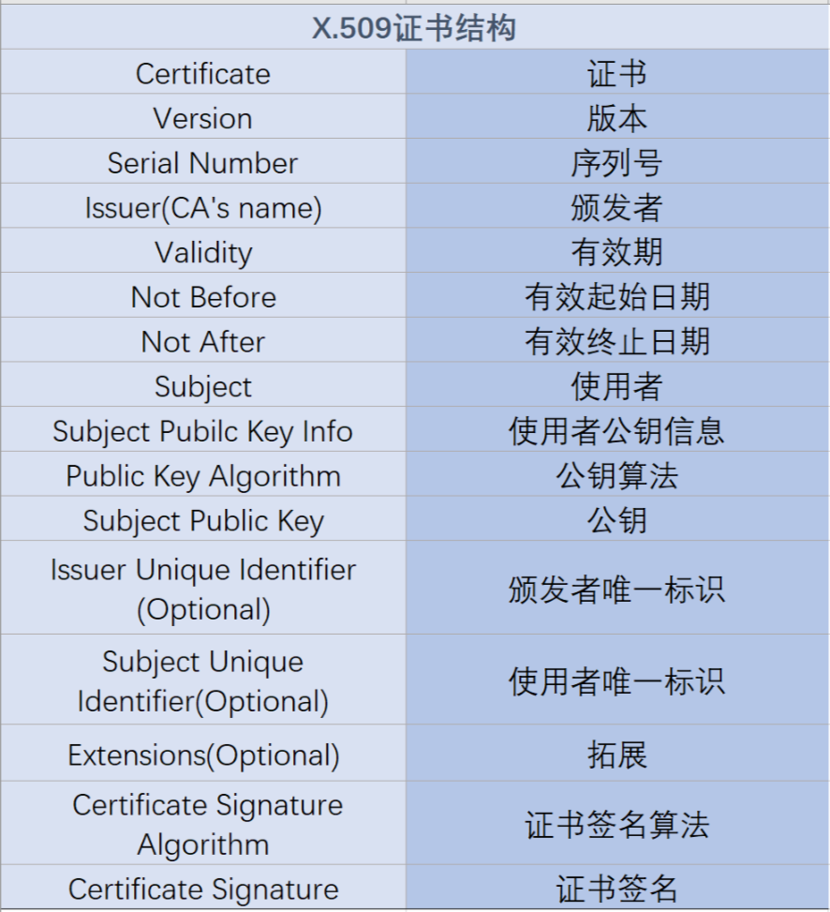

2.