Supplementary Materials for
Physical interaction within protein complexes links positive genetic interactions to disease vulnerability
Li-Tzu Wang, Han-Ying Jhuang*

Materials and Methods
Data sources. PPI data were obtained from the structurally resolved S. cerevisiae interactome (6), which provides 31,004 PPIs with composite confidence scores computed as score_FDR + score_cor (range 2-10). GI data were obtained from the SGA dataset (3), providing pairwise epistasis scores (epsilon) and P-values for non-essential gene pairs. Human PPI data were obtained from BioPlex 3.0 (12) (118,162 interactions) and HuRI (13) (51,640 interactions). Protein complex definitions used Michaelis Markov clustering (617 complexes) (6), CORUM (14) (2,075 human complexes), hu.MAP 2.0 (15) (6,965 human complexes), and CYC2008 (623 yeast complexes). SMF values were from the SGA strain collection. Disease gene sets were from OMIM (17,648 genes), HPO (16) (5,252 genes), and ClinVar (11,081 genes). Cancer genes comprise 67 curated genes from the literature. Evolutionary rates were from Xia et al. (17) (5,537 ORFs). Ortholog mapping used the Alliance of Genome Resources (18).
Pair classification. Gene pairs were classified into four architecture classes. Direct within-complex (intra co-purified, n = 5,526) have detected PPI (score >= 2) and share complex membership. Indirect same-complex (intra non-co-purified, n = 11,975) share complex membership but lack detected pairwise PPI. Between-complex (inter co-purified, n = 3,471) have detected PPI but belong to different complexes. PPI-only (n = 22,007) have detected PPI but were not tested for GI. The total dataset comprises 42,979 pairs.
Statistical analyses. GI significance was set at P < 0.05. GI sign was determined by the sign of epsilon, with one pair at epsilon = 0 excluded. Spearman rank correlations were used for association tests. Logistic regression was fit by maximum likelihood. Fisher's exact tests were used for 2 x 2 contingency tables. Complex-clustered block bootstrap (2,000 resamples, seed = 42) resampled entire complexes with replacement. ROC analysis used PPI score as predictor and GI significance as outcome. Wilson score intervals were used for binomial proportions. All P-values are two-sided.
Evolutionary metrics. Normalized evolutionary rates (dN/dS rank-transformed to 0-1) from Xia et al. (17). Codon adaptation index (CAI) computed from S288C coding sequences using the Sharp and Li reference set. Pair-level metrics computed as arithmetic means of gene-level values.
Cross-species conservation. Ortholog mapping from S. cerevisiae to H. sapiens used Alliance of Genome Resources (18). Human ortholog gene symbols were matched to BioPlex interactions via NCBI Entrez Gene IDs to avoid false negatives from gene symbol nomenclature changes between the Alliance (NCBI-current symbols) and BioPlex (2019 symbols). Ortholog projections collapsed to 18,481 unique gene pairs to remove pseudoreplication.
Disease and GO analysis. Cancer subtypes identified by keyword matching against HPO annotations, mapped through orthologs. Only subtypes with at least 20 gene pairs reported. GO enrichment used biological process annotations from SGD with ontology propagation and Benjamini-Hochberg FDR correction.

Supplementary Figures
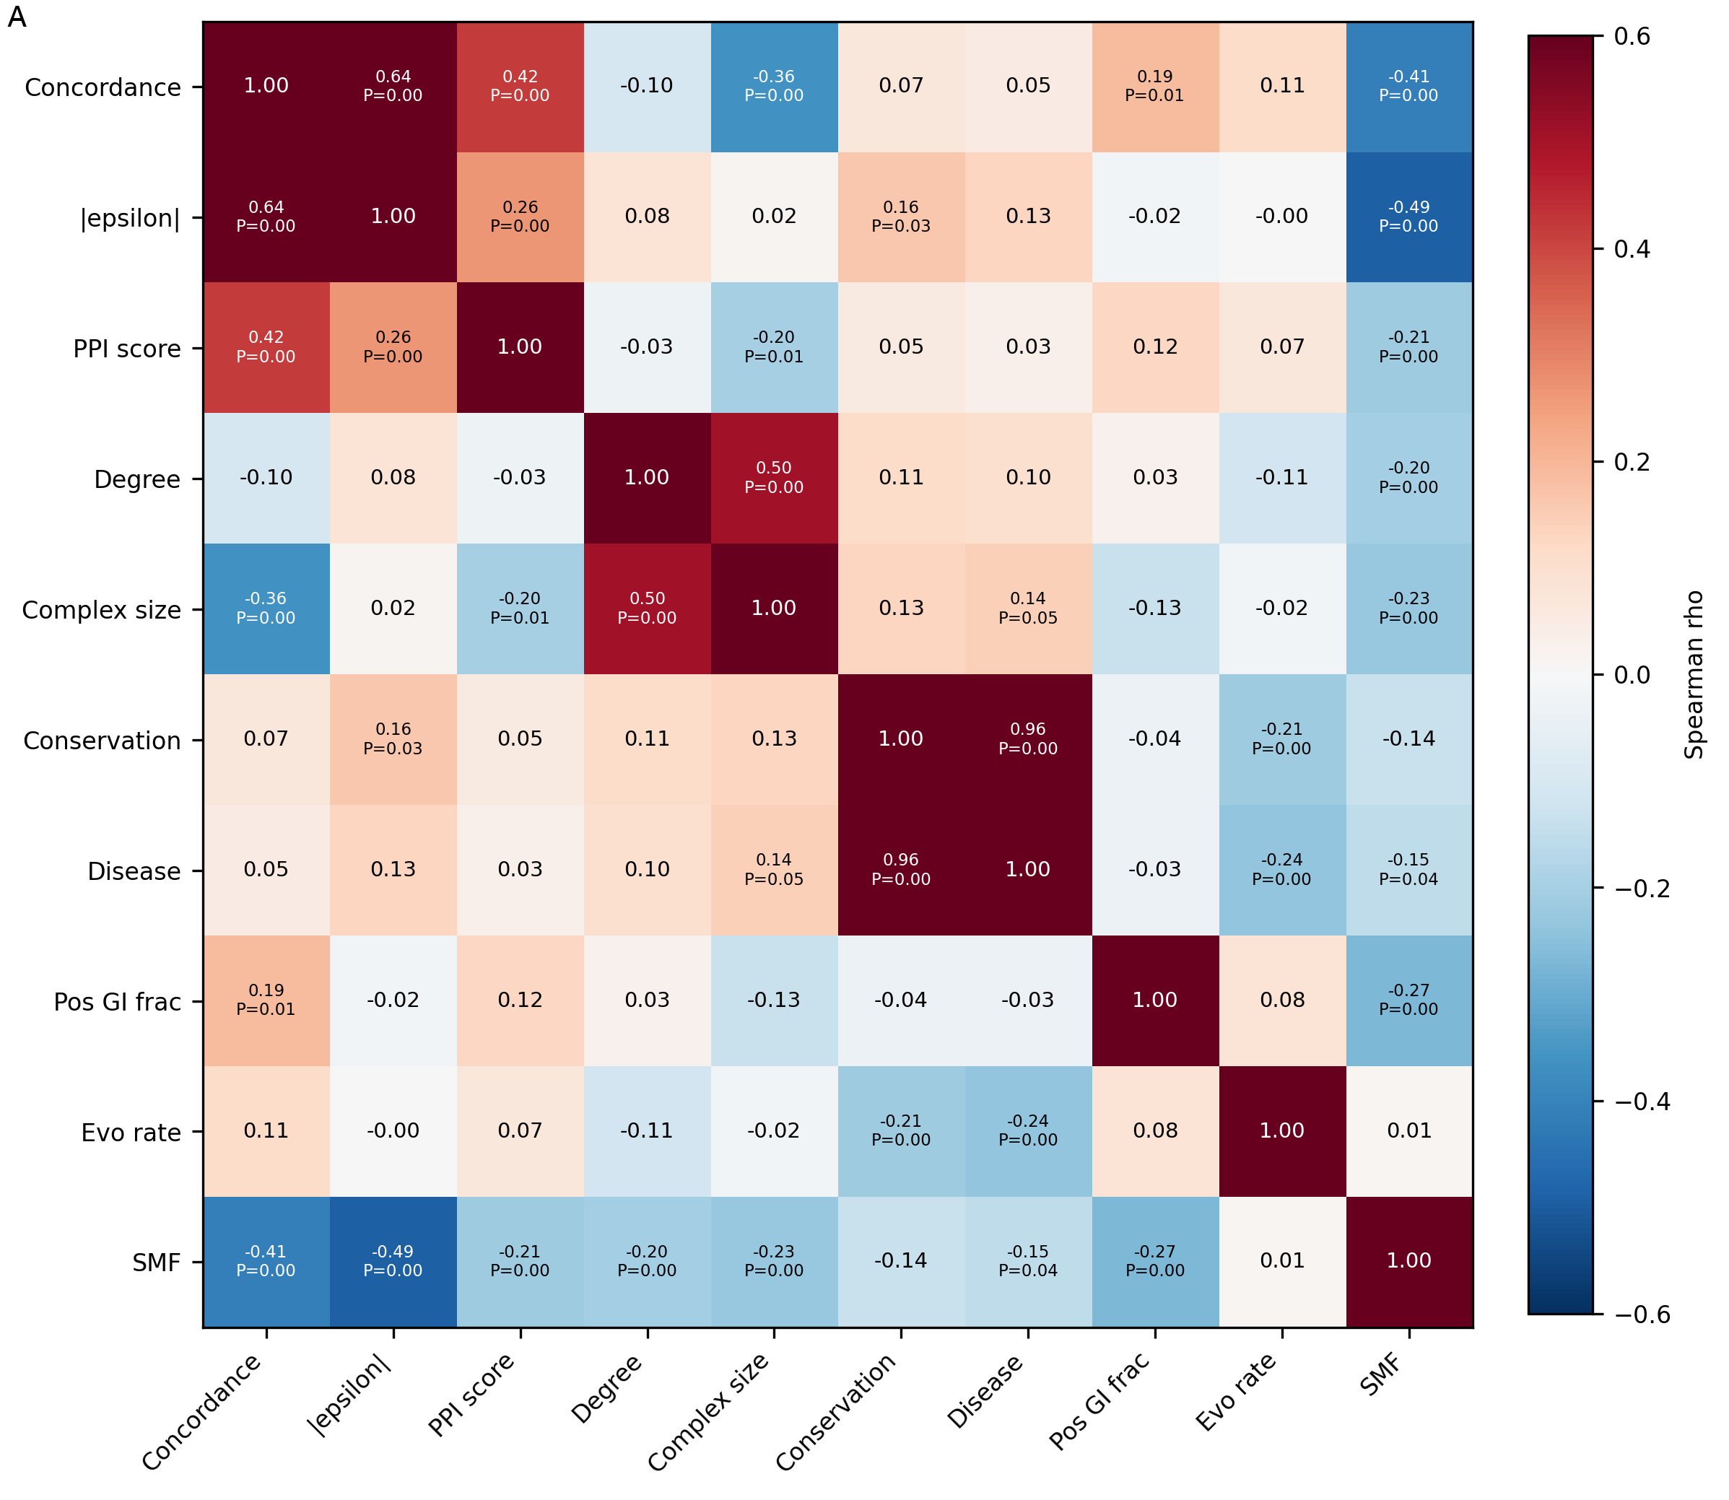
Supplementary Figure 1. Complex-level metric correlation heatmap. Spearman correlations among complex size, mean PPI score, GI detection rate, positive GI fraction, mean evolutionary rate, and mean SMF across all complexes with at least 3 tested pairs. Significant correlations (P < 0.05) are marked.

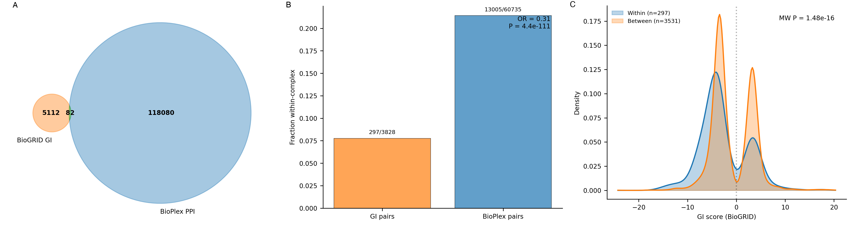
Supplementary Figure 2. Human GI-PPI analyses using BioPlex 3.0, BioGRID, and hu.MAP 2.0. (A) Venn diagram showing overlap between human GI pairs (BioGRID, concordant entries) and PPI pairs (BioPlex 3.0). Both databases use standard HGNC gene symbols. (B) Fraction of within-complex pairs (hu.MAP 2.0) among GI pairs versus BioPlex PPI pairs, with Fisher exact test. (C) GI score distribution (kernel density) for within-complex versus between-complex pairs, with Mann-Whitney test.

