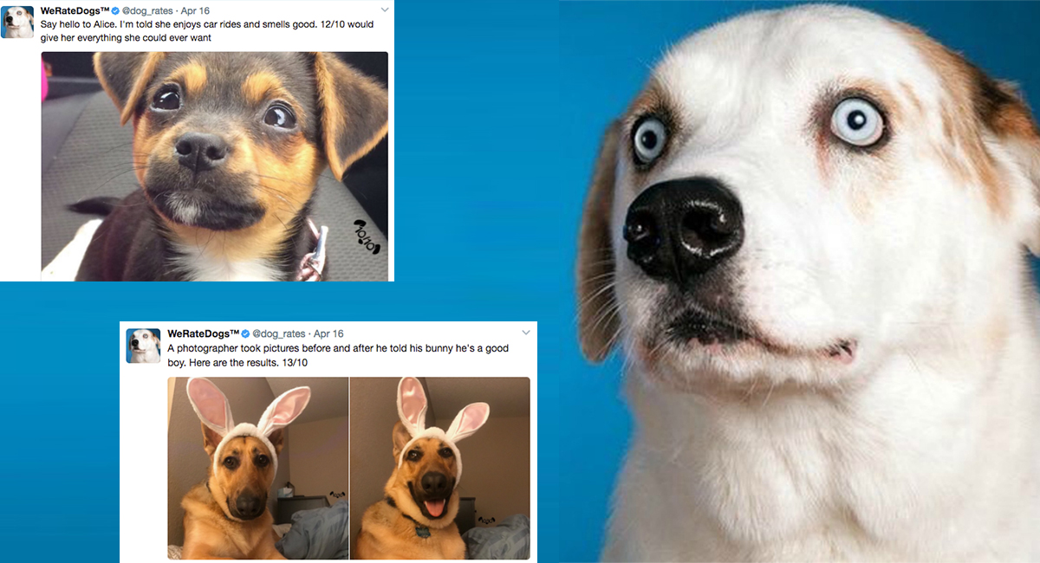

Too many people using twitter and they are variant in what they like and dislike

WeRateDogs account for people who love dogs

|  |  |  |
| --- | --- | --- |
|  |  |  |

Here we can find just in 2015 year how verity people like for WeRateDogs account

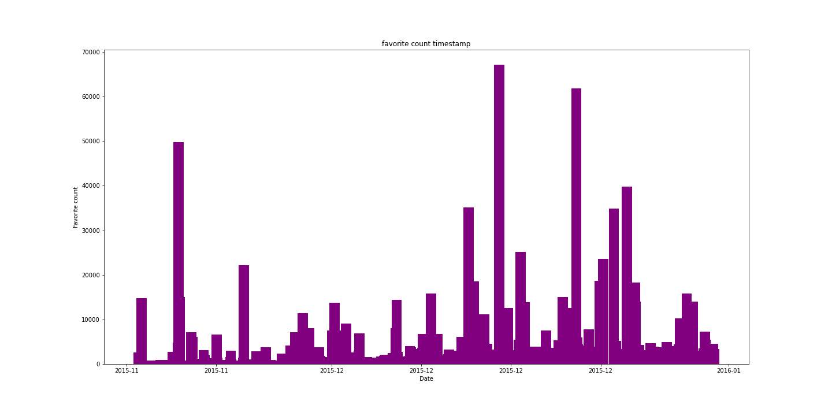

Many people breed dogs and they like to share their image with others and many also breed other pits

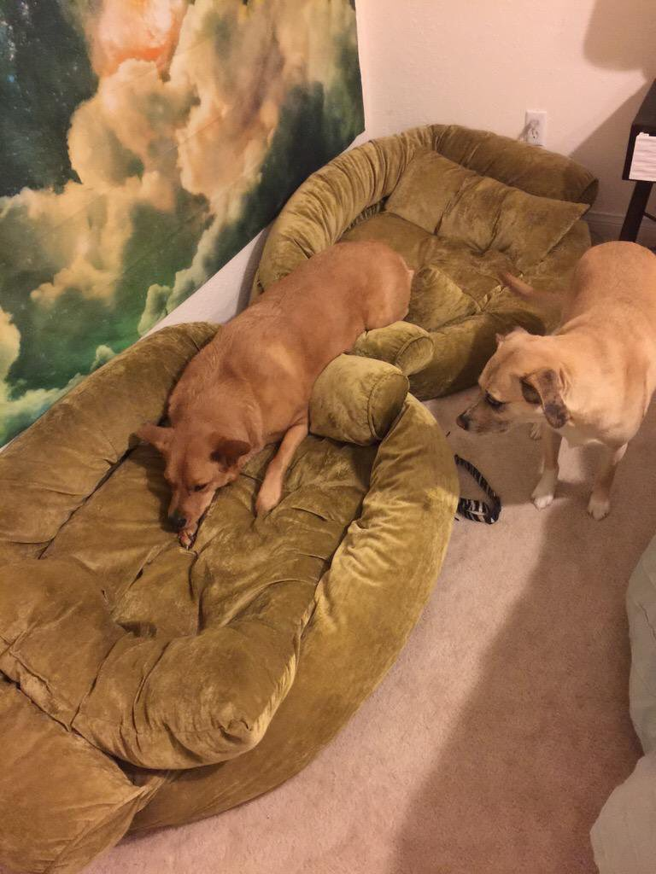

And here we can find a comparison between uploaded images for breeding dogs or other pits

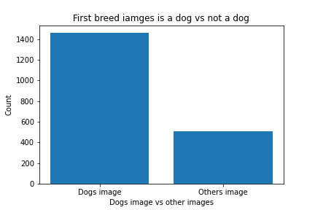

Dog name is something important to people and they may spend a long time choosing a name for their dog



Here we list the top 10 dog names if you like to choose from

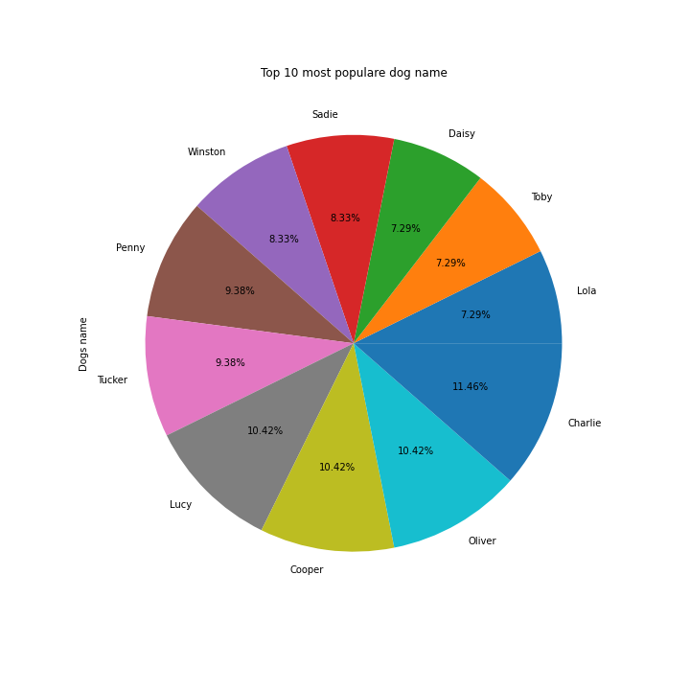

Twitter over time be a popular social media source and WeRateDogs account is a very popular account on Twitter and getting popular every year as we can notice in this diagram

