**SECTION A**

**NOTE: AFTER INSTALLATION STEPS**

To run projects or applications, these four steps below should be completed

1. Go to working directory
2. *cd your_assignment_folder_directory*
3. *vagrant up*
4. All projects will run from the root site and can be accessed using the link below

<http://localhost:8080/>

**IMPORTANT LINKS**

1. GitHub Classroom assignment link created by your Instructor **replace this link with the classroom assignment**
2. Course organization link created by your Instructor **replace this link with the classroom organization link**

**SECTION B**

**INSTALLATION INTRUCTIONS**

**Prerequisite Installations on local machine (Windows)**

Download and install Git (<https://git-scm.com/downloads> )

Download and install Virtual Box (<https://www.virtualbox.org/> )

Download and install Vagrant (<https://www.vagrantup.com/> )

**Getting Started**

1. Access the GitHub Classroom assignment link created by your Instructor in SECTION A (5) above
2. Register an account on GitHub or login if you have an account (<https://github.com/join/>)

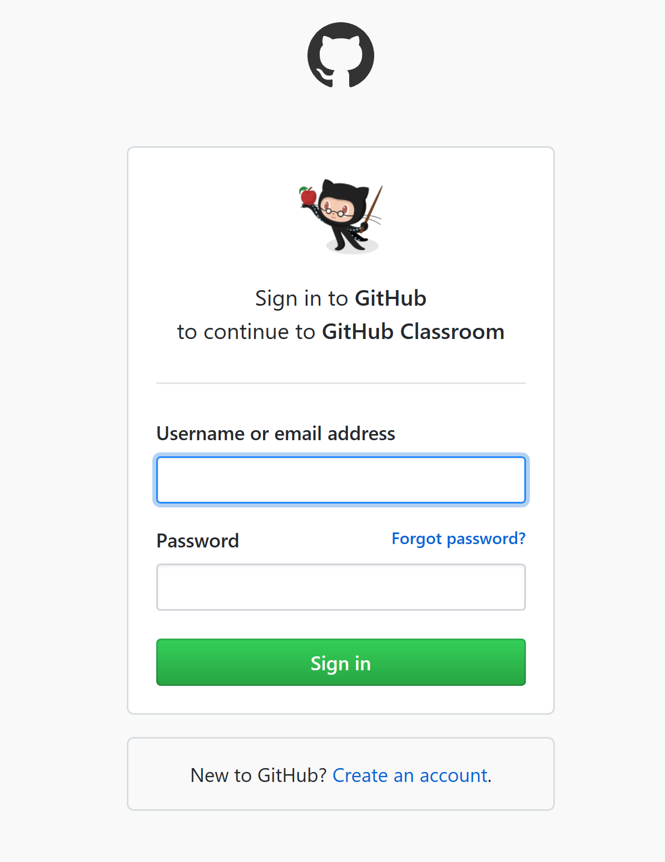

1. After creating your account, authorize GitHub Classroom as shown in the screenshot below

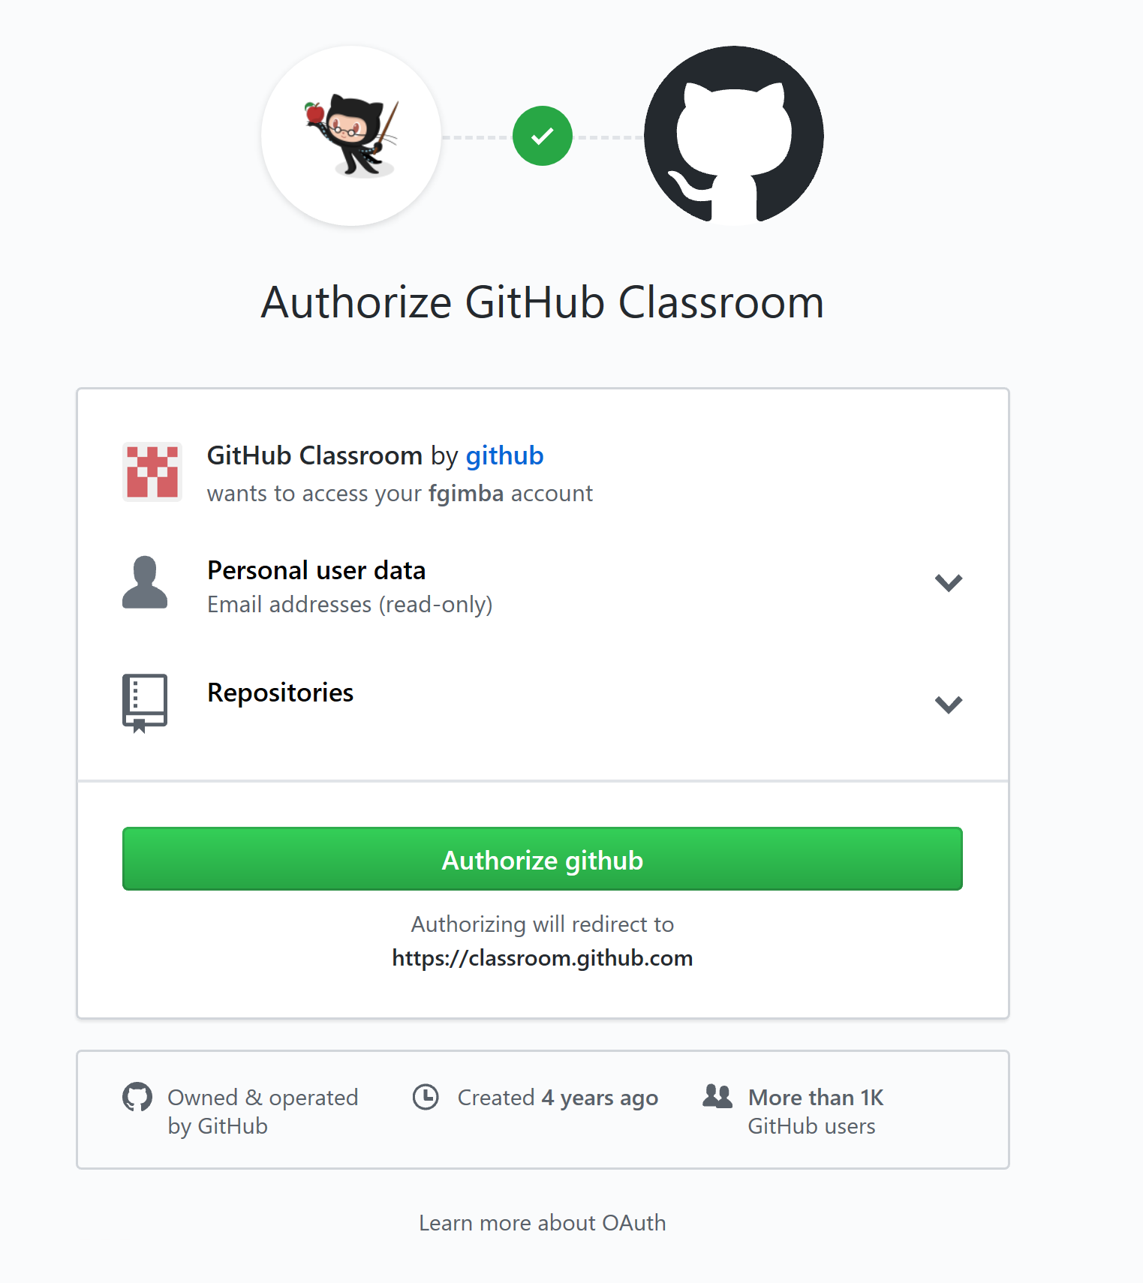

1. Accept the assignment

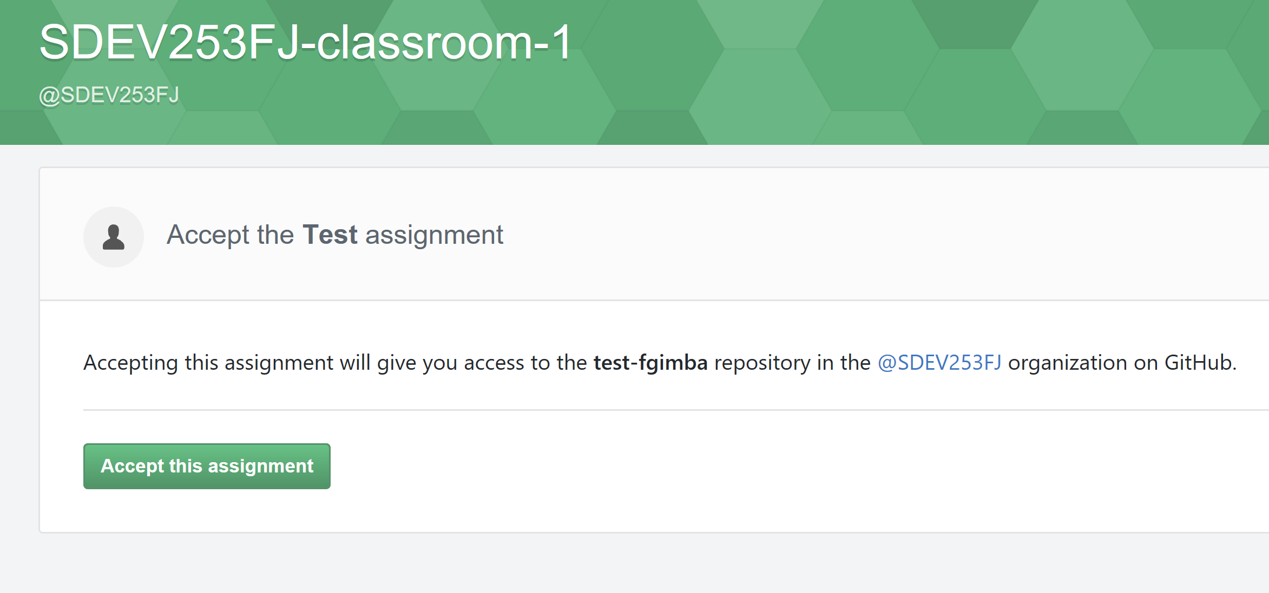

1. Wait for the your repository to be created

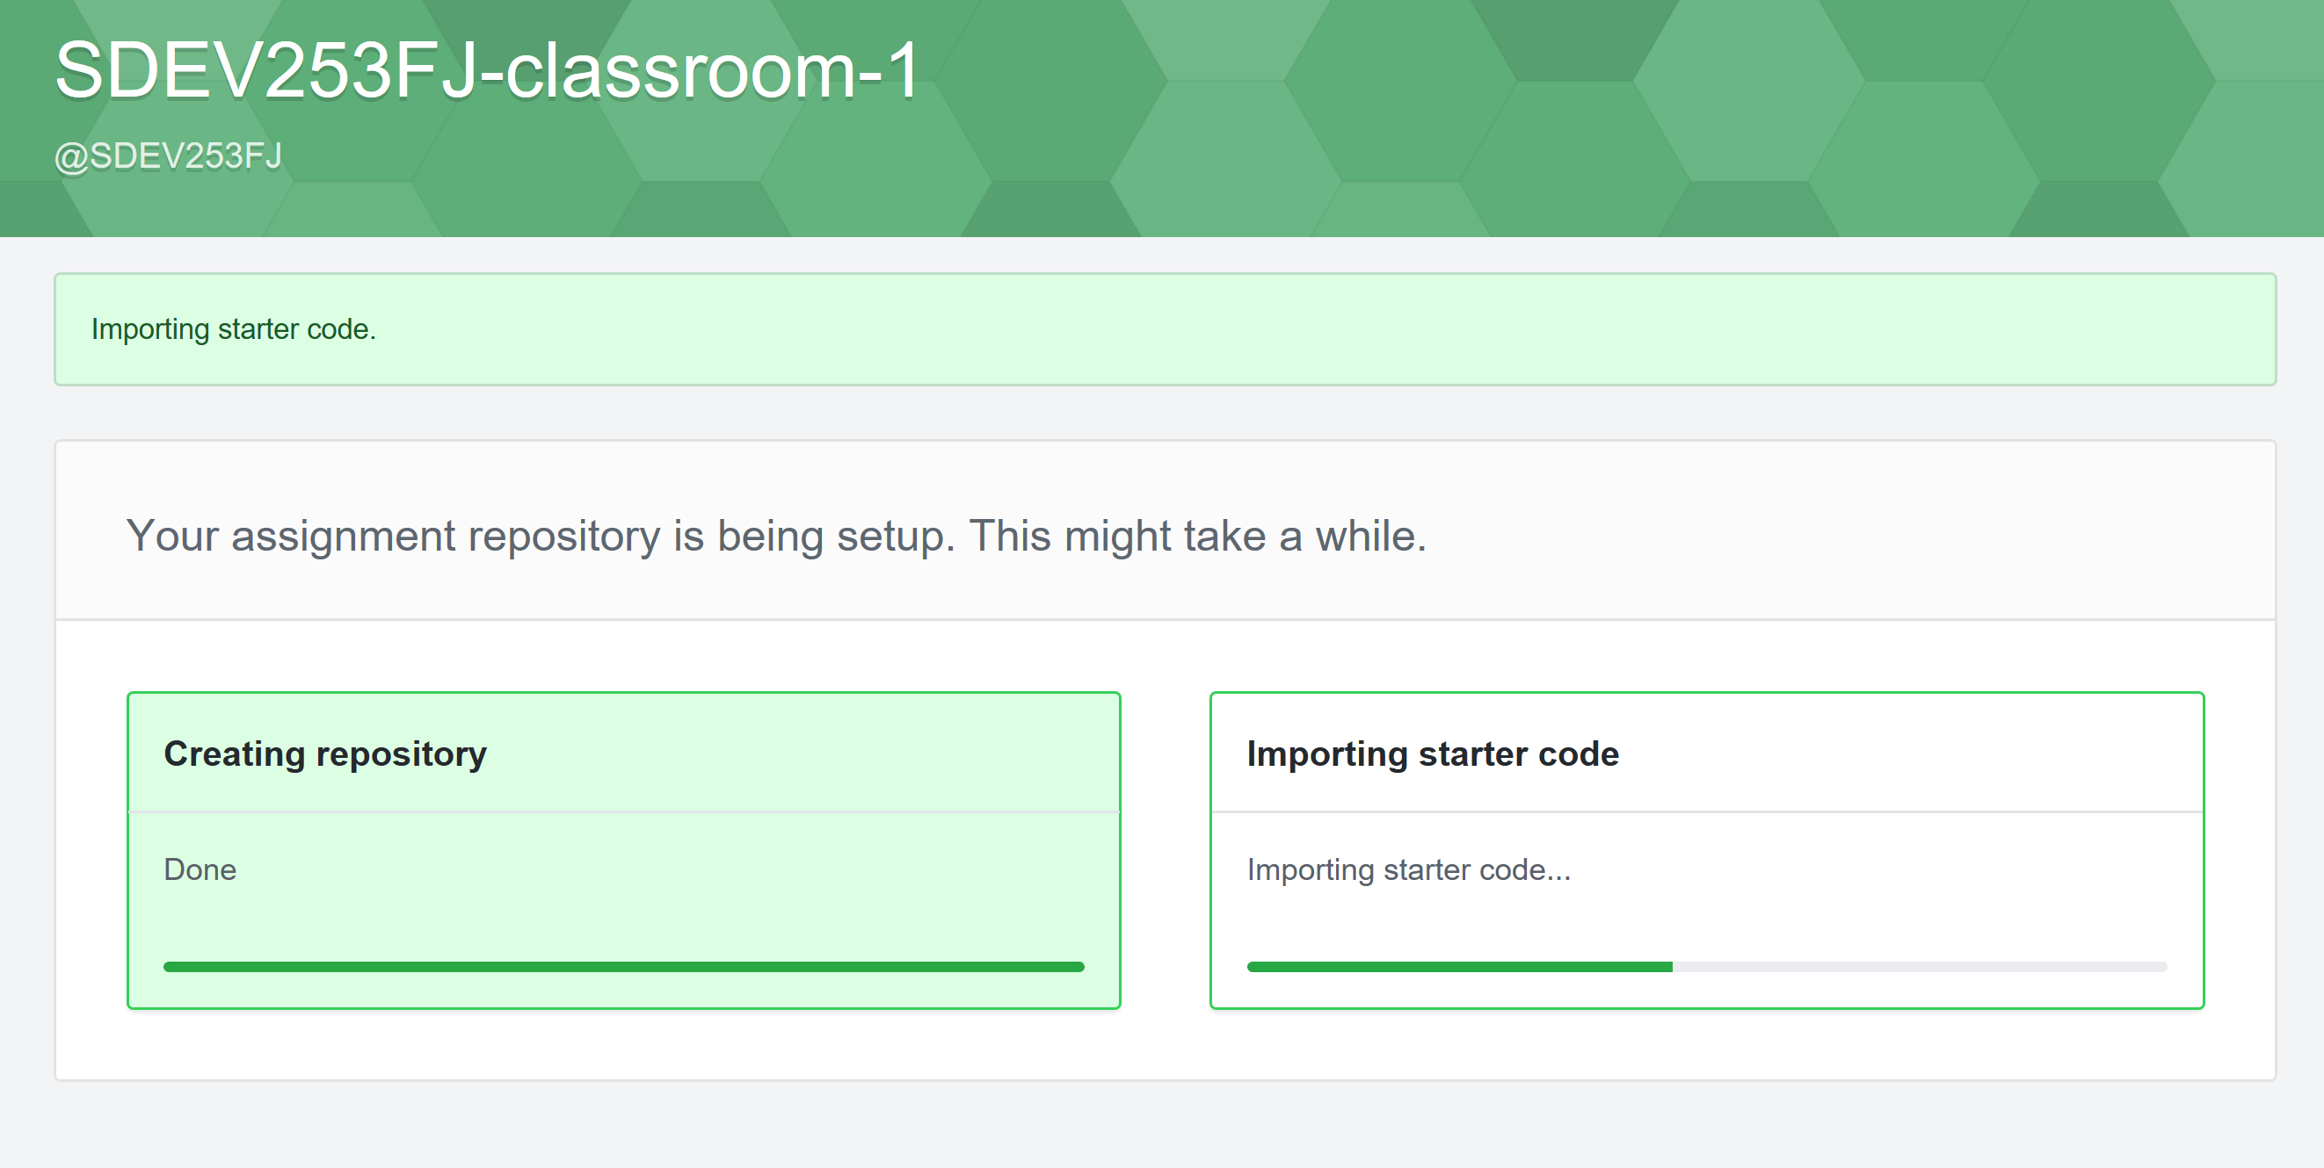

1. Access your assignment link

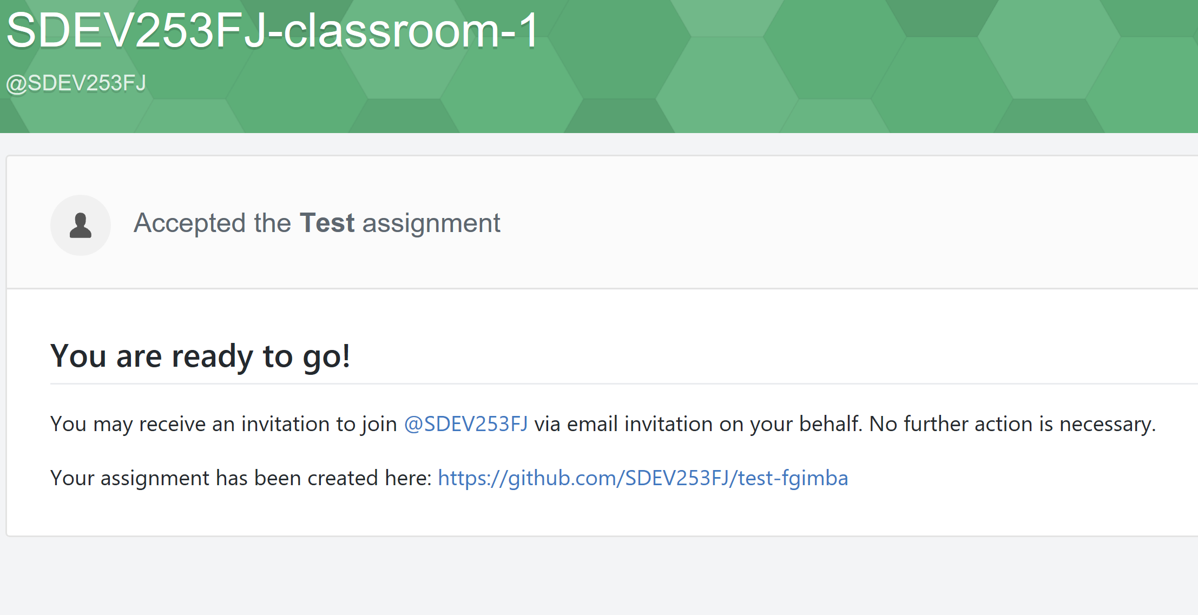

1. Retrieve your folder name at the end of the link as shown below.

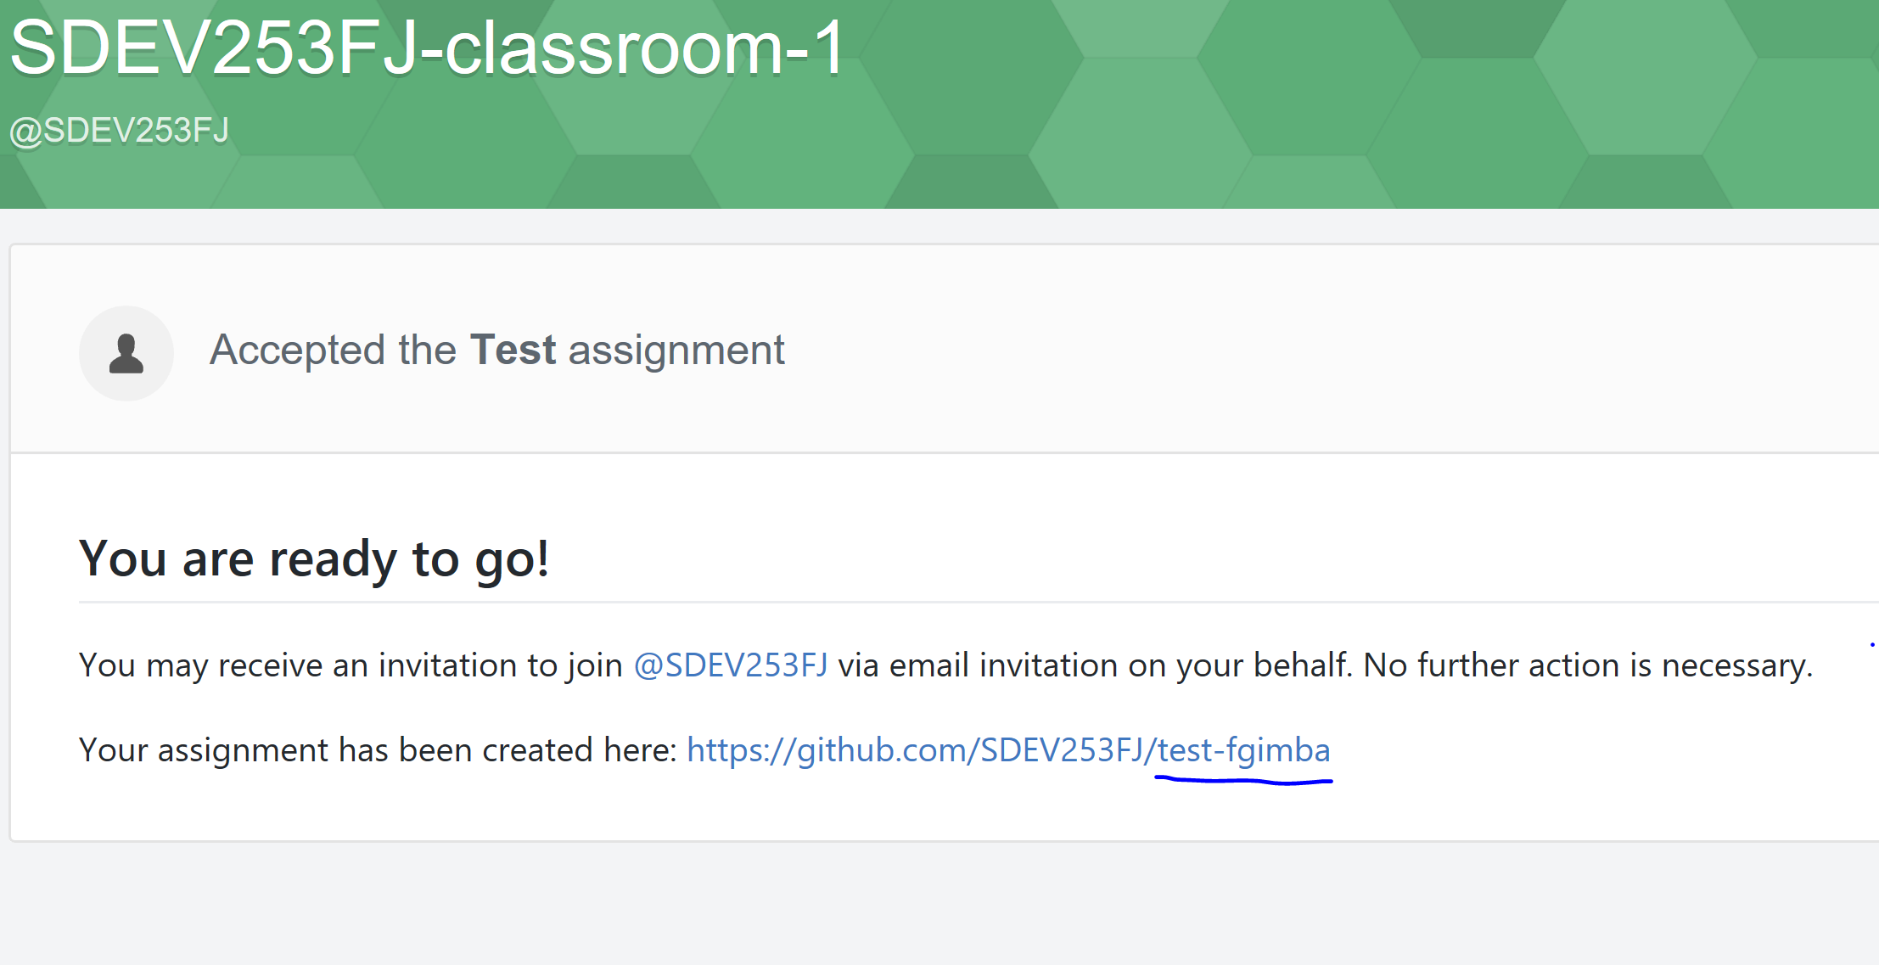

1. Go to your assignment repository
2. Click on the Clone or Download button and copy the clone address as shown in the screenshot below

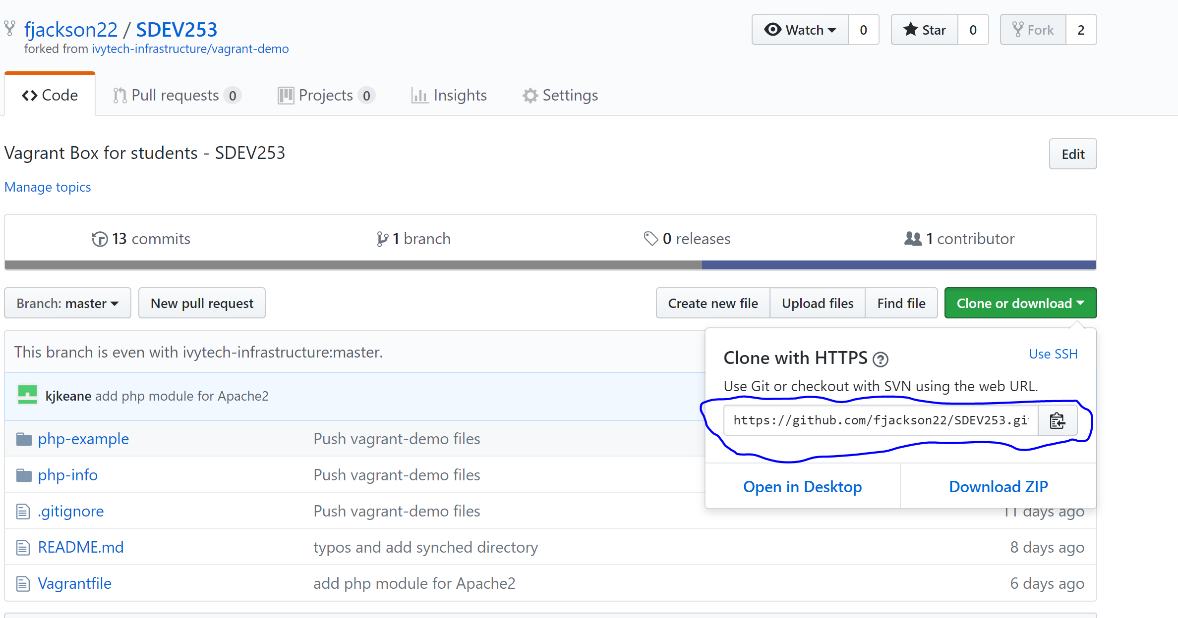

1. Open Git Bash from you search or apps menu (Windows 10)

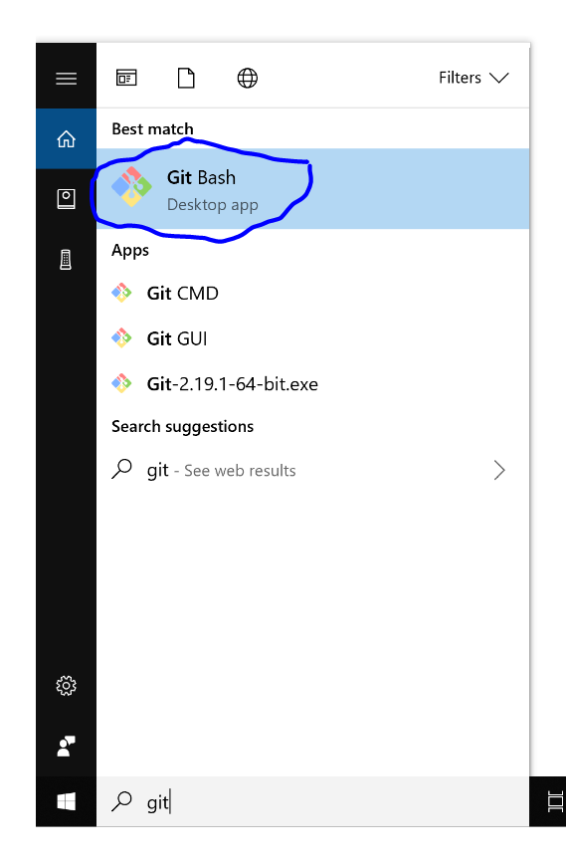

1. Go to your working directory by typing the command below. For example, for the purpose of this documentation, the folder Projects was created as a working directory in the windows Documents folder

Type ***cd Desktop/Documents/Projects***

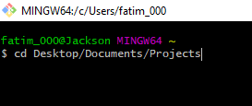

1. Go to the working directory as shown below

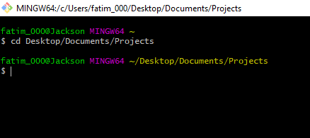

1. Clone the copied repository forked in step 14 above by typing the script below

***git clone “copied repository address from step 14”***  as shown below

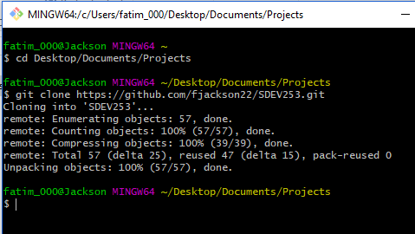

1. Go to the main master folder of the cloned directory. Use the name copied from step 13

***cd “Folder name copied from step 13”***

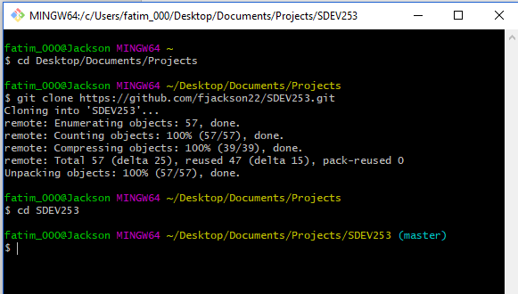

1. Start the virtual machine locally by typing vagrant up as shown below

***vagrant up***

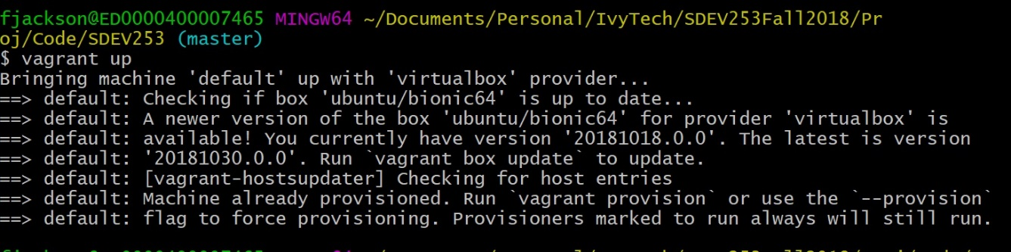

1. Update your username and email (email used to sign up for a GitHub account in step 8) as shown below to ensure that updated work is pushed to your repository.

NB: You will need to complete this step to be able to push code to GitHub

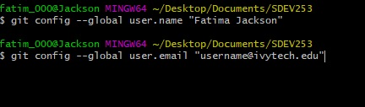

1. In case of any mistakes during installation or afterwards. The installation steps (SECTION B) can be repeated again after running the command below and deleting the master folder created. In the case of this specific example, the master folder is the folder name copied from step 13 (SECTION B) on your local machine’s working directory.

***vagrant destroy***

NOTE: The Installation step (SECTION B) only needs to be completed once but SECTION A needs to be completed each time the virtual machine is accessed. To close the git bash window at any time, simple type ***exit***

**SECTION C**

**Custom Work (Testing your setup)**

1. Go to the folder php-example
2. Create the file hello.php and type a simple hello word code as shown below

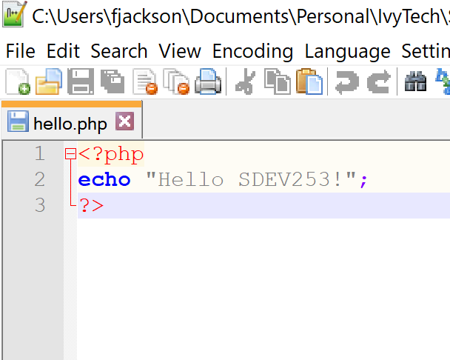

1. Go to the link: <http://localhost:8080/php-example/hello.php>
2. Confirm that your code runs correctly

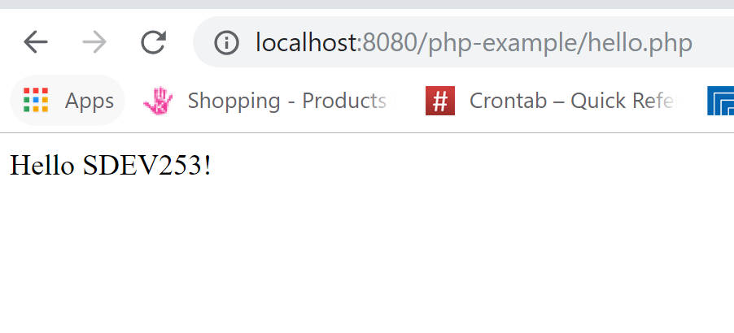

**SECTION D**

**Submitting your assignment**

1. It is recommended that all class assignments and projects be saved in the Class_Projects and provide your instructor with your lab assignment or project path in the submission for each assignment in the modules.

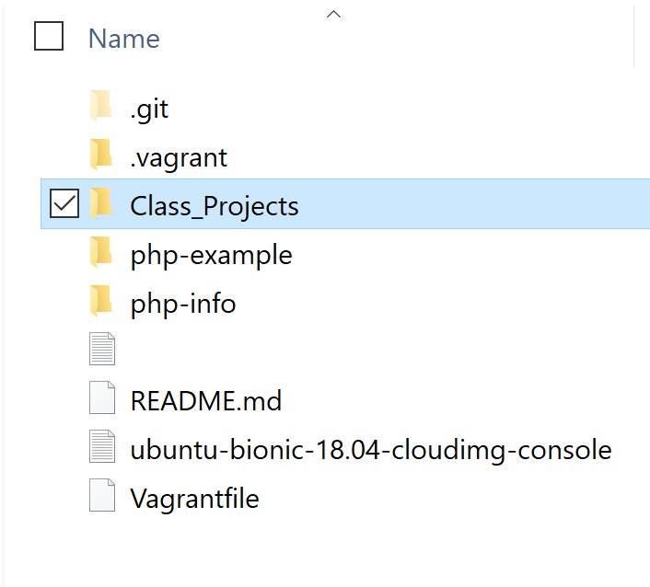

1. See additional simple steps below:
2. Type the command below to add all changed files



1. Type the command below to commit and provide a text to document the specific commit. See example below



1. Type the command below to push the code to the origin. See example below where the origin is called “master” which is the default.



1. Visit the link below to review additional information and documentation on how to push code on GitHub.

<https://help.github.com/articles/adding-a-file-to-a-repository-using-the-command-line/>