Differential Expression Analysis Report

Dataset: GSE174431 (Breast Cancer PBMCs)

Prepared by: Hanieh Roodashty

GitHub: https://github.com/hanyroze/GSE174431_DESeq2_BreastCancer

Date: August 30, 2025

Introduction
Dataset: GSE174431
Context: RNA-seq analysis of PBMCs from metastatic breast cancer patients. Samples were separated into lineage-positive (Lin+) and lineage-negative (Lin–) populations.
Objective: Identify differentially expressed genes between Lin+ (differentiated) and Lin– (stem-like/progenitor) cells.

Methods
- Downloaded raw exon count files from GEO (GSE174431).
- Processed and merged counts into a single matrix in R.
- Used DESeq2 for normalization and differential expression analysis.
- Groups defined from sample metadata (LinPositive vs LinNegative).
- Significance threshold: adjusted p-value (FDR) < 0.05.

Results
- PCA shows clear separation between Lin+ and Lin– samples.
- Volcano plot highlights significantly up- and down-regulated genes.
- Heatmap of the top 20 DE genes reveals distinct clustering by condition.

Figure 1. PCA Plot

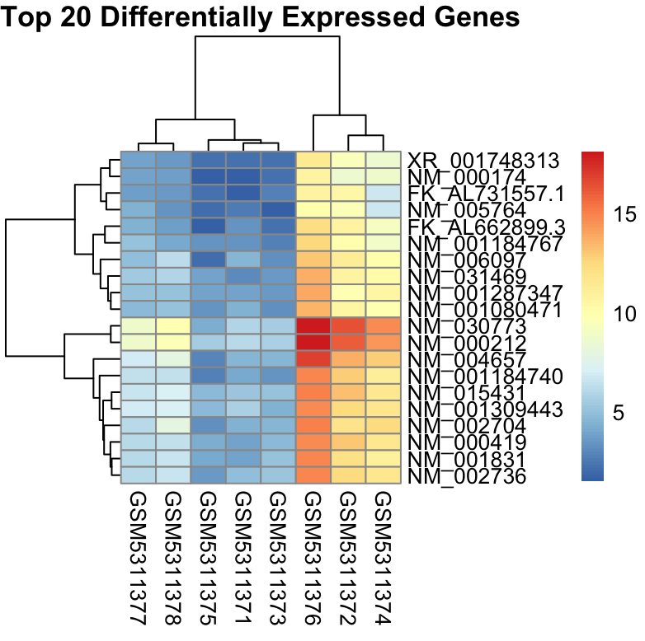

Figure 2. Volcano Plot

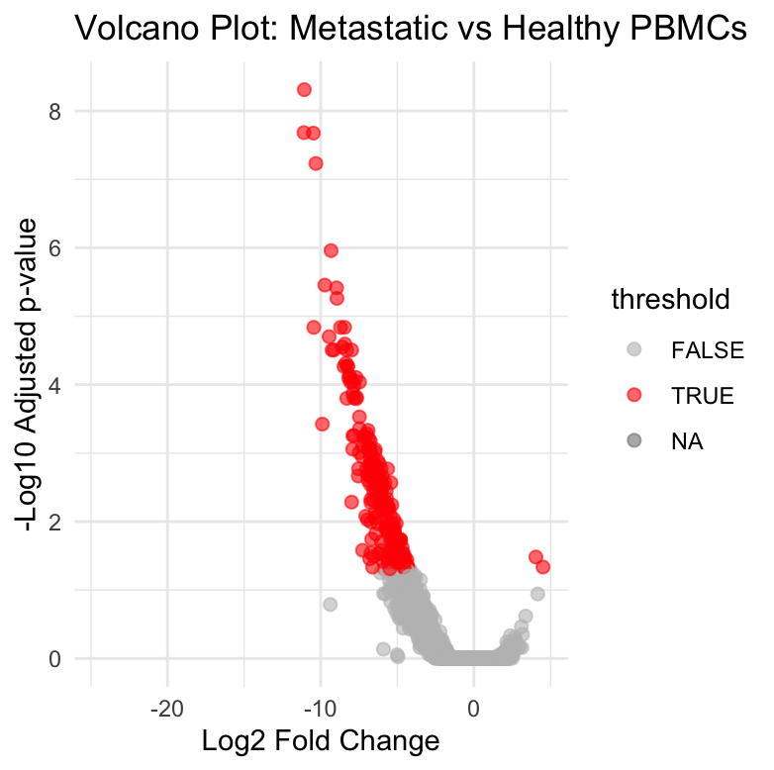

Figure 3. Heatmap of Top 20 DE Genes



Table 1. Top 20 Differentially Expressed Genes

Gene | log2FC | Adj.P.Val
NM_030773 | -11.07 | 4.89e-09
NM_004657 | -11.10 | 2.07e-08
NM_000212 | -10.48 | 2.11e-08
NM_001184740 | -10.32 | 5.86e-08
NM_002704 | -9.32 | 1.10e-06
XR_001748313 | -9.73 | 3.51e-06
NM_000419 | -8.97 | 3.85e-06
NM_031469 | -8.94 | 5.48e-06
NM_000174 | -10.45 | 1.45e-05
NM_001831 | -8.71 | 1.45e-05
NM_015431 | -8.44 | 1.45e-05
FK_AL662899.3 | -9.45 | 1.99e-05
NM_002736 | -8.42 | 2.55e-05
NM_001287347 | -8.58 | 2.82e-05
NM_001184767 | -8.31 | 3.11e-05
NM_005764 | -9.26 | 3.11e-05
NM_001309443 | -7.98 | 3.11e-05
FK_AL731557.1 | -9.14 | 3.11e-05
NM_001080471 | -8.35 | 4.88e-05
NM_006097 | -8.23 | 5.35e-05

Conclusion
This analysis identified significant transcriptional differences between Lin+ and Lin– breast cancer cell populations.
- Lin– cells (lineage negative) show expression patterns consistent with stem-like/progenitor features.
- Lin+ cells (lineage positive) display more differentiated gene expression signatures.
These findings align with the hypothesis that lineage-negative cells may represent cancer stem-like populations contributing to tumor progression and metastasis.

