1-Data Binding:

Data binding in Vue.js allows you to bind DOM elements to your Vue instance's data properties.

This means that any changes in the data are automatically reflected in the DOM and vice versa.

Types of Data Binding:

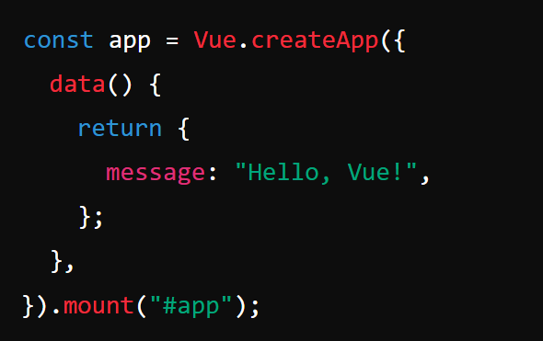Interpolation ({{ }}): The simplest form of data binding, where you display the value of a data property in the DOM

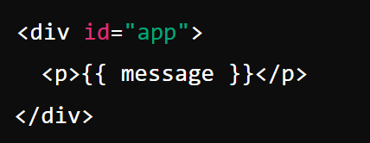

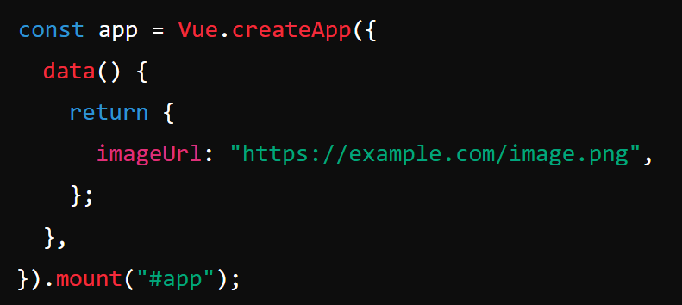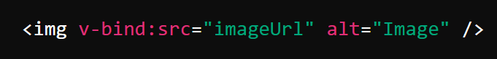**Attribute Binding (v-bind: or :)**: You can bind data to HTML attributes like class, style, src, etc.

**Two-Way Data Binding (v-model)**: This is a special directive that allows you to create a two-way binding between form input elements and data properties. This means that changes in the input element will update the data property, and vice versa.

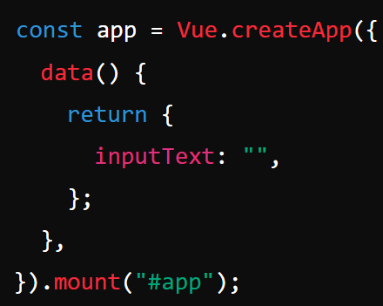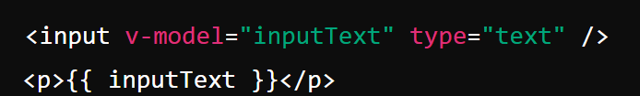يعني بدل ما هتعمل ليسن علي الإنبت وبعدين تروح تحط الفاليوا بتاعته فيه برده عشان لو غيرت فيها تتشال من الإنبت بعدل ما هتحط اتنين هتستعمل ال v-model => v-bind:value + v-on:input=” اسم الفنشكن ”

Here, the inputText property is bound to the input field. Any change in the input field will update the inputText data property, and any change in inputText will be reflected in the input field.

2. Event Binding

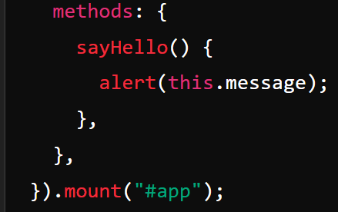Event binding in Vue.js allows you to listen for and respond to DOM events (like clicks, keypresses, etc.). Vue provides the v-on directive (or the shorthand @) for this purpose.

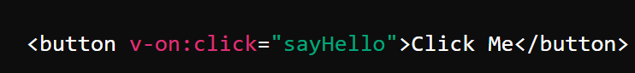**Basic Event Binding**:

**Event Binding with Inline Handlers**:



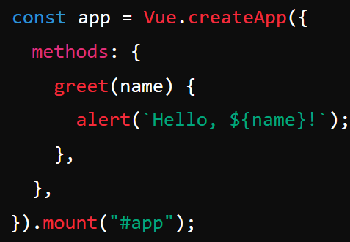**Passing Arguments to Event Handlers:**

Vue.js provides **event modifiers** to handle common event behavior easily:

* **.stop**: Stops the event from propagating.
* **.prevent**: Prevents the default action associated with the event.
* **.capture:** Adds the event listener in the capture mode.
* **.self**: Only triggers the event if it was triggered on the element itself, not its children.
* 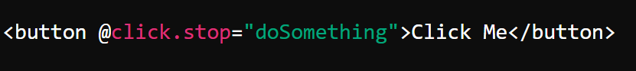**.once:** The event will be triggered only once.

Summary

* Data Binding: Connects your Vue instance's data with the DOM, allowing automatic updates and synchronization.
* Event Binding: Allows you to listen to and respond to user interactions (events) on the DOM elements.

**Compare between watcher, computed and methods in Vue and when we use ease one**