Hany SRENG

BP 511 Street. 371Phum Tropeang Chhuk

Sangkat Tek Thla, Khan Saen Sokh, pp

Phone: 0964 776 129

Email: hany.sreng@student.passerellesnumeriques.org

Date: 14/01/2019

Company: MangoTango

Address: #184, Monireth Blvd (217), Sangkat Tumnob Teuk,

Khan Chamkarmorn, Phnom Penh

HP: 012 31 71 74

Email: [jobsbt@mangotango.asia](mailto:jobsbt%40mangotango.asia)

**Dear Sir/Madam**

My name is Hany SRENG.I am particularly interested in position as web developer which is advertised in Bong Thom.com website. I believe that my education background, experiences, and commitment will fit well to the position.

As you can see from my CV, I am expecting to graduate with an associate degree in WEP programming from Passerelles Numeriques Cambodia (PNC) in September 2019. During my first year, I had built a static of website with HTML, CSS, JQuery, JavaScript and design banner. More importantly, during second year, I built dynamic website with PHP, JavaScript, Bootstrap, HTML, CSS, and Database. I am also responsible for Logo page, communicate with client and guide line.

I have a good communication with other and teacher, problem solving with experience in the development and delivery of language programs. I am a person that open mind and always help my friends to solve the problems that they have meet and I like to share the idea to my team or my friends to do something good. I always smile and I have enough confident to solve the problems. Once more, I am a good listener. I always listen to my friend when they have something to shear.

With my related experience and education background, I believe I can make a significant contribution. I would like an opportunity to further discuss the position an any qualification. I can reached via my call phone, +855 964 776 129 or by email: hany.sreng@student.passerellesnumeriques.org.Thank you your time and consideration.

Yours faithfully,

Hany SRENG

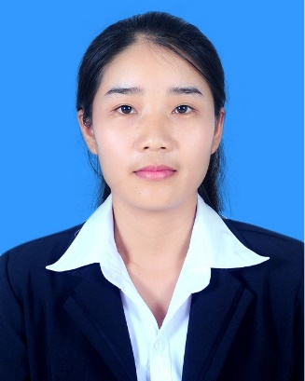Name : Hany SRENG

National : Cambodia

Birth of Date : March 02, 1997

Birth place : PreshNetPresh district, Benteay Meanhey Province

Present address : BP 511 St.371 Phum Tropeang Chhuk (Borey Sorlar)

SangKat Tek Thla, Khan Saen Sokh,PP,Combodia

E-mail : [hany.sreng@gmail.com](mailto:hany.sreng@gmail.com)

Tel : 0964776129

Sex : Female

**OBJECTIVE**

Position : Web Programming Intern.

**EDUCATION BACKGROUND**

2017 – Present : Studying associate degree in Information Technology

at Passerelles.numeriques Cambodia.

Major: Web programming

2016 – 2017 : High School Certificate (Baccalaureate II) for Rolhal School

**WORK EXPERIENCES**

01Jan – 31Mar.2019: School Project: Architecture and Engineering (Dynamic website) at

Passerelles.numeriques Cambodia.

* Analyze database.
* Designing
* Coding (PHP, HTML, CSS, JavaScript, JQuery).
* Do report and Presentation.

**TRAINING COURSES and WORKSHOPS**

Jan- 2019 : Join training about ‘Conflict Management' at PNC

Dec- 2018 : Join training about ‘Presentation Workshop’

Dec – 2018 : Join training about ‘Goal Setting and who I am’

Oct – 2018 : Join Barcam workshop at Tichno Unibersity

Feb – 2017 : Get certificate by join training about ‘Choosing skill when finis High school’

**SKILLS**

Technical : HTML, CSS, java, Design, PHP, Bootstrap, JavaScript. Database.

Microsoft (word, power point, excel)

Soft skill : Leadership, communication, Task management, Time management

**LANGUAGE SKILLS**

Khmer : Fluent

English : Basic

**REFERENCES**

Name : Rady Y

Position : WEP Programming Training

Tel : 08888 46 094

E-mail : rady.y@passerellesnumeriques.org

Name : Tanghout TENG

Position : Professional Life Training at PNC

Tel : 0818 111 73

E-mail : tanghuot.teng@passerellesnumeriques.org