GAME DESIGN DOCUMENT (GDD)

GUNAROK

VERSION NO.1

Designed by:

Acejo, Kharl Kim – 20224776@s.ubaguio.edu
Asas, Jenny – 20247545@s.ubaguio.edu
Bulong, Kingsly – 20244746@s.ubaguio.edu
Osian, Paul Christian – 20225550@s.ubaguio.edu
Puguon, Hanz Geric – 20245353@s.ubaguio.edu

Date:
19/09/2026

Course Code and Title | GAMDES1 – Game Design and Development
Program and Section | BSCS - IAC1
Term and School Year | First Semester Year 2026-2027
Team / Studio Name | BOPAA Team
Working Game Title | Gunarok
Submission Stage | ☒ Draft GDD (First Evaluation)
Version No. / Date Submitted | V1 - 30/10/2026
Instructor | Erna-kristi Martinez

Development Team and Roles
No. | Member Name (Surname, First Name) | Primary Role | Secondary Role
1 | Osian, Paul Christian | Designer | Programmer
2 | Puguon, Hanz Geric | Designer | Programmer
3 | Bulong, Kingsly | Programmer | Designer
4 | Acejo, Kharl Kim | Artist | Programmer
5 | Asas, Jenny | Producer | Artist

Table of Contents
I. GAME OVERVIEW 4
1.1 High Concept Statement 4
1.2 Elevator Pitch 4
1.3 Genre, Platform, and Target Audience 4
1.4 Scope and Feasibility Statement 5
II. FORMAL ELEMENTS 8
III. MDA AND PLAYER EXPERIENCE 13
3.1 Mechanics, Dynamics, and Aesthetics 13
3.2 Targeted Kinds of Fun 14
3.3 Player Types and Motivation 15
3.4 Player Experience (PX) Goals 15
IV. CORE GAMEPLAY LOOP 16
4.1 Core Loop Diagram 16
4.2 Loop Walkthrough 16
4.3 Macro and Micro Loops 17
4.4 In-Game and Out-Game Actions 17
V. LEVEL DESIGN 18
5.1 Level Layout Pattern 18
5.2 Annotated Level Map 18
5.3 Pacing and Difficulty Curve 19
5.4 Teaching Mechanics Through Level Sequencing 21
VI. SYSTEMS AND BALANCE 22
6.1 Resource Economy 22
6.2 Progression Curve 24
6.3 Symmetry, Asymmetry, and Fairness 26
6.4 Randomness and Probability 27
VII. NARRATIVE DESIGN 29
7.1 Premise and Setting 29
7.2 Narrative Delivery Method 29
7.3 Branching and Player Agency 30
VIII. TECHNICAL DESIGN 31
8.1 2D, 3D, or Hybrid Decision 31
8.2 Camera System 32
8.3 Control Scheme and Input Mapping 33
8.4 Godot Scene Tree Plan 34
8.5 Signals and Event Wiring 36
IX. ACCESSIBILITY CONSIDERATIONS 39
9.1 Accessibility Trade-Off Statement 42
X. CONTENT RATING AND PROFESSIONAL STANDARDS SELF-ASSESSMENT 42
10.1 Content Rating Self-Assessment 42
10.2 Intellectual Property and Asset Sourcing 43
10.3 Monetization and Player Wellbeing 43
XI. PROTOTYPE SCOPE AND DEVELOPMENT PLAN 44
XII. REFERENCES AND ASSET ATTRIBUTION 46
12.1 Design References 46
12.2 Asset Attribution 47
XIII. REVISION LOG 48
13.1 Changes Made Without Being Asked 48

GAME OVERVIEW

1.1 High Concept Statement
Gunarok is a 2D fighting game where the player chooses a legendary warrior from across history, from Spartan kings to modern snipers, and duels rival champions in Tekken-style one-on-one matches, fighting up an arcade ladder until they face a god of mythology. It is compelling because it answers the "who would win?" question with history's most famous fighters, each with a distinct fighting style, and lets friends settle it in 2-player matches.

1.2 Elevator Pitch
What if history's greatest warriors from every era could finally settle the score? Gunarok is a 2D fighting game where you pick a legend like Leonidas, Musashi, Lapu-Lapu, or the sniper Simo Häyhä and fight one-on-one, Tekken style: drain your opponent's health before the timer runs out and win the best of three rounds. Every warrior has a unique fighting style built from their weapons and reputation, so each matchup feels different. Play solo in Arcade mode, climbing a ladder of rivals toward the ultimate boss, a god from Greek, Norse, or other mythologies, or challenge a friend in local 2-player Versus mode. Beat the gods and become the strongest fighter of all time. It is made for casual players and fans of fighting games or history who enjoy quick, replayable matches.

1.3 Genre, Platform, and Target Audience
Genre and sub-genre | 2D fighting game (one-on-one versus fighter with an arcade-ladder structure), set in a historical and mythological theme.
Genre conventions the game keeps | Best-of-three rounds, health bars and a round timer, a character select screen, unique movesets per character, blocking and special attacks, a ladder of opponents ending in a boss, and a local 2-player versus mode.
Genre conventions the game breaks | The roster is real historical warriors from different eras and cultures instead of fictional fighters, and the final bosses are gods from mythology. Controls are also deliberately simple (punch, kick, block, special) instead of long combo lists, so new players can pick it up quickly and the team can build it within one term.
Target platform | Desktop PC (Windows), played with a keyboard or gamepads. One player in Arcade mode against the CPU; two players in Versus mode, sharing one keyboard or using one gamepad each.
Target audience | Teens and young adults (about 13 to 25), from casual players to fighting-game fans, especially those interested in history. Played solo against the computer or locally with a friend.
Expected session length | One match: about 2 to 3 minutes. One full Arcade run: about 15 to 20 minutes. A typical sitting: 15 to 30 minutes.

1.4 Scope and Feasibility Statement
In scope for this term | - 8 playable historical warriors sharing one move template, each with its own weapon, stats, and named special: Leonidas, Julius Caesar, Ragnar, Musashi, Lapu-Lapu, Crazy Horse, Simo Häyhä, and a Muay Thai master (Nai Khanom Tom)  - 1 mythological god boss: Zeus  - 3 stages: Ancient Arena, Battlefield, and Mythic Summit  - Main menu, character select, pause menu, and result, ending, and Game Over screens  - Arcade mode: a fixed six-match ladder ending in Zeus, with 3 continues and a score  - Local 2-player Versus mode (one keyboard or two gamepads) with a stage choice  - Best-of-three rounds with health bars, a special meter, and a 60-second round timer  - Basic moves: punch, kick, block, and one special attack  - Win and lose screens
Out of scope (deliberately cut) | - Full Story mode with per-character intros and endings  - Future roster: Saladin, Templar Knight, King Baldwin, Oda Nobunaga, Shaolin Monk, Hannibal, and Andres Bonifacio  - A second god boss and gods from other mythologies (for example Odin and Bathala)  - Online multiplayer  - Complex combo systems and super meters  - Voice acting and cutscenes
Feasibility justification | The team has five members covering design, programming, art, and production. A 2D game is realistic for one term, and the biggest cost is character animation, so the roster is limited to 8 warriors that share one basic move template. Arcade mode is built first as the core of the prototype, since it needs only the fighting system, character select, and an opponent ladder. The 2-player Versus mode reuses the same fighting system and character select with a second input mapping, so it adds little extra work. Story mode and extra characters are added only if time remains, which keeps the deliverable playable even if the schedule slips. The work is planned around our weekly lab hours: each of the five members owns one part of the build (fighting system, CPU and ladder, menus and HUD, stages and art, audio and testing), so the parts are built in parallel during lab time, and anything that does not fit those hours moves to the cut list above.

FORMAL ELEMENTS
Players | Two fighters, one match, always one-on-one. The prototype supports two configurations: single-player versus CPU (Arcade: a ladder of five AI-controlled rival warriors ending in the god boss Zeus), and two-player local competitive (Versus: both players on one keyboard or on two gamepads). Play is strictly zero-sum; there is no cooperative mode. Story mode is not a playable configuration in the prototype.
Objectives | Reduce the opponent's health from 100 to 0 before the 60-second round timer expires. Win 2 of 3 rounds to take the match. In Arcade, the full objective is to win all six matches in order (M1 to M5 against rival warriors, then M6 against Zeus) without running out of continues. In Versus, the objective is to win the match against the other player.
Rules | - Each fighter begins every round with 100 health and a shared 60-second timer. Health does not regenerate during a round and resets to 100 at the start of each round (Zeus has 150).  - The special meter (0 to 100) carries across rounds within a match and resets when the match ends. A special attack needs 50 or more meter and costs 50.  - Fighters automatically face each other at all times. A fighter can block only while standing or crouching on the ground and not in startup, recovery, hitstun, or knockdown. Blocking cannot be used while airborne.  - A blocked attack still deals 25% of its damage (chip damage).  - A fighter cannot move, attack, or block during hitstun or knockdown. Only one attack can be active at a time; it must finish its recovery before another input registers.  - Height rules: punches are high attacks and miss a crouching fighter. Kicks are low attacks and miss a jumping fighter but hit a crouching one. The special is a mid attack and hits crouching and jumping fighters.  - Neither fighter may cross the left or right stage wall. The timer never pauses during active play.  - All eight warriors share the same move template (punch, kick, block, special). They differ in damage, reach, and speed (Section 6.3), in weapon and animation, and in the name and look of their special.
Procedures | 1. Both players select a warrior from the roster of eight at the character select screen (Arcade: only the player picks).  2. The stage loads. Before round 1 of each match only, the opponent intro card shows for about 2 seconds. Fighters spawn facing each other at mid-distance. The ROUND and FIGHT banners play and the timer starts at 60.  3. In real time, each player may move, jump, crouch, block, or attack. Player 1: A/D move, W jump, S crouch, F punch, G kick, H block, T special. Player 2: Left/Right move, Up jump, Down crouch, Numpad 1 punch, Numpad 2 kick, Numpad 3 block, Numpad 5 special. Gamepad controls are in Section 8.3.  4. Each attack resolves in three phases: startup, active, recovery. Damage applies only if the attacker's hitbox overlaps the defender's hurtbox during the active phase. Base damage: punch 6, kick 10, special 22, multiplied by the warrior's damage rating (Section 6.3).  5. Meter gained: +0.5 per point of damage dealt, +1 per point of damage taken, capped at 100. The damaged fighter enters hitstun; a special causes knockdown followed by a get-up animation.  6. The round ends on a KO or when the timer reaches 0. Health resets and the next round starts with the ROUND and FIGHT banners (step 2 without the intro card), until one fighter has won 2 rounds.  7. The Result screen follows every match. Arcade: the winner moves on to the next ladder opponent, and a loser chooses Retry or Quit. Versus: the players choose a rematch or a return to character select.
Resources | Health — 100 per round, spent by taking hits, unrecoverable within a round.  Special meter — 0–100, built by dealing and taking damage, spent in 50-point blocks. Because it also builds from damage received, the losing player accrues it faster, preserving comeback potential.  Time — 60 seconds per round, contested by both players; the fighter ahead on health is incentivised to stall, the one behind to press.  Screen space — the horizontal distance between fighters; being cornered against a wall is a spent positional resource with no escape route.  Continues — a limited number of retries in Arcade before the run ends.
Conflict | The opposing fighter, pursuing the identical objective. Layered on top: CPU opponents of escalating difficulty along the Arcade ladder; the god boss, with elevated health and damage, acting as a deliberate skill wall; the countdown timer, which punishes passive play; the scarcity of special meter, forcing a choice between spending now and banking for a decisive moment; and the stage walls, which remove a cornered fighter's retreat option.
Boundaries | Physical: a fixed-width 2D arena bounded by solid walls on both sides — no ring-out, no falling, no environmental hazards. The camera tracks both fighters and never leaves the arena. All action occurs on a single horizontal plane; there is no depth axis or sidestep. Play is local only, on one shared keyboard or one gamepad per player; there is no networked or online play.  Conceptual: the roster admits historically attested warriors from any era — antiquity through the twentieth century — and gods drawn from world mythologies. No fictional characters, no living persons. Because the roster spans from Leonidas to Simo Häyhä, firearms and modern weapons are within the fiction; the anachronism is the premise, not a violation of it. Combat is always 1v1: no teams, no interference, no items, no environmental interaction. Defeating the god boss is the content ceiling.
Outcome | - KO victory — the opponent's health reaches 0; the round is awarded to the attacker.  - Time-out decision — the timer expires with both alive; the fighter with more remaining health takes the round.  - Draw round — equal health at time-out, or a double KO; neither player is awarded the round and it replays. A match allows at most two replays. A third draw goes to the fighter who dealt more total damage in the match; if that is equal, to the fighter who landed the most recent hit; if no hit was landed at all, the match is a no contest (Arcade counts it as a loss, Versus offers a rematch).  - Match win — first to 2 rounds; the Result screen follows (Arcade: the next opponent, or Retry or Quit after a loss; Versus: rematch or character select).  - Arcade completion — every ladder opponent and the god boss defeated; ending screen and final score. Score: +1000 for each match won, +10 for each point of health the winner has left at the end of the deciding round, and +500 for a perfect (2–0) match. Retrying does not lower the score.  - Partial outcomes — reaching the boss but losing to it, clearing part of the ladder before continues run out, or winning a match 2–1 versus a flawless 2–0 (tracked as a perfect).

MDA AND PLAYER EXPERIENCE

3.1 Mechanics, Dynamics, and Aesthetics
Mechanic (as authored) | Dynamic it is expected to produce | Aesthetic / kind of fun it serves
Special meter builds faster from damage taken than from damage dealt: +1 per point taken, +0.5 per point dealt | A losing player closes the gap by banking meter while under pressure, so matches stay contestable even when one side is ahead on health | Challenge: comeback tension keeps the match undecided until the last hit
Special attack costs 50 of 100 meter | Players hold back a full special rather than spending it the moment it's available, waiting for a safer or more damaging opening | Challenge: risk/reward decision-making
Round timer counts down and never pauses | The fighter ahead on health plays defensively to run out the clock; the fighter behind is forced to attack | Challenge and Sensation: rising tension as time runs low
Chip damage lets blocked attacks still deal 25% damage | Players cannot block indefinitely to stall for the timer | Challenge: removes a "safe" passive strategy
Fixed stage walls with no ring-out | A cornered fighter loses their retreat option and must fight or attempt to escape past the opponent | Challenge: positioning becomes a resource, not just health
Local 2-player Versus on one keyboard or two gamepads, where all 8 warriors share one move template and differ only by damage, reach, and speed | Two friends can pick any matchup, read each other’s habits, and call for an instant rematch, since neither has new inputs to learn | Fellowship: friendly rivalry and rematches between two people in the same room
Arcade ladder ends in a god boss with higher health and damage | Players feel the difficulty rise steadily, with the boss as a clear "you've made it this far" skill wall | Challenge: a visible long-term goal

3.2 Targeted Kinds of Fun
Gunarok primarily targets Challenge and Fellowship.

Challenge comes first because the whole game is built on head-to-head competition where the losing side always has a way back into the fight, the meter system rewards a player who is losing, the timer punishes stalling, and chip damage removes passive blocking. These rules exist so that no match feels decided too early, which is the core feeling a fighting game needs to deliver.

Fellowship is the second target because Versus mode is meant to be played with a friend on the same keyboard. Sharing one simple move template across all 8 warriors supports this: two players can pick any matchup and know the fight will be fair, since no character has moves the other doesn't also have in some form.

We are deliberately not pursuing Narrative as a primary kind of fun. The game has a premise (historical warriors clash across time to fight a god) but no branching story, dialogue, or cutscenes in this prototype. We made this trade-off because our team's biggest cost is character animation, not writing, and a strong combat feel matters more to a first playable build than a story layer. Narrative content is listed as out of scope in Section 1.4 for the same reason.

3.3 Player Types and Motivation
Gunarok is designed mainly for the Killer and Achiever player types

Killers are players who are motivated by directly beating other players. Versus mode is built for this type: two players compete on equal footing, same move template, same stats structure, so a win feels like it came from skill, not from an unfair character advantage.

Achievers are players who are motivated by clearing goals and progressing through a system. Arcade mode is built for this type: the fixed ladder of opponents, the escalating difficulty, and the god boss as a final goal all give the Achiever player something concrete to work toward and finish.

3.4 Player Experience (PX) Goals
PX goal (what the player should feel, and when) | Design feature intended to produce it | How you would observe it in a playtest
The player should feel tension in the last 10 seconds of a close round, unsure who will win | The round timer combined with the time-out rule, higher health wins | Watching whether players lean forward, stop talking, or comment on the clock during close rounds
The player should feel a chance to come back even after falling behind on health | The special meter building faster from damage taken than damage dealt | Asking losing players mid-match if they still feel they can win, and checking if comeback wins actually occur in playtest data
The player should feel a sense of achievement after defeating the god boss | The escalating Arcade ladder ending in a boss with higher stats | Observing reactions like cheering, restarting to try another character immediately after a boss win in playtest sessions
The player should feel that a match against a friend is fair from the first round | The shared move template across all 8 warriors | Asking players after a Versus match whether they felt their character choice gave them an unfair advantage or disadvantage

CORE GAMEPLAY LOOP

4.1 Core Loop Diagram
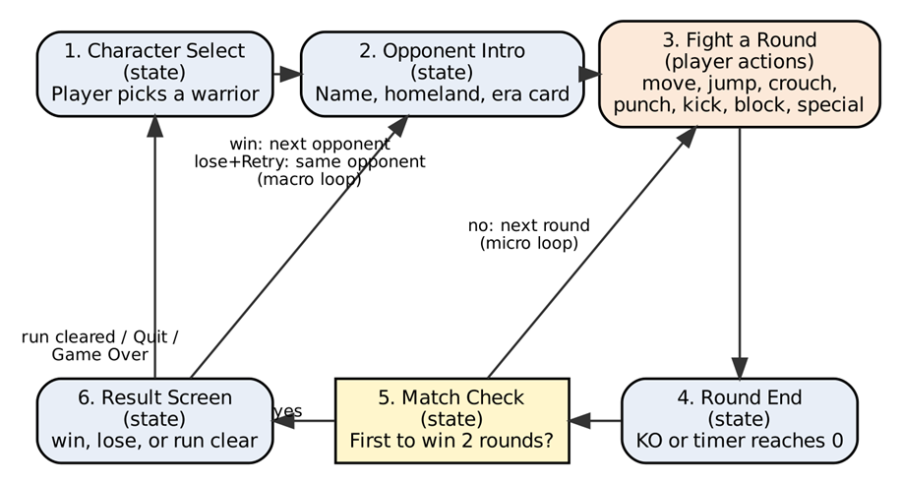
Figure 1. Core gameplay loop of Gunarok (micro loop: nodes 3 to 5; macro loop: nodes 2 to 6)

4.2 Loop Walkthrough
The player starts at the character select screen and picks one of the eight warriors. The game then shows the opponent's intro and the first round begins. During the fight, the player moves, attacks with punches and kicks, blocks incoming hits, and uses a special attack, trying to drain the opponent's health bar before the round timer runs out. The round ends when one health bar reaches zero (a KO) or when the timer expires, in which case the fighter with more health wins. The match check counts rounds won, and the first fighter to win two of three rounds wins the match. On the result screen, a win sends the player to the next opponent on the Arcade ladder, while a loss lets the player retry or quit. When the run ends, either after the god boss is defeated or when the player quits, the game returns to character select. One pass through the loop, from opponent intro to result, takes about 2 to 3 minutes.

4.3 Macro and Micro Loops
Micro loop | Within a round, the player watches the opponent, attacks or blocks, lands or takes a hit, and the health bars change. This repeats every few seconds until a KO or the timer ends.
Macro loop | Across an Arcade run, the player selects a warrior, fights a ladder of opponents (each a best-of-three match), faces a god boss, sees the result screen, and then picks a warrior again to try a different playstyle. A full run takes about 15 to 20 minutes.
Relationship between them | Every hit landed or blocked in the micro loop moves the health bars, which decides the round. Rounds decide the match, and matches move the player up the ladder in the macro loop. Losing at the micro level delays or stops progress at the macro level, and finishing a run gives the player a reason to replay with another warrior.

4.4 In-Game and Out-Game Actions
In-game actions | Move left and right, jump, crouch, punch, kick, block, and use a special attack. The player also watches the health bars and round timer to decide when to attack or defend.
Out-game actions | Choose a game mode (Arcade or 2-Player Versus), select a character, open the pause menu (resume, restart, or quit), choose to continue, retry, or quit on the result screen, and return to the main menu

LEVEL DESIGN

5.1 Level Layout Pattern
Layout pattern: Linear. Gunarok uses a linear arcade ladder. There are six fixed matches that are played in order across three stages. The only hub is the Character Select screen. The player starts the run there and returns there when the run ends. Once the player starts, there are no branches, side paths, or choices of opponents.
The core loop is a simple forward process: the player chooses a warrior, watches the opponent introduction, fights a best-of-three match, checks the result, and then moves to the next opponent. The bigger loop is climbing the ladder, with the main goal being the feeling of achievement after defeating the god boss.
A linear layout works for this because we can control the difficulty of every match. The order of the opponents becomes the difficulty curve. If we used an open or hub-and-spoke layout, the player could choose an easier opponent or skip ahead to the boss. This would affect the steady increase in challenge that is important for the Achiever player type and Section 3.4.
What the linear layout allows us to do. First, it gives us a teaching order because each mechanic can be introduced in a specific match before the player needs to use it. Second, it lets us control the pacing by placing harder and easier parts where we want them. Third, it keeps the project within our scope because we only need one fighting system and one AI system with different tier settings. We do not need a map screen or branching logic, which is more realistic for a five-member team working within one term.
Trade-off. The player cannot choose different routes through the arcade ladder. To add some replay variety, the player can choose a different warrior from the Character Select screen. The game also has Versus mode, where the same arena can be played against another human player.

5.2 Annotated Level Map
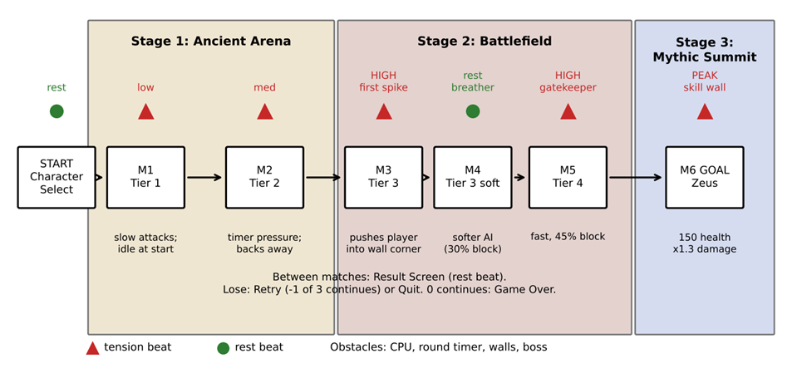

Figure 2. Annotated level map of the six-match Arcade ladder with tension (red) and rest (green) beats

5.3 Pacing and Difficulty Curve
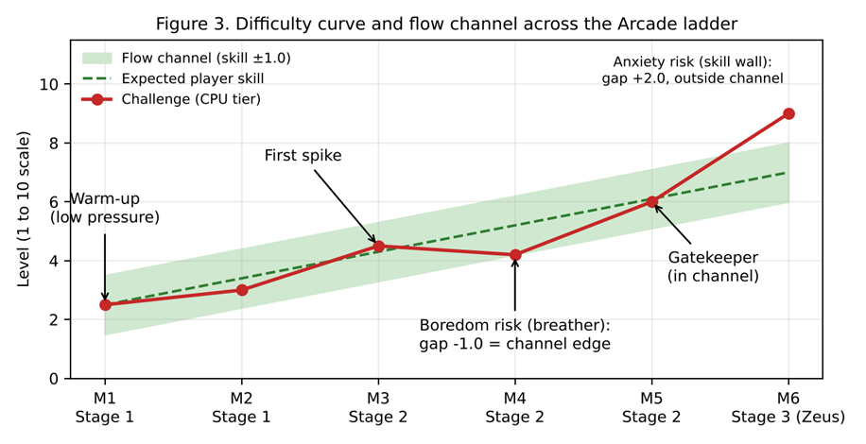
Figure 3. Difficulty curve against expected skill, with the flow channel shaded
Figure 3 plots the challenge of each match against the skill we expect the player to have by then. The table below names where each match sits in the flow channel and how the design handles the boredom or anxiety risk at that point. Table A (Section 6.2) gives the numbers behind the curve.

Where the player sits in the flow channel | Risk | How the design handles it
M1 and M2 (gap 0.0 and -0.4): inside the channel, at the easy end | Boredom for returning fighting-game players if the opponent is too passive | Matches are short, attacks speed up in Round 2 and in M2, and the player can use specials early
M3 (gap +0.2): inside the channel, first spike | Anxiety from the first opponent that pressures the player into a corner | The corner can be escaped by a jump, a skill already practiced in M1; the meter now helps the player come back
M4 (gap -1.0): exactly at the lower edge | Boredom if the breather feels too easy | The CPU still blocks 30% of the time and uses its special when it has meter, so the player must stay alert. The match is short and leads straight into the M5 gatekeeper, so it reads as a rest beat, not a dull fight.
M5 (gap -0.1): inside the channel | Low risk. A fair test of what the player has learned | Tier 4 settings: faster reaction, more blocking
M6 (gap +2.0): outside the channel on purpose | Anxiety and frustration at the god boss | Softened by the comeback meter, 3 continues, and a retry that is always the same fight (Section 6.4). If too hard, we lower block chance and damage before health

5.4 Teaching Mechanics Through Level Sequencing
Mechanic to be taught | Where it is introduced | How the level teaches it (no written instructions)
Movement, jump, crouch | M1, Round 1 (Stage 1) | The player starts in a safe space. The Tier 1 opponent does not attack for the first few seconds of Round 1 and then uses slow, easy-to-see attacks. The player can move around the arena and learn where the walls are. Jumping over or crouching under a slow attack makes it miss and leaves the opponent open, so the player can see the result.
Punch and kick | M1, Round 1 (Stage 1) | The player can see the effect of each hit. The opponent flashes, plays a recoil or hitstun effect, and loses health. A kick does more damage than a punch (10 vs 6 base damage), so the difference can be learned by looking at the health bar.
Block and chip damage | M1, Round 2 (Stage 1) | The opponent attacks more often in Round 2, and attacks have a clear wind-up flash. Getting hit removes a large amount of health, while blocking shows a spark and causes a much smaller health drop. Blocking still causes 25% chip damage, showing the player that blocking forever is not enough.
Special meter and special attack | M1, Rounds 2 to 3 (Stage 1) | The meter fills when the player deals and receives damage. When it reaches 50, the bar pulses and the warrior glows. The meter carries between rounds, so the player should have enough meter by Round 3. Since the Tier 1 opponent recovers slowly, the first special attack can be used safely.
Round timer and time-out rule | M2 (Stage 1) | The Tier 2 opponent defends and backs away when it has more health. During the last 10 seconds, the timer turns red and pulses. If the player waits too long, they can lose by health when time runs out. This teaches the player that they need to keep attacking.
Positioning and corners | M3 (Stage 2) | The Tier 3 opponent moves forward and pushes the player toward a wall. The camera stops at the arena edge and the stage art shows the wall, making the boundary clear. To escape, the player can jump over the opponent, which is a movement skill already practiced in M1.

SYSTEMS AND BALANCE

6.1 Resource Economy
Gunarok has six resources: health, special meter, time (the round timer), rounds won, continues, and screen space. The table shows where each one comes from (source), where it goes (sink), and what it starts at. The numbers come from Section II unless we mark them as provisional.

Resource | Source (how it enters play) | Sink (how it leaves play) | Starting value
Health | Refills to 100 at the start of every round. There is no healing, regeneration, or pickups during a round. | Taking hits: punch 6, kick 10, special 22 (modified per warrior). A blocked hit still deals 25% chip damage. | 100 per round (god boss 150)
Special meter | Damage taken: +1 per point. Damage dealt: +0.5 per point. Capped at 100, and any extra is lost. | A special attack costs 50. Resets to 0 when the match ends. | 0 (carries over between rounds of the same match)
Time (round timer) | Refilled to 60 seconds at the start of every round. | Counts down every second and never pauses. At 0 the round ends and the fighter with more health wins. | 60 seconds
Rounds won | +1 for each round won by KO or time-out. A draw round gives nothing and is replayed. | Resets to 0 when the match ends. The first fighter to reach 2 wins the match. | 0
Continues (Arcade only) | Given once at the start of an Arcade run. | -1 each time the player loses a match and retries it. At 0 the run ends in Game Over. | 3
Screen space | The arena has a fixed width. A fighter gets space back by moving away from the wall or pushing the opponent toward the other wall. | Lost when a fighter is pushed against a wall, which removes their retreat. | Both fighters start facing each other at mid-distance

Count one action (a punch, kick, block, or special) as 2 seconds, so a 60-second round is about 30 actions, around 15 for each fighter. This 2-second rule is only for paper and is provisional. On each action, the attacker deals punch 6, kick 10, or special 22 damage, and a special needs 50 meter. If the target blocks, it only takes 25% of that damage. After every hit, update both fighters: the attacker's meter goes up by 0.5 for each point of damage dealt, and the defender's meter goes up by 1 for each point of damage taken, up to 100. A round ends when someone reaches 0 health or the actions run out, and the fighter with more health wins. Equal health means the round is replayed. On paper, every warrior uses the base damage numbers.

Source and sink check: Some resources look one-sided at first, so we checked each one. Health only comes back through the round reset. This is on purpose, because healing would let a fighter stall until the timer runs out. Continues are only given once at the start of a run, which is also on purpose, so a run can't go on forever and the boss stays a real wall. The special meter has a source (damage) and a sink (the 50 cost), and it is capped at 100 and reset at the end of each match, so it can't pile up forever or carry from one ladder opponent to the next. Screen space can be won back by moving, so being cornered is a position the player can get out of. The timer and rounds won both refill or reset, so every resource has a way in and a way out.
Paper check: Working through the numbers showed two things we want to watch in playtests. First, 15 punches only deal 90 damage, so a fighter who only punches can't get a KO, and has to mix in kicks or specials or win on time. Second, a fighter who wins a round without being hit ends it with 50 meter (0.5 x 100), while the loser ends with 100 (capped), which is two specials at the start of the next round. This is the comeback we want, but it may be too strong, so if playtests show the loser snowballing in round 2, we will lower the meter gained from damage taken.

6.2 Progression Curve
Gunarok has no levels, XP, or upgrades, so the player's capability and the challenge don't grow the usual way. Inside a run, every fighter stays the same: 100 health, the same four moves, and the same meter rules. Capability here means the player's own skill, which grows as they learn each opponent and learn when to save meter. Challenge grows by raising the CPU tier. We put both on the same 1 to 10 scale so we can compare them. Expected player skill is the middle of the flow channel in Section 5.3. It starts at 2.5 in M1 and goes up by about 0.9 each match until it reaches 7.0 at M6. All of the numbers below are provisional, and we will adjust them after playtesting.

Table A. Expected player skill vs. challenge
Match | Expected player skill | Challenge | Gap (challenge minus skill) | What we expect
M1 | 2.5 | 2.5 | 0.0 | Warm-up. The player learns the controls.
M2 | 3.4 | 3.0 | -0.4 | Warm-up. The player feels comfortable.
M3 | 4.3 | 4.5 | +0.2 | First spike. The player has to start blocking and using meter.
M4 | 5.2 | 4.2 | -1.0 | Breather, at the lower edge of the flow channel.
M5 | 6.1 | 6.0 | -0.1 | Gatekeeper. A fair test of what the player has learned.
M6 | 7.0 | 9.0 | +2.0 | God boss. A skill wall, so we expect a retry or two.

Table B. CPU settings behind the challenge
Match | AI tier | CPU reaction delay | CPU block chance | CPU attack gap | CPU health / damage
M1 | Tier 1 | 0.60 s | 15% | 2.0 s | 100 / x0.8
M2 | Tier 2 | 0.50 s | 25% | 1.7 s | 100 / x0.9
M3 | Tier 3 | 0.40 s | 35% | 1.4 s | 100 / x1.0
M4 | Tier 3 (softer) | 0.45 s | 30% | 1.6 s | 100 / x1.0
M5 | Tier 4 | 0.30 s | 45% | 1.1 s | 100 / x1.1
M6 | God boss | 0.20 s | 55% | 0.8 s | 150 / x1.3

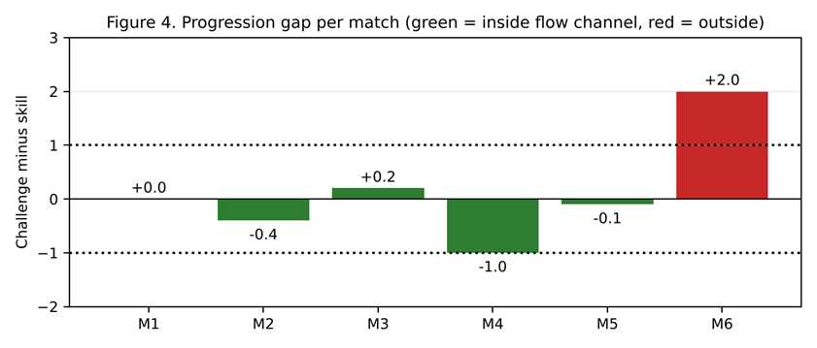
Figure 4. Progression gap per match (challenge minus expected skill): green bars are inside the flow channel, red is outside
Reading the curve: Challenge and skill rise together from M1 to M3. The dip at M4 is a deliberate breather before the M5 gatekeeper, and the gap there (-1.0) is exactly the edge of the flow channel, as Figure 4 shows, so we will watch for boredom in playtests. The M6 gap of +2.0 is outside the channel on purpose, because the god boss is meant to be the final skill wall. We soften it with the comeback meter and 3 continues, and the boss is always fought at the same settings on a retry. If the boss turns out to be too hard, we will lower its block chance and damage multiplier first before touching its health.

6.3 Symmetry, Asymmetry, and Fairness
Versus mode is symmetric in the rules and slightly asymmetric in the roster. Both players get the same arena, 100 health, 60-second timer, four moves, meter rules (+1 per point taken, +0.5 per point dealt, special costs 50), and the same spawn distance. Nobody gets a first-move advantage, and a draw round is replayed instead of favoring one side. The outcome feels fair because everything that hurts a player can be seen and answered. Every attack has a startup, active, and recovery phase, damage is fixed with no hidden dice, and a hit only lands when the hitbox overlaps the hurtbox. So when a player loses, it comes from their own timing and positioning.

Keeping the roster fair, the 8 warriors differ in damage, reach, and movement speed. To keep this fair, every warrior gets the same stat budget: each stat is rated 1 to 5 and the three ratings add up to 9 (Table C). A warrior who is strong in one stat has to be weaker in another. For example, a long-reach spear fighter like Leonidas gives up speed, while a quick striker like Nai Khanom Tom gives up reach. No warrior has a move the others don't have in some form, so a loss can't be blamed only on the character that was picked.
Table C. Warrior stat ratings (each 1 to 5; every warrior totals 9)
Warrior | Homeland | Weapon | Damage | Reach | Speed | Special
Leonidas | Sparta | Spear and shield | 3 | 5 | 1 | Phalanx Charge
Julius Caesar | Rome | Gladius | 3 | 3 | 3 | Legion's March
Ragnar | Scandinavia | Axe | 5 | 2 | 2 | Berserker Cleave
Miyamoto Musashi | Japan | Two swords | 3 | 2 | 4 | Two Heavens Strike
Lapu-Lapu | Mactan | Kampilan | 4 | 3 | 2 | Kampilan Storm
Crazy Horse | Oglala Lakota | War club | 4 | 2 | 3 | Warrior's Charge
Simo Häyhä | Finland | Rifle | 2 | 5 | 2 | White Death (long range)
Nai Khanom Tom | Ayutthaya | Fists (Muay Thai) | 3 | 1 | 5 | Ten Champions Flurry
Zeus (boss) | Mount Olympus | Thunderbolt | 4 | 4 | 3 | Thunderbolt (outside the budget)
Arcade mode is asymmetric on purpose, since the player faces CPU fighters and a god boss. We keep it fair in four ways. First, the CPU follows the same rules as the player: hitstun, one attack at a time, stage walls, and meter costs. Second, the CPU has a reaction delay and cannot read the player's inputs. Third, difficulty rises in steps (Section 6.2) with a breather at M4. Fourth, the boss's extra strength is shown openly as more health and damage (150 health, x1.3 damage) and is not hidden. The player also has the comeback meter and 3 continues.
One known fairness risk, two players sharing one keyboard can hit key-rollover limits, where the keyboard can't register many keys pressed at the same time. We will test both key layouts early and move keys if one player's inputs get dropped more than the other's.

6.4 Randomness and Probability
System using randomness | Probability / range of values | Purpose of the randomness | Safeguard against unfair outcomes
CPU blocking (Arcade only) | Each time the CPU sees an attack coming, after its reaction delay, it rolls to block. Chance for M1 to M6: 15%, 25%, 35%, 30%, 45%, 55%. | So the CPU doesn't block in a fixed pattern, and higher tiers feel smarter. | The chance is capped at 55%, so at least 45% of attacks get through on average. Even a blocked hit still deals 25% chip damage.
CPU attack timing (Arcade only) | The gap between CPU attacks is random within the tier average +/- 0.3 s. Averages for M1 to M6: 2.0, 1.7, 1.4, 1.6, 1.1, 0.8 s. | So there is no fixed rhythm to memorize, but it is not so wild that it feels unfair. | The shortest possible gap is 0.5 s. The CPU can only use one attack at a time and must finish its recovery, so the player always gets a window to block or hit back.
CPU attack choice (Arcade only) | Punch 50%, kick 50%. When the CPU has 50 or more meter: special 30%, punch 35%, kick 35%. | So the player has to react to both quick and slow attacks. | The CPU follows the same meter rule, so it can't use a special without paying 50. The weights are fixed for each match.
Combat damage, hits, ladder order, and stages | None (0%). Damage is fixed: punch 6, kick 10, special 22, and 25% chip damage. Matches M1 to M6 are always in the same order (Section 5.1). | None on purpose. A hit lands only when the hitbox overlaps the hurtbox, so results come from skill, and we keep control of the difficulty curve. | Not needed, since nothing here is random. Retrying a lost match gives the same opponent at the same settings.

Protection against an unwinnable run: Combat has no randomness because fighting game players expect to win or lose from their own timing and positioning. The only random part is how the CPU picks its actions, and it is limited in five ways. The block chance is capped at 55%. A blocked hit still does chip damage, so even if the CPU blocks every hit in a row, its health still goes down. The CPU cannot skip startup or recovery, so it always leaves an opening. The settings are fixed for each match, so a retry is the same fight. The player also has the comeback meter and 3 continues. Because of these limits, bad luck can't make a run unwinnable.

NARRATIVE DESIGN

7.1 Premise and Setting
Premise. The gods of mythology have always claimed that no mortal can stand against them. To test that claim, history's greatest warriors are pulled out of their own eras and into one arena outside of time. They fight each other up a ladder, and the last fighter standing earns a match against a god: Zeus, king of the Greek gods, who answers for all of them. This is the same idea as the elevator pitch in Section 1.2: beat the god and become the strongest fighter of all time.
Setting. The story has no fixed place or year, which is why a Spartan king, a samurai, and a Finnish sniper can share one ring without explanation. The mix of eras is the premise, as stated in the Boundaries row of Section II. The three stages carry the setting: Stage 1, Ancient Arena (M1 and M2); Stage 2, Battlefield (M3 to M5); and Stage 3, Mythic Summit (M6, Zeus).
The player's role. The player is the warrior they pick at Character Select (Section 4.2). There is no created hero, no dialogue, and no backstory screen. Section 3.2 deliberately keeps Narrative as a kind of fun we do not pursue, and Section 1.4 cuts Story mode, per-character intros and endings, voice acting, and cutscenes. The premise is only there to give every match a reason to happen.

7.2 Narrative Delivery Method
How the story reaches the player. There are no cutscenes and no dialogue. The story comes through four things the player already sees while playing: the stage art, a short opponent intro card, the size of Zeus's health bar, and the ending screen. Nothing has to be read to play, so none of it slows the 2 to 3 minute match.

Opponent intro card. Before round 1 of every match (node 2 of the core loop, Figure 1), the game shows the opponent's name, homeland, and era for about two seconds, for example "Leonidas, Sparta, Ancient Greece" or "Simo Häyhä, Finland, 20th century". It is drawn in the engine over the stage with the warrior's idle pose, so it needs no cutscene.
Environmental storytelling examples.
- Stage 1, Ancient Arena (M1 and M2): banners and shields from many different eras hang from the stone walls, and silhouettes of a crowd watch from the stands. The mixed banners tell the player that fighters from different times have been gathered here. The wall art also makes the arena edge easy to see, which is the job Section 5.4 gives it.
- Stage 2, Battlefield (M3 to M5): the ground is scorched, and old weapons from different periods are stuck in the dirt, such as a spear, a katana, a broken shield, and a rifle. They show that earlier challengers have already fallen here. The sky is tinted a little darker each match from M3 to M5, so the player feels the run closing in on the end without any text.
- Stage 3, Mythic Summit (M6): marble columns, clouds under the floor, and statues of gods much taller than the fighters at the edges of the screen. It is the only stage that does not look like it belongs to mortals, which tells the player that Zeus is a different kind of opponent.
Zeus's health bar: Zeus starts with 150 health instead of 100, so his bar is drawn longer than any other opponent's, and his special is drawn as lightning. The player reads "this one is stronger" before the first hit lands.
Warriors tell their story through play. The weapon and stat trade-off of each warrior, for example Leonidas giving up speed for reach and Nai Khanom Tom giving up reach for speed, shows who they are in how they fight. This stands in for per-character stories, which are out of scope.
Ending. Defeating Zeus ends the run on a final screen with one or two lines of text and the final score. Running out of continues shows the Game Over screen instead.

7.3 Branching and Player Agency
The narrative is linear. The Arcade ladder is a fixed order of six matches and every run ends in the same place: Zeus at Stage 3. We kept it linear because a branching story needs separate writing, art, and testing for every path, Section 1.4 already cuts Story mode, and the fixed order is what lets us control the difficulty curve.

Where the player still chooses. There are two decision points, shown in Figure 6, and each one costs the player something.
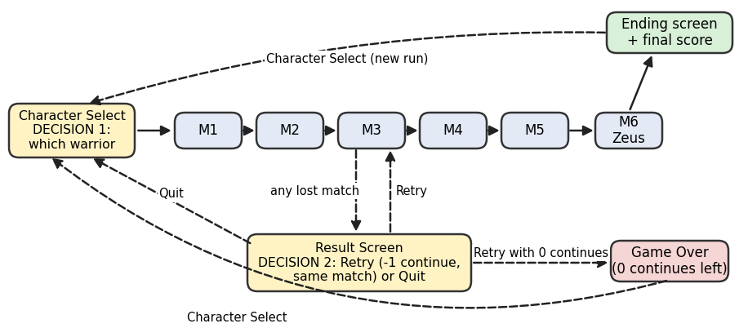

Figure 6. Branching map: the fixed ladder and the two player decisions

Decision 1, which warrior (Character Select). Choosing one warrior gives up the strengths of the other seven. Every warrior has the same stat budget (three ratings that add up to 9, Section 6.3), so taking more reach means giving up speed or damage. Coming back with a different warrior is the replay variety described in Section 5.1, and it also changes which five rivals appear in M1 to M5.

Decision 2, retry or quit after a loss (Result screen). Retrying spends one of the 3 continues and replays the same opponent at the same settings (Section 6.4). Quitting gives up all progress on the ladder. With no continues left the choice is taken away and the run ends in Game Over. In-match choices, such as spending meter on a special, are covered in Section 3.1 and do not change the story.

TECHNICAL DESIGN

8.1 2D, 3D, or Hybrid Decision
Decision: 2D. Gunarok is a 2D side-view fighting game built in Godot 4. We did not choose full 3D or a hybrid (3D models fighting on a 2D plane).
Readability. The whole fight happens on one horizontal plane, with no depth axis and no sidestep. In 2D the distance between the two fighters is the most important thing on screen: it shows who is in range, who is cornered, and whether a jump will clear the opponent. A fixed HUD at the top shows health, meter, and the timer. A 3D camera adds angles that can hide the wind-up pose and the stage walls, and Section 5.4 depends on both to teach blocking and corners.
Scope. Section 1.4 names character animation as the biggest cost. In 2D, each warrior needs one set of sprite animations (idle, walk, jump, crouch, punch, kick, block, special, hitstun, knockdown, get-up, and KO), and all eight share the same move template, so the animation list is the same for everyone. 3D would add modeling, rigging, and animation for 8 warriors and a god, plus rules for a depth axis that the game does not have. That is not realistic for one term.
Team skill. All five members have programming as a primary or secondary role, and Godot's 2D nodes are simpler to learn than its 3D ones. Only two members cover art (Acejo as primary, Asas as secondary), so 2D sprite sheets are the only art pipeline that fits the team.
Why not a hybrid. A hybrid would still need the 3D art pipeline and would not remove any of the 2D work, so it adds cost without helping any design goal.

8.2 Camera System
Camera type | Fixed-angle, side-scrolling follow camera (Camera2D, node CameraRig). It follows the midpoint between the two fighters, moves only left and right, and has no zoom or rotation. Its limits are set to the stage walls, so it stops at the arena edge (Section 5.4) and never leaves the arena (Section II, Boundaries). Position smoothing keeps it from jittering.
What the camera must always keep visible | Both fighters at all times: they cannot get further apart than the screen width minus a margin, so neither can walk off screen. Also the full height of a jump, and the stage wall when a fighter is cornered. The HUD: both health bars, both meters with the 50-point mark, the round timer, and the rounds won. The HUD sits on its own CanvasLayer, so it never moves with the camera and stage art cannot cover it.
Readability risks | 1. Fighters overlap at close range and it is hard to tell who is who. Mitigation: P1 and P2 tags above each fighter, a different outline for each, and an alternate palette when both players pick the same warrior.  2. A cornered fighter is half hidden by the screen edge. Mitigation: the camera limits leave a margin, so a fighter touching the wall is fully on screen.  3. Hit effects cover the opponent's wind-up. Mitigation: effects are short, small, and drawn behind the fighters, and the wind-up has its own pose, not just a flash (Section IX, Visual).  4. A jump goes above the top of the screen. Mitigation: the stage height leaves room for the highest jump, which we check in the first prototype (Section XI).

8.3 Control Scheme and Input Mapping
Every action is a named action in the Godot Input Map (Project Settings, Input Map). Player 1 uses the p1_ actions and Player 2 uses the p2_ actions. Gamepad events are added to the same actions, so keyboard and gamepad work together. Gamepad 1 controls Player 1 and gamepad 2 controls Player 2. Button names use the Xbox layout.

Player action | Primary input | Alternate input | Rationale
Move left / right | P1: A / D  P2: Left / Right arrows | D-pad left/right or left stick | Fighters face each other automatically, so there is no turn button. Moving away is how a player retreats.
Jump | P1: W  P2: Up arrow | D-pad up or left stick up | Jumping over the opponent is the way out of a corner that M3 teaches (Section 5.4), and it dodges kicks.
Crouch | P1: S  P2: Down arrow | D-pad down or left stick down | Lets the player duck high attacks (punches), as taught in M1 (Section 5.4).
Punch | P1: F  P2: Numpad 1 | X button | Fast attack with the lowest base damage (6). One press, no combos.
Kick | P1: G  P2: Numpad 2 | A button | Stronger than a punch (base damage 10). The difference can be read from the health bar (Section 5.4).
Block(hold) | P1: H  P2: Numpad 3 | Left bumper (LB) | Block has its own key, so the player does not need to hold back at the right moment. A blocked hit still deals 25% chip damage.
Special | P1: T  P2: Numpad 5 | Y button | One key, needs 50 meter. No motion inputs, which keeps the controls simple.
Menus (move, confirm, back) | Arrow keys, Enter, Backspace | D-pad, A button, B button | Covers the out-game actions in Section 4.4: mode select, character select, result screen, and pause menu. In Versus character select, each player moves with their own movement keys, confirms with Punch or Kick, and cancels with Block, so both can pick at once.
Pause | Esc | Start button | Pause can be used at any time during a round (Section 4.4).
Two Players in one keyboard | P1 on the left side of the keyboard; P2 on the arrows and numpad | One gamepad each if the key-rollover test fails (Section 6.3) | Keeps the players' hands apart and spreads out the keys pressed at the same time, which lowers the chance of dropped inputs.

8.4 Godot Scene Tree Plan
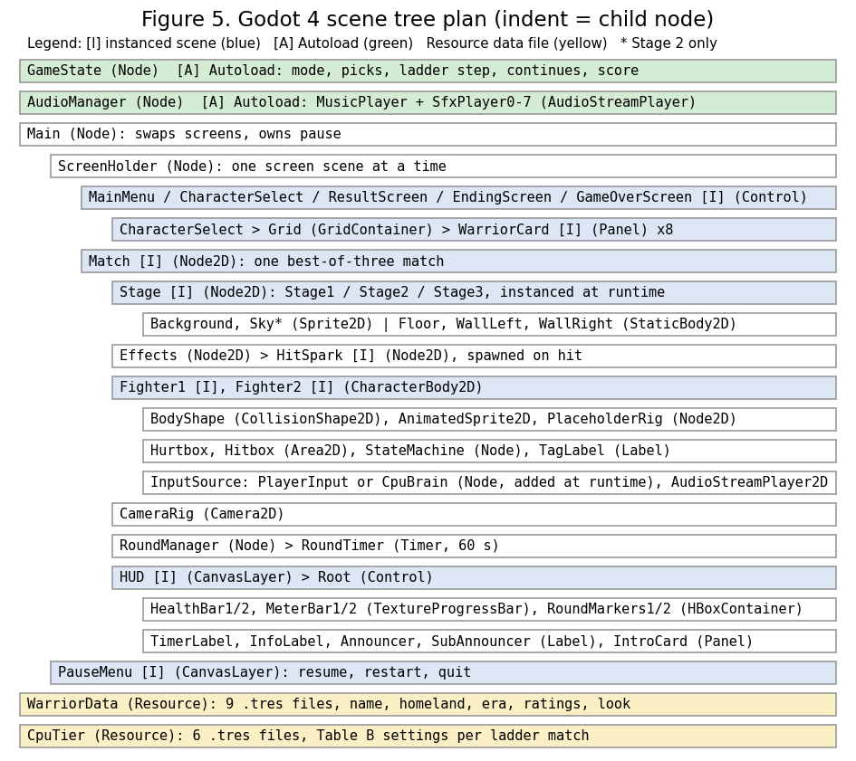

Figure 5. Godot 4 scene tree plan with node types and instanced scenes

Instanced scenes. Figure 5 shows the scene tree as built. Instanced scenes: Stage (one of three stage scenes, loaded at runtime), Fighter (twice), HUD, PauseMenu, and the menu screens, which Main swaps inside ScreenHolder. GameState and AudioManager are Autoloads. Fighter.tscn is reused for Player 1, Player 2, the rival CPU warriors, and Zeus: only the InputSource child changes (PlayerInput for people, CpuBrain for Arcade opponents). This is why Arcade and Versus share one fighting system.
Data as Resources. WarriorData holds the 8 warriors' stat ratings (Table C in Section 6.3) and CpuTier holds the settings in Table B (Section 6.2), including the god boss. They can be edited in one place without changing code, which makes the tuning that Section 6.1 expects after playtests cheap.

8.5 Signals and Event Wiring
Signal | Emitted by | Connected to | What happens as a result
warrior_selected (player, warrior) | CharacterSelect | GameState | Stores the pick. Arcade: builds the ladder, sets the step to M1, and loads the Match. Versus: after both picks and the stage choice, loads the Match.
match_started (stage, p1, opponent) | GameState | Match, HUD | Match loads the stage and sets up both fighters at mid-distance with their InputSource, then connects the signals below. HUD resets rounds won and shows the opponent intro card.
round_started (round_no) | RoundManager | Fighters, HUD, RoundTimer | Health back to full (150 for Zeus), fighters back to mid-distance, and the timer back to 60. HUD shows ROUND and FIGHT; input unlocks after the banner. Meter carries over.
hit_landed (attacker, defender, damage, blocked) | Hitbox (Area2D) | Defender Fighter, HUD | Applies damage (25% if blocked), hitstun or knockdown on an unblocked hit, the hit spark, and the hit sound. Attacker meter +0.5 per damage dealt, defender meter +1 per damage taken.
health_changed, meter_changed (fighter, value) | Fighter | HUD (both); RoundManager (health_changed) | Bars update. Meter at 50 or more: the bar pulses, SPECIAL READY appears, and the warrior glows. Health at 0: RoundManager ends the round by KO (a double KO is a draw).
time_changed (seconds), time_up | RoundTimer | HUD (time_changed); RoundManager (time_up) | Last 10 seconds: timer turns red and pulses (Section 5.4). At 0: more health wins the round. Equal health is a draw and the round replays (Section II, Outcome).
round_ended (winner, reason) | RoundManager | HUD, Match, GameState | HUD shows the KO, TIME, or DRAW banner and fills a round marker; Match freezes both fighters; GameState counts rounds won in the run. RoundManager then starts the next round, or ends the match when a fighter has 2 rounds. A third draw is decided as in Section II.
match_ended (winner, perfect, winner_health) | RoundManager | GameState | GameState adds the score (Section II, Outcome) and opens the ResultScreen. Arcade win: the next rival, or run_completed after M6. Arcade loss (lose state): Retry or Quit. Versus: the winner is shown with Rematch or Character Select.
next_chosen, retry_chosen, quit_chosen | ResultScreen | GameState | Next: the next ladder match (Arcade) or a rematch (Versus). Retry: continues -1 and the same match reloads at the same CPU tier (Section 6.4); with 0 continues left, game_over is emitted instead. Quit: back to Character Select.
run_completed (score), game_over | GameState | Main | run_completed: EndingScreen with the final score, then Character Select. game_over: Game Over screen, then Character Select.
screen_requested (screen) | GameState | Main | Main swaps the screen inside ScreenHolder: main menu, character select, match, or result (deferred, so a screen is never freed while it is handling input).
resume_chosen, restart_chosen, menu_chosen | PauseMenu | Main | Main closes the pause menu and unpauses the SceneTree, then resumes, reloads the match, or goes to the main menu.
pause_pressed | Main (pause action) | PauseMenu, SceneTree | Pauses the game. Resume continues, Restart reloads the match, Quit returns to the main menu (Section 4.4).

ACCESSIBILITY CONSIDERATIONS
Category | Barrier the current design creates | Accommodation | Core mechanic or optional setting?
Visual | The game depends on small, fast information: health bars, meter, and the timer. Some cues use color alone, such as the red timer in the last 10 seconds and the wind-up flash that teaches blocking (Section 5.4). Flashing hit effects can also bother players who are sensitive to flashing. | Core: every color cue gets a second cue. The timer also pulses and grows, the meter also pulses and shows SPECIAL READY at 50, the wind-up flash comes with a raised-weapon pose, and P1 and P2 have different tags and outlines. The HUD is large, high-contrast, and fixed at the top (Section 8.2). Optional: a Reduce Flashing setting that swaps hit flashes for a steady outline, and a color-blind-friendly HUD palette. | Both. The second cues are core. Reduce Flashing and the palette are optional settings.
Motor | Two players share one keyboard, and keys can be dropped when many are pressed at once (Section 6.3). Holding block while moving and attacking takes finger coordination. | Core: every action is one key or one button. There are no combos, motion inputs, or button mashing, only one attack is active at a time, and the CPU never attacks faster than once every 0.5 s (Section 6.4). Block is a hold on its own key. Gamepad support is built in through the Input Map (Section 8.3). Optional: an in-game key remapping screen (cut from this term). | Core for the single-key actions and gamepad. Optional for remapping.
Cognitive | A new player has to learn movement, four attacks, blocking, chip damage, meter, and the timer, and a fighting game moves fast. | Core: only four moves, shared by all eight warriors. The ladder teaches one mechanic at a time with no written instructions (Section 5.4). The first opponent starts slow, nothing is random in combat (Section 6.4), a retry is always the same fight, and the result screen between matches is a rest point (Section 5.2). Optional: the pause menu shows the key layout as a reminder. | Mostly core. The key layout reminder is an optional setting.
Hearing | Hit sounds, the round start call, and the low-time warning are audio cues. A player who cannot hear them could miss that a hit landed or that time is running out. | Core: every sound cue has a visual twin. Hits show a spark and recoil, blocks show a different spark, banners show ROUND, FIGHT, KO, and TIME, and the timer warning is visual. The game has no voice acting or spoken story (out of scope in Section 1.4), so nothing needs captions. Optional: separate music and effects volume sliders. | Core for the visual twins. Volume sliders are optional settings.

9.1 Accessibility Trade-Off Statement
Considered and not adopted: an option to turn off or lengthen the round timer. It would help players who feel stressed by the countdown or who need more time to react. We did not adopt it because the timer is part of the core design, not an extra rule. It is what stops the player who is ahead from stalling. It creates the tension in the last 10 seconds that PX goal 1 depends on (Section 3.4). Every number in Tables A and B and the paper play in Section 6.1 (about 30 actions in 60 seconds) is built around a 60-second round. In Versus, a timer setting would also change the game for both players unless they agreed on it, and it would make Arcade scores and difficulty hard to compare. What we do instead: M1 and M2 are low-pressure, with slow, easy-to-read attacks, and the M1 opponent does not attack for the first few seconds (Section 5.4). The timer warning is visual as well as audio. We accept that a player who finds the timer itself a barrier has no setting to remove it, and we will revisit this if playtesters report it.

CONTENT RATING AND PROFESSIONAL STANDARDS SELF-ASSESSMENT

10.1 Content Rating Self-Assessment
Target rating category | ESRB Teen (T), suitable for ages 13 and up (Entertainment Software Rating Board, n.d.). This matches the target audience of about 13 to 25 in Section 1.3. Gunarok is a fighting game with armed combat between human warriors and a mythological boss and shows no blood or gore. Teen is the safer choice over Everyone 10+ because of the weapons, including the sniper's rifle.
Applicable content descriptors | Violence: fighters hit each other with fists, kicks, and period weapons such as a spear, sword, katana, club, and rifle. A defeated fighter falls in a knockdown animation (Section II, Outcome). Fantasy Violence: applies to Zeus, whose special attack is drawn as lightning.
Content deliberately excluded | Blood, gore, dismemberment, and finishing moves. A KO is a knockdown, not a death, and wounds are never shown, including firearm hits, which use the same hit spark and recoil as any other attack. Also excluded: gambling and loot boxes (Section 10.3), profanity, sexual content, and references to drugs, alcohol, or tobacco. No real flags, symbols, or slogans of hate groups. No jokes or caricatures about any culture or religion: the warriors are shown with respect, and the gods are shown as mythological characters.

10.2 Intellectual Property and Asset Sourcing
Every asset in Gunarok is either original, licensed for our use, or in the public domain.
Original. The warrior and god boss sprite sheets are drawn by the team; until they are finished, the build draws each warrior with simple placeholder shapes. The stage backgrounds, HUD and menu art, sound effects, and music in the current build are listed with their sources in Section 12.2. None of the art is traced, copied, or edited from other games, films, TV shows, or photographs. This matters most for warriors who already have famous screen versions, such as Leonidas and Ragnar. Our designs come from our own drawings of the person and their period clothing and weapons, not from any film or TV costume.
Historical and mythological figures. The warriors and Zeus are people and characters from history and mythology, and their names are not owned by anyone. Simo Häyhä (died 2002) is the only roster member from recent history. He is not a living person (Section II, Boundaries), and his design is drawn from period descriptions, not from photographs.
Third-party. The Godot Engine (MIT License), plus the font and any outside sound effects or music, which we only take from public-domain or openly licensed sources (such as CC0, CC BY, or the Bitstream Vera font licence), with credit given. Every third-party item is listed in Section 12.2 with its license. We do not use ripped assets, and if an asset has no clear license we do not use it.

10.3 Monetization and Player Wellbeing
Monetization. Gunarok has no monetization. It is a course project with no purchases, ads, loot boxes, or paid unlocks, so there is nothing to disclose before purchase.
Player wellbeing. The parts of the design that could pull a player into playing too long are the Arcade ladder, which has a "one more run" loop (Section 4.3), and the urge to rematch a friend in Versus. We keep these in check in four ways. A full run is only about 15 to 20 minutes and a typical sitting 15 to 30 minutes (Section 1.3). There are no daily rewards, streaks, timed events, or login bonuses, and no XP, levels, or unlocks to chase (Section 6.2). Continues are limited to 3 and cannot be bought or refilled, so a player cannot spend or grind their way past the boss (Section 6.1). And the game can be paused at any time (Section 4.4). Zeus is meant to be a skill wall (Section 6.2), which could cause frustration. It is softened by the comeback meter and the 3 continues, and a retry is always the same fight, so there is no hidden bad luck to blame (Section 6.4).

PROTOTYPE SCOPE AND DEVELOPMENT PLAN
Mechanics in the prototype | Everything marked in scope in Section 1.4: move, jump, crouch, punch, kick, block with 25% chip damage, and one special attack (50 meter). The meter rule (+1 per point taken, +0.5 per point dealt). Hitbox and hurtbox hits with startup, active, and recovery, and the high/low rules in Section II. Hitstun and knockdown. 100 health, a 60-second timer, and best-of-three rounds. Character Select with 8 warriors sharing one move template and differing in damage, reach, and speed. The Arcade ladder with the CPU tiers in Table B and 3 continues. Local 2-player Versus on one keyboard or two gamepads.
Level or encounter included | The six-match Arcade ladder (M1 to M6) across the three stages in Figure 2, which is the one complete level in this linear design. Stage 1 with M1 and M2 is built first as a playable slice, because it also holds the teaching sequence in Section 5.4.
Win and lose states | Win a round: KO, or more health when time runs out. A draw replays the round. Win a match: first to 2 rounds. Arcade shows the Result screen and moves to the next opponent. Versus offers a rematch or a return to Character Select. Clear the run: beat Zeus at M6 and see the ending screen with the final score. Lose a match: the Result screen offers Retry (uses 1 of 3 continues) or Quit. With no continues left the game shows Game Over and returns to Character Select. All of these states are driven by the signals in Section 8.5.
First thing to be prototyped | One fight between two placeholder rectangles that already uses the real rules: keyboard input for two players, hitbox and hurtbox, health, meter, the 60-second timer, and best-of-three rounds. It comes first because it is the riskiest part and everything else reuses it. It tests whether hits feel fair, whether the two keyboard layouts survive the key-rollover problem (Section 6.3), and whether the comeback meter is too strong (the paper check in Section 6.1). Character Select, the warriors, the CPU ladder, and Zeus all sit on top of this fight, so a problem found later would break all of them.
Known technical risks | 1. Key rollover with two players on one keyboard (Section 6.3). Fallback: move the keys or use gamepads.  2. Fighter state machine bugs (hitstun, knockdown, one attack at a time). Fallback: drop the get-up animation and use a short recovery after knockdown.  3. Animation workload for 8 warriors and Zeus (Section 1.4). Fallback: ship with fewer finished warriors, keep every system and the ladder as designed, and reuse a recolored sprite for Zeus.  4. CPU feel (Table B). Fallback: reuse the Tier 3 settings for more matches and tune only reaction delay and block chance.  5. The comeback meter being too strong or too weak (Section 6.1). Fallback: change the one number for meter gained from damage taken, which lives in the WarriorData and CpuTier resources (Section 8.4).

REFERENCES AND ASSET ATTRIBUTION

12.1 Design References
Adams, E., & Dormans, J. (2012). Game mechanics: Advanced game design. New Riders.
Bartle, R. (1996). Hearts, clubs, diamonds, spades: Players who suit MUDs. Journal of MUD Research, 1(1).
Capcom. (1991). Street Fighter II: The World Warrior [Video game]. Capcom.
Csikszentmihalyi, M. (1990). Flow: The psychology of optimal experience. Harper & Row.
Entertainment Software Rating Board. (n.d.). Ratings guide. Retrieved October 29, 2026, from https://www.esrb.org/ratings-guide/
Fullerton, T. (2018). Game design workshop: A playcentric approach to creating innovative games (4th ed.). CRC Press.
Game Accessibility Guidelines. (n.d.). Game accessibility guidelines. Retrieved October 29, 2026, from https://gameaccessibilityguidelines.com/
Godot Engine contributors. (n.d.). Godot Engine documentation. Retrieved October 29, 2026, from https://docs.godotengine.org/
Hunicke, R., LeBlanc, M., & Zubek, R. (2004). MDA: A formal approach to game design and game research. In Proceedings of the AAAI Workshop on Challenges in Game AI (Vol. 4, No. 1, pp. 1-5). AAAI Press.
Namco. (1994). Tekken [Video game]. Namco.
Schell, J. (2019). The art of game design: A book of lenses (3rd ed.). CRC Press.

12.2 Asset Attribution
Asset | Type | Source | Licence and permitted use
Godot Engine 4 | Software | godotengine.org | MIT License. Free to use, change, and ship. The copyright notice is kept in the credits.
Warrior and god boss sprite sheets | Art (2D) | Original, made by the team | Owned by the team. No outside license needed.
Stage backgrounds (3), HUD, and menu art | Art (2D)
Hit, block, and menu sound effects | Audio
Background music (menus, stages, boss) | Audio
Text and HUD font | Font | DejaVu Fonts. (n.d.). DejaVu Sans Condensed Bold [Typeface]. https://dejavu-fonts.github.io/ | Bitstream Vera Fonts licence, with DejaVu changes in the public domain. Free to use and embed in the game. Credit is given.

REVISION LOG
Leave this section blank for the draft submission. Complete it in full for the revised submission: every change made in response to the first evaluation must be logged here, with the page or section where the change can be found.
No. | Comment received on the draft | Section revised | What was changed | Reason for the change
1

2

3

4

5

6

13.1 Changes Made Without Being Asked

