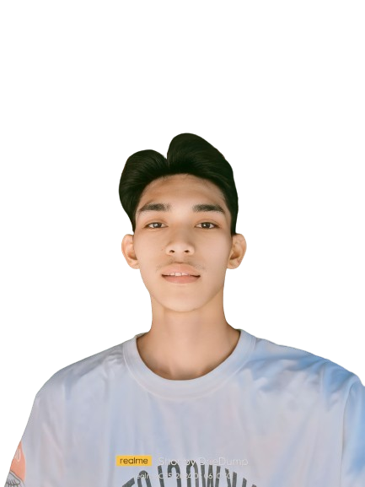**CAREER OBJECTIVE**

Diligent and competent software engineer seeking a challenging role for my first professional

experience. Possess a solid foundation in software development principles, a strong work ethic, and a commitment to continuous learning. Eager to contribute to innovative projects, collaborate with experienced professionals, and make meaningful contributions to a dynamic work environment. Ready to apply my skills, and knowledge to drive success in software engineering projects.

**PERSONAL INFORMATION**

**Date of Birth. :** May,10,2003  
**Age**  : 20 **Place of Birth :** San Carlos City Pang. **Civil Status :** Single  
**Citizenship :** Filipino **Sex :** Male **Religion :** Roman Catholic

**EDUCATIONAL BACKGROUND**

**Tertiary Level**Bachelor of Science in Computer Engineering in Philippine College of Science and Technology (PHILCST) -2nd year college

**2023-2024**

**Secondary Level** Urbiztondo Catholic School (Senior High)  
**2020-2021**

Guelew Integrated School (Grade 10)

**2018- 2019**

**Primary Level** Guelew Integrated School

**2014-2015**

**SKILLS AND INTEREST**

**Skills:**  Microsoft Office, C++, Printing, and Slide Presentation

**Interest:** Documentaries, Photography, Blogging, Community Service

**CHARACTER REFERENCE**

**ANGELINE JUNIO**

**#09776698917**

**458 Sitio Pacita, Barangay Calbueg, Malasiqui, Pangasinan   
WILFORD MADAYAG**

**#09208788433**

**Cabilocaan Calasiao, Pangasinan**

I hereby certify that the above information is true and correct to the best of my knowledge and belief.

________________________

**APPLICANT**