Create 3 different stored procedure:

* First is simple static dbo.sp_IdArrangeOnEmployee.
* Second is dbo.sp_PaggingOnEmployee with 2 paremeter (starting number and ending number)  
   like exec dbo.sp_PaggingOnEmployee 1,15
* Third is dbo.sp_ProductSelling with 2 parameter (product_id and product_quantity)  
   like exec dbo.sp_ProductSelling 1,30  
  use 2 tables :

Product

(pid,pName,pUnitPrice,pQtyAvl) -- pid is primary key and Auto Increment

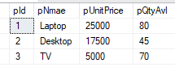

ProductSales

(psid,pid,QtySold) -- psid is primary key and Auto Increment, pid is foreign key

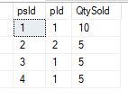

sp_ProductSelling through insert new record in ProductSales and update its qty in product table.