From the scatter plot of Sepal Dimensions (Length vs. Width) by Species, here are some insights and observations
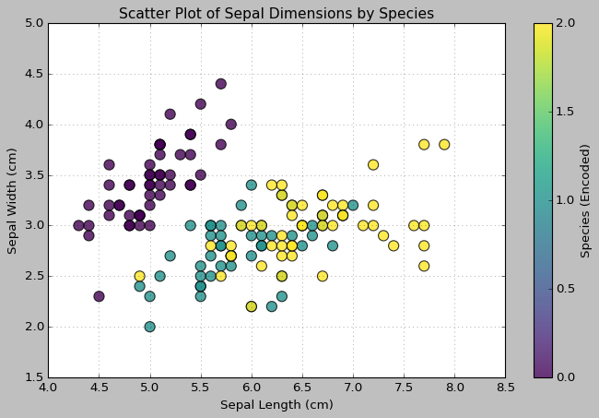
Insights:
- Clustering of Species:
  - Species 0 (Purple): Points are clustered in the top-left region of the plot. This indicates that Iris-setosa has relatively smaller sepal length and larger sepal width compared to other species.
  - Species 1 (Cyan): Points are distributed in the middle region with moderate sepal length and width, representing Iris-versicolor.
  - Species 2 (Yellow): Points are scattered towards the bottom-right, showing Iris-virginica has longer sepal length and smaller width.
- Separation of Species:
  - There is a clear separation between Iris-setosa and the other two species (Iris-versicolor and Iris-virginica). This suggests Sepal Length and Sepal Width are good features for distinguishing Iris-setosa.
  - Iris-versicolor and Iris-virginica overlap slightly, indicating these two species are less distinct in sepal dimensions.
- Feature Relationships:
  - Iris-setosa: Sepal width decreases slightly with increasing sepal length, but the range of values is compact, forming a tight cluster.
  - Iris-versicolor & Iris-virginica: Both species have more variability in sepal length and width, showing greater diversity in their sepal dimensions.
- Species Variability:
  - Iris-setosa: Low variability in both sepal length and width, indicating consistent sepal dimensions.
  - Iris-versicolor and Iris-virginica: Higher variability in sepal length, with Iris-virginica having the longest sepals.

Inferences:
- Classification Feasibility:
  - The distinct clustering of Iris-setosa suggests it can be easily classified using simple classification algorithms like Logistic Regression or Decision Trees based on these features.
  - Distinguishing Iris-versicolor and Iris-virginica might require more complex models or additional features like petal dimensions.
- Feature Importance:
  - Sepal dimensions alone are moderately effective for species classification, especially for distinguishing Iris-setosa.
  - Petal dimensions (not shown in this plot) may provide better separation between Iris-versicolor and Iris-virginica.
- Real-world Implication:
  - Sepal dimensions can serve as a preliminary feature for identifying Iris-setosa, but further analysis of petals may be needed for finer classification between the other two species.

