The Islamia University of Bahawalpur
Department of Information Technology

SOFTWARE DESIGN DOCUMENT
(SDD DOCUMENT)
for
Restaurant Management System
with Card Payment Integration
Version 1.0
By
MUHAMMAD HANZLA
Roll No: S23BINFT1E02004
Session 2023 – 2027
Supervisor
DR. MUSARAT KARIM
Bachelor of Science in Information Technology

TABLE OF CONTENT
Revision History I
Document Approval I
1. Introduction 1
1.1 Purpose 1
1.2 Scope 1
1.3 Abbreviations 1
2. System Overview 1
3. System Architecture 1
3.1 Architecture Style 1
3.2 Architecture Diagram 2
3.3 Tier Descriptions 2
4. Component & Module Design 2
4.1 Component Diagram 3
4.2 Frontend Modules (React.js) 3
4.3 Backend Modules 3
5. Database Design 4
5.1 ER Diagram 4
5.2 Table Definitions 4
5.3 Design Decisions 5
6. Key Process Flows 5
6.1 Order & Payment Flow 6
6.2 Authentication Flow 6
6.3 Card Payment Flow 6
7. Interface Design 6
7.1 REST API Design Principles 6
7.2 Real-Time Interface (WebSocket) 7
7.3 Payment Gateway Interface 7
8. Security Design 7
9. Non-Functional Design Decisions 7
9.1 Performance 7
9.2 Reliability 8
9.3 Maintainability 8
10. Deployment View 8
10.1 Deployment Environment 8
10.2 Deployment Steps (Summary) 8
11. Constraints and Assumptions 9
11.1 Constraints 9
11.2 Assumptions 9
12. Requirements Traceability 9

Revision History
Date | Description | Author | Comments
 | Version 1.0 | Muhammad Hanzla | Initial Draft

Document Approval
The following Software Requirements Specification has been accepted and approved by the following:
Signature | Printed Name | Title | Date
 | Dr. Musarat Karim | Supervisor, IT Department

1. Introduction

1.1 Purpose
This Software Design Document (SDD) describes the architectural and detailed design of the Restaurant Management System (RMS) with Card Payment Integration. It translates the requirements from the SRS into a concrete technical blueprint for the development team and academic evaluators.

1.2 Scope
The RMS is a web-based application covering table management, menu management, order processing, billing, card and cash payment, inventory, staff management, and reporting. This document covers the system architecture, database design, component interfaces, and key interaction flows.

1.3 Abbreviations
Term / Abbreviation | Definition
RMS | Restaurant Management System
SDD | Software Design Document
SRS | Software Requirements Specification
API | Application Programming Interface
JWT | JSON Web Token (used for session auth)
KDS | Kitchen Display System – browser-based order screen in kitchen
PCI-DSS | Payment Card Industry Data Security Standard
ER | Entity-Relationship (database diagram)
REST | Representational State Transfer (API style)
WebSocket | Full-duplex communication protocol for real-time updates

2. System Overview
The RMS follows a three-tier web architecture: a browser-based frontend (React.js), a REST API backend (Django/Node.js), and a relational database (PostgreSQL/MySQL). Real-time updates to the Kitchen Display System are handled via WebSocket or long-polling. Card payments are delegated to a PCI-DSS compliant third-party gateway (Stripe or HBL Pay) and are never stored locally.
All communication between browser and server is encrypted over HTTPS (TLS 1.2+). Role-based access control (RBAC) is enforced server-side for all API endpoints. The system operates on a local network (LAN) even without internet connectivity, except for card payment processing which requires an active internet connection.

3. System Architecture

3.1 Architecture Style
The system uses a layered, three-tier architecture with a separation between the presentation layer (browser frontend), business logic layer (backend API), and data layer (database). The architecture supports horizontal scalability by stateless API design and JWT-based session tokens.

3.2 Architecture Diagram
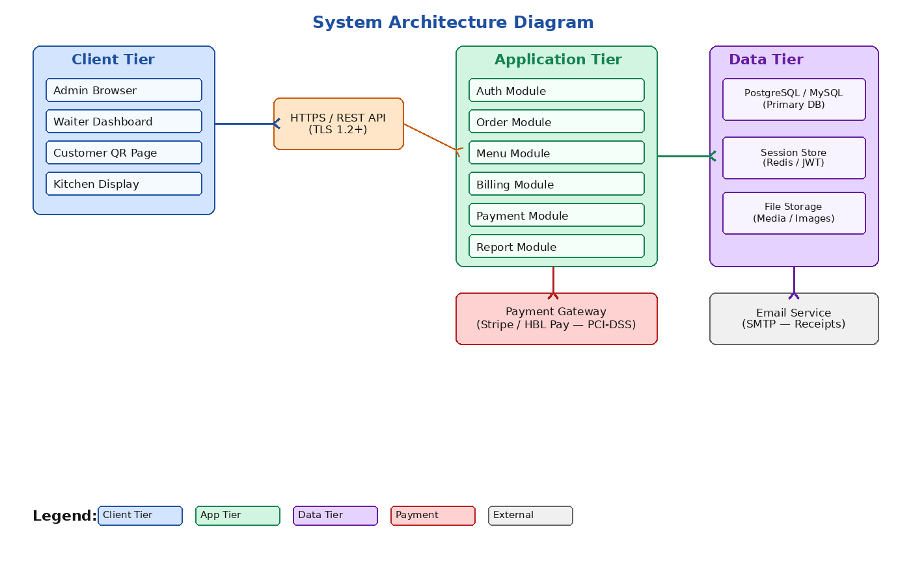
Figure 1: System Architecture Diagram – Restaurant Management System

3.3 Tier Descriptions
Tier | Technology | Responsibility
Client Tier | React.js / Browser | Renders UI for Admin, Waiter, Customer QR page, and Kitchen Display. Communicates with backend via HTTPS REST calls.
Application Tier | Django (Python) or Express (Node.js) | Handles all business logic: authentication, order processing, billing, payment orchestration, and report generation.
Data Tier | PostgreSQL / MySQL + Redis | Stores all persistent data. Redis handles session tokens and real-time pub/sub for KDS updates.
Payment Gateway | Stripe / HBL Pay | Processes card transactions via iframe/redirect. Only transaction IDs are returned to the backend.
Email Service | SMTP (e.g., SendGrid) | Sends digital receipts to customers after payment.

4. Component & Module Design

4.1 Component Diagram
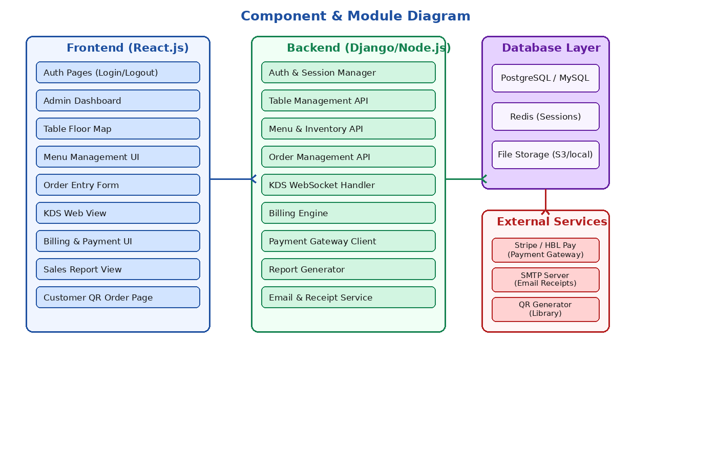
Figure 2: Component and Module Diagram – Restaurant Management System

4.2 Frontend Modules (React.js)
Module | Description
Auth Pages | Login and logout pages. Sends credentials to /api/auth/login. Stores JWT in httpOnly cookie.
Admin Dashboard | Real-time summary: sales today, active tables, pending orders, stock alerts. Polls or subscribes via WebSocket.
Table Floor Map | Visual grid of tables with colour-coded status (Available/Occupied/Reserved/Cleaning). Click to change status or start order.
Menu Management UI | Add/edit/delete menu items, set categories, upload images, toggle availability.
Order Entry Form | Select table, add items, enter special instructions, submit order to backend.
KDS Web View | Kitchen-only screen showing pending and in-progress orders. Marks items as Ready.
Billing & Payment UI | Generates itemized bill, applies discounts, initiates card (iframe/redirect) or cash payment.
Sales Report View | Displays daily/weekly/monthly charts; exports PDF or Excel.
Customer QR Order Page | Public page opened by QR scan. Shows menu, lets customer add to order without login.

4.3 Backend Modules
Module | Endpoints (prefix) | Responsibility
Auth & Session | /api/auth/ | Login, logout, JWT issue/refresh, role check middleware.
Table Management | /api/tables/ | CRUD for tables; status updates; floor map state.
Menu & Inventory | /api/menu/, /api/inventory/ | Manage menu items; track stock; auto-mark unavailable.
Order Management | /api/orders/ | Create/edit orders; route to KDS; track order status.
KDS WebSocket | ws://host/ws/kds/ | Push new/updated orders to kitchen screen in real time.
Billing Engine | /api/bills/ | Generate itemized bill with GST (16%), discounts.
Payment Gateway Client | /api/payments/ | Initiate card payment, handle gateway callback, save txn_id.
Report Generator | /api/reports/ | Aggregate sales data; produce PDF/Excel exports.
Email & Receipt | /api/receipts/ | Send email receipts via SMTP after payment.

5. Database Design

5.1 ER Diagram
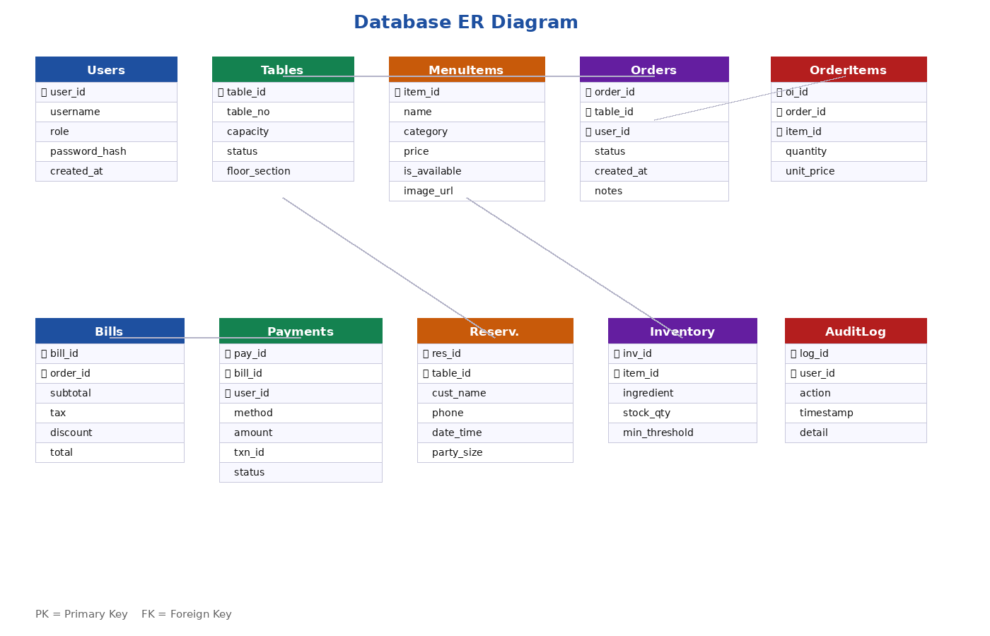
Figure 3: Entity-Relationship Diagram – Restaurant Management System

5.2 Table Definitions
Key tables and their primary attributes are described below. All tables include created_at and updated_at timestamp columns by default.
Table Name | Primary Key | Key Columns
users | user_id (UUID) | username, password_hash, role (Admin/Manager/Waiter/Kitchen), is_active
tables | table_id (INT) | table_no, capacity, status (Available/Occupied/Reserved/Cleaning), floor_section
menu_items | item_id (INT) | name, category, price (DECIMAL), is_available (BOOL), image_url
orders | order_id (UUID) | table_id (FK), user_id (FK), status (Pending/In-Progress/Ready/Served), notes
order_items | oi_id (INT) | order_id (FK), item_id (FK), quantity, unit_price
bills | bill_id (UUID) | order_id (FK), subtotal, tax (16% GST), discount, total
payments | pay_id (UUID) | bill_id (FK), user_id (FK), method (Card/Cash/Split), amount, txn_id, status
reservations | res_id (INT) | table_id (FK), cust_name, phone, date_time, party_size, status
inventory | inv_id (INT) | item_id (FK), ingredient_name, stock_qty, min_threshold, unit
audit_log | log_id (BIGINT) | user_id (FK), action, timestamp, detail (JSON)

5.3 Design Decisions
- UUIDs are used for all transaction-critical tables (orders, bills, payments) to prevent enumeration attacks.
- Card numbers are never stored. Only the payment gateway transaction ID (txn_id) is persisted.
- The audit_log table records every financial event server-side with a timestamp and staff ID.
- inventory.stock_qty is decremented automatically on order submission. A trigger alerts when qty < min_threshold.
- All foreign key constraints enforce referential integrity; soft deletes (is_deleted flag) are used instead of hard deletes.

6. Key Process Flows

6.1 Order & Payment Flow
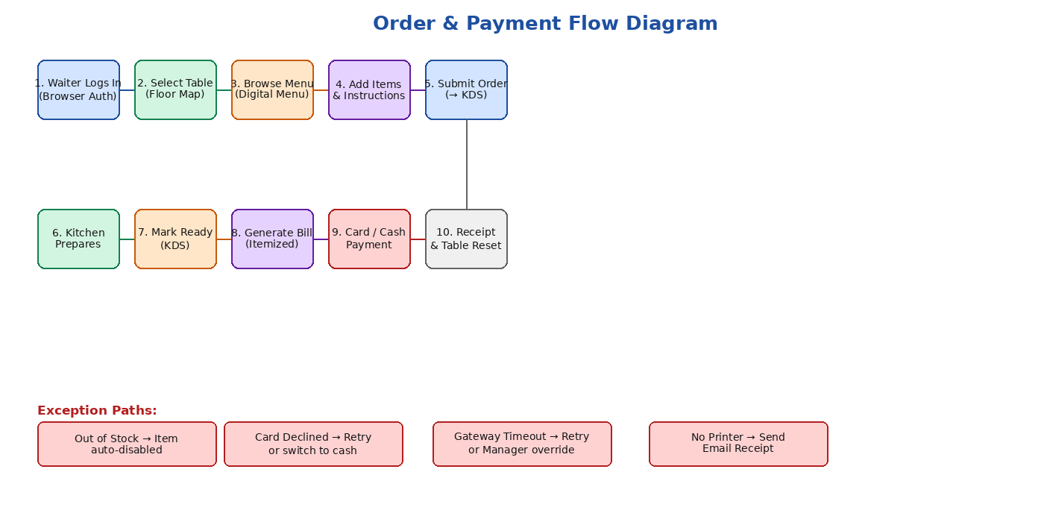
Figure 4: Order and Payment Flow Diagram – Restaurant Management System

6.2 Authentication Flow
1. Waiter opens the website and submits username + password.
2. Backend validates credentials, checks role, and issues a signed JWT (30-minute expiry).
3. JWT is stored in an httpOnly, Secure cookie. All subsequent API calls include this cookie.
4. On each API request, middleware verifies the JWT signature and checks role permissions.
5. On expiry, the user is redirected to the login page. Unsaved order drafts are preserved in localStorage.

6.3 Card Payment Flow
1. Cashier clicks Generate Bill on the billing page.
2. Backend creates a bill record and returns an itemized summary.
3. Cashier selects Card Payment. Frontend calls /api/payments/initiate/.
4. Backend creates a payment session with the gateway (Stripe/HBL Pay) and returns a redirect URL or iframe token.
5. Customer enters card details on the gateway-hosted page (PCI-DSS compliant). Card data never touches the RMS server.
6. Gateway sends a webhook callback to /api/payments/callback/ with the result.
7. Backend updates payment status, logs to audit_log, resets table status to Available, and triggers email receipt.

7. Interface Design

7.1 REST API Design Principles
- All endpoints use JSON request/response bodies and follow RESTful conventions (GET/POST/PUT/DELETE).
- All endpoints except /api/auth/login require a valid JWT.
- Role-based guards deny access to endpoints outside the user's role (e.g., waiters cannot access /api/reports/).
- HTTP status codes are used correctly: 200 OK, 201 Created, 400 Bad Request, 401 Unauthorized, 403 Forbidden, 404 Not Found, 500 Internal Server Error.
- CSRF tokens are enforced on all state-changing requests.
- Input validation and sanitization are applied on all endpoints to prevent SQL injection and XSS.

7.2 Real-Time Interface (WebSocket)
The Kitchen Display System (KDS) uses a WebSocket connection at ws://host/ws/kds/. When an order is submitted, the backend broadcasts a message to the kds channel. The KDS web view receives the event and updates the screen immediately without page refresh. This ensures orders appear within 2 seconds as required by the SRS.

7.3 Payment Gateway Interface
The payment module integrates with Stripe (or HBL Pay) using their hosted payment page (redirect) or embedded iframe method. The backend never handles raw card data. After transaction completion, the gateway sends a signed webhook to the backend callback URL. The backend verifies the webhook signature before updating payment records.

Security Design

Security Concern | Design Decision
Authentication | Username/password login. JWT tokens issued with 30-minute expiry, stored in httpOnly Secure cookies.
Authorization | Role-based access control (RBAC) enforced server-side on every API endpoint.
Transport Security | All traffic over HTTPS (TLS 1.2+). HTTP requests are redirected to HTTPS.
Card Data | Never stored on the server. Only txn_id from gateway is saved. PCI-DSS compliant gateway used.
CSRF Protection | CSRF tokens generated and validated on all state-changing form submissions.
Input Validation | All input sanitized and validated server-side to prevent SQL injection and XSS.
Session Timeout | Sessions expire after 30 minutes of inactivity. Login page shown on timeout.
Audit Trail | All financial transactions logged with user_id, timestamp, and action detail.
Password Storage | Passwords stored as bcrypt hashes (cost factor ≥ 12). Plain-text passwords never stored.

9. Non-Functional Design Decisions

9.1 Performance
- Database queries on orders and bills tables are indexed on table_id, created_at, and status columns.
- Frontend uses lazy loading for menu images and pagination for order history.
- KDS WebSocket avoids repeated HTTP polling; reduces server load under high concurrency.
- The system is designed to handle at least 50 simultaneous active browser sessions.

9.2 Reliability
- Offline mode: Orders are saved in the browser (localStorage/IndexedDB) if the LAN connection drops. They sync automatically on reconnection.
- Card payment requires internet; the system displays a clear error and suggests cash if the gateway is unreachable.
- Automated database backup runs at end of each business day via a scheduled cron job.

9.3 Maintainability
- Frontend and backend are independently deployable (decoupled SPA + API).
- Environment configuration (DB credentials, gateway keys, SMTP) is stored in environment variables, not source code.
- System logs are stored for a minimum of 1 year for audit and debugging.
- Admin can update menu, prices, and table layout entirely through the web UI without any code changes.

10. Deployment View

10.1 Deployment Environment
Component | Specification
Server OS | Ubuntu Linux (LTS)
Server Hardware | Minimum 4 CPU cores, 8 GB RAM, 100 GB SSD
Web Server | Nginx (reverse proxy + static file serving)
App Server | Gunicorn (Django) or PM2 (Node.js)
Database | PostgreSQL 15 / MySQL 8
Cache / Session | Redis 7
SSL Certificate | Let’s Encrypt (auto-renewed) or institutional certificate
Network | Local LAN (Wi-Fi 802.11ac) + optional internet domain

10.2 Deployment Steps (Summary)
- 1. Install Nginx, PostgreSQL, Redis on Linux server.
- 2. Clone repository; install Python/Node dependencies.
- 3. Configure environment variables (.env): DB URL, JWT secret, gateway keys, SMTP credentials.
- 4. Run database migrations to create all tables.
- 5. Build React frontend (npm run build); serve static files via Nginx.
- 6. Start backend app server (Gunicorn / PM2) behind Nginx reverse proxy.
- 7. Configure SSL certificate (HTTPS) on Nginx.
- 8. Test all roles in browser; verify WebSocket KDS connection.

11. Constraints and Assumptions

11.1 Constraints
- Card payment requires a live internet connection to the payment gateway.
- The system is designed for desktop/laptop browsers at 1280px width or wider; mobile responsiveness is not a primary requirement.
- Only four user roles are supported in v1.0: Admin, Manager, Waiter, Kitchen Staff.
- The payment gateway must be PCI-DSS compliant; card numbers are never handled by the RMS backend.

11.2 Assumptions
- The restaurant has a functioning LAN (Wi-Fi) connecting all POS terminals, the kitchen display, and the server.
- Staff have basic browser familiarity; no special hardware or OS is required beyond a modern PC.
- A valid merchant account with Stripe or HBL Pay is available before deployment.
- An SMTP server or email service (e.g., SendGrid) account is configured for digital receipts.

12. Requirements Traceability
SRS Req. ID | Requirement Title | SDD Section(s)
FR-1 | Table Layout and Status | Section 4.2 (Table Floor Map), Section 5.2 (tables table)
FR-2 | Digital Menu | Section 4.2 (Menu Management UI), Section 5.2 (menu_items)
FR-3 | QR Code Self-Order | Section 4.2 (Customer QR Order Page), Section 4.3 (Order API)
FR-4 | Place and Edit Orders | Section 4.3 (Order Management), Section 6.1 (Order Flow)
FR-5 | Bill Generation | Section 4.3 (Billing Engine), Section 5.2 (bills)
FR-6 | Card Payment | Section 6.3 (Card Payment Flow), Section 7.3, Section 8
FR-7 | Cash Payment | Section 4.3 (Payment Gateway Client), Section 5.2 (payments)
FR-8 | Split Payment | Section 4.3 (Payment Gateway Client), Section 5.2 (payments)
FR-9 | Discount and Coupon | Section 4.3 (Billing Engine), Section 5.2 (bills.discount)
FR-10 | Receipt – Print and Digital | Section 4.3 (Email & Receipt Service), Section 6.3
FR-11 | Refund Processing | Section 4.3 (Payment Gateway Client), Section 8 (Audit Trail)
FR-12 | Table Reservation | Section 5.2 (reservations table), Section 4.2 (Floor Map)
FR-13 | Inventory and Stock Alerts | Section 5.2 (inventory), Section 4.3 (Menu & Inventory API)
FR-14 | Staff Accounts and Roles | Section 5.2 (users), Section 6.2 (Auth Flow), Section 7.1
FR-15 | Sales Reports | Section 4.3 (Report Generator), Section 4.2 (Sales Report View)
FR-16 | Admin Dashboard | Section 4.2 (Admin Dashboard), Section 7.2 (WebSocket)

