„Machine learning-based snow cover modelling in the high mountain region of Kazbegi, Georgia“

Table of contents
1. Introduction
2. Theoretical background
2.1 Region of Interest
2.2. Physical Characteristics of Snow
2.3. Remote Sensing of Snow
2.4. (Time Series Analysis)
2.5. Random Forest Regression
2.6. Satellite imagery
3. Methodology
4. Results
5. Discussion
6. Conclusion

Object of research
Due to socio-economic changes a shift from an agriculturally oriented economy towards a service-based economy can be witnessed in many post-Soviet countries. This plays a crucial role in the changing of landscape and its side effects of altered water and carbon cycles. A good example of this change is the Kazbegi region in the Caucasus mountain range. With the exception of a small area south of the Cross mountain pass around the village of Gudauri, the municipality of Kazbegi is congruent with the Georgian part of the Terek (Tergi in Georgian) river water basin which spans over 995 km². The region of interest is remarkable in its economical shift from a pastoralist economy towards a region with a strong focus on tourism. The abandonment of agricultural practices has lead to a loss of highly biodiverse mountain pastures and meadows. This promotes shrub encroachment and natural reforestation processes (Hansen et al., 2018). While the reduction in herbivory is mainly leading to a downslope forest expansion, there are also trends for an ascending upper slope tree line. These trends are mainly triggered by atmospheric warming which further promotes thawing of alpine permafrost (Myers-Smith et al., 2011).

Higher temperatures in turn affect the temporal and spatial snow patterns in mountainous regions and will lead to an earlier retreat of snow cover, longer vegetation periods and changes in the water cycle. This is essential for policymakers both on regional and international levels as the Terek river ecosystem provides valuable services for improved water supply in an intensified agricultural landscape of more than 1 million hectares of the Terek-Kuma lowland (Zonn et al., 2010). The significance of the size of the snow cover and the time of snowmelt is further enhanced by the fact that 44% of the water in the Terek basin comes from snow and ice melt and the region of interest delivers an annual average of 40-50 litres runoff per square kilometre (E. Rets & Kireeva, 2010; E. P. Rets et al., 2018). For the Hindu Kush Himalaya region, a similarly mountainous area, Anderson et al. (2020) showed a significant increase in vegetation over large subnival areas between 1993 and 2017. On a small scale though, high mountainous areas are characterised by large spatial microclimatic variations due to their heterogeneous topography (Little et al., 2016; Ohler et al., 2020). This gives highly adapted plants a higher chance of survival without migrating along large altitudinal distances. These issues raise two crucial questions in relation to snow patterns and their temporal trends. First, are there significant trends of a reduction both in the timespan and area of snow cover over the last decades, and secondly, are there trends towards a spatial fragmentation of snow patches? These questions need to be raised, and possibly, answered to sustain the following hypotheses:
- The period of snow cover has decreased significantly over the last decades.
- Snow cover has receded into higher regions.
- Fragmented patches of snow cover are remaining due to microclimatic niches throughout the region of interest.

Therefore, both a high temporal and spatial resolution are required to monitor the snow cover in the region over the last decades.

Region of Interest
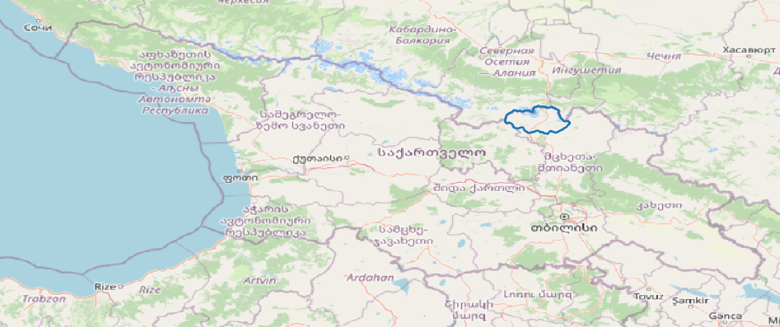Region of Interest in Georgia.
The Georgian part of the Terek river water basin is situated in the north-western edge of the Mtskheta-Mtianeti region in Georgia. Originally, the area can be described as a high-altitude pastoralist landscape in the Caucasus mountain range. Nevertheless, the study area is quite atypical for Georgia from a hydrological perspective, as it is mainly draining to the northern side of the Greater Caucasus mountain range.
However, despite its topographical remoteness from the rest of Georgia, the region has been the main transport route between Cis- and Transcaucasia for centuries. Being situated at the easily accessible Cross mountain pass (Jveri Pass) at 2,379 m.a.s.l, the region has undergone profound socio-economic changes since the collapse of Soviet Union. The formerly agriculturally oriented economical activities have been steadily transitioning towards a tourism-oriented economy (Gugushvili et al., 2017). This is in stark contrast to similarly mountainous regions in Georgia like Tusheti or Svaneti that lack such a major international road. The higher revenues in tourism have been a triggering factor for the progressive abandonment of traditional farming practices in the region (Magiera, 2017).

Snow

Physical characteristics of snow
Around 3% of global precipitation falls in solid form (Baumgartner & Liebscher, 1996, p. 278). The physical processes behind the formation of solid precipitation are described as follows: A water molecule is formed from two hydrogen atoms and a single oxygen atom through a covalent bond, expressed by the molecular formula H₂O (DeWalle & Rango, 2008, p. 15). Since water molecules feature two lone electron pairs, oxygen atoms can bond to up to four hydrogen atoms (DeWalle & Rango, 2008, p. 15) This grid of water molecules forms a hexagonal ice crystal I_{h}. (DeWalle & Rango, 2008, p. 15). Additional water molecules bond to the rougher surface of the corners of the ice crystals which leads to the creation of six-armed snowflakes that alter its crystal structure while travelling through the atmosphere (Libbrecht, 2005, p. 861). When fresh snow finally reaches the earth’s surface it it has a density between 10 and 200 kg/m³ (Baumgartner & Liebscher, 1996, p. 288). Over the course of months, fresh snow transforms into ice grains of the size of 10 to 15 mm through a process of regelation which describes the repeated process of melting and refreezing under pressure (Baumgartner & Liebscher, 1996, p. 289). If this process persists throughout the summer, the snowpack is transformed into firn (Fohrer et al., 2016, p. 294). If the weather is favourable, new loads of snow add more pressure to the underlying layers of firn and slowly transform those layers into ice with a density of at least 820 kg/m³. This marks the point when the layer becomes impermeable for air or water (Baumgartner & Liebscher, 1996, p. 289), thus forming glacial ice without interconnected air spaces (DeWalle & Rango, 2008, p. 55). which is present in high altitude regions of Kazbegi as well. The age of the snow also plays a crucial role to its optical properties. Older snowpacks feature consist of larger grain sizes and are exposed to a higher amount of dark particles over time, which in turn leads to a decrease of its albedo (DeWalle & Rango, 2008, p. 154) Albedo in turn plays a crucial role in snow cover detection as will be discussed further below.
Local driving factors of snow cover
Based on global measurements from 1966 to 2004, the mean snow cover extent in the northern hemisphere fluctuates between 45.2 × 10⁶ km² in the month of January and 1.9 × 10⁶ km² in August (Lemke et al., 2007, p. 342). This seasonality of snow cover depends on a variety of environmental parameters that are crucial for the creation and persistence of snow cover. The two main driving parameters of snow are air temperature and precipitation (Beniston, 2012, p. 350; Morán-Tejeda et al., 2013, p. 2135). Depending on the altitude either of these two drivers prevails: Morán-Tejeda et al. (2013, p. 2134) have demonstrated for Switzerland that temperature is the main driver for snowpack variability in lowland regions (below 1,450 m.a.s.l.), whereas precipitation assumes this role in high-altitude regions. This is due to the fact that the duration of days having temperatures above freezing level in high-lying regions is too short to influence the snow cover in a higher degree than precipitation (Beniston, 2012, p. 353). Other driving factors are atmospheric humidity, incoming short-wave and long-wave radiation and near-surface wind speed and direction (IPCC, 2019, p. 139). Both long- and short-wave radiation can cause two ways of snow ablation that differ in energetic efficiency. It can cause snow to sublime at a cost of 2838 J/g or melt at 335 J/g (Baumgartner & Liebscher, 1996, p. 294). Wind can transport fallen snow over several kilometres. This leads both to substantially higher sublimation rates as the full surface of snow grains are exposed to the air which in turn promotes convection. (DeWalle & Rango, 2008, p. 33)
Environmental role of snow
Snow plays a crucial role in its environment. It acts as a thermal insulator between atmosphere and soil temperature. Measurements of soil temperature beneath a layer of snow have shown insulation effects of up two 1.94 °C in 5 cm depth of the soil compared to snow-free areas (Decker et al., 2003, p. 1237). Thick layers of insulating snow further amplify the subnivian microbial acitivity and thus lead to CO₂ fluxes that contribute significantly to the annual total efflux (Laybourn-Parry et al., 2012, p. 44). During snowfall events snow acts as a scavenger. Due to their larger surface snowflakes can accumulate higher concentrations of air pollutants compared to raindrops. (DeWalle & Rango, 2008, p. 212). This leads to

DEPOSITION FAR AWAY
HIGH RELEASE WHEN MELTING
BLACK CARBON ON SNOW

The reflective characteristics of snow influence atmospheric conditions in the boundary layer.

Measurement of snow

Methodology
Gründe besser erläutern großer kontext
warum fernerkundung, welche möglichkeiten gibt es noch
Due to the small number of weather stations in the Caucasus and incomplete time series data provided by these stations, it is difficult to obtain statistically reliable climate data for the region. The mountainous terrain and remoteness of large parts of the region of Kazbegi make it nearly impossible to obtain area-wide data by classical land-based meteorological methods. Remote sensing offers a suitable alternative to answer climatological questions in remote areas. Especially sun-synchronous earth observation satellites like MODIS provide valuable climatological information for the last decades. The two MODIS platforms Terra and Aqua have been providing daily recordings since February 2000, respectively July 2002, in cloudless scenarios. Owing to the advantage of daily imagery in cloudless scenarios, this study has laid its focus on the MODIS imagery. The relevant snow product in MODIS has a spatial resolution of 500 m. In the region of interest, this corresponds to 5,429 pixels per image. Since both Aqua and Terra data were used, only those years were considered in which both satellites were available throughout the year (2003-2020). This timespan equals 6,575 days. Multiplying the amount of pixels by days and numbers of satellites, this totals a theoretical amount of 71,391,350 pixels of snow cover information provided by MODIS over the timespan for the region of Kazbegi.
As MODIS data is dependent on clear-sky conditions, only images that feature at least one cloud-free pixel in the region of Kazbegi were taken into account. To reduce computational time these filtering and preprocessing steps were done by the means of Google Earth Engine (GEE). This platform enables users to quickly process large amounts of satellite data on external servers. The amount of measured snow cover varies substantially from the theoretical amount of pixels. Only WIEVIELE MODIS-DATEN TATSÄCHLICH pixels have been measured by the MODIS sensors on Terra, and AQUA ZAHL pixels were measured by Aqua. Especially in this REGION YEAR data was missing.
To fill these missing snow cover values, it was necessary to acquire additional data that may explain the snow cover values measured by MODIS. Weidinger et al. (2018, p. 185) used remotely sensed land surface temperature, precipitation and elevation data and locally measured temperature, radiation and precipitation data to explain snow cover changes in the Himalaya mountain range through a random forest modelling approach. In their study, especially the land surface temperature and elevation (WARUM) data have shown high importance in the modelling of snow. For this reason, remotely sensed elevation data, land surface temperature, precipitation and radiation data were used in this study as well. As the datasets are coming from different satellites and in different spatial resolution, they were first resampled to the response variable snow cover (VEREINIGEN NÄCHSTER SATZ).
To create a database that was as coherent as possible in terms of both time and space, the data from the different sources were cloud-masked and bilinearly resampled to the spatial resolution of the first available MODIS snow cover image using Google Earth Engine. After these preprocessing steps have been taken, the images were downloaded in GeoTiff format for the further analysis that was done locally using R (Zitat) software. The local analysis is separated in two parts: At first, the daily land surface temperature data had (WARUM LÜCKEN) been predicted for cloudy areas by the means of a spatio-temporal random forest (WARUM NIX ANDERES) regression model. Furthermore, the MODIS predictor variables were accompanied by daily CHIRPS rainfall data, daily ERA5-Land (WARUM, ZITAT) solar radiation and topographic parameters obtained from a 30 m digital surface model by ALOS. The following table shall give a comprehensive overview of the various datasets used to predict snow cover:
Parameter | Platform | Satellite product | Original spatial resolution (m) | Temporal resolution (h) | Range
Snow | MODIS | MOD10A1/MYD10A1,  Version 6.0 | 500 | 24
Land surface temperature | MODIS | MOD11A1/MYD11A1,  Version 6.0 | 1000 | 24
Warming rate | MODIS | MOD11A1/MYD11A1,  Version 6.0 | 1000 | 24
Precipitation | CHIRPS | CHIRPS, Version 2.0 | ~ 4,090 | 24
Incoming solar radiation | ERA5 | ERA5-Land | ~ 11,000 | 1

MODIS
The Moderate Resolution Imaging Spectroradiometer (MODIS) came into use in 1999, when NASA launched its Terra satellite into orbit (Parkinson et al., 2006, p. 225). First satellite images for the region of interest are available from February 26, 2000 (Hall et al., 2015c, p. 5). Since July 7, 2002 Terra has been accompanied by Aqua, the second satellite equipped with MODIS (Hall et al., 2015b, p. 5). Both satellites are part of the Earth Observing System (EOS), a long-lasting project by NASA that has been established in the early 1990s. Due to their sun-synchronous orbit, they achieve full global coverage every one to two days. Terra visits the region of interest daily in the morning at around 11:00 AM local solar time, Aqua passes over the region two hours later in the afternoon at 13:00 PM local solar time.

MODIS Snow Data
For this study, snow data provided by MODIS has been used. It comes in a spatial resolution of 500 metres at nadir. The so-called snow products MOD10A1 from the Terra platform and MYD10A1 from the Aqua platform feature a band called NDSI_Snow_Cover that ranges from 0 to 100. These values describe the NDSI (Normalized Difference Snow Index) that makes use of the very high reflectance of snow in visible bands and its very low reflectance in the shortwave infrared band. (Riggs et al., 1994, p. 1943) These bands are represented in MODIS by band 4 (WELCHES HIGH REFLECTANCE) (center of bandwidth at 0.55 µm) and band 6 (center of bandwidth at 1.6 µm), which are then used to calculate the NDSI as follows (Hall et al., 2015a, p. 9):
NDSI = (Band 4 – Band 6) / (Band 4 + Band 6)
The resulting NDSI values between -1.0 and <0.1 (WARUM) are assigned the value 0, while values from 0.1 to 1.0 are remapped to a range from 10 to 100 in the snow cover band used in this study (Hall et al., 2015c, p. 9, 2015b, p. 9). Other pixels that are obscured by cloud cover or show too low reflectance in the visible band due to bad lighting conditions have been flagged and assigned values above 100 (Hall et al., 2015c, p. 6, 2015b, p. 6). All daily MODIS Terra and Aqua NDSI scenes were downloaded from Google Earth Engine, where NDSI values above 100 have been set to “No data”. Before downloading, all scenes in the region of interest (ROI) have been reprojected to the first available MODIS snow cover scene of the ROI and clipped to the ROI before download as GeoTiffs from Google Earth Engine.PYTHON API

MODIS Land Surface Temperature Data
Land surface temperature was taken from the daily MODIS products MOD11A1/MYD11A1, Version 6.0. This product has a spatial resolution of 1,000 m and is gridded in the Sinusoidal projection. It is calculated from the daily pixel values of land surface temperature under clear-sky conditions by a split-window algorithm that maps all valid land surface temperature values to the sinusoidal grid. (Wan, 2013, p. 16) From this product the bands LST_Day_1km (daytime land surface temperature), LST_Night_1km (nighttime land surface temperature) and the band containing the view time of the daytime land surface temperature were used. Land Surface Temperature values are stored in 2/100 Kelvin. Before using this data in the Random Forest regression analysis, various preprocessing steps had been taken. Using Google Earth Engine, these four bands were bilinearly resampled to the snow dataset at 500 m resolution. Furthermore, the values of land surface temperature were converted to °Celsius by °C = x * 0.02 – 273.15. While the daytime values were passed to the random forest regression model without further changes, the nighttime values were used to calculate a warming rate:
Warming rate = LST_{Daytime –} LST_{Nightime (previous day)}
This warming rate parameter allows to detect swift atmospheric changes, e.g. under clear-sky circumstances when high outgoing long-wave radiation is followed by high incoming short-wave solar radiation. (Weidinger et al., 2018, p. 189)

Precipitation data WARUM
To include a proxy for snowfall data, precipitation data has been added to the Random Forest regression models as a potential predictor variable of snow cover. Whereas there are plentiful radar-derived high-resolution precipitation datasets for regions like Central Europe (e.g. RADOLAN), there are no freely available precipitation datasets for the Caucasus region in a daily 1 km resolution. Therefore a substitute had to be found. The CHIRPS (Climate Hazards Group InfraRed Precipitation with Station data) daily precipitation data (version 2.0) proved adequate. It combines satellite precipitation estimates with data from over 200,000 unique weather stations through a modified inverse distance weighting algorithm. (Funk et al., 2015, pp. 4–5) This data comes in an original spatial resolution of 0.05 arc degrees (~ 4,090 m at the central latitude of the Kazbegi region) and was bilinearly resampled to the resolution of the snow cover parameter (500 m) using Google Earth Engine and then downloaded as GeoTiff.

Radiation data
Radiation plays a crucial role in frost-thaw cycles and hence, snow cover modelling. Radiation data also serves as a possible explanatory variable for the random forest regression model of land surface temperature. Potential solar radiation can be calculated on a theoretical by geographical coordinates and a value of time. To account for possible shadowing effects, a digital elevation model can be inserted into the calculation, e.g. through R packages like ‘solrad’. (Seyednasrollah, 2018, n.p.) This potential radiation data does not include atmospheric conditions though. Another option are remotely sensed radiation data like ERA5-Land that were used in this study. ERA5-Land is a reanalysis dataset of climatological variables at a native spatial resolution of 9 km and a temporal resolution of 1 hour. The spatial resolution had been regridded to a resolution of 0,1° × 0,1° degree which equals 11,132 m × 8,180 m in the region of interest. (Muñoz Sabater, 2019, n.p.)
For this study, the daily surface solar radiation downwards at 8 AM UTC (corresponding to Terra’s overpassing time) and 10 AM UTC (corresponding to Aqua’s overpassing time) was bilinearly resampled to the snow cover resolution of 500 m and downloaded from Google Earth Engine as GeoTiff. The data describes the cumulative solar radiation that has reached the earth’s surface between midnight and the respective time in Joule/m² for each day. (Yang, 2021, n.p.)

Elevation data
Elevation above sea level and the secondary topographic parameters of slope and aspect were included in both random forest regression models as well. (WARUM)These parameters were calculated from ALOS World 3D-30m (Version 2.2), a global surface model in a spatial resolution of 30 m. This dataset was converted from a DSM with a native horizontal resolution of 5 m that had been created from 3 million scenes between 2006 and 2011. The scenes for the creation of this DSM were recorded by the PRISM panchromatic stereo mapping sensor that is attached to the Advanced Land Observing Satellite “DAICHI” (ALOS). (Japan Aerospace Exploration Agency, 2020, p. 1) This data was downloaded from Google Earth Engine in its native resolution of 30 m for a larger region including areas around the region of interest to avoid unwanted edge effects when calculating secondary topographic parameters. The secondary parameters slope and aspect were calculated by the use of the “raster” package (Hijmans, 2020, n.p.) in R. To keep the resolution of this dataset consistent with other parameters used in this study, the elevation data and its derivatives were then bilinearly resampled to 500 m and clipped to the extent and masked to the shape of the region of interest.
Due to the circular nature of aspect values ranging from 0 to 360 degrees, aspect was converted to the so-called parameter “northness”, a variable often used in studies of biogeographical distribution modelling (e.g. Feldmeier et al., 2020, p. 1485). It is expressed by the cosine of radians ranging from -1 to 1. Thus, north-facing slopes (0°) were assigned the value 1, while south-facing slopes (180°) were converted to -1. However, due to this conversion the information on east- and west-facing slopes is lost as they are both expressed by the value of 0. In most studies, this information is kept by adding a so-called “eastness” parameter which is formed by the sine of the aspect value. Instead of the calculation of these two parameters, a different approach was chosen in this study. Warum The unique aspect values in degrees of each training point were shifted by one degree. This has been repeated 359 times, thus allowing the north-facing angle (0°) to move along the compass rose. The 360 resulting possibilities have then been converted into the cosine of radians and correlated with the respective values for land surface temperature and snow cover of the 500 training points.
If the compass rose would face north at 176 degrees, the strongest positive correlation between aspect and land surface temperature was noted in the region of interest. WARUM In other words, the probability of finding the lowest land surface temperatures in the region is highest on slopes facing 356 degrees north. The snow cover parameter shows a reversed correlation with the highest possibility of snow cover on slopes facing a little more to the northwest, at 338°. Despite the relatively weak strength of these relationships, both show a high significance with a p-value < 2.2 e⁻¹⁶. To achieve a possibly stronger signal in the following random forest regression analysis these slightly shifted values of the cosine aspect were used in the land surface temperature and snow cover models. Windroses of cosines of aspect starting at around 90° or 270°, representing eastness, have not shown any correlations with land surface temperature or snow cover (see fig. xy). Therefore, the eastness parameter has not been included in the further analysis.
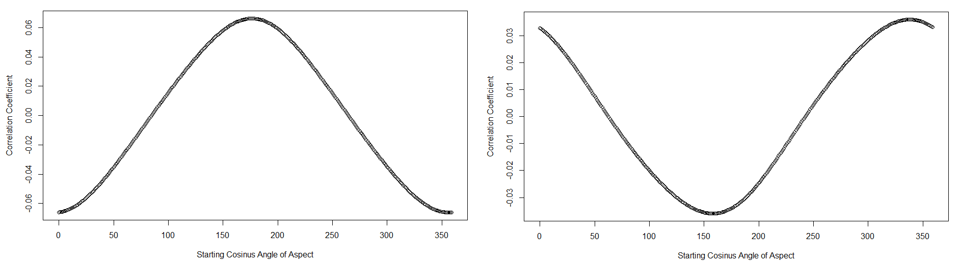Fig. xy: Pearson correlation coefficients between land surface temperature (left) or snow cover (right) and the cosine of aspect set at 0 on a shifting compass rose.

Time data
The mean of the daytime view times of pixels containing land surface temperature was calculated for both satellites. For better comparability this value was converted into UTC time instead of local solar time as stored in the original MODIS LST product by t_{UTC} = t_{Solar} – 44.54475/15 where 44.54474 stands for the center longitude of the region of interest in decimal degrees. The resulting UTC time values were further converted into minutes since midnight. This parameter was called “Minute” and served as a possible predictor to reflect possible intra-day trends in snow cover.
The days of the recording times of the MODIS scenes were also included in the analysis. On the one hand, a numerical value of the point in time of each data point was included in the analysis for this purpose. This is given as seconds that have passed since 1 January 1970. On the other hand, a modified version of the day of the year (DOY) was also added to the analysis to account for the seasonality of the data. Since the DOY ranges from 1 to 365 (366 in leap years), 31 December and 1 January are considered very distant dates. In order to take into account the proximity of these points in time, radians were used again, similar to the conversion of the aspect which is a cyclic variable as well. For this purpose, the 366 possible DOY values were first converted into degrees of a full circle using x = DOY/366 *360. The results were then converted to the cosine of the radians. This process was repeated 365 times with the DOY values being offset by one day each time. The resulting 366 different cosine values for the DOY were then correlated with land surface temperature and snow cover values of the 500 training points.
Both land surface temperature and snow cover show a strong seasonal trend. In order to reproduce this trend as well as possible in the following random forest regression analyses, an adjusted DOY value was adopted representing the strongest correlation with the respective parameter. For the land surface temperature this parameter is thence expressed by cosine values of the DOY starting with the 209th day of a year (July 28 in regular years, July 27 in leap years). This relation shows a highly significant positive correlation of 0.89 (p-value: 2.2e⁻¹⁶) Thus, land surface temperature values tend to be higher, when they are closer to July 28. For snow cover the strongest positive correlation (0.81, p-value: 2.2e⁻¹⁶) has been observed for the 42nd day of the year (February 11). Since no other seasonal trends were discernible in the correlation analysis (e.g. trends between spring and autumn), only these two strongly pronounced summer-winter trends described above were taken into account for further analyses.
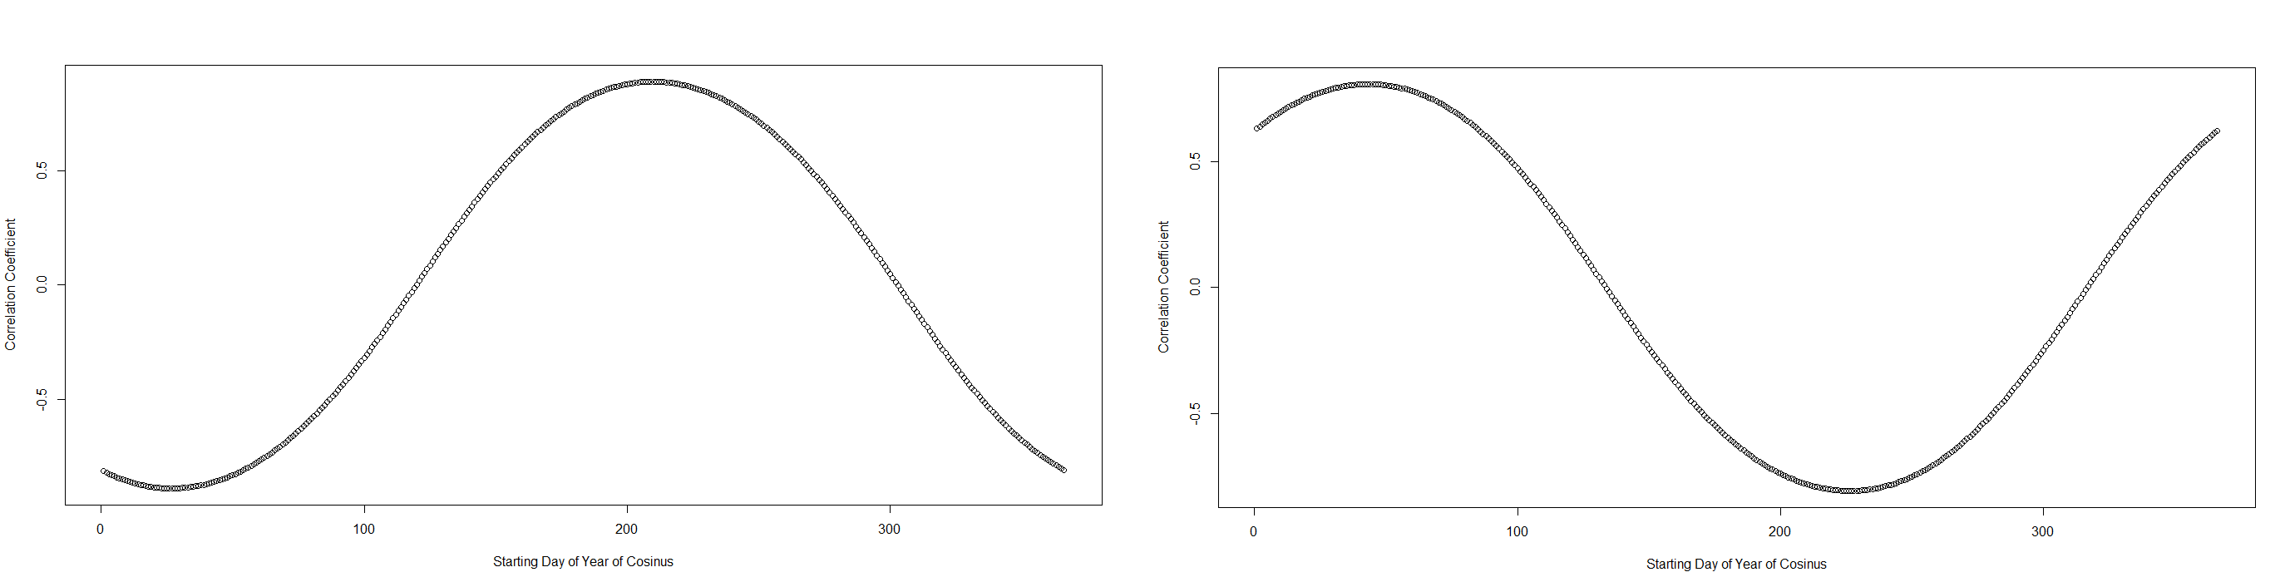Fig. xy: Pearson correlation coefficients between land surface temperature (left) or snow cover (right) and the cosine of the radians of the day of the year.

Random Forest Regression
Random Forests (Breiman, 2001, p. 5) is a machine learning algorithm often used in snow cover modelling and prediction scenarios. For example, Weidinger et al. (2018, p. 185) applied a Random Forests classification to model snow cover in the Himalaya and Hu et al. (2020, p. 4) used Random Forests regression to model daily snowline dynamics in the Alps. Random Forests uses an ensemble of decision trees that are built on independent sample vectors that share the same distribution. (Breiman, 2001, p. 5f.) In remote sensing, Random Forests can be applied to categorical data to solve classification problems as summarized by Belgiu and Drăguț (2016, p. 24) . It can also be applied to numerical data to calculate ensemble regressions, e.g. to calculate daily regional snowline elevations in the Alps as done by Hu et al. (2020, p. 4). Each tree in Random Forests is based on the principles of so-called “classification and regression trees” (CART). These tree structures are binary classifiers that consist of repeated splits of subsets of a dataset. (Breiman et al., 1984, p. 21) At each split (or node) the tree branches into two new subsets based on a decision that partitions the dataset at a minimum cost. This minimum cost is described as a maximization of the homogeneity of a selected predictor variable. In regression trees this cost is measured by the residual sum of squares (RSS). The predictor variable is randomly chosen out of a number of candidate variables (m_{try}) at each split. This tree is grown until no further splits are possible without pruning it back. The resulting fully-grown tree is able to predict the response value based on the decisions involving the predictor variables. In Random Forests, n number of such regression trees are grown and only a random sample with replacement (a so-called bootstrapped dataset) is used for each tree. Since only about a third of the instances is represented in the bootstrapped dataset, the remaining instances (out-of-bag samples) are used for the validation of the regression tree. As bootstrapping represents sampling with replacement each instance of the dataset constitutes an out-of-bag sample in approximately one of three cases. Therefore, whenever an instance falls out of the bag, this instance can be used to calculate the error between the prediction and the true response value of this instance. Thus, it is possible to calculate the mean square error (MSE) by averaging the square errors between the true values Y_{i} and the predictions for each instance Ŷ^{OOB}(X_{i}) whenever it fell out of the bag (OOB) (Svetnik et al., 2003, p. 1949):
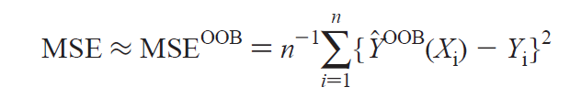
The aim of a low mean square error through bootstrapping and aggregating (bagging) is to reduce the bias in the predictions. (Breiman, 2001, p. 29) Especially in spatial questions, this reduction of the bias often leads to overestimation as many instances used in validation are spatially very near to instances of the training dataset. (Schratz et al., 2019, p. 110) The reason for the creation of this bias is related to Tobler’s first law of geography: “everything is related to everything else, but near things are more related than distant things” (Tobler, 1970, p. 236) Hence, to avoid the pitfall of spatial autocorrelation a “spatial cross-validation” (Schratz et al., 2019, p. 110) or “leave-location-out cross-validation” (Meyer et al., 2018, p. 2) was applied to the random forests algorithm. To account for temporal autocorrelation this cross-validation was extended two a third dimension by adding a time variable. This spatio-temporal cross-validation is called “leave-location-and-time-out cross-validation” (LLTO-CV) by Meyer (2018, p. 3) and its process is compared with the process of an ordinary 3-fold random cross-validation below:
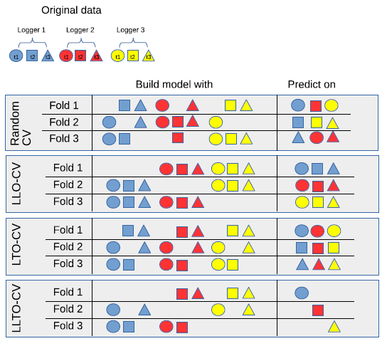Fig. xy: Tabelle 1: Schematic overview of 3-fold random cross-validation (CV), leave-location-out (=spatial) cross-validation (LLO-CV), leave-time-out (=temporal) cross-validation (LTO-CV) and leave-location-and-time-out (=spatio-temporal) cross-validation (LLTO-CV) on three different sites (Logger 1-3) at three different points in time (t1-3). (Meyer et al., 2018, p. 4)
In this study, the LLTO cross-validation has been applied to 500 training points that constitute the spatial variable and 12 months, representing the temporal variable.
To calculate the importance of every potential variable that could influence the prediction of land surface temperature and snow cover in the region of Kazbegi, a forward feature selection method was chosen. This method starts with predicting the response variable with a predefined number of explanatory variables, e.g. 2. After having tried each possible combination of two variables out of the pool of all explanatory variables, all models are spatio-temporally cross-validated and ranked according to their predictive performance. This process is repeated by adding one potential variable until there is no increase in predictive performance. (Meyer et al., 2018, p. 4)

3.2. Correlation analysis
Various Pearson correlations have been calculated for the variables before calculating the random forest model. The
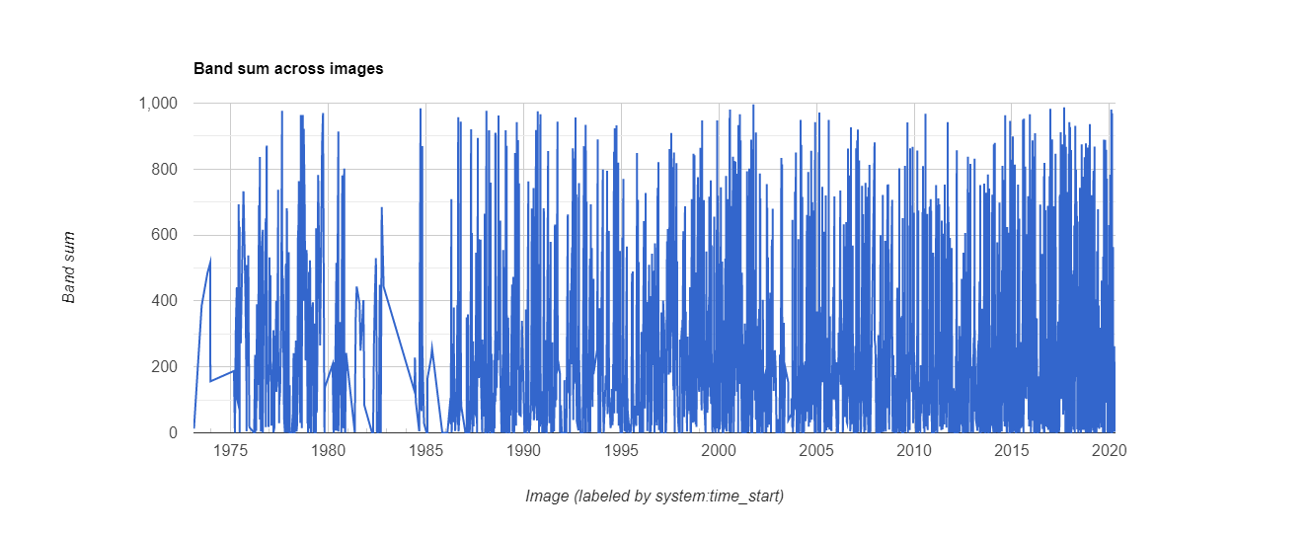Landsat data coverage in the region of interest (approx. 995 km²) in km².
This will help answer the question of snow coverage in the region of Kazbegi for the last 40 to 50 years.

Literature:
Anderson, K., Fawcett, D., Cugulliere, A., Benford, S., Jones, D., & Leng, R. (2020). Vegetation expansion in the subnival Hindu Kush Himalaya. Global Change Biology, 26(3), 1608–1625. https://doi.org/10.1111/gcb.14919
Baumgartner, A., & Liebscher, H.-J. (1996). Allgemeine Hydrologie. Quantitative Hydrologie. (2nd ed., Vol. 1). Gebrüder Borntraeger.
Belgiu, M., & Drăguț, L. (2016). Random forest in remote sensing: A review of applications and future directions. ISPRS Journal of Photogrammetry and Remote Sensing, 114, 24–31. https://doi.org/10.1016/j.isprsjprs.2016.01.011
Beniston, M. (2012). Is snow in the Alps receding or disappearing? WIREs Clim Change, 3, 349–358. https://doi.org/10.1002/wcc.179
Breiman, L. (2001). Random Forests. Machine Learning, 45, 5–32. https://doi.org/10.1023/A:1010933404324
Breiman, L., Frieman, J. H., Olshen, R. A., & Stone, C. J. (1984). Classification and Regression Trees. Chapman & Hall/CRC. https://books.google.de/books?id=MGlQDwAAQBAJ&printsec=frontcover&hl=de#v=onepage&q&f=false
Decker, K. L. M., Wang, D., Waite, C., & Scherbatskoy, T. (2003). Snow Removal and Ambient Air Temperature Effects on Forest Soil Temperatures in Northern Vermont. Soil Science Society of America Journal, 67(4), 1234–1242. https://doi.org/10.2136/sssaj2003.1234
DeWalle, D. R., & Rango, A. (2008). Principles of snow hydrology. Cambridge University Press. http://search.ebscohost.com/login.aspx?direct=true&scope=site&db=nlebk&AN=234375
Feldmeier, S., Schmidt, B. R., Zimmermann, N. E., Veith, M., Ficetola, G. F., & Lötters, S. (2020). Shifting aspect or elevation? The climate change response of ectotherms in a complex mountain topography. Diversity and Distributions, 26(11), 1483–1495. https://doi.org/10.1111/ddi.13146
Fohrer, N., Bormann, H., Miegel, K., Casper, M., Bronstert, A., Schumann, A., & Weiler, M. (2016). Hydrologie (1st ed., Vol. 4513). Haupt Verlag.
Funk, C., Peterson, P., Landsfeld, M., Pedreros, D., Verdin, J., Shukla, S., Husak, G., Rowland, J., Harrison, L., Hoell, A., & Michaelsen, J. (2015). The climate hazards infrared precipitation with stations—A new environmental record for monitoring extremes. Scientific Data, 2(1), 150066. https://doi.org/10.1038/sdata.2015.66
Gugushvili, T., Salukvadze, G., & Salukvadze, J. (2017). Fragmented development: Tourism-driven economic changes in Kazbegi, Georgia. Annals of Agrarian Science, 15(1), 49–54. https://doi.org/10.1016/j.aasci.2017.02.005
Hall, D. K., Riggs, G. A., & Solomonson, V. (2015a). MODIS/Aqua Snow Cover 5-Min L2 Swath 500m [Data set]. NASA National Snow and Ice Data Center DAAC. https://doi.org/10.5067/MODIS/MYD10_L2.006
Hall, D. K., Riggs, G. A., & Solomonson, V. (2015b). MODIS/Aqua Snow Cover Daily L3 Global 500m SIN Grid [Data set]. NASA National Snow and Ice Data Center DAAC. https://doi.org/10.5067/MODIS/MYD10A1.006
Hall, D. K., Riggs, G. A., & Solomonson, V. (2015c). MODIS/Terra Snow Cover Daily L3 Global 500m SIN Grid [Data set]. NASA National Snow and Ice Data Center DAAC. https://doi.org/10.5067/MODIS/MOD10A1.006
Hansen, W., Magiera, A., Theissen, T., Waldhardt, R., & Otte, A. (2018). Analysing Betula litwinowii encroachment and reforestation in the Kazbegi region, Greater Caucasus, Georgia. Journal of Vegetation Science, 29(1), 110–123. https://doi.org/10.1111/jvs.12589
Hijmans, R. J. (2020). Raster: Geographic Data Analysis and Modeling. R package version 3.4-5. https://CRAN.R-project.org/package=raster
Hu, Z., Dietz, A., Zhao, A., Uereyen, S., Zhang, H., Wang, M., Mederer, P., & Kuenzer, C. (2020). Snow Moving to Higher Elevations: Analyzing Three Decades of Snowline Dynamics in the Alps. Geophysical Research Letters, 47(12). https://doi.org/10.1029/2019GL085742
IPCC. (2019). IPCC Special Report on the Ocean and Cryosphere in a Changing Climate. IPCC.
Japan Aerospace Exploration Agency (Ed.). (2020). ALOS Global Digital Surface Model (DSM) “ALOS World 3D-30m (AW3D30) Ver.2.2” Product Description. https://www.eorc.jaxa.jp/ALOS/en/aw3d30/aw3d30v22_product_e_a.pdf
Laybourn-Parry, J., Tranter, M., & Hodson, A. J. (2012). The ecology of snow and ice environments. Oxford University Press.
Lemke, P., Ren, J., Alley, R. B., Allison, I., Carrasco, J., Flato, G., Fujii, Y., Kaser, G., Mote, P., Thomas, R. H., Zhang, T., Box, J., Bromwich, D., Brown, R., Cogley, J. G., Comiso, J., Dyurgerov, M., Fitzharris, B., Hagen, J. O., … Zhang, T. (2007). Observations: Changes in Snow, Ice and Frozen Ground. Climate Change 2007: The Physical Science Basis. Contribution of Working Group I to the Fourth Assessment Report of the Intergovernmental Panel on Climate Change, 48.
Libbrecht, K. G. (2005). The physics of snow crystals. Reports on Progress in Physics, 68(4), 855–895. https://doi.org/10.1088/0034-4885/68/4/R03
Little, C. J., Wheeler, J. A., Sedlacek, J., Cortés, A. J., & Rixen, C. (2016). Small-scale drivers: The importance of nutrient availability and snowmelt timing on performance of the alpine shrub Salix herbacea. Oecologia, 180(4), 1015–1024. https://doi.org/10.1007/s00442-015-3394-3
Magiera, A. (2017). Assessment of species composition, productivity and functionality of grassland in the Greater Caucasus (Georgia, Kazbegi Region) by means of remote sensing. Justus-Liebig-University Giessen.
Meyer, H., Reudenbach, C., Hengl, T., Katurji, M., & Nauss, T. (2018). Improving performance of spatio-temporal machine learning models using forward feature selection and target-oriented validation. Environmental Modelling & Software, 101, 1–9. https://doi.org/10.1016/j.envsoft.2017.12.001
Morán-Tejeda, E., López-Moreno, J. I., & Beniston, M. (2013). The changing roles of temperature and precipitation on snowpack variability in Switzerland as a function of altitude. Geophysical Research Letters, 40(10), 2131–2136. https://doi.org/10.1002/grl.50463
Muñoz Sabater, J. (2019). ERA5-Land hourly data from 1981 to present. Copernicus Climate Change Service (C3S) Climate Data Store (CDS). https://cds.climate.copernicus.eu/doi/10.24381/cds.e2161bac
Myers-Smith, I. H., Forbes, B. C., Wilmking, M., Hallinger, M., Lantz, T., Blok, D., Tape, K. D., Macias-Fauria, M., Sass-Klaassen, U., Lévesque, E., Boudreau, S., Ropars, P., Hermanutz, L., Trant, A., Collier, L. S., Weijers, S., Rozema, J., Rayback, S. A., Schmidt, N. M., … Hik, D. S. (2011). Shrub expansion in tundra ecosystems: Dynamics, impacts and research priorities. Environmental Research Letters, 6(4), 045509. https://doi.org/10.1088/1748-9326/6/4/045509
Ohler, L.-M., Lechleitner, M., & Junker, R. R. (2020). Microclimatic effects on alpine plant communities and flower-visitor interactions. Scientific Reports, 10(1), 1366. https://doi.org/10.1038/s41598-020-58388-7
Parkinson, C. L., Ward, A., & King, M. D. (Eds.). (2006). Earth Science Reference Handbook. A Guide to NASA’s Earth Science Program and Earth Observing Satellite Missions. National Aeronautics and Space Administration. https://eospso.gsfc.nasa.gov/sites/default/files/publications/2006ReferenceHandbook.pdf
Rets, E., & Kireeva, M. (2010). Hazardous hydrological processes in mountainous areas under the impact of recent climate change: Case study of Terek River basin. Global Change: Facing Risks and Threats to Water Resources, 11.
Rets, E. P., Dzhamalov, R. G., Kireeva, M. B., Frolova, N. L., Durmanov, I. N., Telegina, A. A., Telegina, E. A., & Grigoriev, V. Yu. (2018). Recent Trends of River Runoff in the North Caucasus. GEOGRAPHY, ENVIRONMENT, SUSTAINABILITY, 11(3), 61–70. https://doi.org/10.24057/2071-9388-2018-11-3-61-70
Riggs, G. A., Hall, D. K., & Salomonson, V. V. (1994). A snow index for the Landsat Thematic Mapper and Moderate Resolution Imaging Spectroradiometer. Proceedings of IGARSS ’94 - 1994 IEEE International Geoscience and Remote Sensing Symposium, 4, 1942–1944. https://doi.org/10.1109/IGARSS.1994.399618
Schratz, P., Muenchow, J., Iturritxa, E., Richter, J., & Brenning, A. (2019). Hyperparameter tuning and performance assessment of statistical and machine-learning algorithms using spatial data. Ecological Modelling, 406, 109–120. https://doi.org/10.1016/j.ecolmodel.2019.06.002
Seyednasrollah, B. (2018). solrad: To calculate solar radiation and related variables based on location, time and topographical conditions. (1.0.0) [Computer software]. http://doi.org/10.5281/zenodo.1006383
Svetnik, V., Liaw, A., Tong, C., Culberson, J. C., Sheridan, R. P., & Feuston, B. P. (2003). Random Forest: A Classification and Regression Tool for Compound Classification and QSAR Modeling. Journal of Chemical Information and Computer Sciences, 43(6), 1947–1958. https://doi.org/10.1021/ci034160g
Tobler, W. R. (1970). A Computer Movie Simulating Urban Growth in the Detroit Region. Economic Geography, 46, 234. https://doi.org/10.2307/143141
Wan, Z. (2013). Collection-6 MODIS Land Surface Temperature Products Users’ Guide. 33.
Weidinger, J., Gerlitz, L., Bechtel, B., & Böhner, J. (2018). Statistical modelling of snow cover dynamics in the Central Himalaya Region, Nepal. Climate Research, 75(3), 181–199. https://doi.org/10.3354/cr01518
Yang, X. (2021, April 28). ERA5-Land: Data documentation. ERA5-Land: Data Documentation. https://confluence.ecmwf.int/display/CKB/ERA5-Land%3A+data+documentation
Zonn, I. S., Kosarev, A. N., Glantz, M., & Kostianoy, A. G. (2010). The Caspian Sea Encyclopedia. Springer Science & Business Media.

