| Step | Line man | System Response |
| --- | --- | --- |
| 1 | Line Man login into the system | System validates Line Man's credentials |
| 2 | Request to assign allocated area | provide information about the allocated area |
| 3 | Line Man receives real-time data and status updates | System provides real-time data and status updates to Line Man |
| 4 | Line Man detects irregularities activities | System notifies Line Man about potential irregularities or suspicious activities |
| 5 | Line Man confirms theft and reports to WAPDA | Line Man reports confirmed theft line to the WAPDA Department Officer (DO) |
| 6 | Line Man logs out of the system | System logs out Line Man, session ends |

|  |
| --- |
| **Muhammad Irfan**  **Registration No: Fa21-BSE-027**  **Section: 4A** |

**Question no 1:**

**Main success scenario of monitor line use case**

**SSD**

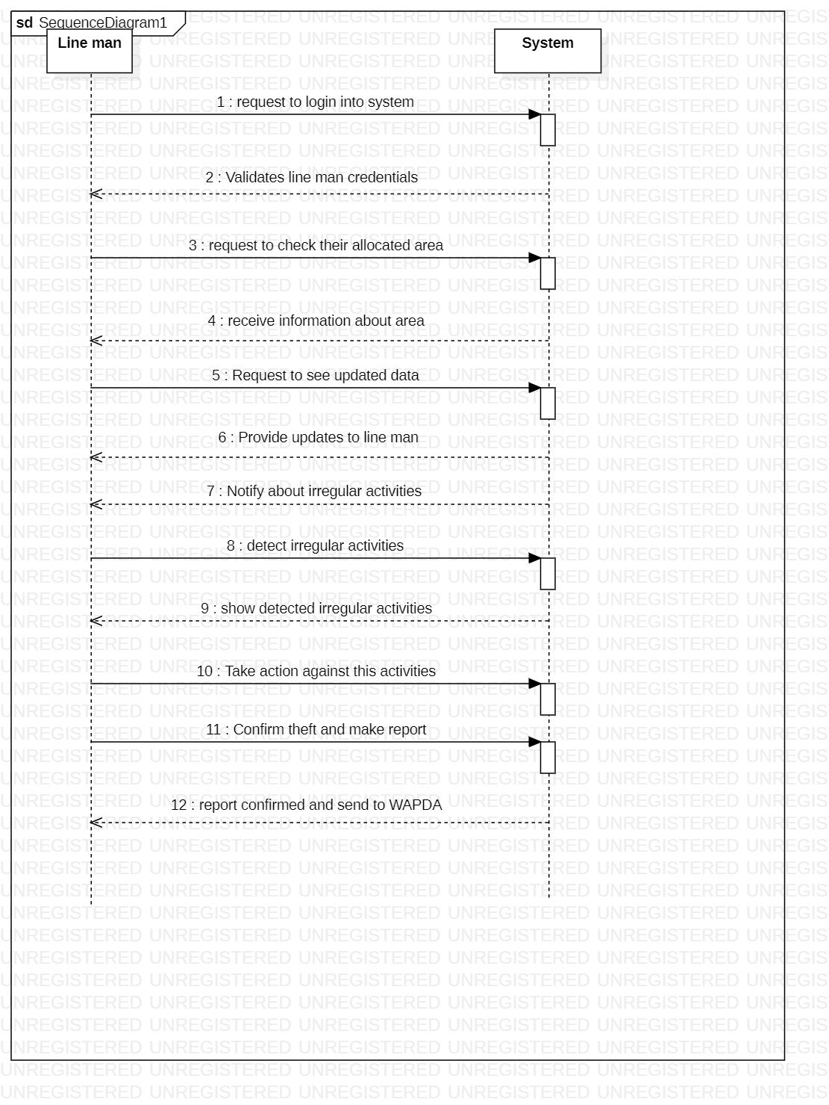

**On page Main Success Scenario :**

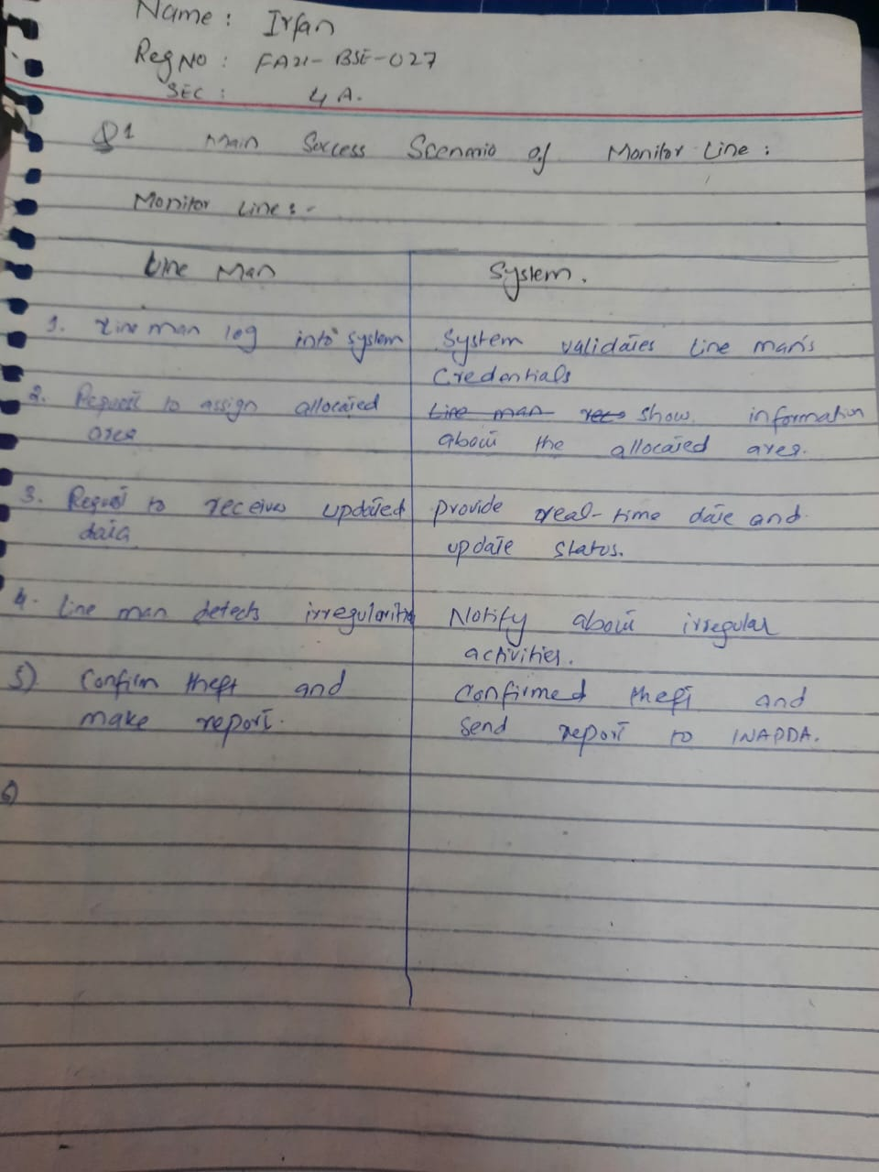

**SSD:**

**Prototype**

**Login:**

**Operation:**

**Detection:**

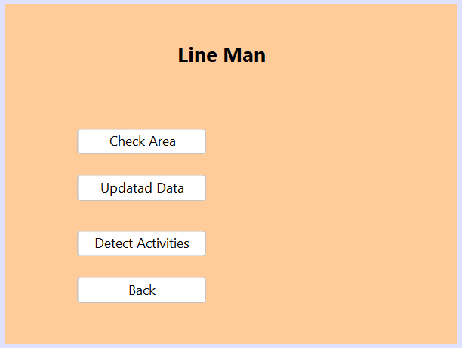

**Line man:**

