**OOSE LAB MID**

**Name:** Arfah Ali

**Reg. No. :** FA21-BSE-080

**Date:** 24 May, 2023

**Submitted to:** Sir Mukhtiar Zamin

Table of Contents

**CASE STUDY:** 2

Use Case: Add Meter (SDO) 2

**Main Success Scenario:** 2

**System Sequence Diagram:** 4

**On Page:** 4

**On StarUML:** 5

Prototypes: 6

**DASH BOARD:** 6

**ADD METER FORM:** 6

**CONFIRMATION MESSAGE PAGE:** 7

# **CASE STUDY:**

**Electricity Theft Detection System (ETDS)**

Electricity Theft Detection System (ETDS) is a solution with digital meters which periodically report the number of units consumed by each output line along with input units disperesed in multiple lines. Reported data is processed by a service in such a manner that every output line is either mapped to a customer or another digital meter for splitting. In case of meters the input energy is checked against consumed and if more than threshold value difference between two meters then a theft line is detected and reported to WAPDA line man. Line man are monitoring the lines according to allocated area in two shifts. At the end of the month bills are generated for customers and their collection is reported to SDO. WAPDA policies are enforced by the system along with warnings, notifications and then court cases for detected thefts. The system ensure a minimal loss of energy and also take care of the allowed quota system for each WAPDA employee.

# Use Case: Add Meter (SDO)

## **Main Success Scenario:**

|  |  |
| --- | --- |
| **User Interaction** | **System Response** |
| The SDO selects the "Add Meter" option from the system's main menu. | The system displays a form for entering the details of the new meter. |
| The SDO fills in the required information for the new meter, such as the meter ID, customer details (if applicable), and location. | The system validates the entered information and checks for any potential conflicts or errors. |
| The SDO submits the form to add the new meter to the system. | The system verifies the submitted data and checks for any duplications or inconsistencies. |
|  | The system sends a confirmation message to the SDO, indicating that the meter has been successfully added. |
| The SDO receives the confirmation message. |  |
| The SDO proceeds to install the physical meter at the designated location. |  |
| Once the meter is installed, the SDO performs a physical verification to ensure its proper functioning. |  |
| The SDO updates the system with the status of the installed meter (e.g., active, pending verification). | The system updates the status of the meter in its database. |
| The SDO completes the process and exits the "Add Meter" functionality. | The system returns to the main menu. |

# **System Sequence Diagram:**

## **On Page:**

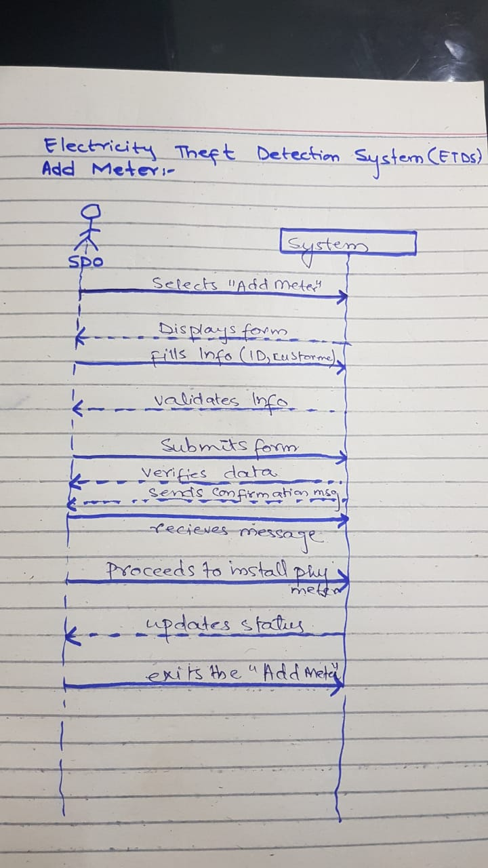

## **On StarUML:**

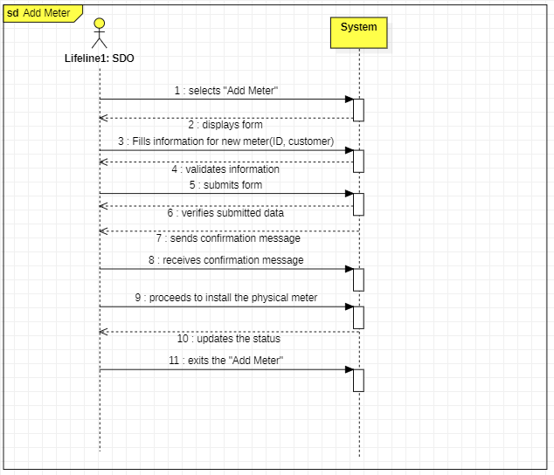

# Prototypes:

## **DASH BOARD:**

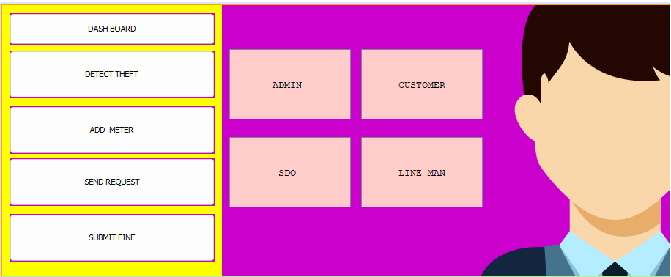

## **ADD METER FORM:**

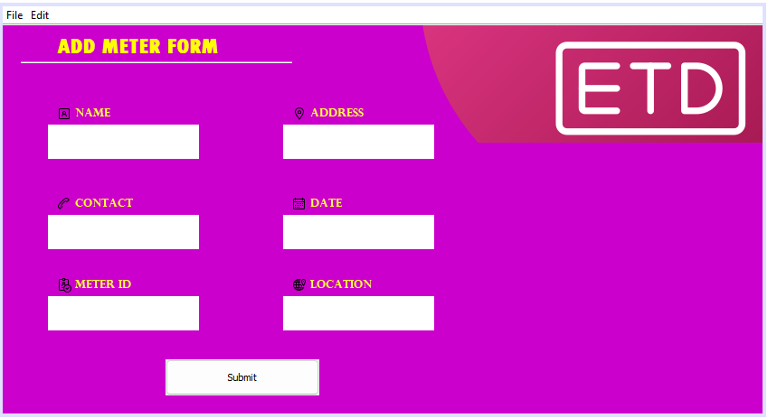

## **CONFIRMATION MESSAGE PAGE:**

