VALUE Model Methodology
  - Mathematical formulation Algorithms Input data
Edition 0.3 4 October 2026
Implementation and data basis 2 October 2026

Contents
1 Model framework
2 Initial data and input processing
3 Weather and available generation
4 Operation and annual feedback
5 National dispatch algorithms
6 Annual investment and asset evolution
7 Transmission and network constraints
8 Perfect-foresight dispatch and natural hydrology
9 Carbon accounting parameters

1 Model framework
VALUE links electricity-system operation to annual changes in the asset fleet. In each model year, available generation, storage and transmission capacity determine the supply–demand balance. Operating revenues, costs and expansion limits then enter the investment rules that form the following year's fleet. The principal outputs are generation and storage operation, unserved energy, system resource cost, carbon emissions, and capacity additions and retirements.

Temporal and spatial representation
VALUE uses a 0.5-hour operating interval and 17,520 intervals per model year. Power is measured in MW and interval energy in MWh, with energy equal to power multiplied by the interval duration. Investment is updated after a complete operating year, and the sequence of annual updates determines fleet development over the study period.
The national model represents Great Britain's electricity system as a single supply–demand node, with external electricity exchange represented by boundary offers. The zonal model additionally specifies the locations of resources and demand and the capacities of corridors between nodes. The two zonal research configurations use 23 zones and 22 corridors, and 11 zones and 14 computational corridors, respectively. Each configuration uses its associated demand allocation, asset mapping and boundary capacities.

Annual calculation
The initial fleet, construction pipeline, demand and weather determine annual operation. At the start of the year, the model advances construction projects that have reached their scheduled commissioning date and constructs available generation and boundary-exchange inputs. The selected dispatch module then calculates operation for that year. At year end, the investment rules use these results to propose additions and retirements, with development times and planning success applied to new projects.
Read the initial fleet, construction pipeline, demand, weather,
technology costs and study parameters
for each model year:
Advance the construction pipeline and update the operating fleet
Construct interval demand, available generation and boundary inputs
Run the selected annual dispatch method
Calculate annual revenue, costs and capacity-expansion limits
Determine investment and retirement decisions
Update the following year's fleet and construction pipeline
Return annual operating results and asset fleets
Dispatch methods connect to investment through common input and annual-output structures. The current staged market, the R029 national research algorithm, national joint clearing, and perfect-foresight linear programming each specify their own bidding, storage-dispatch and cost calculations. Chapters 4–6 describe annual markets and investment, Chapter 7 describes transmission constraints, and Chapter 8 describes perfect-foresight dispatch and hydrology.

Data and research configurations
The research inputs comprise demand, weather, initial assets, techno-economic parameters, construction projects and boundary exchange. Chapter 2 describes the contents, time coverage and units of the input files. Chapter 3 describes the conversion from weather to available generation. Relevant dataset names and implementation functions follow the corresponding calculation, connecting input processing to the mathematical assumptions.
The R029 national study uses the calendar-corrected data package and its associated annual investment rules. Zonal studies use their regional mappings and boundary inputs. Each chapter states the initial conditions and parameters for the relevant research configuration. Teaching examples use synthetic data distributed with the software.

2 Initial data and input processing
VALUE selects demand, weather, initial assets, planned projects and external market data through the study configuration, then converts these inputs into capacities and period energies on a common time axis. Teaching, national and zonal studies use the combinations below. Model years represent the evolution of assets and markets; the demand shape and weather sample years are specified separately by the data configuration.
Study configuration | Data combination | Time coverage and purpose
VALUE 101 | value-101-baseline-v1 | Bundled synthetic teaching inputs; the full course covers 2025–2026 with 17,520 half-hours per year, alongside a 48-period exercise
R029 national study | value-uk-calendar-vx-trade001 | Simulates 2025–2034; the demand shape is from 2022 and weather is the 2020–2024 calendar climatology
Current GB zonal study | value-uk-open-data-pack-v1, with the 23-zone network pack | Simulates 2025–2034; national inputs retain the compatibility time series, while network inputs provide a 23-zone spatial allocation

Temporal resolution and input roles
The national model balances supply and demand using half-hourly energy. For power  in MW and time step 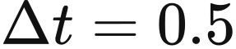 h, period energy  and annual energy  are
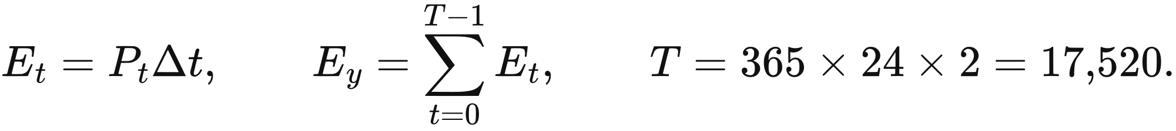
Capacity is expressed in MW, stored energy in MWh, monetary costs in GBP and electricity prices in GBP/​MWh. Demand CSV values are loaded as MW and multiplied by the time step before dispatch. VALUE 101 demand columns that retain mwh in their names follow the same numerical convention.
Data bindings assign physical files to defined computational roles. Demand files supply actual demand and the day-ahead forecast, the fleet table supplies technology, capacity and representative location, and planning tables supply project status and dates. Weather and technology-average profiles support spatial available generation and the corresponding investment rules, respectively.
Input role | Main data or fields | Computational use
Actual and forecast demand | demand_​mw in actual_​mw.csv; forecast_​mw in forecast_​mw.csv | Real-time balancing, day-ahead clearing and demand error
Fleet and initial assets | fleet.json, annual operating_​state | Technology parameters, representative locations and dispatch capacities
Projects and planning | repd_​projects_​normalized.csv, regional_​technology_​success_​rates.csv, planning_​timelines.json | Initial operational assets, project success rates and stage durations
Weather | calendar_​mean_​solar_​2020_​2024.nc, calendar_​mean_​wind_​2020_​2024.nc | Available wind and solar generation at representative points
Technology-average profiles | sa.csv, wa.csv, we.csv | Compatibility investment inputs for solar, onshore wind and offshore wind
Capital and policy | capital_​costs.json, model_​parameters.json, mechansim cost.xlsx | Investment costs, financial parameters and policy expenditure
External markets | Country-specific flow_​mw, price_​gbp_​per_​mwh | Available interconnector exchanges and external offers
Zonal network | Zones, corridors, boundaries, asset mapping and zonal demand | Spatial supply–demand balance and transmission constraints

R029 demand loading uses fixed column names, MW units and a complete 17,520-period time axis. doctoral_​demand preserves the decimal precision of the input sequence. The interconnector reader also checks consecutive periods and two price records per hour, placing demand, flows and prices in a defined computational order.
The current general-purpose reader accepts teaching and compatibility inputs through numerical-column selection and length adjustment. canonical_​psm_​data selects the column with the most valid numbers, repeats hourly profiles into half-hours, and cycles or truncates sequences to the required period count in the following order.
read_​series(file, header):
attempt numerical conversion of each column
select the column with the most valid numbers; select the first column in a tie
remove rows that fail conversion; terminate loading if finite values are absent
align(values, T, hourly_​repeat):
if length equals T: return the original sequence
if hourly_​repeat and 2 × length >= T: repeat each value twice, then take the first T values
if length is less than T: cycle to T values
otherwise: take the first T values
actual_​energy = align(read_​series(actual_​demand_​file, header=0), T, false) × 0.5
forecast_​energy = align(read_​series(forecast_​file, header=0), T, false) × 0.5
technology_​profile = clip(align(read_​series(profile_​file, header=None), T, true), 0, 1)
This reading rule determines the effective sequences in the original GB compatibility pack: the first forecast value, 21,560, is treated as a header, and the first 17,520 of the remaining 26,203 values are used; the actual-demand file contains 26,204 values after its header. R029 uses the paired UTC demand files described above, so each configuration's temporal input follows its own data and loading procedure.

Demand series and calendar processing
R029 uses NESO's 2022 day-ahead half-hourly demand forecasts and corresponding actual demand as the base demand shapes for model years. actual_​mw.csv and forecast_​mw.csv each contain 17,520 rows. Their initial statistics are given below; subsequent scenario scaling acts on these base shapes.
Series | Minimum power MW | Maximum power MW | Mean power MW | Annual energy MWh
Actual demand | 15,080 | 46,042 | 26,587.967637 | 232,910,596.5
Day-ahead forecast | 14,240 | 46,760 | 26,611.131963 | 233,113,516

Demand preprocessing identifies duplicate records by settlement date and period, then converts UK local dates to a UTC time axis. For a given settlement period, it retains the latest publication; equal publication times are resolved by retaining the last row. The original 17,518 rows become 17,516 after duplicate consolidation, and four missing half-hours are filled by linear interpolation in UTC.
Linear interpolation distributes the difference between the known endpoint values evenly across each gap. For endpoint values 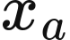 and 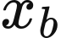, with  missing values between them,
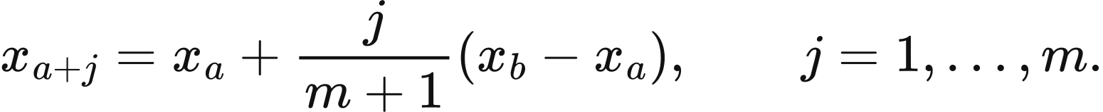
Each gap in the 2022 input contains at most two consecutive periods, and all filled values occur on 30 October. The table reports MW values to six decimal places.
UTC time | Forecast demand MW | Actual demand MW
2022-10-30 09:00 | 22,638.666667 | 24,649
2022-10-30 09:30 | 22,899.333333 | 24,727
2022-10-30 23:00 | 19,063.333333 | 20,494.666667
2022-10-30 23:30 | 19,086.666667 | 19,689.333333

Initial assets and planned projects
Initial wind, solar and storage assets are determined jointly by REPD technology, operational status, commissioning year and capacity. The input uses the second-quarter 2025 edition of the DESNZ Renewable Energy Planning Database, released in July. The source table contains 12,977 projects and 53 fields; normalisation retains 10,653 projects and 14 fields.
Normalisation retains recognised technologies with positive capacity and standardises technology names, numerical fields and dates. The 14 fields cover project identifier, site name, standardised and source technology names, MW capacity, development status, region, country, application date, permission date, construction date, operational date and two coordinates. Failed numerical conversions and missing source dates remain missing for subsequent filtering. Standardised technologies include onshore wind, offshore wind, solar, batteries and gas.
Initial operating capacity comprises assets commissioned by the study's starting year. build_​repd_​operational_​snapshot selects wind, solar and storage projects with Operational status, a commissioning year at or before the starting year, and positive capacity, then maps them to representative assets. Battery capacity is allocated according to storage-template pool_​limit weights. Nuclear capacity follows a separate station policy and annual commissioning and retirement schedule.
R029 enters dispatch in 2025 with the capacities listed below. Asset rows represent operational model assets; nuclear, gas and several other technologies use aggregate representations.
Technology | Asset rows | Power MW | Stored energy MWh
Combined-cycle gas turbine CCGT | 1 | 28,000 | —
Run-of-river hydro | 1 | 2,000 | —
Nuclear | 1 | 5,958 | —
Open-cycle gas turbine OCGT | 1 | 4,146 | —
Biomass and waste | 1 | 4,762 | —
Offshore wind | 18 | 14,679 | —
Onshore wind | 11 | 14,711.65 | —
Solar | 11 | 10,066.98 | —
0.25C battery | 1 | 299.984165 | 1,199.936659
0.5C battery | 1 | 2,465.869834 | 4,931.739667
1C battery | 1 | 74.996041 | 74.996041
Hydrogen storage | 1 | 0.749960 | 187.490103
Pumped hydro | 1 | 2,828 | 26,700

Planning inputs specify project success rates by technology and region, and duration distributions by technology and stage. regional_​technology_​success_​rates.csv contains 46 records. The general input pathway matches technology and region, then the GB aggregate, and finally a default success rate of 1, with probabilities restricted to 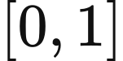. Chapter 6 describes R029's regional success-rate rule. planning_​timelines.json supplies historical stage durations in months. Development and construction medians are shown below; project entry, progression and commissioning rules are presented in the annual investment chapter.
Technology | Median development months | Median construction months
Solar | 27.8 | 4.9
Onshore wind | 62.5 | 15.0
Offshore wind | 110.1 | 32.2
Battery | 31.3 | 10.1

Costs and storage parameters
Investment inputs specify unit capital costs, payback targets and technical operating parameters separately. R029 uses capital_​costs.json and model_​parameters.json from its study configuration. Upstream capital-cost sources include BEIS Electricity Generation Costs 2020 and Arup material; the table reports the parameters adopted by the model. The default capital discount rate is 0.05. The table gives the base-configuration payback targets and preferred_​rate parameters. R029's investment rule sets the effective threshold for all four expandable storage technologies to 0.12; Chapter 6 defines its profit ratio and decision rules.
Technology | Capital cost GBP/​MW | preferred_​rate | Target payback years
Solar | 659,000 | 0.076 | 25
Onshore wind | 1,588,000 | 0.076 | 30
Offshore wind | 3,976,000 | 0.089 | 30
CCGT /​ OCGT | 2,400,000 | 0.089 | 25
Biomass and waste | 1,500,000 | 0.089 | 20
1C battery | 330,000 | 0.0825 | 10
0.5C battery | 350,000 | 0.165 | 10
0.25C battery | 415,000 | 0.0825 | 10
Hydrogen storage | 600,000 | 0.01375 | 25 (default)

Storage parameters assign charging efficiency, discharging efficiency, duration and lifetime to inventory and cost calculations. Round-trip efficiency is ; for example, the 0.5C battery uses 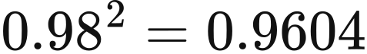. Catalogue economic lifetimes and the payback targets above enter the calculations as separate parameters. The cycle parameter  determines reference annual cycles. The three battery technologies also use it for cycle depreciation, while pumped hydro and hydrogen storage use time recovery.
Technology | Catalogue duration h | Charging efficiency | Discharging efficiency | Catalogue economic life years | Cycle parameter
Pumped hydro | 4 | 0.87 | 0.87 | 30 | 1,000,000
1C battery | 1 | 0.81 | 0.81 | 15 | 3,000
0.5C battery | 2 | 0.98 | 0.98 | 15 | 5,000
0.25C battery | 4 | 0.81 | 0.81 | 15 | 8,000
Hydrogen storage | 250 | 0.57 | 0.57 | 10 | 1,000

Annual asset schedules can specify storage power and energy directly. The 2025 pumped-hydro asset state therefore uses 2,828 MW and 26,700 MWh.
Initial stored energy depends on the operating configuration. It is zero in the doctoral-aligned configuration and defaults to 50% of maximum inventory in the general chronology configuration.
Financial calculations select time parameters by computational purpose and technology configuration. Biomass uses an economic life of 25 years and a payback target of 20 years. The gas prototype has a 20-year payback target, while the R029 run configuration sets CCGT and OCGT to 25 years.
Policy expenditure inputs combine historical aggregation with forward assumptions. mechansim cost.xlsx assembles NESO Capacity Market and balancing-cost data, Ofgem RO/​FIT/​REGO material and LCCC CfD data for annual policy expenditure calculations.

Interconnectors and zonal demand
External market inputs describe cross-border exchange opportunities through flow limits and prices for each half-hour. R029 provides one 17,520-row file for each of France, Belgium, the Netherlands, Norway and Ireland, binding each file to both flow and price roles. Fields include period, flow_​mw, price_​gbp_​per_​mwh, the source price hour, a half-hour marker, and source row numbers for flows and prices.
Boundary prices use European day-ahead prices assembled by Ember from ENTSO-E data. France, Belgium, the Netherlands and Norway use 2022 prices, while Ireland uses 2021. Each hourly price is repeated twice and saved in GBP/​MWh after conversion using 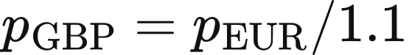. R029 retains negative input prices; the current general chronology resources apply 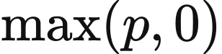.
Boundary flows enter the model as exogenous exchange limits ordered by period index. For file value 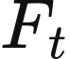 in MW, positive values assign import capacity and negative values assign export capacity. The corresponding half-hour energy limits are
This configuration combines mixed price years with flows arranged by index, and its temporal interpretation follows those input conventions. Flow ranges and mean prices are reported below.
Boundary | Flow range MW | Price year | Mean price GBP/​MWh
Belgium | −1,022 to 1,020 | 2022 | 222.292608
France | −3,091 to 2,997 | 2022 | 250.789325
Ireland | −987 to 998 | 2021 | 123.937076
Netherlands | −1,076 to 1,062 | 2022 | 219.917959
Norway | −1,263 to 1,399 | 2022 | 126.503575

Zonal studies distribute scenario-level national demand using the network pack's period-specific regional shares. With network demand 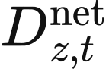 and study demand , scenario_​scaled_​zonal_​shares applies
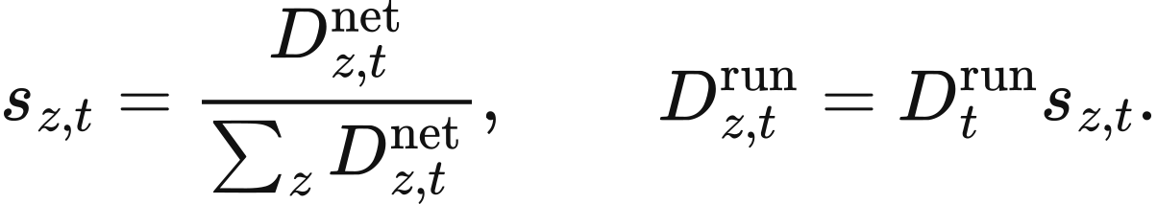
The final zone receives national demand minus the sum of the other zones, conserving the spatial total. Loading terminates if network national demand is zero while study demand is non-zero. The alternative network_​pack_​absolute_​demand uses network national demand directly and adjusts the forecast using the original forecast-to-actual ratio. Zone, corridor and asset-mapping constraints are defined in the transmission chapter.

VALUE 101 synthetic inputs
VALUE 101 generates daily peaks, seasonal variation and local supply–demand disturbances with deterministic functions. Let the half-hour index be , day index 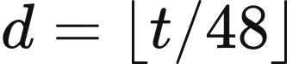, and hour of day 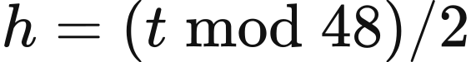. The base daily demand shape is
The weekday factor is 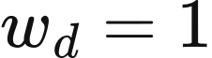, with 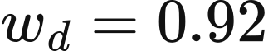 when 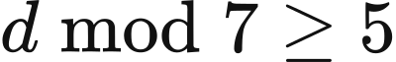. A disturbance 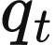 equals 30 MW when 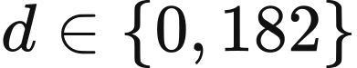 and 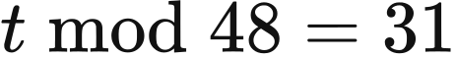, and zero otherwise. Actual demand is then
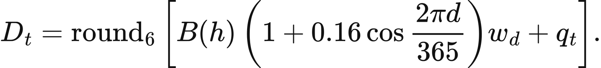
Forecast demand exceeds actual demand by 12 MW at 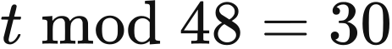 on those same two days, and equals actual demand in the remaining periods.
The teaching solar profile multiplies a daylight shape by a seasonal factor. Define . Then
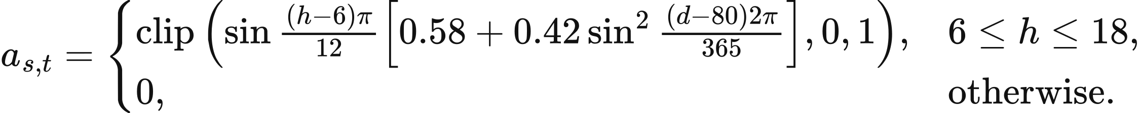
The teaching wind technology profiles combine daily, 29-day and annual components. Onshore and offshore coefficients are
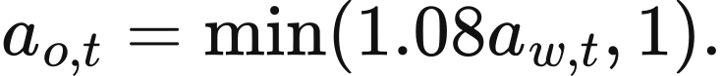
Technology profiles are saved to six decimal places. The teaching weather files separately define one grid point at 52°N, 0°E with 8,760 hours. Solar irradiation in hour  is 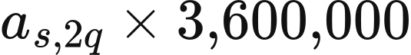 J/​m², and wind speed is
Weather wind speed is converted through the generation curve for dispatch, while the preceding wind technology profiles serve the corresponding investment inputs. The French boundary has a 12 MW import limit and a price of 82 GBP/​MWh. The other four boundaries have zero exchange capacity and placeholder prices of 200 GBP/​MWh. build_​value_​101_​packs writes the demand, weather and market inputs generated by these functions into the teaching pack.

Data and implementation
Demand comes from NESO's Day-ahead half-hourly demand forecast performance dataset, projects from the DESNZ REPD, weather from Copernicus ERA5 single levels, and boundary prices from Ember's compilation of ENTSO-E data. import_​scheme_​c_​1000twh normalises REPD inputs, doctoral_​demand and doctoral_​interconnectors load R029 time series, canonical_​psm_​data assembles general inputs, and zonal_​demand_​alignment aligns zonal demand. Subsequent chapters describe weather transformations, operational dispatch and annual investment.

3 Weather and available generation
VALUE calculates period-specific available wind and solar energy from weather at spatial representative points and asset capacity. For asset , let capacity be 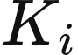 MW and the available-output coefficient be 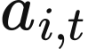. Its available power and half-hour energy limit are
The weather module supplies this physical limit, and market dispatch determines accepted generation within it. Annual wind and solar expansion rules then use either available generation or technology-average profiles, according to the selected configuration, to calculate capacity-addition limits.

Weather sequences and representative-point sampling
R029 converts hourly ERA5 data for 2020–2024 into a 365-day climatology and reuses it in each model year. The original sequence contains 43,848 hours. Removing 48 hours from the two leap days leaves five samples for each month, day and hour; their mean gives an 8,760-hour sequence. For weather variable  at location 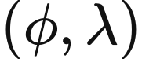, the calendar mean outside 29 February is
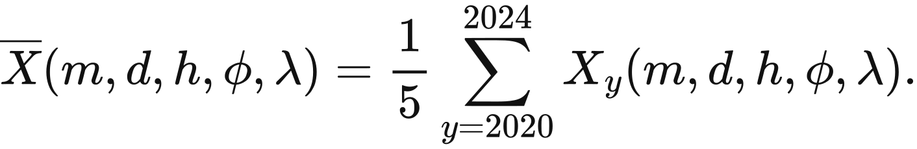
Wind speed is calculated from the magnitude of the 100 m wind vector at each original hour before calendar averaging. For each original hour, 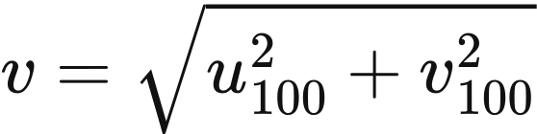. The weather file stores u100, v100 and wind_​speed obtained in that order, with the generation curve preferentially using wind_​speed. For inputs containing only vector components, the reader calculates the magnitude at the corresponding input time.
The climatology retains a 0.25° grid over Great Britain and nearby seas. The solar file represents downward solar radiation as ssrd, while the wind file provides 100 m wind information. Spatial and temporal array dimensions are given below.
Input | Latitude range | Longitude range | Latitude × longitude × day × hour
Solar radiation | 45°–65°N | 14°W–4°E | 81 × 73 × 365 × 24
100 m wind | 46°–65°N | 14°W–5°E | 77 × 77 × 365 × 24

Each asset representative point uses weather from the nearest latitude and nearest longitude grid coordinates. For representative point 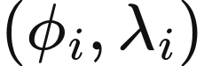 and grid coordinates 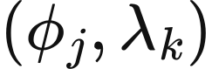,
doctoral_​weather extracts the hourly sequence at the selected point, accepting latitude–longitude–day–hour and time–latitude–longitude layouts, and terminates loading for masked or non-finite values. Half-hour period uses source hour 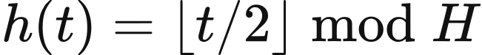, where  is the source-series length. Each hourly value therefore applies to two consecutive half-hours.
The original GB compatibility weather pack uses day-of-year grouping to produce a 366-day, 8,784-hour sequence, of which annual dispatch uses the first 8,760 hours. R029 aligns leap and ordinary years by month, day and hour and uses its full 8,760-hour climatology. Each study configuration retains its corresponding weather input.

Wind and solar generation curves
The wind coefficient follows cut-in, cubic growth, rated output and cut-out segments. Let wind speed be  m/​s, rated speed 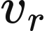, cut-out speed 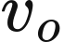, and cut-in speed 3 m/​s. Then
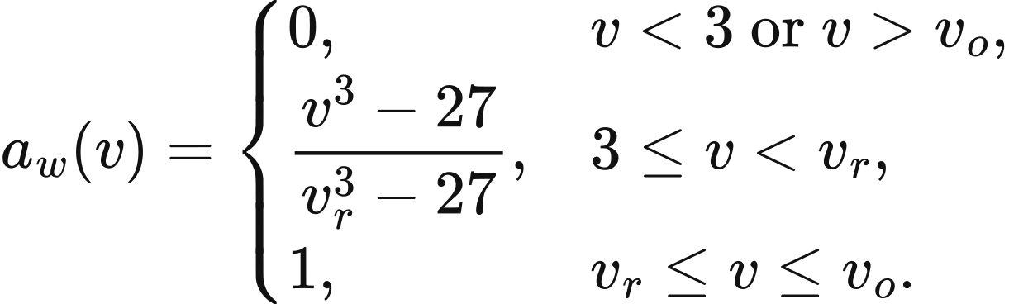
Onshore wind uses 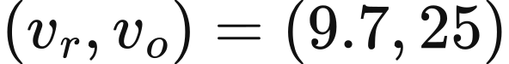 m/​s, and offshore wind uses 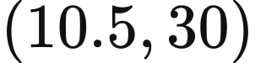 m/​s. The curve remains at 1 at the cut-out boundary and falls to zero for speeds strictly above it. These technology parameters and asset capacity jointly determine the weather-to-generation conversion.
At 8 m/​s, the onshore coefficient is 0.5476061707. A 100 MW asset therefore has 54.76061707 MW of available power and a half-hour energy limit of 27.38030853 MWh. The retained market kernel represents wind in 20 MW units and multiplies by a capacity multiplier of , yielding the same .
The solar coefficient is obtained by normalising hourly accumulated solar radiation. For ssrd value  in J/​m²,
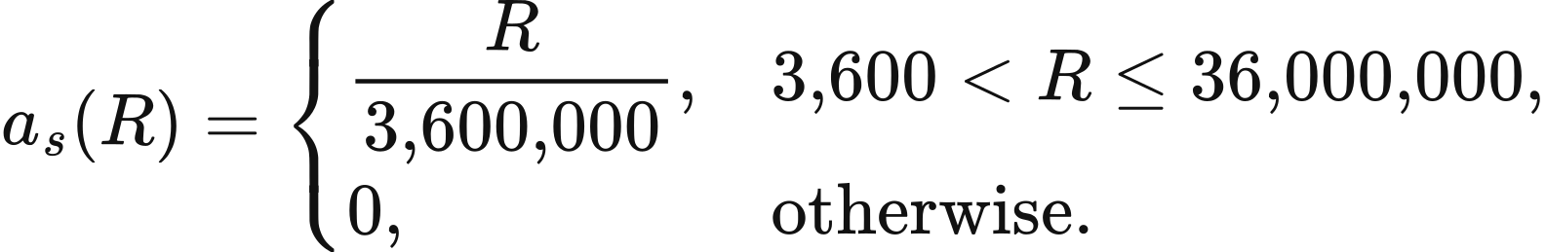
At 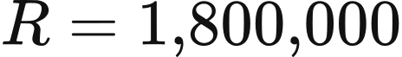 J/​m², 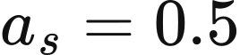, so 10 MW of solar provides 2.5 MWh of available energy in a half-hour. The function reaches 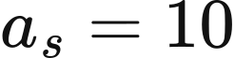 at its upper boundary. The maximum radiation in the R029 climatology is 3,322,188.75 J/​m², corresponding to a maximum coefficient of approximately 0.9228302. The separate spatial aggregation interface requires input profiles within , so new weather data must meet the profile range of the selected interface.

Project locations, asset aggregation and zones
Wind and solar projects obtain their spatial weather correspondence through representative points of the same technology. The initial GB template contains 11 solar and 11 onshore representative points, plus 21 offshore point names. R029's 2025 operating state contains 11 solar, 11 onshore and 18 offshore assets with positive capacity. fleet.locations and generator names jointly specify representative-point locations.
Projects with explicit coordinates are assigned to the nearest same-technology representative point using great-circle distance. With latitudes and longitudes for project and candidate point expressed in radians,
Equal distances retain the first point in the candidate list. Solar and onshore projects without an explicit location first use the REPD region mapping below.
REPD region | Representative point
East Midlands | Nottingham
Eastern | Ipswich
London | London
North East | Newcastle
North West | Manchester
Scotland | Edinburgh
South East | Portsmouth
South West | Bournemouth
Wales | Cardiff
West Midlands | Birmingham
Yorkshire and Humber | Sheffield

Remaining unlocated projects are allocated among representative points in proportion to existing same-technology capacity. For operating capacity , the allocation weight is 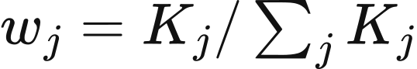. Located projects commissioned in the same year enter capacity first, followed by allocation of the remaining projects; the final point receives the floating-point remainder. Zero existing capacity selects the first representative point, and allocated shares of at most 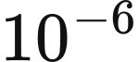 MW are skipped.
Assets with mixed weather sources retain the weights assigned when they enter operation. If weather_​source_​weights for asset are 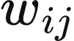, its available-output coefficient is
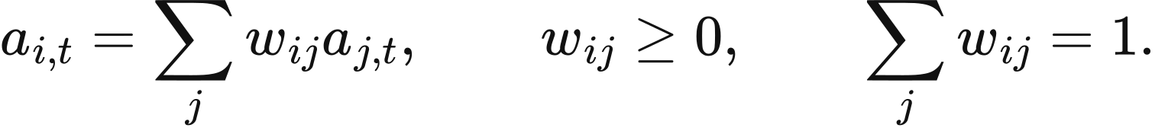
doctoral_​weather_​mapping establishes the project-to-point correspondence, and the weather reader checks weights and technology consistency. Subsequent capacity changes retain the asset's existing weather weights.
The current national market maps annual assets onto a fixed market-agent and representative-weather topology. Mapping first uses identical asset identifiers, then selects agents of the same technology with matching region and allocates by previously mapped capacity. Zero capacity invokes template capacity and then equal allocation. Each market agent's final capacity is the sum of the annual assets assigned to it.
Zonal operation divides assets by capacity shares while retaining the original weather profile and economic owner. For asset share 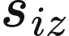 in zone 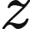,
holds when 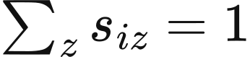. StagedBidAtCostPSM applies the same share allocation to generation capacity and to storage power, energy capacity and inventory.
A separate aggregation interface combines precomputed project profiles by capacity. For project set  sharing an owner, technology and zone, REPDERA5AggregatedWeather.build calculates
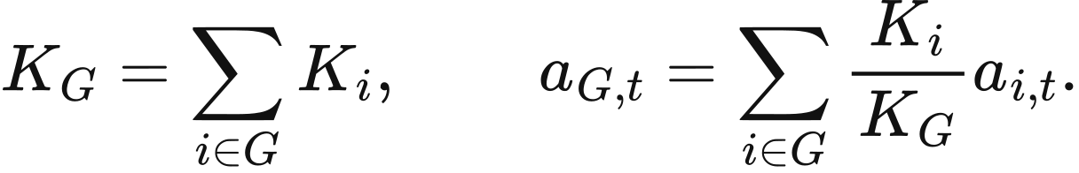
This interface accepts equal-length finite profiles within and positive total capacity. The current zonal execution path uses representative-profile replication as described above. The separate aggregation interface receives source profiles already generated by its caller.

Annual wind and solar capacity limits
The current general investment rule calculates capacity headroom from peak demand and the peak of a technology profile. Let peak actual demand be  MW, the peak CSV profile for technology  be 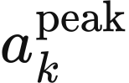, and its operating capacity be 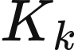. Then
Technology-average profiles combine 2022 ERA5 data with fleet and project assumptions. Solar sa.csv contains 8,761 values, of which the first 8,760 hours are used after conversion to half-hours; onshore wa.csv and offshore we.csv each contain 8,760 hourly values.
canonical_​psm_​data reads these profiles, and the annual expansion definition applies . For example, 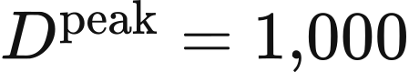 MW, 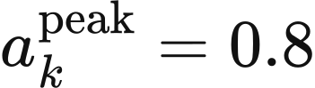 and  MW give headroom of 950 MW and an annual limit of 190 MW. A zero profile peak invokes the denominator floor of 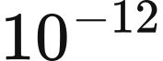.
R029's thesis_​final9.6 investment configuration sets capacity limits from the count of negative net-demand periods. It first constructs 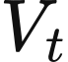 from the physical available energy of all operating wind and solar assets, and calculates available energy per MW, 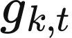, for each technology:
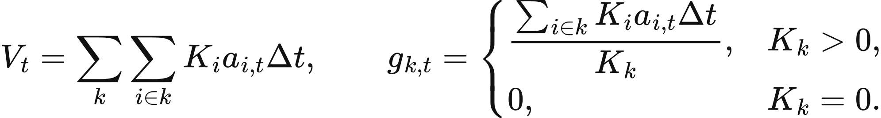
Here has units of MWh/​MW/​period. For actual demand energy , net demand is 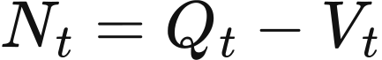, and the existing count of negative net-demand periods is 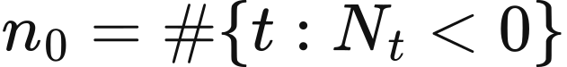. The threshold 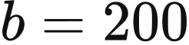 half-hours corresponds to 100 hours.
The expansion limit follows the order statistic of the added capacity at which net demand reaches zero. If 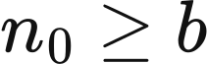, the limit is zero. Otherwise, periods with  and 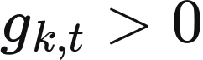 give ratios 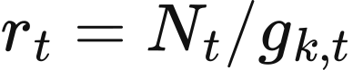. The 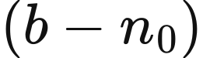-th smallest ratio defines critical capacity , and . Fewer than 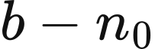 eligible ratios give a zero limit. Capacity equal to a particular 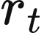 makes that period's net demand exactly zero; the strict negative-net-demand criterion remains .
input: full-year demand Q, asset capacities K, half-hourly available-output coefficients a
V[t] = sum K[i] × a[i,t] × 0.5 over all operating wind and solar assets
N[t] = Q[t] − V[t]
n0 = count(N[t] < 0)
for each wind or solar technology k:
calculate capacity-weighted available energy per MW, g[k,t]
if n0 >= 200: annual_​cap[k] = 0
otherwise:
ratios = N[t] /​ g[k,t] for periods with N[t] >= 0 and g[k,t] > 0
if number of ratios < 200 − n0: annual_​cap[k] = 0
otherwise: annual_​cap[k] = 0.20 × the (200 − n0)-th smallest ratio
output: annual capacity-addition limits by technology
R029 constructs these quantities from annual physical inputs and aligns total available wind and solar generation with annual market summaries. Its 2025 operating sequence contains 1,878 negative net-demand periods, giving zero annual limits under this rule for solar, onshore wind and offshore wind.

Data and implementation
calendar_​mean_​solar_​2020_​2024.nc and calendar_​mean_​wind_​2020_​2024.nc supply the R029 calendar climatology. doctoral_​weather extracts representative-point series and converts wind and solar inputs, while doctoral_​weather_​mapping manages project locations and mixed weather weights. scheme_​c_​native_​psm aggregates capacity into national market agents, and staged_​psm divides capacity among zones. Annual limits use the general peak rule in canonical_​psm_​data and v2_​module_​definitions, or the net-demand threshold rule in R029's doctoral_​expansion_​inputs and doctoral_​policy.

4 Operation and annual feedback
The current VALUE annual workflow feeds half-hourly operation into the following year's investment and asset state. Projects advance at the start of the year, commissioned assets participate in dispatch, and annual income and capacity limits determine additions and retirements. This chapter describes the current staged market and general investment rules; the annual investment chapter gives the accounts and financing rules used in the R029 national study.

Model clock and annual state
Each model year contains 365 days and 17,520 half-hour periods, with h. The indices , , ,  and denote year, period, asset, economic owner and technology. Demand, scheduled output and charging or discharging in this market workflow are measured in MWh per period, rated power in MW, and storage capacity in MWh.
The annual state contains operating assets, projects awaiting commissioning, storage-pricing observations and accumulated financial quantities. Projects due at the start of a year enter the operating portfolio after their site and input conditions are checked. Annual income determines year-end decisions, and new proposals enter the construction pipeline for subsequent years. Several assets may belong to one economic owner; spatially divided physical resources and financial projects retain separate identities.
Input operating assets, construction projects, demand, weather,
technology parameters and selected modules
for each model year:
Advance projects due for commissioning and form the operating portfolio
Construct demand, availability and boundary-trade series
Run the selected dispatch module; aggregate physical flows and market income
Calculate renewable and storage expansion limits
Allocate income to investment accounts; determine additions and retirements
Apply planning success rates and create projects awaiting commissioning
Update assets, construction pipeline and storage-pricing observations
Output annual operation, costs, emissions, investment and terminal asset state
At the end of the study window, report_​only retains the terminal state, pipeline_​tail advances existing construction projects, and full_​extension extends the complete annual workflow. These options determine whether remaining projects enter service and whether operation and investment continue in subsequent years.

Ahead market and realisation
The staged market first meets forecast demand and then adjusts the schedule against actual demand. Let 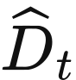 and  be forecast and actual demand,  rated power, 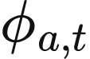 the supplied availability factor, and 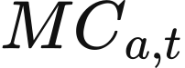 a time-varying or constant marginal cost. The offered energy and price of a non-storage resource are
The bid multiplier defaults to 1. Input conversion determines the upper bound of the availability factor, while the offer function clips negative values. This dispatch representation uses continuous energy, with generation bounded by current available capacity and intertemporal physical state represented by storage inventory. Forecast and realisation share the declared resource-availability series, and the supplied forecast and actual demand series determine the demand difference between stages.
Storage supply is limited jointly by discharge power and opening inventory. With stored-side inventory 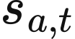 and discharge efficiency 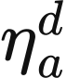,
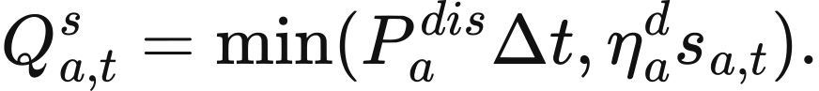
Offers are sorted by increasing price and then by offer identifier. Starting with residual demand 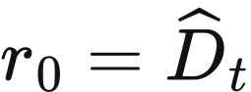, sorted offer is accepted according to
Clearing ends when residual demand falls to MWh or below. The national price 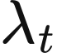 is the price of the last accepted offer, and all accepted energy receives this common price. The price is 0 when accepted supply is zero. Any ahead shortfall is recorded and passed to the realisation stage.
Realisation uses 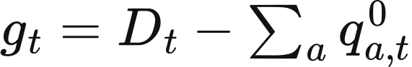 to determine the adjustment direction. Generation and imports offer upward capacity 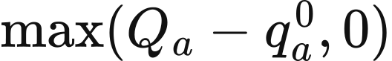 at 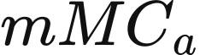. Their downward capacity is 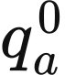, priced at the negative of the curtailment cost, which defaults to 0. Storage downward capacity first permits withdrawal of scheduled discharge and then charging:
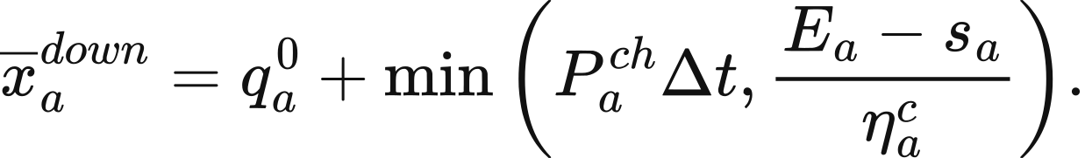
Storage downward bids are priced at 0. Exports are negative injections constrained by the export-capacity series and connection location. Boundary-trade inputs specify import and export prices and availability.
Copperplate balancing accepts upward offers in ascending price order for a positive gap and downward offers in descending price order for a negative gap. Identifiers break price ties, and each acceptance is bounded by the offer quantity and remaining imbalance. With accepted adjustment 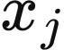 and direction 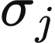, final injection and balancing cash are
A positive gap remaining after upward offers are exhausted becomes unserved energy . Feasible upward offers are accepted in price order until demand is met or offered capacity is exhausted. Final energy balance requires
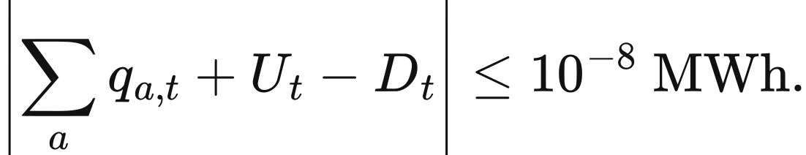
A remaining negative gap above this tolerance stops the run. When a network module is selected, zonal redispatch adds nodal balance and transmission constraints to the same ahead schedule, as described in the transmission chapter.
Market payments and resource expenditure describe different quantities. For example, forecast demand of 50 MWh is served by wind offering 30 MWh at £0/​MWh and gas offering 30 MWh at £60/​MWh. The ahead schedule accepts 30 MWh of wind and 20 MWh of gas at a common price of £60/​MWh, giving £3,000 in total payments. If actual demand rises to 55 MWh, gas supplies a further 5 MWh and receives £300 in balancing income. Gas operating expenditure is calculated from its final 25 MWh output and equals £1,500.

Storage inventory and bids
Storage inventory follows final net injection. Positive 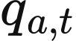 denotes discharge and negative values denote charging. Charging efficiency 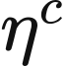 and discharge efficiency 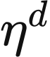 act on their respective directions, giving round-trip efficiency 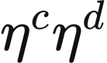.
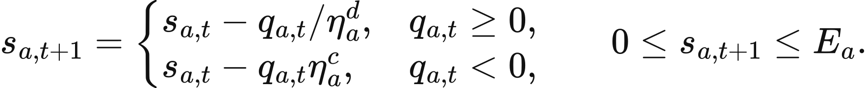
Copperplate inventory updates allow a rounding correction of 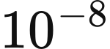 MWh. Zonal dispatch uses separate charging and discharging variables and rejects simultaneous charging and discharging above MWh.
Opening inventory in each year comes from that year's initial_​soc_​mwh input. canonical_​psm_​data.py sets this to 0 for doctoral-aligned configurations and to  for ordinary configurations. Inventory is continuous within a year, and the current annual state carries storage-pricing observations forward. The following year's input determines its opening physical inventory. Directly constructed inputs use their declared inventory values. R029 carries dated inventory batches between years under the rules in the annual investment chapter.
Dynamic storage bidding divides annual equipment costs between cycle recovery and time recovery. Let  be total capital cost,  economic lifetime,  annual fixed maintenance and  the discount rate. The annual amount to recover is
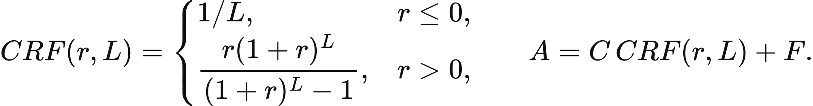
The reference bid uses catalogue duration , cycle life , actual energy capacity  and actual discharge efficiency. Reference cycles, annual delivered energy and holding periods are
Positive sales in the previous year give and 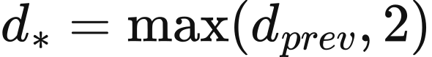; otherwise the reference values apply. Previous holding time 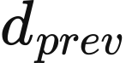 is weighted by delivered MWh. Defaults are 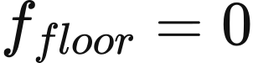 and 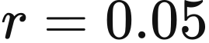. Technologies with cycle depreciation use
Other technologies use 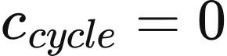, and a recovery term with an invalid denominator is set to 0. DynamicAnnualStorageCost implements these equations. The current staged caller passes a holding time 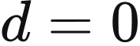 and records sale ages as 0, so its realised storage bids use the cycle component. The next chapter describes national algorithms that price dated inventory batches.
Chapter 2 gives storage-catalogue durations, efficiencies, lifetimes, cycle counts and construction costs. Dynamic bidding also uses the following fixed-maintenance rates and a pumped-hydro catalogue capital cost of 360,000 GBP/​MW, expressed in 2025 GBP.
Technology | Fixed maintenance GBP/​kW/​year
Pumped hydro | 13.4
1C battery | 6.6
0.5C battery | 6.6
0.25C battery | 6.6
Hydrogen storage | 19.7

The three battery technologies include cycle depreciation; pumped hydro and hydrogen storage use time recovery. Bid duration, lifetime, cycle count and fixed-maintenance rates come from the catalogue, while capital, power, energy and discharge efficiency come from the supplied asset. The asset retains its input .
Alternative bid policies include fixed fees and user expressions. The fixed-fee policy uses 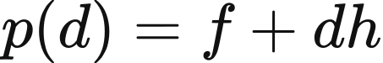, with supplied rates 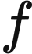 and . User expressions can use cycle recovery, holding time, holding-recovery rate, annual cost and reference sales.

Current storage expansion limit
The current general expansion module estimates additional capacity from operating supply and demand duration curves. It receives accepted renewable energy , actual demand and actual storage discharge 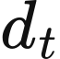, and constructs
These inputs follow the call in v2_​module_​definitions.py. The helper also accepts explicit residual surplus or existing charging series. The current caller leaves these additional fields empty, so 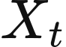 follows directly from accepted renewable energy and demand.
The virtual store starts empty, with power and energy limits of 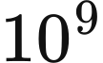 MW and MWh, charging efficiency 0.98 and discharge efficiency 1. Each period charges before discharging:
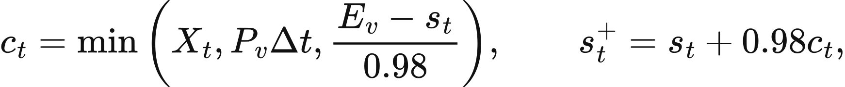
Duration curves count hours for which charging or discharging power exceeds . With 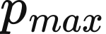 equal to the smaller of peak charging and peak discharging power,
storage_​expansion_​cap.py calculates this boundary using 64 bisection steps. It returns 0 when the required duration is unattainable and when 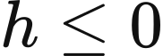. Daily, inter-day, weekly and seasonal bands are respectively 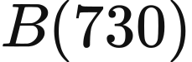, , and 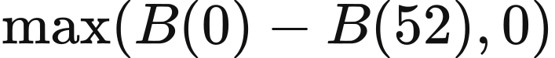.
Each of the three battery technologies receives a limit of 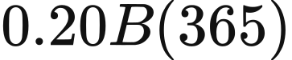, while hydrogen storage receives 20% of the seasonal band. Investment accounts within a technology share its budget, and this caller uses the incremental band directly. Price and ROI are separate from this duration-curve calculation. The annual investment chapter describes the economic storage screening used in R029.

Current investment and planning rules
General investment first allocates owner income to assets and then forms decision groups by owner, technology and region. When dispatch reports income by economic owner, adapt_​market_​for_​investment uses operating-capacity shares:
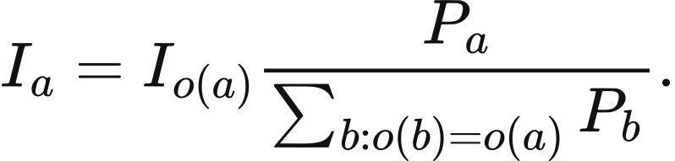
Income belonging to an owner with several technologies therefore follows MW weights. Custom inputs require corresponding dispatch-owner and investment-owner fields. Results reported by asset enter investment accounts directly.
For an asset group, define 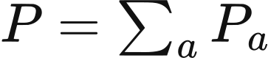, 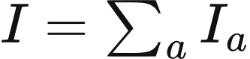, 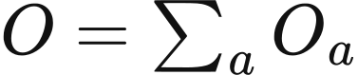 and 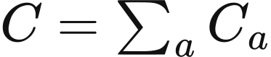. Operating-cost field  comes from annual_​operational_​cost_​gbp and defaults to 0. Profit, unit capital cost, return and payback period are
A group with negative profit and  retires 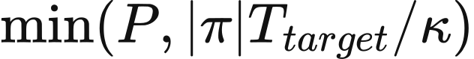. Otherwise,  above the preferred rate gives high-return investment, and  gives profit-funded investment. Both branches request 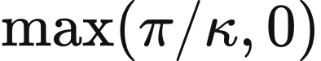, subject to the remaining technology limit:
Wind, solar, the three battery technologies and hydrogen storage require a positive technology limit. CCGT, OCGT, gas and biomass may use uncapped requests under the eligibility policy. Nuclear follows an exogenous construction schedule; new hydro and pumped-hydro projects require site and hydrological inputs. Groups consume the same technology budget in stable order, and concurrent policy limits use their minimum.
A group uses the maximum preferred return, minimum lifetime and target payback, maximum development time and minimum success probability among its members. Defaults are a preferred return of 0.08, lifetime of 25 years, target payback equal to lifetime, and development time of 1 year. Zero values in these fields trigger their default fallback, while a success probability of 0 remains 0. New storage inherits the group's ratio.
Commissioning occurs in . Expected-capacity planning multiplies power, energy, capital and total annual costs by success probability once. Fixed-seed planning generates a deterministic draw  from the project identifier and seed, retaining the full project when 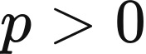 and 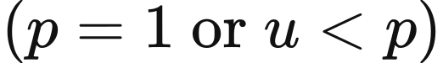. Rates, lifetimes and ratios retain their original values. SchemeCPlanningPipelineDefinition implements admission and sampling, while SchemeCStateTransitionDefinition scales assets with retirement and applies declared withdrawal years.

Costs and emissions
System resource cost comprises annual capital recovery, fixed maintenance and actual operating expenditure for assets in service. With annual demand  and unserved energy , the cost per unit of served energy is
The intensity is empty when served energy is zero. Market payments, policy transfers, construction commitments and residual values are reported separately. Zonal constraint expenditure is attributed through the difference between zonal and copperplate operation from the same period-opening state, and is included in final operating expenditure.
Reliability expenditure follows the selected balancing module. The current copperplate return accumulates positive injections multiplied by resource unit costs and reports unserved energy separately. Zonal balancing includes unserved energy multiplied by VoLL. Comparisons use a common served-energy denominator and state the composition of reliability expenditure.
Operating emissions multiply actual generation by its applicable factor. For  in MWh and 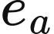 in kg/​MWh, operating emissions in tonnes and total carbon intensity are
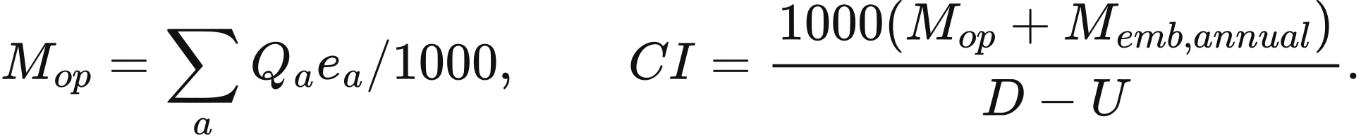
Chapter 9 gives factor values and their CO₂ or CO₂e labels; carbon intensity retains the emissions basis of the selected factors. Annual embodied emissions use in-service MW and annual t/​MW factors. A battery-manufacturing factor expressed in kg per kWh of capacity gives annual emissions of 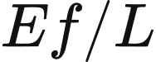 tonnes. Hydrogen storage treats power and energy components separately. Components lacking required factors remain unassessed, and legacy doctoral carbon scalars retain separate diagnostic units.
Storage carbon tracing uses a mixed inventory. Charging  adds 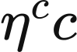 to energy inventory and charging energy multiplied by source intensity to carbon inventory. Discharging  withdraws 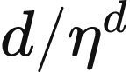 from stored energy and transfers carbon in the same inventory fraction. Total emissions are measured at source generation; storage carbon inventory describes energy provenance and loss allocation. This tracing requires complete charging, discharging and source-intensity series.

Data and implementation
canonical_​psm_​data.py assembles demand, resource availability, boundary trades and initial inventory into annual inputs. staged_​psm.py constructs the ahead schedule and balancing offers, and copperplate_​balancing.py performs price-ordered clearing. storage_​cost.py calculates storage bids, while storage_​expansion_​cap.py gives duration-curve capacity limits. v2_​module_​definitions.py connects annual investment and planning, and cost_​ledger.py and carbon_​ledger.py aggregate resource expenditure and emissions.

5 National dispatch algorithms
VALUE provides Native and Doctoral sequential-clearing pathways for national single-node dispatch. Both allocate supply every half-hour using bids and physical states, balance aggregate national demand, and represent cross-border imports and exports as exogenous trading capacity. Native retains the original Scheme C market agents and expenditure statistics. Doctoral separates the ahead plan, realisation and state commitment, with period-by-period energy and cash checks. The current Doctoral entry point produces annual operating results. The R029 national study adds start-up event costs, technology storage pools and inventory carry-over, and connects complete annual accounts to investment, as described in the annual investment chapter.

Inputs and agents
The national algorithms dispatch power in MW and convert it to energy using 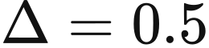 h. Forecast and actual demand are and , available power is , realised power is 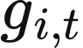, and the ramp allowance per period is 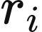. Standard annual inputs contain 17,520 periods. Demand in the input interface is supplied as 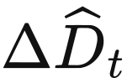 and 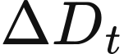 MWh.
Operating cost follows the agent-constructor parameters. Gas and biomass unit costs combine gen_​cost + fuel_​cost + carbon_​price + unit_​time_​cost; nuclear, renewables and natural-flow hydro combine gen_​cost + unit_​time_​cost. The carbon_​price field is already expressed as expenditure per unit of generation. Ordinary generator bids in the two current national pathways are
where  is composite unit operating cost, 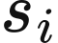 the start-up bid adder, 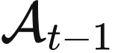 the previously accepted generator set, and defaults to 1. Hydro and renewables have a zero start-up adder. R029 uses the separate start-up event equations in the annual investment chapter.
Native maps the year's operating and commissioned assets to existing market agents. It first matches names, then technology and normalised region. Multiple candidates are weighted by previously mapped capacity, constructor capacity, or equal shares, in that order. For allocation weight 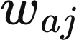 from asset to agent , agent capacity and the income returned to assets are
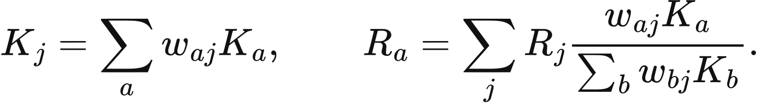
Wind-agent capacity multipliers are , solar multipliers are , and conventional-generator power limits are . Storage power and energy are aggregated by technology. scheme_​c_​native_​psm.py creates new agents each year and restores previous annual sales and sales-weighted holding time for bidding. Physical inventory follows the initial state of the newly created objects.
Doctoral constructs agents from annual asset capacities, resource availability, nuclear policy, and complete generator and storage parameter rows. These rows specify costs, efficiencies, ramps, opening output, downward prices and natural hydro or biomass budgets. A new asset may reuse a row through doctoral_​parameter_​source_​id, retaining that row's ramp and budget values. Storage has equal rated charging and discharging power. Empty opening batches correspond to zero inventory; non-zero inventory is recovered with its batch ages. Direct renewable electrolysis and the common electrolyser are switched off in this Doctoral pathway.
Demand error comes directly from the supplied series 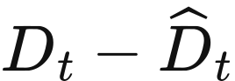. Compatibility filenames are 2022fd.csv and 2022reald.csv, with actual files bound by the data pack. canonical_​psm_​data.py forms half-hourly energy inputs using the reading and time-alignment rules in Chapter 2.

Native availability and storage
Native derives site wind speed from the magnitude of wind components and uses the wind curves in Chapter 3. piecewise_​limit1 to piecewise_​limit4 use cut-in, rated and cut-out speeds 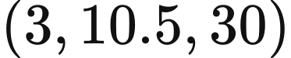 m/​s, while piecewise_​limit5 uses 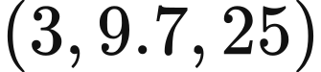 m/​s. The kernel first calculates output for a 20 MW turbine, then applies asset-capacity multiplier . Solar uses the same radiation interval and normalisation as Chapter 3. Hourly values are repeated for two half-hour periods, following the compatibility clock.
Native creates stored-side MWh batches indexed by charging period. Let 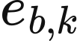 be inventory in storage  charged during period , with rated power , energy , and current-period batch 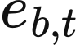. Grid-side charging power is
Here is the surplus power available for charging at that step. A batch can discharge at most 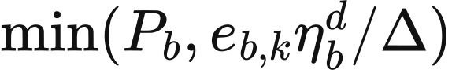, and delivery of MW reduces inventory by 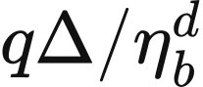. Batch offers within a stage share a declining power budget. The ahead market accepts all existing batches; balancing accepts batches aged at least 2 periods. Each stage constructs its power budget separately, so total output is read from the combined stage results.
Inventory is multiplied by 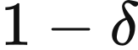 each period for self-discharge. Electrochemical and other types use 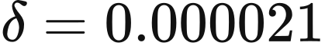, pumped hydro uses 0.000001, and hydrogen storage uses 0.000005. Batches below 0.001 MWh are removed. Dynamic bidding applies the annual cost-recovery equations in the preceding chapter with actual batch age 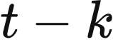:
Native uses the selected storage.bid-cost-function. The dynamic policy records delivered MWh and MWh multiplied by age for the next year's bids. Positive holding fees make newer batches cheaper; zero holding fees preserve stable batch order.

Native clearing and expenditure statistics
Native performs forecast clearing, surplus allocation and actual-demand balancing in sequence. Conventional generator acceptance is bounded by
with hydro and biomass additionally constrained by the remaining cumulative budget 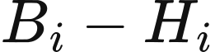. Budget variables are cumulative MW-period values, converted to MWh by multiplying by . An ordinary generator accepts the smaller of the limit and residual forecast demand. When nuclear's upper limit exceeds remaining demand , it accepts 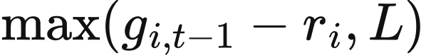, with the excess entering inflexible surplus. Renewables serve remaining demand up to availability and retain the remainder as available surplus.
for each half-hour:
Update weather availability, boundary prices and capacity,
hydro and biomass budgets; apply self-discharge
Construct generator and storage-batch offers; stably sort by price
Meet forecast demand subject to ramps, capacities, budgets and inventory
if actual demand is below forecast:
Charge storage from forecast oversupply, then from existing surplus
Accept positive-price exports in descending external-price order
Supply the common electrolyser, then apply downward dispatch
else:
Use existing surplus and charge storage with the remainder
Merge the marginal and subsequent generators, batches aged at least
2 periods, and import offers
Fill the gap by price; record remaining shortage as unserved energy
Aggregate final output, stage expenditure, income and supply-demand residuals
The compatibility configuration retains a common electrolyser as flexible demand. Source initial parameters are 10 MW, a ramp of 0.125 MW per period and efficiency 0.65, with overrides supplied by the running data pack.
Natural-budget returns after downward dispatch depend on the national algorithm. Native applies its budget branch to hydro, while Doctoral applies it to hydro and biomass.
Native settles generators and storage at separate uniform prices. Ahead generator income is 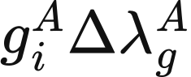, while storage income is 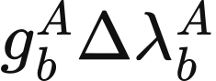; each price is the largest accepted bid in its respective category. Balancing income follows the same categorisation. When storage alone supplies demand and the accepted generator set is empty, the current Native income function returns an empty account map.
Native's displayed price divides stage expenditure by actual demand in MW. Let be the source accumulator of accepted-offer, storage, downward and upward charges. Then
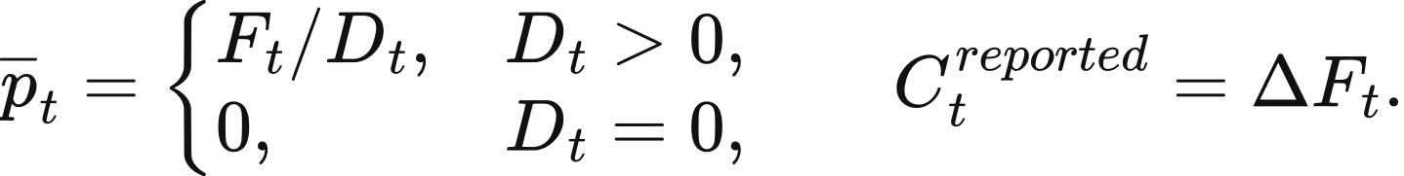
Annual agent income comes from separate income accounts, while the displayed price describes this stage-expenditure measure. Annual operating expenditure is 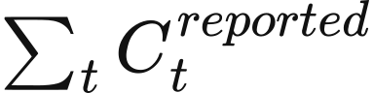 plus reported current-cycle depreciation; annual system expenditure adds annualised capital and fixed maintenance. Final boundary supply enters annual generation, while storage discharge is reported separately from this annual generation statistic.
Native retains both raw supply-demand residuals and compatibility adjustments. Using energy quantities for supply , unserved demand , forecast and actual demand 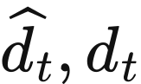, and recorded charging ,
The compatibility adjustment aligns the reported quantities. The physical supply-demand relationship is assessed using 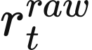 together with the recorded flows. This expenditure view contains historical stage charges and bid components; physical resource-cost analysis uses separate components tied to actual operation.

Doctoral batch inventory
Doctoral represents each batch by a raw quantity 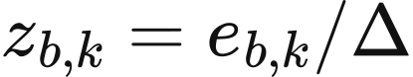, with rated inventory 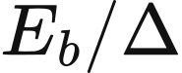. Reported physical inventory is 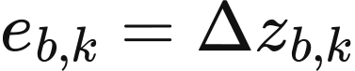 MWh. Self-discharge uses the preceding section's period parameters, and batch prices use fixed fee 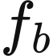 and per-period holding fee 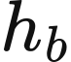 from the bound parameter rows:
The prototype config.py provides the following rates. A run uses the complete storage rows bound by doctoral_​market_​factory.py; dynamic annual cost recovery is an optional Native bidding policy.
Prototype technology | Charge efficiency | Discharge efficiency | Fixed fee | Holding fee per period
Pumped hydro | 0.87 | 0.87 | 0 | 1.1008
1C battery | 0.81 | 0.81 | 0 | 1.0558
0.25C battery | 0.81 | 0.81 | 0 | 0.7369
0.5C battery | 0.98 | 0.98 | 135.26 | 0.1736
Hydrogen storage | 0.57 | 0.57 | 884.4 | 0.0055

All batches and both ahead and balancing stages share the delivered-power limit of a battery. If power already delivered in the period is 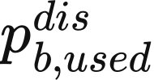, and remaining demand is , batch withdrawal and grid-side delivery are
Delivered energy is 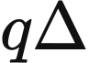. The ahead stage accepts all existing batches, and the upward stage accepts batches aged at least 2 periods. Raw balances below 0.001 are removed, corresponding to at most 0.0005 MWh per batch. The raw expenditure diagnostic retains , while sale cash uses delivered MWh and the settlement price.
Charging orders storage by ascending 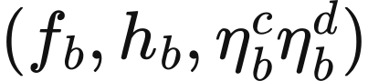. Grid-side charging power uses the raw inventory headroom:
The final term directly uses raw inventory headroom, giving a conservative charging bound. For the 0.5C prototype, a batch aged 4 periods bids . A 10 MWh batch has raw quantity 20. Delivery of 10 MW, or 5 MWh, withdraws 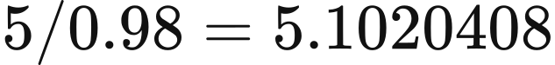 MWh from stored energy and earns £679.772 when settled at that bid.

Doctoral planning and realisation
Doctoral forms its ahead plan on a copy of the opening state. It updates natural budgets and self-discharge and accepts generator and storage offers in stable price order. Conventional generators use the ramp bounds above; hydro and biomass also respect remaining budgets. Nuclear retains ramp-constrained output according to . When nuclear is absent from the accepted set, its remembered output is multiplied by 0.99. Unaccepted renewable availability and surplus already generated by nuclear are recorded separately.
Realisation selects the adjustment direction from the power already scheduled to serve demand. Subtracting the non-renewable surplus already generated in the ahead stage gives
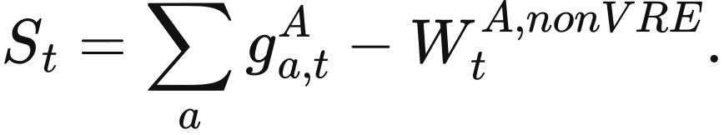
When , the downward target is 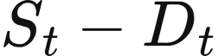. Storage charges first, existing surplus is then processed, positive-price exports are accepted in descending external-price order, and generators are curtailed in configured downward-price order. For accepted output , previous output , and ramp allowance , the thermal downward bound and accepted quantity are
Hydro and biomass return curtailed quantities to their used budgets, and previous generator output is read by object identity. Non-renewable output retained by ramp limits is recorded separately as spill.
When , upward dispatch first uses existing surplus and offers remaining surplus to storage. It then starts from the last generator accepted ahead, merges that generator and subsequent generators with storage batches aged at least 2 periods and import offers, and fills the remaining gap. An empty ahead generator set starts from the first generator in the offer list.
For the accepted marginal generator, upward output is bounded by . Unaccepted generators use 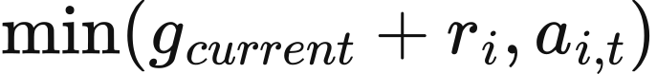, with remaining-budget constraints for hydro and biomass. Imports use the original external price. Positive-price exports in this branch are accepted in ascending external-price order, and any remaining positive gap becomes unserved energy.
Final physical quantities are aggregated from the dispatch-output list, with renewable energy sent to storage and exports allocated back to its source. Let include final generation, storage discharge and imports; be charging, exports,  non-renewable spill and actual demand, all in MWh. Then
Commitment requires 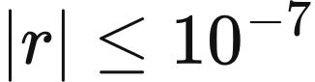 MWh, non-negative generation and renewable output within availability. Storage additionally reconciles opening and closing inventory with three loss categories:
Here and are grid-side charging and discharging energy. Inventory losses comprise self-discharge, conversion losses and small-batch removal; COMMIT passes closing inventory and generator output to the next period.

Doctoral settlement and annual expenditure
Doctoral settles generators and storage separately in ahead and upward markets. Ahead cash is determined before downward realisation changes output: generator income is , and storage income is . Storage-only supply still receives its corresponding cash. Accepted downward quantity 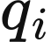 uses the configured signed rate 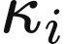:
Downward amounts for nuclear, renewables and batteries remain historical expenditure diagnostics. Variable generation expenditure is 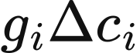, import procurement is imported MWh multiplied by the external price, and storage variable operating expenditure is 0. Fuel, carbon-price and other costs decompose this variable expenditure. Export receipts and external procurement retain their separate cash directions.
Annual expenditure adds fixed maintenance, annualised capital and reliability expenditure:
Fixed and capital expenditure enter only complete 17,520-period annual summaries; both are 0 in shorter diagnostic runs. Annual generation statistics include storage discharge and boundary supply. The displayed clearing_​price is the ahead generator price. Investment accounts read actual market cash, operating expenditure and annual capital separately to calculate profit under the following chapter's rules.

Data and implementation
scheme_​c_​native_​psm.py passes annual assets to modular_​simulation_​model.py and connects the selected storage policy through storage_​cost.py. For Doctoral, doctoral_​market_​factory.py reads parameter rows, doctoral_​market_​kernel.py performs sequential bidding, doctoral_​market.py manages planning, realisation and state commitment, and doctoral_​settlement.py produces cash and expenditure components. Reconstructing either pathway requires its corresponding demand, resource availability, boundary prices and capacity, technology parameters and initial batches. Each pathway's settlement mapping supplies its annual accounts.

6 Annual investment and asset evolution
The R029 national study uses annual operating income to drive expansion, financing and retirement. It covers 2025–2034, with 17,520 half-hour periods per year and the thesis_​final9.6 investment rules. Its basic scenario sets capacity-market, ancillary-service and decarbonisation-support budgets to zero. Renewable and storage expansion fractions are both 0.20, and investment decisions use complete annual operating accounts.

Connecting national operation across years
R029 charges start-up expenditure when a physical start occurs. Let be asset nameplate capacity, the start-up rate in GBP/​MW, and 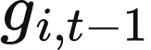 and the opening and final output. Power is measured in MW, h, is composite variable expenditure in GBP/​MWh, and is the bid multiplier. Generator bids use , while operating expenditure includes
Start-up expenditure uses the nameplate MW of the entire dispatch asset and is measured in GBP per event. Existing nuclear retains positive initial output from its source parameters. Fuel, carbon-price, other operating and start-up expenditure jointly form actual variable expenditure, while income follows the national settlement rules.
R029 combines 1C, 0.5C and 0.25C batteries and hydrogen storage into one national physical pool per technology. Members share , efficiencies and operating-bid parameters; pumped hydro retains separate asset representation. Pool capacities and allocation to projects are
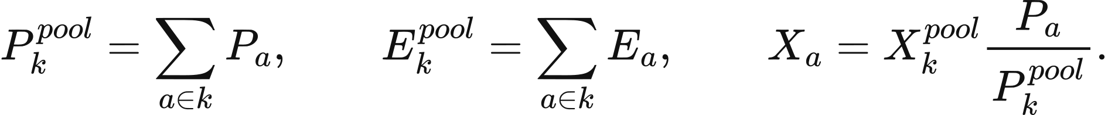
Quantity may represent actual income, operating expenditure or a physical pool total. allocate_​pool_​amounts distributes it by operating MW, with the final member receiving the rounding remainder. Project capital, financing, commissioning and withdrawal dates remain separate. Domestic asset cash and boundary-trade cash are aggregated separately.
Inventory retains batch ages through absolute charging periods. Positive holding fees and bid multipliers give newer batches priority; exact price ties follow original clock order. Generator, storage-batch and import streams are merged stably. Each pool shares its power limit across all batches and both ahead and balancing stages. PriceLots and PriceInventory retain remaining batches and apply self-discharge through a common inventory scale.
Annual state carries closing batches, the absolute clock and generator memory forward. When storage capacity changes from 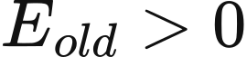 to , each previous batch is multiplied by
Expansion preserves existing inventory, contraction writes inventory off in proportion to capacity, and complete withdrawal clears the store. This energy is recorded as retirement loss, with zero associated sales or receipts. New generators use their own opening output, and withdrawn generators leave the operating state.

Annual accounts and decision units
Investment accounts combine actual ahead income, signed balancing income, variable expenditure, fixed expenditure and annualised capital. For project , let capacity-market, incremental decarbonisation and ancillary-service income be , 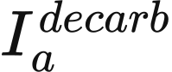 and 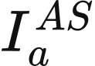, annual fixed expenditure 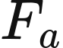, and annualised capital 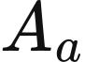. Operating surplus and annual profit are
build_​thesis96_​asset_​accounts constructs these accounts from complete annual cash flows. net_​revenue_​gbp corresponds to , and net_​profit_​gbp to 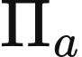. Retired projects with financing obligations retain expenditure accounts and use their declared operating income.
Investment decisions are grouped by owner and technology, then allocated across regions. Retired financed assets in a group continue to contribute and ; operating MW and regional shares use active members. Exogenous REPD projects retain separate reporting accounts, while endogenous investment requires an investment owner. Nuclear and direct electrolysis use exogenous representations, and new natural-flow or pumped hydro requires additional site inputs.
For group , let operating capacity be , operating surplus , annualised capital 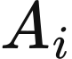, and unit new-build capital the capacity-weighted average of members' capital per MW. An eligible decision group requires 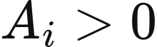 and 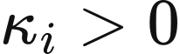. Return and decision class are
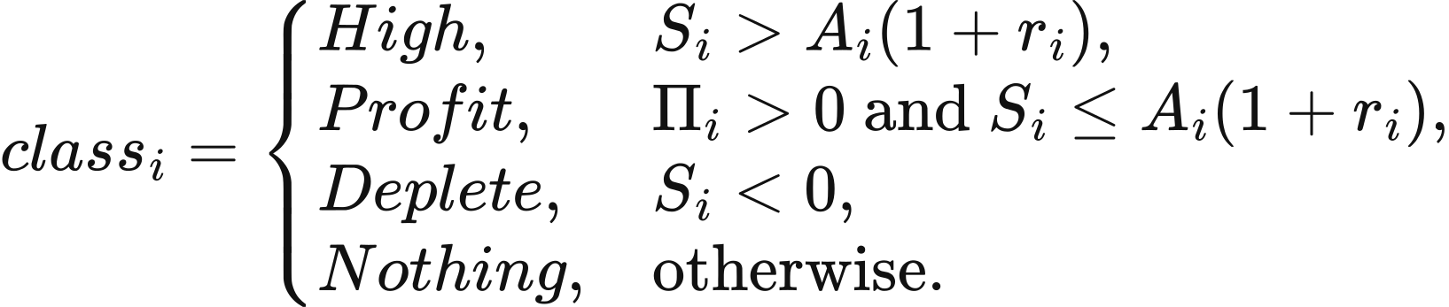
The high-return class uses a strict inequality, so a profitable group exactly at the threshold enters Profit. Assets with 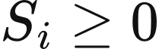 and 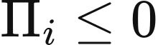 remain in operation. Preferred returns are 0.076 for solar and onshore wind, 0.089 for offshore wind, and 0.12 for the four expandable storage technologies. Other technologies use the largest bound member parameter; R029 CCGT and OCGT both use 0.089.
Loss-driven retirement uses target payback 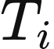. Solar uses 25 years, onshore and offshore wind 30, CCGT and OCGT 25, biomass 20, the three batteries 10, and hydrogen storage 25. The literal technology key gas uses 20 years. This horizon enters the retirement quantity below, while the return denominator remains annualised capital.

Storage opportunities and economic screening
R029 storage expansion uses complete renewable availability and existing storage charging and discharging. Define half-hour energy demand , existing charging 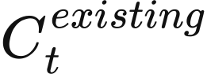, available renewables 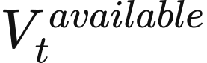, and existing discharge 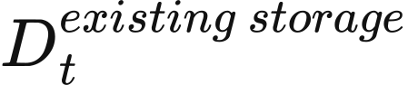. Then
Here is charging surplus and 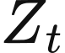 remaining demand. Discharge earns the same-period ahead clearing price 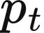. doctoral_​expansion_​inputs.py aligns demand, dispatch, prices and renewable availability weighted by operating capacity period by period.
Each candidate technology independently dispatches an initially empty virtual store with a 100 TWh energy limit. Rated energy is 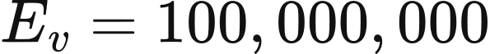 MWh, power is 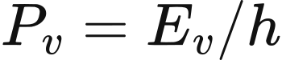, charging and discharging ratings are equal, and per-period inventory retention is 1. Duration and efficiency tuples are for 1C, 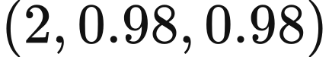 for 0.5C, 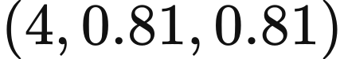 for 0.25C, and 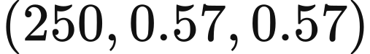 for hydrogen. The four replays evaluate supply-demand opportunities for each technology separately.
The virtual power axis is divided into continuous layers of width  MW, with per-MW inventory 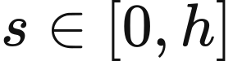 measured in MWh/​MW. Each period allocates charging budget from the lowest capacity coordinate, then allocates discharge budget  in the same order. With inventory-retention factor , per-MW bounds and updates are
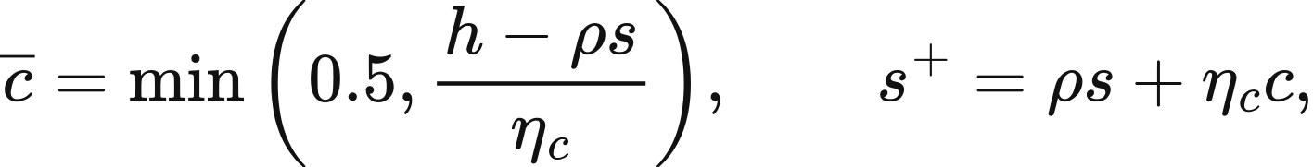
A budget exhausted inside a layer splits it exactly into accepted and residual portions. Adjacent layers may merge when their physical and financial histories are identical. Physical replay follows capacity order, and prices are subsequently used for economic screening. Closing inventory is retained, and income accumulates from actual discharge.
Layer earns 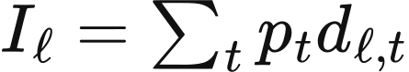, incurs annualised capital 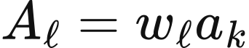, and incurs maintenance 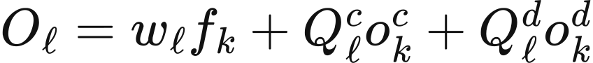. Here 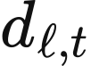 is period discharge from the whole layer, while  are its annual charging and discharging energy, all in MWh. Rates 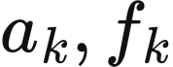 are annual capital and fixed maintenance in GBP/​(MW·year), and 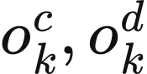 are variable charging and discharging rates in GBP/​MWh.
Charging procurement and variable charging or discharging expenditure are 0 for the candidate technologies, while fixed maintenance follows the catalogue. Annualisation uses a 5% cost of capital and technology lifetime, with battery construction split into equipment and development components below.
Screening includes layers exactly at the 12% threshold. Equivalent cycles are 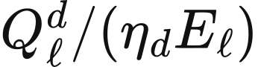, while half-hours with discharge are reported separately. Tail capacity that never charges leaves the candidate set. dispatch_​virtual_​storage performs continuous-layer replay, and assess_​virtual_​storage calculates expenditure and qualifying MW.
N ← demand + existing charging − available renewables − existing discharge
X ← max(−N,0); Z ← max(N,0)
for each candidate storage technology:
Create an empty 100 TWh virtual store and continuous capacity axis
for each half-hour:
Allocate charging and discharging in capacity-coordinate order
Split layers at budget cut-offs; accumulate delivered energy
and income at the period price
Reconcile inventory; merge adjacent layers with identical
physical and financial histories
Screen layers for a 12% return using income, maintenance and annual capital
Multiply total qualifying MW by 0.20 to obtain technology opportunity H
Renewable expansion uses the boundary of 200 negative-net-demand periods in the weather and availability chapter, with the 0.20 expansion fraction. Both types of limits enter annual investment allocation.

Investment quantities and funding
Retained profit can purchase 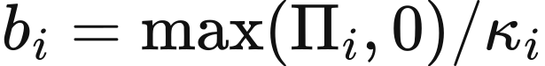 MW for group . For renewables, operating-capacity share 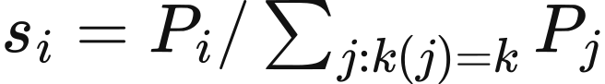 allocates technology headroom as 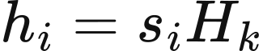. Requests are
Decision and technology | Requested addition MW
High renewables | 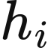
Profit renewables | 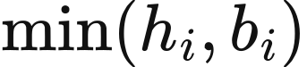
High CCGT, OCGT and biomass | 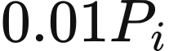
High storage | 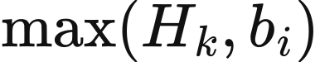
Profit other eligible technologies | 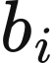
Deplete or Nothing | 0

Several High storage accounts within one technology share capacity while retaining profit-funded floors. Let requests be , summing to . The total allocation is
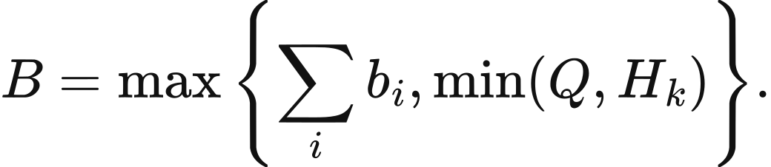
Allocation starts at . Any account below its profit-funded floor receives that floor first; the remaining budget is redistributed in proportion to the other requests until complete. Retained-profit purchasing capacity can therefore exceed technology opportunity 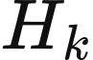. Profit storage invests directly at . Loss-making groups separately retire 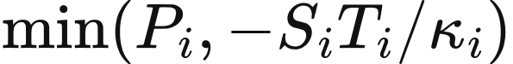.
Final addition  requires capital expenditure . Retained-profit funding and external finance are
After the owner determines its total, projects are allocated by existing regional MW shares. New storage inherits regional members' , the minimum lifetime, maximum development period and minimum success probability. Planned commissioning is . External finance is a funding source specified by these decision rules.
For example, a renewable group has 100 MW, technology-wide capacity of 1,000 MW, headroom of 200 MW, unit capital of £1m/​MW, annualised capital of £10m, operating surplus of £11m and a 7.6% threshold. Its £1m annual profit gives a 10% return, placing it in High with a 20 MW request. Retained profit funds £1m and external finance funds £19m.

Annual charges and loan repayment
The three battery technologies split construction expenditure between equipment and development. With equipment share , total annual construction recovery  and fixed maintenance  are classified as
Equipment recovery enters annualised capital, and development recovery enters fixed expenditure. This classification also determines the capital denominator of investment returns. Other technologies use .
Technology | Equipment GBP/​MW | Development GBP/​MW | Total construction GBP/​MW
1C battery | 130,000 | 200,000 | 330,000
0.5C battery | 160,000 | 190,000 | 350,000
0.25C battery | 230,000 | 185,000 | 415,000

Endogenous projects draw finance on commissioning. For equity , debt , positive integer lifetime and borrowing rate 0.05, annual debt payment is . Opening principal 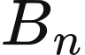 gives interest and principal repayment
The final year clears remaining principal. Equity is recovered linearly at , giving annual construction recovery
Equity recovery and debt payments are zero after year . Projects retired physically before then continue their committed recovery and debt obligations, which remain in annual accounts. Construction retains an undrawn-finance state, and debt interest begins in the commissioning year.
Expected-capacity planning multiplies project power, energy, capital, annual charges, equity and debt commitments by success probability once. The financial schedule is prepared before operation and settled after acceptance of the complete year. doctoral_​finance.py manages drawdown and repayment, and doctoral_​storage_​costs.py classifies battery expenditure.

Policy scenarios
R029 uses basic, with all policy budgets set to zero. Optional scenarios with_​cm, decarbonisation_​base, subsidy_​as_​usual and governmental_​target use explicit annual budgets and technology targets in 2025 GBP. All non-basic scenarios enable the capacity market and ancillary services; the latter three also include existing decarbonisation support.
When the capacity market is enabled, a fixed annual budget of £5.44bn is allocated by de-rated capacity:
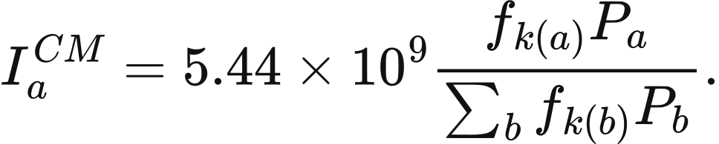
Technology | De-rating factor
CCGT, OCGT and biomass | 0.95
Nuclear | 0.85
Pumped hydro | 0.95
1C battery | 0.05
0.5C battery | 0.15
0.25C battery | 0.60

Hydrogen-storage eligibility factors are supplied explicitly by the scenario. Ancillary services are allocated by operating MW of thermal, nuclear and storage assets. subsidy_​as_​usual and governmental_​target allocate incremental decarbonisation budgets by eligible renewable MW. The target scenario ends a technology's eligibility when its operating capacity reaches the specified target.
Existing decarbonisation support enters the policy-cost report, while incremental support enters eligible investment income. Budgets remain unallocated when eligible capacity is zero. allocate_​thesis96_​policy calculates these transfers from the scenario, annual budgets, de-rating factors and capacity targets.
The historical thesis expenditure view includes policy levies and unserved energy valued at £8,000/​MWh in the numerator, with non-battery generation, including imports where present, as the denominator. The resource-expenditure view uses actual capital, operating and reliability expenditure per unit of served energy, with VoLL supplied by the run configuration. Historical carbon indicators follow their original scalar equations. The current physical emissions ledger uses the factors in Chapter 9 and reports tCO₂e; these outputs retain their respective units and calculations.

Construction pipeline and exogenous schedules
Initial REPD projects form a commissioning pipeline according to technology, region and development stage. Success probabilities first use technology-region values, then the arithmetic mean of known regions for that technology, and finally 0.75. Probabilities apply to projects whose configured status requires them. R029 endogenous planning uses expected-capacity mode with seed 0, multiplying capacity and financial totals by the success probability once. An initial external snapshot that already contains successful capacity retains that effective capacity thereafter.
External completion dates follow stage duration and a fixed project perturbation. completion_​year_​from_​months uses deterministic between −6 and 6 months, giving the base completion year
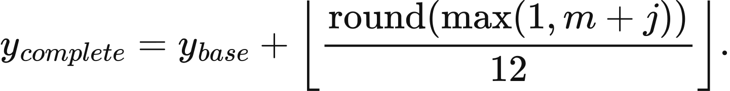
For approved projects, includes pre-construction and construction. Application dates use day-first parsing. Completion is also bounded by the full development period from application, the model starting year, and starting year plus 1 for an initial snapshot. External projects completing exactly in the starting year may be deferred by 1–3 years under a fixed project rule.
Project screening uses status, technology, capacity and dates. Capacity must be at least 1 MW and completion no later than 2040. Terminated, operating, previously completed and stalled projects leave the pending set. The default stale-project threshold is 2015 and construction grace period is 2 years. lookup_​regional_​success_​rate, resolve_​repd_​success and preprocess_​doctoral_​project_​records connect regional probabilities to REPD fields. Optional stochastic planning uses a deterministic draw from project name, region and technology for external projects, and from seed and proposal identifier for endogenous projects. This R029 case uses expected capacity.
The initial 2025 pipeline contains 2,775 standardised project components, including 536 source storage projects each divided into four technologies. The table gives capacity after planning-success expectations, scheduled for later commissioning.
Technology | Project components | Expected MW | Completion years
Solar | 386 | 13,106.265796 | 2026–2027
Onshore wind | 215 | 6,871.231070 | 2026–2030
Offshore wind | 27 | 29,924.275000 | 2027–2034
1C battery | 536 | 1,505.519970 | 2026–2028
0.5C battery | 536 | 49,501.496623 | 2026–2028
0.25C battery | 536 | 6,022.079881 | 2026–2028
Hydrogen storage | 536 | 15.055200 | 2026–2028
Nuclear | 3 | 6,460.000000 | 2031–2035

Pumped-hydro power, energy and annual charges follow an exogenous fleet schedule. Expenditure in the table is already annualised and enters the year's fixed maintenance and capital recovery directly.
Model year | MW | MWh | Annual maintenance GBP million | Annual capital GBP million
2025 | 2,828 | 26,700 | 85.4 | 377.9
2026–2027 | 2,927.9 | 27,400 | 87.8 | 388.5
2028 | 3,377.9 | 30,200 | 96.1 | 425.1
2029 | 3,587.9 | 31,800 | 99.9 | 441.5
2030 | 4,187.9 | 40,800 | 112.4 | 496.8
2031–2034 | 5,687.9 | 70,800 | 134.9 | 596.4
2035 | 11,387.9 | 195,800 | 241.9 | 1,070.8

Nuclear follows the model's fixed exogenous schedule. Heysham 1, Hartlepool, Heysham 2 and Torness have 1,155, 1,185, 1,230 and 1,190 MW respectively and withdraw from model year 2031. Sizewell B has 1,198 MW and withdraws from 2056. The two 1,630 MW Hinkley C units begin full-year operation in 2031 and 2032. Sizewell C's 3,200 MW remains in the 2035 pipeline. Initial nuclear capacity totals 5,958 MW. This schedule comes from value_​uk_​nuclear_​policy_​v1.json; new nuclear engineering costs await a common price base before entering the main resource-expenditure calculation.

Annual update and numerical example
The annual loop prepares financing expenditure before operation, determines investment and retirement afterwards, and carries physical and financial states together. doctoral_​annual_​cem.py requires complete annual demand, cash, costs and expansion inputs before calling doctoral_​policy.py for owner decisions.
for each model year:
Prepare annual equity recovery and debt schedule
Apply exogenous pumped-hydro and nuclear schedules; advance due projects
Restore inventory batches across years and run the complete half-hourly year
Build project accounts from actual market cash; allocate scenario transfers
Calculate renewable limits and economic storage opportunities
Group by owner and technology; decide additions and retirements
Split projects by region and apply planning success rates
Settle financing; update physical assets while retaining financing obligations
Save closing batches, generator memory and the remaining construction pipeline
The R029 2025 CCGT account provides a numerical example of retirement. It operates 28,000 MW, has unit new-build capital of £2.4m/​MW, operating surplus of −£429,488,780.128199 and target payback of 25 years. Retirement is therefore
This calculation uses operating surplus . Of 47 decision accounts that year, 6 enter Deplete, 38 retain capacity and 3 enter High. Renewable and storage technology limits are all zero, giving zero new proposals. The initial pipeline comes from 2025/​input.json.gz, and the account example from 2025/​year-result.json.gz, connecting the annual rules to saved model quantities.

7 Transmission and network constraints

Spatial representation of zonal redispatch
Zonal redispatch adds spatial constraints to the schedule produced by the national market. Each half-hour retains the national ahead schedule and accepts upward and downward bids across zones so that final injections satisfy zonal demand, corridor limits and geographical boundary limits. The formulation represents a lossless transport network, with flows determined by nodal conservation and the declared capacity constraints. Both the 23-zone case and the 11-zone transmission experiment use this representation. DC network dispatch and AC feasibility calculations are separate optional modules defined later in this chapter.
Redispatch uses period energy as its decision quantity. Let the period length be h, with zones, corridors, geographical boundaries, assets, bids and storage indexed by 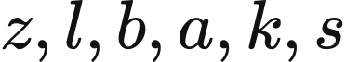, respectively. Zonal demand 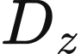, scheduled asset injection and accepted bid magnitude 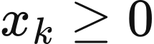 are measured in MWh. The direction sign is 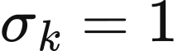 for upward adjustments and 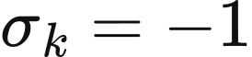 for downward adjustments;  is the bid price in GBP/​MWh. Corridor energy 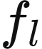 is positive from the declared origin to the destination, and 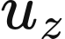 is unserved energy. The incidence matrix 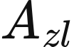 takes 1 at the origin and −1 at the destination, so  is net outflow from the zone.
Demand enters the model through the spatial rule selected for the case. The 23-zone case preserves the zonal shares of the network data and scales the original series 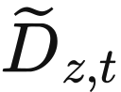 to national scenario demand . The 11-zone experiment uses absolute demand from the network data and retains the forecast-to-actual ratio in the base demand series:
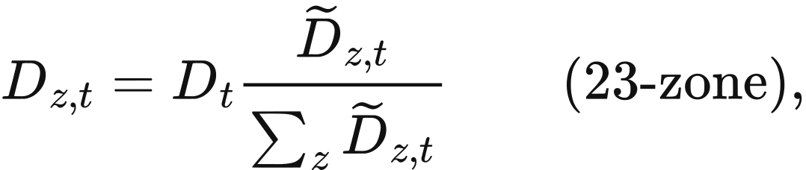
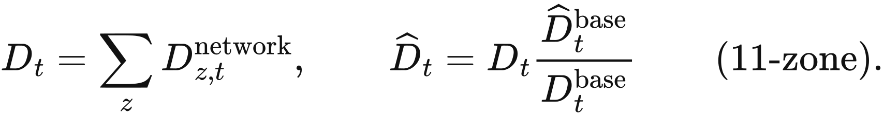
The final zone in the share-based calculation receives the national total less the sum of the preceding zones, preserving aggregate demand. Inputs also provide the fixed zone of each asset, its actual availability and interconnector import/​export ranges. A zero denominator with positive required demand is treated as an input error.

Adjustment objectives and operating constraints
Redispatch sequentially minimises bid payments, adjustment volume, physical throughput and a stable ordering objective. The four linear programmes share physical constraints, and each later programme retains tolerance bounds on earlier objectives. Let 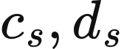 be storage charging and discharging energy, 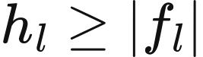, and be the decision vector:
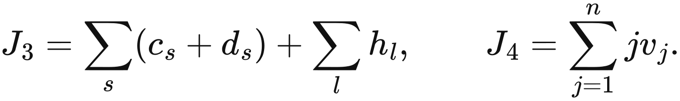
Both zonal cases use a value of lost load of  GBP/​MWh. The downward payment term is 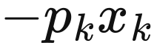, so the bid sign directly affects payment. 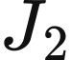 selects lower total adjustment, 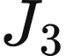 selects lower storage throughput and absolute corridor flow, and  resolves ties through a fixed variable order. Bid, corridor, zone and storage identifiers define the fixed variable order.
Asset adjustments connect zonal energy conservation to the national schedule. Final net injection 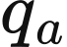 combines scheduled injection with accepted signed adjustments:
A bid limit uses declared available MWh where provided; an MW limit is multiplied by 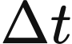. Ordinary generating assets satisfy 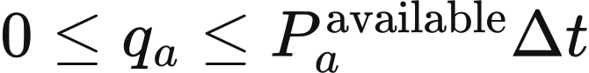, while interconnectors satisfy 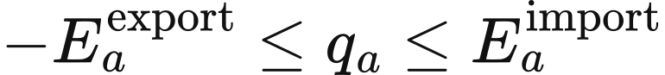. Ordinary non-storage bids sharing zone, direction, network effect, price and resource class are accepted in proportion to their available quantities. For a reference bid  within the group,
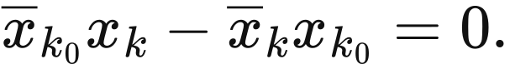
A geographical boundary limits the signed aggregate flow of its member corridors. Let 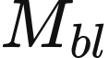 be the membership coefficient and 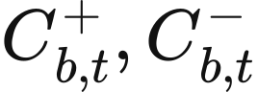 the forward and reverse MW capacities. All boundaries apply simultaneously:
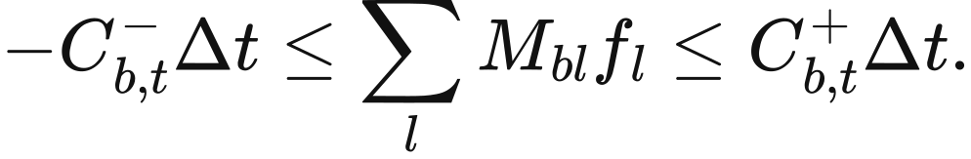
Declared corridor-specific limits additionally impose 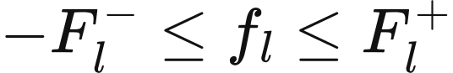, while 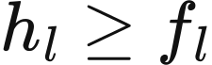 and 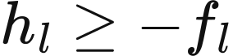 represent absolute flow. Capacities supplied directly in MWh enter the constraints as given. For example, the B6 limit of 6,700 MW becomes 3,350 MWh per half-hour, and the Western Link limit of 2,200 MW becomes 1,100 MWh. A corridor without its own limit remains subject to nodal balance and its geographical boundary memberships.
Storage inventory advances according to realised redispatch. Let 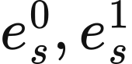 be initial and final internal inventory,  energy capacity, and 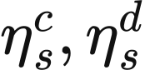 separate charging and discharging efficiencies:
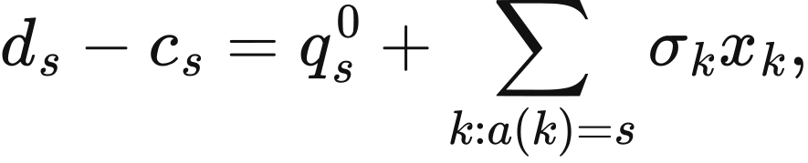
Storage bids follow convex_​net_​power_​v1, with at most one bid in each direction and 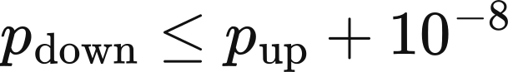. Charging and discharging are continuous variables, with final trajectories satisfying 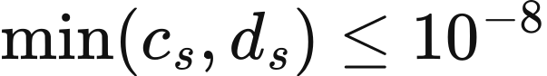 MWh. Final inventory passes to the next period. Intertemporal value enters the current decision through the schedule and bids supplied by the higher-level strategy.
Bid payments and physical resource costs are accounted for separately. Bid cash flow is , while zonal operating resource cost uses actual positive injections and shortage:
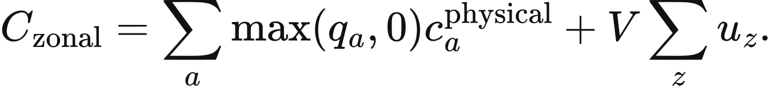
The current copperplate balancing result uses the first term of this expression for operating cost. Comparisons therefore report unserved energy and reliability charges for each balancing method alongside their cost difference, separating generation resource expenditure from the treatment of shortage.

Numerical solution
Redispatch solves 4 linear objectives sequentially, retaining tolerance bounds on earlier objectives in later stages. The first stage permits at most 1 GBP of payment-objective degradation per complete period; the second and third stages use numerical tolerances scaled to their objectives. HiGHS dual simplex with presolve uses primal and dual tolerances of 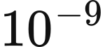. Physical constraints are recalculated for the final solution, with maximum violation of equalities, inequalities and variable bounds within 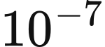.
for each half-hour t:
obtain the national ahead schedule and current storage inventory
align zonal demand and construct available upward and downward bids
build asset, nodal balance, corridor, boundary and storage constraints
solve J1, J2, J3 and J4 in sequence, retaining earlier objective caps
check physical feasibility and objective caps
return actual injections, transfers, shortage, payments and resource costs
pass final storage inventory to the next period

The two zonal cases
The 23-zone case contains 22 computational corridors and the B6 and B7a geographical boundaries. Their forward and reverse capacities are 6,700 MW and 9,400 MW, respectively, with constant ratings across periods. The scenario covers 2025–2034 under fixed network capacity; annual changes enter through higher-level demand and asset states. Its spatial input assigns CCGT, OCGT, nuclear, run-of-river hydro, biomass and waste, and 4 storage classes to the aggregate ENGLAND_​FALLBACK node. This aggregation determines the network location of these resources.
The 11-zone experiment represents British regions as T1–T11 and compares transmission outcomes for a single year with fixed assets. The regions are N. Scotland, S. Scotland, N. England, N. Wales/​the Mersey/​the Humber, Midlands, Central England, E. Anglia, S. Wales/​the Severn, S.W. England, S. England and South-East England. It uses 2022 demand and weather over 17,520 half-hours with a 2025 model background. Asset capacities remain fixed throughout the experiment, with annual investment outside its execution path.
The 11-zone network combines 13 computational corridors classified as AC assets with Western Link. Ordinary corridors connect 1–2, 2–3, 3–4, 4–5, 5–6, 5–8, 6–7, 6–8, 6–11, 8–9, 8–10, 9–10 and 10–11; Western Link connects T2→T4. The table gives geographical boundary capacities and the separate Western Link limit. The 2029 values form an independent sensitivity input, while base cases use 2025 capacities.
Boundary | 2025 capacity in each direction, MW | 2029 sensitivity capacity, MW | Positive-flow members
B4 | 4,002 | 4,923 | f12
B6 | 6,700 | 11,456 | f23 + fWL
B7a | 9,400 | 10,609 | f34 + fWL
B8 | 11,000 | 14,005 | f45
B9 | 11,500 | 12,900 | f56 + f58
EC5 | 3,300 | 5,925 | −f67
LE1 | 11,223 | 13,917 | f6,11 + f10,11
B13 | 3,500 | 6,575 | −f89 + f9,10
Western Link | 2,200 | 2,200 | fWL

Western Link flow consumes the stated capacity of both B6 and B7a. The 8 geographical boundaries use symmetric reverse capacities, while the Western Link input specifies a bidirectional rating. In the base reduced network, T6, T8 and T10 have identical boundary memberships, leaving modelled transfer between them without a finite upper bound. In its 14-dimensional corridor space, the nodal incidence matrix has rank 10, the geographical boundary matrix rank 8, and the matrix including the HVDC limit rank 9. The 5-dimensional constraint null space contains 3 circulation directions and 2 directions that alter nodal net transfers.
The thermal-capacity sensitivity adds separate limits to 8 southern corridors while retaining geographical boundaries. Its construction contracts known substations within each zone to the zone node, retains unknown intermediate nodes, excludes other known zones, and calculates corridor capacity by network maximum flow/​minimum cut. Parallel line capacities add, while serial paths are limited by their bottlenecks; MVA is converted to MW at an assumed power factor of 1. The ordinary summer and winter inputs are shown below; separate upper-bound sensitivities use their own files.
Corridor | Summer MW | Winter MW
T5–T6 | 19,086 | 21,052
T5–T8 | 3,424 | 3,934
T6–T8 | 4,436 | 5,558
T6–T11 | 16,684 | 19,849
T8–T9 | 8,088 | 9,217
T8–T10 | 6,470 | 7,834
T9–T10 | 4,434 | 5,558
T10–T11 | 6,587 | 7,500

DC network dispatch
The DC network module jointly selects resource output, storage trajectories and nodal angles over a given full horizon. Let , , 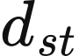 and 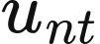 denote resource supply, storage charging, storage discharging and nodal unserved energy in MWh;  denotes MW flow and  denotes angles in radians. With fixed assets, the objective is
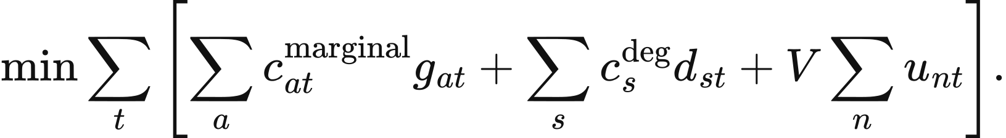
Nodal conservation connects period energy and line power through the period length:
Storage satisfies power and energy bounds, with a terminal condition chosen as free, equal to initial inventory, or equal to a specified target. Unserved energy is either fixed at zero or bounded by 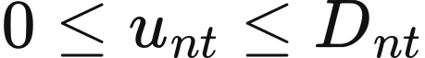, according to configuration. Resource availability lies in , and marginal costs are nonnegative.
Active flow on AC lines and transformers follows an angle-difference relationship. Let  be base capacity, 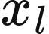 reactance, 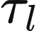 tap ratio, 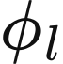 phase shift and  the number of circuits:
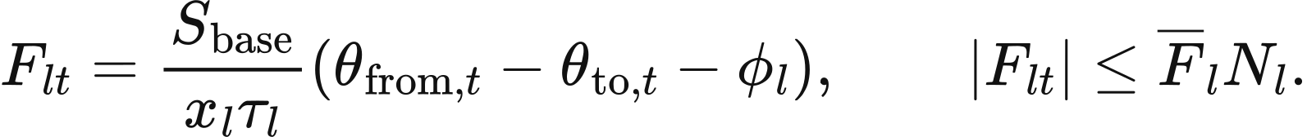
Base capacity defaults to 100 MVA and the tap ratio to 1; phase shifts are converted from degrees to radians. Circuit count scales thermal capacity, while reactance enters the angle equation at its declared equivalent value. Each connected island has one reference node with zero angle; other angles lie in 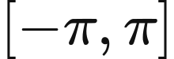. Out-of-service branches have zero flow, and DC links enter nodal balance as controllable flows within declared bounds.
Nodal prices are the marginal operating cost of nodal demand. HiGHS solves all periods in one linear programme, using primal and dual tolerances of and an equality-residual limit of . Dual variables of the nodal energy balances provide prices in GBP/​MWh, and the displayed system price is weighted by nodal demand. Available capacity, the linear network and storage constraints define the operating conditions of this continuous model for full-horizon cost comparisons.

AC feasibility calculation
The AC module tests the local steady-state power flow associated with a given active-power schedule. Inputs include nodal active and reactive demand, generator active and reactive bounds, voltage setpoints, branch impedances and charging susceptances, fixed taps and phase shifts, voltage bounds and MVA ratings. Each connected island has one slack balancing asset. PV and slack buses require generators, and generators at the same bus share a voltage setpoint. Storage enters through its given active charging and discharging schedule.
Nodal complex power is calculated from complex voltage and the admittance matrix. Let 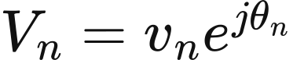 and let  be the nodal admittance matrix:
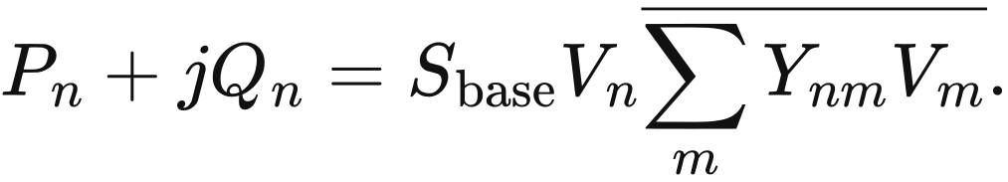
Branches use an impedance π representation. With 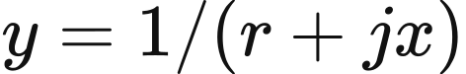, 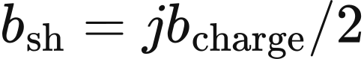 and 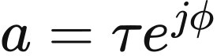, the terminal admittances are
The solver fits active-power balance at non-slack buses and reactive-power balance at PQ buses, holding PV and slack voltage magnitudes fixed. The slack generator supplies residual active power and network losses; nodal reactive power is checked against the aggregate limits of generators at that bus. Sending-end power and active loss are
Apparent power at each terminal is bounded by the MVA rating multiplied by circuit count. Every in-service branch enters the admittance matrix using its declared impedance. The calculation uses fixed topology and fixed device settings.
Power flow is solved by nonlinear least squares from multiple initial conditions. The model checks consistency of voltage magnitudes and angles across converged solutions, then tests generator active and reactive limits, bus voltages, branch MVA limits and system balance among supply, charging, demand and active losses. Outputs describe local steady-state feasibility and power-flow trajectories for the given active-power schedule under fixed topology and device settings.

Optional line expansion
The line-expansion module screens candidates using observed congestion and externally supplied benefits. Candidate data contain endpoints, line parameters, circuit numbers and limits, capital cost, fixed operation and maintenance, lifetime, discount rate, lead time, delay, planning-success probability and budget group. For candidate , annual peak utilisation of its trigger branches and the benefit-cost ratio are
Candidates are screened in descending benefit-cost ratio and ascending identifier order. Earliest decision year, the peak-utilisation threshold, minimum benefit-cost ratio, total budget and budget-group allowance determine admission. A zero annual cost produces an infinite benefit-cost ratio. Standard parameter defaults are 0 GBP for total annual budget and 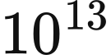 GBP per budget group, so positive total funding activates proposals. Each accepted proposal deducts its complete construction capital cost, and expected commissioning is the decision year plus lead time and delay.
Planning success is determined by a reproducible uniform number generated from the seed and proposal identifier. A value above the success probability marks planning failure. The default seed is 0, and the proposal identifier includes the run identifier, so both define the random experiment. At the start of each year, projects commission on completion and retire in their commissioning year plus the ceiling of economic lifetime. Active new branches enter the next annual network topology. The 23-zone and 11-zone cases retain fixed networks; this screening rule is a separately selected expansion method.

Data and implementation
Zonal inputs comprise zones, corridors, cutsets, asset-map, demand, ratings and interconnector-landings. align_​zonal_​demand applies the two demand rules, build_​single_​period_​problem constructs redispatch constraints, solve_​lexicographic solves the 4 objectives sequentially, and ZonalRedispatchBalancing returns actual injections, inventory and costs. build_​network_​data.py constructs the 11-zone network; cutsets_​2025.json, cutsets_​2029.json and the summer/​winter thermal files supply its capacity scenarios. fixed_​fleet_​runner.py executes the fixed-asset experiment.
The independent network modules use buses, branches, asset-to-bus mappings and period demand. ReferenceDCNetworkPSM and validate_​dc_​solution implement linear dispatch and its physical checks; load_​ac_​data_​from_​pack, ReferenceACFeasibilityPSM and validate_​ac_​result implement AC inputs, power flow and feasibility checks. ReferenceTransmissionExpansion reads candidates and budgets and advances construction states, while apply_​commissioned_​network_​assets inserts active new lines into the network.

8 Perfect-foresight dispatch and natural hydrology

Perfect-foresight single-node dispatch
The perfect-foresight module jointly schedules generation, imports and storage across a complete time series with given asset capacities. It provides an optional single-node resource-cost comparison for national operation, with capacity investment supplied by the outer model. Inputs include period demand, resource availability and marginal cost, storage power and energy capacities, efficiencies and initial inventory. The standard application uses a half-hourly clock.
Resources and storage enter the model as period energy. Let  be resource supply, 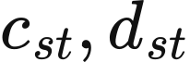 grid-side charging and discharging, 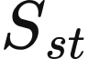 end-period internal inventory, and 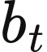 unserved energy, all in MWh. Resource capacity is  MW, availability is 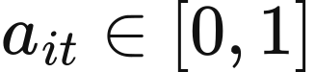, nonnegative marginal cost is  GBP/​MWh, and storage discharge degradation cost is 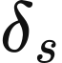 GBP/​MWh. The operating objective is
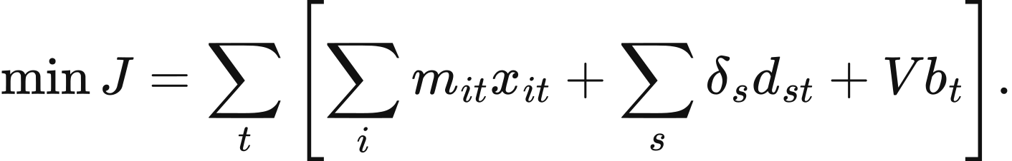
Supply balance and storage continuity are
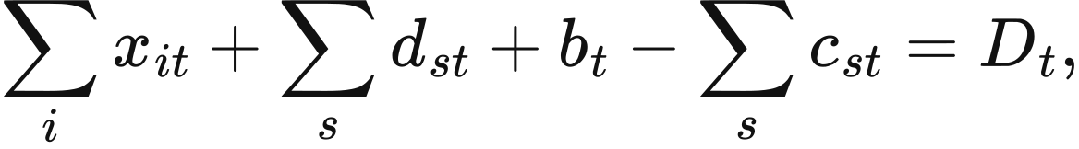
Resource output satisfies 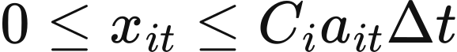; storage power bounds are 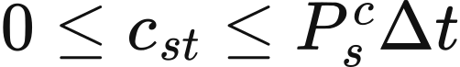 and 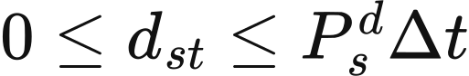; and inventory satisfies . Inventory here measures internal energy, so separate charging and discharging efficiencies enter the transition. Every available resource can supply charging through the single-node balance.
Initial and terminal inventory rules determine storage's net energy exchange over the study horizon. Initial inventory is supplied for each asset. The default cyclic rule equates final and initial inventory; fixed uses a supplied target; free allows terminal inventory anywhere within its bounds. When shortage is allowed, 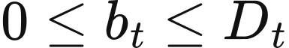; otherwise 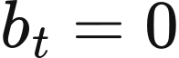. Defaults are h,  GBP/​MWh and 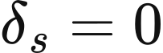, with value of lost load configurable from 0–1,000,000 GBP/​MWh.
Two-stage linear optimisation selects physical trajectories at equivalent cost. The first stage minimises . The second retains the original constraints and adds
while minimising 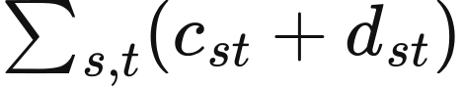. Both stages use HiGHS with primal and dual feasibility tolerances of . The final trajectory requires 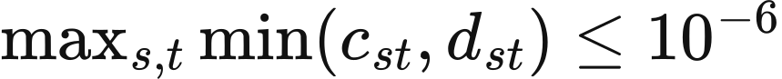 MWh. Unused renewable energy is available output less actual supply.
Prices are the first-stage marginal operating cost of period demand. The supply-balance dual has units GBP/​MWh, while physical output follows the second-stage trajectory. Resource revenue is , net storage market revenue is 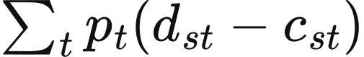, and consumer payment is 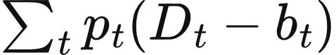. System cost adds the annualised capital and fixed-maintenance fields of operating assets to variable resource expenditure, storage degradation and shortage cost.
read the complete chronology, resource availability, costs and storage states
expand scalar availability or cost inputs to the declared time horizon
build period energy balance, resource limits and storage transitions
LP1: minimize variable resource cost, degradation and shortage cost
retain the LP1 optimum within the declared cost tolerance
LP2: minimize total storage charging and discharging
verify the solution and calculate unused renewable energy
return LP2 trajectories, LP1 demand duals and separate cost components
PerfectForesightPSM constructs and solves this problem, and validate_​chronology checks period inputs. Resource availability in PSMInput.chronology may be a scalar or a complete series; marginal cost may be a scalar, a single-element series or a complete series. Storage inputs provide power, energy, efficiencies and the terminal rule. Hydro in this input acts as an ordinary resource with specified availability. Natural inflows and reservoir inventories follow the independent hydrological methods below.

Available run-of-river electricity
Run-of-river hydro converts current inflow into current available electricity. Site parameters comprise the bus, capacity , turbine efficiency , period length and water-to-energy coefficient . For an input already expressed as a normalised electrical availability factor 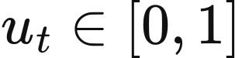,
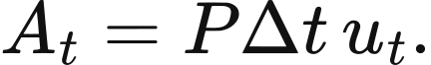
For an input expressed as period water volume 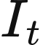, turbine conversion and the power limit jointly determine
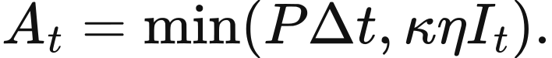
Accepted generation satisfies 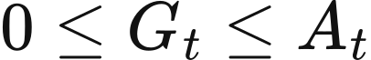, defaulting to all available energy. Unused electrical potential is 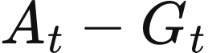. For example,  MW, h and availability factors 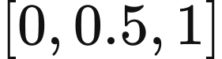 give 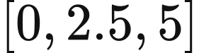 MWh of available electricity. Run-of-river calculation is period-local; conventional reservoirs separately represent intertemporal regulation.

Conventional reservoir dispatch
A conventional reservoir schedules releases over complete inflow and electricity-value series to maximise generation value. Period decisions are turbine release , ecological bypass 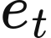, spill 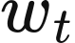 and end-period volume . The first three are water volume per period, and inventory is water volume. Given electricity value , the objective is
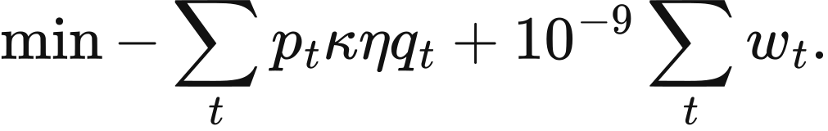
Water continuity and storage bounds constrain releases across time:
Turbine, ordinary-release and ecological requirements are
The ordinary-release ceiling and ecological minimum both apply to 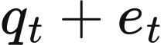, with spill entering water balance separately. Initial volume is supplied explicitly. An optional terminal target  adds a final equality; other configurations allow terminal volume within the storage bounds. Parameters also satisfy  and 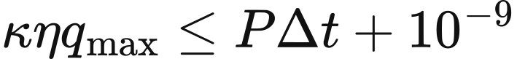, keeping turbine water release consistent with electric power.
Reservoir dispatch uses one full-horizon linear programme. The algorithm reads all inflows and values together, solves with SciPy/​HiGHS, and returns period water volumes, generation and conservation residuals. Its reported objective includes the small spill penalty. The input labels myopic, rolling_​horizon and perfect_​foresight all call this same full-horizon algorithm, with the label returned as metadata. The mathematical definition in this chapter therefore uses perfect foresight.
read site parameters, complete inflow and external electricity values
validate water units, turbine conversion, power limits and storage boundaries
build turbine release, ecological bypass, spill and end-period storage
enforce water balance, ecological release and optional terminal storage
solve the full-horizon linear programme
return electricity generation, water trajectories and balance residuals

Hydrological inputs and module connection
Natural-hydrology studies require five input roles: the site table, asset-to-site mapping, run-of-river inflow, reservoir inflow and reservoir parameters. Sites are classified as run-of-river or conventional reservoir and include capacity, efficiency, bus, source and licence. Pumped storage retains the electrical-storage model. The applicable mapping assigns each asset to a single site, with mapping shares in 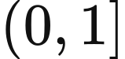 and total shares per asset at most 1.
Inflow uses CSV series with timezone-aware timestamps. The adapter filters by site and requires finite nonnegative values, unique period identifiers and consistent units. If an expected period sequence is supplied, the complete order is checked entry by entry. Metadata declare interval length and timezone, with missing-value treatment set to none. Site, mapping and parameter tables accept JSON or CSV; the inflow reader uses the CSV adapter.
Hydrological functions can be called independently for run-of-river and conventional-reservoir studies. load_​hydrology_​inputs_​from_​pack assembles inputs, adapt_​hydrology_​csv converts inflow, validate_​site_​mapping processes asset mapping, run_​of_​river_​dispatch calculates run-of-river electricity, and reservoir_​dispatch solves reservoir operation. Connecting these hydrological inputs to the annual market workflow requires dedicated integration. British applications additionally require the relevant sites, inflows, abstraction conditions, conversion coefficients, storage capacities and terminal rules.

9 Carbon accounting parameters
VALUE calculates operational emissions and equipment-construction emissions separately before combining them under the selected accounting scenario. Operational emissions vary with generation and imported electricity, while construction emissions vary with installed capacity and the annualisation rule. Current physical accounting uses the value_​current_​authoritative_​v1 factor set. Historical R029 results use the factor set associated with that research configuration.

Generation and imported electricity
Operational emissions are calculated by multiplying interval generation by the corresponding technology factor. Let 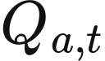 denote the electricity supplied by technology or import source in interval , in MWh, and let denote its factor in kg/​MWh. Annual operational emissions are
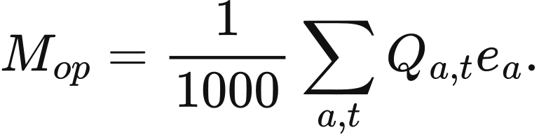
The result is in tonnes, retaining the CO₂ or CO₂e definition of the selected factor. Zero values in the table refer to the direct operational generation boundary. Equipment-construction emissions are calculated using the capacity-based emissions factors in the next section. Import factors use fixed national averages or fallback values.
Generation technology or import source | Factor kg/​MWh | Gas basis | Data basis
Combined-cycle gas | 394 | CO₂ | NESO regional carbon-intensity methodology 2024
Open-cycle gas | 651 | CO₂ | NESO regional carbon-intensity methodology 2024
Biomass | 120 | CO₂e | NESO regional carbon-intensity methodology 2024
Wind Solar Nuclear Conventional hydro Pumped hydro | 0 | CO₂ | NESO generation boundary
Imports from France | 53 | CO₂ | NESO fixed fallback factor
Imports from the Netherlands | 474 | CO₂ | NESO fixed fallback factor
Imports from Belgium | 179 | CO₂ | NESO fixed fallback factor
Imports from Ireland | 458 | CO₂ | NESO fixed fallback factor
Imports from Norway | 11.9 | CO₂e | NVE annual mean for physical electricity delivery in 2024

The source factors are converted to kg/​MWh, with 1 g/​kWh numerically equal to 1 kg/​MWh. The original unit of Norway's factor is gCO₂e/​kWh.
The biomass calculation uses the fixed factor of 120 kgCO₂e/​MWh in the table. Its source reports an uncertainty range of ±120 gCO₂/​kWh.

Construction emissions annualised by power capacity
Construction emissions from generating equipment are annualised by operating power capacity. Let  denote the installed capacity of technology , in MW, and 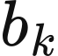 its annual construction-emissions factor, in tCO₂e/​(MW·year). Then
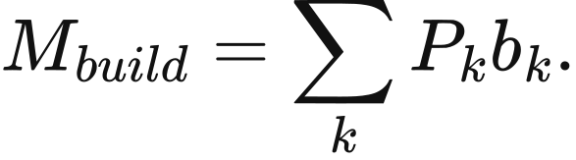
The following annual factors are those used in the research postprocessing input embodied_​factors_​desnz_​unece.csv. The study configuration fixes the factor selection. Open-cycle gas uses the combined-cycle gas construction factor, and the electrolyser uses the literature proxy recorded in that input table.
Technology | Annual factor tCO₂e/​(MW·year)
Solar | 38.544
Onshore wind | 47.304
Offshore wind | 96.1848
Nuclear | 43.362
Conventional hydro | 61.32
Pumped hydro | 98.55
Combined-cycle gas | 16.2936
Open-cycle gas | 16.2936
Biomass | 22.0752
Electrolyser | 1.25

Storage emissions measured by energy capacity
Battery manufacturing emissions are annualised by rated energy capacity and equipment life. The model uses a manufacturing factor of 89 kgCO₂e/​kWh of capacity, the midpoint applied in the Longfield Solar Farm environmental statement of 2022. For capacity in MWh and life in years, annual manufacturing emissions are
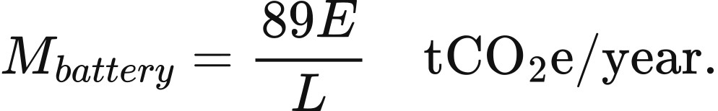
Hydrogen storage accounts separately for power equipment and energy storage. The energy-storage component uses a lifetime factor of 0.0006 tCO₂e/​MWh of capacity, annualised over a 10-year life. It is stored as ch4_​h2_​store_​lifetime in factor_​catalog.csv, with the original thesis Chapter 4 storage parameters recorded as its source. The electrolyser power component uses the annual factor in the preceding section.

Data and implementation
factor_​catalog.csv stores the factors, units, accounting boundaries and source locations, while sources.csv stores source names. CarbonFactorDatabase reads value_​carbon_​factors.sqlite. build_​operational_​carbon_​ledger connects dispatched electricity and operating assets to the selected factor set, and _​asset_​embodied_​lines calculates annualised equipment-construction emissions.

