RAMITERRE, Diana Jade S. HUM 1
BSFT 2C - 1

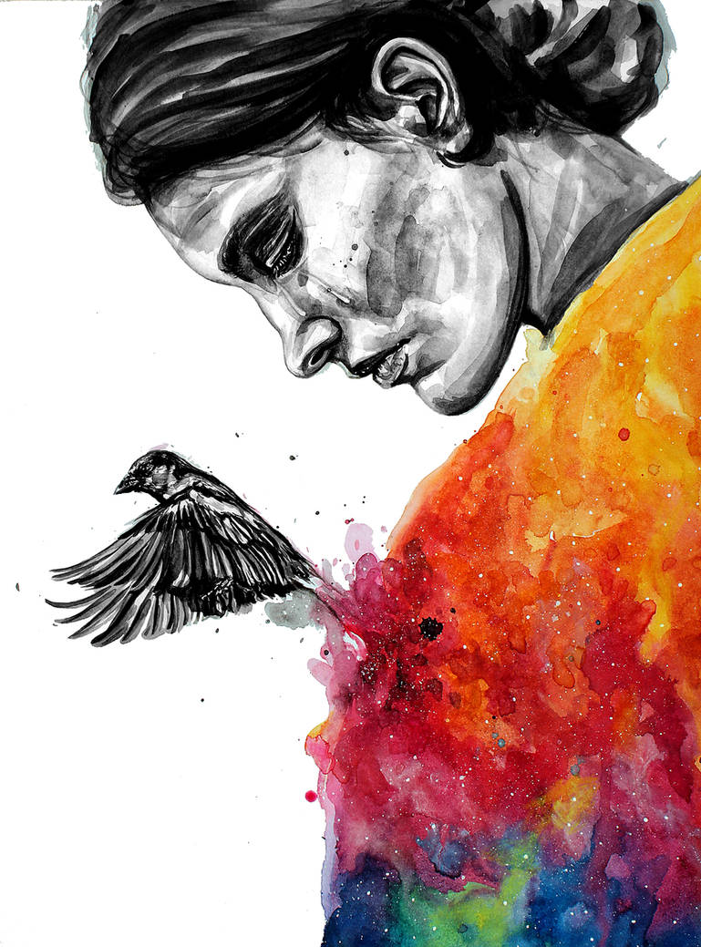
“Life is good and full of color again after depression” they said and that's true because I have seen many people who have walked this journey before and have returned to happiness and hope. Although my depression is still here, I know how to deal with it and avoid letting it take over my thoughts because I'm having fun again. Even when it feels difficult, it's okay to take it one day at a time. It's important to build something again that has been damaged or destroyed because rebuilding is the key to living life again.
This is an artwork that might best describe my personality would be the “Good bye depression” by KlarEm on DevianArt. I've given it some thought, and I find it difficult to choose one. It's not just an artwork for me but it symbolizes more than simply art. It's a path toward healing, a contrast to darkness, a sign of hope, and the power of self-acceptance.

“Good bye depression” | By KlarEm on DevianArt

