Module/SW:

NMF

Revision of this document: 1.1
Document Status: released
Job Co-ordinator: Albold Oliver / ID RD SW OC C / +49-6073-12-4644

State
Tested and released for |  |  |  | COMforCE
Author, Editor: | Manuela Tamas | Date: | 31.08.2012 | X
Versionlabel: | _gen.sw.pkg.nmf_COMMON_Var1.V01.00.01.int |  |  | X
Reason: | Initial revision  MR 12740 NMF: First version for NMF |  |  | X

Table of Contents
1 State 1
2 Table of Contents 2
3 Details 3
3.1 Version _gen.sw.pkg.nmf_COMMON_Var1.V01.00.01.int 3
4 Frequently asked questions 13
5 Organization 14
6 File descriptions 15
7 History of the module 16

Details

Version _gen.sw.pkg.nmf_COMMON_Var1.V01.00.01.int

Contents of Delivery

Path: /id/_gen/sw/pkg/Comforce/Common/nmf/project.pj
Files | Revision | Changed
nmf_ts1.zip | 1.1 | new
nmf_tr1.zip | 1.1 | new
nmf1c1.h | 1.1 | new
nmf1ct.h | 1.1 | new
nmf1cv.h | 1.1 | new
nmf_internal.c | 1.1 | new
nmf_internal.h | 1.1 | new
nmf_interface.c | 1.1 | new
nmf_interface.h | 1.1 | new
nmf_cfg_1st_h.xsl | 1.1 | new
nmf_cfg_2nd_c.xsl | 1.1 | new
comforce_nmf.xsd | 1.1 | new

Differences to the last version
MR-№ (CDS) | MR-№ (CC) | Description | Bug | Sporadic  Error | Errorfree label
12740 |  | NMF: First version for NMF  Version SW: -  Planned SW: _gen.sw.pkg.nmf_COMMON_Var1.V01.00.01.pre  Implement a new network management package for FOTON based on the ustomer specification :  “FOTON High Speed CAN Network Management Specification For Passenger Vehicle_V1_1_20120723.pdf”

Known errors/ problems with temporary solutions
none

Known errors/ problems without a temporary solution
none

Test Status
All tests have passed.

Integration Hints
- call NMF_vInit after CSM_vReset
- integrate NMF_vCyclicTask in the 10ms container
- use NMF_vNetworkRequest in order to request the network and NMF_vNetworkRelease in order to release it
- use NMF_vPassiveStartup in order to request a passive startup
- - please configure the nmf timings in ConfigTool(the below pictures are just an examples)

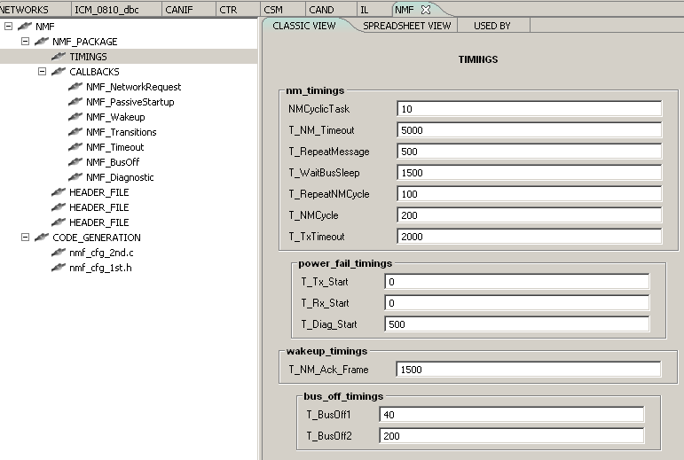
- Please configure the nmf Callbacks in ConfigTool(the below pictures are just an examples)
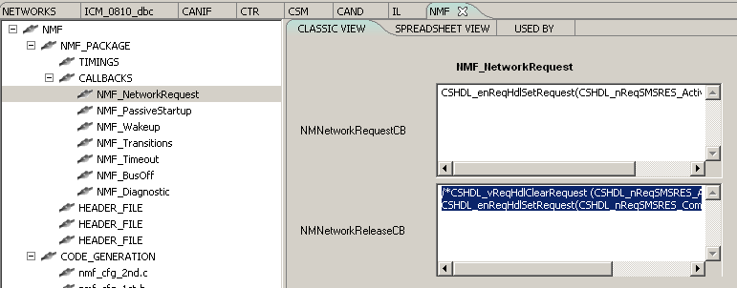

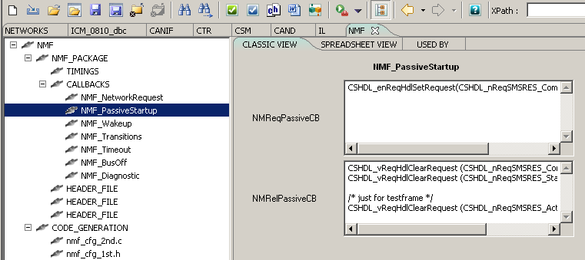

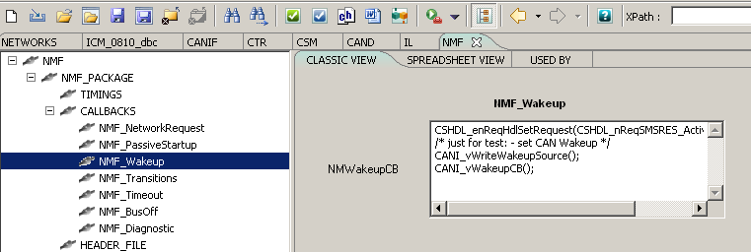

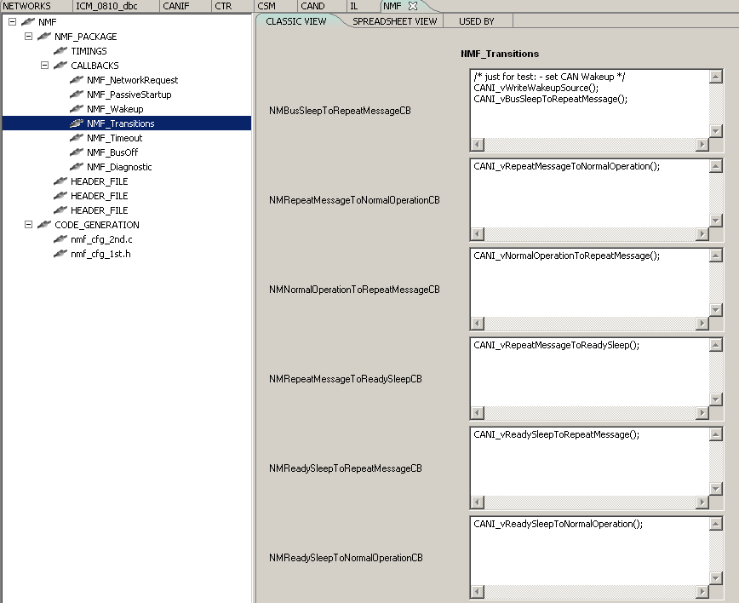
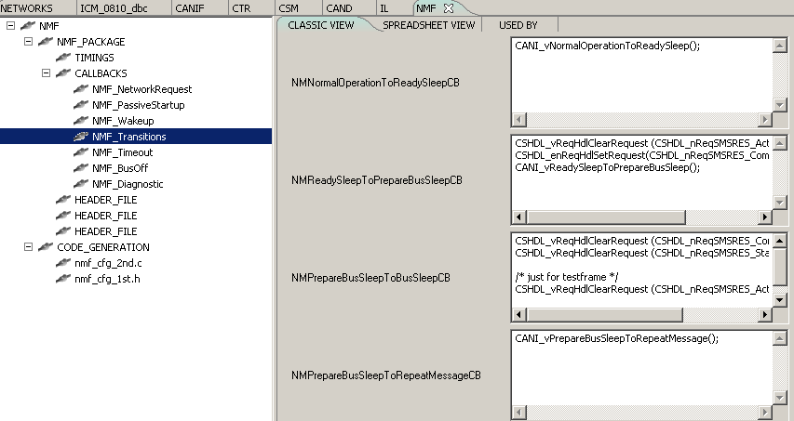

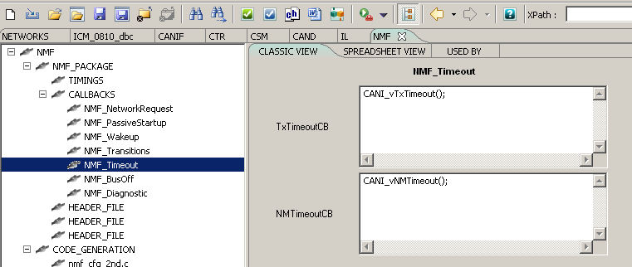

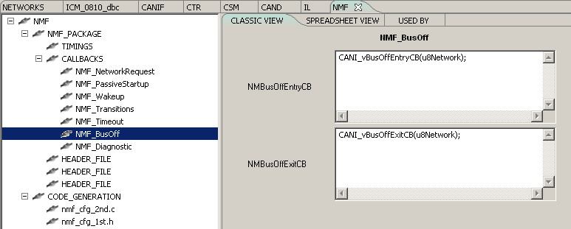
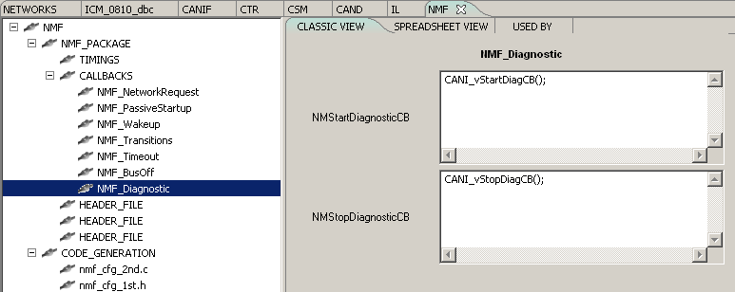

- Please configure in ConfigTool, the nmf files for generated code(nmf_cfg_2nd_c.xsl, nmf_cfg_1st_h.xsl) . Generate the files and integrate them into the system.
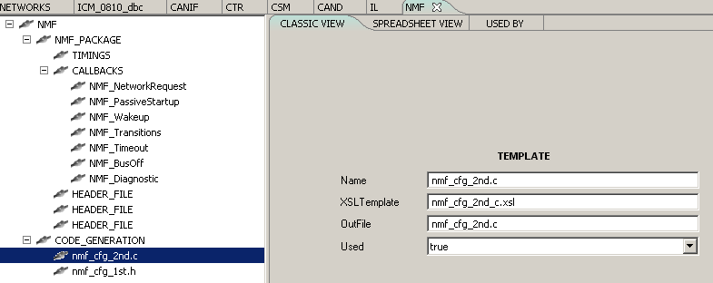
- Configure the NM logical channel
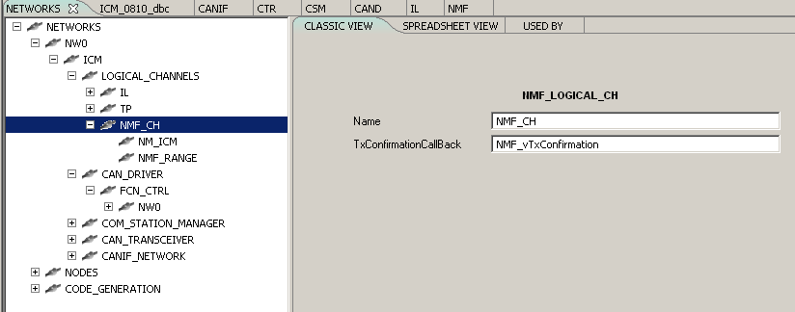

- Configure the range for NM Pdus
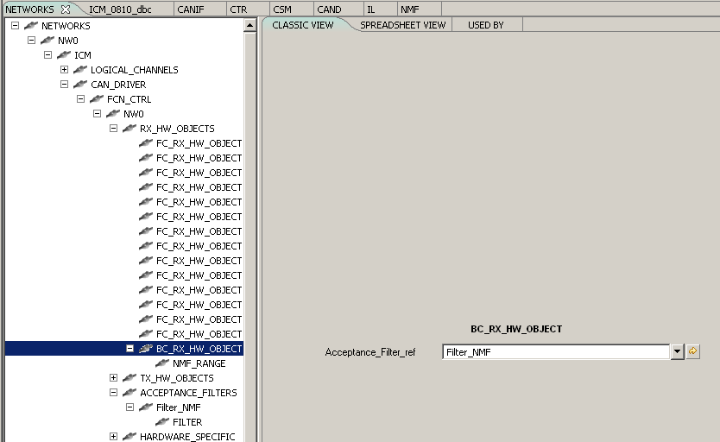

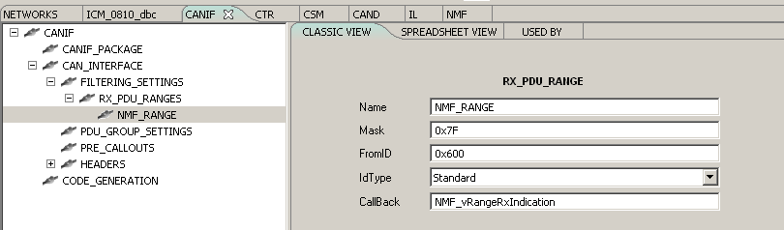
-configure the nmf BusOff function
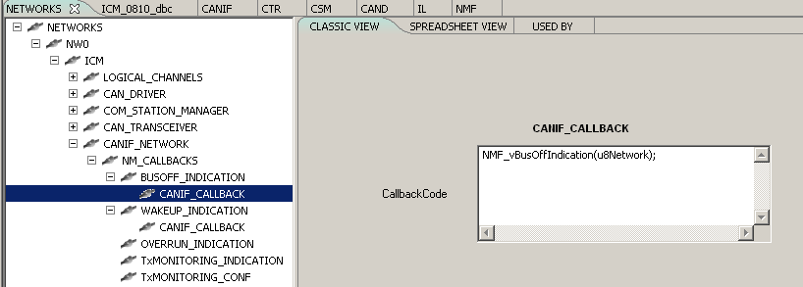
-configure the nmf wakeup function
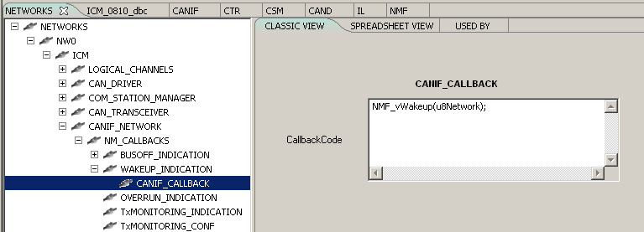
- Other NMF interfaces
- NMF_enGetCurrentState
- NMF_vWakeup
- NMF_vBusOffIndication
- NMF_vRangeRxIndication
- NMF_vTxConfirmation
- NMF_vRepeatMessageReq
- NMF_vNormalToUnderVoltage1
- NMF_vNormalToUnderVoltage2
- NMF_vUnderVoltageToNormal3
- NMF_vUnderVoltageToNormal4
- NMF_vNormalToOverVoltage5
- NMF_vNormalToOverVoltage6
- NMF_vOverVoltageToNormal7
- NMF_vOverVoltageToNormal8
- NMF_vSetWakeupSource
- NMF_vGetWakeupSource
- NMF_vSetNMActiveSource
- NMF_vGetNMActiveSource
- NMF_vGetNMState

Frequently asked questions
N/A

Organization
N/A

File descriptions
S. No. | (File Name) | Description
1 | nmf1c1.h | package API header
2 | nmf1ct.h | package API type header
3 | nmf1cv.h | Version checker for NMF package
4 | nmf_internal.c | Internal behaviour
5 | nmf_internal.h | Internal behaviour
6 | nmf_interface.c | The definition of functions exported by module
7 | nmf_interface.h | The definition of functions exported by module
8 | nmf_cfg_1st_h.xsl | NMF's first pass header file
9 | nmf_cfg_2nd_c.xsl | NMF's second pass configuration file
10 | comforce_nmf.xsd | Description of NMF schema.

History of the module
Please see cap 1.

